# PART xx. MIXER CONVERSION GAIN SIMULATION

In this part, we will try to simulate conversion gain of the mixer.

## Mixer conversion gain versus LO drive level

In this part, we will try to simulate conversion gain for the mixer and determine the effect of LO drive level on gain and DC bias.

The RF and LO frequencies and the LO power level have been defined as variables.

The RF drive level is specified at -50 dBm, while the harmonic balance controller is set up to sweep the LO drive level from -30 to -5 dBm. A simulation measurement equation defines the output power, in dBm, at the IF:

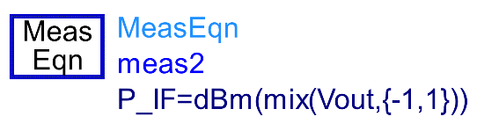

This measurement equation defines it here instead of the data display page makes it possible to optimize for output IF power, if needed. The “**mix**” function will return the component of the Vout spectrum defined by {-1, 1}, meaning {-Freq[1] + Freq[2]} or -LO + RF = IF (45 MHz). The “**P_IF**” equation calculates the dBm value of the mix function.

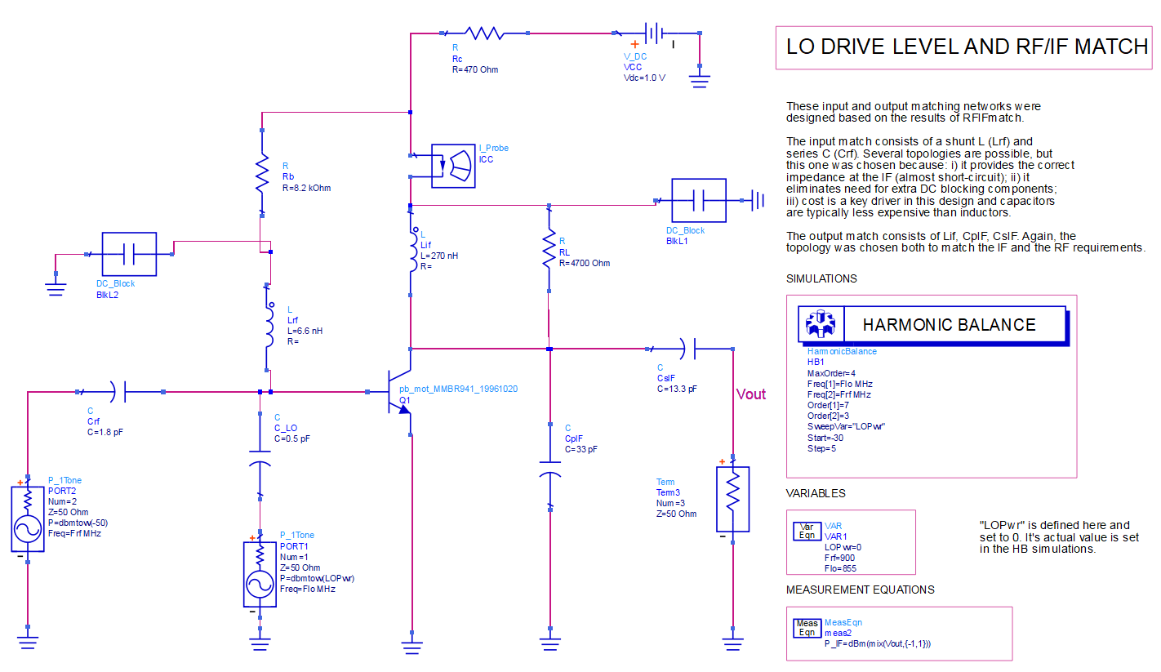

Since the conversion gain is the difference between P_IF and the RF, and the RF power is fixed at -50 dBm, the conversion gain can be calculated with a simple expression.

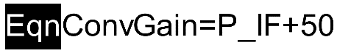

Note that the default dataset, **LODrive**, contains results for a 4.7 kΩ load resistor, and the conversion gain for this simulation is calculated by the equation “**ConvGain**”.

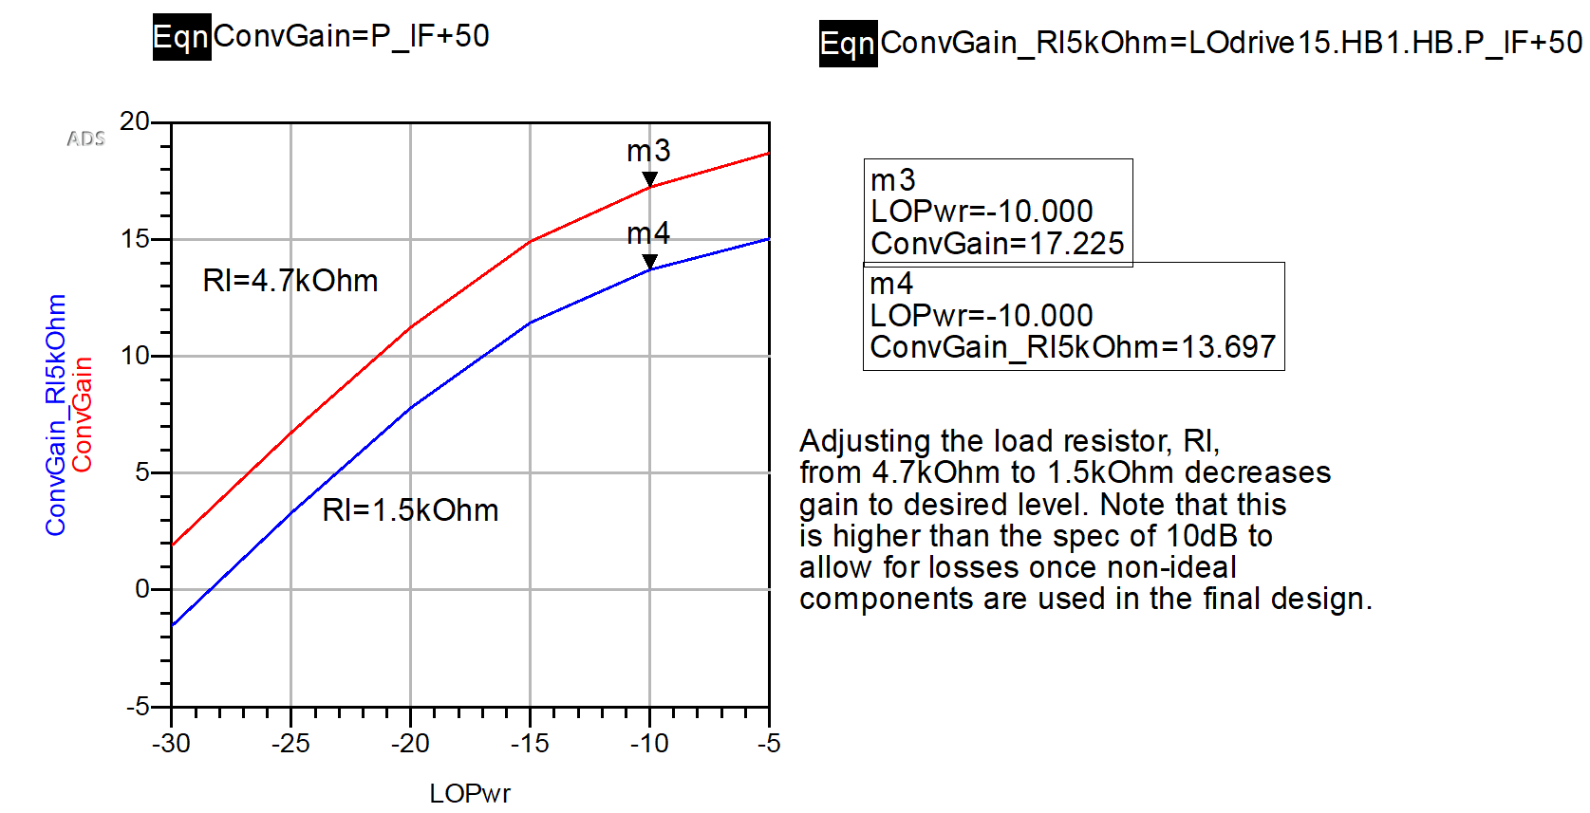

The conversion gain for a -10 dBm LO drive is 17 dB, which is unacceptably high. A second simulation was run with the load resistor reduced 1.5 kΩ, which creates a lossy mismatch on the output. The results for that simulation were output to dataset LOdrive15, and equation “**ConvGain_Rl5kOhm**” shows the conversion gain is reduced to 13.7 dB. This is still higher than the specification of 10 dB but will be left at this value for now since conversion gain can be expected to decrease further when non-ideal surface mount components replace the ideal components.

The graph below shown illustrates the effect of the LO drive level on DC bias. Increasing the LO signal at the base drives the output swing on the collector harder, shifting the DC component higher (see Figure 19). In practice, a 5 to 15 percent shift in collector bias current typically gives good performance for a mixer of this type.

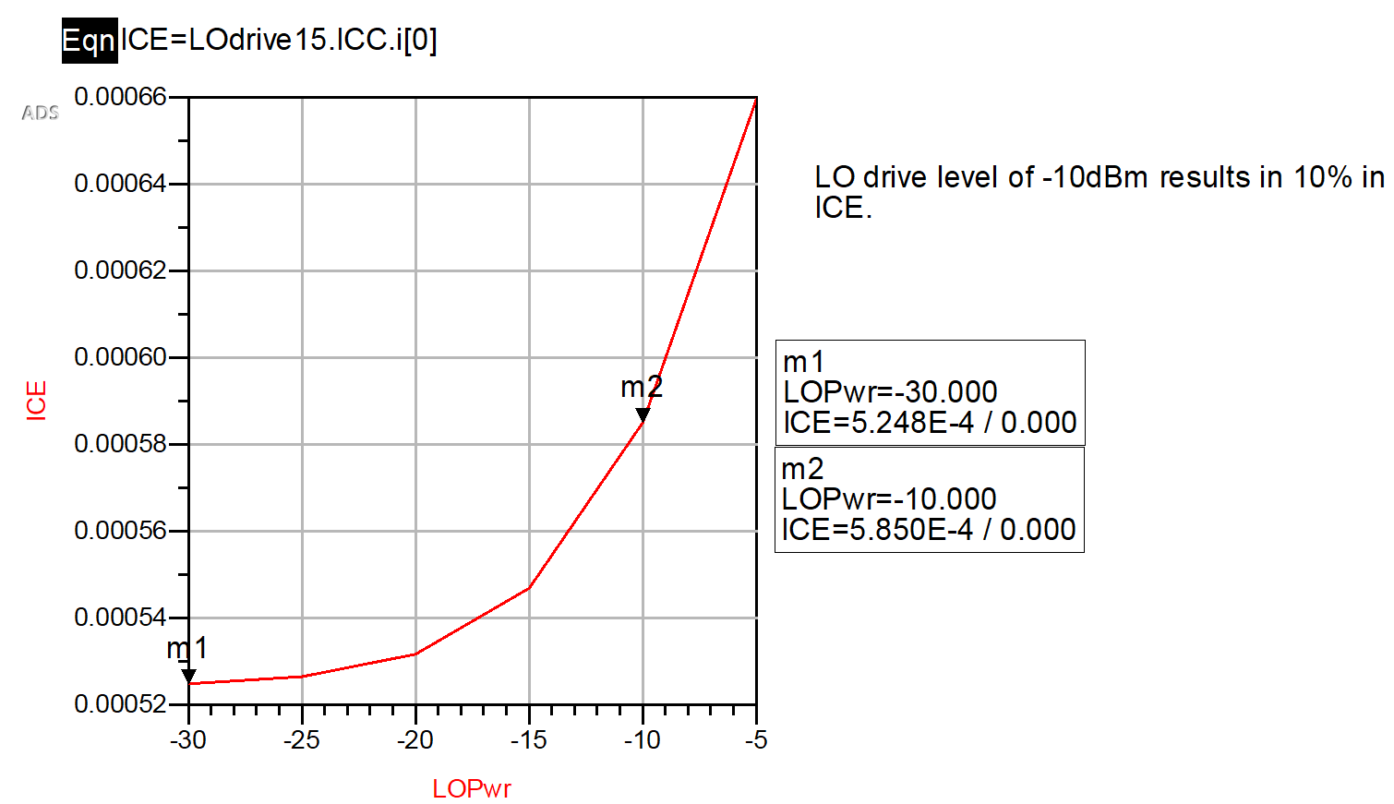

## Mixer conversion gain versus RF signal level

The set-up for measuring mixer compression is very similar to LOdrive, except that the LO power level is now held constant at -10 dBm, while the RF power is swept from -50 to 0 dBm.

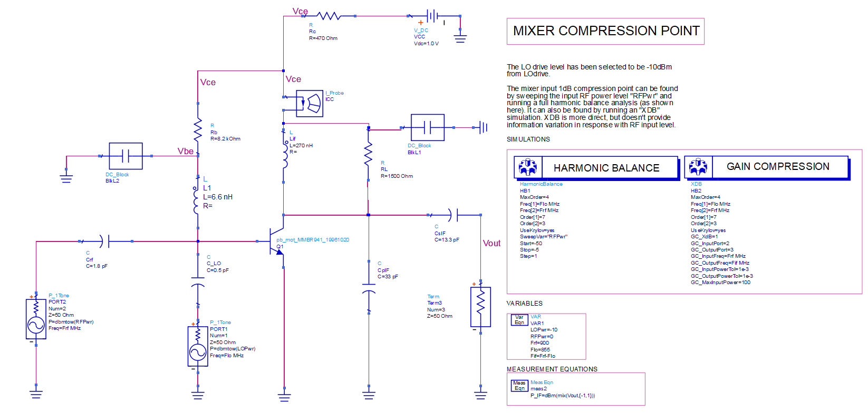

As the results in Figure below show, the mixer’s conversion gain reaches 1 dB compression at an input signal level of -27 dBm.

