# INTRODUCTION

## What is a mixer

* One of the most useful radio frequency processes is mixing, which is performed by a RF mixer. Unlike a conventional audio mixer where sounds are simply added together to create an interesting sound effects, RF mixing refers to a different process. Where signals are multiplied together to create a new signal with a different frequency
* RF mixers are used in virtually every cellphones and many other devices like radios, spectrum analyzers. It can change signal’s frequencies for different purposes. For example, with mixers a signal can be undertaken on a lower frequency where it is easier to perform signal processing. On contrary, the can also be increased to a higher frequency for transmitting.
* In electronic, a mixer, or frequency mixer, is a nonlinear electrical circuit that creates new frequencies from two signals applied to it. In its most common application, two signals are applied to a mixer, and it produces new signals at the sum and difference of the original frequencies. Other frequency components may also be produced in a practical frequency mixer.
* Mixers are widely used to shift signals from one frequency range to another, a process known as heterodyning, for convenience in transmission or further signal processing. For example, a key component of a superheterodyne receiver is a mixer used to move received signals to a common intermediate frequency. Frequency mixers are also used to modulate a carrier signal in radio transmitters.
* As the heart of the superheterodyne transceivers, mixer play an important role of selecting channels, where changing the local oscillator frequency would result in selecting different radio channel but still maintain the same intermediate frequency. Thus it can be used with same filters and signal processing method for different channels or frequencies

* A mixer contains 3 ports: Input signal, local oscillator and output signal:

If the output signal has frequency lower than the input signal’s, then the mixer will perform a down conversion transform, else it will perform an up conversion transform.

* There are 2 main type of mixer:
  + **Passive mixers**: Passive mixers typically use passive components in the form of diodes as the switching element within the RF circuit. As a result they cannot exhibit any gain, but many forms can provide excellent levels of performance.

Passive mixers mainly use Schottky diodes because of their low turn-on voltage, but they require the use of a balun / RF transformer if they are to be used in a balanced or double balanced mixer. This can limit the frequency response.

* + **Active mixers**: As the name of the Active RF mixer contains active electronic components like a bipolar transistor, FET or even a vacuum tube / thermionic valve. These types of RF mixer are able to provide gain as well as proving the multiplication or RF mixer capability.
* Mixers are also looked at by whether they are balanced or not. Balancing them requires baluns - balanced to unbalanced transformers - but this provides improvements in performance:
  + Unbalanced mixer
  + Single balanced mixer
  + Double balanced mixer
  + Triple balanced mixer

***References:***

[Understand RF Mixing & Frequency Mixers » Electronics Notes (electronics-notes.com)](https://www.electronics-notes.com/articles/radio/rf-mixer/rf-mixing-basics.php)

[Frequency mixer - Wikipedia](https://en.wikipedia.org/wiki/Frequency_mixer)

## Operating Principle

To lower the center frequency, the signal is multiplied by a sinusoid $A_{0}cos ω_{LO}t$, which is generated by a local oscillator (LO). Since multiplication in the time domain corresponds to convolution in the frequency domain, we observe from Fig. 4.7(b) that the impulses at ± $ω_{LO}$ shift the desired channel to ±( $ω_{in}$ ± $ω_{LO}$). The components at ±( $ω_{in}$ ± $ω_{LO}$) are not of interest and are removed by the low-pass filter (LPF) in Fig. 4.7(a), leaving the signal at a center frequency of $ω_{in}$ - $ω_{LO}$. This operation is called “downconversion mixing” or simply “downconversion.” Due to its high noise, the downconversion mixer is preceded by a low-noise amplifier [Fig. 4.7(c)].

Called the intermediate frequency (IF), the center of the downconverted channel, $ω_{in}$- $ω_{LO}$, plays a critical role in the performance. “Heterodyne” receivers employ an LO frequency unequal to $ω_{in}$ and hence a nonzero IF.

How does a heterodyne receiver cover a given frequency band? For an N-channel band, we can envision two possibilities. The LO frequency is constant and each RF channel is downconverted to a different IF channel [Fig. 4.8(a)], i.e., $f_{IFj} =f_{RFj} - f_{LO}$. The LO frequency is variable so that all RF channels within the band of interest are translated to a single value of IF [Fig. 4.8(b)], i.e., $f_{LOj} =f_{RFj} - f_{IF}$. The latter case is more common as it simplifies the design of the IF path; e.g., it does not require a filter with a variable center frequency to select the IF channel of interest and reject the others. However, this approach demands a feedback loop that precisely defines the LO frequency steps, i.e., a “frequency synthesizer”.

Problem of Image Heterodyne receivers suffer from an effect called the “image.” To understand this phenomenon, let us assume a sinusoidal input and express the IF component as

$Acosω_{IF}t=Acos\left(ω_{in}-ω_{LO}\right)t$ $=Acos\left(ω_{LO}-ω_{in}\right)t$

That is, whether $ω_{in}-ω_{LO}$ is positive or negative, it yields the same intermediate frequency. Thus, whether $ω_{in}$ lies above $ω_{LO}$ or below $ω_{LO}$, it is translated to the same IF. Figure 4.9 depicts a more general case, revealing that two spectra located symmetrically around $ω_{LO}$ are downconverted to the IF. Due to this symmetry, the component at $ω_{im}$ is called the image of the desired signal. Note that .

What creates the image? The numerous users in all standards (from police to WLAN bands) that transmit signals produce many interferers. If one interferer happens to fall at $ω_{im} = 2ω_{LO} - ω_{in}$, then it corrupts the desired signal after downconversion.

While each wireless standard imposes constraints upon the emissions by its own users, it may have no control over the signals in other bands. The image power can therefore be much higher than that of the desired signal, requiring proper “image rejection.”

## What is GSM 900?

* GSM900 is a version of Global System for Mobile Communications, a popular second generation cellular system, which offer full-duplex voice communication service and operate at 900 MHz band
* The 900 MHz band defined in the ETSI standard includes the primary GSM band (GSM-P), the extension (see E-GSM) and the part of the 900 MHz band that is reserved for railways (R-GSM).
* The total GSM900 band defined in the standard ranges from 876 - 915 MHz paired with 921 - 960 MHz. Mobiles transmit in the lower band and base stations transmit in the upper band.
* In daily life, the term GSM900 band is used for the parts of the band that are used by the GSM operators to offer public services, which exludes the R-GSM band. This part of the band that remains ranges from 880 - 915 MHz paired with 925 - 960 MHz band.
* The system adopts FDD scheme with duplexing distance of 45 MHz. The multiple access scheme is a combination of FDMA and TDMA, where the spectrum for each transmission irection is divided into frequency subband of 200 kHz and each of the subband carries 8 voice channels in a time division.
* 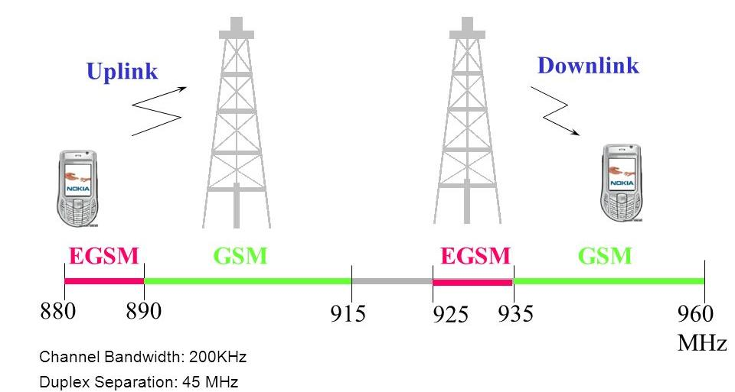

***References:***

[1 - Giới thiệu mạng di động GSM (byethost7.com)](http://tamthien.byethost7.com/noi_dung/DTDD/ch-1/ch-1.htm?i=1)

[GSM900 - Telecom ABC](http://www.telecomabc.com/g/gsm900.html)

## Important Parameters of a Mixer.

### Conversion loss

***The conversion loss*** of a mixer is the ratio of the desired IF output (voltage or power) to the RF input signal value (voltage or power), corresponding to each level of the LO.

If the input impedance and the load impedance of the mixer are both equal to the source impedance, then the voltage conversion gain and the power conversion gain of the mixer will be the same in dB’s.

The Conversion Loss of the RF Mixer measured in dBm is given by:

* For Lower Sideband:
$${CL}_{LSB}= \frac{P_{Diff}}{P_{RF}}=P_{Diff}[dBm]- P_{RF}[dBm]\left|\begin{aligned} \\ P_{Diff} is the power of f_{IF}=f_{LO}-f_{RF}\end{aligned}\right.$$

* For Upper Sideband:
$${CL}_{USB}= \frac{P_{Sum}}{P_{RF}}=P_{Sum}\left[dBm\right]- P_{RF}\left[dBm\right]\left|\begin{aligned} \\ P_{Sum} is the power of f_{IF}=f_{LO}+f_{RF}\end{aligned}\right.$$

* Generally:

The typical ***conversion gain*** of an Active Mixer is approximately +10dB, when the ***conversion loss*** of a typical Diode Mixer is approximately -6dB.

### Noise Figure

Noise Figure is the ratio between the Signal to noise ratio (SNR) at the input and at the output.

$$NF= \frac{{SNR}_{in}}{{SNR}_{out}}$$

### High-side and Low-side Injection:

* If FLO > FRF: High-side injection. The LO will be called as high-side LO (HSLO).
* If LO < FRF: Low-side injection. The LO will be called as low-side LO (LSLO).

### Third Order Intercept Point (IP3 or TOI)

***IP3*** is an important parameter to consider the linearity of the mixer. It is the fictional value defined by the extrapolated intersection of the primary IF response with the two-tone 3rd intermodulation IF product that results when two RF signals are applied to the RF port.

Denote the local oscillator’s frequency as FLO­ then the IP3 products are (2F­1 ± F2) ± F­LO and (2F­2 ± F1)± F­LO. For the downconversion case, the significant noise products are (2F­1 - F2) - F­LO and (2F­2 - F1) - F­LO since they are near around the Intermediate Frequency (IF).

### 1-dB Compression Point

Within the small input signal level, the output power increases linearly with the input one. If the input power continuously increases, the conversion loss will start to increase. The 1-dB Compression Point is where it gains 1-dB compared to the linear one. Mixer must be designed under this point to avoid the unexpected outputs (such as third or higher order products).

### Isolation

***Isolation*** is the amount of LO power that leaks into either the IF or the RF ports, usually in dB. This is one of the most significant drawback when designing a transceiver system.

There are multiple types of isolation: LO-to-RF, LO-to-IF and RF-to-IF isolation.

### Linearity

The linearity of a mixer is the ability of controlling the signal level. The higher linearity a mixer gains, the upper its IP3 is.

### Image Frequency

As mentioned above, $f_{RF}= \left|f_{LO}±f_{IF}\right|$, hence there are several options for fRF. As the above figure, if we choose fRF > fLO (LSLO case), then aside, fIF we also obtain another unexpected signal at frequency fLO – fIF and so on. Those frequencies are called ***Image Frequency*** and we have to choose an appropriate filter to eliminate them out.

***Reference:***