**CHAPTER 3: S-PARAMETER SIMULATIONS**

We continue mixer testing by taking several S-parameter measurements and find network values that match.

**3.1. S-parameter**

S-parameters are complex numbers that can be used directly or in a matrix to display reflection/transmission characteristics in the frequency domain (amplitude and optionally phase).

It is terminated with the component or circuit's characteristic impedance, which is generally 50 ohms for most RF work.

The arrangement of S-parameters and the resulting scattering matrix measures how RF energy propagates through a multi-port network. It provides for accurate characterization and description of component and circuit propertises, including parasitic and stray values. This eliminates the need to model the circuit's impedances, resistors, capacitances, and inductances at higher frequencies, when such modeling would be extremely difficult and likely miss many real-world problems.

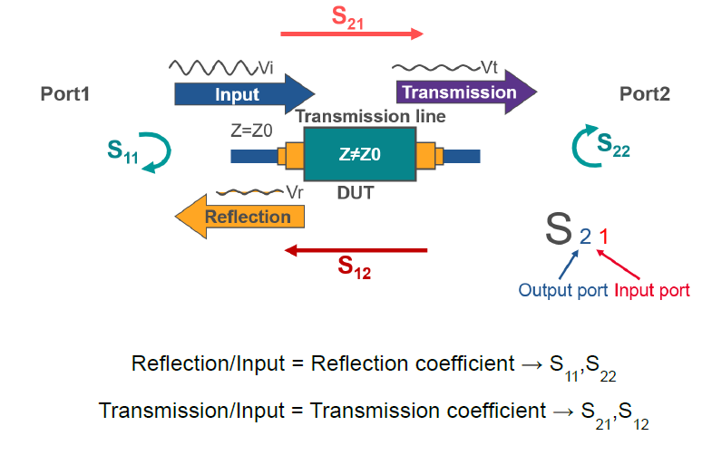

**3.2. S-parameter simulation**

***3.2.1. Set up***

Simulation S-parameter setup:

- Start point: 45 MHz

- Stop point: 900MHz

- Step value: 855MHz

To represent the impedance of the local osscilator (LO), adding series RC to ground:

R= 50 Ohms; C= 0.5pF and insert these components onto base of transistor.

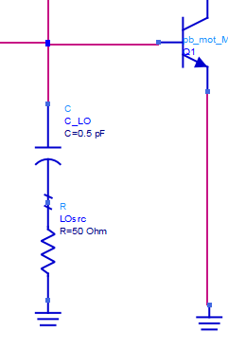

*Figure 3.1: LO components: series R-C to ground*

***3.2.2. Simulate $S_{2,1}$***

As mentioned before, $S_{2,1}$ is the measure of signal flow coming out relative to the RF stimulus entering in.

In figure 3.3, the plot of $S_{2,1}$ with the frequency range from 100MHz to 2 GHz (100 MHz steps) shows results before and after deactivating the LO components.

Clearly in this figure, the $S_{2,1}$ decreases nearly 0.6dB in circuit with LO impedance.

***(a)***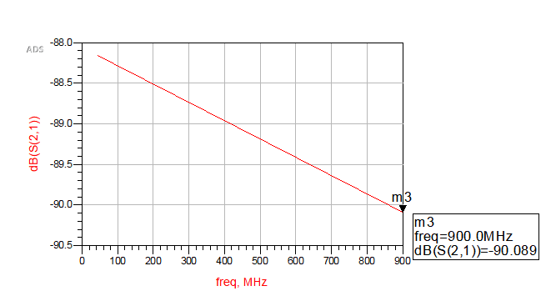

***(b)***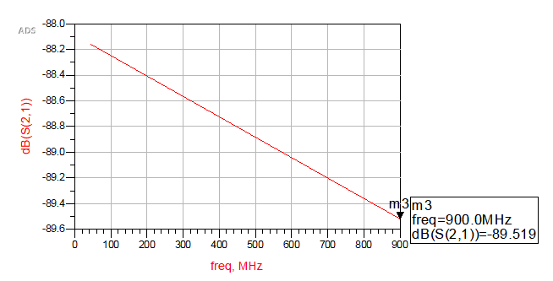

*Figure 3.2: Plot $S_{2,1}$ (a) with LO impedance and (b) with deactivated LO components*

***3.2.3. Plot $S_{1,1}$ impedance***

The S-11 trace is depicted in a Smith chart

The marker displays the reflection coefficient with magnitude/phase as well as the impedance (real and imaginary).

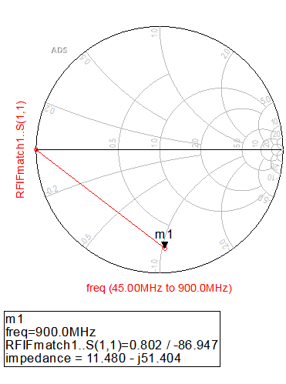

*Figure 3.3: S-11 Smith chart*

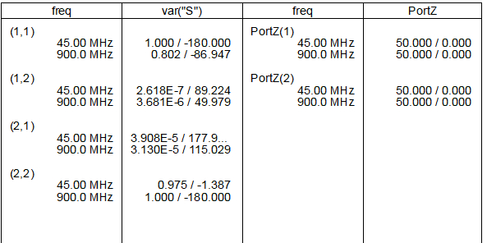

*Figure 3.4: List of four S-parameters*

Rather than picking just one of the S values, we can use a tabular structure to see all four of S-parameters. In addition, the termination's port Z=50 Ohms impedance is provided.

***3.2.4. Frequency sensitive termination for RF and IF***

Frequency sensitive Z ports to specify how a termination reacts to the variety of frequency.

For S-11 matching, the Z port on the output is designed to be an RF short to ground, similar to a filter. The Z port at the input, on the other hand, is set to be an IF short to ground. After generating the matching networks, this offers a better estimate of the final S-parameters.

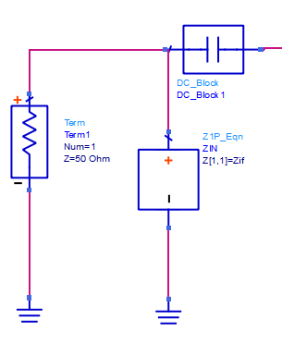

*Figure 3.5: The Z port at the input*

The Equation Based-Linear Z port is designed to be a short at the IF frequency, using when building the output matching network S-2,2

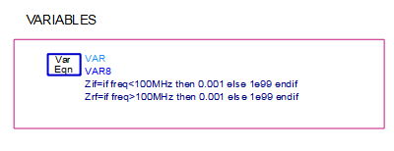

***2.2.4.*** *DC feed inductors and DC block capacitor*

The DC path must be protected from RF signals, and lower frequency signals must be blocked from RF signals because feedback from the drain to the gate might produce oscillation. DC feed components behaves as ideal inductors short at DC and as an open circuit (impedance at any AC signal) at all other frequencies.

A DC feed inductor has an inductance value of L= ∞, whereas ordinary inductors have a limited L value.

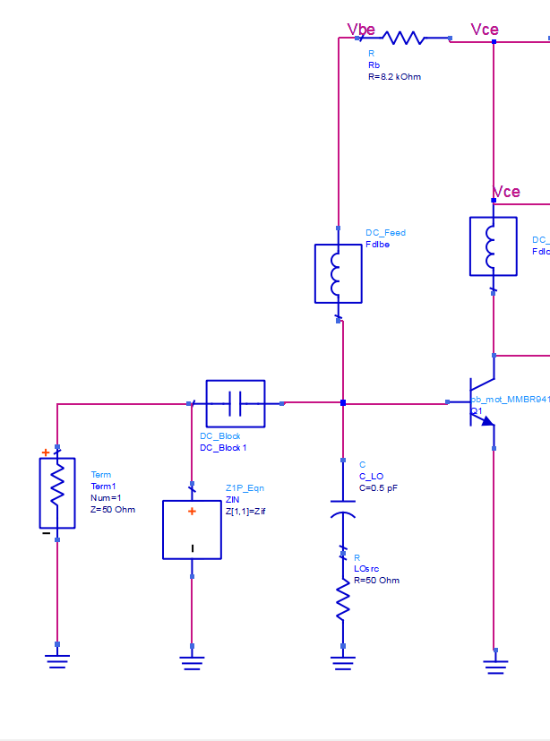

*Figure 3.6. DC componenst in design*

Connect the transistor base to the resistor Rb with a DC feed inductor, then connect the collector to the resistor Rc with another DC feed inductor.

***3.2.5.Calculate L and C values***

The biased circuit's transmission and reflection characteristics indicate roughly -90 dB of gain with a mismatch of 50 ohms at the input. Furthermore, the DC feeds and blocks are ideal and should be changed with real values.

For the capacitive reactances at of 10pF at 900MHz, we have the equation of Xc

$$X_{C}=\frac{-1}{2π×900MHz×{10}^{-12}}= -176.83Ω$$

For the inductance values and reactances, we have a table value:

$$X_{L}=2π×900MHz×L$$

|  |  |
| --- | --- |
| Xl-value | L_value |
| 5.6548 | 1nF |
| 288.39 | 51nF |
| 571.14 | 100nF |
| 853.88 | 150nF |
| 1023.5 | 180nF |
| 1130.97 | 200nF |
| 1357.17 | 240nF |

Since the inductance value increases, reactance value at 900MHz increases. Therefore, a value of 240nF is enough for the DC feed (RF stroke)

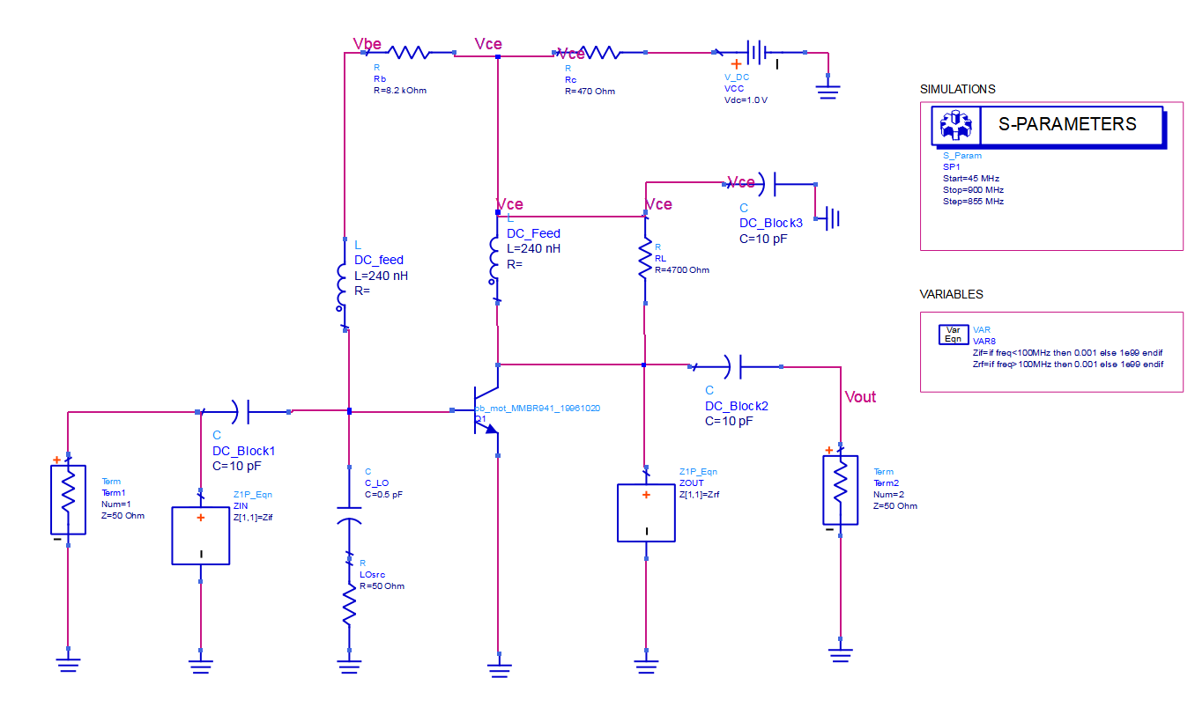

*Figure 3.7. Scematic after replacing inductor and capacitor*

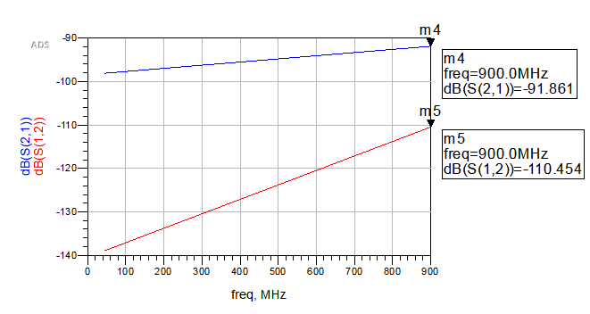

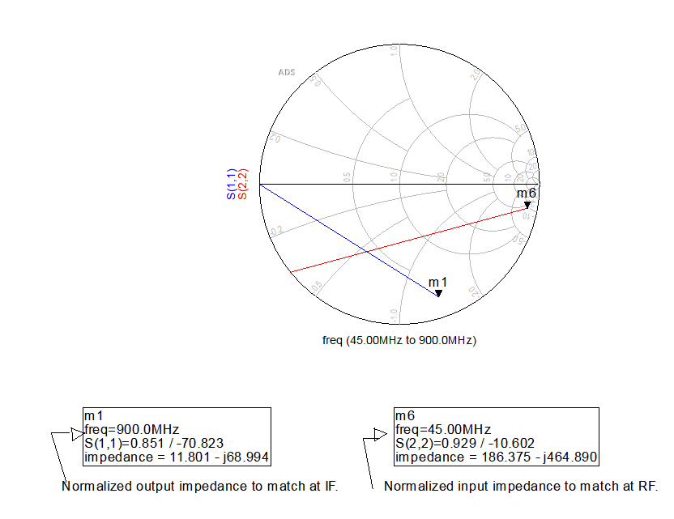

*Figure 3.8. Simulation after replacing inductor and capacitor*

In the data display, plot the transmission (S12 and S21) and reflection (S11 and S22) data with markers as shown here. The gain is fairly constant, the leakage is acceptable, but still with the mismatch 50 ohms.

Next step is building an input matching network.