**CHAPTER 2: DESIGN A MIXER**

As mention in the previous part, GSM900 is the technology that usually be used on mobile devices, especially, cellphones, which battery lifetime is critical. Therefore, the mixer also needs to be power efficient, comparing between 2 kind of mixers, the active mixer having huge advantage over power consumption, which makes it suitable for implementing in the GSM900 devices.

**2.1. Single-ended active mixer**

The single ended mixer is one of the simplest active mixers. The mixing performed by the mixing is performed by modulating the transconductance of the driver stage with the LO signals. Because of architecture simplicity, single ended mixers have lowest noise figure within active mixers

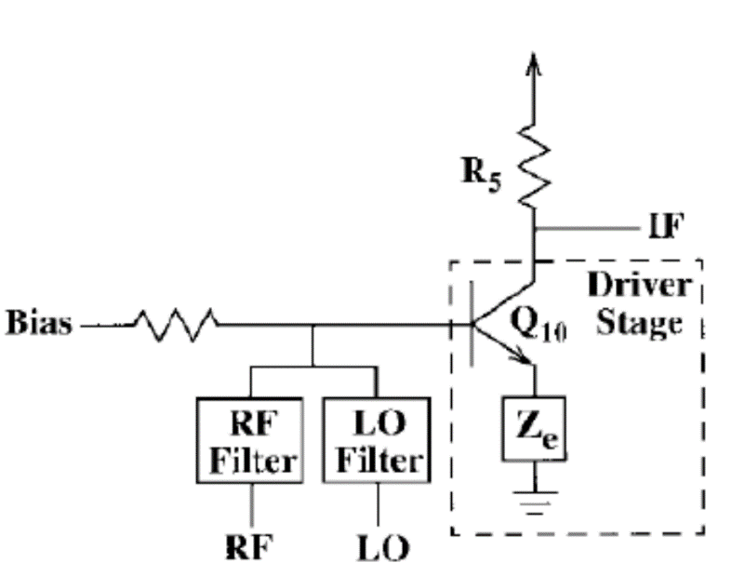  
*Figure x: single ended active mixer example*

Some parameters would be considered in mixer design (mentioned in previous chapter):

* Conversion loss
* Noise figure
* Isolation
* Linearity

**2.2. Design a single-ended mixer**

***2.2.1. Selecting devices***

The purposed design consists of a transistor, resistors, capacitors. For the transistor, the purposed candidate is the MMBR941 bipolar junction transistor from Motorola. It doesn’t have as good mixing properties as RF field-effect transistor, it’s very low cost and has accurate simulation model available with a reasonable performance. This BJT model is available with Keysight Advance Design System, where it can be verified and also evaluated the design.

For resistors and capacitors, they are just generic passive devices in the simulation.

***2.2.2. DC curve verification***

In order to verify the device under DC parameters, the I-V Curve of the transistor is needed. So as to plotting the I-V Curve of the transistor, the sweeping parameters function of ADS is used. Therefore, the device can be tested how it would behave under different value range and DC configuration. The parameters are tested in this part are Collector – Emitter Voltage and Base current of the transistor

Simulation sweeping setup:

* Parameter: **VCE**
  + Start value: 0V
  + Sweeping step: 0.1V
  + Stop value: 6V
* Parameter: **IBB**
  + Start value: 50uA
  + Sweeping step: 75uA
  + Stop value: 350uA

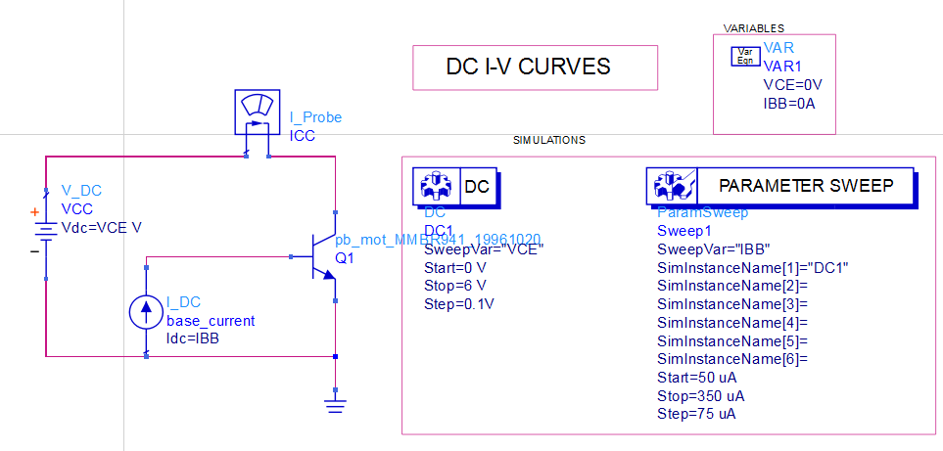

*Figure x: DC curve verification simulation*

Since the DC controller can only sweep one value, the Parameter sweep will be used for sweeping IBB. Both parameters are set as variable for sweeping controller. The current probe is for measuring the change of Collector current for reference in the I-V Curve plot.

The simulation result:

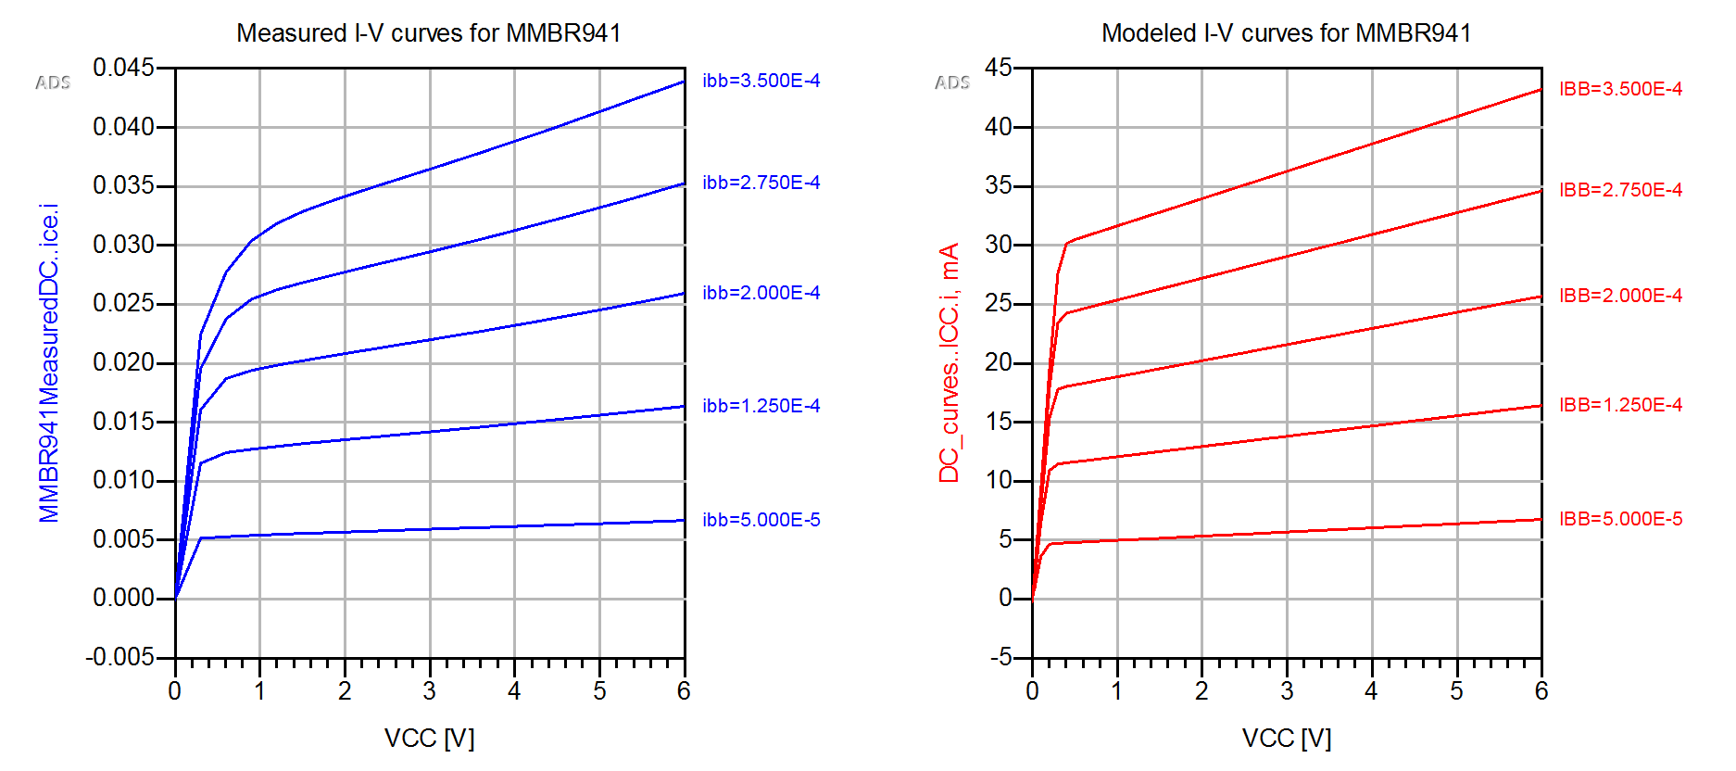

*Figure x+1: Comparison of Measured (blue) and Simulated (red) DC I-V Curve*

There are not much different between simulated and measured result, the curve show that at the specified operating point of VCE = 1V, ICE < 0.6mA the device will operate at low current region.

***2.2.3. DC bias network***

This part will help to select device operation point calculating the base and collector resistors. Therefore, the base current needs to be determined, as the collector voltage and current are already specified.

In this setup VCC will be fixed at 1V and IBB will be swept:

* Parameter: **IBB**
  + Start value: 1uA
  + Sweeping step: 0.5uA
  + Stop value: 10uA

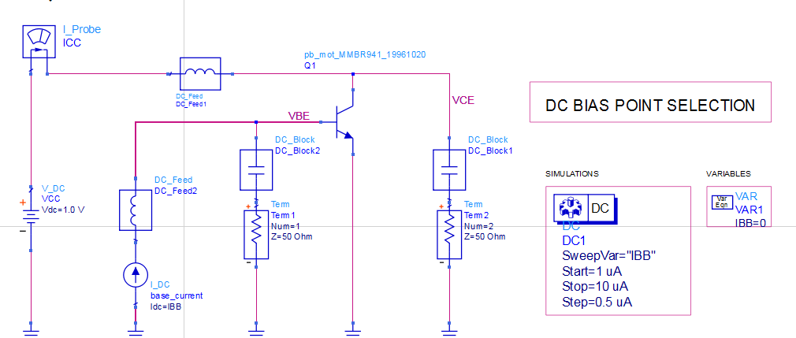

*Figure x+2:bias network schematic*

To mimic the real setup, the bias tee components (the DC_Feed and DC_Block components) and 50 Ω terminations are added. The bias point current is lower than the specified final value, because the device will have to work with large LO signal, which cause a shift in the DC component of the collector current.

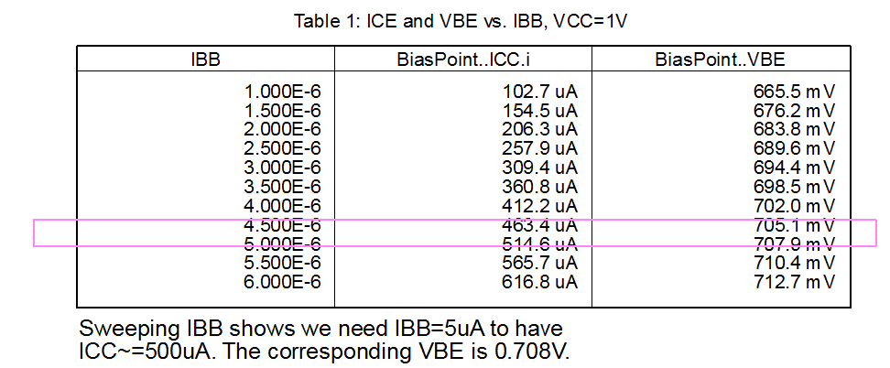

*Figure x+3: Result table of VBE and IBB*

The figure x+3 shows that IBB need to be 5uA to have ICC= 514.6uA with corresponding VBE of 707.9V which is well below the specification

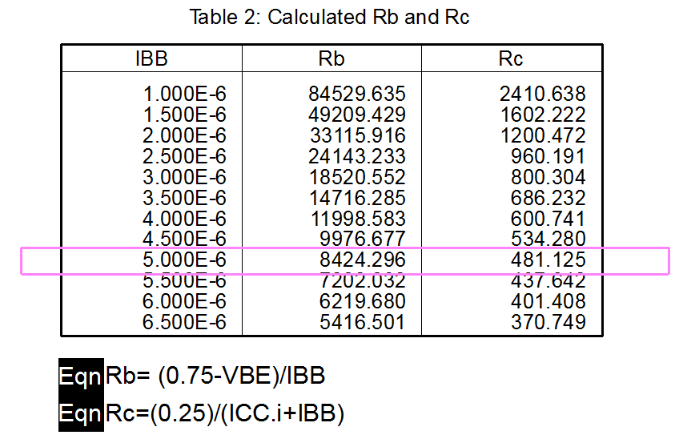

*Figure x+3: Result table of Rb and Rc*

To calculate Rb and Rc, the collector-emitter voltage of 0.75 V, at the point of IBB = 5uA, the correspond Rb and Rc are 8424.296 Ω and 481.125 Ω.

The next step will confirm this bias operation using these standard values of Rb and Rc and then verify the S-parameters of the model against measured value.

***2.2.4. DC bias network verification***

In this part, the bias configuration obtained from 2.1.3 will be verified. The schematic incluse bias tee components (DC feeds and blocks) to make sure the performance of RF

This simulation will run with both values of the exact resistor values and nearest standard values (Rc = 470 Ω, Rb = 8.2 kΩ) to verify the RF performance

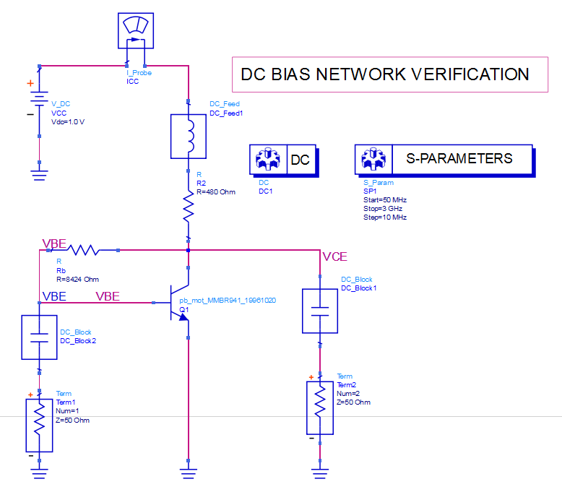

*Figure x+4: schematic of DC bias network*

The S-parameters controller will run the frequency sweep to see the circuit’s frequency response and and displayed, together with measured.

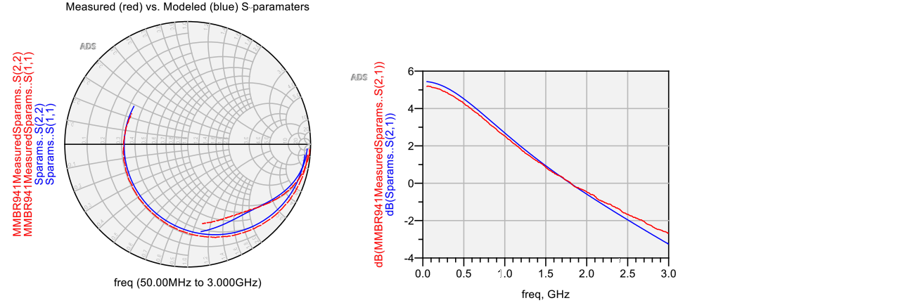

*Figure x+5: simulation result of DC bias network*

There is a great alignment between values obtained here verifies the small-signal RF performance. The device compression point will be simulated next to confirm large-signal operation.

***2.2.4. Large-Signal Verification (gain compression)***

The output compression at frequency of 900MHZ will be calculated in this step. The first method to calculate is using Harmonic Balance controller, by sweeping the input power level from low to high values until the output power compresses (the ratio Pout/Pin starts to fall off from its small-signal value. The input power variable, “PwrIn” is swept from -45 to -5 dBm and a Measurement Equation component is used to define the output power at 900 MHz, in dBm.

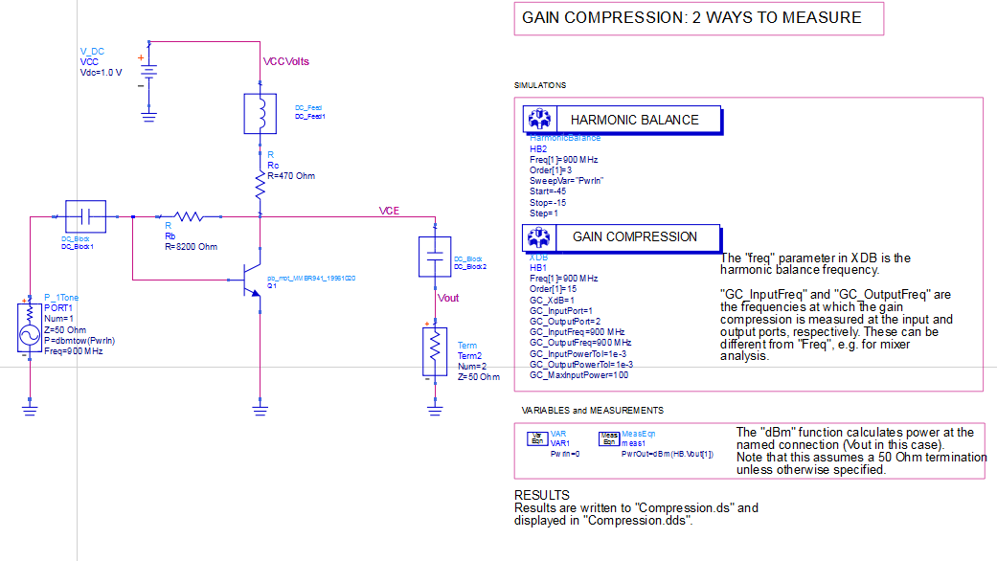

*Figure x+6: schematic gain compression*

The dBm function assumes the power is being delivered to a 50 Ω load. The argument “HB.Vout[1]”, specifies the fundamental frequency.

The second method is more direct and does not require graphs or sweeping variables. The Gain Compression controller “XDB” performs a harmonic balance analysis that correctly calculates and outputs the input and output power levels at the specified compression point. the output from this method: the input and output power levels at 1 dB compression are listed in dBm

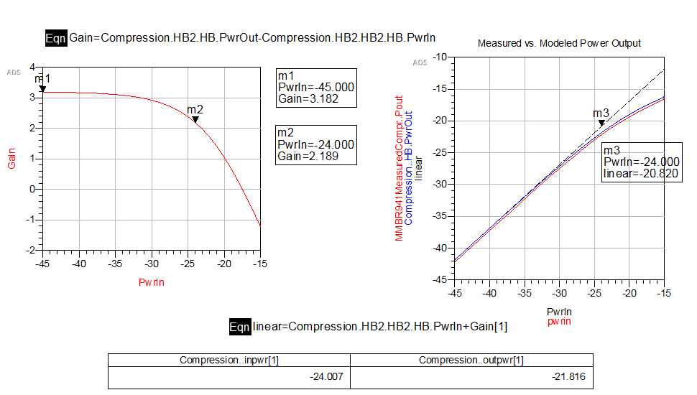

*Figure x+6: result of gain compression*

The result graphs show both calculate method of the simulation agreed with the measured data.