Hotel Information
Hilton Garden Inn Buffalo Downtown

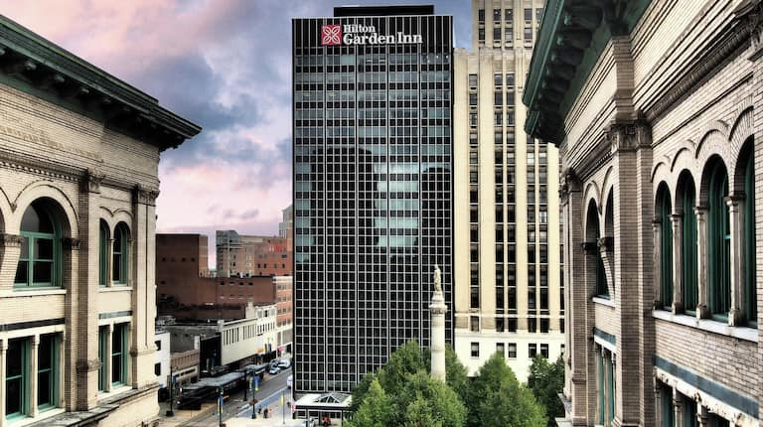
For hotel accommodations, we recommend staying at the Hilton Garden Inn Buffalo Downtown, which is approximately a 20-minute walk from the conference venue. We have arranged a special discounted rate for ICIBM 2026 attendees. Please see the booking information below.

Please note that rooms available at this discounted rate are limited. If you have any special needs or are unable to book a room using the conference rate, please contact us at icibm.common@gmail.com.

Map and Directions
Special Conference Room Rate: $149 + tax and fees, 2 Queen or King.
Reservation details: please use this Special Link to make a reservation.

