

Ryana Calendars

**Menter: Nguyen Dinh Trong**

**Batch: 159**

**Group: 1**

**Member:**

* **Le Nguyen Kha**
* **Le Nguyen Toan**
* **Vuong Hoang Long**

Contents:

1. **Research Purpose**
2. **Introduce website:**
3. **Admin**
4. **Customer**
5. **Website interface & Functionility**
6. **Project Plan**
7. **Advantage & Disadvantage:**
8. **Advantage**
9. **Disadvantage**
10. **Development**

**I.Resreach Purpose:**

* Our team was assigned to the project to design a sales website that includes products: Calendars, Journals, Diaries and Folders. We decided to design the website with the following criteria :
* Create a simple interface, easy to use, easy access for new people or have used the internet for a long time.
* Help people save time and solve problems when choosing product.

**II.Introduce:**

* We built Ryana Calendars in learned languages like HTML, CSS, and some basic JavaScript. Ryana Calendars has basic functions such as being able to select the item to search, categorize the item according to its function, view product details, search for it on Google Map, send feedback to the admin. In the languages mentioned above we have been trying for the past 1 month to do the best we can for ourselves, now I invite teachers and everyone to see the results of our group.

**1.Admin:**

* Add and Remove Products
* Update And Maintenance
* Provide User Account

**2.Customer:**

* Buy Products
* Feedback
* Message for Admin

**III.Interface Website and Functionality:**

 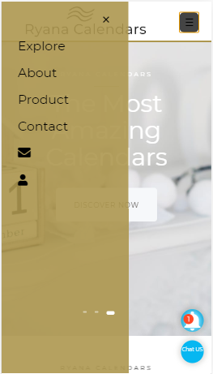

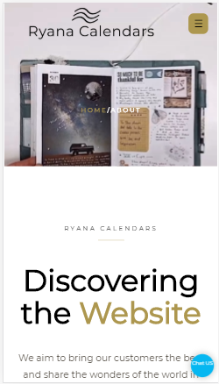 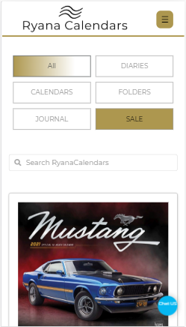

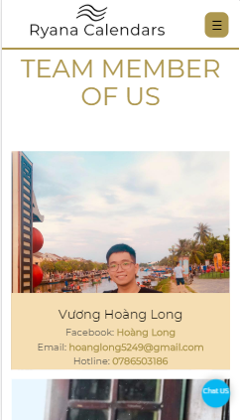 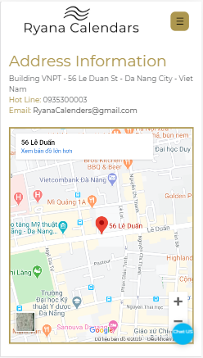

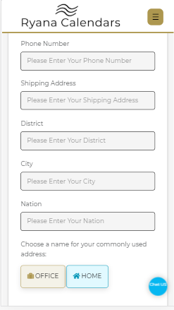

**IV.Project Plan:**

|  |  |  |  |
| --- | --- | --- | --- |
| **Website Interface And Functionality** | **Member** | **Start** | **Finish** |
| Layout Ideas And Contents | All Members | 19/05/2020 | 26/05/2020 |
| Design Logo | Vuong Hoang Long | 22/05/2020 | 24/05/2020 |
| Project Plan | All Members | 26/05/2020 | 26/06/2020 |
| Menu | Vuong Hoang Long | 26/05/2020 | 01/06/2020 |
| Footers Website | Le Nguyen Toan | 26/05/2020 | 3/6/2020 |
| Home Page | Le Nguyen Kha | 26/05/2020 | 6/6/2020 |
| Page About | Le Nguyen Kha | 7/6/2020 | 15/06/2020 |
| Search Products | Le Nguyen Toan | 4/6/2020 | 10/6/2020 |
| Information Products | Vuong Hoang Long | 2/6/2020 | 10/6/2020 |
| Products Suggestions | Vuong Hoang Long | 10/6/2020 | 15/6/2020 |
| Page Location | Le Nguyen Toan | 14/06/2020 | 16/06/2020 |
| Feedback | L.N.Toan & V.H.Long | 18/6/2020 | 23/06/2020 |
| Login | Le Nguyen Kha | 16/6/2020 | 19/6/2020 |
| Payment | Le Nguyen Toan | 11/6/2020 | 16/6/2020 |
| Box Chat | Le Nguyen Toan | 18/6/2020 | 30/6/2020 |
| Price List | Le Nguyen Toan | 19/6/2020 | 20/6/2020 |
| Images For Website | Le Nguyen Kha | 27/5/2020 | 9/7/2020 |
| Text For Website | Le Nguyen Kha | 15/6/2020 | 1/7/2020 |
| Code Completion | All Members | 30/6/2020 | 1/7/2020 |
| SlideShow | Le Nguyen Kha | 2/7/2020 | 9/7/2020 |
| Document | Le Nguyen Kha | 10/7/2020 | 12/7/2020 |

**V.Advantage & Disadvantage:**

**1. Advantage:**

* The dedicated guidance of the instructor
* The dedicated guidance of the instructor
* Know how to use Github in teamwork
* Solidarity of team members
* Planning carefully before implementing the project

**2.Disadvantage:**

* Not fluent in Javascript
* The code is not optimized
* Restriction about English
* No experience in designing websites
* Some functions have not been perfected

**VI.Development:**

* Database development
* Code optimization
* More funcitons for the website
* Developed on the mobile platform
* Online marketing on social networking