# jsp Standart file

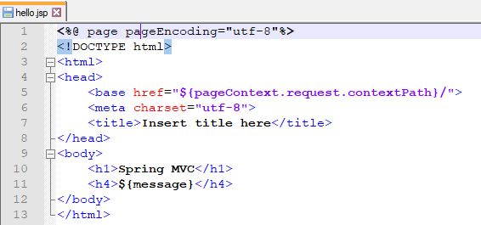

# Tiles

pom.xml

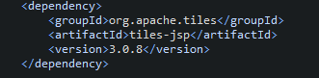

/WEB-INF/tiles.xml

<https://tiles.apache.org/framework/tutorial/basic/pages.html>

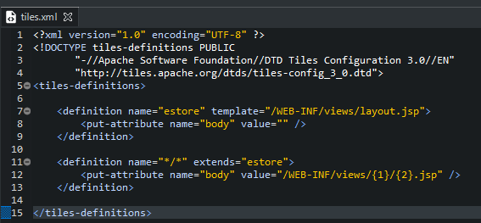

TilesConfiguration.java

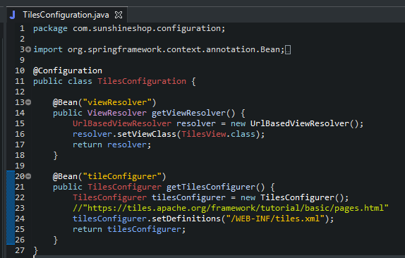

From standard file create jsp files:

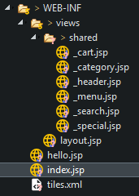

Create index.jsp file to test

