FPT University – PRN232 Practical Exam
---------------------------------------
Full Name: Hoàng Minh Dương
Student ID: QE180057
Class: SE18B02
Subject: PRN232 – Practical Exam (Movie Watchlist)

Movie Management System (React + .NET)
1. GitHub Repository & Deployment Links
Mục | Link
GitHub Repository (Public) | https://github.com/hoangminhduongqe180057/PE_PRN232_QE180057
Frontend (Vercel) | https://pe-prn-232-qe-180057-u89a.vercel.app/
Backend (Render) | https://pe-prn232-be-v9k4.onrender.com/

2. Project Description

Overview
The Movie Watchlist System is a full-stack web application that allows users to manage a personal movie list.
A movie contains:
- Title (required)
- Genre (optional)
- Rating (1–5, optional)
- Poster image (via URL or file upload)
The app includes full CRUD functionalities and follows the technical requirements of the PRN232 Practical Exam.

Technologies Used
- Frontend: React + Vite + TailwindCSS
- Backend: ASP.NET Core Web API + Entity Framework Core
- Image Upload: Cloudinary (optional)
- Database: SQLite / PostgreSQL (Render)
- Deployment:
  - Frontend → Vercel
  - Backend → Render

3. Functionalities Implemented
Requirement | Implementation Summary
1. Main Page | Shows all movies in a responsive grid layout. Includes search (by title), sorting (A–Z / Z–A), pagination (2/4/6 movies per page).
2. Add Movie | User can add movie with title, genre, rating, poster URL or file upload. Real-time poster preview.
3. Edit Movie | User can update movie info. Supports switching between “Link mode” vs “File upload mode”. Preview displayed.
4. Delete Movie | Custom confirm popup (“Delete / Cancel”), includes isDeleting state to prevent spam clicks.
5. View Movie Detail | Clicking a movie card opens a modal showing full poster, title, genre, rating, and created time.
6. Deployment | Backend live on Render, frontend on Vercel. Connected via REST API using Axios.
7. Extra Improvements | Smooth UI, loading skeletons, better image rendering, responsive grid, polished UX.

4. Screenshots
Home Page / List
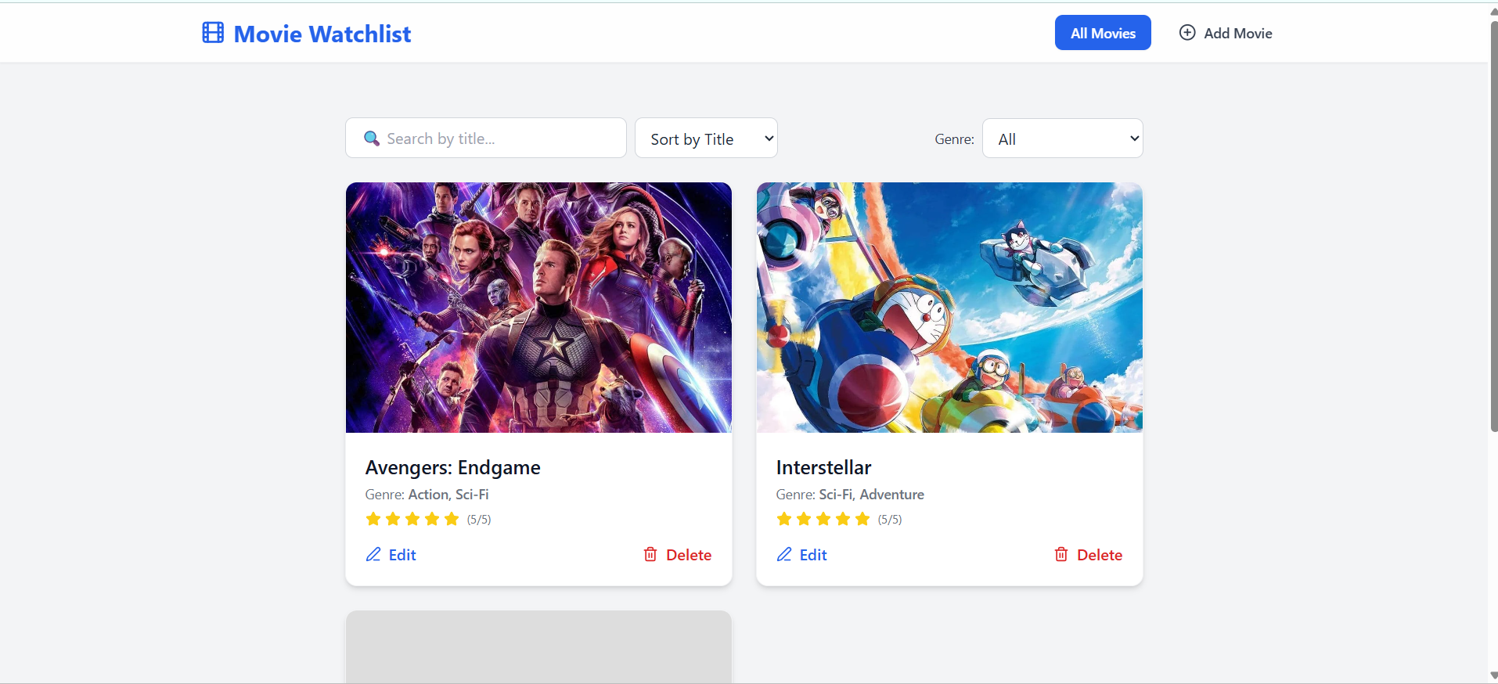
Create Post Page
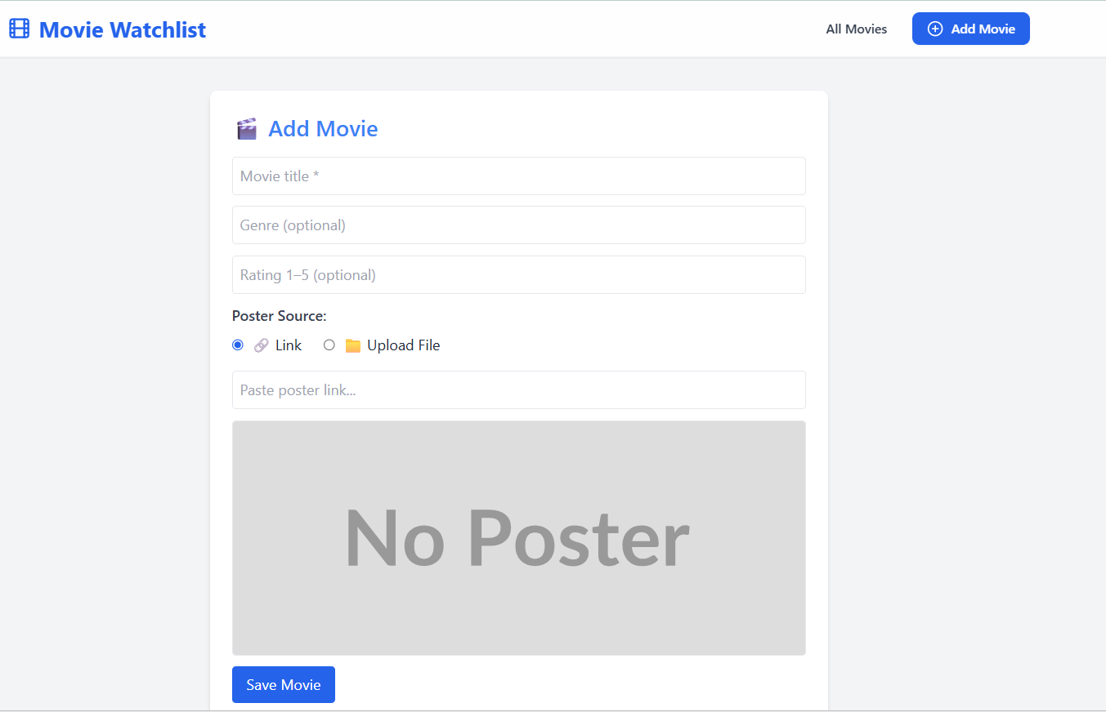
Edit Post
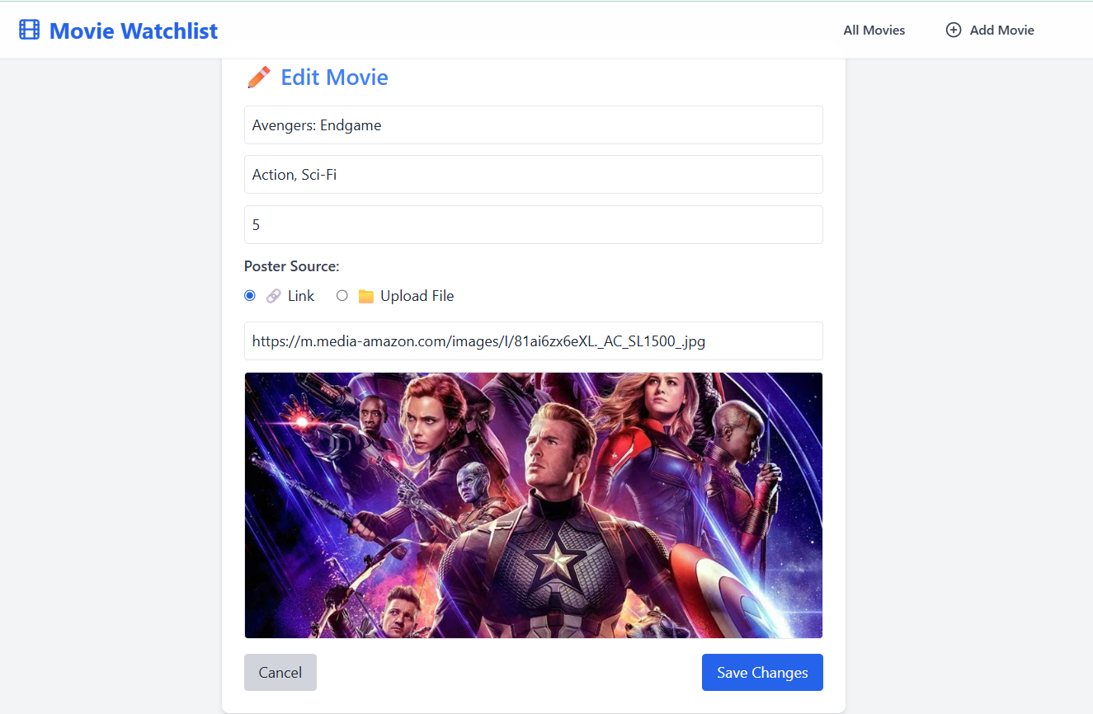
Delete Confirmation
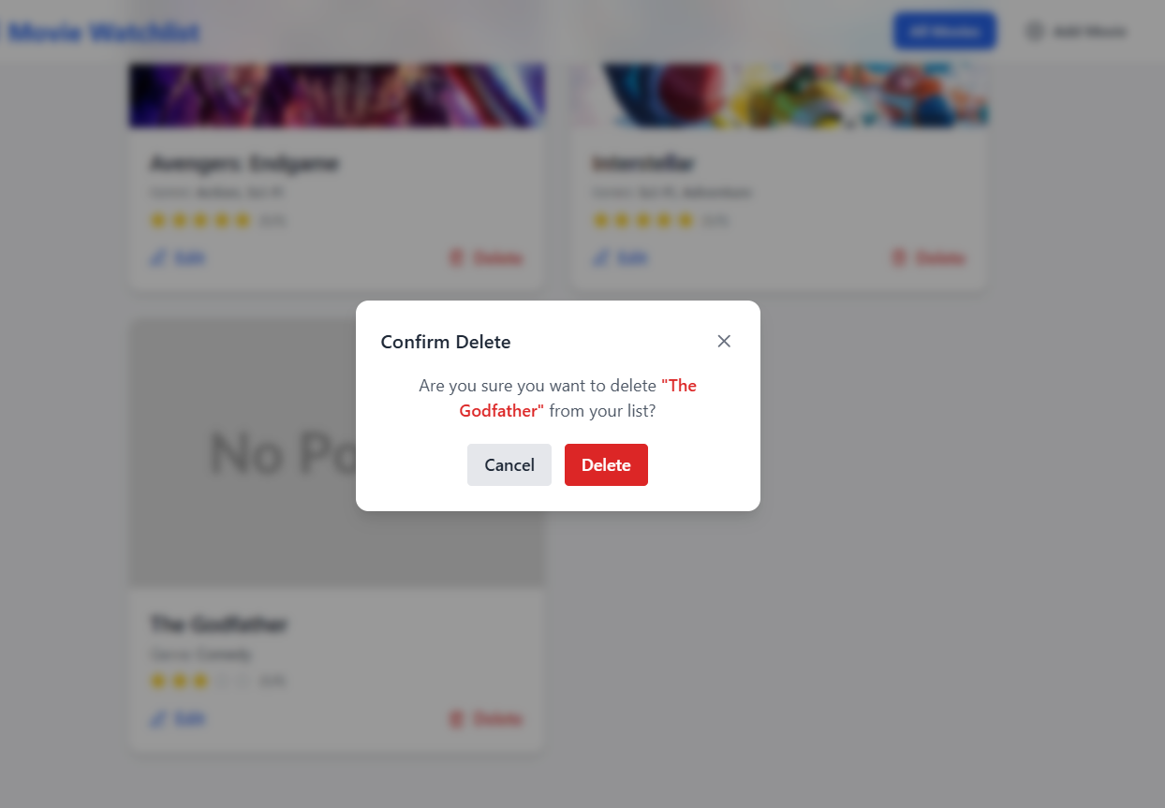
Deployment (FE + BE)
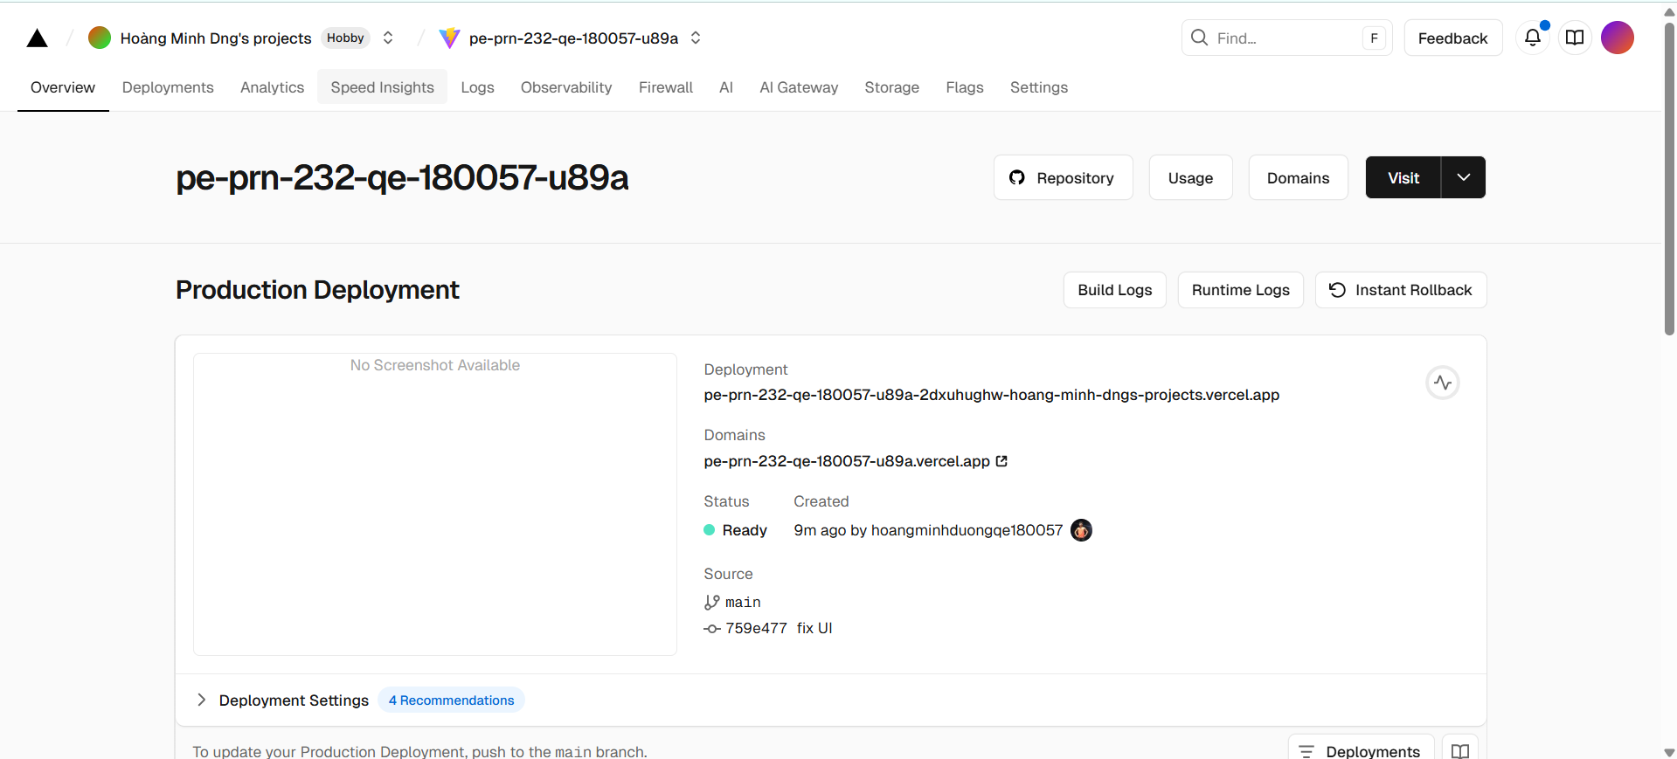
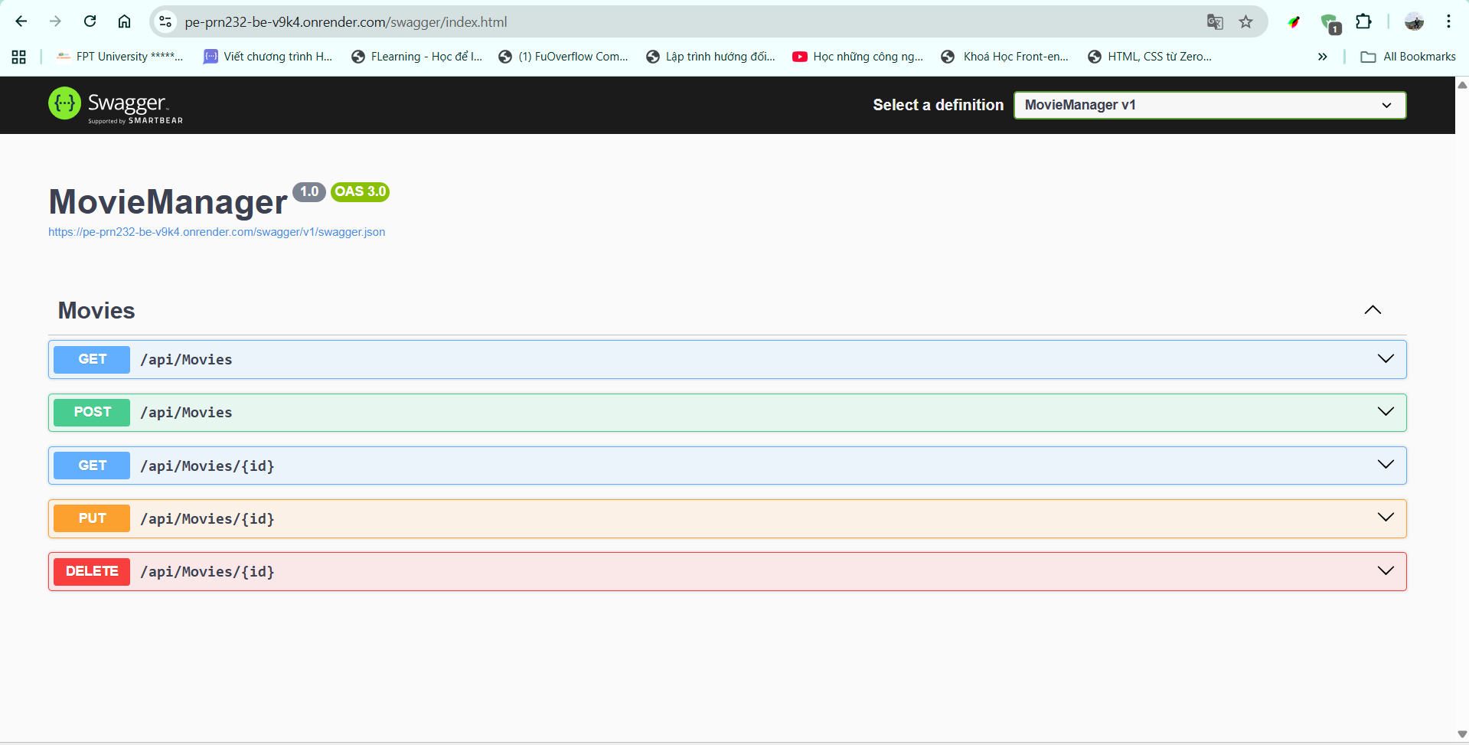
5. Steps to Run Locally

🔹 Backend (.NET API)

cd backend/MovieManager

dotnet restore

dotnet ef database update

dotnet run

🔹 Frontend (React + Vite)
- cd frontend
- npm install
- npm run dev

6. Conclusion
The Movie Watchlist System fully implements all exam requirements:
✔ Create / Read / Update / Delete movies
✔ Search, sort, and pagination
✔ Poster upload via link or Cloudinary
✔ Fully responsive UI
✔ Deployed live on both frontend & backend
✔ All features tested and working

