**Submission for Assignment 04**______________________________________________________________________________

**Task 1**

1- Open app to see two images with filler content underneath  
2- Click an image to edit the meta data associated with it  
3- Press back button to see the updated Name and Data

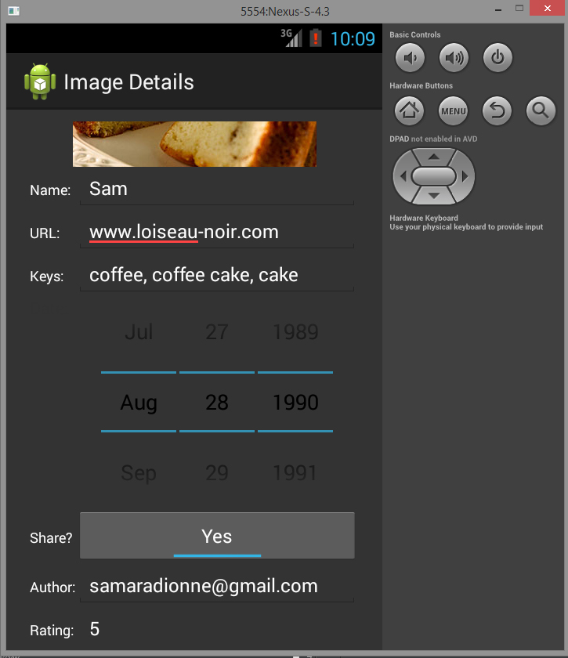

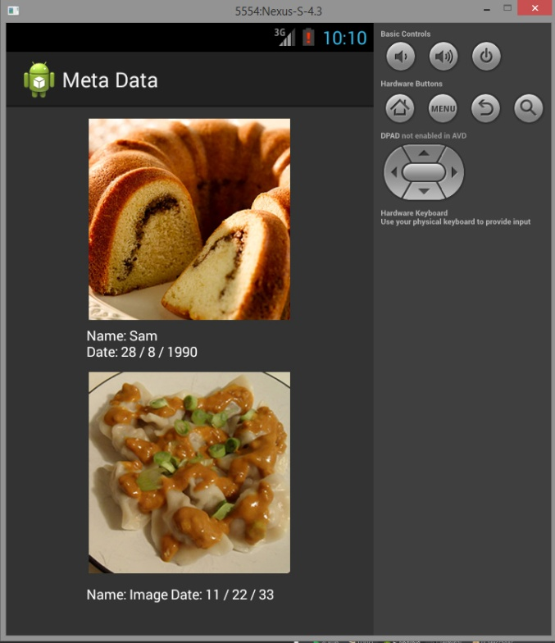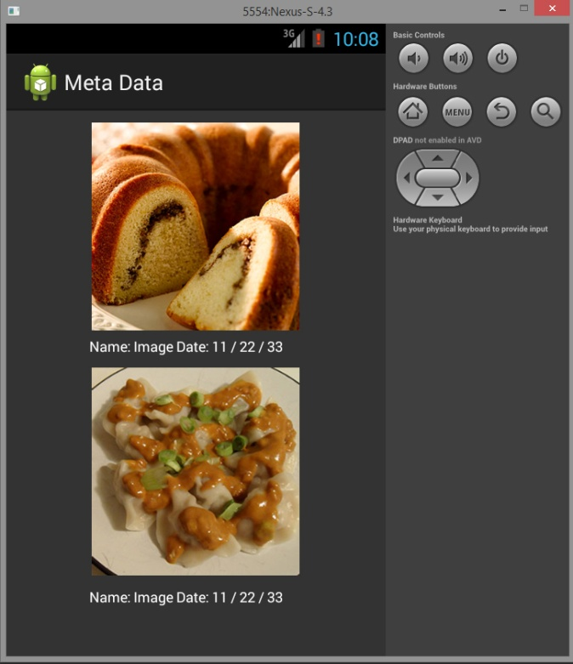

**Error Handling -**

A toast would pop up if the name was left empty or if the email was invalid.

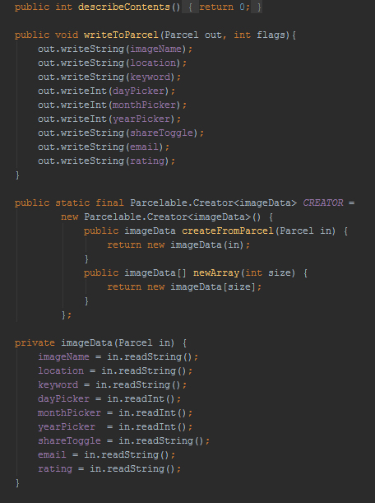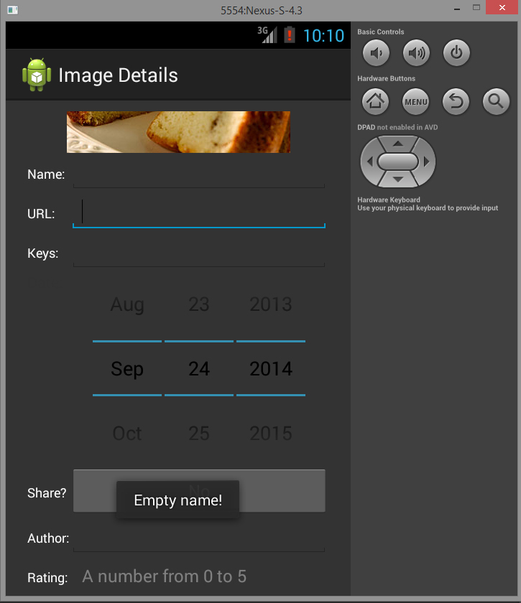

**Parcels -**

Similar to bundles in that store data (simple text information), but Parcels are specific to storing objects. Parcels also utilize intents to send data back and forth between activities. In terms of this meta data application, the parcel puts all the data from the form into an array which is flattened and packaged in an intent. Using the toString() method we are able to obtain the data (in this case, only the name and data) and display it on the main activity screen.

Code from imageDetails.class shows how the toggle was indicated, how the email was validated, and how the data would not be sent unless there was a valid email and name (which would open a toast if invalid).

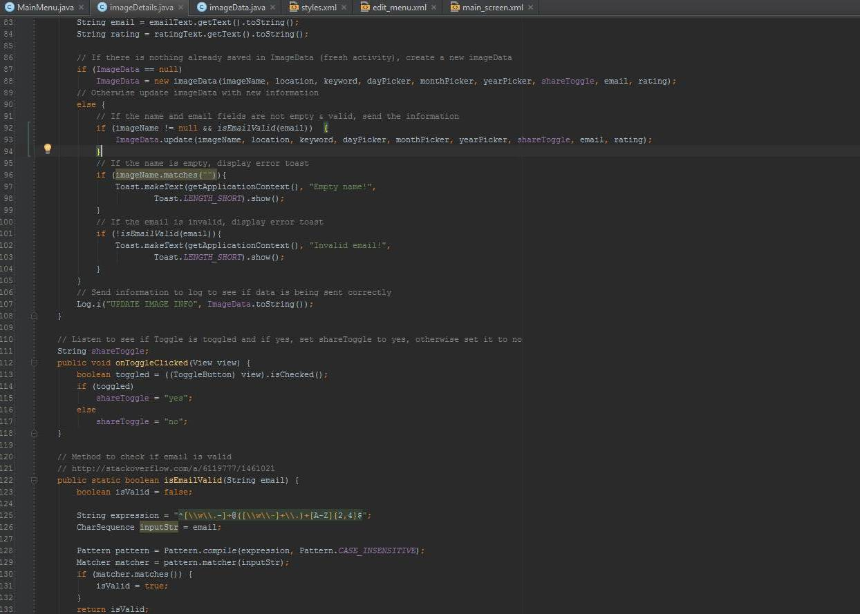

Use of styles

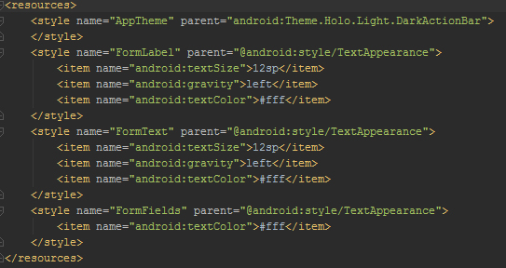

**Task 2**

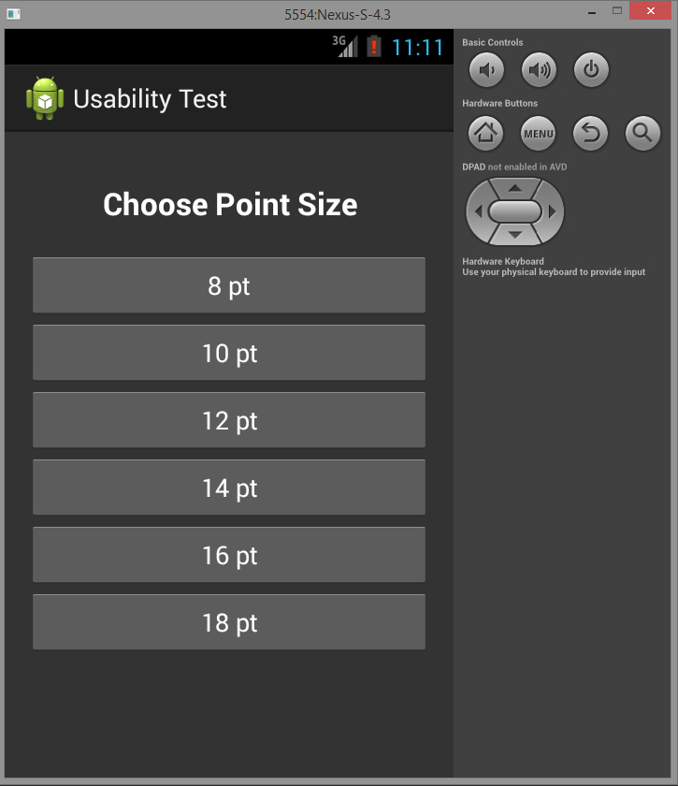

Objective of this task is to discern which point size type is the most legible for form labels.

To test this, I created an application that changed the layout and style depending on which type size they chose. Each layout re-used the same form and text, but at different point sizes.

The application initially had 6 options, but I narrowed it down to 3. The user viewed the 8pt, 12pt and 14pt options. I chose 8pt to begin as it is a quite obvious in difference from the other two, and I was more concerned with if people prefer 12 and 14pt type.

I used three different paragraphs of text as the amount of data can vary between fields.

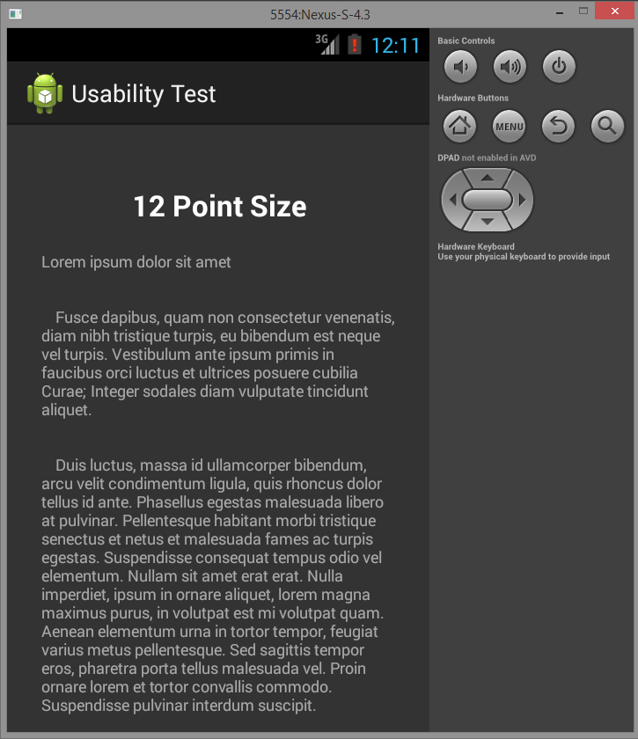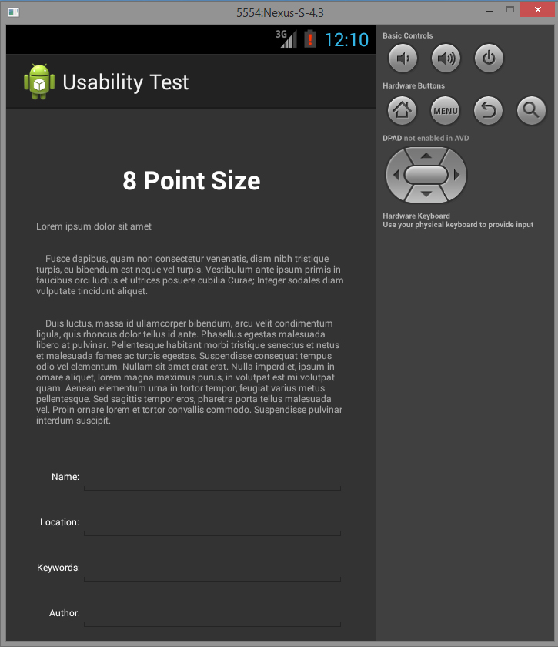

I asked the tester these questions:

1- Age

2- Smartphone experience or comfort

3- Quality of vision

4- If they had glasses, near or far sighted

5- Do they often fill in forms via Smartphone?

6- Which size would they prefer for field labels?

7- Which size for output?

|  |  |  |  |  |  |  |  |
| --- | --- | --- | --- | --- | --- | --- | --- |
| **Name** | **Age** | **Experience** | **Vision** | **(Near/Far)** | **Frequency** | **Labels** | **Ouput** |
| Sam | 23 | Comfortable | Glasses | Near | Seldom | 14pt | 14pt |
| Lockland | 20 | Comfortable | Glasses | Far | Seldom | 14pt | 12pt * |
| Gabriel | 20 | Comfortable | 20/20 | N/A | Often | 14pt | 12pt |

* Additional comment: Lockland wasn't overly fussed over the output size as he does not mind scrolling if the text is larger (14pt). Another question I should of asked was if people mind scrolling a lot to see information.

I was surprised, though it makes sense, that someone who is nearsighted preferred larger text up and someone who is farsighted preferred smaller text. Comparing it to myself, I am also nearsighted but prefer my text to be smaller as I would like to see more information on the screen and do not like scrolling a lot as sometimes mobiles can lag.

**Conclusion:**

I believe that the best type size for labels is 14pt and the best size for output is 12pt. However I think I would need to test a few more people from each section (more nearsighted, farsighted and people without glasses) before making a more concrete decision.