**Submission for Assignment 05**______________________________________________________________________________

**Task 1**

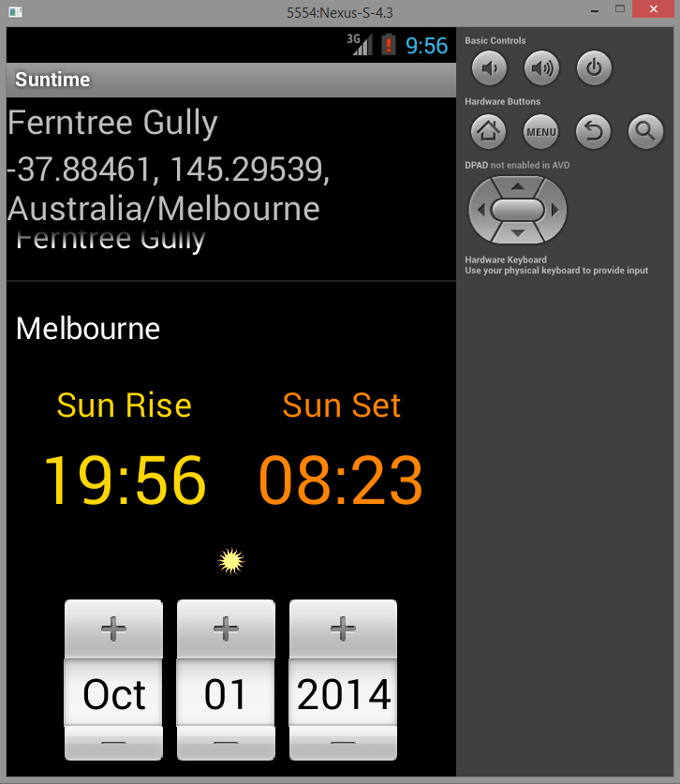

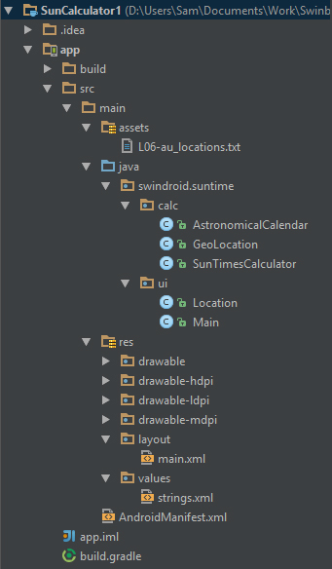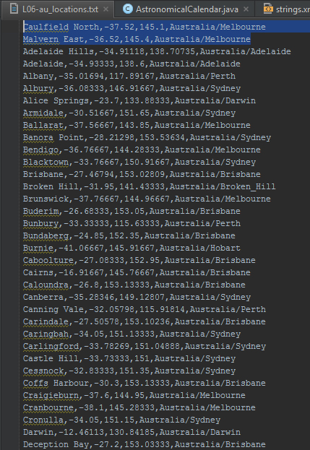No changes to the original Sun rise/set calculator in terms of layout. The two additional cities I added were Caulfield North and Malvern East. Screenshot below & left of the updated au_locations.txt file. Screenshot directly below is the structure of the program.

To read the au_locations.txt file, I used assetManager, to convert the file into a string, a string into an array and then finally into an ArrayList. Using a for loop I access the contents of the ArrayList (using .get()) and output it into the log as well as return it to the HashMap.

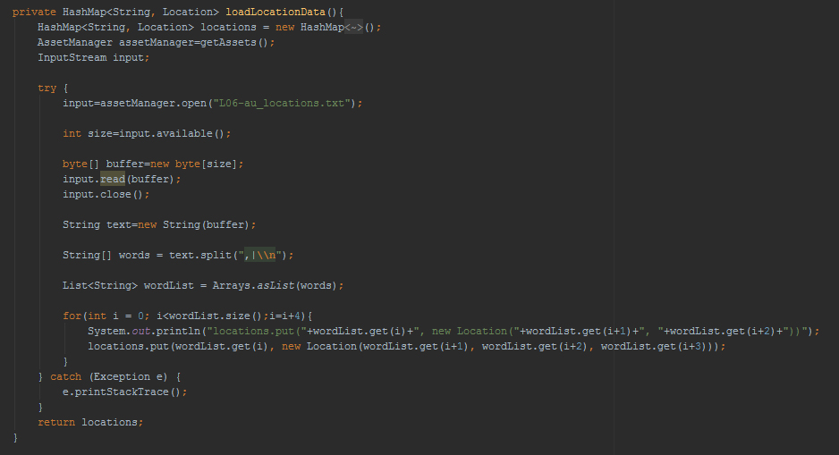

Logcat of some of the locations being sent to the ListView

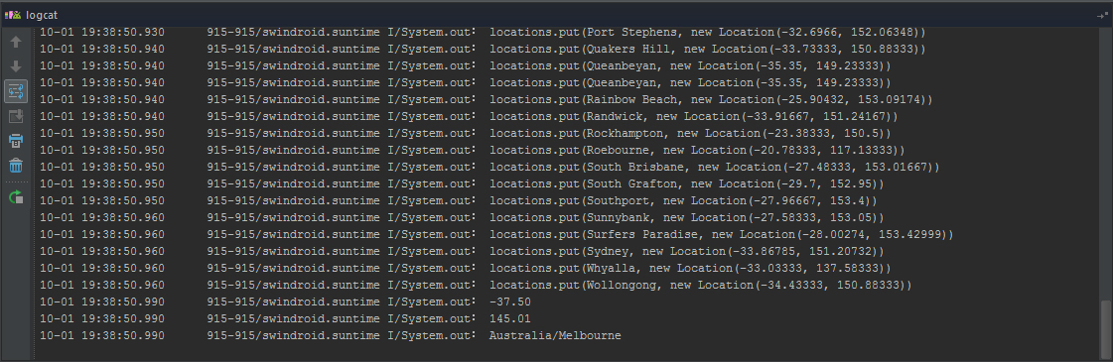

Modified the original Location.java to include the timezone (tZone).

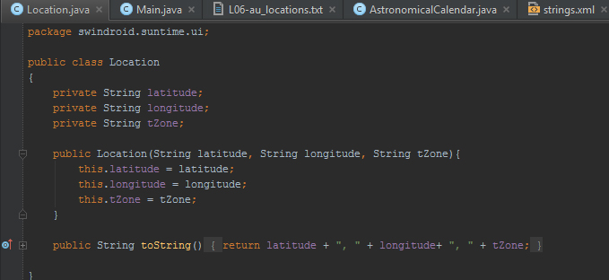

To send the latitude, longitude and time zone to the GeoLocation class, I get the text ouput by the Location class in the latLongTextView, store it into a string and split that string (with commas and line breaks) and store it into an array. I then assign the variables to latitude, longitude and tZone and use those variables in the new GeoLocation instead of static data.

*GeoLocation geolocation = new GeoLocation(CityName, latitudeDbl, longitudeDbl, tz);*

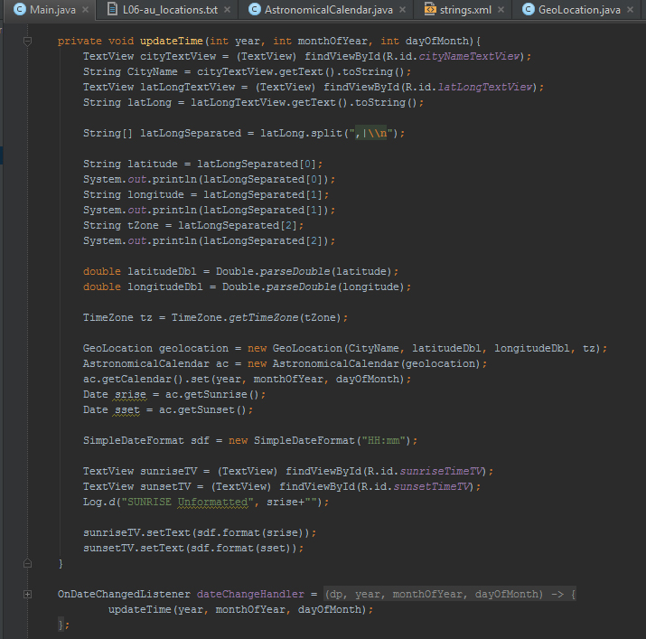

**Task 2**

**Sub-Task A -**

i) As a photographer, I want to know when the sun sets next month while traveling in Wellington, NZ so that I give myself sufficient time to take pictures during the 3 day holiday.

ii) As a religious being, I want to know when the sun rises and sets during a 40 day period (starting in May). This is so that while I am traveling in remote locations (without internet access) I can refer to the schedule.

iii) As a recently promoted individual, I want to know when the sun rises so that I can walk on the beach tomorrow and be able to reflect on the purpose of life.

iv) As late campers, we need know when the sun rises from our current location so that we are able to get back on schedule. We want to be able to send the sun-rise information with a message to our friends so that they are able to leave at the same time.

**Sub-Task B-**

I believe that the scenarios are easier to understand than user stories, as in a user story the person might put a lot of focus on one thing they like but neglect to mention something else they need. There is no such thing as too much information, it's just a matter of re-organizing the information and ranking its importance.

**Sub-Task C-**

i) Loading Screen 🡪 Main Menu 🡪 Sun Check Menu 🡪 Location Selector 🡪 Sun Check Menu 🡪 Date Picker 🡪 Sun Check Menu 🡪 Final Screen

ii) ) Loading Screen 🡪 Main Menu 🡪 Sun Check Menu 🡪 Location Selector 🡪 Sun Check Menu 🡪 Date Picker 🡪 Sun Check Menu 🡪 Final Screen 🡪 7 Day Range Menu 🡪 Share Menu

iii) Loading Screen 🡪 Main Menu 🡪 Sun Check Menu 🡪 Location Selector 🡪 Sun Check Menu 🡪 Date Picker 🡪 Sun Check Menu 🡪 Final Screen

iv) Loading Screen 🡪 Main Menu 🡪 Sun Check Menu 🡪 Location Selector 🡪 Sun Check Menu 🡪 Date Picker 🡪 Sun Check Menu 🡪 Final Screen 🡪 Share Menu