Name: Nguyen Duc Hoang

ID: 20235938

1. Use-case diagram & class diagram:

1. Working with method overloading:

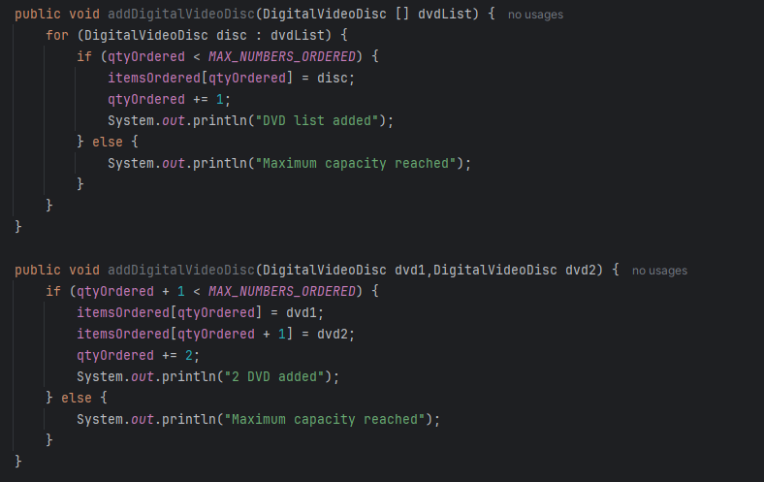

I choose array parameter because it is easy to add DVDs.

1. Passing parameter:

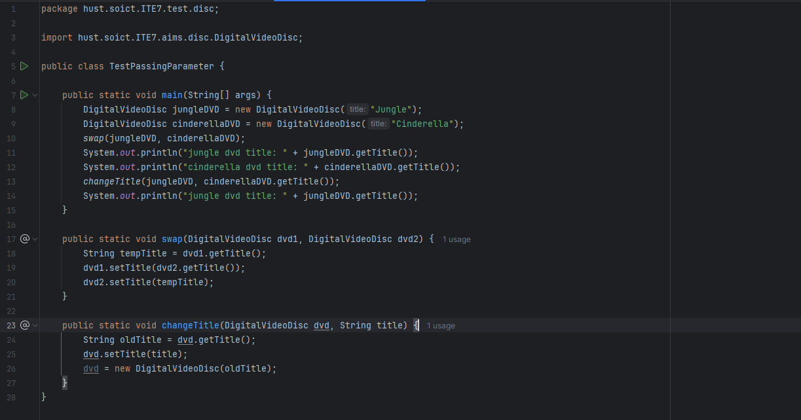

* Java is a **pass-by-value** language, meaning that when objects are passed to methods, the **value** of the reference (i.e., the memory address) is passed, not the actual object.
* Because it’s just a method which is a way to copy, so the original object is not changed.
* The func changeTitle take all address and modify at that, so it will change the original object.

1. Debug:

1. Classifier and Instance:

1. Open the Cart class:

* String.
* A screen shot of a computer program

  Description automatically generated
* A screen shot of a computer code

  Description automatically generated
* A screen shot of a computer program

  Description automatically generated
* A black rectangular object with a white border

  Description automatically generated

1. Impliment Store class:

1. String, Strting Builder & StringBuffer:

