

# Quản Lý Siêu Thị

**DETAIL DESIGN DOCUMENT**

**Screen design**

**Project Code:**

**Document Code: Quản lý Siêu Thị -DD – v1.0**

**<Location, issued date of the Document>**

**RECORD OF CHANGE**

#### *A - Added M - Modified D – Deleted

|  |  |  |  |  |
| --- | --- | --- | --- | --- |
| Effective Date | Changed Items | A* M, D | Change Description | New Version |
|  |  |  |  |  |
|  |  |  |  |  |
|  |  |  |  |  |
|  |  |  |  |  |
|  |  |  |  |  |
|  |  |  |  |  |
|  |  |  |  |  |
|  |  |  |  |  |
|  |  |  |  |  |
|  |  |  |  |  |
|  |  |  |  |  |
|  |  |  |  |  |
|  |  |  |  |  |

**SIGNATURE PAGE**

**ORIGINATOR:**<Name> <Date>

#### <Position>

**REVIEWERS:** <Name> <Date>

#### <Position>

<Name, if it’s needed> <Date>

<Position>

**APPROVAL:** <Name> <Date>

#### <Position>

Contents

Quản Lý Siêu Thị 1

1 INTRODUCTION 5

1.1 Purpose 5

1.2 Overview 5

1 SCREEN FLOW 6

1.1 Main Form 6

1.2 Employee Form 9

1.3 Customer Form 15

1.4 Commodolity Form 21

1.5 Sell Form 26

1.6 Bill Form 32

### INTRODUCTION

## Purpose

This part will give general description of the document including:

* + - *Purpose of document.*
    - *What are contained in the doc*
    - *Reader of document*
    - *Other description about scope of document, limitation,.*

## Overview

This application allows users to search for places to book tour

### SCREEN FLOW

<List of screen>

|  |  |  |
| --- | --- | --- |
| **No** | **Screen Name** | **Description** |
| 1 | Home form | The main screen at the start of the application will have toolbar, menutrips bar click on the items will move to the corresponding screen |
| 2 | Employee form | contains the basic functions presented in the report  Can help user manage staff conveniently |
| 3 | Customer form | contains the basic functions presented in the report  Can help user manage customer conveniently |
| 4 | Commodity form | contains the basic functions presented in the report  Can help user manage commodity conveniently |
| 5 | Sell form | contains the basic functions presented in the report  Can help user manage sales conveniently |
| 6 | Bill form | contains the basic functions presented in the report  Can help user manage bill conveniently |

## Main Form

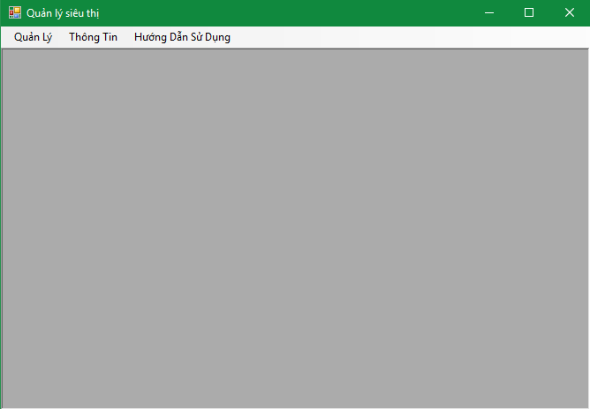

**Image 1:** main form

|  |  |  |  |  |  |
| --- | --- | --- | --- | --- | --- |
| **No** | **Component Name** | **Required** | **Format** | **Reference** | **Note** |
|  | 1 field menutrips |  |  | * Use menutrips : * Text : menuStrip1 * Use menutrips : * TextSize: 1362, 24 * AutoSize: True |  |
|  | 1 toolbars |  |  | * Use menuStrip toolbars * Text : menuStrip1 * Use menutrips : * TextSize: 1362, 24 * AutoSize: True |  |
|  | 1 item “quản lý” |  |  | * Use menutrips : * Text : menuStrip1 * Use menutrips : * TextSize: 1362, 24 * AutoSize: True |  |
|  | 1 Sub items”Nhân viên” |  |  | * Use menutrips : * Text : menuStrip1 * Use menutrips : * TextSize: 1362, 24 * AutoSize: True |  |
|  | 1 Sub items “Khách hàng” |  |  | * Use menutrips : * Text : menuStrip1 * Use menutrips : * TextSize: 1362, 24 * AutoSize: True |  |
|  | 1 Sub items “Hàng hóa” |  |  | * Use menutrips : * Text : menuStrip1 * Use menutrips : * TextSize: 1362, 24 * AutoSize: True |  |
|  | 1 Sub items “Bán hàng” |  |  | * Use menutrips : * Text : menuStrip1 * Use menutrips : * TextSize: 1362, 24 * AutoSize: True |  |

## Employee Form

## 

**Image 2:** employee form

|  |  |  |  |  |  |
| --- | --- | --- | --- | --- | --- |
| **No** | **Component Name** | **Required** | **Format** | **Reference** | **Note** |
|  | 1 Button “Thêm” |  |  | * Use button : * Text : “Thêm” * Use : btnThem : * Size: 90, 48 * AutoSize: True |  |
|  | 1 Button “Xóa” |  |  | * Use button : * Text : “Xóa” * Use : btnXoa : * Size: 90, 48 * AutoSize: True |  |
|  | 1 Button “Lưu” |  |  | * Use button : * Text : “Lưu” * Use : btnLuu : * Size: 90, 48 * AutoSize: True |  |
|  | 1 Button “Sửa” |  |  | * Use button : * Text : “Sửa” * Use : btnSua : * Size: 90, 48 * AutoSize: True |  |
|  | 1 Button “Hủy” |  |  | * Use button : * Text : “Hủy” * Use : btnHuy : * Size: 90, 48 * AutoSize: True |  |
|  | 1 Button “Thoát” |  |  | * Use button : * Text : btnThoat * Use : btnThoat : * Size: 90, 48 * AutoSize: True |  |
|  | 1 GroupBox “Thông tin” |  |  | * Use GroupBox : * Text : grbThongTin * Use grbThongTin: * TextSize: 749, 129 * AutoSize: True |  |
|  | 1 GroupBox “Chức năng” |  |  | * Use GroupBox * Text : grbChucNang * Use grbChucNang * TextSize: 749, 129 * AutoSize: True |  |
|  | 1 datagirdView |  |  | * Use datagridView * Text : dtgvNhanVien * Use dtgvNhanVien: * TextSize: 749, 182 * AutoSize: True |  |
|  | 1 DateTimePicker “date” |  |  | * Use dtpNgaySinh : * Text : default * Use dtpNgaySinh : * TextSize: 97, 20 * AutoSize: True |  |
|  | 1 Label “ID nhân viên” |  |  | * Use : Label * Text : “ID nhân viên” * Use lblID * TextSize: 80, 13 * AutoSize: True * Font: Microsoft Sans Serif |  |
|  | 1 Label “Họ tên” |  |  | * Use : Label * Text : “Họ tên” * Use lblTen * TextSize: 80, 13 * AutoSize: True * Font: Microsoft Sans Serif |  |
|  | 1 Label “Giới tính” |  |  | * Use : Label * Text : “Giới tính” * Use lblGioiTinh * TextSize: 80, 13 * AutoSize: True * Font: Microsoft Sans Serif |  |
|  | 1 Label”Địa chỉ” |  |  | * Use : Label * Text : ” Địa chỉ” * Use : lblDiaChi * TextSize: 80,gv 13 * AutoSize: True * Font: Microsoft Sans Serif |  |
|  | 1 Label “Số điện thoại” |  |  | * Use : Label * Text : “Số điện thoại” * Use lblSDT * TextSize: 80, 13 * AutoSize: True * Font: Microsoft Sans Serif |  |
|  | 1 Label “Ngày sinh” |  |  | * Use : Label * Text : “Ngày sinh” * Use lblNgaySinh * TextSize: 80, 13 * AutoSize: True * Font: Microsoft Sans Serif |  |
|  | 1 Radio button ”Nam “ |  |  | * Use : Radio button ” Nam” * Text : default * Use Radio button ” Nam” * TextSize: 80, 13 * AutoSize: True * Font: Microsoft Sans Serif |  |
|  | 1 Radio button ”Nữ “ |  |  | * Use : Radio button ” Nữ” * Text : default * Use Radio button ” Nữ” * TextSize: 80, 13 * AutoSize: True * Font: Microsoft Sans Serif |  |
|  | 1 Textbox “ID nhân viên” |  |  | * Use Textbox * Text : default * Use : txtID_NhanVien * TextSize: 97, 20 * AutoSize: True |  |
|  | 1 Textbox “Họ tên” |  |  | * Use Textbox * Text : default * Use : txtTenNV * TextSize: 97, 20 * AutoSize: True |  |
|  | 1 Radio button “Nam” |  |  | * Use Radio button * Text : “Nam” * Use : rabNam * TextSize: 97, 20 * AutoSize: True |  |
|  | 1 Radio button “Nữ” |  |  | * Use Radio button * Text : “Nữ” * Use : rabNu * TextSize: 97, 20 * AutoSize: True |  |
|  | 1 Textbox “Địa chỉ” |  |  | * Use Textbox * Text : default * Use : txtDiaChi * TextSize: 97, 20 * AutoSize: True |  |
|  | 1 Textbox “Số điện thoại” |  |  | * Use Textbox * Text : default * Use : txtSDT * TextSize: 97, 20 * AutoSize: True |  |

## Customer Form

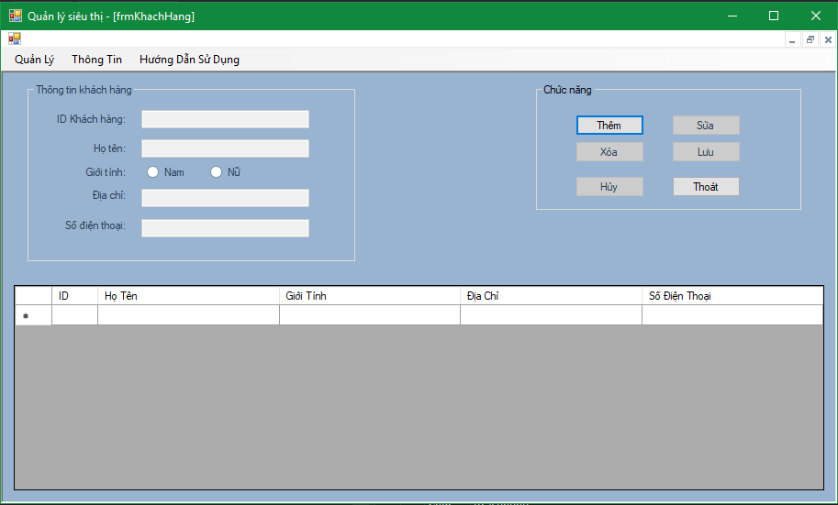

**Image 3:** Customer form

|  |  |  |  |  |  |
| --- | --- | --- | --- | --- | --- |
| **No** | **Component Name** | **Required** | **Format** | **Reference** | **Note** |
|  | 1 Button “Thêm” |  |  | * Use button : * Text : “Thêm” * Use : btnThem : * Size: 90, 48 * AutoSize: True |  |
|  | 1 Button “Xóa” |  |  | * Use button : * Text :”Xóa” * Use : btnXoa : * Size: 90, 48 * AutoSize: True |  |
|  | 1 Button “Lưu” |  |  | * Use button : * Text : “Lưu” * Use : btnLuu : * Size: 90, 48 * AutoSize: True |  |
|  | 1 Button “Sửa” |  |  | * Use button : * Text : “Sửa” * Use : btnSua : * Size: 90, 48 * AutoSize: True |  |
|  | 1 Button “Hủy” |  |  | * Use button : * Text : “Huy” * Use : btnHuy: * Size: 90, 48 * AutoSize: True |  |
|  | 1 Button “Thoát” |  |  | * Use button : * Text : “Thoát” * Use : btnThoat : * Size: 90, 48 * AutoSize: True |  |
|  | 1 GroupBox “Thông tin” |  |  | * Use GroupThongTin : * Text : GroupThongTin * Use GroupThongTin: * TextSize: 749, 129 * AutoSize: True |  |
|  | 1 GroupBox “Chức năng” |  |  | * Use GroupChucnang: * Text : dtgvKhachHang * Use dtgvKhachHang: * TextSize: 749, 129 * AutoSize: True |  |
|  | 1 datagirdView |  |  | * Use datagridView * Text : dtgvKhachHang * Use dtgvKhachHang: * TextSize: 749, 182 * AutoSize: True |  |
|  | 1 Label “ID nhân viên” |  |  | * Use : Label * Text : “ID Khách Hàng” * Use lblID_KhachHang * TextSize: 80, 13 * AutoSize: True * Font: Microsoft Sans Serif |  |
|  | 1 Label “Họ tên” |  |  | * Use : Label * Text : “Họ tên” * Use lblTenKH * TextSize: 80, 13 * AutoSize: True * Font: Microsoft Sans Serif |  |
|  | 1 Label “Giới tính” |  |  | * Use : Label * Text : “Giới tính” * Use lblGioiTinh * TextSize: 80, 13 * AutoSize: True * Font: Microsoft Sans Serif |  |
|  | 1 Label”Địa chỉ” |  |  | * Use : Label * Text : ” Địa chỉ” * Use : lblDiaChi * TextSize: 80,gv 13 * AutoSize: True * Font: Microsoft Sans Serif |  |
|  | 1 Label “Số điện thoại” |  |  | * Use : Label * Text : “Số điện thoại” * Use lblSDT * TextSize: 80, 13 * AutoSize: True * Font: Microsoft Sans Serif |  |
|  | 1 Label “Ngày sinh” |  |  | * Use : Label * Text : “Ngày sinh” * Use lblNgaySinh * TextSize: 80, 13 * AutoSize: True * Font: Microsoft Sans Serif |  |
|  | 1 Radio button ”Nam “ |  |  | * Use : Radio button ” Nam” * Text : default * Use Radio button ” Nam” * TextSize: 80, 13 * AutoSize: True * Font: Microsoft Sans Serif |  |
|  | 1 Radio button ”Nữ “ |  |  | * Use : Radio button ” Nữ” * Text : default * Use Radio button ” Nữ” * TextSize: 80, 13 * AutoSize: True * Font: Microsoft Sans Serif |  |
|  | 1 Textbox “ID Khách Hàng” |  |  | * Use Textbox * Text : default * Use :txtID_KhachHang * TextSize: 97, 20 * AutoSize: True |  |
|  | 1 Textbox “Họ tên” |  |  | * Use Textbox * Text : default * Use : txtTenKH * TextSize: 97, 20 * AutoSize: True |  |
|  | 1 Radio button “Nam” |  |  | * Use Radio button * Text : “Nam” * Use : rabNam * TextSize: 97, 20 * AutoSize: True |  |
|  | 1 Radio button “Nữ” |  |  | * Use Radio button * Text : “Nữ” * Use : rabNu * TextSize: 97, 20 * AutoSize: True |  |
|  | 1 Textbox “Địa chỉ” |  |  | * Use Textbox * Text : default * Use : txtDiaChi * TextSize: 97, 20 * AutoSize: True |  |
|  | 1 Textbox “Số điện thoại” |  |  | * Use Textbox * Text : default * Use : txtSDT * TextSize: 97, 20 * AutoSize: True |  |

## Commodolity Form

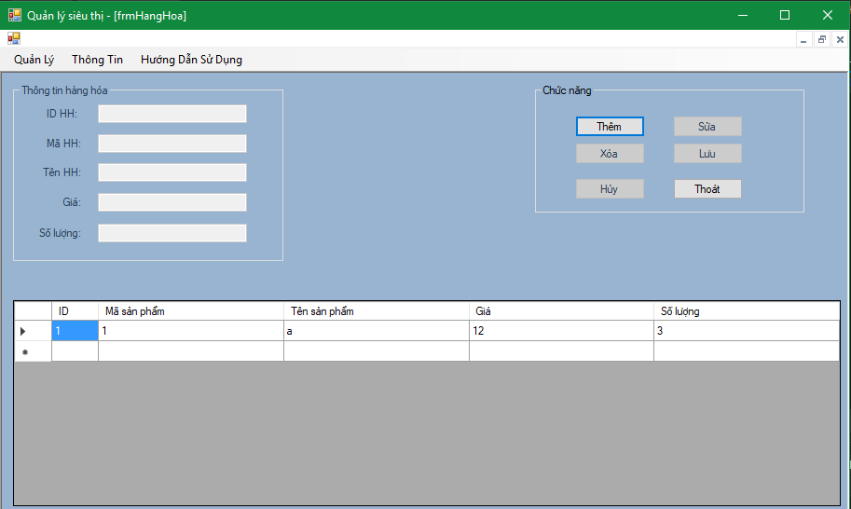

**Image 4:** commodility form

|  |  |  |  |  |  |
| --- | --- | --- | --- | --- | --- |
| **No** | **Component Name** | **Required** | **Format** | **Reference** | **Note** |
|  | 1 Button “Thêm” |  |  | * Use button : * Text : “Thêm” * Use : btnThem : * Size: 90, 48 * AutoSize: True |  |
|  | 1 Button “Xóa” |  |  | * Use button : * Text :”Xóa” * Use : btnXoa : * Size: 90, 48 * AutoSize: True |  |
|  | 1 Button “Lưu” |  |  | * Use button : * Text : “Lưu” * Use : btnLuu : * Size: 90, 48 * AutoSize: True |  |
|  | 1 Button “Sửa” |  |  | * Use button : * Text : “Sửa” * Use : btnSua : * Size: 90, 48 * AutoSize: True |  |
|  | 1 Button “Hủy” |  |  | * Use button : * Text : “Huy” * Use : btnHuy: * Size: 90, 48 * AutoSize: True |  |
|  | 1 Button “Thoát” |  |  | * Use button : * Text : “Thoát” * Use : btnThoat : * Size: 90, 48 * AutoSize: True |  |
|  | 1 GroupBox “Thông tin” |  |  | * Use GroupThongTin : * Text : GroupThongTin * Use GroupThongTin: * TextSize: 749, 129 * AutoSize: True |  |
|  | 1 GroupBox “Chức năng” |  |  | * Use GroupChucnang: * Text :GroupChucNang * Use GroupChucNang: * TextSize: 749, 129 * AutoSize: True |  |
|  | 1 datagirdView |  |  | * Use datagridView * Text : dtgvHangHoa * Use dtgvHangHoa * TextSize: 749, 182 * AutoSize: True |  |
|  | 1 Label “ID HH” |  |  | * Use : Label * Text : “ID HH” * Use lblID_HangHoa * TextSize: 80, 13 * AutoSize: True * Font: Microsoft Sans Serif |  |
|  | 1 Label “Mã HH” |  |  | * Use : Label * Text : “Mã HH” * Use lblMaHH * TextSize: 80, 13 * AutoSize: True * Font: Microsoft Sans Serif |  |
|  | 1 Label “Tên HH” |  |  | * Use : Label * Text : “Tên HH” * Use lblTenHH * TextSize: 80, 13 * AutoSize: True * Font: Microsoft Sans Serif |  |
|  | 1 Label “Giá” |  |  | * Use : Label * Text : “Giá” * Use lblGia * TextSize: 80, 13 * AutoSize: True * Font: Microsoft Sans Serif |  |
|  | 1 Label”Số Lượng” |  |  | * Use : Label * Text : ” Số Lượng” * Use : lblSoLuong * TextSize: 80,gv 13 * AutoSize: True * Font: Microsoft Sans Serif |  |
|  | 1 Textbox “ID HH” |  |  | * Use Textbox * Text : default * Use :txtID_HangHoa * TextSize: 97, 20 * AutoSize: True |  |
|  | 1 Textbox “Mã HH” |  |  | * Use Textbox * Text : default * Use :txtMaHH * TextSize: 97, 20 * AutoSize: True |  |
|  | 1 Textbox “Tên HH” |  |  | * Use Textbox * Text : default * Use : txtTenHH * TextSize: 97, 20 * AutoSize: True |  |
|  | 1 Textbox “Giá” |  |  | * Use Textbox * Text : default * Use : txtGia * TextSize: 97, 20 * AutoSize: True |  |
|  | 1 Textbox “Số Lượng” |  |  | * Use Textbox * Text : default * Use : txtSoLuong * TextSize: 97, 20 * AutoSize: True |  |

## Sell Form

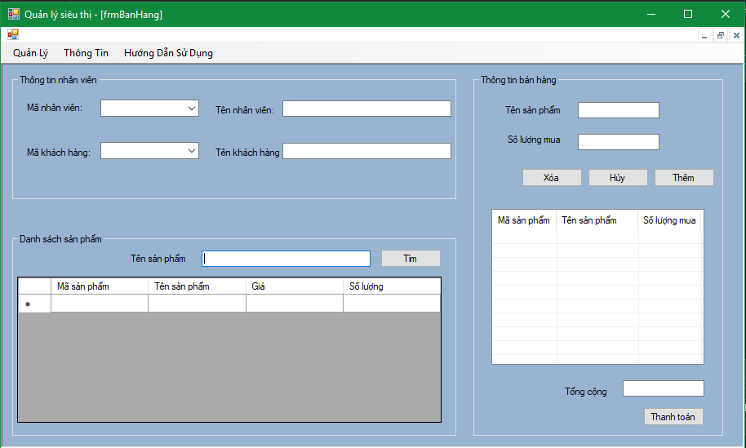

**Image 5:** Sell form

|  |  |  |  |  |  |
| --- | --- | --- | --- | --- | --- |
| **No** | **Component Name** | **Required** | **Format** | **Reference** | **Note** |
|  | 1 Button “Thêm” |  |  | * Use button : * Text : “Thêm” * Use : btnThem : * Size: 90, 48 * AutoSize: True |  |
|  | 1 Button “Xóa” |  |  | * Use button : * Text :”Xóa” * Use : btnXoa : * Size: 90, 48 * AutoSize: True |  |
|  | 1 Button “Hủy” |  |  | * Use button : * Text : “Huy” * Use : btnHuy: * Size: 90, 48 * AutoSize: True |  |
|  | 1 Button “Tìm” |  |  | * Use button : * Text : “Tìm” * Use : btnTim : * Size: 90, 48 * AutoSize: True |  |
|  | 1 Button “Thanh Toán” |  |  | * Use button : * Text : “Thanh Toán” * Use : btnThanhToan : * Size: 90, 48 * AutoSize: True |  |
|  | 1 GroupBox “Thông tin nhân viên” |  |  | * Use GroupBox * Text : default * Use grbThongTinNhanVien * TextSize: 749, 129 * AutoSize: True |  |
|  | 1 GroupBox “Danh sách sản phẩm” |  |  | * Use GroupBox * Text frbThongTinSanPham * Use frbThongTinSanPham * TextSize: 749, 129 * AutoSize: True |  |
|  | 1 GroupBox “Thông tin bán hàng” |  |  | * Use GroupBox * Text : default * Use grbThongTinBanHang * TextSize: 749, 129 * AutoSize: True |  |
|  | 1 datagirdView |  |  | * Use datagridView * Text : dtgvHangHoa * Use dtgvHangHoa: * TextSize: 749, 182 * AutoSize: True |  |
|  | 1 ListView |  |  | * Use listView * Text : lvBanHang * Use lvBanHang * TextSize: 749, 182 * AutoSize: True |  |
|  | 1 Label “Mã nhân viên” |  |  | * Use : Label * Text : “Mã Nhân Viên” * Use lblMaNV * TextSize: 80, 13 * AutoSize: True * Font: Microsoft Sans Serif |  |
|  | 1 Label “Tên nhân viên” |  |  | * Use : Label * Text : “Tên nhân viên” * Use lblTenNV * TextSize: 80, 13 * AutoSize: True * Font: Microsoft Sans Serif |  |
|  | 1 Label “Mã khách hàng” |  |  | * Use : Label * Text : “Mã khách hàng” * Use lblMaKH * TextSize: 80, 13 * AutoSize: True * Font: Microsoft Sans Serif |  |
|  | 1 Label “Tên khách hàng” |  |  | * Use : Label * Text : “Tên khách hàng” * Use lblTenKH * TextSize: 80, 13 * AutoSize: True * Font: Microsoft Sans Serif |  |
|  | 1 Label “Tên sản phẩm” |  |  | * Use : Label * Text : “Tên sản phẩm” * Use lblTenSP * TextSize: 80, 13 * AutoSize: True * Font: Microsoft Sans Serif |  |
|  | 1 Label “Số lượng mua” |  |  | * Use : Label * Text : “Số lượng mua” * Use lblSoLuongMua * TextSize: 80, 13 * AutoSize: True * Font: Microsoft Sans Serif |  |
|  | 1 Label “Tổng cộng” |  |  | * Use : Label * Text : “Tổng cộng” * Use lblTongCong * TextSize: 80, 13 * AutoSize: True * Font: Microsoft Sans Serif |  |
|  | 1 Textbox “Mã Khách Hàng” |  |  | * Use Textbox * Text : default * Use :txtMaKH * TextSize: 97, 20 * AutoSize: True |  |
|  | 1 Textbox “Tên khách hàng” |  |  | * Use Textbox * Text : default * Use : txtTenKH * TextSize: 97, 20 * AutoSize: True |  |
|  | 1 Textbox “Mã nhân viên” |  |  | * Use Textbox * Text : default * Use :txtMaNV * TextSize: 97, 20 * AutoSize: True |  |
|  | 1 Textbox “Tên nhân viên” |  |  | * Use Textbox * Text : default * Use :txtTenNV * TextSize: 97, 20 * AutoSize: True |  |
|  | 1 Textbox “Tên sản phẩm” |  |  | * Use Textbox * Text : default * Use : txtNhapTenSP * TextSize: 97, 20 * AutoSize: True |  |
|  | 1 Textbox “Tên sản phẩm” |  |  | * Use Textbox * Text : default * Use : txtTenSP * TextSize: 97, 20 * AutoSize: True |  |
|  | 1 Textbox “Số lượng mua” |  |  | * Use Textbox * Text : default * Use : txtSoLuongMua * TextSize: 97, 20 * AutoSize: True |  |
|  | 1 Textbox “Tổng cộng” |  |  | * Use Textbox * Text : default * Use : txtTongCong * TextSize: 97, 20 * AutoSize: True |  |

## Bill Form

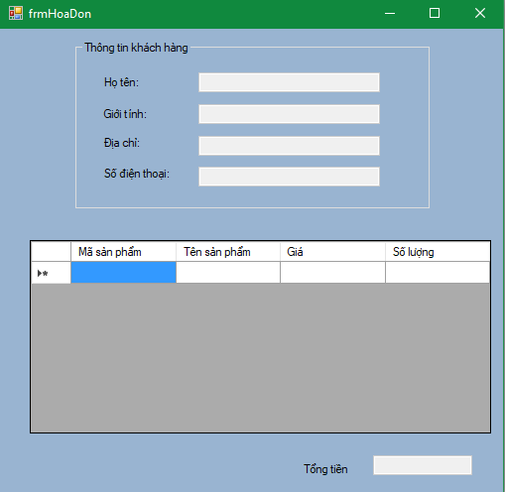

**Image 6:** Bill form

|  |  |  |  |  |  |
| --- | --- | --- | --- | --- | --- |
| **No** | **Component Name** | **Required** | **Format** | **Reference** | **Note** |
|  | 1 GroupBox “Thông tin khách hàng” |  |  | * Use GroupBox * Text : default * Use grbThongTin * TextSize: 749, 129 * AutoSize: True |  |
|  | 1 datagirdView |  |  | * Use datagridView * Text : dtgvHangHoa * Use dtgvHangHoa: * TextSize: 749, 182 * AutoSize: True |  |
|  | 1 Label “Họ tên” |  |  | * Use : Label * Text : “Họ tên” * Use lblTen * TextSize: 80, 13 * AutoSize: True * Font: Microsoft Sans Serif |  |
|  | 1 Label “Giới tính” |  |  | * Use : Label * Text : “Giới tính” * Use lblGioiTinh * TextSize: 80, 13 * AutoSize: True * Font: Microsoft Sans Serif |  |
|  | 1 Label “Địa chỉ” |  |  | * Use : Label * Text : “Địa chỉ” * Use lblDiaChi * TextSize: 80, 13 * AutoSize: True * Font: Microsoft Sans Serif |  |
|  | 1 Label “Số điện thoại” |  |  | * Use : Label * Text : “Số điện thoại” * Use lblSDT * TextSize: 80, 13 * AutoSize: True * Font: Microsoft Sans Serif |  |
|  | 1 Label “Tổng tiền” |  |  | * Use : Label * Text : “Tổng tiền” * Use lblTongTien * TextSize: 80, 13 * AutoSize: True * Font: Microsoft Sans Serif |  |
|  | 1 Textbox “Họ tên” |  |  | * Use Textbox * Text : default * Use : txtTenKH * TextSize: 97, 20 * AutoSize: True |  |
|  | 1 Textbox “Giới tính” |  |  | * Use Textbox * Text : default * Use : txtGioiTinh * TextSize: 97, 20 * AutoSize: True |  |
|  | 1 Textbox “Địa chỉ” |  |  | * Use Textbox * Text : default * Use :txtDiaChi * TextSize: 97, 20 * AutoSize: True |  |
|  | 1 Textbox “Số điện thoại” |  |  | * Use Textbox * Text : default * Use :txtSDT * TextSize: 97, 20 * AutoSize: True |  |
|  | 1 Textbox “Tên sản phẩm” |  |  | * Use Textbox * Text : default * Use : txtNhapTenSP * TextSize: 97, 20 * AutoSize: True |  |
|  | 1 Textbox “Tên sản phẩm” |  |  | * Use Textbox * Text : default * Use : txtTenSP * TextSize: 97, 20 * AutoSize: True |  |
|  | 1 Textbox “Tổng tiền” |  |  | * Use Textbox * Text : default * Use : txtTongTien * TextSize: 97, 20 * AutoSize: True |  |

***---------- End of Document ----------***