Software Requirement Specification

Group-SRS-001

Version 1.0

**Revision History**

| Date | Version | Description | Author | Revised by |
| --- | --- | --- | --- | --- |
| 23/05/2018 | 1.0 | First version | Group |  |
|  |  |  |  |  |
|  |  |  |  |  |
|  |  |  |  |  |
|  |  |  |  |  |

Table of Contents

**1.** **Introduction** 4

**1.1** **Overview** 4

**1.2** **Scope** 4

**2.** **Functional Requirements** 5

**2.1** **Feature/Component #1: Home screen** 5

2.1.1 User Interfaces 5

2.1.2 Functional Requirements 6

**2.2** **Feature/Component #2:** ***management screen*** 7

2.2.1 User Interfaces 7

2.2.2 Functional Requirements 8

**2.3** **Feature/Component #3: employee form** 9

2.3.1 User Interfaces 9

2.3.2 Functional Requirements 10

**2.4** **Feature/Component #4:** **Customer form** 12

2.4.1 User Interfaces 12

2.4.2 Functional Requirements 13

**2.5** **Feature/Component #5:** ***Commodity form*** 16

2.5.1 User Interfaces 16

2.5.2 Functional Requirements 17

**2.6** **Feature/Component #6:** ***Sell form*** 19

2.6.1 User Interfaces 19

2.6.2 Functional Requirements 20

***2.7*** **Feature/Component #7:** ***Bill form*** 22

2.7.1 User Interfaces 22

2.7.2 Functional Requirements 23

# **Introduction**

## **Overview**

Application provides and presents specific recipes suitable for all ages and genders

## **Scope**

Demo version

Demo version is for display purpose only, not link to Database, not link to affiliated sites

* test devices: PC, Laptop.

Support screen orientation in landscape mode only

# **Functional Requirements**

## **Feature/Component #1: Home screen**

### User Interfaces

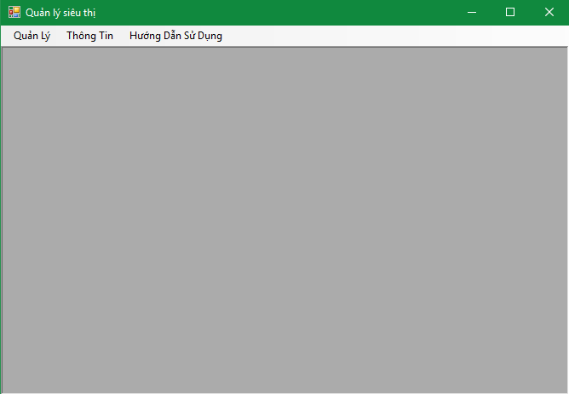

*Image1:* Home screen

### Functional Requirements

|  |  |  |  |
| --- | --- | --- | --- |
| **Item** | **Description** | **Action** | **Response** |
| home srceen | Include:   * 1 Toolbars | N/A | N/A |
| Toolbars | Contains two "management", "information" and User manual | Click | Click item” management” of menutrip move to form flight management  Click item “information” display  MessageBox  Information group |
| “Quản Lý” | Contains two "management", "information" and User manual | Click | Displays a list of form functions. |
| “Hướng dẫn sử dụng” | When the user clicks on, they will show how to use the app | Click | Display the manual screen |
| “Thông Tin” | When the user clicks on, they will display the information of the app | Click | Displays the information of the app |

## **Feature/Component #2:** ***management screen***

### User Interfaces

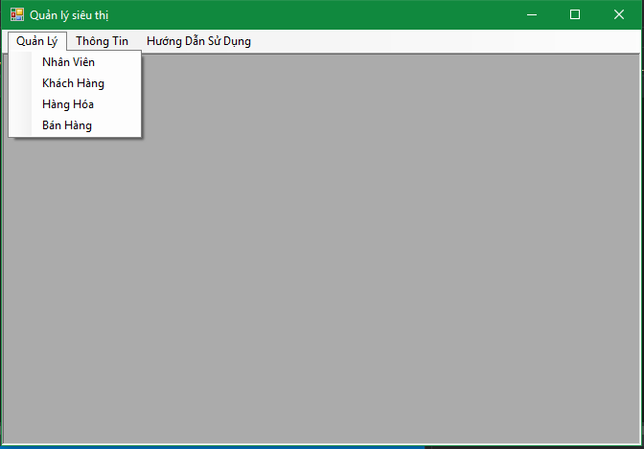

*Image2: management screen*

### Functional Requirements

|  |  |  |  |
| --- | --- | --- | --- |
| **Name** | **Description** | **Action** | **Response** |
| *Management screen* | Include:   * MenuStrip * toolbars | N/A | N/A |
| Toolbars | Contains two "management", "information" and User manual | Click | Click item” management” of menutrip move to form flight management  Click item “information” display  MessageBox  Information group, Click item “user manual” display  User manual screen. |
| *menuStrip* | Display function names for easy-to-use users | N/A | N/A |
| *“Nhân Viên”* | When the user clicks on, he or she will switch to an employee form | Click | Show employee form |
| *“Khách Hàng”* | When the user clicks on, will switch to the customer form | Click | Display customer form |
| *“Hàng Hóa”* | When the user clicks on it will convert to commodity form | Click | Display form of goods |
| *“Bán Hàng”* | When users click on, they will switch to the sales form | Click | Display sales form |

## **Feature/Component #3: employee form**

### User Interfaces

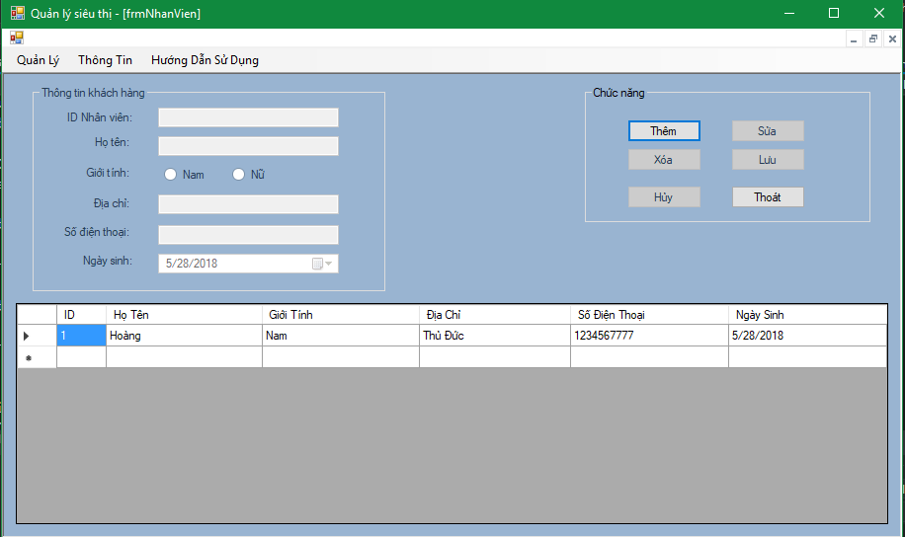

*Image3:* employee form

### Functional Requirements

|  |  |  |  |
| --- | --- | --- | --- |
| **Item** | **Description** | **Action** | **Response** |
| employee  manager | Include:   * 6 button * 2 radio button * 1 toolbars * 2 Group box * 6 label * 4 text box * 1 datetime picker * 1 datagirdView | N/A | N/A |
| Toolbars | List of app categories | N/A | N/A |
| GroupBox "Thông tin khách hàng" | Contains lables, textboxes, etc. for users to enter employee information. | N/A | N/A |
| GroupBox "Chức năng" | Contains the functions of the form | N/A | N/A |
| datagirdView | Display information of the entire staff | N/A | N/A |
| Button “Thêm” | When the user clicks on the add button, the text boxes, radio buttons, and datime pickers will light up and let the user enter the information. | Click | After the user completes the information and clicks the new button, the new employee's information is entered into the datagridView. |
| Button “Xóa” | Allows users to delete employee information in the datagirdView | Click | The user selects the employee to delete and presses the delete button, the employee is deleted from the datagirdView |
| Button “Lưu” | Saves employee information after editing and updating data-girdView | Click | Saves employee information after fixing and updating da-tagirdView |
| Button “Sửa” | Change employee information selected | Click | Change the taskbar information and update the datagridView again |
| Button “Hủy” | Cancel the function you are working on | Click | Cancel the selected function. |
| Button “Thoát” | Exit employee form | Click | Leave the employee form, return to the main form |
| Label “ID nhân viên” | Employee ID | N/A | N/A |
| Label “Họ tên” | Name of employee | N/A | N/A |
| Label "Giới tính" | Sex worker | N/A | N/A |
| Label "Địa chỉ" | Employee address | N/A | N/A |
| Label "Số điện thoại " | Employee phone number | N/A | N/A |
| Label "Ngày sinh" | The date of birth of the employee | N/A | N/A |
| Text box " ID nhân viên " | Enter employee ID | N/A | N/A |
| Text box “Họ tên” | Enter the employee's name | N/A | N/A |
| Radio button “giới tính” | Select employee sex | N/A | N/A |
| Text box “Địa chỉ” | Enter the address of the employee | N/A | N/A |
| Text box “Số điện thoại” | Enter employee ID | N/A | N/A |
| datetimePicker “Ngày sinh” | Choose birth date | N/A | N/A |

## **Feature/Component #4:** **Customer form**

### User Interfaces

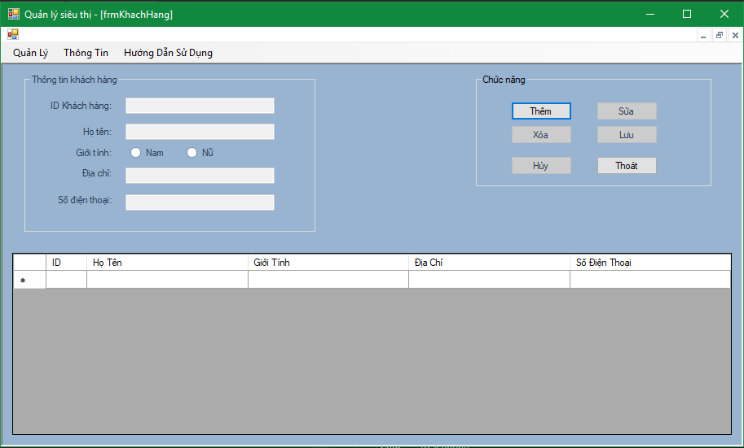

*Image4: customer form*

### Functional Requirements

|  |  |  |  |
| --- | --- | --- | --- |
| **Item** | **Description** | **Action** | **Response** |
| Customer form | Include:   * 6 button * 2 radio button * 1 toolbars * 2 Group box * 6 label * 4 text box * 1 datagirdView | N/A | N/A |
| Toolbars | List of app categories | N/A | N/A |
| GroupBox "Thông tin khách hàng" | Contains lables, textboxes, etc. for users to enter employee information. | N/A | N/A |
| GroupBox "Chức năng" | Contains the functions of the form | N/A | N/A |
| datagirdView | Display information of the whole customer | N/A | N/A |
| Button “Thêm” | When the user clicks on the add button, the text boxes, radio buttons, and datime pickers will light up and let the user enter the information. | Click | After the user completes the information and clicks the new button, the new customer's information is entered into the datagridView. |
| Button “Xóa” | Allows users to delete customer information in the datagirdView | Click | The user selects the customer to delete and presses the delete button, the customer is deleted from the datagirdView |
| Button “Lưu” | Retain customer information after fixing and updating data-girdView | Click | Retain the customer's information after fixing and updating da-tagirdView |
| Button “Sửa” | Change the selected customer information | Click | Change the taskbar information and update the datagridView again |
| Button “Hủy” | Cancel the function you are working on | Click | Cancel the selected function. |
| Button “Thoát” | Exit the customer form | Click | Exit the customer form, return to the main form |
| Label “ID khách hàng” | Customer ID | N/A | N/A |
| Label “Họ tên” | Name of customer | N/A | N/A |
| Label "Giới tính" | Sex customer | N/A | N/A |
| Label "Địa chỉ" | Address of customer | N/A | N/A |
| Label "Số điện thoại " | Phone number of the customer | N/A | N/A |
| Text box " ID khách hàng " | Enter customer ID | N/A | N/A |
| Text box “Họ tên” | Enter customer name | N/A | N/A |
| Radio button “giới tính” | Select the genders of the customer | N/A | N/A |
| Text box “Địa chỉ” | Enter the address of the customer | N/A | N/A |
| Text box “Số điện thoại” | Enter the customer ID | N/A | N/A |

## **Feature/Component #5:** ***Commodity form***

### User Interfaces

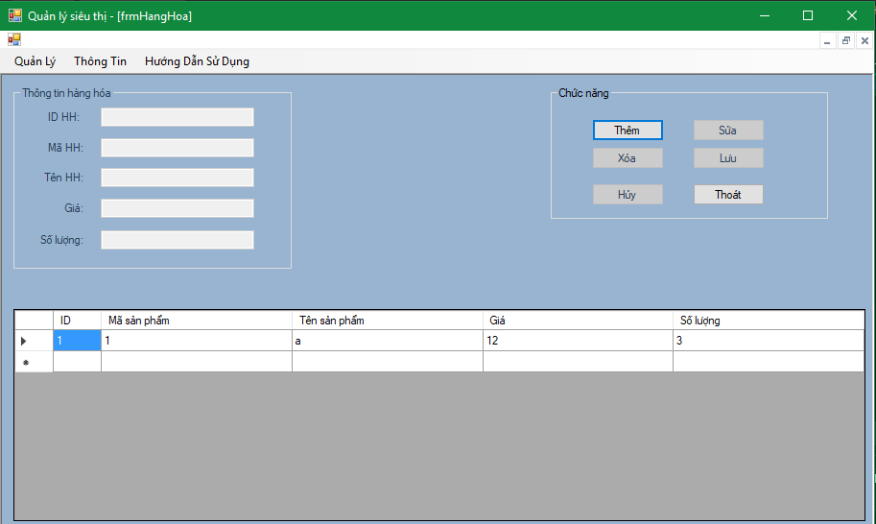

*Image5: commodity form*

### Functional Requirements

|  |  |  |  |
| --- | --- | --- | --- |
| **Item** | **Description** | **Action** | **Response** |
| commodity form | Include:   * 6 button * 1 toolbars * 2 Group box * 5 label * 5 text box * 1 datagirdView | N/A | N/A |
| Toolbars | List of app categories | N/A | N/A |
| GroupBox "Thông tin hàng hóa" | Contains lables, text boxes, .. for users to enter information of the product. | N/A | N/A |
| GroupBox "Chức năng" | Contains the functions of the form | N/A | N/A |
| datagirdView | Display information of the whole product | N/A | N/A |
| Button “Thêm” | When the user clicks on the add button, the textboxes will light up and let the user enter information. | Click | After the user enters the information and clicks the add button, the information of the new product will be entered into the datagridView. |
| Button “Xóa” | Allows user to delete product information in datagirdView | Click | The user selects the product to delete and presses the delete button, the product is removed from the datagirdView |
| Button “Lưu” | Saves the product information after correcting and updating the data-girdView | Click | Save the product information after fixing and updating da-tagirdView |
| Button “Sửa” | Change the selected product information | Click | Successfully changed the information and updated the datagridView |
| Button “Hủy” | Cancel the function you are working on | Click | Cancel the selected function. |
| Button “Thoát” | Exit form of goods | Click | Get rid of the form of goods, return to the main form |
| Label “ID sản phẩm” | ID of the product | N/A | N/A |
| Label “Mã HH” | Product code | N/A | N/A |
| Label "Tên HH" | Product's name | N/A | N/A |
| Label "Giá" | Price of the product | N/A | N/A |
| Label "Số Lượng " | Phone number of the product | N/A | N/A |
| Text box " ID Hàng hóa " | Enter the product ID | N/A | N/A |
| Text box “Mã HH” | Enter the product code | N/A | N/A |
| Text Box “Tên HH” | Enter the product name | N/A | N/A |
| Text box “Số lượng” | Enter the quantity of the product | N/A | N/A |
| Text box “Giá” | Enter Price of the product | N/A | N/A |

## **Feature/Component #6:** ***Sell form***

### User Interfaces

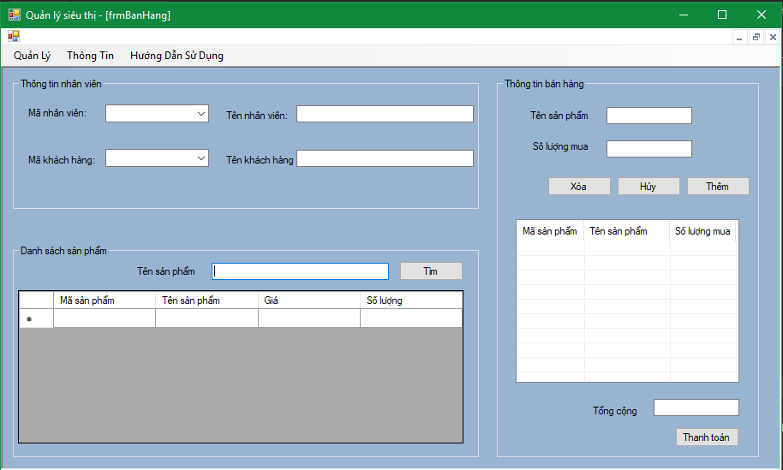

*Image6: Sell form*

### Functional Requirements

|  |  |  |  |
| --- | --- | --- | --- |
| **Item** | **Description** | **Action** | **Response** |
| Sell form | Include:   * 5 button * 1 toolbars * 3 Group box * 7 label * 5 text box * 2 combobox * 1 datagirdView * 1 listView | N/A | N/A |
| Toolbars | List of app categories | N/A | N/A |
| GroupBox "Thông tin nhân viên" | Contains content related to employees | N/A | N/A |
| GroupBox "thông tin bán hàng" | Contains content related to sales | N/A | N/A |
| GroupBox "danh sách sản phẩm" | Contains content related to the product | N/A | N/A |
| datagirdView | Display information of the whole product | N/A | N/A |
| listView | Display purchase information | N/A | N/A |
| Button “Thêm” | When the user clicks on the add button, the textboxes will light up and let the user enter information. | Click | After the user enters the information and presses the button, the product information will be added to the listView |
| Button “Xóa” | Allows user to delete product information in listView | Click | The user selects the product to delete and presses the delete button, the product is removed from the listView |
| Button “Hủy” | Cancel the function you are working on | Click | Cancel the selected function. |
| Button “Thanh toán” | Performing the charge function | Click | Checkout and bill |
| Button “Tìm” | Find products by name | Click | Search for products by name and alerts. |
| Label “Mã nhân viên” | Employee code | N/A | N/A |
| Label "Tên nhân viên" | Staff's name | N/A | N/A |
| Label “Mã khách hàng” | Customer's code | N/A | N/A |
| Label “tên khách hàng” | Customer name | N/A | N/A |
| Label “Tên sản phẩm” | Product's name | N/A | N/A |
| Label “Số lượng mua” | Quantity purchased | N/A | N/A |
| Label “tổng cộng” | Amount to pay | N/A | N/A |
| Text box "tổng cộng " | into money | N/A | N/A |
| Text box " ID Hàng hóa " | Enter the product ID | N/A | N/A |
| Text box “nhập tên sản phẩm ” | Enter product name to find. | N/A | N/A |
| Text box “Mã HH” | Enter the product code | N/A | N/A |
| Text Box “Tên HH” | Enter the product name | N/A | N/A |
| Text box “Số lượng” | Enter the quantity of the product | N/A | N/A |
| Text box “Giá” | Enter Price of the product | N/A | N/A |

## **Feature/Component #7:** ***Bill form***

### User Interfaces

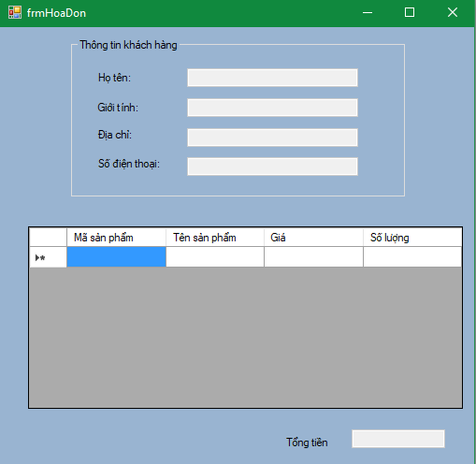

*Image7: bill form*

### Functional Requirements

|  |  |  |  |
| --- | --- | --- | --- |
| **Item** | **Description** | **Action** | **Response** |
| Sell form | Include:   * 1 Group box * 5 label * 5 text box * 1 datagirdView | N/A | N/A |
| GroupBox "Thông tin khách hàng" | Contains the information of the buyer | N/A | N/A |
| datagirdView | Display information of the whole product | N/A | N/A |
| Label "Họ tên" | Customer name | N/A | N/A |
| Label “Giới tính” | Sex customer | N/A | N/A |
| Label “Địa chỉ” | Customer address | N/A | N/A |
| Label “Số điện thoại” | Customer phone number | N/A | N/A |
| Label “tổng tiền” | Amount to pay | N/A | N/A |
| Text box " Họ tên " | Display customer name | N/A | N/A |
| Text box " Giới tính " | Showing the gender of the customer | N/A | N/A |
| Text box “Địa chỉ ” | Show customer address | N/A | N/A |
| Text box “Số điện thoại” | Show customer phone number | N/A | N/A |
| Text Box “tổng tiền” | Show amount to pay | N/A | N/A |

***---------- End of Document ----------***