**Recurrent Neural Networks**

Humans don’t start their thinking from scratch every second, information like words in a sentence are connected and is an addition of each other.

Traditional neural networks weakness is unable to persist data, and it seems like a major shortcoming.

Recurrent neural networks address this issue. They are networks with loops in them, allowing information to persist.

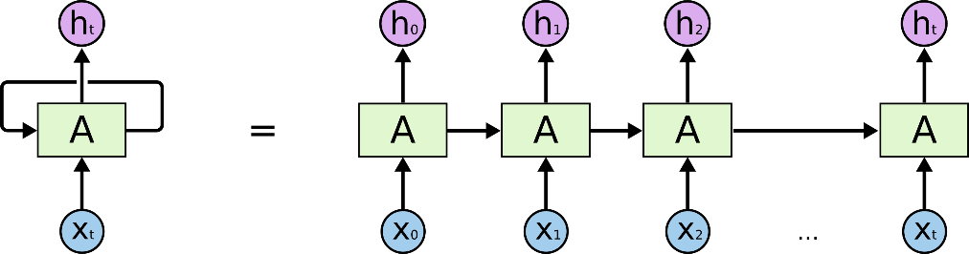

This chain-like nature reveals that recurrent neural networks are intimately related to sequences and lists. They’re the natural architecture of neural network to use for such data.

**The Problem of Long-Term Dependencies**

In cases where the gap between the relevant information and the place that it’s needed is small, RNNs can learn to use the past information.

But as the context grow, the gap between the relevant information and the point where it is needed to become very large, RNNs become unable to learn to connect the information.

## LSTM Networks

LSTMs are explicitly designed to avoid the long-term dependency problem. Remembering information for long periods of time.

LSTMs have a chain like structure containing four neural network layers, interacting in a special way.

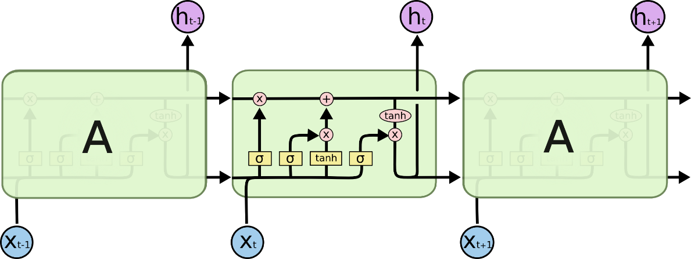

## Reference

## <https://colah.github.io/posts/2015-08-Understanding-LSTMs/>