**Name:** Nguyen Thi Cam Hoang **Date:** June 24th, 2017

**Student ID:** 20165327

# Final project

* The analysis need the data of trading date in the period of 6 years from 2003-09-10 to 2009-09-09. To get the data frame with the trading date, I downloaded the daily stock price data from the link: <https://wrds-web.wharton.upenn.edu/wrds/ds/crsp/stock_a/dsf.cfm?navGroupHeader=Annual%20Update&navGroup=Stock%20%2F%20Security%20Files>.
* To get the list of trading date annually, I use Python for convenience, one more thing can be noticed here is that all the stocks were trading in the same days within the analysis period

|  |  |  |
| --- | --- | --- |
| **No** | **Period** | **Number of trading days** |
| 1 | 2003-09-10 – End of 2003 | 79 |
| 2 | 2004 | 252 |
| 3 | 2005 | 252 |
| 4 | 2006 | 251 |
| 5 | 2007 | 251 |
| 6 | 2008 | 253 |
| 7 | Begin of 2009 – 2009-09-09 | 173 |
|  | **Total** | **1511** |

* Information of stock for analysis:

|  |  |  |  |
| --- | --- | --- | --- |
| **No** | **Ticker** | **Stock Market** | **Company name** |
| 1 | WHR | N | WHIRLPOOL CORP |
| 2 | MOT | MOTOROLA INC |
| 3 | AMAT | Q | APPLIED MATERIALS INC |
| 4 | QCOM | QUALCOMM INC |

To compute the liquidity variables, these steps were performed:

* **Step 1**: Create BuySellIndicators (Previous assignment).
* **Step 2**: Compute some parameters for each day. There are 17 parameters in total (Question 1). Then concatenate everyday data into one.
* **Step 3**: Perform analysis (Question 2).

Because **Step 1** is already mentioned in the previous assignment, I will only point out how I perform **Step 2** and **3**.

## Question 1

It would be easier to get the data with all necessary variables before computing the parameters.

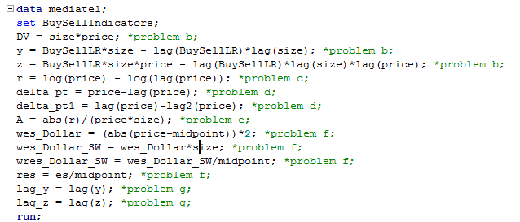

1. For each day d (from 2003-09-10 to 2009-09-09), identify the last closing price.

* This can be done by using **last**.

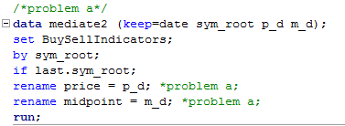

1. Compute daily share trading volume Vd and dollar trading volume DVd. Further, define two order imbalances yt and zt at each time t and compute daily order imbalances (yd and zd).

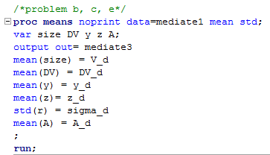

* Problem b, c and e can be solved by using **proc means** in sas.

1. Compute the intra-day volatility of return series which is the standard deviation of return series r**t**.

* Mentioned in b

1. Compute the Roll's implicit spread measures.

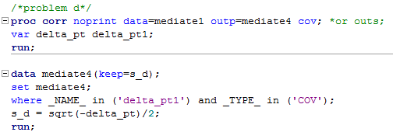

* To compute covariance, we can using **proc corr** in sas.
* Then, select the right number by accessing the row and column and compute s_d parameter.
* To plot s_d, we can use proc gplot:

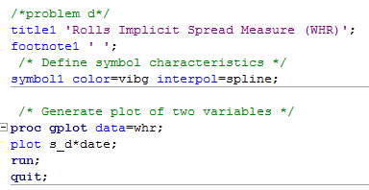

1. Compute the daily Amihud' measure from intra-day data.

* Mentioned in b

1. Compute the daily volume(size) weighted average of e_ective spread (es**d**) and relative e_ective spread (res**d**). Plot.

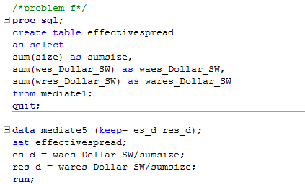

* We already learn how to compute weighted average of effective spread in class.
* For the weighted average of relative effective spread, the computation is similar. The relative effective spread equals the effective spread over midpoint.
* Plot es_d and res_d:

|  |  |
| --- | --- |
|  |  |

1. Estimate the two regressions for each stock. Plot.

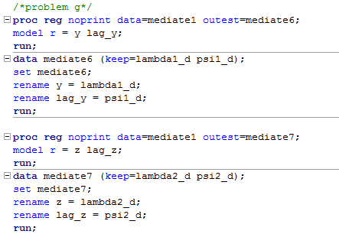

* Estimate the coefficients can be done by using **proc reg**.
* We need to use some addition options: noprint (no need picture output), outest (to get value).
* Plot **Price Impact Coefficient** and **Price Reversal Coefficient.**

|  |  |
| --- | --- |
|  |  |

1. Estimate the two time series model for each stock.

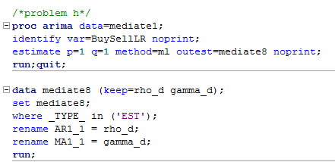

* This problem is similar to problem g, we can use **proc arima**.
* The place to put options is slightly different.

Now, we have all variables denoted for everyday. We should merge all variables into one file named estim.

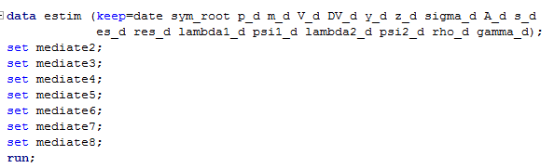

Up to here, we just calculate for only one day. In order to derive all parameters for 6-year period, a loop running over many small chunk of time should be formed. Instead, I replicated the code to perform the computation for each stock during the whole period. Therefore, I have four sas file named **job_whr.sas**, **job_mot.sas**, **job_amat.sas** and **job_qcom.sas.**

Here is how I did looping:

* I used macro function, the argument of function is the list of date.

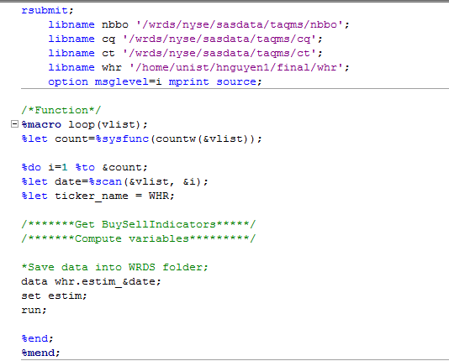

Code for this part is explained above.

* I called the function for each value in the list of date

Replace with the full list of date. This way is not good since we need to list all the date and may not be efficient to deal with longer period. However, I have no time to search for a function dealing with this in sas .

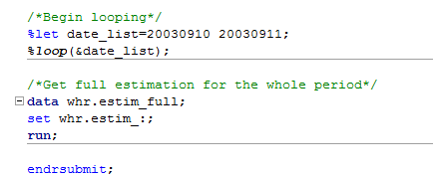

Merge all single estim into one for further analysis

After getting the job code, I submitted into server by using command line. The downloading process may take 45 minutes for the whole period. This is how the dataset looks like:

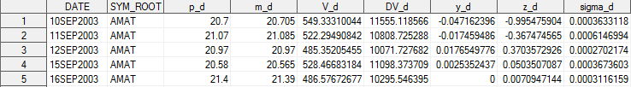

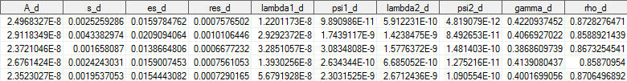

Result:

**WHR**

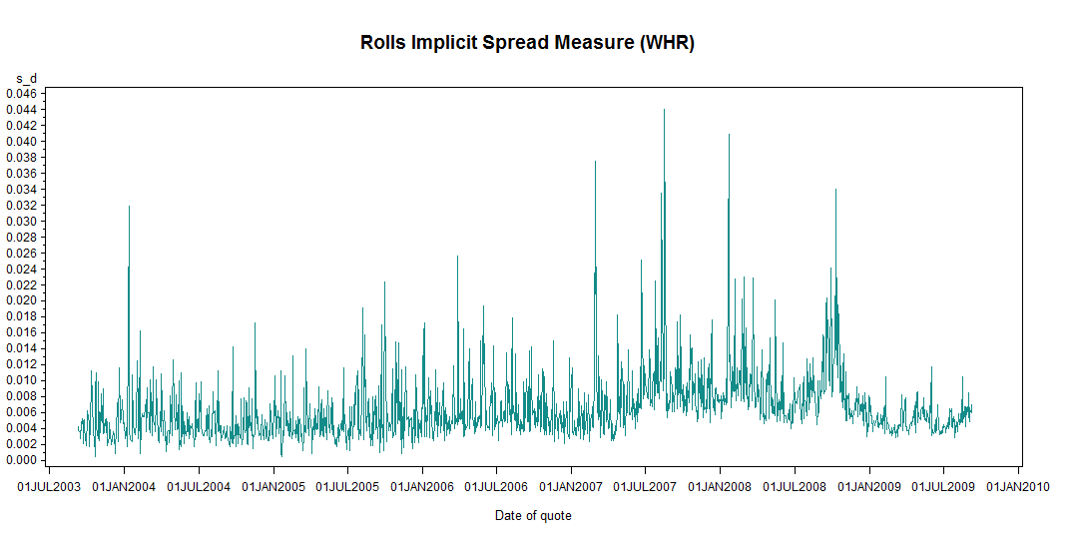

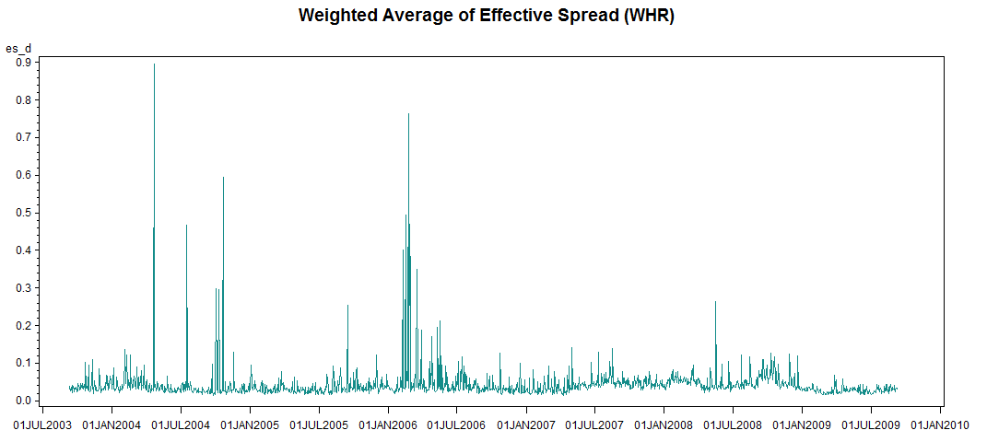

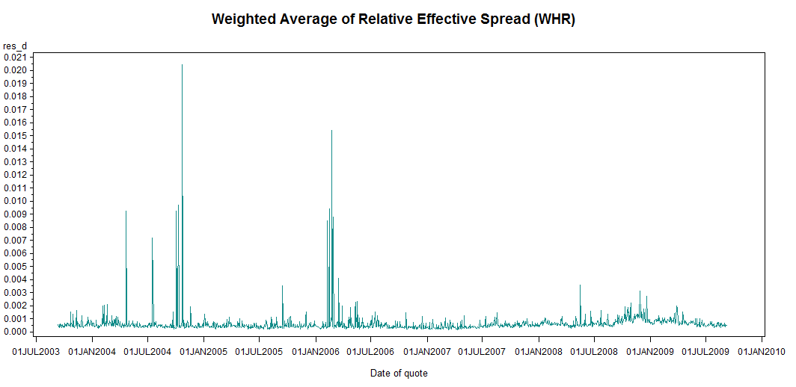

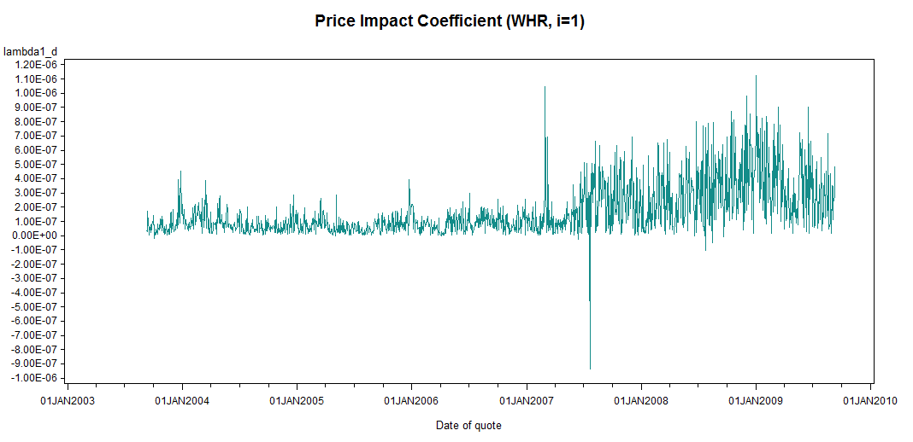

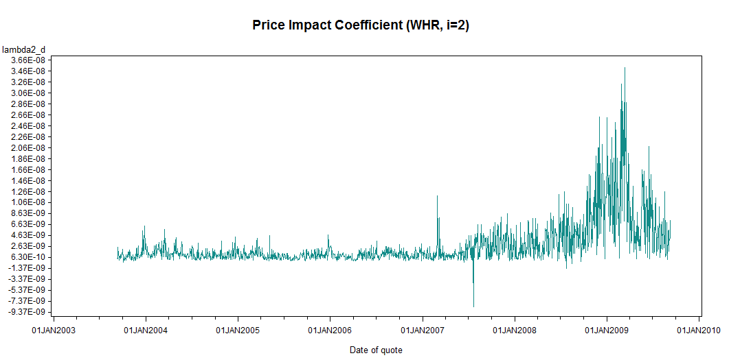

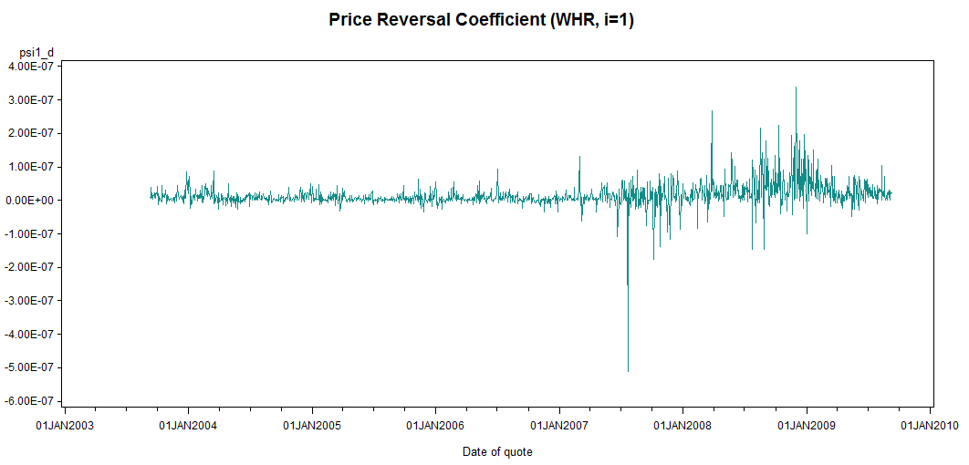

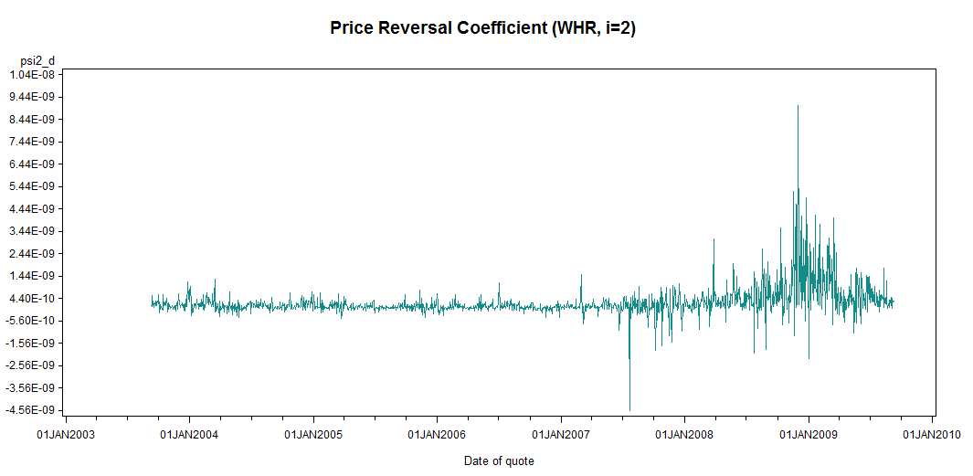

**MOT**

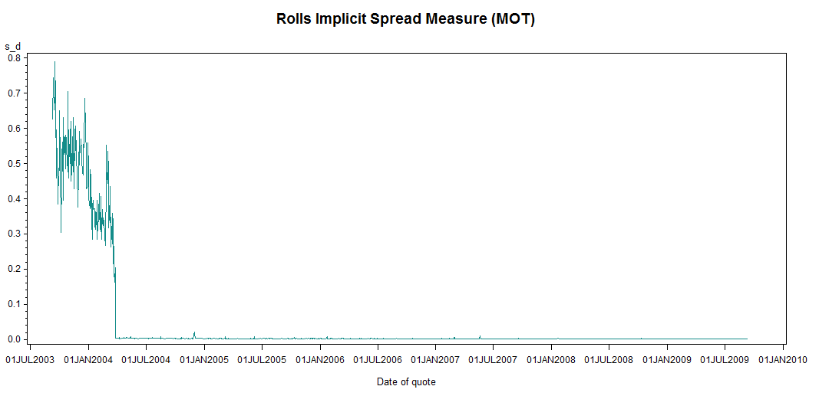

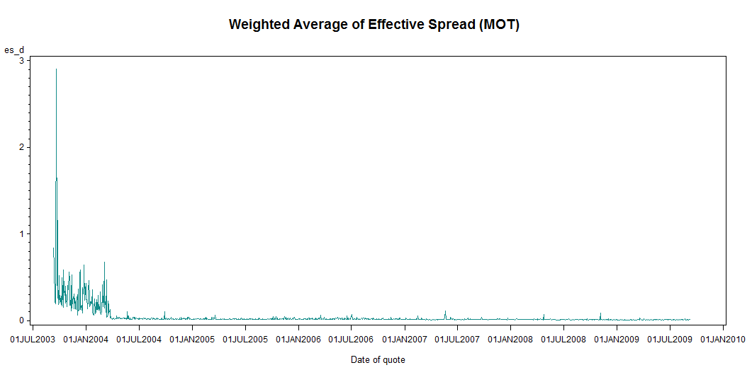

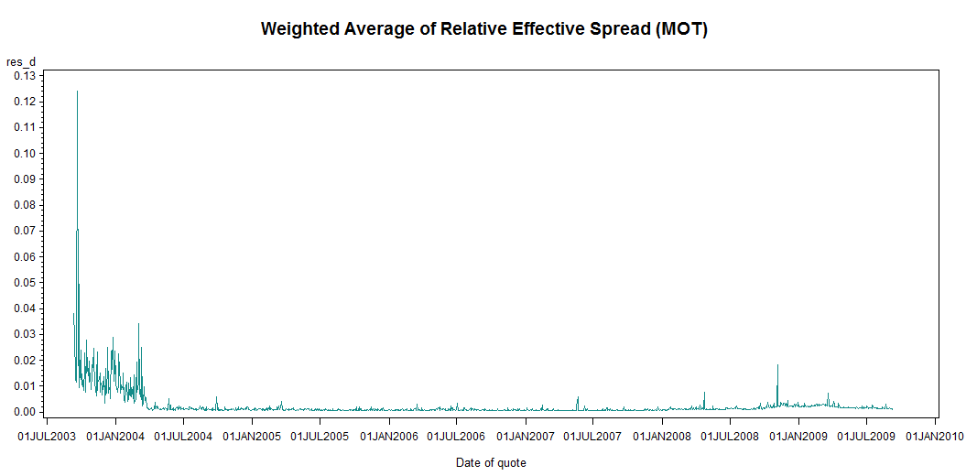

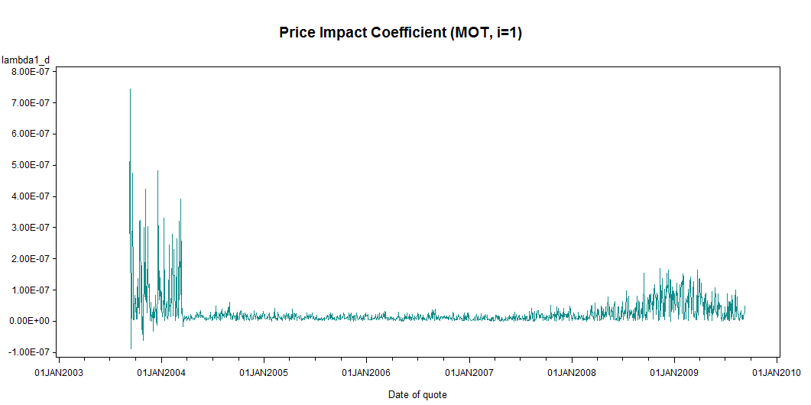

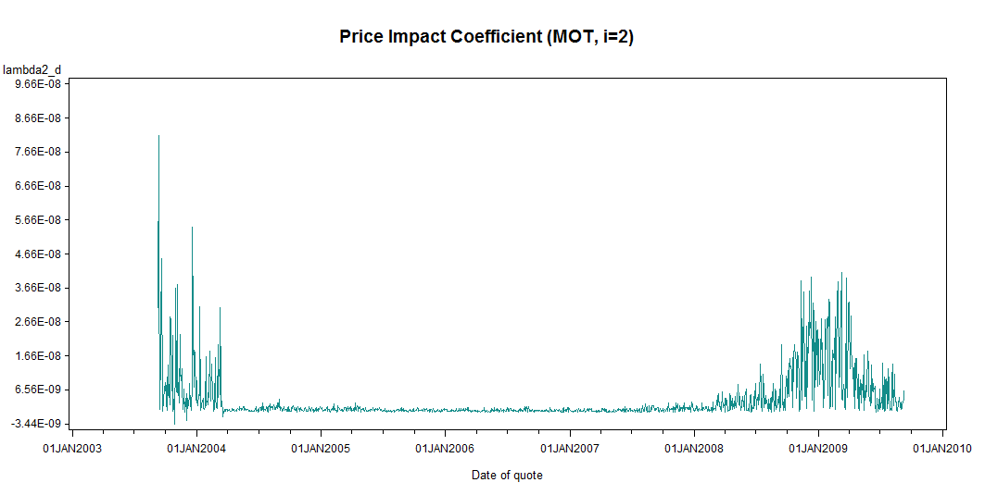

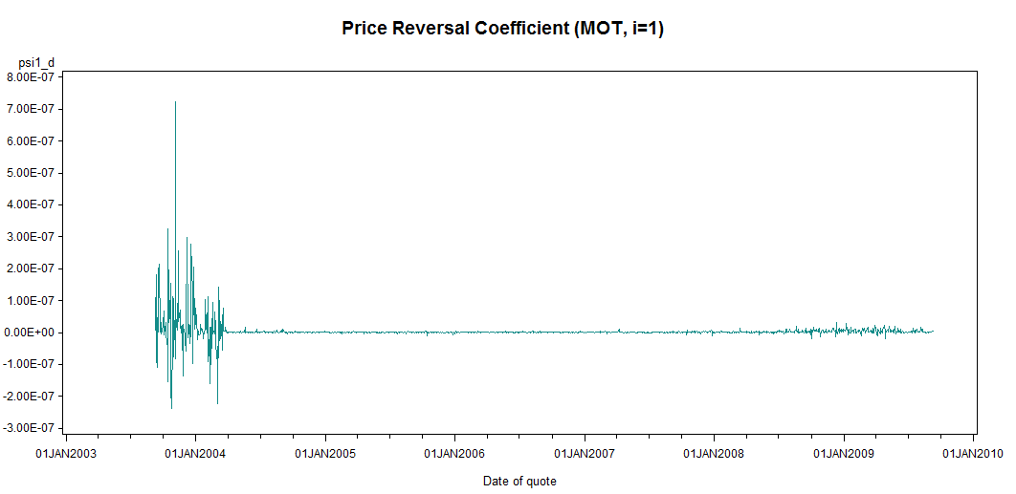

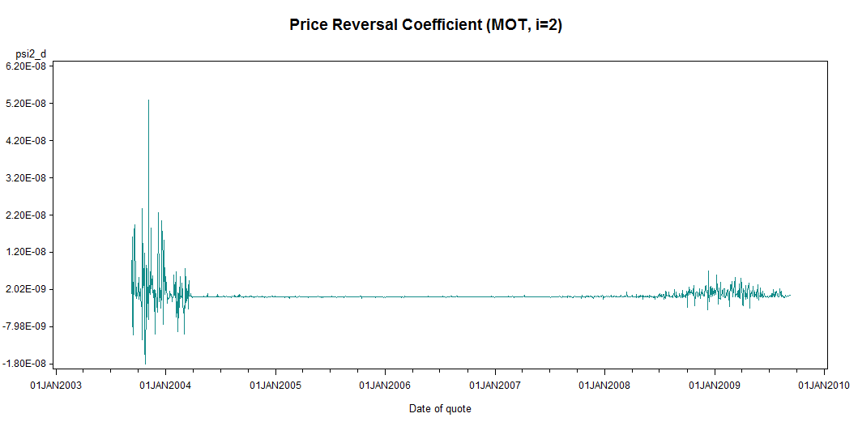

**AMAT**

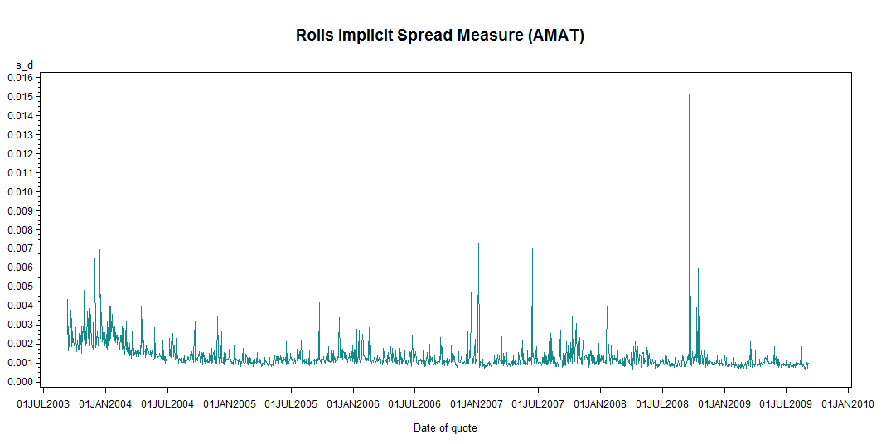

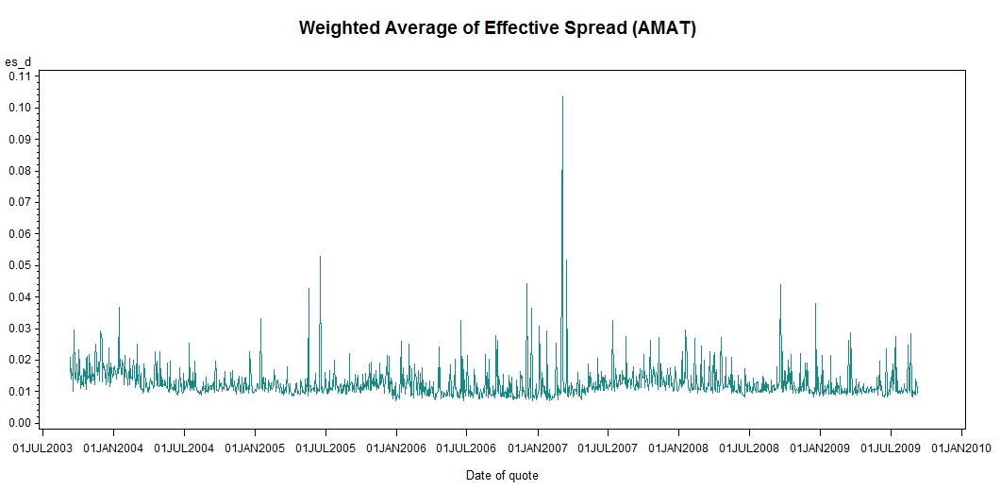

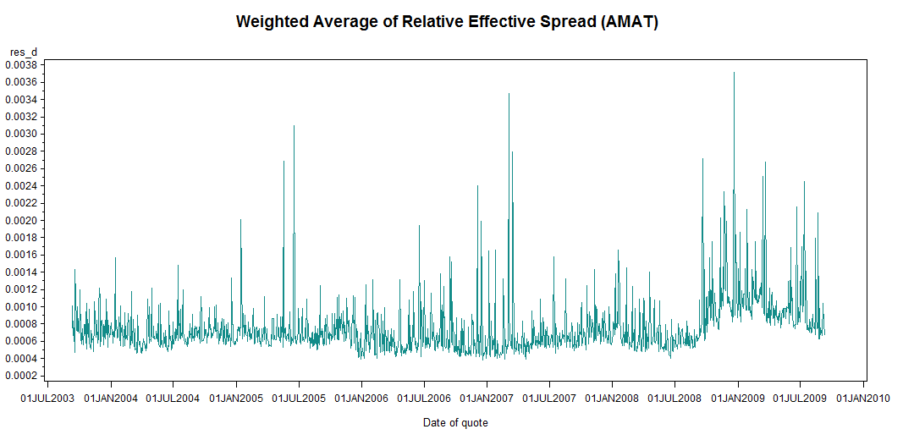

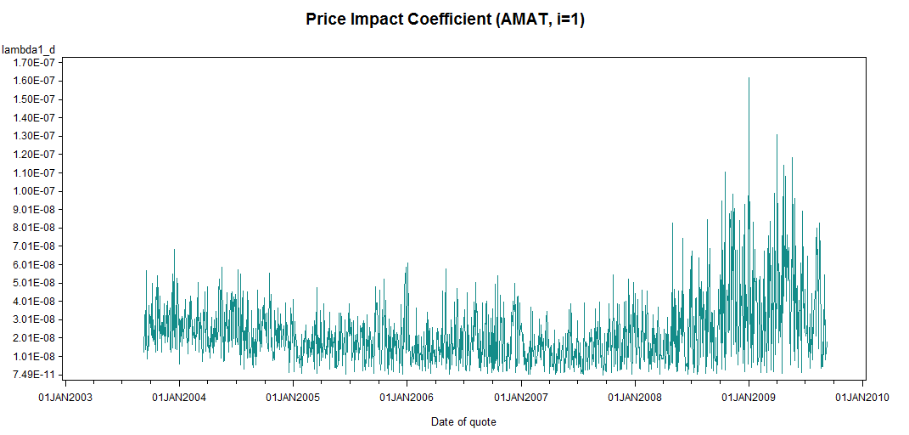

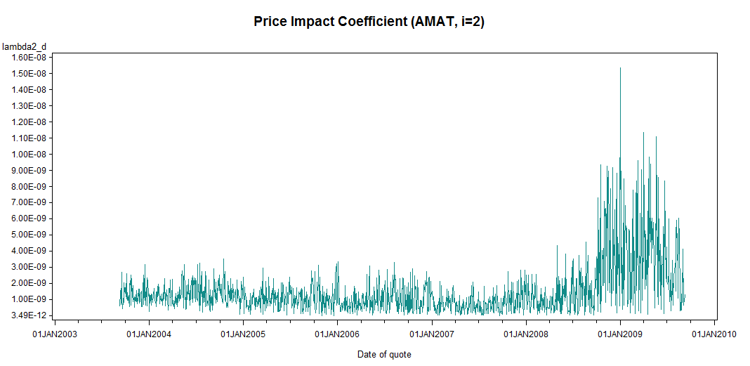

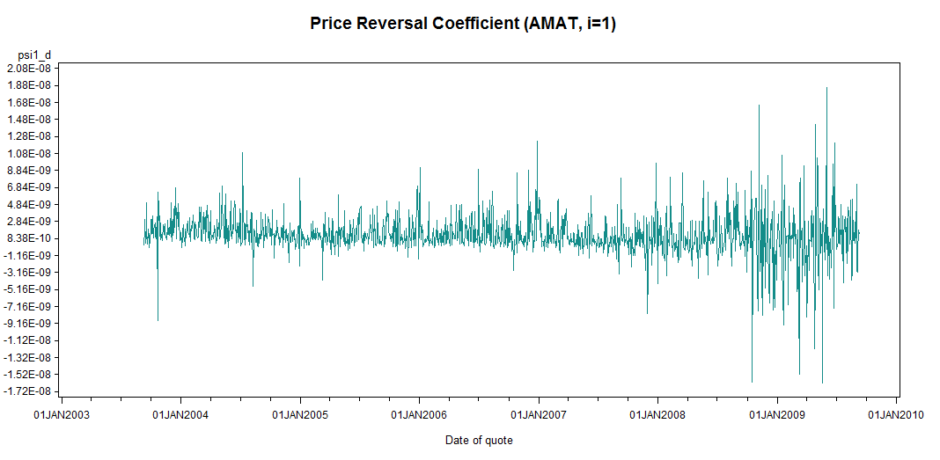

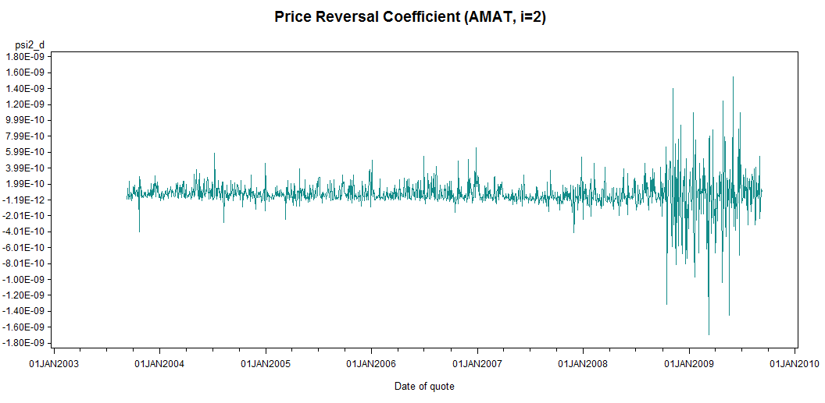

**QCOM**

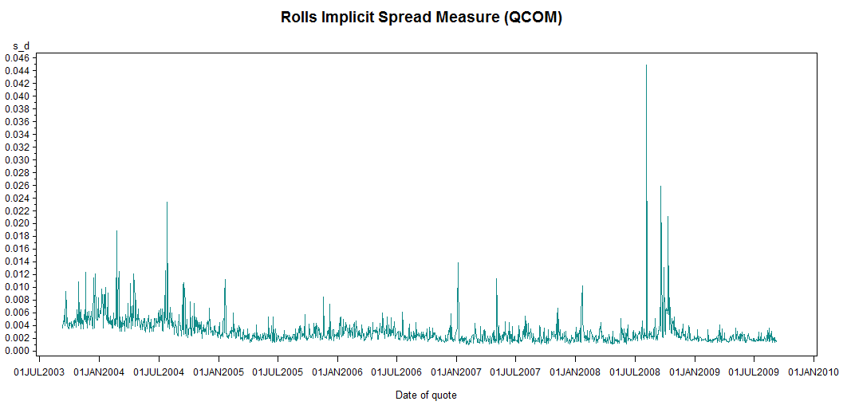

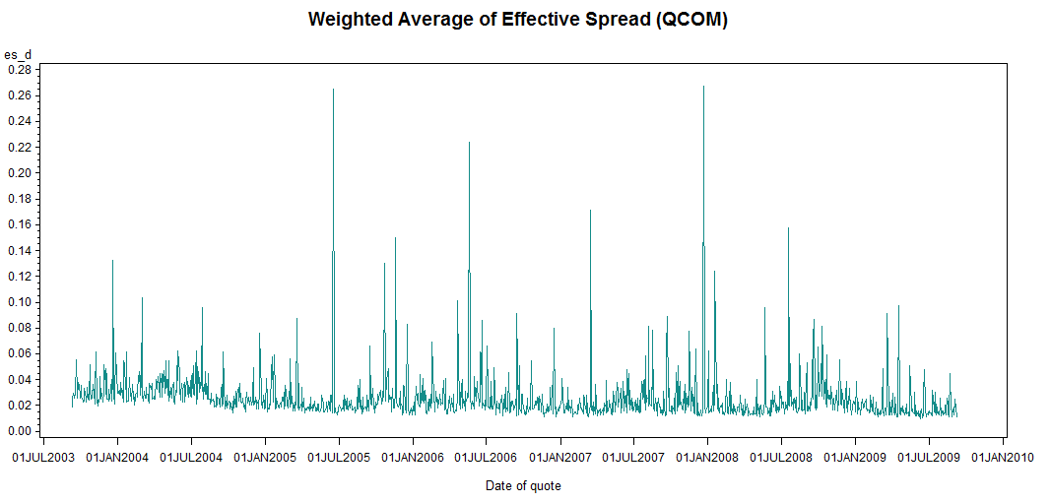

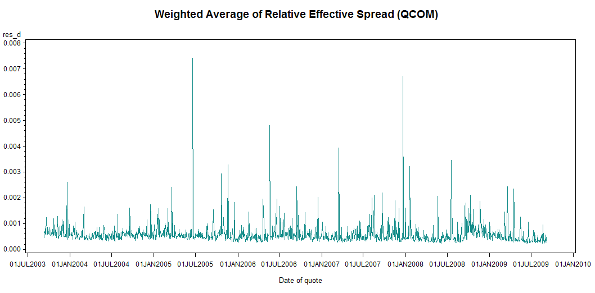

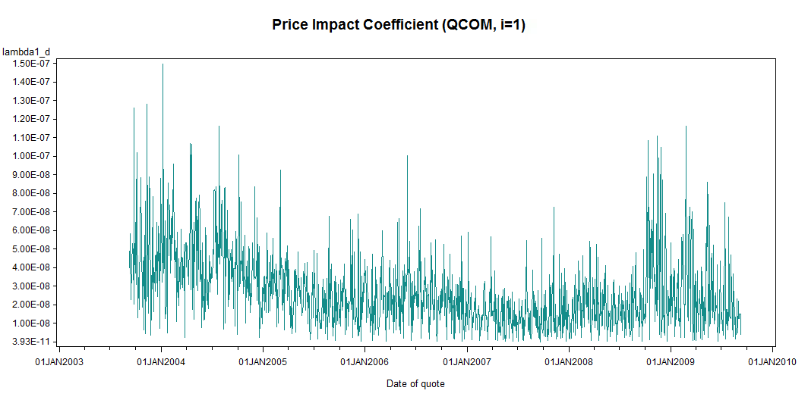

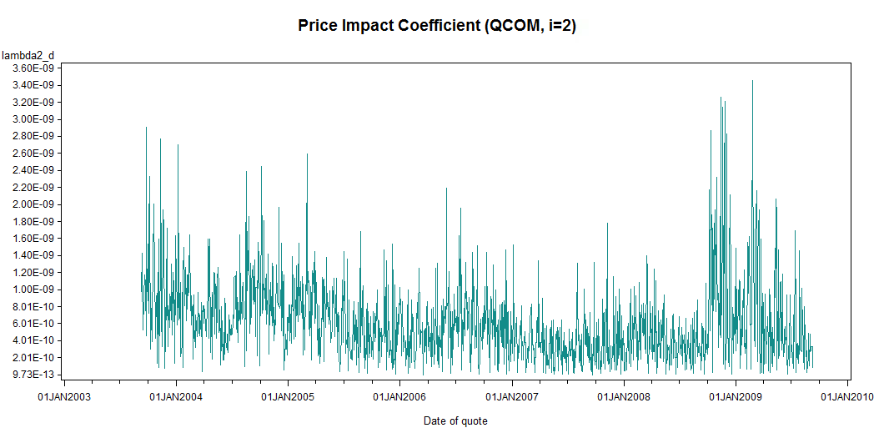

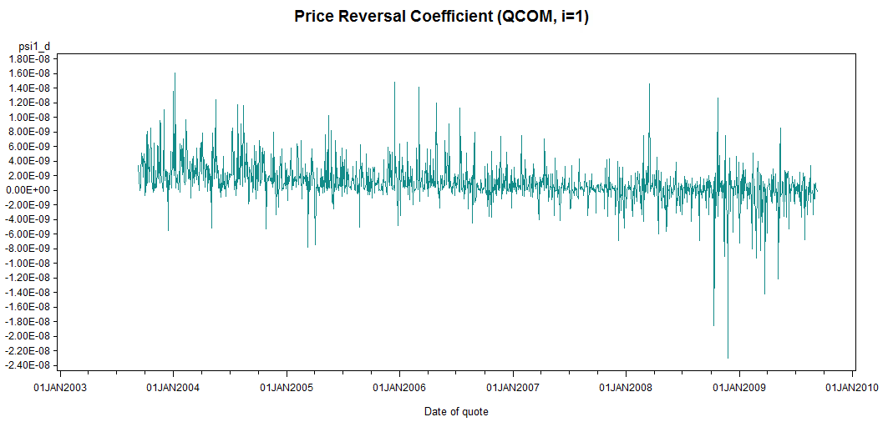

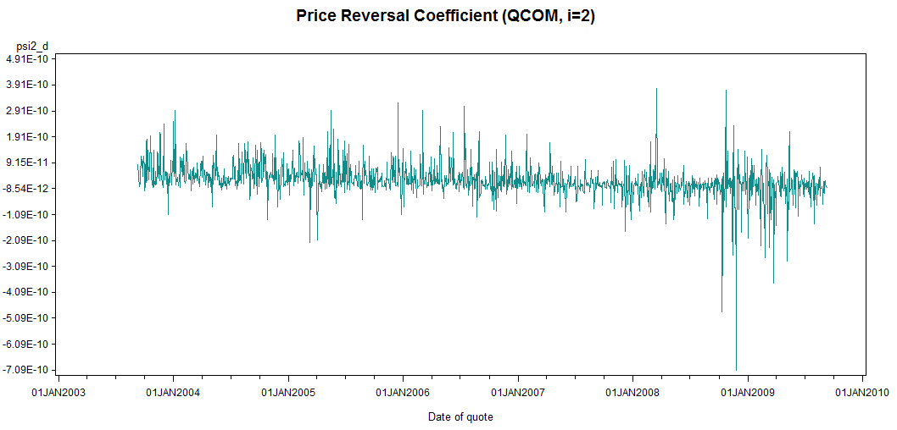

## Question 2

1. Provide correlation table for variables

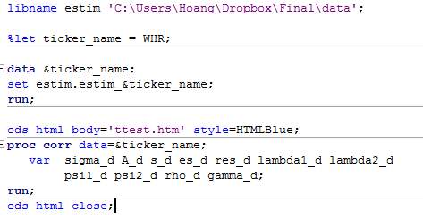

1. Fit four regressions separately for each stock
2. Run regressions for each stock

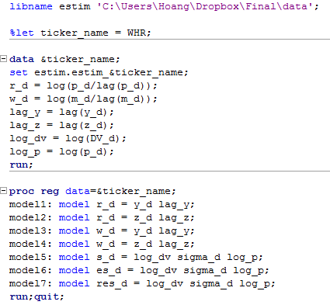

Result:

**WHR**

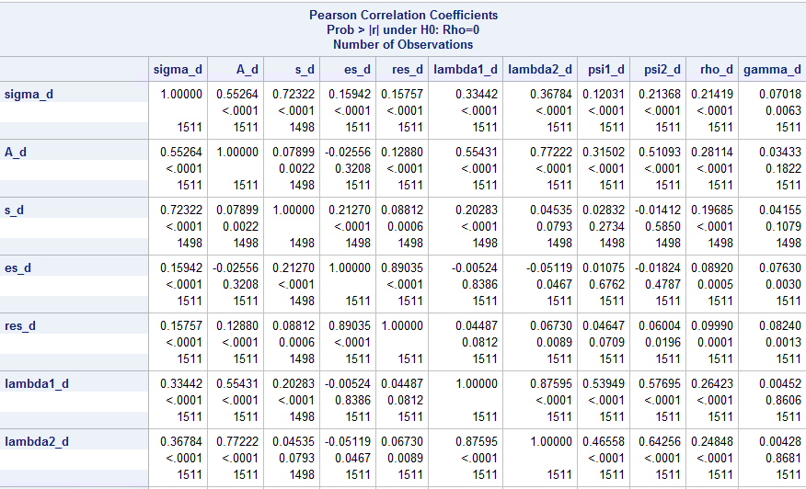

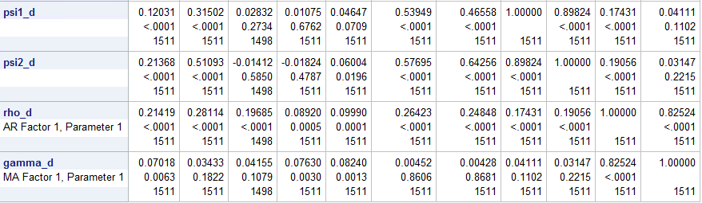

1. **Regression**

|  |  |
| --- | --- |
| **Model 1** | **Model 2** |
|  |  |
| **Model 3** | **Model 4** |
|  |  |

1. **Regression**

|  |  |
| --- | --- |
| **Model 5** | **Model 6** |
|  |  |
| **Model 7** |  |
|  |  |

**MOT**

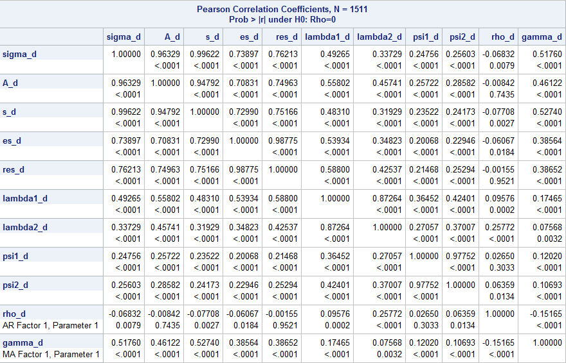

|  |  |
| --- | --- |
| **Model 1** | **Model 2** |
|  |  |
| **Model 3** | **Model 4** |
|  |  |

|  |  |
| --- | --- |
| **Model 5** | **Model 6** |
|  |  |
| **Model 7** |  |
|  |  |

**AMAT**

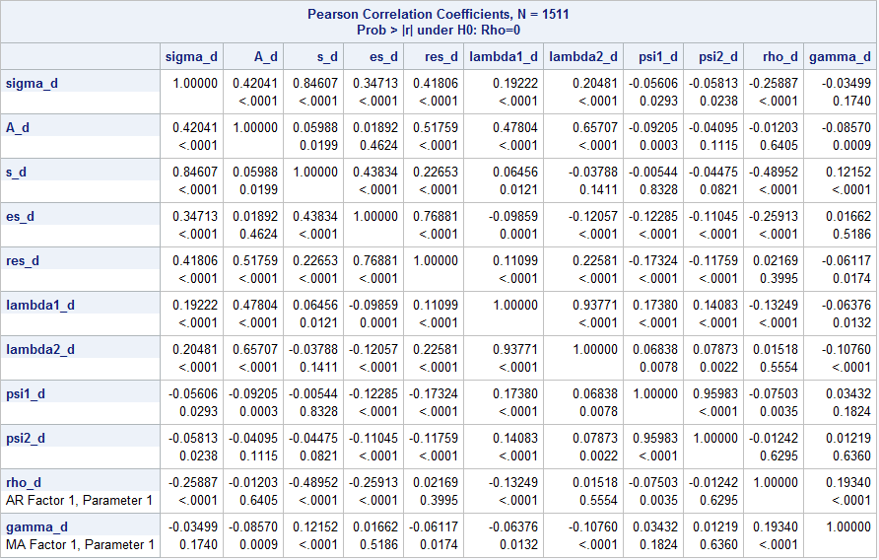

|  |  |
| --- | --- |
| **Model 1** | **Model 2** |
|  |  |
| **Model 3** | **Model 4** |
|  |  |

|  |  |
| --- | --- |
| **Model 5** | **Model 6** |
|  |  |
| **Model 7** |  |
|  |  |

**QCOM**

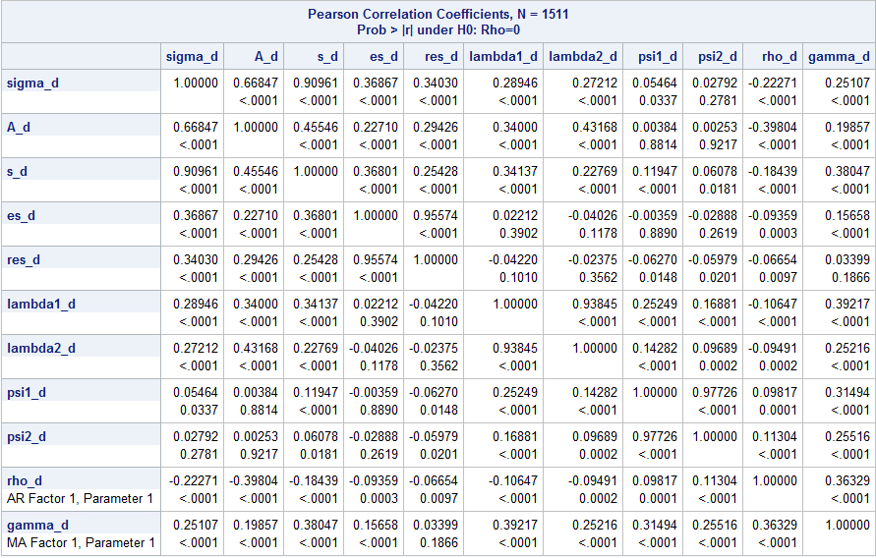

|  |  |
| --- | --- |
| **Model 1** | **Model 2** |
|  |  |
| **Model 3** | **Model 4** |
|  |  |

|  |  |
| --- | --- |
| **Model 5** | **Model 6** |
|  |  |
| **Model 7** |  |
|  |  |