**Nguyen Van Quoc Khanh**

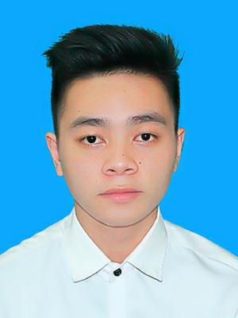

Position: PHP Developer

**Date of birth:** September 02, 1997

**Gender:** Male

**Phone:** **0961574484**

**Email:** [quockhanhnv0209@gmail.com](mailto:quockhanhnv0209@gmail.com)

**Address:** Hanoi, Viet Nam

**Facebook:** http://fb.com/quockhanh02091997

**OBJECTIVE**



- Take advantages of programing skills and experience and understanding of IT to become a professional developer and bring a lot value to Customers. From that, I will contribute to development of VNPT Company

**EDUCATION**



|  |  |
| --- | --- |
| Jun 2016 – Jun 2020 | **- Student at Ha Noi University of industry** |
|  | - Major: Software Engineering |
|  | - GPA: 2.76/4 |
|  |  |
|  |  |

**SKILLS**



|  |  |
| --- | --- |
| **Major** | - Git, HTML, CSS, Javascript, MySQL, PHP, Restful API |
|  | MVC, OOP, Laravel Framework, Docker, sketchy Angular 5 |
|  |  |
|  |  |
| **Pulsant Project** | - Upload File, CRUD, Unit test, Build Repository Patter, Custom Validation |
|  |  |
| **Hi5 Education** | - Docker compose, User Permissions, Manage Courses, Unit test |
|  |  |
| **Isus Online Delivery** | - Upload images, CRUD, Config Multiple Connection, JWT for login |
| **Soft Skills** | - Teamwork |
|  | - Sense of responsibility |
|  | - Enthusiasm |
|  |  |
|  |  |

**My Product**



Project <http://education.animals.vn/>:

<https://github.com/quockhanhnv/lamsao>

<https://github.com/quockhanhnv/library>

**Activity**



Aug 2016 – Sep 2020

* Volunteer
* Football championship HAUI
* English club .

