Define a base class shape that can describe any simple shape, such as a square, circle, or equilateral triangle. The size of all these shapes can be reduced to a single dimension.
Define derived classes for each of the three shapes.
Create a virtual function in the base class that returns the area of each shape.
Note that you will need to more precisely define what dimensions are stored in the base class. (Is the size in the base class for circle the radius of the circle or the diameter?)

: Write a base class called pet that describes any common household pet. Define two derived classes called fish and dog with items specific to that type of animal. Write pure virtual functions in the base class for operations that are common to both types of animals yet are handled in different ways by each of them.
Exercise 3:
Write a base class number that holds a single integer value and contains one member function, print_it. Define three derived classes to print the value in hex, octal, and decimal.
Exercise 4:
Create a doubly linked list in C++ programming language by using Object-Oriented Programming(OOP) concept.
The doubly linked list is much similar to the singly linked list, except that in the doubly linked list, we add a previous link to the element of the list. By doing this the list can be traversed forward and backward.
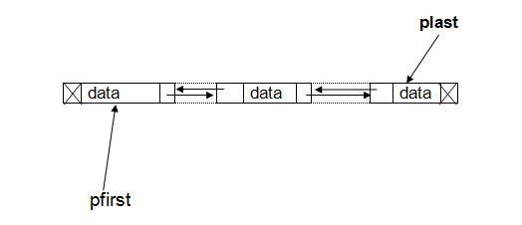
In this solution to the exercise, we are going to build a doubly linkedlist that has two pointers--one(pfirst) points to the first item of the list and another one(plast) point to the last item of the list. The program also provides a menu of choices that a user can use do some operations on the linkedlist.
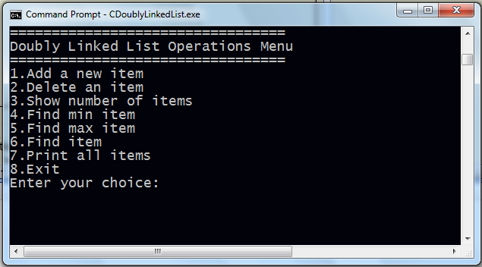
To keep the solution simple, we divide it in to different steps as you see their links on the right menu.
Exercise 5
We want to implement in C++ stacks and queues as linked lists, using templates and inheritance.

Define a class element with the following fields:
a field info of parametric type T (the information contained in the element)
a field next of type pointer to element (the next element in the list)
Define a template class stack_or_queue parametric on T, containing element as an internally declared class, and
a method pop which removes the first element of the list and returns its information
a method is_empty which returns true or false depending on whether the list is empty or not
Define a template class stack (parametric on T) as subclass of stack_or_queue, with an additional method push which adds a new element as first element of the list.
Define a template class queue (parametric on T) as subclass of stack_or_queue, with an additional method insert which adds a new element as last element of the list.

Defining appropriate constructor and destructor methods is part of the exercise. All the methods, except the destructors, should be executed in constant time (i.e. no scanning of the list should be required). You can of course use additional (private) fields and methods if you find them useful. Take care of protecting the implementation correctly.

