PROJECT REPORT
Java Web Application Development
Project Name | GrillHouse – Online BBQ Food Ordering System
Student Name | Nguyễn Huy Hoàng
RollNo | HE200144
Technology | Java Servlet, JSP/JSTL, SQL Server, Tomcat
Architecture | MVC2 Pattern
Payment | VNPay Payment Gateway Integration
AI Feature | Google Gemini AI Chatbot
Academic Year | 2025 – 2026

1. Case Study

1.1 System Description
GrillHouse is a full-stack Java Web application designed to provide an online ordering platform for a BBQ restaurant specializing in Vietnamese grilled dishes such as grilled duck, grilled pork ribs, and fresh seafood. The system allows customers to browse the menu, add items to a shopping cart, place orders, and pay online through the VNPay payment gateway. Restaurant administrators can manage the menu, process orders, and monitor business performance through a dedicated admin dashboard. The system also integrates an AI-powered chatbot using the Google Gemini API to assist customers with menu recommendations and order inquiries in real-time.

1.2 Business Rules
- Customers must register and log in before placing an order. Google OAuth2 login is also supported.
- Orders with a total amount of 500,000 VND or more automatically receive a 10% discount.
- Free shipping is applied to all orders regardless of total amount.
- Products marked as out-of-stock (Stock = 0) cannot be added to the shopping cart.
- Each order goes through the following status cycle: Pending → Confirmed → Shipping → Completed → Cancelled.
- Only administrators (isAdmin = 1) can access the /admin/* routes, enforced by AdminFilter.
- Soft delete is applied to products: instead of permanently removing a record, IsActive is set to 0 to preserve order history integrity.
- VNPay payment verification uses HMAC-SHA512 signature validation to ensure transaction security.
- Passwords are hashed using SHA-256 before being stored in the database.
- The AI chatbot is provided with real-time domain knowledge (menu, prices, policies) from the database on each request.

1.3 System Scope
The system covers three main functional areas: (1) Customer-facing features including product browsing, cart management, checkout, and order tracking; (2) Admin features including product CRUD operations, order management, and dashboard analytics; and (3) Integration features including VNPay payment gateway, Google OAuth2 authentication, and Gemini AI chatbot support.

2. Database Design

2.1 Logical Design
The database consists of 6 core entities with the following relationships:
- Account (1) --- (N) Order: One customer can place many orders.
- Category (1) --- (N) Product: One category contains many products.
- Order (1) --- (N) OrderDetail: One order contains many order line items.
- Product (1) --- (N) OrderDetail: One product can appear in many order line items.
- Account (1) --- (N) Review: One customer can review many products.
- Product (1) --- (N) Review: One product can have many reviews from different customers.

2.2 Physical Design
Database: FoodStoreDB on Microsoft SQL Server 2019+

Table: Account
Column Name | Data Type | Constraint | Description
AccountID | INT IDENTITY | PRIMARY KEY | Auto-increment unique identifier
FullName | NVARCHAR(100) | NOT NULL | Customer full name
Email | VARCHAR(100) | NOT NULL UNIQUE | Login email address
Phone | VARCHAR(15) | NULL | Contact phone number
Password | VARCHAR(255) | NOT NULL | SHA-256 hashed password
Address | NVARCHAR(255) | NULL | Default delivery address
Avatar | VARCHAR(255) | NULL | Profile picture URL
IsAdmin | BIT | DEFAULT 0 | 1 = Administrator, 0 = Customer
IsActive | BIT | DEFAULT 1 | Account active status
CreatedAt | DATETIME | DEFAULT GETDATE() | Registration timestamp

Table: Category
Column Name | Data Type | Constraint | Description
CategoryID | INT IDENTITY | PRIMARY KEY | Auto-increment identifier
CategoryName | NVARCHAR(100) | NOT NULL | Category display name
Description | NVARCHAR(255) | NULL | Short description
ImageURL | VARCHAR(255) | NULL | Category banner image
IsActive | BIT | DEFAULT 1 | Visibility flag
SortOrder | INT | DEFAULT 0 | Display order on menu

Table: Product
Column Name | Data Type | Constraint | Description
ProductID | INT IDENTITY | PRIMARY KEY | Auto-increment identifier
CategoryID | INT | FK → Category | Parent category reference
ProductName | NVARCHAR(150) | NOT NULL | Dish name
Description | NVARCHAR(MAX) | NULL | Detailed description
Price | DECIMAL(10,2) | NOT NULL | Regular selling price (VND)
SalePrice | DECIMAL(10,2) | NULL | Promotional price, NULL if no promo
ImageURL | VARCHAR(255) | NULL | Product photo URL
Stock | INT | DEFAULT 0 | Available quantity in portions
IsFeatured | BIT | DEFAULT 0 | Show on homepage highlight section
IsActive | BIT | DEFAULT 1 | Soft delete flag
CreatedAt | DATETIME | DEFAULT GETDATE() | Creation timestamp

Table: Order
Column Name | Data Type | Constraint | Description
OrderID | INT IDENTITY | PRIMARY KEY | Auto-increment identifier
AccountID | INT | FK → Account | Ordering customer reference
OrderDate | DATETIME | DEFAULT GETDATE() | Order placement timestamp
TotalAmount | DECIMAL(10,2) | NOT NULL | Sum of all items before discount
DiscountAmount | DECIMAL(10,2) | DEFAULT 0 | Discount applied (10% if >= 500K)
FinalAmount | DECIMAL(10,2) | COMPUTED | TotalAmount - DiscountAmount (persisted)
ShipAddress | NVARCHAR(255) | NOT NULL | Delivery destination
Phone | VARCHAR(15) | NOT NULL | Recipient contact number
Note | NVARCHAR(500) | NULL | Special instructions
Status | TINYINT | DEFAULT 0 | 0=Pending 1=Confirmed 2=Shipping 3=Done 4=Cancelled
PaymentMethod | NVARCHAR(50) | DEFAULT 'COD' | COD / VNPay / MoMo
IsPaid | BIT | DEFAULT 0 | Payment confirmed flag

Table: OrderDetail
Column Name | Data Type | Constraint | Description
OrderDetailID | INT IDENTITY | PRIMARY KEY | Auto-increment identifier
OrderID | INT | FK → Order | Parent order reference
ProductID | INT | FK → Product | Ordered product reference
Quantity | INT | NOT NULL > 0 | Number of portions ordered
UnitPrice | DECIMAL(10,2) | NOT NULL | Price at time of purchase (snapshot)
Subtotal | DECIMAL(10,2) | COMPUTED | Quantity × UnitPrice (persisted)

Table: Review
Column Name | Data Type | Constraint | Description
ReviewID | INT IDENTITY | PRIMARY KEY | Auto-increment identifier
ProductID | INT | FK → Product | Reviewed product
AccountID | INT | FK → Account | Reviewer account
Rating | TINYINT | 1-5 CHECK | Star rating 1 to 5
Comment | NVARCHAR(500) | NULL | Optional review text
ReviewDate | DATETIME | DEFAULT GETDATE() | Review submission timestamp

Note: A UNIQUE constraint on (ProductID, AccountID) in the Review table ensures each customer can only review a product once.

3. System Design

3.1 MVC2 Architecture
The application follows the Model-View-Controller 2 (MVC2) pattern, also known as the Front Controller pattern. This separates the application into three distinct layers:
- Model Layer: Plain Java classes (POJOs) in the model package representing database entities: Account, Product, Category, Order, OrderDetail, Cart, and Voucher. These classes contain private fields with getter/setter methods.
- View Layer: JavaServer Pages (JSP) files with JSTL tags for dynamic HTML rendering. JSP files receive data through HttpServletRequest attributes set by Controllers and never directly access the database.
- Controller Layer: Java Servlets in the controller package handle all HTTP requests, apply business logic, call DAO methods, set request/session attributes, and forward/redirect to the appropriate View.
- Data Access Layer (DAL): DAO classes (ProductDAO, AccountDAO, OrderDAO, CategoryDAO) extend DBContext and encapsulate all SQL queries using PreparedStatement for security and performance.

3.2 Project Package Structure
Package / Location | Contents & Responsibility
src/controller/ | Servlets: HomeServlet, LoginServlet, RegisterServlet, CartServlet, CheckoutServlet, VNPayServlet, VNPayReturnServlet, GeminiServlet, OrderHistoryServlet
src/controller/admin/ | Admin Servlets: AdminHomeServlet, AdminProductServlet, AdminOrderServlet + AdminFilter
src/dal/ | DBContext, ProductDAO, AccountDAO, CategoryDAO, OrderDAO, PasswordUtil
src/model/ | POJO entities: Account, Product, Category, Order, OrderDetail, Cart, Voucher
src/util/ | VNPayConfig (payment gateway configuration)
web/views/customer/ | JSP files: home, login, register, cart, checkout, order-history, product-detail, payment-failed
web/views/admin/ | JSP files: dashboard, product-list, product-form, order-list
web/views/common/ | Shared JSP includes: header (with AI chatbot widget)
web/WEB-INF/ | web.xml (servlet mappings, filters), lib/ (JDBC driver JAR)
web/ | index.html (landing page)

3.3 Key Design Decisions
Session Management
The Cart object is stored in HttpSession as a serializable Java object. This allows the cart to persist across multiple page requests without database writes, improving performance. The session also stores the authenticated Account object, which is checked by AdminFilter and individual servlets to enforce access control.

Transaction Management in OrderDAO
The createOrder() method uses JDBC manual transaction management (Connection.setAutoCommit(false)) to atomically insert into the Order table, insert all OrderDetail records via batch execution, and decrement Stock values for each product. If any step fails, the transaction is fully rolled back, ensuring data consistency.

Soft Delete Strategy
Products are never permanently deleted from the database. Setting IsActive = 0 hides the product from the customer-facing menu while preserving all historical OrderDetail records that reference the product. This maintains referential integrity and allows accurate order history display.

Price Snapshot in OrderDetail
The UnitPrice column in OrderDetail stores the product price at the moment of purchase, not a foreign key reference to the current price. This ensures that historical orders display the correct price even if the product price is later updated by the administrator.

3.4 New Technologies
VNPay Payment Gateway
VNPay is Vietnam's leading payment gateway supporting domestic ATM cards, Visa/Mastercard, and QR Code payments. Integration follows the VNPay API v2.1.0 specification. The key security mechanism is HMAC-SHA512 signature generation: all request parameters are sorted alphabetically, concatenated as key=value pairs, and signed using the merchant's secret key. The return callback verifies the signature to prevent tampering.

Google OAuth2 (OpenID Connect)
The Google Sign-In JavaScript library generates a JWT credential token after the user authenticates with Google. This token is sent to the server-side GoogleAuthServlet, which verifies it using the GoogleIdTokenVerifier library. Upon successful verification, the user's email, name, and profile picture are extracted from the token payload. If the email does not exist in the database, a new account is automatically created with password = 'GOOGLE_AUTH'.

Google Gemini AI API
GeminiServlet acts as a server-side proxy to the Gemini 2.0 Flash API. On each request, a dynamic system prompt is constructed by querying the live database for the current menu, categories, prices, and stock status. This domain knowledge is injected into every API call, allowing the AI to answer questions about specific dishes, availability, and pricing accurately without any pre-training on restaurant-specific data. The Java 11+ HttpClient is used for non-blocking HTTP communication with the Gemini endpoint.

Jakarta EE 10 (Servlet 6.0)
The project targets Jakarta EE 10, which migrated all APIs from the javax.* namespace to jakarta.*. This required deployment on Apache Tomcat 10.1, which implements the Jakarta EE 10 Web Profile, unlike Tomcat 9 which only supports Jakarta EE 9 / javax.* APIs.

3.5 Coding Conventions
- Package names: all lowercase (controller, dal, model, util).
- Class names: PascalCase (ProductDAO, HomeServlet, OrderDetail).
- Method names: camelCase (getAllProducts, createOrder, buildSystemPrompt).
- Constants: UPPER_SNAKE_CASE (GEMINI_API_KEY, HASH_SECRET, STATUS_PENDING).
- JSP files: kebab-case (home.jsp, product-detail.jsp, order-history.jsp).
- All SQL queries use PreparedStatement — never string concatenation — to prevent SQL injection.
- All JSP output is processed through JSTL <c:out> or HTML-escaped to prevent XSS.
- DAO classes follow the Single Responsibility Principle: each DAO manages exactly one database table.
- Every DAO method uses try-with-resources to ensure Connection, PreparedStatement, and ResultSet are always closed.

4. Screenshots & Site Map

4.1 Site Map
The following describes the complete navigation structure of the GrillHouse application:

Area | URL / Route | Access Level
Public | /GrillHouse/ (index.html) | Everyone
Public | /GrillHouse/home | Everyone
Public | /GrillHouse/home?category={id} | Everyone
Public | /GrillHouse/search?q={keyword} | Everyone
Public | /GrillHouse/product?id={id} | Everyone
Public | /GrillHouse/login | Guest only
Public | /GrillHouse/register | Guest only
Customer | /GrillHouse/cart | Logged-in users
Customer | /GrillHouse/checkout | Logged-in users
Customer | /GrillHouse/my-orders | Logged-in users
Customer | /GrillHouse/vnpay/pay | Logged-in users
Customer | /GrillHouse/vnpay/return | VNPay callback
Customer | /GrillHouse/ai/chat | All (AJAX POST)
Admin | /GrillHouse/admin/home | Admin only
Admin | /GrillHouse/admin/products | Admin only
Admin | /GrillHouse/admin/orders | Admin only

4.2 Key Screenshots
The following sections describe the key pages of the GrillHouse application.

Landing Page (index.html)
The landing page features an animated fire effect, the GrillHouse brand identity, key statistics (50+ dishes, 45-minute delivery, 4.9-star rating), a featured menu preview with real dish cards, a 3-step ordering guide, and a technology stack showcase. Call-to-action buttons direct visitors to the main ordering page.
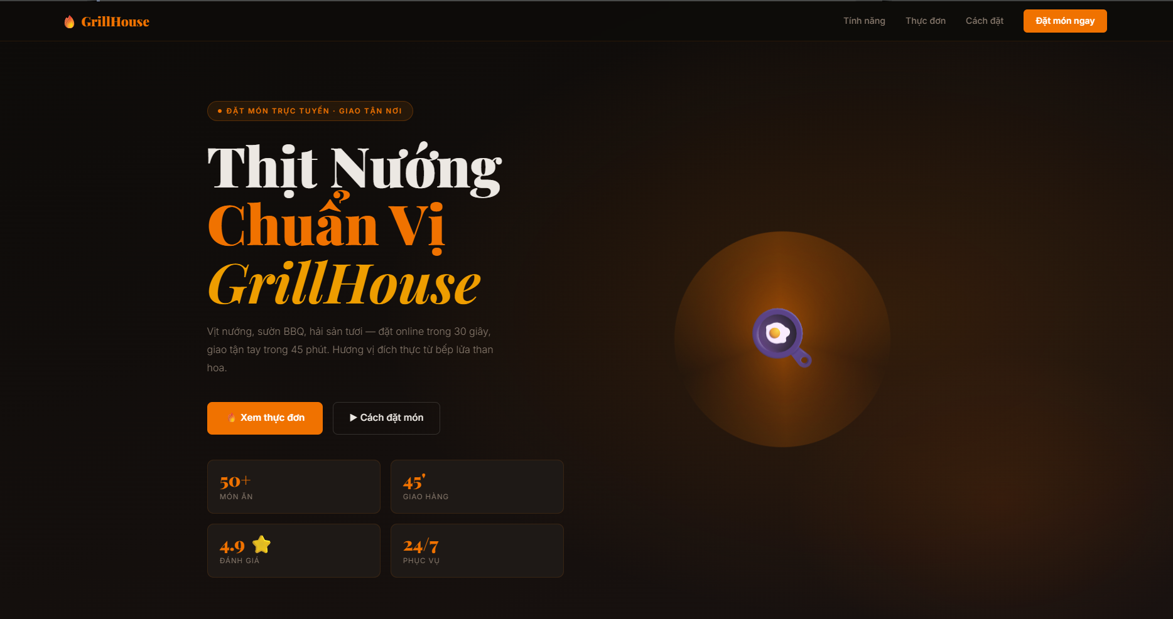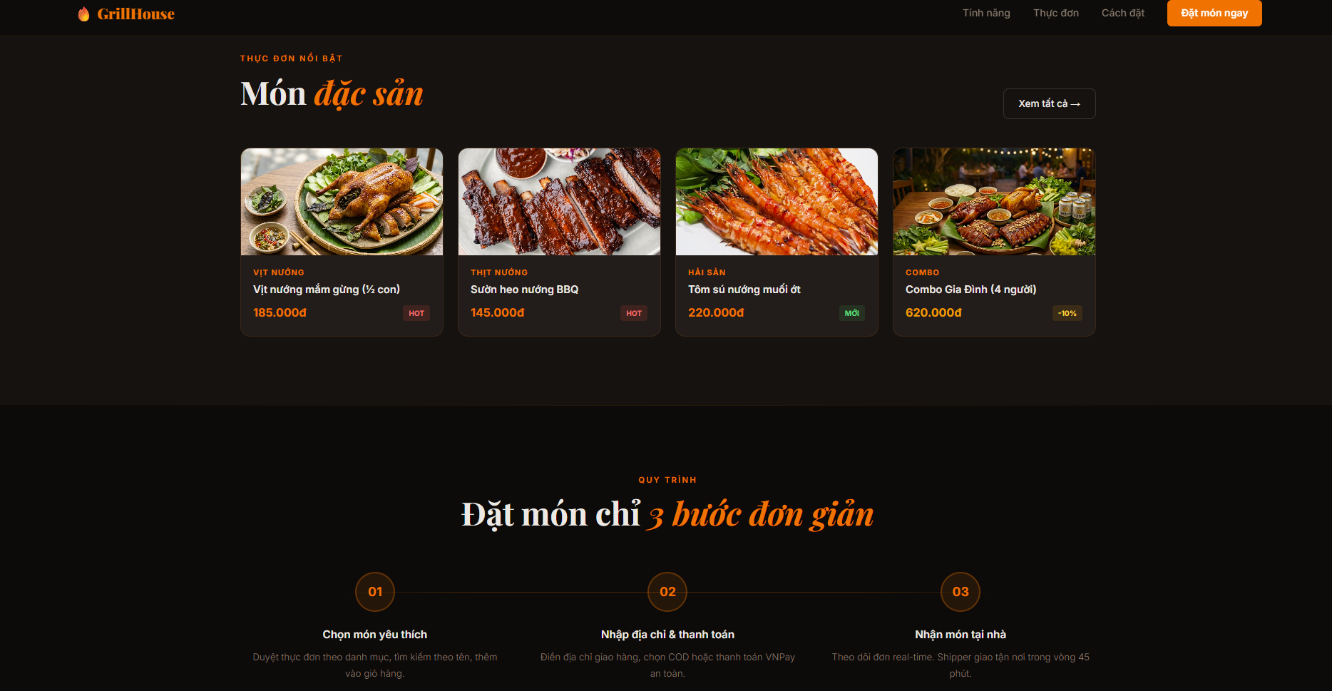

[Screenshot: Landing Page]

Home Page / Menu (home.jsp)
The home page displays the sticky navigation bar with search, cart counter, and user account dropdown. Below the hero banner, category filter tabs allow one-click filtering. Product cards show dish photo, category badge, name, price with promotional pricing, star rating, and Add to Cart / View Detail buttons. Out-of-stock items display a disabled button.

[Screenshot: Home Page with Menu]

Shopping Cart (cart.jsp)
The cart page lists all selected items with product images, names, unit prices, quantity controls (increment/decrement), subtotals per item, and remove buttons. The order summary panel calculates the running total, applies the automatic 10% discount if the threshold is met, and shows the final payable amount with a checkout button.

[Screenshot: Shopping Cart]

Checkout & VNPay Payment
The checkout page presents a two-column layout: the left column collects delivery information (recipient name, phone, address, notes) and payment method selection (COD, VNPay, MoMo); the right column shows an order summary. Selecting VNPay redirects the customer to the VNPay sandbox gateway where they enter card details and OTP for authentication.

[Screenshot: Checkout Page & VNPay Gateway]

Admin Dashboard
The admin panel uses a fixed sidebar navigation with links to Dashboard, Product Management, and Order Management. The dashboard displays summary statistics (total products, pending orders) and a recent orders table. Product management provides a full CRUD interface with image URL preview. Order management allows inline status updates via dropdown selectors.

[Screenshot: Admin Dashboard & Product Management]

AI Chatbot Widget
The GrillHouse AI chatbot appears as a floating orange button in the bottom-right corner of every page. Clicking it opens a chat window with a gradient header, message bubbles distinguishing user and AI responses, quick-reply suggestion buttons, a typing indicator animation while waiting for the AI response, and a text input field. The chatbot is powered by Google Gemini 2.0 Flash and receives real-time menu data from the database.

[Screenshot: AI Chatbot Widget]

5. Conclusion and Discussion

5.1 Achievements
The GrillHouse application successfully implements a complete e-commerce workflow for a BBQ restaurant, covering user authentication (including OAuth2), product catalog management, shopping cart, order placement, VNPay payment gateway integration, admin management tools, and an AI-powered chatbot. The following objectives were fully achieved:
- Full MVC2 architecture with clear separation between Controller, View, and DAL layers.
- Secure user authentication with SHA-256 password hashing and Google OAuth2.
- JDBC transaction management for atomic order creation ensuring data integrity.
- Real VNPay sandbox payment integration with HMAC-SHA512 signature verification.
- Dynamic AI chatbot powered by Gemini API with live database domain knowledge injection.
- Role-based access control via AdminFilter protecting all administrative routes.

5.2 Advantages
- Clear code structure: MVC2 pattern makes each component independently testable and maintainable.
- Data integrity: JDBC transactions and soft deletes preserve historical order data accurately.
- Security: PreparedStatement throughout prevents SQL injection; HMAC-SHA512 validates payment callbacks.
- User experience: Dark-themed responsive UI with smooth animations, AI assistance, and real-time cart updates.
- Scalable menu knowledge: AI chatbot automatically reflects menu changes without code modification.

5.3 Limitations
- No real-time order tracking: order status updates require manual page refresh; WebSocket push notifications were not implemented.
- No email notifications: customers do not receive confirmation emails upon successful order placement.
- No image upload: product images are managed via URL input rather than direct file upload, limiting usability for non-technical admins.
- Limited AI context: the Gemini chatbot does not maintain conversation history across messages, treating each message as an independent request.
- No payment refund flow: the system does not handle VNPay refund API calls for cancelled orders.
- Performance: the system has not been load-tested; high concurrent access may expose N+1 query issues.

5.4 Lessons Learned
- MVC2 separation significantly reduces debugging time by isolating presentation logic from business logic.
- HMAC-SHA512 signature verification is critical for payment security; even a small encoding difference causes signature mismatches.
- Jakarta EE 10 vs EE 9 compatibility issues (javax vs jakarta namespace) require careful version matching between the application and the Tomcat server version.
- Soft delete is preferable to hard delete in e-commerce systems to preserve historical data consistency.
- Injecting live data into AI prompts (Retrieval-Augmented Generation concept) dramatically improves response accuracy without model fine-tuning.

5.5 Future Improvements
- Upgrade to Spring Boot: Replace raw Servlet/JSP with Spring MVC + Thymeleaf for dependency injection, auto-configuration, and easier testing.
- Implement WebSocket for real-time order status push notifications to customer devices.
- Add Cloudinary or AWS S3 integration for direct image upload from the admin panel.
- Integrate multi-turn conversation history in the Gemini chatbot for contextual follow-up questions.
- Implement the VNPay refund API and automated email notifications using JavaMail.
- Add Redis caching for frequently accessed product lists to reduce database load.
- Build a mobile application (Flutter/React Native) consuming a REST API backed by the same business logic layer.
- Introduce an AI-powered dish recommendation engine based on customer order history and preferences.

— End of Report —

