|  |  |  |
| --- | --- | --- |
| **LAB221Assignment** | **Type:** | **LongAssignment** |
| **Code:** |  |
| **LOC:** | **200** |
| **Slot(s):** | **2** |

**Title: Items Management Software**

**Program Specifications**

**The database structure as follow:**

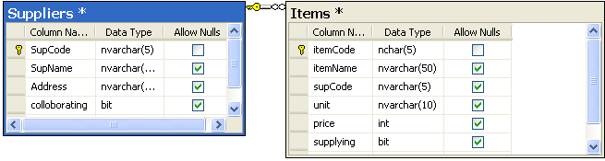

**The project structure is organized as follows:**

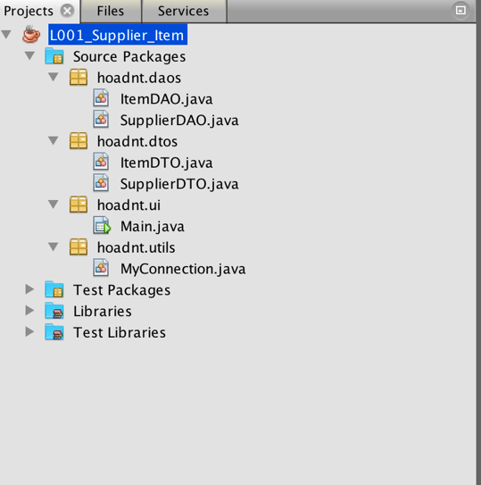

**Supplier management:**

The program has the following basic functions: 100

- When you click on the table, the supplier's details are displayed in detail. 20

- Add a new supplier 20

- Edit supplier information: edit supplier information 20

- Delete a supplier: delete the supplier only when this supplier has no items.A confirm message is displayed before the delete action. 20

- After performing the task and validate data, a notification message is displayed to the user. 20

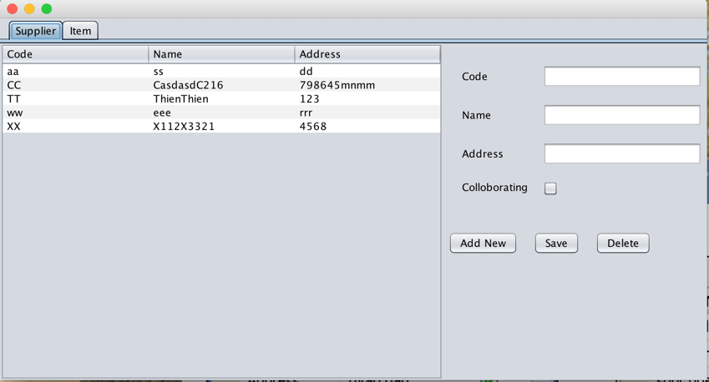

**Item management:**

The program has the following basic functions: 100

- When you click on the table, the item's details are displayed in detail. 20

- Add a new item 20

- Edit item information: edit item information 20

- Delete anitem: delete the selected item. A confirm message is displayed before the delete action. 20

- After performing the task and validate data, a notification message is displayed to the user. 20

