Test case for AW1
As an admin, I want to sign in.

ID | AW1_1
Title | Use HTTP to access to the admin website.
Pre-Conditions | The computer is connected to internet.
Notes | Test on site: http://amun.healint.com:9000/
Test Steps
# | Step | Expected Results | Snapshot
1 | Using a browser navigate to the admin website with HTTP (http://admin.healint.com) | Error message displays.

ID | AW1_2
Title | Use HTTPs to access to the admin website.
Pre-Conditions | The computer is connected to internet.
Notes | Test on site: http://amun.healint.com:9000/
Test Steps
# | Step | Expected Results | Snapshot
1 | Using a browser navigate to the admin website with HTTPs (https://admin.healint.com) | The Login page appears. | 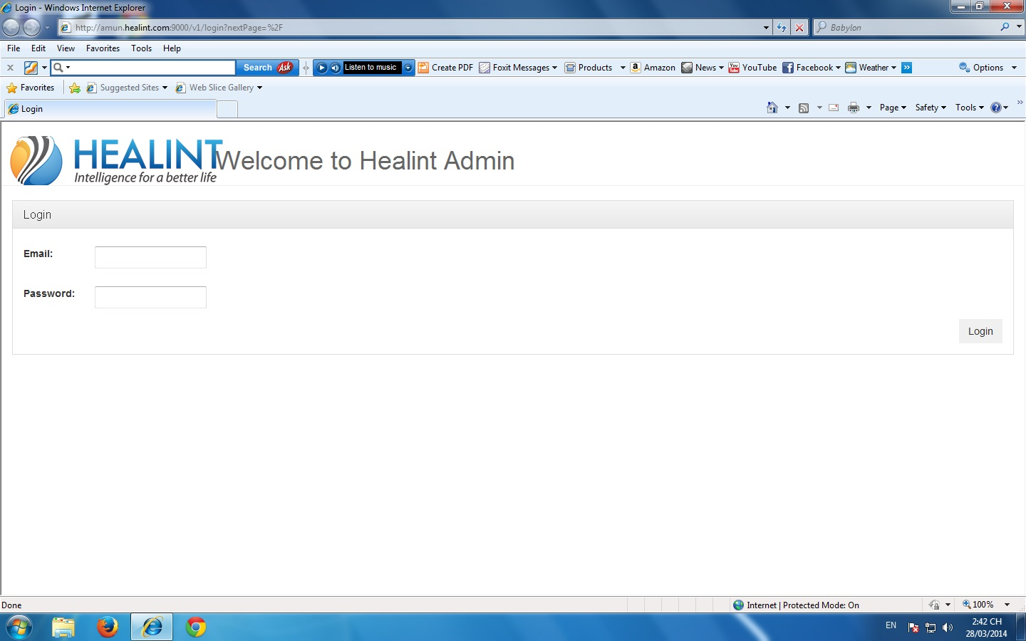

ID | AW1_3
Title | Login with incomplete data.
Pre-Conditions | The computer is connected to internet.
Notes | Test on site: http://amun.healint.com:9000/
Test Steps
# | Step | Expected Results | Snapshot
1 | Navigate to the admin websites with HTTPs. | The Login page appears.
2 | Leave the email and password field empty. | The Login page is shown again with an error message “Enter your email/password” in red and previously entered data.
3 | Enter email field and leave the password field empty. Then click Login. | The Login page is shown again with an error message “Enter your password” in red and previously entered data.
4 | Leave email field empty and enter password field. Then click Login. | The Login page is shown again with an error message “Enter your email address” in red and previously entered data.

ID | AW1_4
Title | Login with malformed data.
Pre-Conditions | The computer is connected to internet.
Notes | Test on site: http://amun.healint.com:9000/
Test Steps
# | Step | Expected Results | Snapshot
1 | Do step 1 as AW1_3 | The Login page appears.
2 | Enter malformed data in at least one field:  - Email bad format.  Then click Login. | The Login page is shown again with an error message “The email you entered is incorrect” in red and previously entered data.

ID | AW1_5
Title | Login with well formed but invalid data.
Pre-Conditions | The computer is connected to internet.
Notes | Test on site: http://amun.healint.com:9000/
Test Steps
# | Step | Expected Results | Snapshot
1 | Do step 1 as AW1_3 | The Login page appears.
2 | Enter well formed input but invalid data in at least 1 field:  1. Unregistered email.  2. Email and password don't match  3. Admin role missing.  Then click Login. | The Login page is shown again with previously entered data and an error message in red:  1. “This email hasn't yet registered. Try another?” if user entered a unregistered email.  2. “The email or password you entered is incorrect” if user entered data with email and password don't match.  3. “Login unsuccessfully. Maybe a permission issue. Please check with your Administrator ” if the entered data didn't belong to Admin user.

ID | AW1_6
Title | Login with complete and valid data.
Pre-Conditions | The computer is connected to internet.
Notes | Test on site: http://amun.healint.com:9000/
Test Steps
# | Step | Expected Results | Snapshot
1 | Do step 1 as AW1_3 | The Login page appears. | 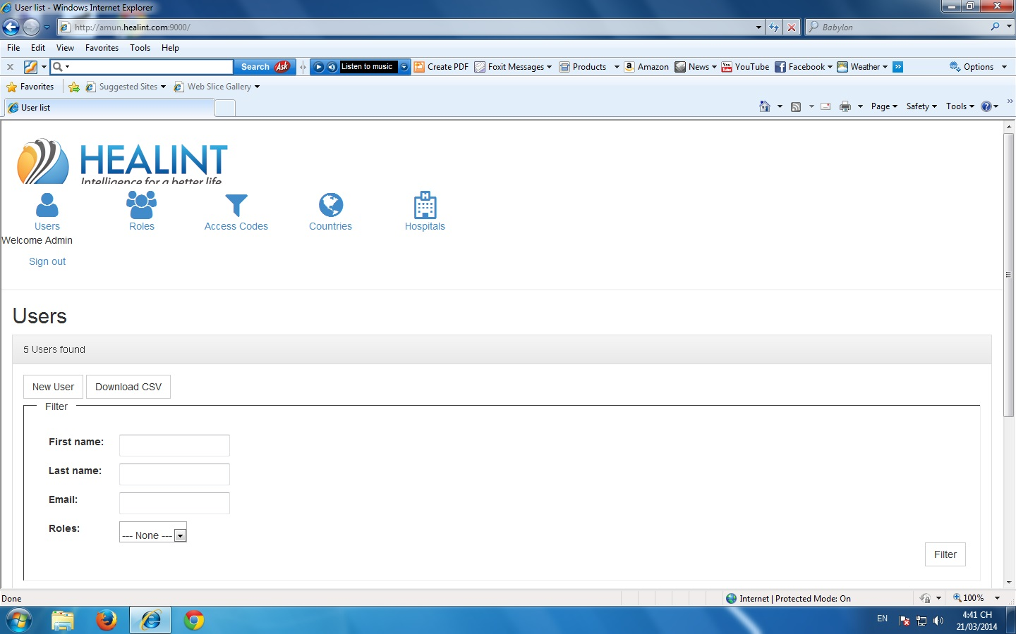  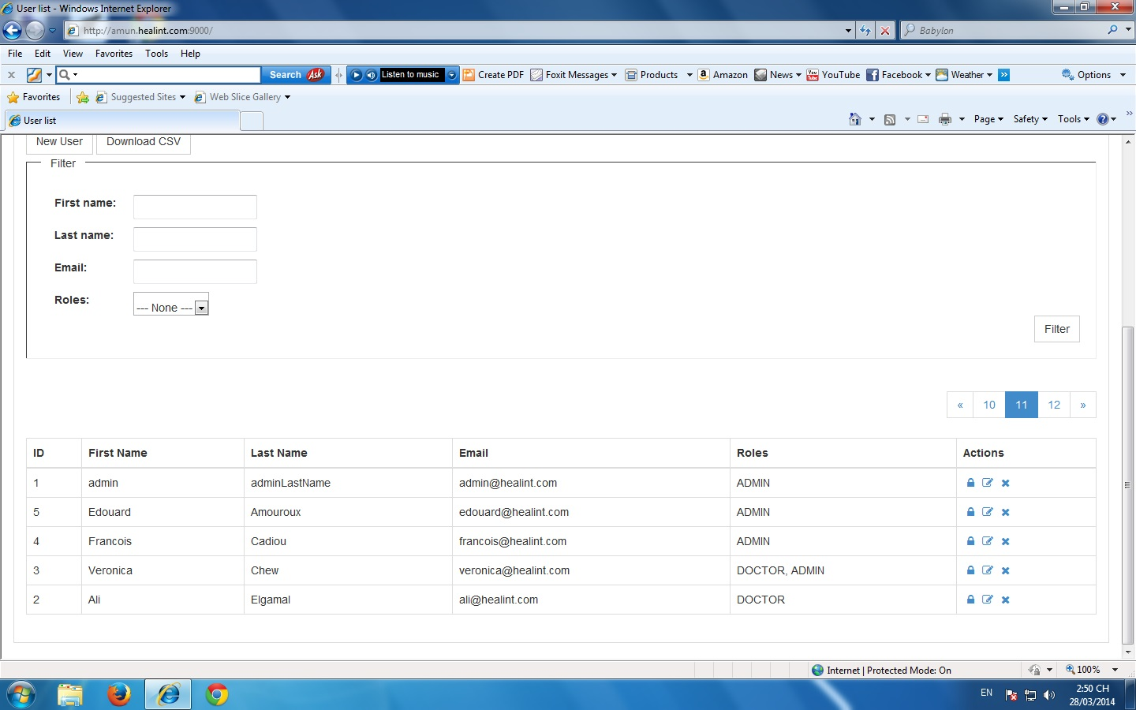
2 | Enter complete and valid data. Then click Login. | The Users page is appeared showing the list of all user. The first name of the admin user appears at the top right corner of the screen

