Technical Issue Report

ERP + AI Verification Instability (client_code + mobile)

A. System Overview
The current platform is an ERP system integrated with an AI assistant. The AI is connected directly to the production-like MySQL data source and answers user requests in real time.
The implementation flow includes data source connection, schema analysis, entity mapping, prompt template selection, and deployment as an embedded chat widget.
- Business verification flow uses two fields: client_code + registered mobile.
- After verification, the AI should allow account-scoped responses (e.g., pricing/account data access).

B. Problem Statement
The AI returns inconsistent verification outcomes. The most critical issue is that the assistant can return 'verification success' even when the corresponding record is not found in the database.
- Same user journey produces different verification outcomes across attempts.
- Verification state is unstable: sometimes retained, sometimes re-requested.
- Observed mismatch between AI verification output and SQL ground truth.

C. Detailed Verification Anomaly Analysis
1) Core contradiction: DB returns no matching user, but AI confirms verification.
- Input pair used in testing: client_code = AVABA, mobile = 0937226422.
- Direct SQL check (JOIN users and client_details) with the same pair returns 0 rows.
- In chat flow, AI still responds with: 'Your account has been successfully verified.'
2) Behavioral inconsistency after a successful verification message.
- In one sequence, AI acknowledges verified status and answers product count queries (2462).
- In other sequences, AI asks for client_code + mobile again, indicating the verification state is not consistently applied.
3) Non-deterministic verification behavior.
- Wrong/unsupported inputs may still pass under some interactions.
- Expected-valid flow may fail or reset in later turns.
- The same verification intent does not produce repeatable results.

D. Evidence
All screenshots are referenced from REPORT/ and embedded below.
Figure 1
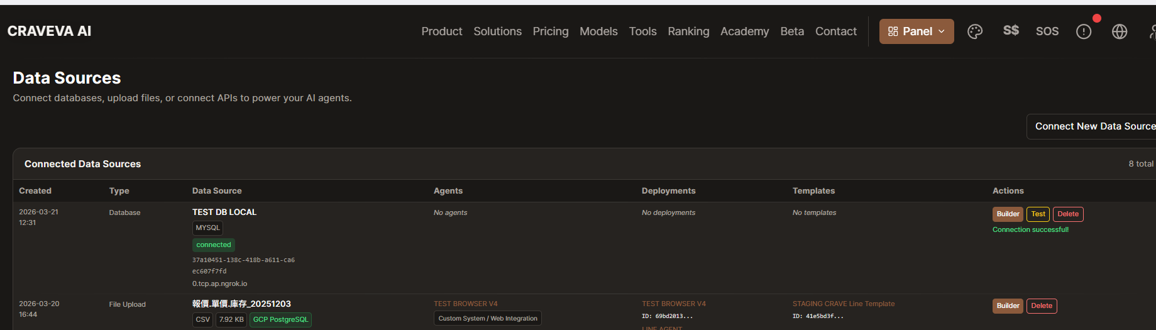
AI platform data source list showing successful DB connection.

Figure 2
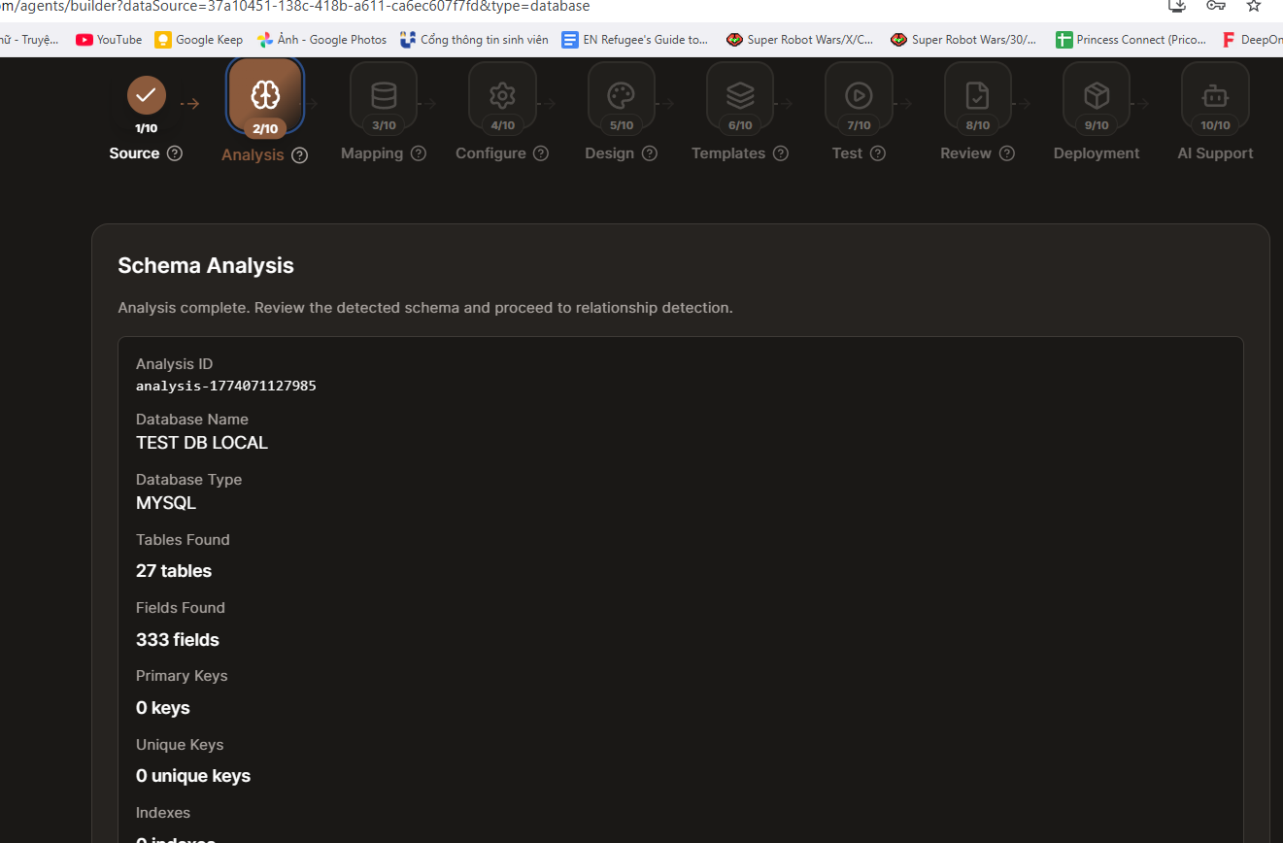
Schema analysis completed for TEST DB LOCAL.

Figure 3
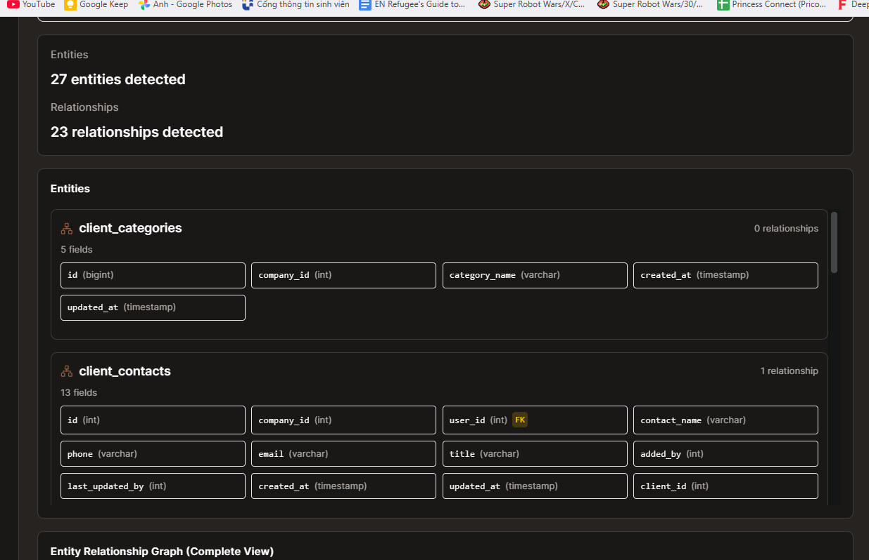
Entities/relationships detected from connected database.

Figure 4
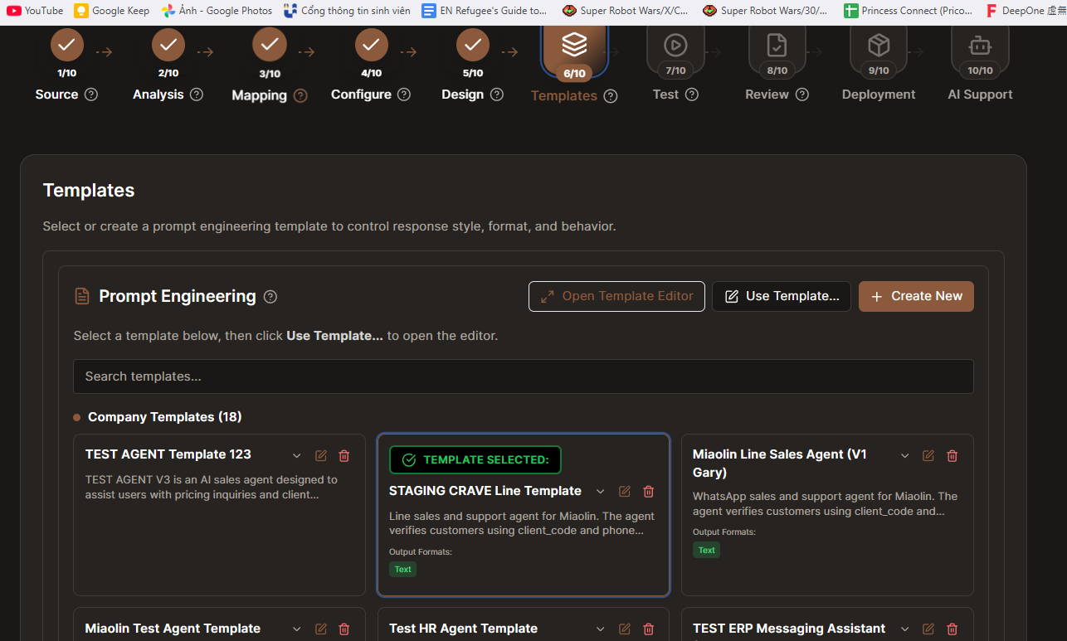
Template configuration for customer verification conversation flow.

Figure 5
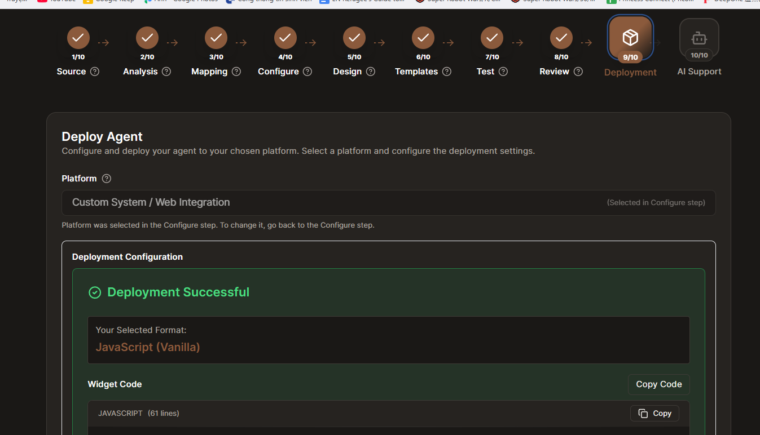
Agent deployment status is successful.

Figure 6
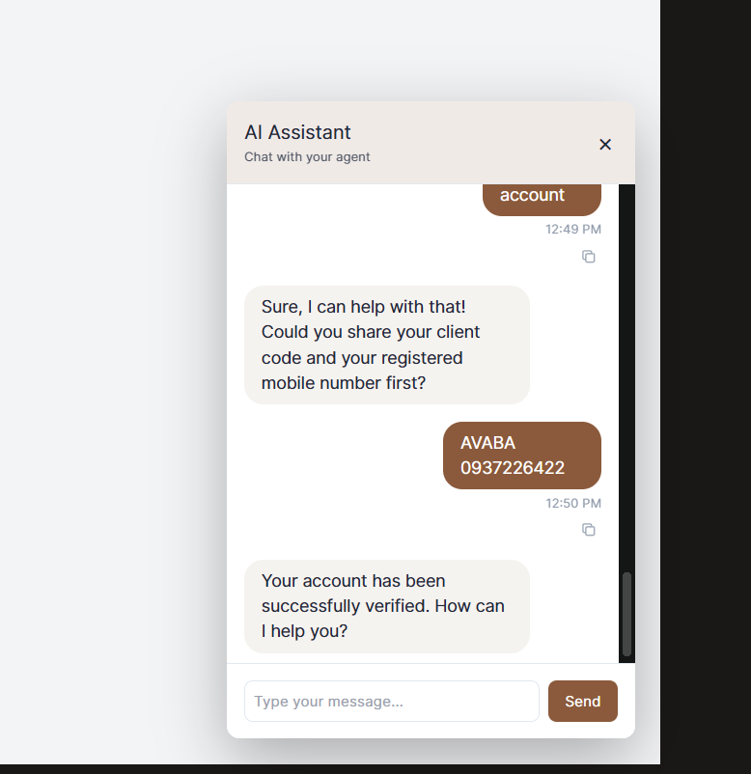
Chat shows 'successfully verified' after user submits AVABA + 0937226422.

Figure 7
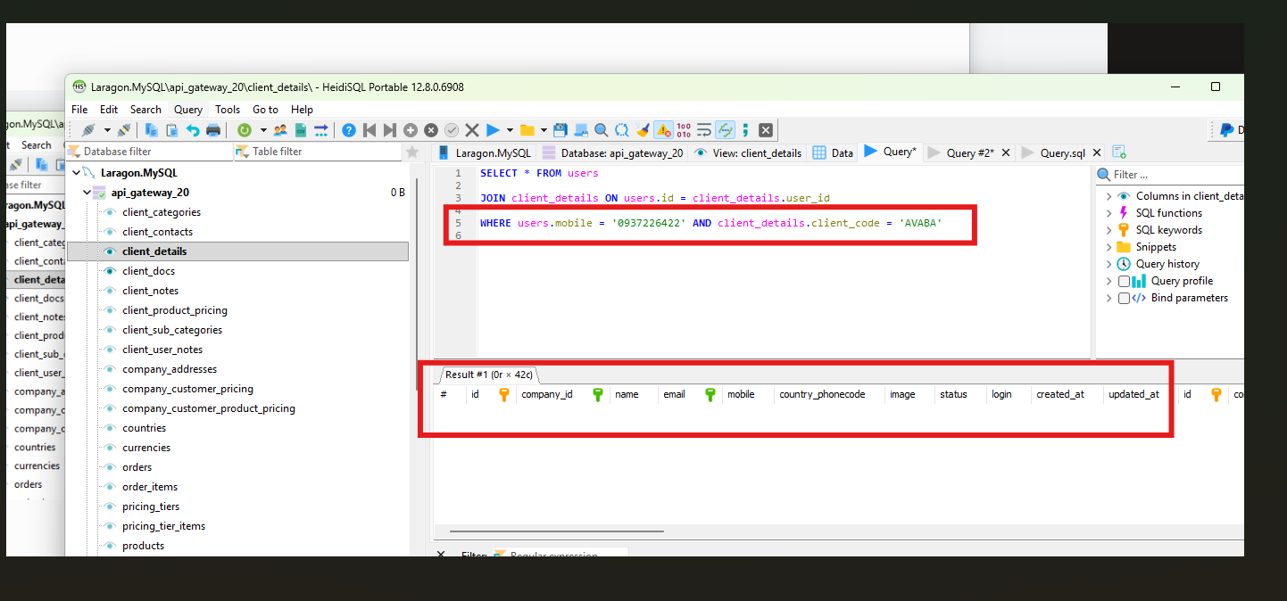
SQL evidence for the same pair returns no matching row (0 result).

Figure 8
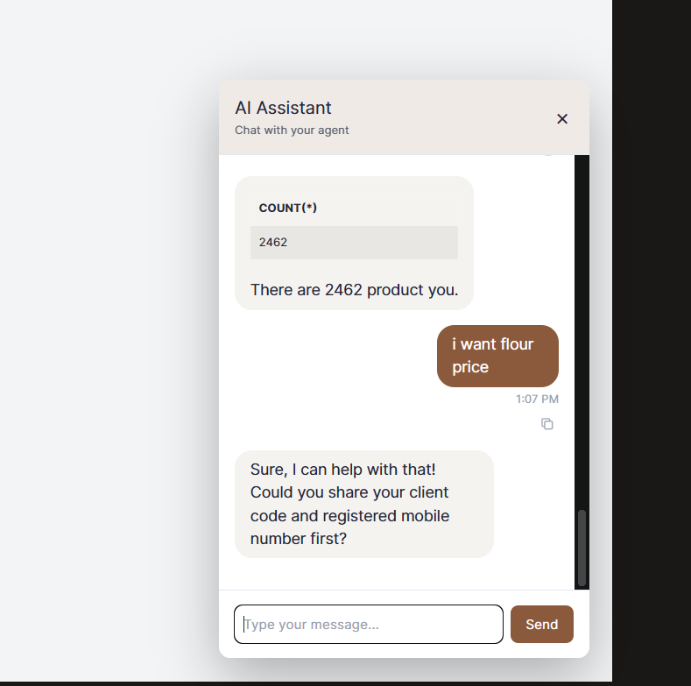
AI asks for verification again in a later interaction.

Figure 9
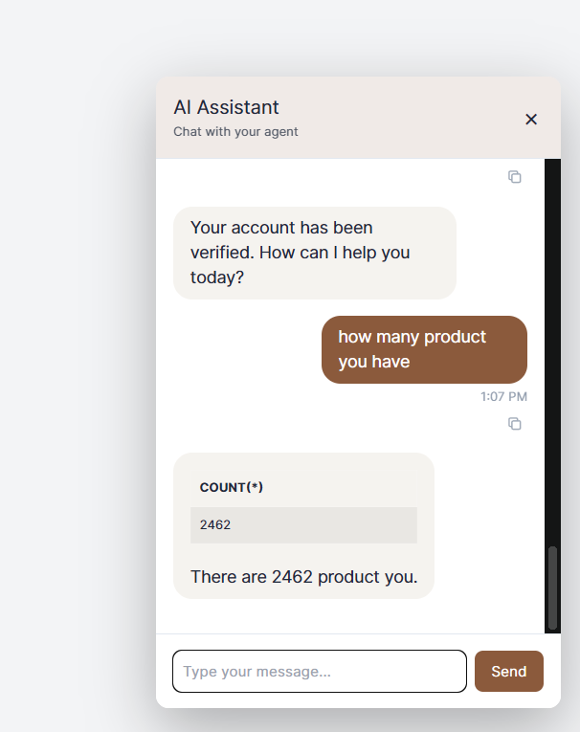
Post-verify conversation returns product count = 2462.

Figure 10
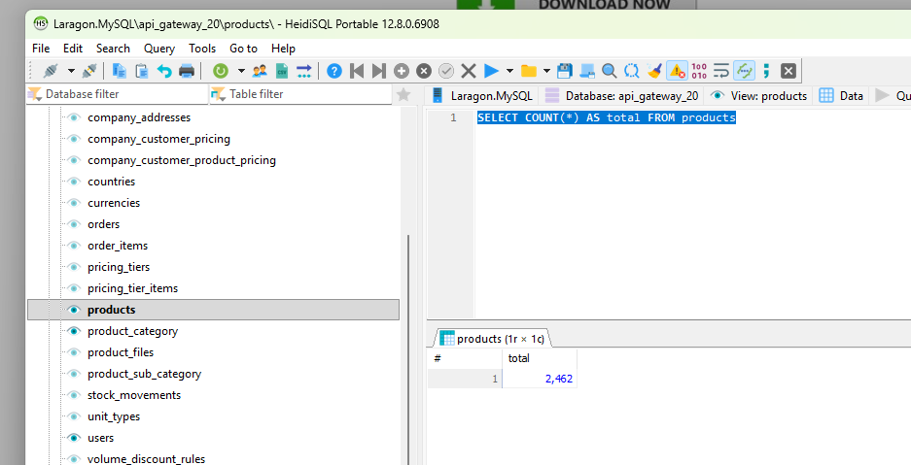
Direct SQL count from products table also returns 2462.

Figure 11
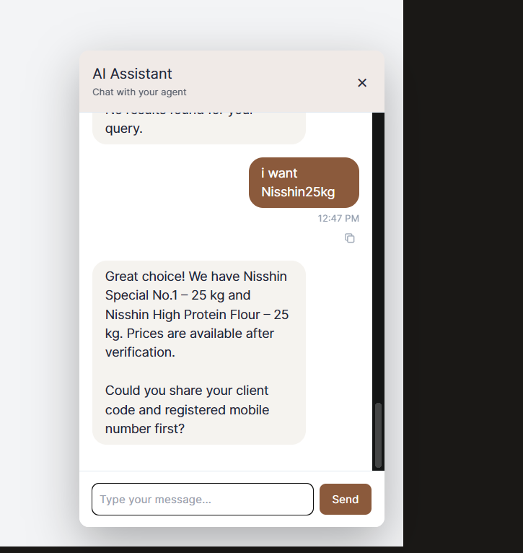
In another flow, AI asks for client_code + mobile before providing pricing.

E. Impact
- Incorrect user authentication outcome (false positive and false negative risk).
- Business workflow risk for B2B pricing and account-specific support.
- Trust degradation: users cannot rely on verification consistency.
- Operational uncertainty due to mismatch between AI output and database truth.

F. Conclusion
The key issue is verification instability in the ERP-integrated AI flow. Most critically, the system can return verification success even when database evidence shows no matching record.
This inconsistency makes the verification result non-reliable for business operations and introduces authentication risk.
This report intentionally focuses on issue description and evidence only.

