1. //insert, update, delete
2. //getdata
3. //view
4. //func

-DetaiController

//insert

dangkydetai($MaDT, $MaSV) ->insertDT(($MaDT, $MaSV)

dexuatdetai(Request $request) ->insertDX(Request $request)

//getdata

getallLVNC()

getallGV()

getallDetai($MaDA) -> getallDT($MaDA)

getMaHocKy_now()

//view

dangkydetai_() ->index()

getAlldata() ->getdata()

//func

checksoluongSV()

checkDKDT()

checkDKDA()

-KehoachthuchienController

//insert

Insert_Sp(Request $request) ->insertSP(Request $request)

//update

Update_Sp($MaDT,$MaKHTH,Request $request) ->updateSP($MaDT,$MaKHTH,Request $request)

//getdata

getMaKHTH_tuan($NgayBD)

getSanPham_MaKHTH($MaKHTH)

getMoTa_MaKHTH($MaKHTH)

getNoidung_tuan($NgayBD,$MaDT)

getModal_Co_SanPham1($Tuan, $MaKHTH, $TenDA, $TenDT, $a, $Noidungthuchien, $MotaSPi, $Sanphami)

getModal_Co_SanPham2($Tuan, $MaKHTH, $TenDA, $TenDT, $a, $Noidungthuchien, $MotaSPi, $Sanphami)

getModal_Ko_SanPham1($Tuan, $MaKHTH, $TenDA, $TenDT, $a, $Noidungthuchien)

getModal_Ko_SanPham2($Tuan, $MaKHTH, $TenDA, $TenDT, $a, $Noidungthuchien)

//view

kehoachthuchien() ->index($MaDA)

-LichbaocaoController

//insert

//update

//getdata

getkehoach($MaDT) ->getKHTH($MaDT)

show()

//view

index($MaDA)

//func

check_day_LBC($NgayBC,$dayBDHK) -> checkdayLBC($NgayBC,$dayBDHK)

check_day_in_week($dayBDHK,$dayz) ->

checkdayinweek($dayBDHK,$dayz)

-SinhVienController

//insert

//update

//getdata

getMaSV()

getMaDT($MaSV) ->getMaDT_MaSV($MaSV)

getMaDA($MaDT) -> getMaDA_MaDT($MaDT)

getMaDA_($MaSV) ->getMaDA_MaSV($MaSV)

//view

index()

tailieuthamkhao()

//func

CSDL

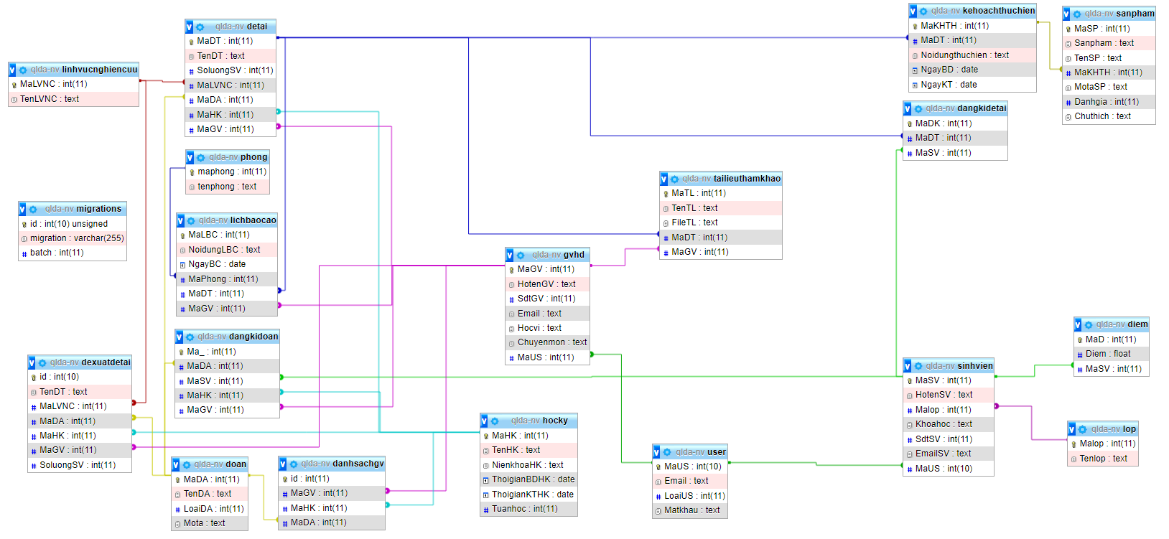

try{

} catch(Exception $e){

}

unlink("upload/".$fname);

Hàm lấy mã đồ án của sinh viên học kỳ hiện tại

getMaDA_MaSV($MaSV)

//debug data datatable

var data = t.rows().data();

alert( 'The table has '+data.length+' records' );