

FINAL PROJECT DESCRIPTION FOR PRM392 COURSE
FALL 2025

TOPIC
Collaborative Team Management in Application Development Projects

Group name:

Information of members
No | Fullname | RollNumber
1 | Tô Hoàng Hiệp | HE173531
2 | Lê Đức Hiếu | HE170444
3 | Trần Hữu Vinh | HE176773
4 | Nguyễn Hồng Quân | HE171267
5 | Hoàng Phúc Lâm | HE176866

No | Name | Screen | Complete
1 | Hoàng Phúc Lâm | Login To Account | v
2 | Hoàng Phúc Lâm | Register Account | v
3 | Hoàng Phúc Lâm | UserProfile | V
4 | Tô Hoàng Hiệp | List Your Projects | v
5 | Tô Hoàng Hiệp | Create Your Managing Project | v
6 | Tô Hoàng Hiệp | List Project Members and Roles | v
7 | Trần Hữu Vinh | Choose Chat Project | v
8 | Trần Hữu Vinh | Chat Screen | v
9 | Trần Hữu Vinh | Calendar Event | v
10 | Trần Hữu Vinh | Notification | v
11 | Nguyễn Hồng Quân | Create Task and Assign Members | v
12 | Nguyễn Hồng Quân | List Your Tasks | v
13 | Lê Đức Hiếu | Global Search | v
14 | Lê Đức Hiếu | Offline Support | v
15 | Tô Hoàng Hiệp | Add Member To Project | v
16 | Lê Đức Hiếu | Light&Dark Theme | v
17 | Lê Đức Hiếu | Navigation Menu | v

I. Introduction
- System Purpose
The “Collaborative Team Management in Application Development Projects” mobile application is designed to enhance coordination, communication, and productivity within software development teams. It provides a centralized platform for project managers and members to plan, assign, and track tasks, manage deadlines, and communicate efficiently.
This system aims to reduce communication gaps, improve transparency in task progress, and help both students and professionals manage multiple collaborative projects effectively within a single Android app environment.
- System Scope
The system primarily targets teams working on collaborative software projects, including both academic and professional contexts.
The core functionalities include:
- User registration, authentication, and profile management.
- Project creation and member invitation with assigned roles (Manager, Member).
- Task creation, assignment, and progress tracking.
- Real-time chat and notification system for collaboration.
- Calendar event and scheduling features.
- Global search and offline access support for improved usability.
- Light and dark theme options for accessibility.
The application is implemented using Android Studio with Java, integrating Firebase for authentication, real-time database, and cloud messaging services. It focuses on usability, responsiveness, and efficient data synchronization in both online and offline modes.

II. Project Objectives

1. General Objective
The main objective of this project is to develop a mobile-based team collaboration platform that allows developers and project participants to effectively manage application development workflows.
It helps users track project status, communicate in real time, and maintain consistent coordination between team members, ultimately increasing productivity and reducing management overhead.

General Objective

2. Specific Objectives

Users:
- Allow individuals to register, log in, and manage their personal profiles.
- Provide an intuitive dashboard displaying all joined projects and tasks.
- Enable switching between different projects with seamless navigation.
- Access offline data when internet connectivity is unavailable.

Project Managers:
- Create and manage multiple projects within the system.
- Invite members via email and assign roles or responsibilities.
- Create, assign, and monitor tasks efficiently.
- Receive notifications for key project events and member updates.

Project Members:
- Accept invitations to join projects and access shared resources.
- Communicate with other team members via chat and notifications.
- View assigned tasks, deadlines, and project progress in real time.
- Update task status and provide feedback to the manager through chat.

System Administrators:
- Oversee the user database and ensure security and data integrity.
- Manage backend resources and handle system-wide notifications.
- Monitor system usage and performance to ensure stable operation.
- Support maintenance, updates, and user account recovery.

III. App screenshot

1. Login

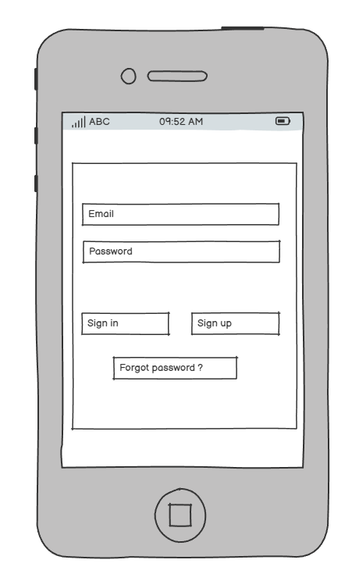

2. Sign up
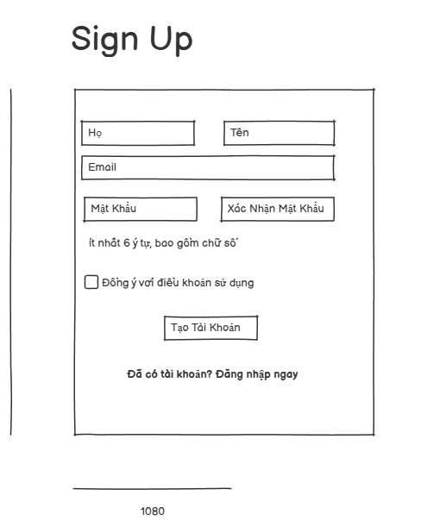

3. Create New Project
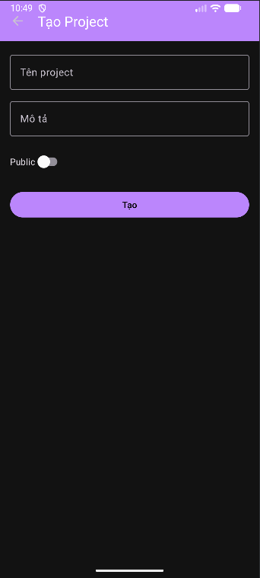

4. View list project
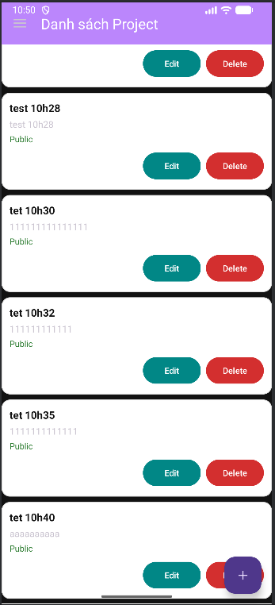

5. Edit project
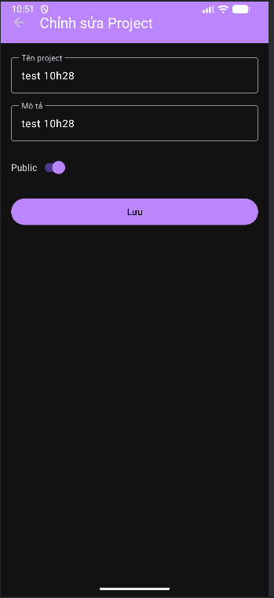

6. View list members project
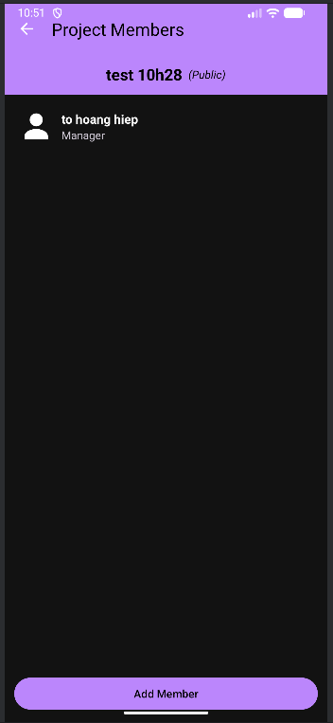

7. Add members project
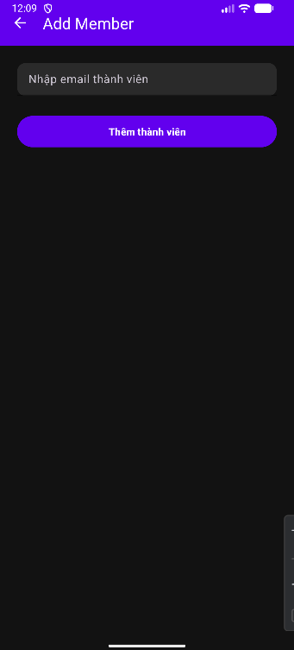

8. Chat Screen
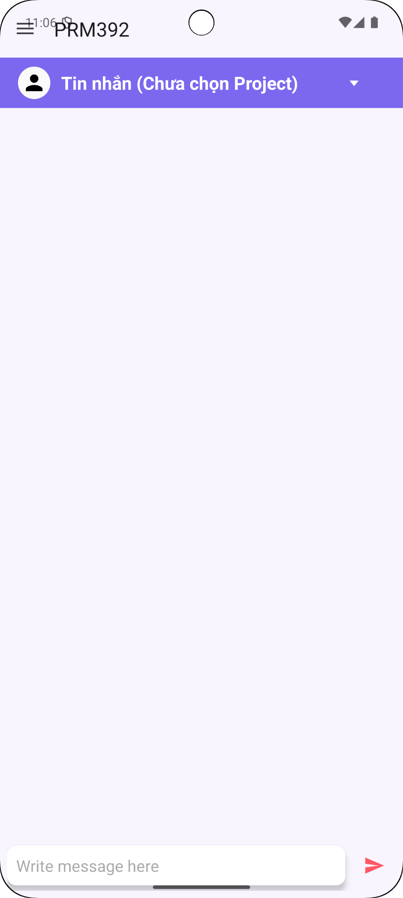

9. Choose Chat Project

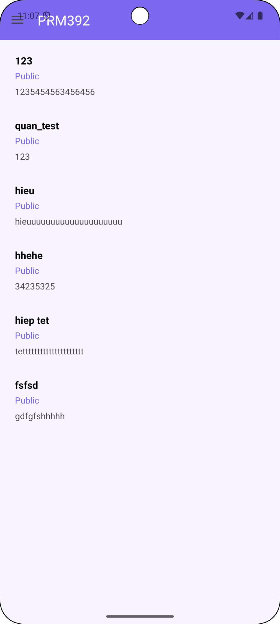

10. Calendar Event

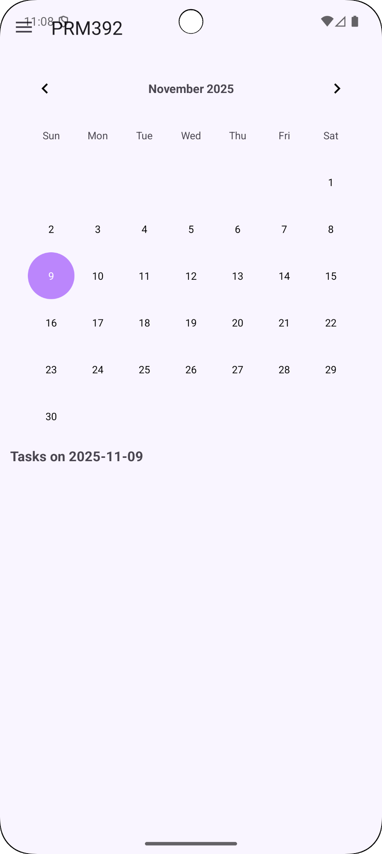

11. Create Task and Assign Members
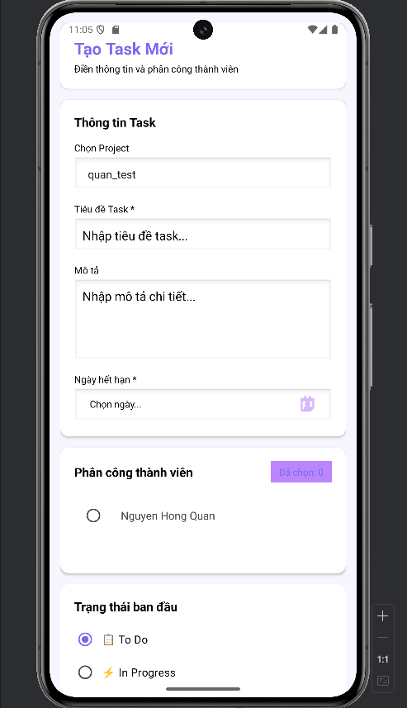

12.List Your Tasks
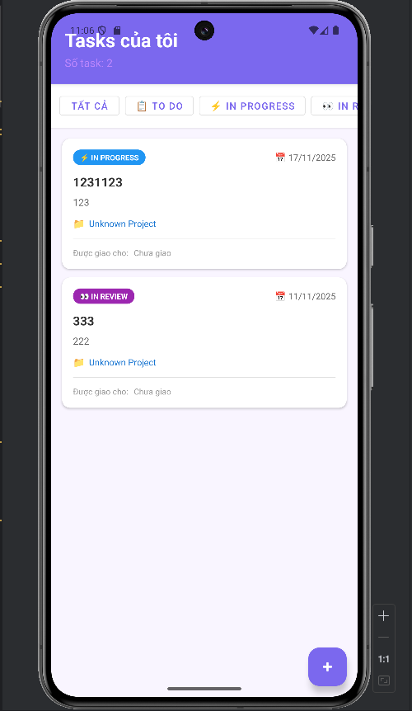

13.Setting

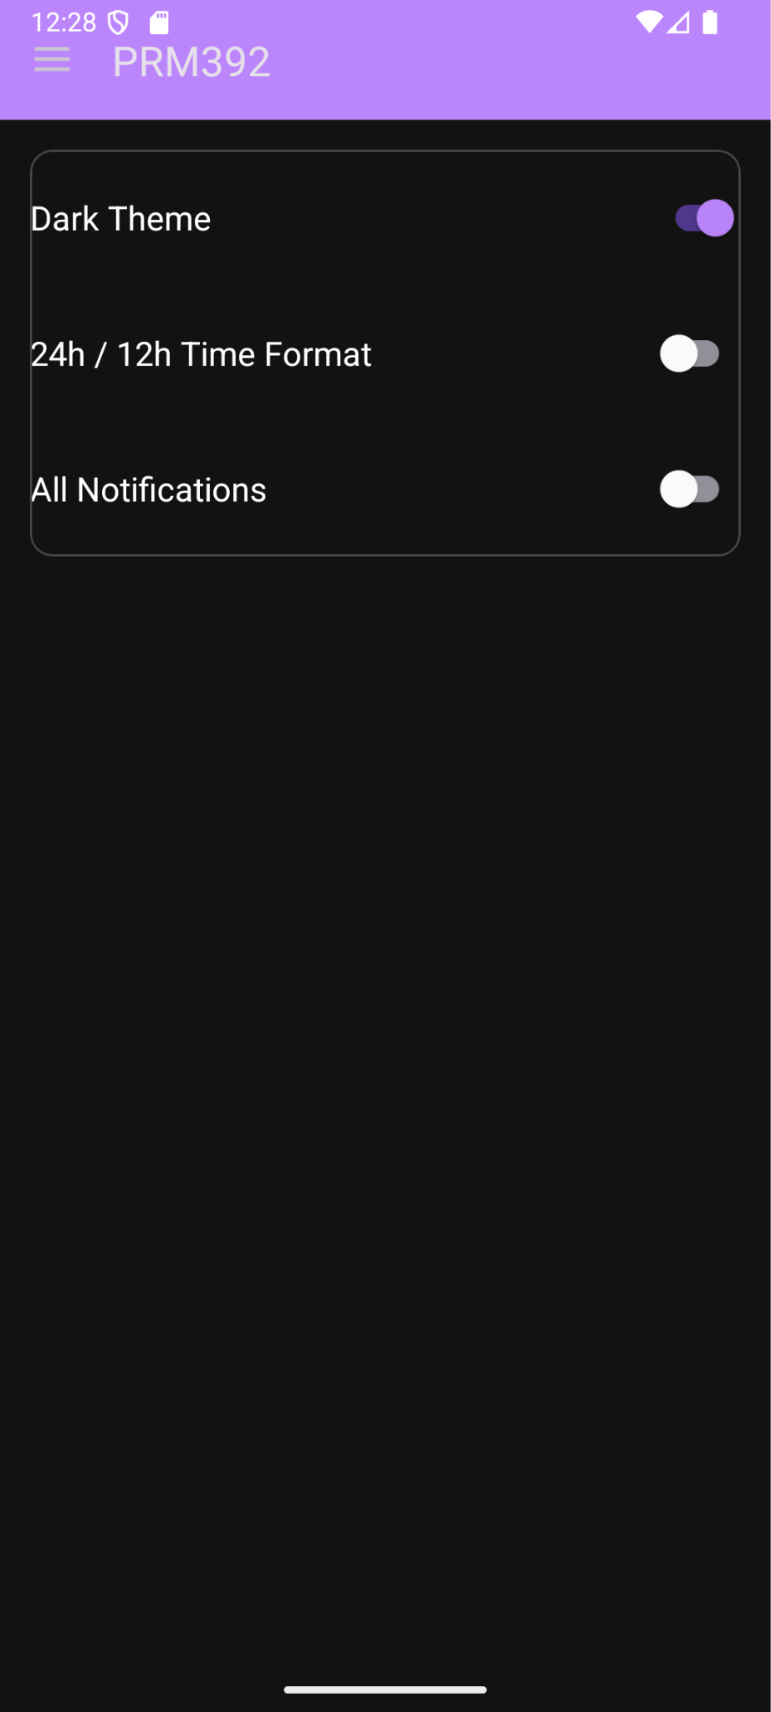

14.Global search
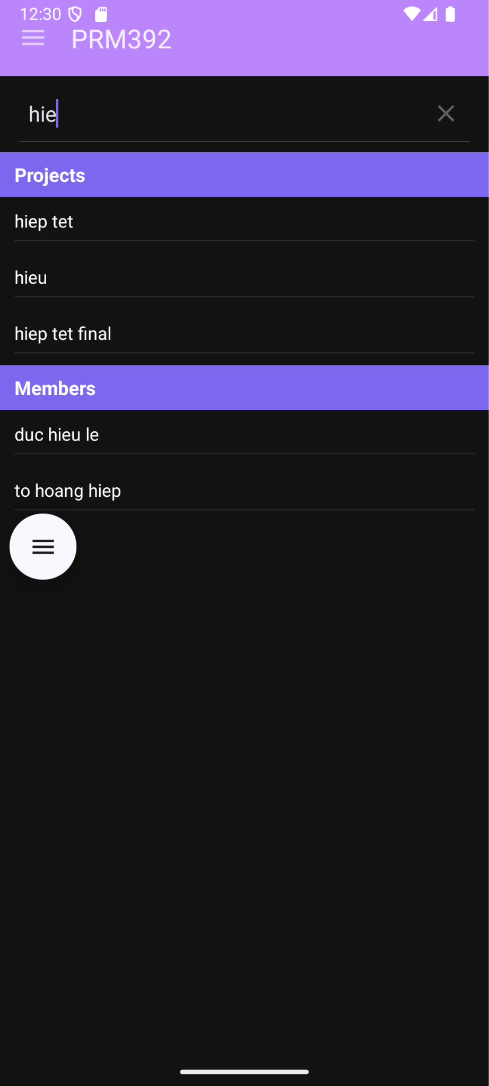

IV - ERD
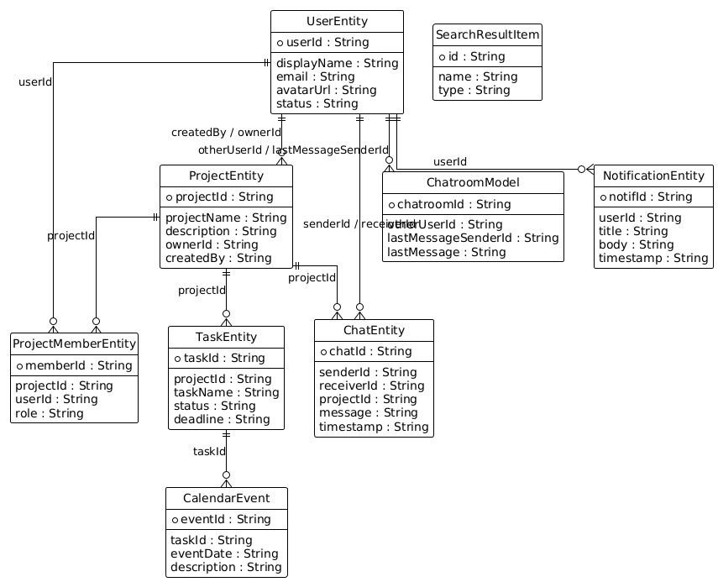

V - Use Case Diagram

1.User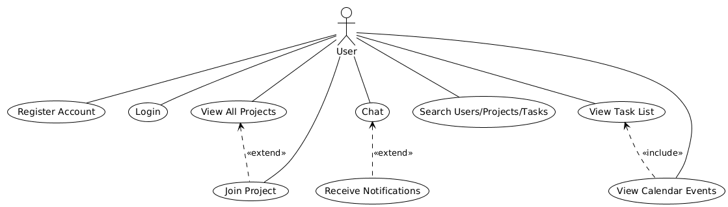

2.Owner
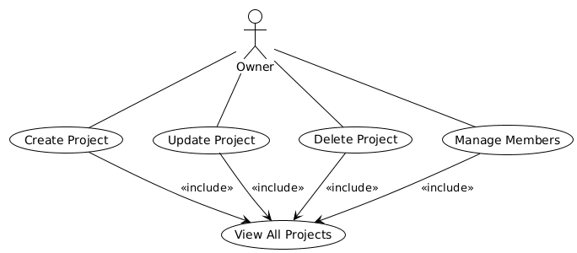

3.Member

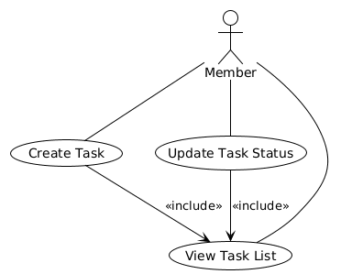
4.System
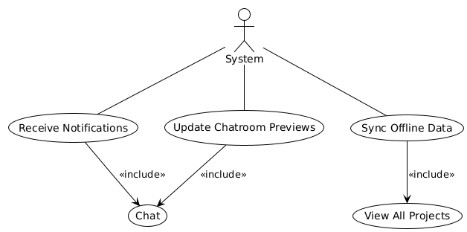

5. Unified
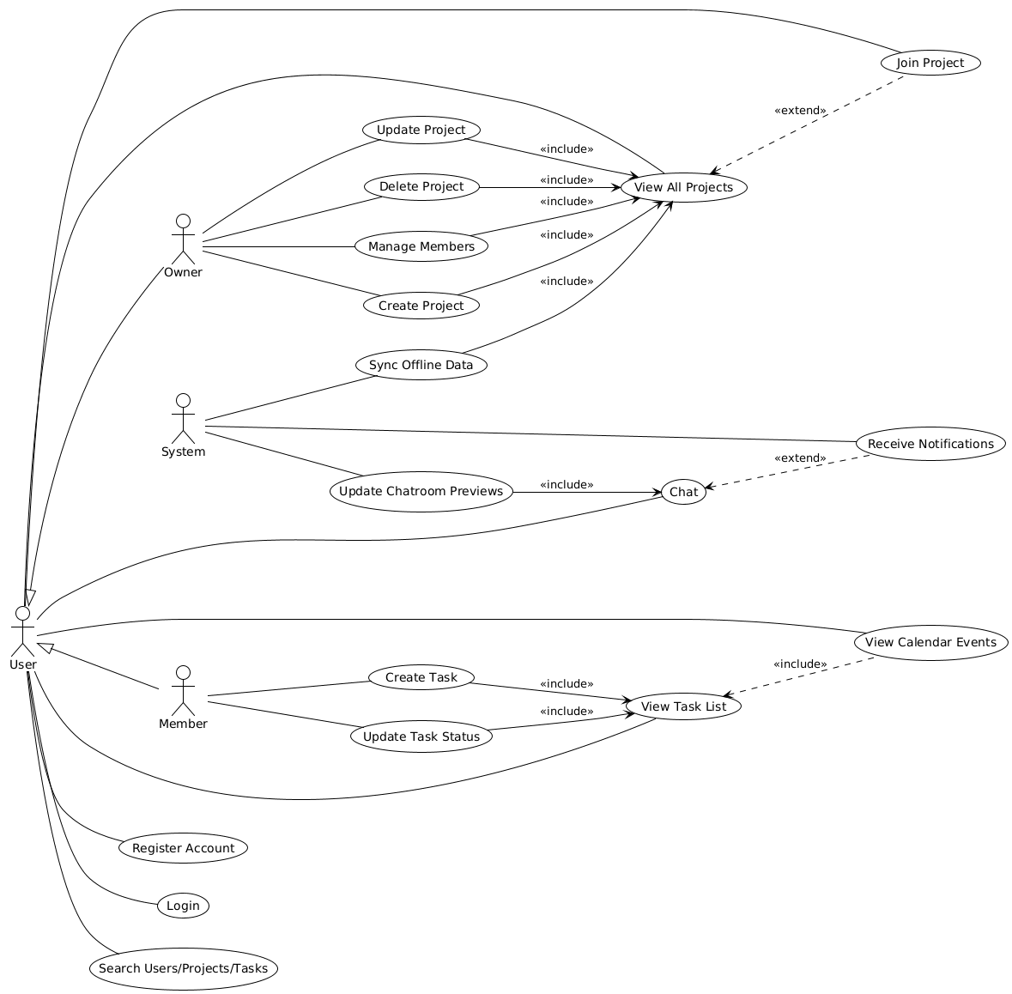

VI - Use Case Description

1.Register Account
Use Case Name | Register Account
Actor | User
Description | User creates a new account using email and password. The system validates and registers them via Firebase Auth.
Precondition | User has not registered yet.
Main Flow | 1. User opens registration screen.  2. Enters email, password, and display name.  3. System validates input.  4. System creates Firebase Auth user and stores details in UserEntity.  5. System displays success message.
Alternate Flow(s) | - Email already exists.  - Invalid input format.
Postcondition | New user created and stored in Firebase and Room DB.

2.Login
Use Case Name | Login
Actor | User
Description | User logs into the application with valid credentials.
Precondition | User account exists.
Main Flow | 1. User opens login form and enters credentials.  2. System validates and authenticates via Firebase.  3. System loads user profile into local session.
Alternate Flow(s) | - Wrong credentials entered.
Postcondition | User session active, app synced.

3.View All Projects
Use Case Name | View All Projects
Actor | User
Description | User views all public and joined projects from the database.
Precondition | User logged in.
Main Flow | 1. User navigates to Projects screen.  2. System loads all projects from Room.  3. System syncs with Firebase for latest updates.
Alternate Flow(s) | N/A
Postcondition | Project list displayed and cached.

4.Join Project
Use Case Name | Join Project
Actor | User
Description | User joins a public project to become a member.
Precondition | User logged in and project is public.
Main Flow | 1. User selects a public project.  2. System checks membership status.  3. If not joined, adds user as ProjectMemberEntity.  4. System confirms join success.
Alternate Flow(s) | - Project is private.
Postcondition | User added as project member.

5.Create Project
Use Case Name | Create Project
Actor | Owner
Description | Owner creates a new project with details stored in ProjectEntity.
Precondition | Owner logged in.
Main Flow | 1. Owner selects Create Project.  2. Fills in details (name, description, privacy).  3. System validates and stores data.  4. System adds creator as first member.
Alternate Flow(s) | - Network issue or validation failure.
Postcondition | New project created and visible to owner.

6.Update Project
Use Case Name | Update Project
Actor | Owner
Description | Owner edits details of an existing project.
Precondition | Owner logged in and project selected.
Main Flow | 1. Owner opens project.  2. Updates name or description.  3. System validates and updates entry.
Alternate Flow(s) | - Invalid data entered.
Postcondition | Project updated successfully.

7.Delete Project
Use Case Name | Delete Project
Actor | Owner
Description | Owner deletes a selected project.
Precondition | Owner logged in and owns the project.
Main Flow | 1. Owner selects Delete Project.  2. System confirms deletion.  3. Removes project and related entities.
Alternate Flow(s) | - User cancels deletion.
Postcondition | Project removed from database and synced.

8.Manage Members
Use Case Name | Manage Members
Actor | Owner
Description | Owner adds or removes project members.
Precondition | Owner logged in and project selected.
Main Flow | 1. Owner opens Members screen.  2. System lists members.  3. Owner adds or removes users.  4. System updates membership data.
Alternate Flow(s) | N/A
Postcondition | Project member list updated.

9.Create Task
Use Case Name | Create Task
Actor | Member / Owner
Description | User creates a new task linked to a project.
Precondition | User logged in and part of the project.
Main Flow | 1. User selects project.  2. Opens Add Task form.  3. Enters task details and saves.  4. System stores TaskEntity in database.
Alternate Flow(s) | - Missing fields or invalid date.
Postcondition | Task created successfully.

10.Update Task Status
Use Case Name | Update Task Status
Actor | Member / Owner
Description | User updates a task status (e.g., completed).
Precondition | Task exists and project active.
Main Flow | 1. User opens task list.  2. Selects a task and changes status.  3. System updates TaskEntity.
Alternate Flow(s) | - Task not found or sync issue.
Postcondition | Task status updated.

11.View Task List
Use Case Name | View Task List
Actor | User
Description | User views all tasks within a selected project.
Precondition | User is a project member.
Main Flow | 1. User opens project.  2. System loads TaskEntity linked to projectId.  3. Displays task list.
Alternate Flow(s) | N/A
Postcondition | Task list displayed.

12.Chat (Direct & Project)
Use Case Name | Chat (Direct & Project)
Actor | User
Description | User sends messages in project or direct chat.
Precondition | User logged in.
Main Flow | 1. User opens chatroom.  2. System loads chat history.  3. User sends a message.  4. System saves ChatEntity and syncs Firebase.
Alternate Flow(s) | - No connection → message saved offline.
Postcondition | Message sent and synced.

13.Receive Notifications
Use Case Name | Receive Notifications
Actor | System
Description | System sends notification to users on events like task updates or new messages.
Precondition | Notification listener active.
Main Flow | 1. System observes events.  2. Generates NotificationEntity.  3. Displays local or push notification.
Alternate Flow(s) | N/A
Postcondition | User notified successfully.

14.View Calendar Events
Use Case Name | View Calendar Events
Actor | User
Description | User views calendar with all task deadlines.
Precondition | User logged in.
Main Flow | 1. User opens calendar screen.  2. System loads events from CalendarEvent.  3. Displays events sorted by date.
Alternate Flow(s) | N/A
Postcondition | Calendar rendered successfully.

15.Search Users/Projects/Tasks
Use Case Name | Search Users/Projects/Tasks
Actor | User
Description | User searches for entities in the system.
Precondition | User logged in.
Main Flow | 1. User inputs keyword.  2. System searches local and Firebase data.  3. Displays SearchResultItem list.
Alternate Flow(s) | - No results found.
Postcondition | Relevant results displayed.

16.Sync Offline Data
Use Case Name | Sync Offline Data
Actor | System
Description | System syncs local Room DB with Firebase when online.
Precondition | Network connection available.
Main Flow | 1. System detects reconnection.  2. Compares data versions.  3. Pushes and pulls updated records.
Alternate Flow(s) | N/A
Postcondition | Local DB synced with cloud.

17.Update Chatroom Previews
Use Case Name | Update Chatroom Previews
Actor | System
Description | System updates chat previews with last message and sender info.
Precondition | Chat message sent or received.
Main Flow | 1. System detects chat updates.  2. Updates ChatroomModel with latest info.
Alternate Flow(s) | N/A
Postcondition | Chatroom preview refreshed.

