

FoodPal platform
Software Requirement Specification

– Danang, June 2024–

RECORD OF CHANGES
DATE | A* M,D | IN CHARGE | CHANGE DETAILS

SOFTWARE REQUIREMENT SPECIFICATION

Product Overview
Our food delivery and shipping services - Foodpal, was developed in order to satisfy the needs of delivering services as more and more citizens tend to live at suburb of the city. Becoming the transporter between the food shop and user, our websites enables people to enjoy food without struggle of distances.
The most notable aspects of the platform is that it could help user to skip their struggle in distance and vehicle that needed to used in order to get to the shop. Instead, we offers mean of transportation to satisfy their demands without having to go out.
One of the main advantages is it’s usability and user-friendly graphic interface. The users can use the app anywhere and anytime they wants, the platform will always be available which provides comfort. Our platform also supply shipper and shop a mean of connections to user with demands in the shortest time which somewhat can increase their income remarkably.
In short, Our food delivery and shipping services platform will supply users with fascinating websites for individuals to satisfy their needs. The platform target not only supply services but also a community for users to share their passions about food.
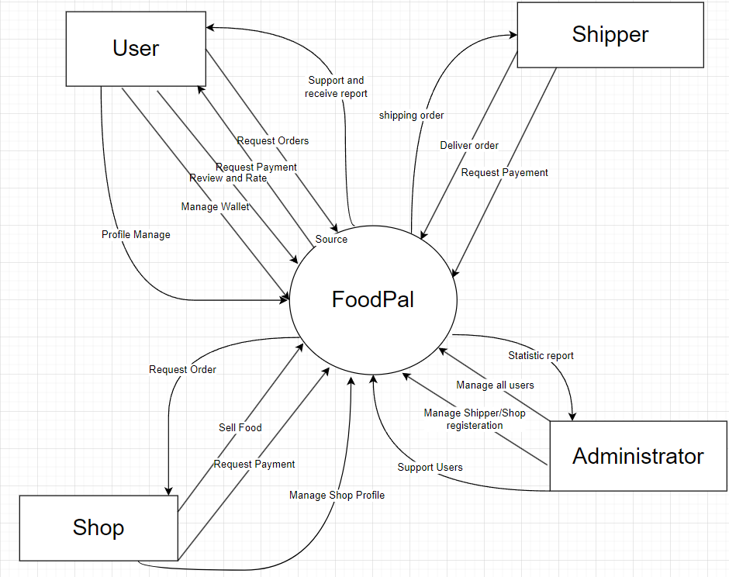
figure 1. Context Diagram

2.User requirements

2.1 Actors

ID | Actor | Description
1 | User | A user is someone who gain full access to Foodpal and all of it offred services
2 | Admin | Admins are someone who on duty for maintaining the platform and managing platform economy
3 | Shop | Shop are accounts that created through admins as shops applications which is the food shop
4 | Shipper | Shipper are accounts that worked as the mean of transport or connection between the shops and users
Table 1. Actors

2.2 Use cases
2.2.1 Diagram(s)
2.2.1.1 Use Case Overview

Below in an overview of the use cases:

2.2.1.2 Use Case for User

Below is a subsystem use case for the User actor.
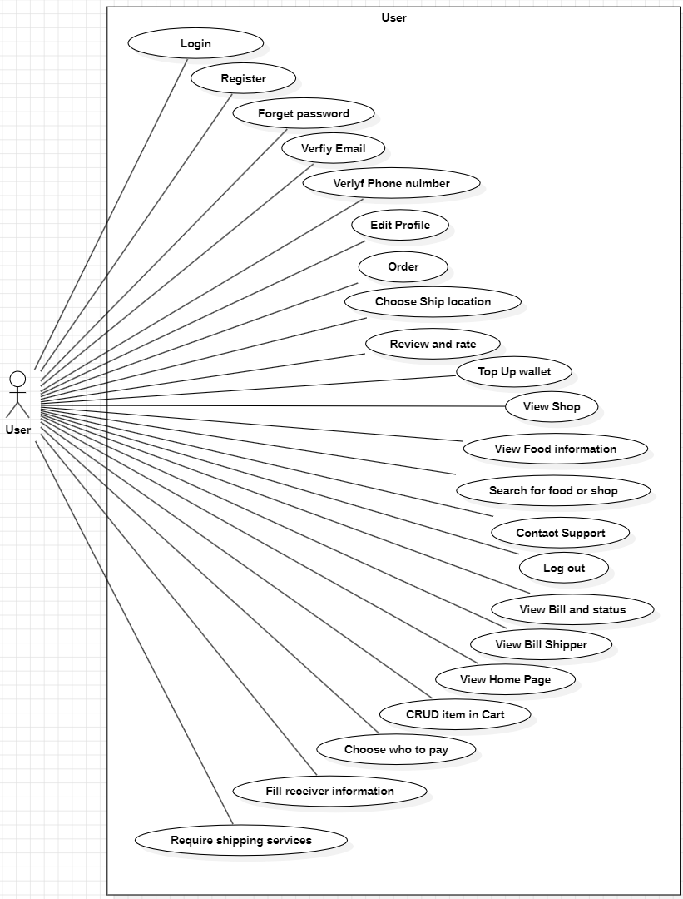
figure 2. User use case

2.2.1.3 Use Case for Shipper

Below is a subsystem use case for the Guest actor.
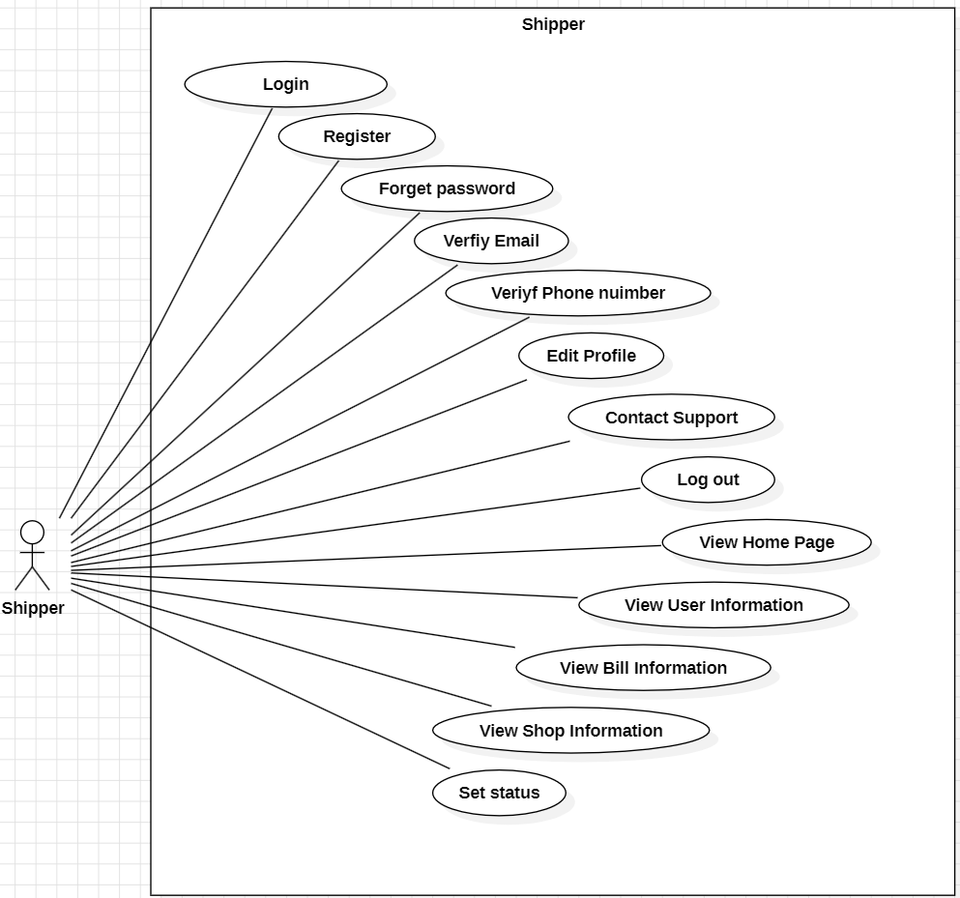
figure 3. Shipper use case

2.2.1.4 Use Case for Admin

Below is a subsystem use case for the Admin actor.

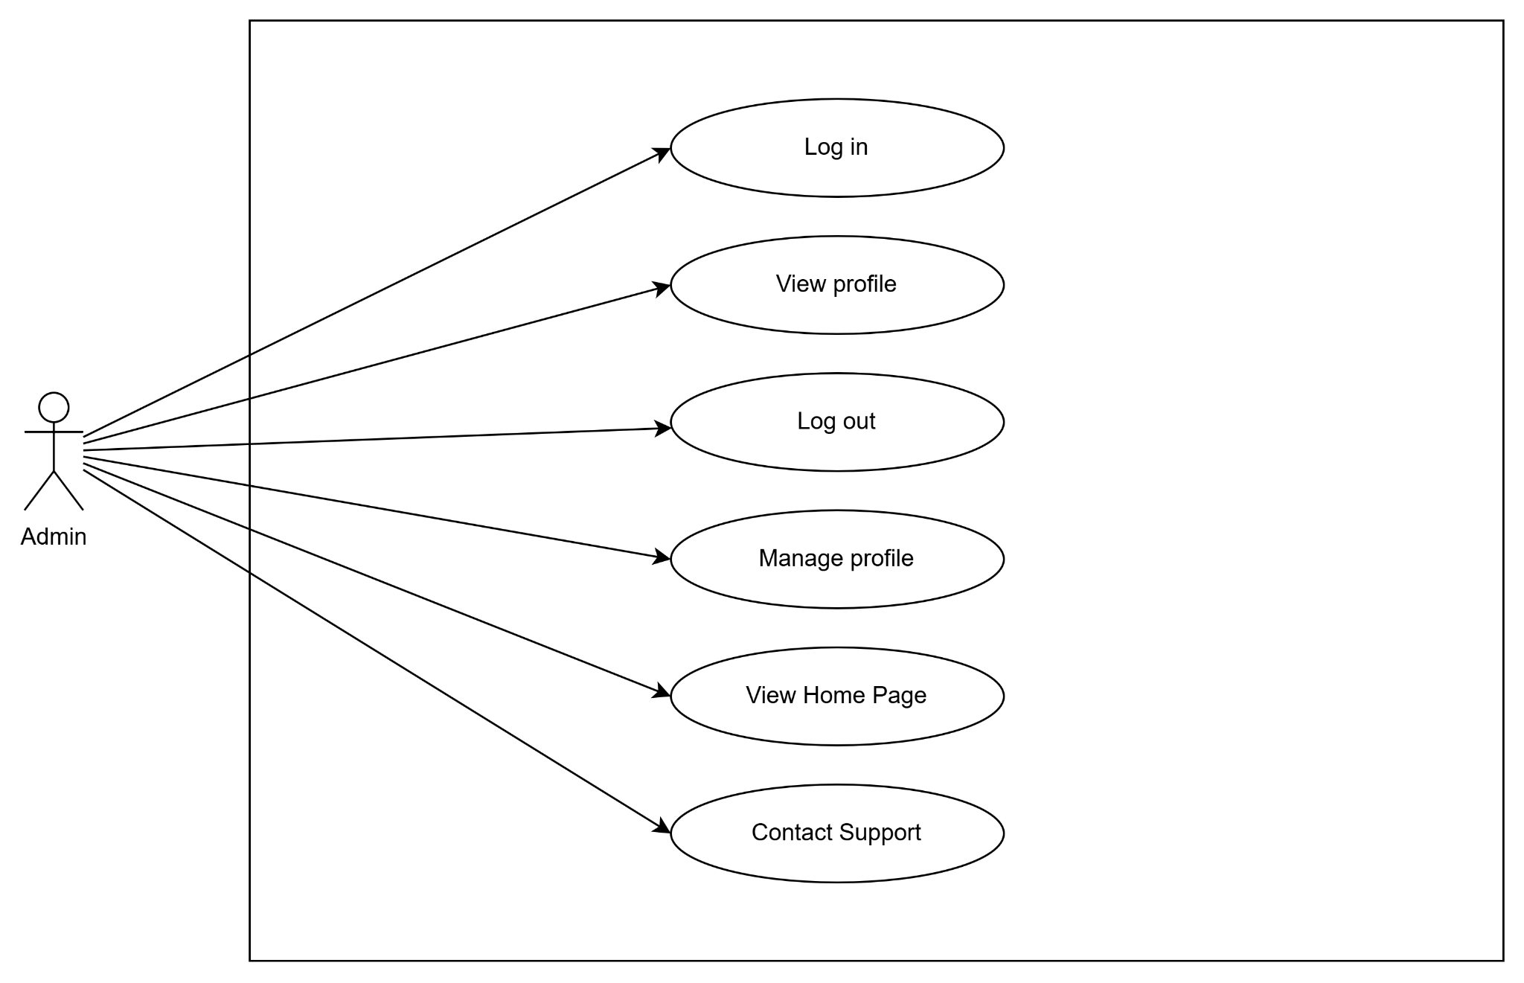

figure 4. Admin use case

2.2.1.5 Use Case for Shop

Below is a subsystem use case for the Shop actor .
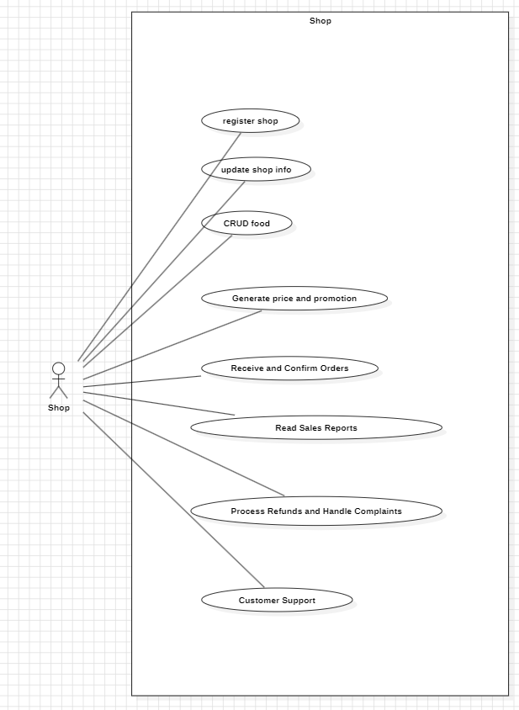

Figure 5. Use Case for Shop.

2.2.2 Swimlane Diagram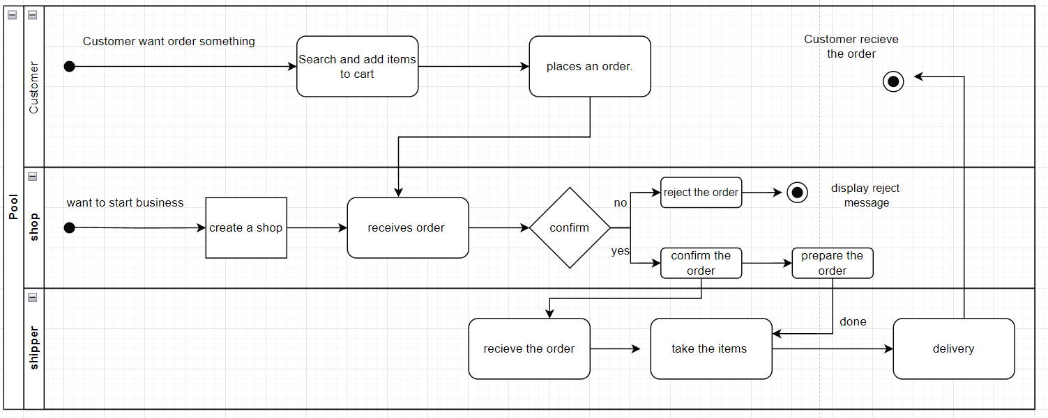
Figure 6. Swimlane Diagram.

2.2.3 Descriptions

ID | Use Case | Actors
UC - 1 | Register | User, Shipper, Shop
UC - 2 | Sign In | User, Shipper, Shop
UC - 3 | Sign Out | User, Shipper, Shop
UC - 4 | Forgot Password | User, Shipper, Shop
UC - 5 | View Profile | User, Shipper, Shop
UC - 6 | Manage profiles | User, Shipper, Shop
UC - 7 | Verify Email | User, Shipper, Shop
UC - 8 | Review and Rate food/ shop | User
UC - 9 | Choose Ship location | User
UC - 10 | Order | User
UC - 11 | Top Up Wallet | User
UC - 12 | View Shop | User
UC - 13 | View Food information | User
UC - 14 | Search for food or shop | User
UC - 15 | Contact Support | User, Admin, Shop
UC - 16 | View Bill Detail and Status | User
UC - 17 | View Bill Shipper | User
UC - 18 | Manage Cart | User
UC - 19 | Require Shipping services | User
UC - 20 | Fill delivery Information | User
UC - 21 | Choose person to pay in shipping services | User
UC - 22 | View Bill User information | Shipper
UC - 23 | View Bill Detail Information | Shipper
UC - 24 | View Shop Information | Shipper
UC - 25 | Set status | Shipper, Shop
UC - 26 | View Home Page | User, Shipper, Shop
UC - 27 | CRUD food | Shop
UC - 28 | Generate price and promotion | Shop
UC - 29 | Receive and Confirm Orders | Shop
UC - 30 | Process Refunds and Handle Complaints | Shop
UC - 31 | Sales Reports | Shop
UC - 32 | Customer Support | Shop
Table 2. Use case Description

2.3 Feature common
2.3.1 Authentication
2.3.1.1 Login

Use Case ID: | UC - 2 | Use Case Name: | Login
Created By: | PhuongPH | Date Created:
Primary Actor: | User, Shop, Shipper | Secondary Actor: | None
Description: | This use case allows all type of users to log in
Priority: | High
Trigger: | User access website
Preconditions: | PRE-01 : Users must have accounts
Post-Conditions: | POST-01 : User login to platform successfully
Basic Flow: | - The user access the platform  - User fill in username and password  - User click button [log in]
Alternative Flow: | none
Exception Flow: | 1.User login with none-exist account  2.User will be returned to Login page
Business Rules:

2.3.1.2 Register

Use Case ID: | UC - 1 | Use Case Name: | Register
Created By: | PhuongPH | Date Created:
Primary Actor: | User, Shipper | Secondary Actor: | None
Description: | This use case allows User and Shipper to register with different Account
Priority: | High
Trigger: | User click in [register[ button in login page
Preconditions: | none
Post-Conditions: | POST-01 : User account is created
Basic Flow: | - User access Login Page  - User click on button [register]  - user fill in all type of information needed  - User click on register
Alternative Flow: | - User access Any Authentication page  - User click on [log in with my account] button  - User click on [register] button  - user fill in all type of information needed  - User click on register
Exception Flow: | 1.User not verify email and phone number  2. User return to login page
Business Rules:

2.3.1.3 Forget Password

Use Case ID: | UC - 4 | Use Case Name: | Forget Password
Created By: | PhuongPH | Date Created:
Primary Actor: | User, Shop, Shipper | Secondary Actor: | None
Description: | This use case allows all type of users to regain access to their account in case they forget their password
Priority: | medium
Trigger: | User click in forget password button
Preconditions: | PRE-01 : Users must have accounts
Post-Conditions: | POST-01 : User reset password successfully
Basic Flow: | - User click forget password button  - Use verify email  - User enter new password
Alternative Flow: | none
Exception Flow: | 1.User try not-exist accounts with given email  2.User return to login page
Business Rules:

2.3.1.4 Verify Email

Use Case ID: | UC - 7 | Use Case Name: | Verify Email
Created By: | PhuongPH | Date Created:
Primary Actor: | User, Shop, Shipper | Secondary Actor: | None
Description: | This use case verify whether the registered email is valid
Priority: | medium
Trigger: | User register a new account
Preconditions: | PRE-01 : Email must exist
Post-Conditions: | POST-01 : User verify email successfully
Basic Flow: | - User enter email to verify  - User fill in given OTP  - User click verify button
Alternative Flow: | none
Exception Flow: | 1.User failed to enter OTP for given email  2.User need to re-enter OTP
Business Rules:

2.3.1.5 Log out

Use Case ID: | UC - 3 | Use Case Name: | Log out
Created By: | PhuongPH | Date Created:
Primary Actor: | User, Shop, Shipper | Secondary Actor: | None
Description: | This use case allow all users to sign out of their account
Priority: | high
Trigger: | User click logout
Preconditions: | PRE-01 : User must be logged in
Post-Conditions: | POST-01 : User log out successfully
Basic Flow: | - User click welcome [name] to show dropdown  - User click Logout  - User redirected to Login
Alternative Flow: | none
Exception Flow: | none
Business Rules:

2.3.2 Home Page
2.3.2.1 View Home Page

Use Case ID: | UC - 12 | Use Case Name: | View Shop
Created By: | PhuongPH | Date Created:
Primary Actor: | User, Shop, Shipper | Secondary Actor: | None
Description: | This use case allow users to view shop page
Priority: | high
Trigger: | User click in shop at home page or search
Preconditions: | PRE-01 : User must be logged in
Post-Conditions: | POST-01 : Shop page is displayed
Basic Flow: | - User click on shop name in home page  - Shop page is displayed
Alternative Flow: | - User search for shop  - User click Shop name  - Shop page is displayed
Exception Flow: | - User try to access shop page without logging in  - User redirected to Login
Business Rules: | BR21

2.3.2.2 View Shop

Use Case ID: | UC - 9 | Use Case Name: | Pick Location
Created By: | PhuongPH | Date Created:
Primary Actor: | User | Secondary Actor: | None
Description: | This use case allow user to set their pick up order location
Priority: | medium
Trigger: | User click pick location in Cart
Preconditions: | PRE-01 : User must be logged in
Post-Conditions: | POST-01 : User pick location successfully
Basic Flow: | - User access Cart  - User click pick location  - User find location in map page  - User click submit  - User redirected to Cart with picked Location
Alternative Flow: | none
Exception Flow: | none
Business Rules: | BR19

2.3.3 Manage profile
2.3.3.1 View Profile

Use Case ID: | UC - 5 | Use Case Name: | View profile
Created By: | PhuongPH | Date Created:
Primary Actor: | User, Shop, Shipper | Secondary Actor: | None
Description: | This use case allow user to view profile
Priority: | medium
Trigger: | User access profile page
Preconditions: | PRE-01 : User must be loggedin
Post-Conditions: | POST-01 : Profile is displayed succesfully
Basic Flow: | - User access home page  - User click on Welcome [user] drop down  - User click on profile tab
Alternative Flow: | - User write URL “showProfile” after logged in
Exception Flow: | 1.User try to access profile without logging in  2. User redirected to Login page
Business Rules:

2.3.3.2 Manage Profile

Use Case ID: | UC - 6 | Use Case Name: | Manage profile
Created By: | PhuongPH | Date Created:
Primary Actor: | User, Shop, Shipper | Secondary Actor: | None
Description: | This use case allow user to editprofile
Priority: | medium
Trigger: | User access profile page and click edit button
Preconditions: | PRE-01 : User must be loggedin
Post-Conditions: | POST-01 : Profile is edited successfully
Basic Flow: | - User access home page  - User click on Welcome [user] drop down  - User click on profile tab  - User click on Edit button
Alternative Flow: | - User write URL “showProfile” after logged in  - User click edit button
Exception Flow: | 1.User try to access profile without logging in  2. User redirected to Login page
Business Rules:

2.3.4 Food
2.3.4.1 Review and Rate food

Use Case ID: | UC - 9 | Use Case Name: | Review and rate food
Created By: | PhuongPH | Date Created:
Primary Actor: | User, Shop, Shipper | Secondary Actor: | None
Description: | This use case allow user to review and rate food
Priority: | medium
Trigger: | User click on rate or review after order food
Preconditions: | PRE-01 : User must have order the food before
Post-Conditions: | POST-01 : Review and rate added to food successfully
Basic Flow: | - User click on order to find food that they have ordered  - User click rate  - User write a review on food information page
Alternative Flow: | none
Exception Flow: | 1.User try to review or rate without having ordered the food  2. User redirected to error page
Business Rules:

2.3.4.2 Report Food
2.3.4.3 View Food Information

Use Case ID: | UC - 13 | Use Case Name: | order
Created By: | PhuongPH | Date Created:
Primary Actor: | User | Secondary Actor: | None
Description: | This use case allow user to view Food Information
Priority: | high
Trigger: | User click Food name in Home Page or in search
Preconditions: | PRE-01 : User must be logged in
Post-Conditions: | POST-01 : Food Information is displayed
Basic Flow: | - User access Home  - User click food name  - Food Information is displayed
Alternative Flow: | - User search for food  - User click in Food name  - Food Information is displayed
Exception Flow: | none
Business Rules:

2.3.5 Shop Management

2.3.5.1 Register

Use Case ID: | UC - | Use Case Name: | Register Shop
Created By: |  | Date Created:
Primary Actor: | Shop | Secondary Actor: | none
Description: | This use case describes how a shop owner registers their store on the food ordering website.
Priority: | Medium
Trigger: | The Shop owner decides to register their store on the website.
Preconditions: | PRE-01: The shop owner must have a valid email address.  PRE-02: The website must have a registration page for stores.
Post-Conditions: | POST-01: The shop is registered on the website and is pending approval.
Basic Flow: | 1.The store owner navigates to the store registration page on the website.  2.The shop owner fills out the registration form with details such as store name, address, contact number, email, and operating hours.  3.The shop owner submits the registration form.  4. The system sends a confirmation email to the shop owner and notifies the system administrator of the new registration.  5.The system administrator reviews the shop information and approves or rejects the registration.  6.The system notifies the shop owner of the approval status.
Alternative Flow: | AF-1: Incomplete Registration Form  - If the registration form is incomplete:  - The system prompts the shop owner to complete all required fields.  - The shop owner completes the form and resubmits.
Exception Flow: | EF-1: Email Already Registered  - If the email address is already registered:  - The system notifies the shop owner to use a different email address or to log in if they already have an account.
Business Rules: | none

2.3.5.2 Update Information

Use Case ID: | UC - | Use Case Name: | Update Shop Information
Created By: |  | Date Created:
Primary Actor: | Shop | Secondary Actor: | none
Description: | This use case describes how a shop owner can update their information store on a website.
Priority: | Medium
Trigger: | The shop owner logs into the website.
Preconditions: | PRE-01: The shop owner has a valid account on the website.  PRE-02: The shop is verified and approved by the system administrator
Post-Conditions: | POST-1: The system operates stably, without errors.
Basic Flow: | 1.The shop owner navigates to the store management section.  2.The shop owner updates details like store name, address, contact number, operating hours, and delivery radius.  3.The shop owner saves the updated information.
Alternative Flow: | AF-1: Invalid Data Entry  - If invalid data is entered:  - The system prompts the store owner to correct the errors.  - The shop owner corrects the data and resubmits.
Exception Flow: | EF-1: System Error  - If there is a system error during the update:  - The system shows an error message.  - The shop owner retries or contacts support.
Business Rules: | none

2.3.5.3 Add New food

Use Case ID: | UC - 28 | Use Case Name: | Add New food
Created By: |  | Date Created:
Primary Actor: | Shop | Secondary Actor: | none
Description: | This use case describes how a Shop owner adds new food on their menu on the website.
Priority: | High
Trigger: | The Shop owner logs into their account and decides to update the menu.
Preconditions: | PRE-01: The Shop owner has a valid account on the website.  PRE-02: The shop is verified and approved by the system administrator
Post-Conditions: | POST-01: The menu is updated and reflected on the website.
Basic Flow: | 1.The shop owner logs into their account on the website.  2.The shop owner navigates to the menu management section.  3.The shop owner selects the option to add a new menu item and enters details such as item name, description, price, and availability.  4.The shop owner saves all changes made to the menu.
Alternative Flow: | AF-1: Incomplete Item Information  - If the item information is incomplete:  - The system prompts the shop owner to complete all required fields.  - The shop owner completes the information and resubmits.
Exception Flow: | EF-1: System Error  - If there is a system error during the update:  - The system shows an error message.  - The shop owner retries or contacts support.
Business Rules: | BR6, BR7

2.3.5.4 Edit Existing food

Use Case ID: | UC - 28 | Use Case Name: | Edit Existing food
Created By: |  | Date Created:
Primary Actor: | Shop | Secondary Actor: | none
Description: | This use case describes how a shop owner can update their food store on a website.
Priority: | Medium
Trigger: | The shop owner logs into the website.
Preconditions: | PRE-01: The Shop owner has a valid account on the website.  PRE-02: The shop is verified and approved by the system administrator
Post-Conditions: | POST-01: The menu is updated and reflected on the website.
Basic Flow: | 1.The shop owner logs into their account on the website.  2.The shop owner navigates to the store management section.  3.The shop owner selects an existing item to edit and updates the necessary fields.  4.The system validates and updates the menu on the website.
Alternative Flow: | AF-1: Incomplete Item Information  - If the item information is incomplete:  - The system prompts the shop owner to complete all required fields.  - The shop owner completes the information and resubmits.
Exception Flow: | EF-1: System Error  - If there is a system error during the update:  - The system shows an error message.  - The shop owner retries or contacts support.
Business Rules: | BR6, BR7

2.3.5.5 Delete food

Use Case ID: | UC - 28 | Use Case Name: | Delete food
Created By: |  | Date Created:
Primary Actor: | Shop | Secondary Actor: | none
Description: | This use case describes how a shop owner can delete their food on a website.
Priority: | Medium
Trigger: | The shop owner logs into the website.
Preconditions: | PRE-01: The Shop owner has a valid account on the website.  PRE-02: The shop is verified and approved by the system administrator
Post-Conditions: | POST-01: The menu is updated and reflected on the website.
Basic Flow: | 1.The shop owner logs into their account on the website.  2.The shop owner navigates to the store management section.  3.The shop owner selects an item to delete and confirms the deletion.  4.The shop owner saves all changes made to the menu.
Alternative Flow: | AF-1: Incomplete Item Information  - If the item information is incomplete:  - The system prompts the store owner to complete all required fields.  - The shop owner completes the information and resubmits.
Exception Flow: | EF-1: System Error  - If there is a system error during the update:  - The system shows an error message.  - The shop owner retries or contacts support.
Business Rules: | BR6, BR7

2.3.5.6 Confirm Order

Use Case ID: | UC - 30 | Use Case Name: | Confirm Order
Created By: |  | Date Created:
Primary Actor: | Shop | Secondary Actor: | none
Description: | This use case describes how a shop owner processes orders received through the website.
Priority: | Medium
Trigger: | A customer places an order on the website.
Preconditions: | PRE-01: The Shop owner has a valid account on the website.  PRE-02: The shop is verified and approved by the system administrator
Post-Conditions: | POST-01: The order is processed, prepared, and delivered to the customer.
Basic Flow: | 1.The shop owner receives a notification for a new order.  2The shop owner reviews the order details and confirms the order.
Alternative Flow: | AF-1: Customer Cancels Order Before Confirmation  - If the customer cancels the order before it is confirmed:  - The system notifies the store owner of the cancellation.  - The shop owner stops the preparation process.
Exception Flow: | EF-1: Out of Stock Item  - If an item is out of stock after the order is placed:  - The system notifies the store owner and suggests alternatives or allows the customer to cancel.  - The shop owner updates the order and proceeds with the preparation.
Business Rules: | BR1. BR2.

2.3.5.7 Customer Support

Use Case ID: | UC - 34 | Use Case Name: | Customer Support
Created By: |  | Date Created:
Primary Actor: | Shop | Secondary Actor: | none
Description: | This use case describes how a shop owner interacts with customers regarding queries, complaints, and feedback.
Priority: | Medium
Trigger: | A customer sends a query, complaint, or feedback through the website.
Preconditions: | PRE-01: The Shop owner has a valid account on the website.  PRE-02: The store is verified and approved by the system administrator
Post-Conditions: | POST-01: The customer query, complaint, or feedback is addressed appropriately.
Basic Flow: | 1.The shop owner receives a notification for a customer query, complaint, or feedback.  2.The shop owner reviews the details of the query, complaint, or feedback.  3.The shop owner responds to the customer with an appropriate resolution or acknowledgment.  4.The shop owner updates the system with the resolution provided to the customer.
Alternative Flow: | AF-1: Escalation to Support  - If the shop owner cannot resolve the issue:  - The shop owner escalates the issue to the system support team.  - The support team assists in resolving the issue.
Exception Flow: | EF-1: Invalid Complaint  - If the complaint is found to be invalid:  - The shop owner notifies the customer of the invalidity.  - The system closes the complaint.
Business Rules: | BR10, BR11, BR13.
2.3.5.8 Process Refunds and Handle Complaints

Use Case ID: | UC - 31 | Use Case Name: | Process Refunds and Handle Complaints
Created By: |  | Date Created:
Primary Actor: | Shop | Secondary Actor: | none
Description: | This use case describes how a shop owner processes refunds and handles customer complaints on the food ordering website.
Priority: | Medium
Trigger: | A customer requests a refund or submits a complaint through the website.
Preconditions: | PRE-01: The Shop owner has a valid account on the website.  PRE-02: The shop is verified and approved by the system administrator
Post-Conditions: | POST-01: The refund is processed, and the customer complaint is addressed..
Basic Flow: | 1.The shop owner receives a notification for a refund request or a customer complaint.  2.The shop owner reviews the details of the refund request or complaint.  3.The shop owner investigates the issue by checking the order details, delivery status, and any provided evidence from the customer (e.g., photos, description of the issue).  4.The shop owner determines the validity of the refund request or complaint.  5.If valid, proceed to step 6. If invalid, proceed to Alternative Flow AF-1.  6.The shop owner initiates the refund process through the payment system.  7.The system processes the refund and notifies the customer.  8.The shop owner responds to the customer with an explanation, resolution, or compensation offer.  9.The shop owner updates the system with the actions taken and closes the request/complaint.
Alternative Flow: | AF-1: Invalid Refund Request/Complaint  - If the refund request or complaint is found to be invalid:  - The shop owner notifies the customer of the invalidity and provides reasons.  - The system closes the request/complaint.
Exception Flow: | none
Business Rules: | BR4, BR10, BR11, BR13.

2.3.5.9 Read Sales Reports

Use Case ID: | UC - 32 | Use Case Name: | Read Sales Reports
Created By: |  | Date Created:
Primary Actor: | Shop | Secondary Actor: | none
Description: | This use case describes how a shop owner reads and interprets sales reports generated on the food ordering website to analyze their store's performance.
Priority: | Medium
Trigger: | The shop owner decides to review sales performance by reading the sales reports available on the website.
Preconditions: | PRE-01: The shop owner has a valid account on the website.  PRE-02: The shop is verified and approved by the system administrator
Post-Conditions: | POST-01: The shop owner successfully reviews and interprets the sales data to make informed business decisions.
Basic Flow: | 1.The shop owner logs into their account on the website.  2.The shop owner navigates to the sales reports section within their account dashboard.  3.The manager owner selects a specific sales report from a list of available reports.  4.The system displays the selected sales report.  5.The shop owner reviews the report, which includes key performance metrics such as total sales, number of orders, average order value, and top-selling items.  6.The report may also include graphs and charts for better visualization of the data.  7.The shop owner analyzes trends and patterns in the sales data to understand performance over time, peak sales periods, and customer preferences.  8.Based on the report data, the manager owner makes informed decisions regarding inventory, promotions, pricing strategies, and operational improvements.
Alternative Flow: | AF-1: Filter Report Data  - If the shop owner wants to view specific data within the report:  - The shop owner applies filters (e.g., date range, specific items) to narrow down the report data.  - The system updates the report display based on the selected filters.
Exception Flow: | EF-1: No Sales Data Available  - If there is no sales data available for the selected report:  - The system notifies the store owner that no data is available.  - The shop owner selects a different report or adjusts the criteria.
Business Rules: | none

2.3.5.10 Generate Price and Promotion

Use Case ID: | UC - 29 | Use Case Name: | Generate Price and Promotion
Created By: |  | Date Created:
Primary Actor: | Shop | Secondary Actor: | none
Description: | This use case outlines the process for generating prices and promotions on the food ordering website to attract customers and optimize sales.
Priority: | Medium
Trigger: | The shop owner decides to launch a new promotion or adjust prices based on market conditions.
Preconditions: | PRE-01: The shop owner must have access to the pricing and promotion management tools.  PRE-02: Relevant data such as cost of ingredients, current market trends, and competitor pricing should be available.
Post-Conditions: | - POST-01: Prices and promotions are updated on the website and reflected accurately for customers.  - POST-02: Promotion effectiveness is monitored to evaluate its impact on sales.
Basic Flow: | 1.The manager logs into their account on the website.  2.The Shop manager navigates to the pricing and promotion management section within their account dashboard.  3.The Shop manager sets base prices for menu items considering cost analysis, competitor pricing, and profit margins..  4.Using the pricing and promotion management tools, the Shop manager updates the website with new prices and promotional details..
Alternative Flow: | AF-1: Emergency Promotion Launch  - If immediate sales improvement is required (e.g., slow sales period):  - The Shop marketing manager launches emergency promotions with short notice to boost sales quickly.  - Monitor closely to assess impact and adjust as needed.
Exception Flow: | EF-1: Technical Issues  - If there are technical issues preventing the update of prices or promotions on the website:  - The Shop marketing manager contacts the system administrator or technical support team to resolve the issue promptly.  - Ensure minimal disruption to customer experience and sales operations.
Business Rules: | BR14, BR15

2.3.5.11 Set Status

Use Case ID: | UC - 25 | Use Case Name: | Set Status
Created By: | PhuongPH | Date Created:
Primary Actor: | Shop, Shipper | Secondary Actor: | None
Description: | This use case allow shop/ shipper to set their status (getting orders or not)
Priority: | low
Trigger: | User set status in their home page
Preconditions: | PRE-01 : User must be logged in  PRE-02 User accounts must have been approved not not banned
Post-Conditions: | POST-01 : User set Status successfully
Basic Flow: | - User access home page  - User click status they want to set  - Status is setted
Alternative Flow: | none
Exception Flow: | 1.User account have been banned or not approved  2.User will be redirected to error page show “Accounts is banned or not approved”
Business Rules:

2.3.6 Order
2.3.6.1 Order

Use Case ID: | UC - 10 | Use Case Name: | order
Created By: | PhuongPH | Date Created:
Primary Actor: | User | Secondary Actor: | None
Description: | This use case allow user to order their cart
Priority: | high
Trigger: | User click order in cart
Preconditions: | PRE-01 : User must be logged in
Post-Conditions: | POST-01 : User order successfully
Basic Flow: | - User access Cart  - User click pay  - User redirected to Orders page
Alternative Flow: | none
Exception Flow: | - User click pay with cart having shop that have closed  - User redirected to Cart with error “There are shops that not available”
Business Rules: | BR18

2.3.6.2 Choose Ship Location

Use Case ID: | UC - 9 | Use Case Name: | Pick Location
Created By: | PhuongPH | Date Created:
Primary Actor: | User | Secondary Actor: | None
Description: | This use case allow user to set their pick up order location
Priority: | medium
Trigger: | User click pick location in Cart
Preconditions: | PRE-01 : User must be logged in
Post-Conditions: | POST-01 : User pick location successfully
Basic Flow: | - User access Cart  - User click pick location  - User find location in map page  - User click submit  - User redirected to Cart with picked Location
Alternative Flow: | none
Exception Flow: | none
Business Rules: | BR19

2.3.6.3 Top up Wallet

Use Case ID: | UC - 11 | Use Case Name: | Top up
Created By: | PhuongPH | Date Created:
Primary Actor: | User | Secondary Actor: | None
Description: | This use case allow user top up their wallet
Priority: | medium
Trigger: | User click topup in welcome dropdown
Preconditions: | PRE-01 : User must be logged in
Post-Conditions: | POST-01 : User wallet is toped up
Basic Flow: | - User click welcome [name] to show dropdown  - User click topup  - User input amount and click top up  - User pay with online banking  - User redirect to homePage
Alternative Flow: | none
Exception Flow: | none
Business Rules: | BR20

2.3.6.4 View Bill Detail and Status

Use Case ID: | UC - 16 | Use Case Name: | View details and status
Created By: | PhuongPH | Date Created:
Primary Actor: | User | Secondary Actor: | None
Description: | This use case allow user to view their orders
Priority: | medium
Trigger: | User details of Order in Order page
Preconditions: | PRE-01 : User must be logged in  PRE-02 User must have ordered
Post-Conditions: | POST-01 : Order details shown
Basic Flow: | - User click Order in navbar  - User click details in of expected Order  - Detail and Status is shown
Alternative Flow: | none
Exception Flow: | - User try to access Order without logging in  - User redirected to Log in
Business Rules:

2.3.6.5 View Shipper of order

Use Case ID: | UC - 17 | Use Case Name: | View Shipper
Created By: | PhuongPH | Date Created:
Primary Actor: | User | Secondary Actor: | None
Description: | This use case allow user to view shipper of their order
Priority: | medium
Trigger: | User view order details
Preconditions: | PRE-01 : User must be logged in  PRE-02 : User must have ordered
Post-Conditions: | POST-01 : User view Shipper
Basic Flow: | - User access order detail  - User click Shipper name  - Shipper profile is shown
Alternative Flow: | none
Exception Flow: | none
Business Rules: | BR22

2.3.6.6 Manage Cart

Use Case ID: | UC - 18 | Use Case Name: | Manage Cart
Created By: | PhuongPH | Date Created:
Primary Actor: | User | Secondary Actor: | None
Description: | This use case allow user to manage their cart
Priority: | medium
Trigger: | User click Cart
Preconditions: | PRE-01 : User must be logged in
Post-Conditions: | POST-01 : User adjust cart successfully
Basic Flow: | - User click Cart in navbar  - User manage items in cart
Alternative Flow: | none
Exception Flow: | none
Business Rules:

2.3.7 Search
2.3.7.1 Search Food or Shop

Use Case ID: | UC - 14 | Use Case Name: | Search Food/ Shop
Created By: | PhuongPH | Date Created:
Primary Actor: | User | Secondary Actor: | None
Description: | This use case allow user to search for food or search by name
Priority: | medium
Trigger: | User input search name in search bar
Preconditions: | PRE-01 : User must be logged in  PRE-02 : Shop or Food must be a valid and existed
Post-Conditions: | POST-01 : Food/ Shop page displayed
Basic Flow: | - User input search term in search bar  - User click on Item name  - Shop/ Food page displayed
Alternative Flow: | - User access Shop page  - User click on Food of shop that they looking for  - Food page displayed
Exception Flow: | none
Business Rules: | BR21

2.3.8 Deliver Service
2.3.8.1 Require delivery

Use Case ID: | UC - 19 | Use Case Name: | Require shipping service
Created By: | PhuongPH | Date Created:
Primary Actor: | User | Secondary Actor: | None
Description: | This use case allow user user delivery service
Priority: | medium
Trigger: | User click choose Delivery in Home page
Preconditions: | PRE-01 : User must be logged in
Post-Conditions: | POST-01 : User required in satisfied
Basic Flow: | - User click Delivery service in Home page
Alternative Flow: | none
Exception Flow: | none
Business Rules:

2.3.8.2 User fill information

Use Case ID: | UC - 20 | Use Case Name: | Fill Information
Created By: | PhuongPH | Date Created:
Primary Actor: | User | Secondary Actor: | None
Description: | This use case allow user Fil in information for delivery order
Priority: | medium
Trigger: | User click Require delivery in delivery service
Preconditions: | PRE-01 : User must be logged in
Post-Conditions: | POST-01 : User information saved
Basic Flow: | - User click require delivery  - User fill in their information  - User fill in receiver information  - User click require button
Alternative Flow: | none
Exception Flow: | none
Business Rules:

2.3.8.3 User choose who to pay

Use Case ID: | UC - 21 | Use Case Name: | Pick payer
Created By: | PhuongPH | Date Created:
Primary Actor: | User | Secondary Actor: | None
Description: | This use case allow user to pick person that pay on platform
Priority: | medium
Trigger: | User click pick location in Cart
Preconditions: | PRE-01 : User must be logged in  PRE-02 : User has fill in all information for delivery
Post-Conditions: | POST-01 : User pick payer successfully
Basic Flow: | - User click require after fill in information  - User pick receiver or them to pay for order  - User click require
Alternative Flow: | none
Exception Flow: | none
Business Rules:

2.3.9 Shipper viewing information
2.3.9.1 View Order Detail

Use Case ID: | UC -22 | Use Case Name: | View Order detail
Created By: | PhuongPH | Date Created:
Primary Actor: | Shipper | Secondary Actor: | None
Description: | This use case allow shipper to view order details
Priority: | medium
Trigger: | Shipper click Details in home page of expected order
Preconditions: | PRE-01 : User must be logged in  PRE-02 : Shipper have confirm order
Post-Conditions: | POST-01 : Information shown
Basic Flow: | - User click details of order in home page  - Details are shown
Alternative Flow: | none
Exception Flow: | none
Business Rules:

2.3.9.2 View User/ Shop Information of order

Use Case ID: | UC -22 | Use Case Name: | View other Users details
Created By: | PhuongPH | Date Created:
Primary Actor: | Shipper | Secondary Actor: | None
Description: | This use case allow shipper to view order details
Priority: | medium
Trigger: | Shipper click Details in home page of expected order
Preconditions: | PRE-01 : User must be logged in  PRE-02 : Shipper have confirm order
Post-Conditions: | POST-01 : Information shown
Basic Flow: | - User click details of order in home page  - Details are shown
Alternative Flow: | none
Exception Flow: | none
Business Rules:

2.3.10 Contact Support

Use Case ID: | UC -15 | Use Case Name: | Contact support
Created By: | PhuongPH | Date Created:
Primary Actor: | User | Secondary Actor: | None
Description: | This use case allow user to contact support
Priority: | medium
Trigger: | Shipper click Send ticket in welcome dropdown
Preconditions: | PRE-01 : User must be logged in  PRE-02 : Shipper have confirm order
Post-Conditions: | POST-01 : Information shown
Basic Flow: | - User click send ticket in welcome dropdown  - User fill in ticket  - User send ticket
Alternative Flow: | - User send email via address in footer
Exception Flow: | none
Business Rules:

3. Functional Requirement

3.1 System Functional Overview

5.Requirement Appendix

5.1 Business Rules
BR1: All orders must be confirmed by the restaurant within 5 minutes of being placed.

BR2: The estimated preparation time for each order must be provided by the restaurant and should not exceed 45 minutes.

BR3: Payment must be authorized before the order is confirmed.
BR4: Full refunds are processed if an order is canceled by the restaurant or if the delivery is more than 30 minutes late past the estimated delivery time.
BR5: The website must support multiple payment methods, including credit/debit cards, digital wallets, and cash on delivery.

BR6: Restaurants must update their menu with accurate prices and availability. Any changes must be reflected on the website within 24 hours.

BR7: Restaurants must provide allergen information for all menu items.

BR8: Each restaurant must specify its delivery radius, and orders
can only be placed if the delivery address falls within this radius.

BR9: The standard delivery time should not exceed 60 minutes from the time the order is confirmed.

BR10: All customer complaints must be addressed within 24 hours.

BR11: Customer support must be available during the restaurant’s operating hours via chat, email, or phone.

BR12: Only verified customers can leave reviews for a restaurant.

BR13: Restaurants should respond to reviews within 48 hours to address any issues or thank customers for their feedback.
BR14: All promotional offers and discounts must have a clear start and end date.

BR15: Any discount or promotion applied to an order must adhere to the minimum order value specified.

BR16: All restaurants must comply with local health and safety regulations.

BR17: Restaurants must have valid operating licenses, which should be verified by the website before they are allowed to list their menu.

BR18: Food that being order must belong to available Shop
BR19: Location must be a valid address
BR20: User payment must user valid banking
BR21: Shop must be a valid registered shop on platform
BR22 : Shipper must be an approved and valid User on platform

5.2 Common Requirement

# | Requirement | Description
1 | Objective | The website must meet its intended purpose by providing specific and detailed tournament information to users.
2 | Functionality | The website must provide essential functions, including adding, deleting, and editing leagues, teams, and scores.
3 | User interface design | The website must have a consistent design, using a limited color palette to avoid distracting users from the main content.
4 | Security | The website must ensure the security and privacy of all user information, including data encryption, secure authentication, and regular security updates.
5 | Responsive | The website must be fully responsive, ensuring compatibility with mobile and tablet devices for ease of access.
6 | Page loading speed | The website should load quickly, minimizing wait times for users interacting with any function such as updating teams or editing scores.
7 | Support | The website should provide comprehensive support to users, including FAQs, user guides, and a support ticket system to assist with any issues or questions about the leagues or posts.
8 | Reliability | The website must be highly reliable, with minimal downtime and consistent performance.
9 | Data management | The website must manage and store user data efficiently, ensuring data integrity and not interfering with user information beyond necessary operations.
10 | Availability | The website should operate stably and continuously, allowing users to access leagues and blogs without interruptions.

5.3 Notification List

# | Message code | Message Type | Context | Content
1 | MSG01 | Inline message

