***Attention students:***

***In order to demonstrate successful completion of all components in the project, please use screenshot(s) to show each completed action step as specified on the instructions page.***

**Identity and Access Management**

1. Proof of Assigned roles and AD assignments
   1. Andrew
   2. Chris
   3. Karl
   4. Lora
   5. Neelima
   6. Neha
   7. Seth
   8. Srinadh
   9. Tom
   10. Winifred

1. Proof of Global Administrator setting with duration, eligibility, expiration

1. Proof of Conditional Access policy all users

1. Proof of Multi-factor authentication(14 days, Charlotte office info)

**

**Network Security**

1. Bastion overview

1. Proof of public IP addresses removed

**Data and Encryption**

1. Proof of Encryption types for VM ( devapp,OpWeb,HRL-App,OPApp, HRL-Web)

1. Firewalls and virtual networks page
   1. Proof of no public access and TLS for SQL servers(prod, dev)

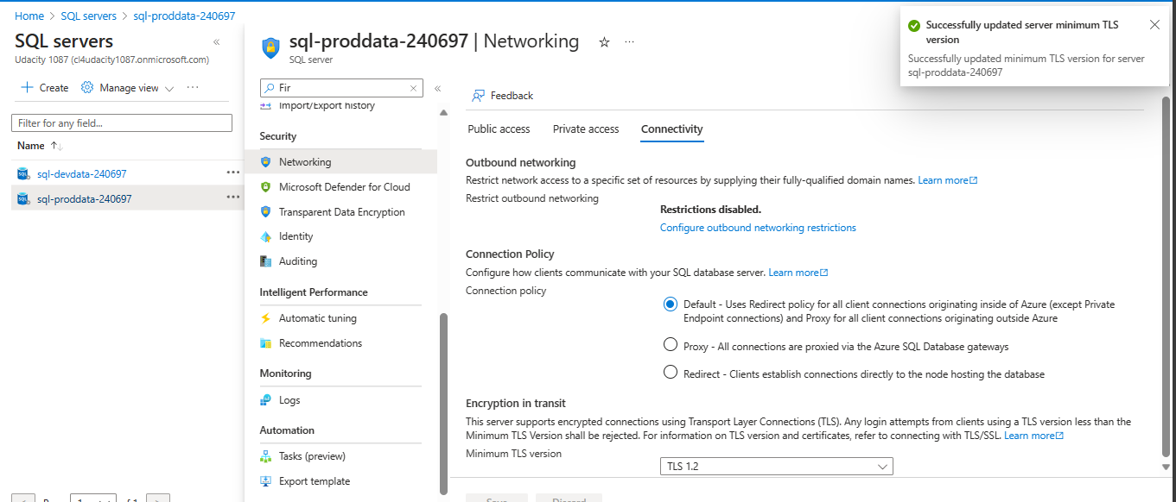

1. Proof of Azure Defender SQL server enabled(prod, dev)

1. Proof of Azure AD authentication for SQL enabled(prod, dev)

**Cloud Protection**

1. Proof of IaaSAntimalware enabled ( devapp,OpApp,HRL-Web, HRL-App,OpWeb)
2. Recommendations

**Monitoring**

1. Proof of Azure SQL auditing with Log analytics (devdata,proddata)

1. Proof of Sentinel connectors (2+)

**Compliance**

1. Proof of NIST SP 800-53 rev4 policy added

