LINUX PROGRAMMING ASSGNMENT REPORT
Assignee: Truong Hoang Quan
--------------------------------------------------------------------------------------------------------------------------

Assignment
Write a C program on Linux that runs 3 threads: SAMPLE, LOGGING, and INPUT. Specifically:
- SAMPLE Thread continuously performs the following task with a period of X nanoseconds (ns):
  - Reads the current system time (with nanosecond precision) and stores it in variable T.
- INPUT Thread monitors the file "freq.txt" to determine whether the sampling period X (of the SAMPLE thread) has been changed.
  - If a change is detected, it updates the period X accordingly.
  - The user can modify the desired period X by using a command such as echo to write a new value into the file "freq.txt".
- LOGGING Thread waits until a new value of T is available, then logs:
  - The current value of T, and
- The interval (the difference between the current value of T and the previous logged value) into a file named "time_and_interval.txt".
Additionally:
- Write a shell script to update the period value X in the file "freq.txt" every 1 minute.The values of X should be updated sequentially as follows:
  - 1000000 ns → 100000 ns → 10000 ns → 1000 ns → 100 ns
- Run both the shell script and the C program for 5 minutes, then stop the C program.
Analysis Task:
- Analyze the file "time_and_interval.txt":
- Plot a graph of the interval values corresponding to each period X.
- Evaluate and comment on the results.
Note: You may refer to The Linux Programming Interface by Michael Kerrisk (2010) for guidance
- Chapter 29: Threads: Introduction (for multithreading)
- Chapter 23: Timers and Sleeping (for time measurement)

Objective of the System
The assignment aims to design and evaluate a multi-threaded real-time-like system on Linux that:
- Generates periodic events with nanosecond resolution
- Supports dynamic reconfiguration at runtime
- Measures timing accuracy (interval/jitter)
- Uses synchronization mechanisms (mutex, condition variable)
- Evaluates system behavior under different timing constraints

Design

Thread Architecture:
The system is designed with 3 main threads separating responsibilities:
- INPUT Thread: Reads configuration from file and updates period.
- SAMPLE Thread: Periodically samples timestamp.
- LOGGING Thread: Logs timestamp and interval to file.

High-level architecture diagram
SAMPLE Thread
1.Periodic wakeup
2.Read period
3.Get current time
INPUT Thread
1.Read file
2.Update period
fred.txt
g_period_ns

g_T
g_new_sample
cond signal

LOGGING Thread
1.Wait condition
2.Calculate interval
3.Write log.txt

Detailed design

INPUT Thread (Configuration Control)
- Purpose:
  - Dynamically update system behavior at runtime
- Execution model:
  - Polling every 100 ms (non-blocking, low CPU cost)
- Main operations:
  - Read freq.txt
  - Detect changes (compare with previous value)
  - Validate input
  - Update: g_period_ns
- Advantages:
  - Uses polling interval (100 ms) → avoids busy loop
  - Uses change detection → avoid unnecessary updates

SAMPLE Thread (Core Timing Engine)
- Purpose:
  - Generate periodic timestamps (real-time behavior)
- Execution model:
  - Runs in precise periodic loop using: clock_nanosleep(..., TIMER_ABSTIME)
- Main operations:
  - Read current period (g_period_ns)
  - Sleep until next deadline
  - Capture timestamp: g_T = now_ns()
  - Notify LOGGING thread:
    - g_new_sample = 1
    - pthread_cond_signal()
- Advantages:
Technique | Benefit
TIMER_ABSTIME | No drift accumulation
Absolute time scheduling | Stable periodic execution
Short critical section | Minimal blocking
Signal-based wakeup | No polling overhead

LOGGING Thread (Consumer)
- Purpose:
  - Process sampled data and write to file
- Execution model:
  - Event-driven (blocking) using condition variable
- Main operations:
  - Wait for signal: pthread_cond_wait()
  - Read: g_T
  - Compute:
    - interval = g_T - prev_T
  - Write to log.txt
- Advantages:
  - No CPU waste (blocking wait)
  - Immediate response when data is ready
  - Decoupled from SAMPLE timing

Data Sharing & Synchronization

Shared Variables
Variable | Purpose
g_T | Latest timestamp
g_period_ns | Sampling period
g_new_sample | Event flag
g_running | Stop control

Synchronization Design

Mutex + Condition Variable
SAMPLE Thread
Lock

Update current time
Set new sample flag

Signal

LOGGING Thread

Critical Section Design
pthread_mutex_lock()
g_T = ...
g_new_sample = 1
pthread_cond_signal()
pthread_mutex_unlock()
Key idea:
- Keep critical section minimal
- Avoid long operations inside lock

Thread Interaction Sequence Diagram
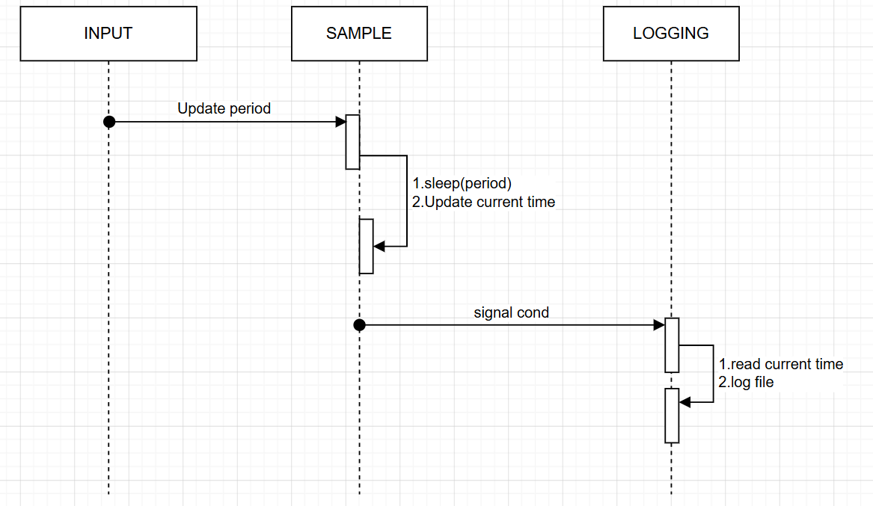

Interval Distribution Survey
