Câu 1:

a.

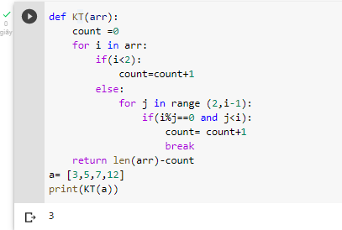

Câu 2:

-SELECT

SUM(grade), city

FROM salesman

GROUP BYT city;

-SELECT * from

Customer c join salesman s on

c.salesman_id =

c.salesman_id where

s.customer_id > 0.12

order by s.costomer_id