

CAPSTONE PROJECT REPORT
Report 3 – Software Requirement Specification

– Ho Chi Minh, October 2026 –

Table of Contents
I. Project Report 3
1. Status Report 3
2. Team Involvements 3
3. Issues/Suggestions 3
II. Software Requirement Specification 4
1. Overall Description 4
1.1 Product Overview 4
1.2 Business Rules 5
2. User Requirements 6
2.1 System Actors 6
2.2 Use Cases 6
3. Functional Requirements 8
3.1 System Functional Overview 8
3.2 <<Feature Name 1>> 10
3.3 <<Feature Name 2>> 10
4. Non-Functional Requirements 11
4.1 External Interfaces 11
4.2 Quality Attributes 12
5. Other Requirements 14
5.1 Appendix1 - Messages List 14
5.2 Appendix2 - … 14
5.3 … 14

I. Record of Changes
Date | A* M, D | In charge | Change Description
23/09/2026 | A | Lê Thị Trà Mi | Updated the Product Overview/Context Diagram description and revised the Screen Descriptions in Section 3.1.2 for consistency and clarity.
23/09/2026 | A | Cao Hữu Trí | Added Section 2.1 Actors, Section 2.2.2 Use Case Descriptions, and Section 3.1.2 Screen Descriptions, including actor definitions, use case details, and screen-level descriptions for HR Connect.
29/09/2026 | A | Cao Hữu Trí | Added Section 3.1.3 Screen Authorization and Section 3.1.4 Non-Screen Functions, including role-based screen access, screen activities, and backend system functions.
06/10/2026 | M | Trương Hoàng Quí | Aligned actors and use cases with the agreed role split (Client Company owns hiring decisions; Internal HR belongs to the platform operator). Renamed "Affiliate Recruiter" to "Affiliate". Reclassified the AI service as an internal subsystem. Completed the Screen Authorization matrix, extended Non-Screen Functions and Entity Descriptions.
06/10/2026 | A | Cao Hữu Trí | Added Sections 3.2 to 3.8 (feature specifications), Section 4 (Non-Functional Requirements) and Section 5 (Business Rules, Common Requirements, Messages List).
21/10/2026 | M | Trương Hoàng Quí | Aligned the SRS with the implemented system: probation removed; Headhunt COD warranty 30 days and Commission earned in full at the end of the warranty; Job visibility replaced by role view permissions per Service Type; PENDING_PAYMENT and Sourcing deposit; disputes, screening, warranty, service fee, Commission and Payout marked implemented; replacement slots, CV Sourcing delivery, CV Builder, job suggestions and real-time notifications added; planned Service Agreement (OTP signing) recorded; business rules confirmed.

*A - Added M - Modified D - Deleted
II. Software Requirement Specification
1. Product Overview
HR Connect is a new software system that replaces the current manual, spreadsheet and Zalo-based processes used by a recruitment agency to coordinate three service lines: Headhunt COD, CV Sourcing and CV Application. It brings Client Companies, Candidates, Affiliates and the agency's own staff onto a single Job and Candidate pipeline.
Release 1.0 covers company and job management, candidate and CV management, candidate submission with duplicate detection and Affiliate attribution, AI-assisted CV-to-JD matching, the interview, offer and placement pipeline, and the recording of service fees, commissions and payouts. Money transfers are performed outside the system: HR Connect records amounts, dates, references and evidence but does not connect to banks or payment gateways in this release.
The context diagram below shows the external entities and interfaces of release 1.0. The human actors are Guest, Candidate, Affiliate, Client Company User, Internal HR and Platform Admin. The external systems are the Email Service (transactional email such as OTP, submission consent requests and notifications) and the Object Storage service (CV files and images). The AI Matching Service is developed as part of this project and is therefore shown inside the system boundary, not as an external entity.
Later releases may connect to banking APIs for automated commission payouts and to Human Resource Information Systems (HRIS) for employee management after the warranty.
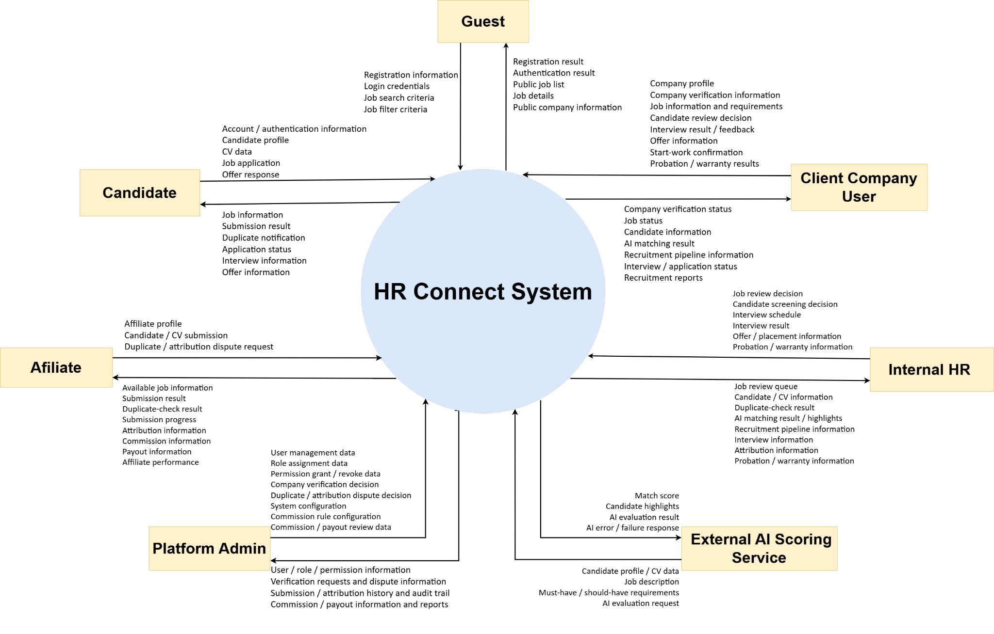
Figure 1. Context Diagram of the HR Connect System
2. User Requirements
2.1 Actors

Table 2.1. HR Connect System Actors
# | Actor | Description
01 | Guest | An unauthenticated user who can view public information, search and view public Jobs, register an account and log in. A Guest can also open a submission consent link received by email.
02 | Platform Admin | A platform-level administrator responsible for user management, Company verification, Affiliate approval, system configuration (Service Types, Commission Rules), dispute handling, audit review, recording service fee payments, approving Commissions and recording Payouts. Platform Admin is not the actor for daily Candidate screening.
03 | Internal HR | A staff member of the platform operator (not of the Client Company). Internal HR reviews and approves Jobs, screens Candidates for services where the platform sources the Candidate (Headhunt COD, CV Sourcing), verifies resignations reported during the warranty, delivers CV Sourcing CVs, and will reconcile Placements before a Headhunt COD fee is charged (planned). Internal HR does not schedule Interviews, record Interview Results or create Offers; these belong to the Client Company.
04 | Client Company User | A representative of a Client Company and the owner of hiring decisions for that Company's Jobs. Manages the Company profile and Jobs, screens Candidates for CV Application Jobs, schedules Interviews, records Interview Results, creates and sends Offers, and confirms Start Work, all within the Company scope.
05 | Candidate | A job seeker whose profile and CVs are managed in the system. A Candidate may search Jobs, manage profile and CVs, apply to public Jobs, confirm or decline a submission made by an Affiliate, view Interview schedules, and respond to Offers. A Candidate record may exist without a user account when it was created by an Affiliate.
06 | Affiliate | An external individual or partner who introduces Candidates to eligible Jobs in exchange for Commission. Views Jobs open to partners, submits Candidates and CVs, tracks own Submissions and Attribution, raises disputes, and views own Commission, Payout and performance.

External systems that interact with HR Connect:
Table 2.1b. External Systems
# | System | Description
E1 | Email Service | External provider used to deliver transactional email: registration OTP, password reset, submission consent requests and result notifications.
E2 | Object Storage | External S3-compatible storage for CV files and images. HR Connect issues temporary signed URLs for authorized access.

The AI Matching Service is an internal subsystem of HR Connect, built by the project team. It is not an actor. Its behaviour is specified as system functions in Section 3.1.4 and Section 3.5.
2.2 Use Cases
A Use Case describes an interaction between one or more actors and HR Connect to achieve a business goal. The Use Case Diagram focuses on goal-level business Use Cases. Internal processing such as duplicate checking, Application creation, AI evaluation, Commission calculation or permission checking is described in Functional Requirements and is not modeled as an independent actor goal.
2.2.1 Diagram(s)
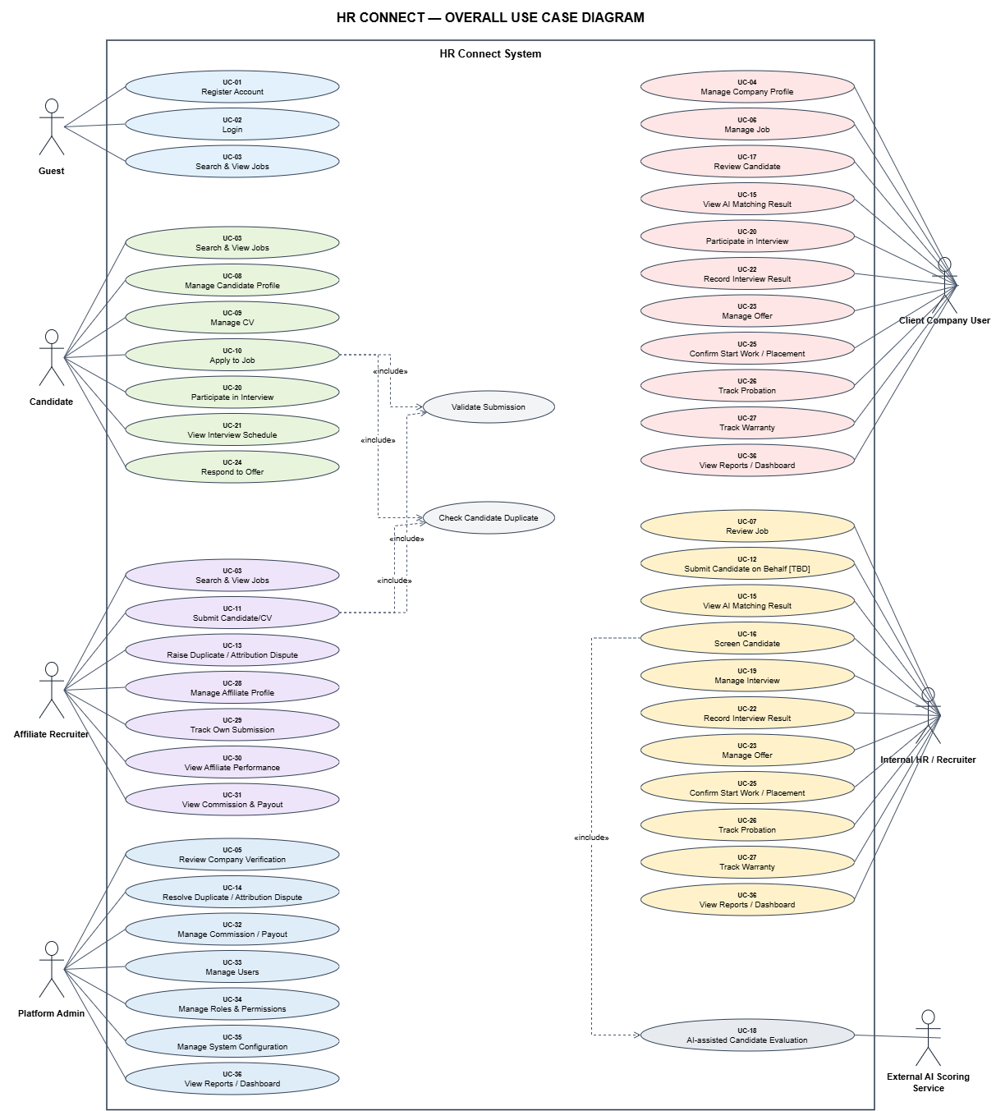
Figure 2.2.1. Overall Use Case Diagram of the HR Connect System
2.2.2 Descriptions
Public & Authentication
Table 2.2.2 a) Public and Authentication Use Cases
ID | Use Case | Actors | Use Case Description
UC-01 | Register Account | Guest | Allows a Guest to create a Candidate, Affiliate or Client account. The account is activated after email verification; Affiliate and Client accounts also require approval.
UC-02 | Login | Registered User (all roles) | Allows a registered user to authenticate with valid credentials and enter the system according to the assigned Role and Permissions.
UC-37 | Verify Email / Recover Password | Guest, Registered User | Allows a user to verify the registered email with a one-time code, and to reset a forgotten password through a one-time code sent by email.
UC-03 | Search & View Jobs | Guest, Candidate, Affiliate | Allows users to search, filter and view Jobs visible within their access scope. Guests and Candidates see CV Application Jobs; Affiliates see Headhunt COD and CV Sourcing Jobs.

Company & Job Management
Table 2.2.2 b) Company and Job Management Use Cases
ID | Use Case | Actors | Use Case Description
UC-04 | Manage Company Profile | Client Company User | Allows a Client Company User to create and update the profile of the Company they represent and submit it for verification.
UC-05 | Review Company Verification | Platform Admin | Allows Platform Admin to review Company verification information and approve or reject it with a reason.
UC-06 | Manage Job | Client Company User | Allows a Client Company User to create, edit, submit, pause, resume and close a Job, including JD, Must-have and Should-have requirements and Service Type; for Headhunt COD and CV Sourcing the Client also proposes commercial terms.
UC-07 | Review Job | Internal HR | Allows Internal HR to review a submitted Job and approve it for publication or reject it with a reason code.
UC-44 | Agree and Sign Service Agreement | Client Company User, Internal HR | Allows Internal HR to send a versioned Service Agreement for a Headhunt COD or CV Sourcing Job, and the Client to accept it or request changes and sign it with a one-time password; the signed agreement is stored as a private PDF. [Planned]

Candidate & CV
Table 2.2.2 c) Candidate and CV Management Use Cases
ID | Use Case | Actors | Use Case Description
UC-08 | Manage Candidate Profile | Candidate | Allows a Candidate to view and update personal and professional profile information and profile visibility.
UC-09 | Manage CV | Candidate | Allows a Candidate to upload, update, delete and manage multiple CVs and choose a primary CV.
UC-46 | Build CV and View Job Suggestions | Candidate | Allows a Candidate to build a CV from a template and export it as a PDF, and to view Jobs suggested by AI matching when the profile is public and has a primary CV.

Candidate/CV Submission
Table 2.2.2 d) Candidate and CV Submission Use Cases
ID | Use Case | Actors | Use Case Description
UC-10 | Apply to Job | Candidate | Allows a Candidate to apply to a public Job with one CV when self-application is permitted for the Job's Service Type.
UC-11 | Submit Candidate/CV | Affiliate | Allows an approved Affiliate to submit a Candidate and CV to an eligible Job. The submission is validated, checked for duplicates and then waits for the Candidate's consent.
UC-38 | Respond to Submission Consent | Candidate | Allows a Candidate to confirm or decline a submission made on their behalf by an Affiliate, through an emailed link or after logging in.
UC-40 | Withdraw Application | Candidate | Allows a Candidate to withdraw an own Application that has not reached Placement.

Duplicate & Attribution Dispute
Table 2.2.2 e) Duplicate and Attribution Dispute Use Cases
ID | Use Case | Actors | Use Case Description
UC-13 | Raise Duplicate / Attribution Dispute | Affiliate | Allows an Affiliate to raise a dispute, within the dispute window, when disagreeing with a duplicate detection or Attribution result.
UC-14 | Resolve Duplicate / Attribution Dispute | Platform Admin | Allows Platform Admin to review Candidate identity, Submission history, timestamps, Attribution and evidence, and uphold or reject the dispute; an upheld dispute transfers the Attribution.

AI Matching & Screening
Table 2.2.2 f) AI Matching and Screening Use Cases
ID | Use Case | Actors | Use Case Description
UC-15 | View AI Matching Result | Internal HR, Client Company User | Allows an authorized reviewer to view the AI Match Score, Match Tier, Candidate Highlight and per-requirement evidence for an Application.
UC-16 | Screen Candidate | Client Company User (CV Application); Internal HR (Headhunt COD, CV Sourcing) | Allows the authorized reviewer for the Job's Service Type to shortlist or reject an Application, using the CV and the AI-assisted result. A rejection requires a reason.
UC-17 | Review Candidate | Client Company User | Allows a Client Company User to review Candidate information and recruitment status for Candidates on the Company's Jobs. For Headhunt COD and CV Sourcing, only shortlisted Candidates are visible.
UC-45 | Review Delivered CVs (CV Sourcing) | Client Company User | Allows a Client Company User to accept or reject, with a reason, each CV delivered by Internal HR for a CV Sourcing Job within the review period; a CV not answered in time is accepted automatically.
UC-18 | (Removed) | — | AI-assisted Candidate Evaluation is reclassified as a system function (Section 3.1.4, functions 9, 10 and 16) because the AI Matching Service is an internal subsystem, not an actor.

Interview Management
Table 2.2.2 g) Interview Management Use Cases
ID | Use Case | Actors | Use Case Description
UC-19 | Manage Interview | Client Company User | Allows the Client Company to schedule, update, reschedule and cancel Interviews for shortlisted Candidates on its Jobs.
UC-20 | Participate in Interview | Candidate, Client Company User | Represents Candidate and Client participation in an Interview arranged through the recruitment process.
UC-21 | View Interview Schedule | Candidate | Allows a Candidate to view own Interview schedule information.
UC-22 | Record Interview Result | Client Company User | Allows the Client Company to record the Interview Result (PASS, FAIL or BACKUP), record a no-show, and decide on backup Candidates.

Offer & Placement
Table 2.2.2 h) Offer and Placement Use Cases
ID | Use Case | Actors | Use Case Description
UC-23 | Manage Offer | Client Company User | Allows the Client Company to create an Offer draft, update it, send it to the Candidate and withdraw it with a reason.
UC-24 | Respond to Offer | Candidate | Allows a Candidate to view an Offer and accept or decline it.
UC-25 | Confirm Start Work / Placement | Client Company User | Allows the Client Company to confirm the planned start date and confirm that the Candidate actually started work, which records the Placement; or to mark the Candidate as not started with a reason.
UC-41 | Reconcile Placement | Internal HR | Allows Internal HR to verify a confirmed Placement, or a not-started result, with the Candidate or Affiliate before a Headhunt COD service fee is charged. [Planned]

Warranty
Table 2.2.2 i) Warranty Use Cases
ID | Use Case | Actors | Use Case Description
UC-26 | (Removed) | — | Probation tracking is out of scope (team decision of 17/10/2026). Commission depends only on the Warranty.
UC-27 | Track Warranty | Internal HR, Client Company User | Allows the Client Company to report that a placed Candidate left during the warranty period, Internal HR to confirm or dismiss the report, and the Client to fill the replacement slot opened by a confirmed resignation.

Affiliate Management
Table 2.2.2 k) Affiliate Management Use Cases
ID | Use Case | Actors | Use Case Description
UC-28 | Manage Affiliate Profile | Affiliate | Allows an Affiliate to view and update the Affiliate profile and bank account information.
UC-39 | Review Affiliate Application | Platform Admin | Allows Platform Admin to approve or reject an Affiliate registration.
UC-29 | Track Own Submission | Affiliate | Allows an Affiliate to view own Submissions, resend a consent request, and follow high-level recruitment progress.
UC-30 | View Affiliate Performance | Affiliate | Allows an Affiliate to view own performance, including submission-to-hire conversion.
UC-31 | View Commission & Payout | Affiliate | Allows an Affiliate to view Commission and Payout history for own valid Attribution records, with the progress of each Commission.

Service Fee, Commission & Payout
Table 2.2.2 l) Service Fee, Commission and Payout Use Cases
ID | Use Case | Actors | Use Case Description
UC-43 | Record Service Fee Payment | Platform Admin | Allows Platform Admin to record that a Client Company has paid a posting fee, service fee or CV Sourcing deposit, with a payment reference, after reconciling the bank statement.
UC-32 | Manage Commission / Payout | Platform Admin | Allows Platform Admin to review and approve earned Commission, hold, adjust or cancel it with a reason, and record successful or failed Payouts.

Administration
Table 2.2.2 m) Administration Use Cases
ID | Use Case | Actors | Use Case Description
UC-33 | Manage Users | Platform Admin | Allows Platform Admin to view user accounts, suspend or reactivate an account, and unlock a locked login.
UC-34 | Manage Roles & Permissions | Platform Admin | Allows Platform Admin to view Roles and system-defined Permissions, adjust Role-Permission assignment and assign Roles to users.
UC-35 | Manage System Configuration | Platform Admin | Allows Platform Admin to maintain Service Types, the Roles allowed to submit per Service Type, Commission Rules and Commission Milestones.
UC-42 | View Audit Log | Platform Admin | Allows Platform Admin to search and view audit records of security-sensitive and business-sensitive actions.

Reporting
Table 2.2.2 n) Reporting Use Cases
ID | Use Case | Actors | Use Case Description
UC-36 | View Reports / Dashboard | Platform Admin, Internal HR, Client Company User | Allows authorized users to view dashboards and reports, including revenue by Service Type and Affiliate performance, according to Role, Permission and data scope.

3. Functional Requirements
3.1 System Functional Overview
HR Connect supports Company and Job management, Candidate and CV management, Candidate submission with duplicate detection, Affiliate attribution, AI-assisted Candidate-to-Job matching, screening, Interview and Offer management, Placement, post-placement tracking, service fee, Commission and Payout recording, administration and reporting.
The system supports the following roles: Guest, Candidate, Affiliate, Client Company User, Internal HR and Platform Admin. An internal AI Matching Service scores each Application against its Job. The AI service supports scoring and ranking only; every recruitment decision remains under human control.
3.1.1 Screens Flow
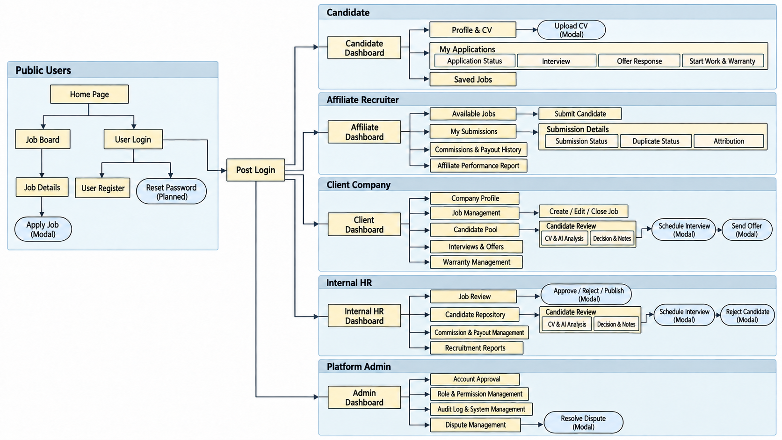
Figure 3.1.1. Overall Screen Flow of the HR Connect System
3.1.2 Screen Descriptions
Table 3.1.2. HR Connect Screen Descriptions
# | Feature | Screen | Description
1 | Public | Home / Public Information | Displays public information about HR Connect and its three services.
2 | Public | Job Search | Allows users to search and filter Jobs visible to them.
3 | Public | Job Detail | Displays Job information according to the public or authorized access scope.
4 | Authentication | Register | Allows a Guest to register a Candidate, Affiliate or Client account and verify the email by OTP.
5 | Authentication | Login | Authenticates the user and redirects according to Role. Includes forgot-password.
6 | Submission | Submission Consent Response | Opened from an emailed link. Shows the Job and the submitting Affiliate and lets the Candidate confirm or decline.
7 | Candidate | Candidate Dashboard | Overview of the Candidate's profile, Applications, Interviews and Offers.
8 | Candidate | Candidate Profile | Allows the Candidate to view and update the profile and its visibility.
9 | Candidate | My CVs | Allows the Candidate to upload, update, delete and manage CVs and set a primary CV.
10 | Submission | Apply to Job | Allows the Candidate to apply to a public Job with one CV.
11 | Candidate | My Applications | Displays the Candidate's Applications and status, and allows withdrawal.
12 | Candidate | Offer Detail | Allows the Candidate to view an Offer and accept or decline it.
13 | Affiliate | Affiliate Dashboard | Overview of the Affiliate's Submissions, Commissions and performance.
14 | Affiliate | Affiliate Profile | Allows the Affiliate to view and update the profile and bank account.
15 | Submission | Submit Candidate/CV | Allows an Affiliate to submit a new Candidate, or one from the own candidate library, to a Job.
16 | Affiliate | My Submissions | Displays the Affiliate's Submissions, consent status and high-level progress; allows resending a consent request.
17 | Attribution | Submission / Attribution Detail | Displays submission source, consent result and Attribution within the permitted scope.
18 | Dispute | Raise Dispute | Allows an Affiliate to raise a Duplicate or Attribution Dispute.
19 | Affiliate | Commission & Payout | Displays Commission and Payout information of the Affiliate.
20 | Affiliate | Affiliate Performance | Displays the Affiliate's performance and conversion metrics.
21 | Client | Client Dashboard | Overview of the Company's recruitment activities.
22 | Company | Company Profile | Allows the Client Company User to create or update the Company profile and submit verification.
23 | Job | Job Management | Displays and manages Jobs of the Company, including pause, resume and close.
24 | Job | Create / Edit Job | Allows the Client Company User to create or edit a Job: JD, Must-have and Should-have requirements, Service Type and proposed commercial terms.
25 | Recruitment | Candidate Pipeline | Displays Applications of a Job or Company by status.
26 | Recruitment | Candidate Review Detail | Displays Candidate information, CV, AI-assisted result and recruitment status.
27 | Interview | Interview Management | Allows the Client Company to schedule, update, reschedule or cancel Interviews and record results or no-shows.
28 | Interview | Interview Detail | Displays an Interview schedule, status, result and history. Candidates see their own schedule.
29 | Offer | Offer Management | Allows the Client Company to create, update, send and withdraw Offers.
30 | Placement | Placement Detail | Confirms planned start date and actual Start Work, or records Not Started with a reason.
31 | Post-placement | Warranty | Tracks the warranty period, resignation reports and replacement slots.
32 | Internal HR | HR Dashboard | Displays the Job review queue, screening queue and workload.
33 | Job Review | Job Review Queue | Displays Jobs waiting for review by Internal HR.
34 | Screening | Screening Workspace | Displays the CV and AI-assisted result and allows the authorized reviewer to shortlist or reject.
35 | Admin | Admin Dashboard | Overview of system-level information and pending approvals.
36 | Administration | User Management | Allows Platform Admin to view accounts, suspend or reactivate them and unlock logins.
37 | Administration | Role & Permission Management | Allows Platform Admin to view Roles and Permissions.
38 | Administration | Company Verification | Allows Platform Admin to review Company verification requests.
39 | Administration | Affiliate Application Review | Allows Platform Admin to approve or reject Affiliate registrations.
40 | Administration | Dispute Management | Allows Platform Admin to review disputes and supporting evidence.
41 | Finance | Service Fee Receivables | Lists service fees owed by Client Companies and lets Platform Admin record payments.
42 | Finance | Commission Management | Allows Platform Admin to review, approve or hold earned Commissions.
43 | Finance | Payout Management | Allows Platform Admin to record and track Payouts. Money transfer happens outside the system.
44 | Administration | System Configuration | Allows Platform Admin to manage Service Types, allowed roles, Commission Rules and Milestones.
45 | Audit | Audit Trail | Allows Platform Admin to search audit records.
46 | Reporting | Reports / Dashboard | Displays dashboards and reports according to Role and data scope.
47 | Candidate | CV Builder | Allows the Candidate to build a CV from a template and export it as a PDF.
48 | Candidate | Job Suggestions | Displays Jobs suggested by AI matching for a public profile with a primary CV.
49 | Recruitment | Sourcing Deliveries | Allows the Client to accept or reject CVs delivered for a CV Sourcing Job.
50 | Administration | Business Settings | Allows Platform Admin to change configurable business values (consent, dispute and warranty periods, fees, limits).
51 | Support | Contact Requests | Allows Internal HR and Platform Admin to process contact form requests.
52 | Job | Service Agreement | Allows the Client to review, accept or request changes to, and sign the Service Agreement of a Job. [Planned]

3.1.3 Screen Authorization
Legend: X = full access; S = access scoped to the user's own data or own Company; R = read-only access for support and oversight; — = no access. For Screening Workspace, access depends on the Job's Service Type.
Table 3.1.3. HR Connect Screen Authorization Matrix
Screen | Guest | Candidate | Affiliate | Client | Internal HR | Platform Admin
Home / Public Information | X | X | X | X | X | X
Job Search / Job Detail | X | X | X | X | X | X
Register | X | — | — | — | — | —
Login | X | X | X | X | X | X
Submission Consent Response | X (by link) | S | — | — | — | —
Candidate Dashboard | — | S | — | — | — | —
Candidate Profile | — | S | — | — | R | R
My CVs | — | S | — | — | R | —
Apply to Job | — | S | — | — | — | —
My Applications | — | S | — | — | — | —
Offer Detail | — | S | — | — | — | —
Affiliate Dashboard | — | — | S | — | — | —
Affiliate Profile | — | — | S | — | — | R
Submit Candidate/CV | — | — | S | — | — | —
My Submissions | — | — | S | — | R | R
Submission / Attribution Detail | — | — | S | — | R | R
Raise Dispute | — | — | S | — | — | —
Commission & Payout | — | — | S | — | R | R
Affiliate Performance | — | — | S | — | R | R
Client Dashboard | — | — | — | S | — | —
Company Profile | — | — | — | S | R | R
Job Management | — | — | — | S | R | R
Create / Edit Job | — | — | — | S | — | —
Candidate Pipeline | — | — | — | S | X | —
Candidate Review Detail | — | — | — | S | X | —
Interview Management | — | — | — | S | R | —
Interview Detail | — | S | — | S | R | —
Offer Management | — | — | — | S | R | —
Placement Detail | — | — | — | S | X | —
Warranty | — | — | — | S | X | —
HR Dashboard | — | — | — | — | X | —
Job Review Queue | — | — | — | — | X | X
Screening Workspace | — | — | — | S (CV Application) | X (Headhunt COD, CV Sourcing) | —
Admin Dashboard | — | — | — | — | — | X
User Management | — | — | — | — | — | X
Role & Permission Management | — | — | — | — | — | X
Company Verification | — | — | — | — | — | X
Affiliate Application Review | — | — | — | — | — | X
Dispute Management | — | — | — | — | R | X
Service Fee Receivables | — | — | — | S | R | X
Commission Management | — | — | — | — | R | X
Payout Management | — | — | — | — | R | X
System Configuration | — | — | — | — | — | X
Audit Trail | — | — | — | — | — | X
Reports / Dashboard | — | — | — | S | S | X
CV Builder | — | S | — | — | — | —
Job Suggestions | — | S | — | — | — | —
Sourcing Deliveries | — | — | — | S | X | R
Business Settings | — | — | — | — | — | X
Contact Requests | — | — | — | — | X | X
Service Agreement | — | — | — | S | X | R

3.1.4 Non-Screen Functions
Table 3.1.4. HR Connect Non-Screen Functions
# | Feature | System Function | Description
1 | Authentication | Verify Email OTP | Verifies the one-time code associated with the registered email and its expiry.
2 | Authentication | Resolve Effective Permissions | Determines effective permissions from the user's active Roles.
3 | Authentication | Lock Login after Failed Attempts | Locks a login for 15 minutes after 5 consecutive failed attempts; Platform Admin can unlock it earlier.
4 | Submission | Validate Submission Eligibility | Checks Job status, Job visibility, Service Type and whether the actor's Role is allowed to submit for that Service Type.
5 | Candidate Identity | Resolve Candidate Identity | Normalizes email and phone, finds an existing Candidate by exact match, or creates a new Candidate.
6 | Duplicate Detection | Check Candidate Duplicate | Determines, synchronously, whether the same Candidate has already been submitted to the same Job.
7 | Submission | Record Blocked Duplicate | Stores a BLOCKED_DUPLICATE Submission and an audit entry without creating another Application.
8 | Submission | Expire Submission Consent | Marks a pending consent request as expired after the configured period (48 hours by default) and archives the pending CV.
9 | Application | Create Application | Creates the single recruitment Application for an accepted Submission.
10 | Attribution | Establish Affiliate Attribution | Records the Affiliate as the source of the Application when the Candidate confirms the Affiliate's submission.
11 | AI Matching | Queue AI Evaluation | Queues the Application for evaluation by the AI Matching Service and dispatches the CV and Job requirements.
12 | AI Matching | Store AI Evaluation Result | Stores Match Score, Match Tier, Candidate Highlight, per-requirement evidence and evaluation status.
13 | AI Matching | Retry AI Evaluation | Retries a failed or timed-out evaluation with increasing delay up to a maximum number of attempts.
14 | Recruitment | Record Status History | Records every Job, Application and Interview status change with actor, time and reason.
15 | Notification | Send Email through Outbox | Queues outgoing email and delivers it through the Email Service, recording delivery status.
16 | Service Fee | Create Service Fee Receivable | Creates the amount owed by the Client Company when a fee trigger occurs: activation of a paid CV Application package, approval of a CV Sourcing Job (deposit) and accepted CVs, or Start Work for Headhunt COD.
17 | Commission | Check Commission Eligibility | Determines whether an attributed Affiliate has earned Commission: the Warranty is completed for Headhunt COD, or a CV is accepted for CV Sourcing.
18 | Commission | Calculate Commission | Calculates Commission according to the Service Type and Commission Rule and stores a snapshot of the rule used.
19 | Audit | Record Audit Trail | Records security-sensitive and business-sensitive actions such as logins, approvals, status changes and dispute decisions.
20 | Storage | Generate CV Signed URL | Generates a temporary signed URL for an authorized CV access request and audits the access.
21 | Notification | Push Real-time Notification | Pushes each new notification to the user over a WebSocket (SignalR) after the transaction commits, with polling as fallback.
22 | Warranty | Progress Warranty and Commission | Runs daily: completes warranties that ended, marks Headhunt COD Commission EARNED and opens or expires replacement slots.
23 | CV Sourcing | Auto-accept Delivered CV | Accepts a delivered CV that the Client has not answered within the review period.
24 | Job Matching | Suggest Jobs to Candidates | Periodically matches public Candidate profiles to open Jobs and notifies the Candidate within a daily limit.

3.1.5 Entity Relationship Diagram
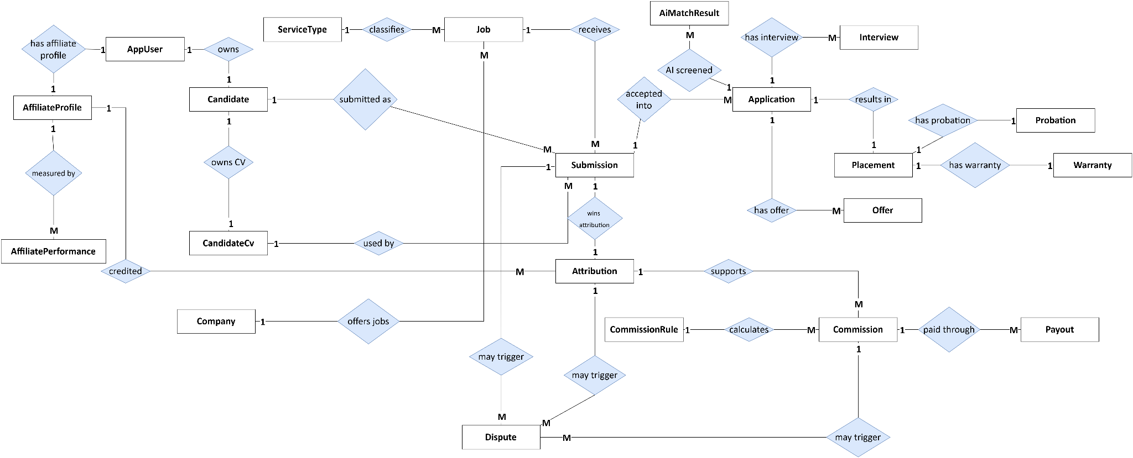
Figure 3.1.5. Core Entity Relationship Diagram of the HR Connect System
Entities Description
Table 3.1.5. HR Connect Entity Descriptions
# | Entity | Description
1 | AppUser | Login identity and basic account information. A user may hold one or more Roles.
2 | AffiliateProfile | Profile of an Affiliate, including contact, approval status and bank account information.
3 | Company | Client Company that creates recruitment demand and Jobs; holds the verification status.
4 | CompanyUser | Links a user to the Company they represent.
5 | Candidate | Master record of a Candidate with normalized identity (email, phone) and profile.
6 | CandidateCv | A CV belonging to a Candidate, used for submission and AI matching.
7 | ServiceType | Recruitment service model of a Job: HEADHUNT_COD, CV_SOURCING or CV_APPLICATION, with the Roles allowed to submit.
8 | Job | Recruitment Job with description, quantity, status, Client Company, Service Type and commercial terms.
9 | JobRequirement | A Must-have or Should-have requirement of a Job, used by AI matching.
10 | Submission | One attempt to submit a Candidate and CV to a Job: source, time, status and duplicate reference.
11 | SubmissionConsent | The Candidate's consent request for an Affiliate submission: status and expiry.
12 | Application | The single recruitment process of a Candidate for a Job, created from an accepted Submission.
13 | ApplicationStatusHistory | History of Application status changes.
14 | Attribution | The Affiliate credited as the source of an Application, based on the winning accepted Submission.
15 | AiMatchResult | AI-assisted matching result: Match Score, Match Tier, Candidate Highlight and requirement assessments.
16 | MatchTierConfig | Configurable score thresholds and colours of Match Tiers.
17 | Interview | Interview round, schedule, status, result and feedback of an Application.
18 | Offer | Offer issued for an Application: version, terms, status and Candidate response.
19 | Placement | Confirmed actual start-work record of an Application.
20 | Probation | Kept in the schema but not used: probation tracking is out of scope.
21 | Warranty | Warranty period and result after Placement.
22 | CommissionRule | Commission calculation rule per Service Type and milestone.
23 | CommissionMilestone | Reference catalogue kept for configuration; Headhunt COD Commission is earned at a single point, at the end of the Warranty.
24 | Commission | Commission generated for an Affiliate from Attribution, Placement and Commission Rule.
25 | Payout | Payment record of an approved Commission: amount, date, reference and evidence.
26 | Dispute | Dispute on a Submission, Attribution or Commission.
27 | AffiliatePerformance | Aggregated Affiliate metrics: Submissions, Shortlists, Interviews, Placements, conversion.
28 | Notification | In-system notification sent to a user.
29 | AuditLog | Audit record of a sensitive action.
30 | ServiceFee | Amount owed by a Client Company (posting fee, service fee or deposit) with due date, status and payment reference.
31 | SourcingDelivery | A CV delivered to the Client for a CV Sourcing Job, with review deadline and decision.
32 | ReplacementSlot | Replacement opened when a resignation within the Warranty is confirmed; filling it creates no new fee.
33 | BusinessSetting | Configurable business value (periods, fees, rates, limits) used at run time.
34 | ContactRequest | A request sent through the public contact form and its handling status.
35 | ServiceAgreement | Versioned agreement of commercial terms, Client response, OTP signature evidence and PDF reference. [Planned]

Sections 3.2 to 3.8 specify each feature. Every function is described with its trigger, actors, processing, validation and business rules, and result. The "Status" row states whether the function exists in the current backend. Screen mock-ups are to be inserted by the team where marked.
3.2 Authentication and Account
3.2.1 Register Account
Item | Specification
Trigger | A Guest chooses "Register" and selects an account type.
Actors | Guest
Description | Creates a Candidate, Affiliate or Client account and starts email verification.
Preconditions | The email is not already registered.
Main processing | 1. The Guest enters the registration data for the chosen account type.  2. The system validates the data and creates the account in an unverified state.  3. The system sends a one-time code to the email address.  4. For Affiliate and Client accounts, the system creates an approval request for Platform Admin.
Validation and business rules | - Email must be unique after normalization.  - Password must meet the password policy (BR-03).  - Affiliate and Client accounts cannot use role-specific functions until approved (BR-02).
Result | An unverified account exists and an OTP email has been sent.
Status | Implemented in backend

3.2.2 Verify Email OTP
Item | Specification
Trigger | The user submits the code received by email.
Actors | Guest
Description | Confirms ownership of the registered email.
Preconditions | An unverified account with a valid, unexpired code exists.
Main processing | 1. The user enters the code.  2. The system checks the code and its expiry.  3. The system marks the email as verified.
Validation and business rules | - The code has 6 digits and is valid for 15 minutes.  - An expired or incorrect code is rejected (MSG05); after 5 incorrect - attempts the code is invalidated and a new one must be requested.  - Requests for a new code are limited to 5 per 10 minutes.
Result | The account email is verified.
Status | Implemented in backend

3.2.3 Login
Item | Specification
Trigger | The user submits email and password.
Actors | Registered User
Description | Authenticates the user and issues an access token and a refresh token.
Preconditions | The account is verified and active.
Main processing | 1. The system verifies the credentials.  2. The system resolves the user's active Roles and Permissions.  3. The system issues tokens and records the login in the audit log.  4. The client redirects the user to the dashboard for the Role.
Validation and business rules | -After 5 consecutive failed attempts the login is locked for 15 minutes (BR-04, MSG07).  - A suspended account cannot log in (MSG08).  - The same error message is shown for unknown email and wrong password (MSG04).  -The access token is valid for 60 minutes and the refresh token for 7 days.  - Login requests are limited to 10 per minute from the same client.
Result | The user is authenticated.
Status | Implemented in backend

3.2.4 Recover Password
Item | Specification
Trigger | The user chooses "Forgot password".
Actors | Guest, Registered User
Description | Resets the password through a one-time code sent by email.
Preconditions | None.
Main processing | 1. The user enters the email address.  2. The system sends a reset code if the email is registered.  3. The user enters the code and a new password.  4. The system updates the password and revokes existing sessions.
Validation and business rules | - The reset code has 6 digits and is valid for 15 minutes.  - Reset requests are limited to 5 per 10 minutes from the same client.
Result | The password is changed and previous sessions are invalid.
Status | Implemented in backend

3.3 Company and Job Management
This feature covers Main Flow MF-01. The activity diagram below shows the creation, review and publication of a Job.
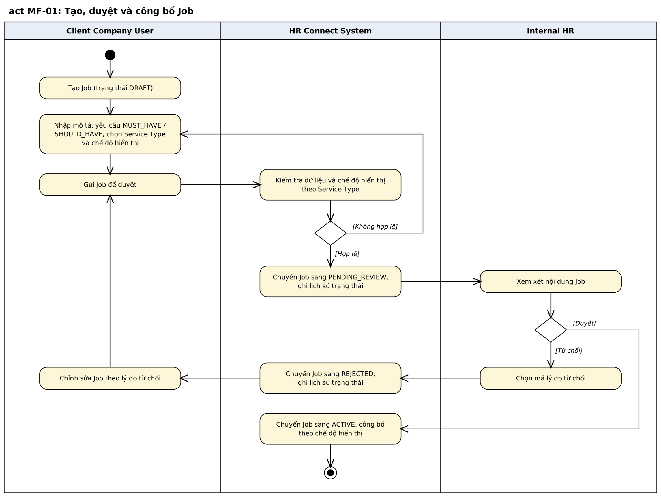
Figure 3.3. Activity Diagram: Create, Review and Publish Job
3.3.1 Manage Company Profile and Verification
Item | Specification
Trigger | A Client Company User opens Company Profile.
Actors | Client Company User, Platform Admin
Description | Maintains the Company profile and obtains verification.
Preconditions | The user is linked to a Company.
Main processing | 1. The Client Company User enters or updates Company information.  2. The user submits the profile for verification.  3. Platform Admin reviews the request and approves or rejects it with a reason.  4. The system updates the Company verification status and notifies the user.
Validation and business rules | - Only a verified Company can submit Jobs for review (BR-05).  - A rejection requires a reason.
Result | The Company is VERIFIED or REJECTED.
Status | Implemented in backend

3.3.2 Create and Edit Job
Item | Specification
Trigger | A Client Company User chooses "Create Job" or edits a Job.
Actors | Client Company User
Description | Creates a Job in DRAFT or edits an editable Job.
Preconditions | The Company is verified.
Main processing | 1. The user enters title, description, benefits, location, salary, experience, quantity and employment type. 2. The user adds Must-have and Should-have requirements. 3. The user selects the Service Type; for Headhunt COD and CV Sourcing the user proposes commercial terms (fee multiplier, warranty, payment term, price per CV and sourcing target). 4. The system validates and saves the Job as DRAFT.
Validation and business rules | - Who can view the Job follows the role view permission of its Service Type (BR-07). - Service Type is fixed at the Job; submitters do not choose it (BR-06). - Concurrent edits are detected; the later save is rejected (MSG12).
Result | A Job in DRAFT is saved.
Status | Implemented in backend

3.3.3 Submit and Review Job
Item | Specification
Trigger | The Client Company User submits a Job; Internal HR opens the Job Review Queue.
Actors | Client Company User, Internal HR
Description | Moves a Job through review to publication.
Preconditions | The Job is DRAFT or REJECTED.
Main processing | 1. The Client Company User submits the Job; status becomes PENDING_REVIEW. 2. Internal HR reviews the description, requirements, Service Type and proposed terms. 3. Internal HR approves or rejects with a reason code. On approval a CV Application Job becomes ACTIVE (free package) or PENDING_PAYMENT (paid package); a Headhunt COD Job becomes ACTIVE with the confirmed terms; a CV Sourcing Job becomes PENDING_PAYMENT until the deposit is recorded. 4. A rejected Job can be edited and submitted again. 5. [Planned] Headhunt COD and CV Sourcing Jobs will instead wait in PENDING_AGREEMENT until the Client signs the Service Agreement (UC-44).
Validation and business rules | - Allowed transitions are defined in BR-08.  - Every status change is recorded with actor, time and reason (BR-30).
Result | The Job is ACTIVE or PENDING_PAYMENT, or REJECTED and returned to the Client.
Status | Implemented in backend

3.3.4 Pause, Resume and Close Job
Item | Specification
Trigger | The Client Company User chooses Pause, Resume or Close.
Actors | Client Company User
Description | Controls whether an active Job accepts submissions.
Preconditions | The Job is ACTIVE or PAUSED and belongs to the user's Company.
Main processing | 1. The user selects the action and a reason.  2. The system changes the status: ACTIVE to PAUSED, PAUSED to ACTIVE, or either to CLOSED.
Validation and business rules | - A PAUSED or CLOSED Job does not accept new submissions.  - CLOSED is final.
Result | The Job status is updated.
Status | Implemented in backend

3.4 Candidate Submission, Duplicate Check and Attribution
This feature covers Main Flow MF-02. There are two entry paths: a Candidate applies directly, or an Affiliate introduces a Candidate.
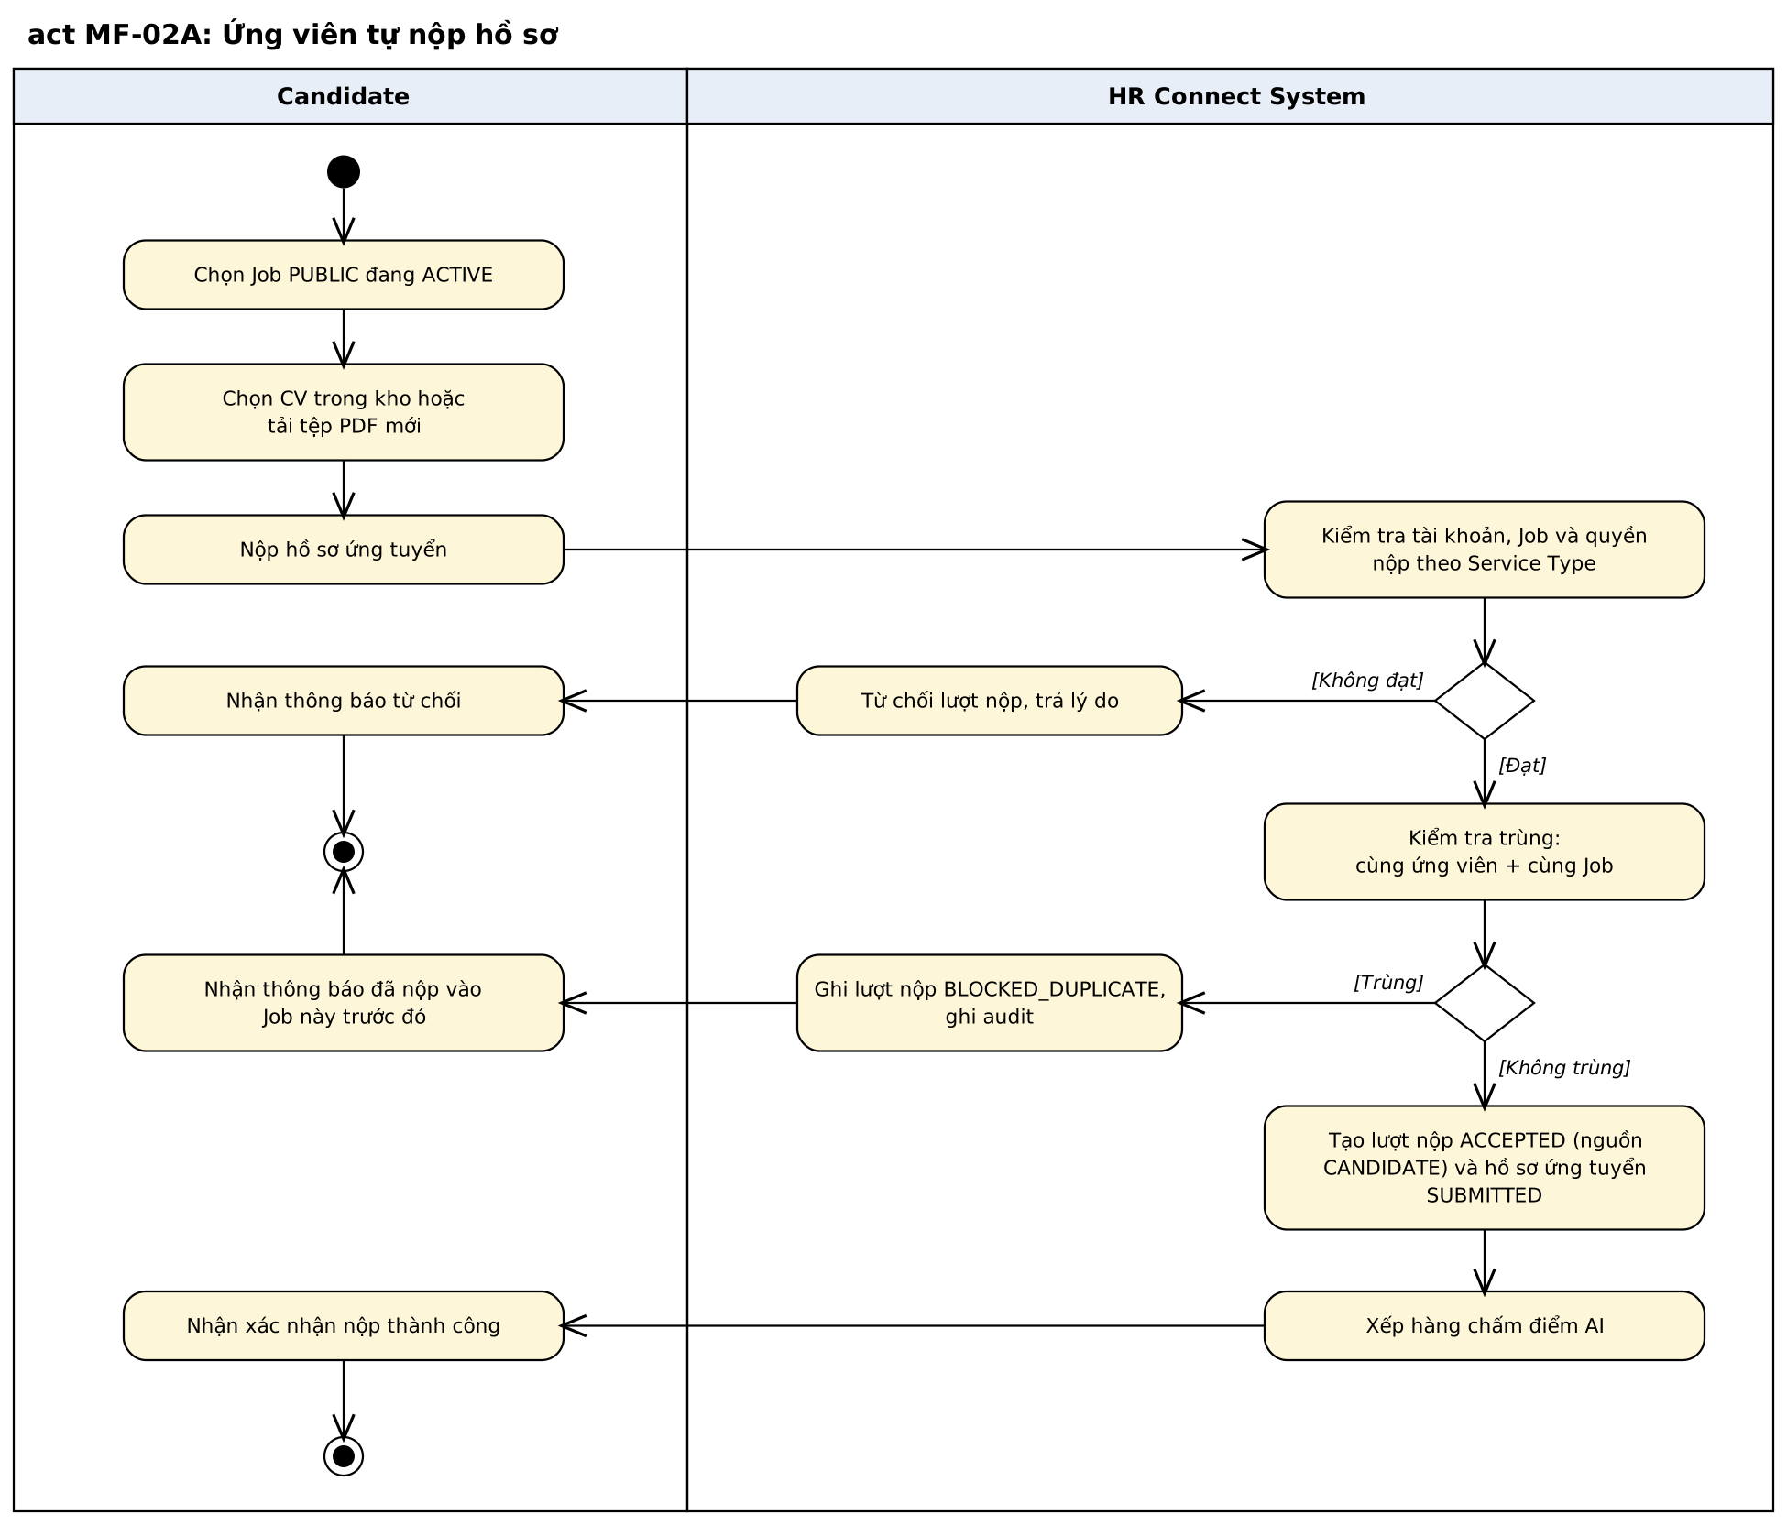
Figure 3.4a. Activity Diagram: Candidate Self-Application
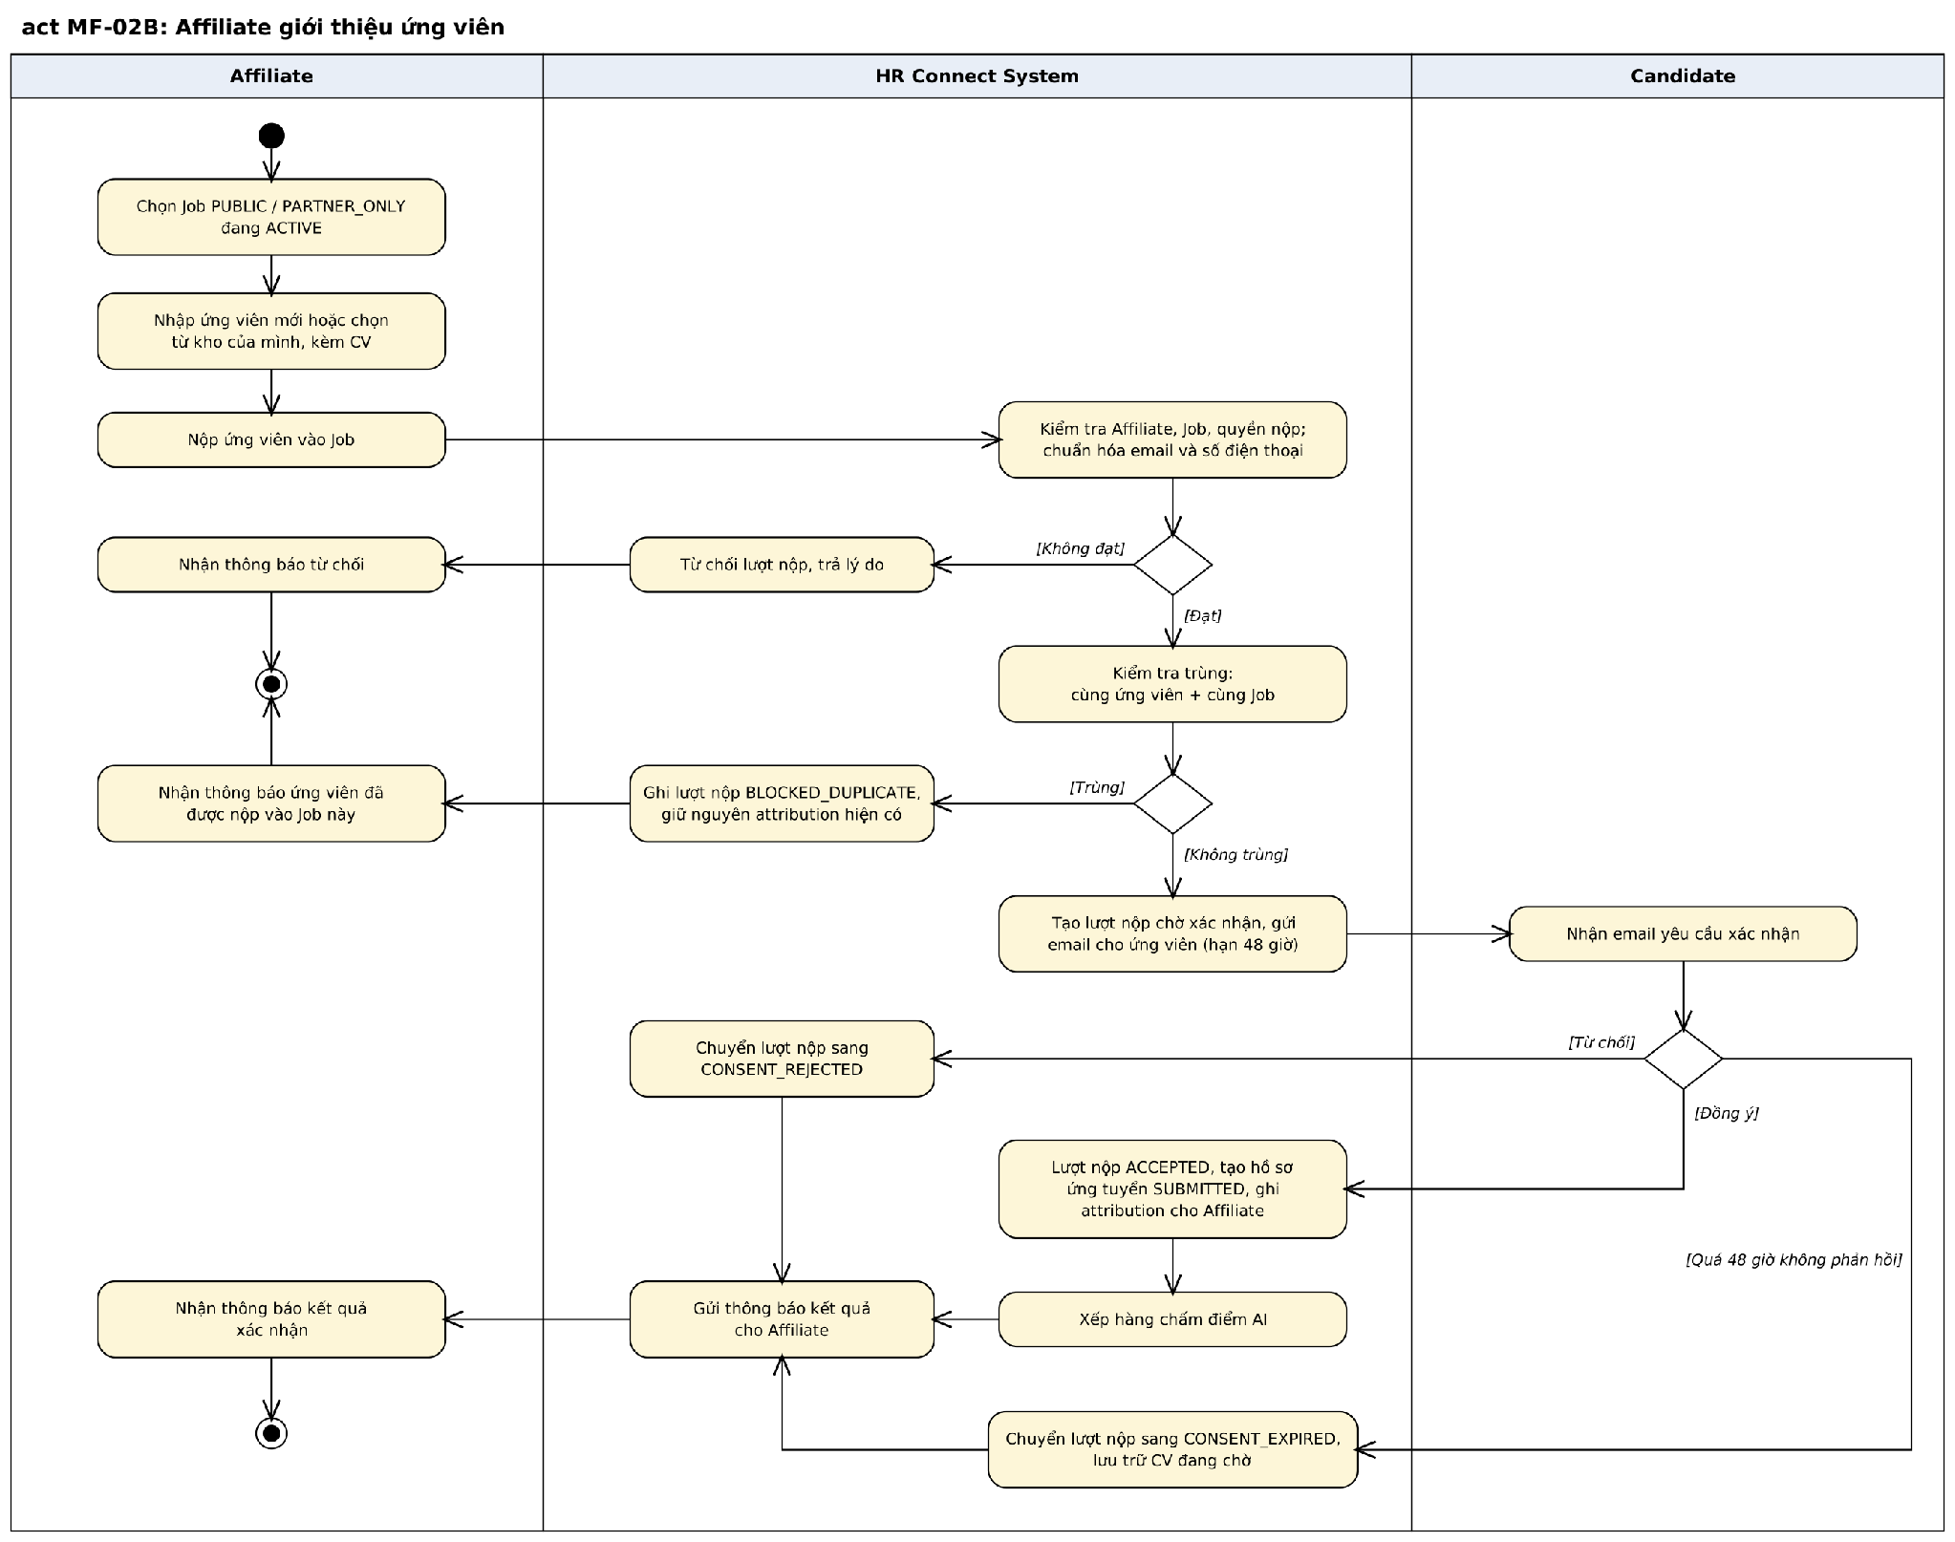
Figure 3.4b. Activity Diagram: Affiliate Submission with Candidate Consent
3.4.1 Apply to Job
Item | Specification
Trigger | A Candidate chooses "Apply" on a Job.
Actors | Candidate
Description | Submits one CV to a public Job.
Preconditions | The Job is an ACTIVE CV Application Job; the Candidate account and profile are active.
Main processing | 1. The Candidate selects an existing CV or uploads a new PDF.  2. The system validates eligibility and the CV.  3. The system checks for a duplicate.  4. If not a duplicate, the system creates an ACCEPTED Submission with source CANDIDATE and an Application in SUBMITTED.  5. The system queues AI evaluation.
Validation and business rules | - Exactly one CV source must be provided (MSG14).  - Same Candidate and same Job is a duplicate: the attempt is stored as BLOCKED_DUPLICATE and no Application is created (BR-11).  - A self-applied Application has no Attribution (BR-15).
Result | An Application in SUBMITTED exists, or the attempt is blocked.
Status | Implemented in backend

3.4.2 Submit Candidate/CV
Item | Specification
Trigger | An Affiliate chooses "Submit Candidate" on a Job.
Actors | Affiliate
Description | Introduces a Candidate to a Job and requests the Candidate's consent.
Preconditions | The Affiliate is approved; the Job is ACTIVE and the Affiliate role may view and submit for its Service Type (Headhunt COD or CV Sourcing).
Main processing | 1. The Affiliate enters a new Candidate or selects one from the own library, with a CV.  2. The system normalizes email and phone and resolves the Candidate identity.  3. The system checks for a duplicate.  4. If not a duplicate, the system creates a Submission awaiting consent and emails the Candidate.
Validation and business rules | - The Candidate must have an email address (MSG15).  - If email and phone match two different Candidates, the submission is rejected (MSG16).  - A duplicate is stored as BLOCKED_DUPLICATE; the existing Attribution is unchanged (BR-11, BR-14).  - While a consent request is pending, another submission of the same Candidate to the same Job is rejected (BR-13).
Result | A Submission awaiting Candidate consent exists, or the attempt is blocked.
Status | Implemented in backend

3.4.3 Respond to Submission Consent
Item | Specification
Trigger | The Candidate opens the consent link or the consent request in the account.
Actors | Candidate
Description | Confirms or declines an Affiliate submission.
Preconditions | The consent request is PENDING and not expired.
Main processing | 1. The Candidate reviews the Job and the submitting Affiliate.  2. The Candidate confirms or declines.  3. On confirm: the system re-checks the Job and the Affiliate, marks the Submission ACCEPTED, creates the Application in SUBMITTED, records Attribution and queues AI evaluation.  4. On decline: the Submission becomes CONSENT_REJECTED.  5. The system notifies the Affiliate of the result.
Validation and business rules | - The request expires after the configured period, 48 hours by default; the Submission becomes CONSENT_EXPIRED (BR-12).  - The Affiliate may resend the request with a cooldown and a maximum number of sends.  - Attribution is recorded at confirmation time with a server timestamp (BR-14).
Result | An attributed Application exists, or the Submission is closed.
Status | Implemented in backend

3.4.4 Raise and Resolve Dispute
Item | Specification
Trigger | An Affiliate disagrees with a duplicate or Attribution result.
Actors | Affiliate, Platform Admin
Description | Records and resolves a duplicate or Attribution dispute.
Preconditions | A blocked Submission or an Attribution related to the Affiliate exists, and the dispute window (configurable) has not closed.
Main processing | 1. The Affiliate raises a dispute with a description and evidence. 2. Platform Admin reviews Candidate identity, Submission history, timestamps and evidence. 3. Platform Admin upholds or rejects the dispute with a resolution. 4. If upheld, the Attribution is transferred to the disputing Affiliate. 5. The Affiliate is notified of the result.
Validation and business rules | - The decision, reason, reviewer and time are audited (BR-30).  - While a dispute is open, related Commission is held (BR-26).
Result | The dispute is UPHELD or REJECTED.
Status | Implemented in backend

3.5 AI Matching and Screening
This feature covers Main Flow MF-03. The AI Matching Service evaluates each Application; a human reviewer makes the screening decision.
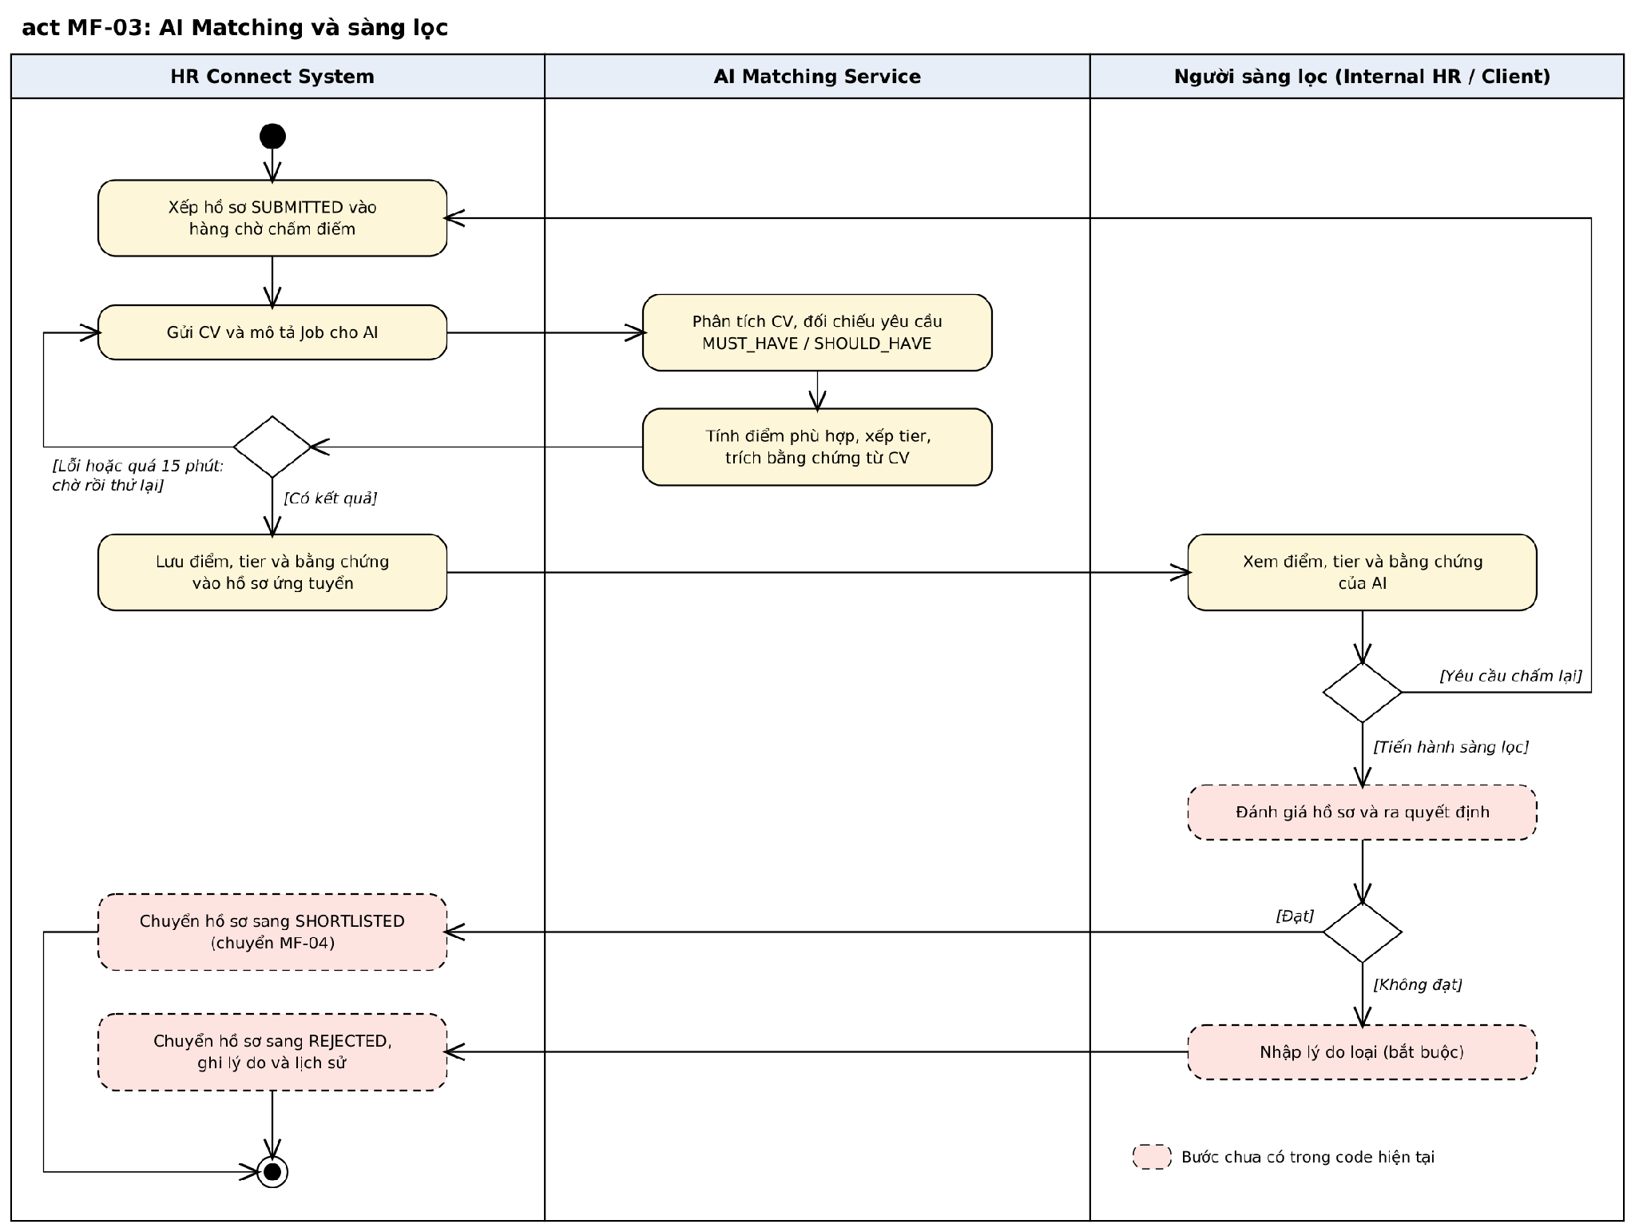
Figure 3.5. Activity Diagram: AI Matching and Screening
3.5.1 Evaluate Application with AI
Item | Specification
Trigger | An Application is created, or Internal HR requests a re-evaluation.
Actors | System (AI Matching Service); Internal HR for retry
Description | Scores the CV against the Job requirements.
Preconditions | The Application has a CV and the Job has requirements.
Main processing | 1. The system queues the Application for evaluation.  2. The dispatcher sends the CV and the Job description to the AI Matching Service.  3. The AI service parses the CV, checks Must-have and Should-have requirements and computes the Match Score.  4. The service returns score, tier, Candidate Highlight and per-requirement evidence.  5. The system stores the result with the Application.
Validation and business rules | - A failed or timed-out evaluation is retried with increasing delay up to a maximum number of attempts; the failure is visible to Internal HR, who can request a re-evaluation (BR-17). - Every evidence quote returned by the AI is checked against the CV text; a requirement whose quotes are not found counts as not found and the Application is flagged for manual review. - The score is computed by the system from the verified results, not by the AI; Match Tier thresholds are configurable (BR-18). - The AI result never changes the Application status (BR-16).
Result | An AI result is stored, or the evaluation is marked failed.
Status | Implemented in backend

3.5.2 View AI Matching Result
Item | Specification
Trigger | A reviewer opens Candidate Review Detail or the Screening Workspace.
Actors | Internal HR, Client Company User
Description | Displays the AI-assisted evaluation next to the CV.
Preconditions | The user is authorized for the Job.
Main processing | 1. The system shows Match Score, Match Tier and Candidate Highlight.  2. The system lists each Must-have and Should-have requirement with its assessment and the evidence found in the CV.
Validation and business rules | - A Client Company User sees only Applications of the own Company.  - For Headhunt COD and CV Sourcing, the Client sees only shortlisted Candidates and contact details are masked (BR-20).
Result | The reviewer can read the evaluation.
Status | Implemented in backend

3.5.3 Screen Candidate
Item | Specification
Trigger | The reviewer chooses Shortlist or Reject.
Actors | Client Company User (CV Application); Internal HR (Headhunt COD, CV Sourcing)
Description | Records the human screening decision.
Preconditions | The Application is SUBMITTED or SCREENING.
Main processing | 1. The reviewer examines the CV and the AI result. 2. The reviewer shortlists the Application (SHORTLISTED), keeps it as backup (BACKUP) or rejects it with a reason (REJECTED). 3. For CV Sourcing, Internal HR delivers a shortlisted CV to the Client, who accepts or rejects it within the review period. 4. The system records the status history and notifies the Candidate or the Affiliate.
Validation and business rules | - The reviewer role depends on the Service Type (BR-19).  - A rejection requires a reason (MSG18).  - Missing evidence for a requirement is a screening matter; it does not make the Submission a duplicate or invalid.  - Screening is allowed even when the AI evaluation has failed.
Result | The Application is SHORTLISTED and can proceed to Interview, or REJECTED.
Status | Implemented in backend

3.6 Interview, Offer and Placement
This feature covers Main Flow MF-04. The Client Company owns every hiring step. Internal HR does not schedule Interviews, record results or create Offers.
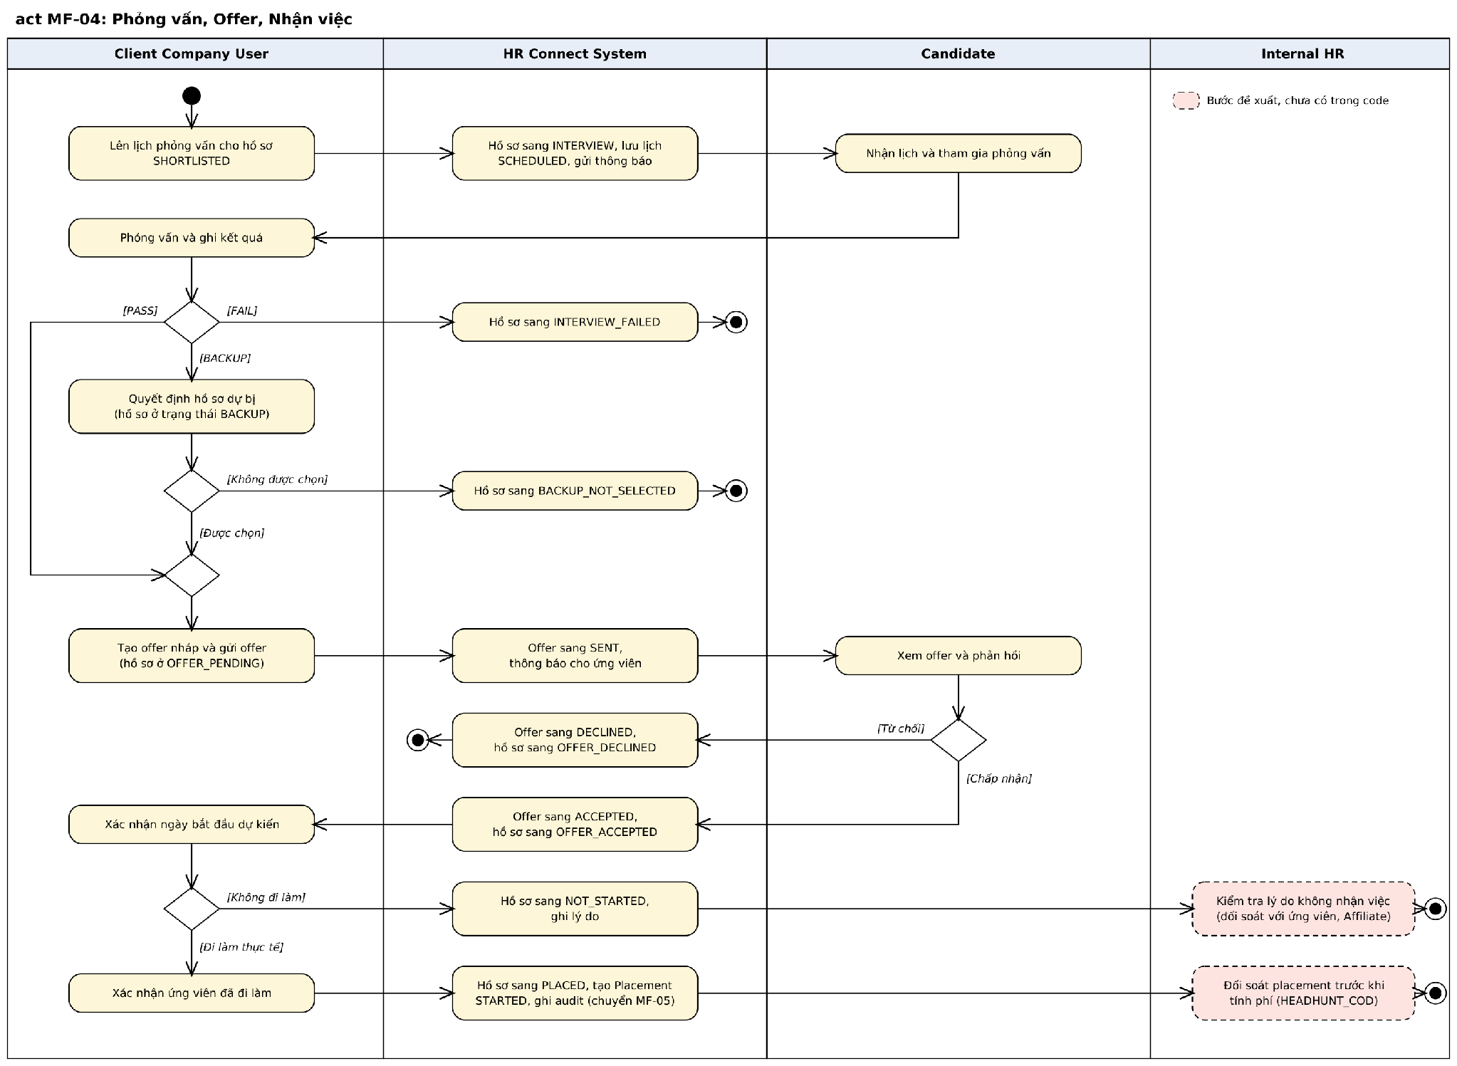
Figure 3.6. Activity Diagram: Interview, Offer and Placement
3.6.1 Manage Interview
Item | Specification
Trigger | The Client Company User chooses "Schedule Interview" for a shortlisted Application.
Actors | Client Company User
Description | Schedules and maintains Interviews.
Preconditions | The Application is SHORTLISTED or INTERVIEW and belongs to the user's Company.
Main processing | 1. The user enters time, duration, round and participants.  2. The system saves the Interview as SCHEDULED and sets the Application to INTERVIEW.  3. The user can update, reschedule or cancel the Interview, or record a no-show.
Validation and business rules | - The time must be in the future; duration must be between 1 and 480 minutes (MSG19).  - An Application can have only one pending Interview at a time (MSG20).  - Round numbers are unique per Application.
Result | An Interview is scheduled and the Candidate can see it.
Status | Implemented in backend

3.6.2 Record Interview Result
Item | Specification
Trigger | The Client Company User records the result after the Interview.
Actors | Client Company User
Description | Records PASS, FAIL or BACKUP and decides on backup Candidates.
Preconditions | The Interview is SCHEDULED.
Main processing | 1. The user selects the result, the next step and feedback. 2. PASS moves the Application to OFFER_PENDING when it is the final round or the next step is Make Offer; FAIL ends it as INTERVIEW_FAILED when it is the final round or the next step is Reject; otherwise another round can be scheduled. BACKUP sets BACKUP. 3. For a BACKUP Application, the user later selects it (OFFER_PENDING) or not (BACKUP_NOT_SELECTED).
Validation and business rules | - INTERVIEW_FAILED and BACKUP_NOT_SELECTED are final (BR-21).
Result | The Application moves to the Offer stage or ends.
Status | Implemented in backend

3.6.3 Manage Offer
Item | Specification
Trigger | The Client Company User creates an Offer for an Application in OFFER_PENDING.
Actors | Client Company User
Description | Creates, updates, sends and withdraws Offers.
Preconditions | The Application is OFFER_PENDING.
Main processing | 1. The user creates an Offer draft with salary and terms.  2. The user sends the Offer; status becomes SENT and the Candidate is notified.  3. The user may withdraw a sent Offer with a reason; the Application returns to OFFER_PENDING.
Validation and business rules | - The agreed salary is required because it is the basis of the Headhunt COD service fee.  - An accepted Offer cannot be withdrawn (MSG21).
Result | An Offer is SENT, or WITHDRAWN.
Status | Implemented in backend

3.6.4 Respond to Offer
Item | Specification
Trigger | The Candidate opens Offer Detail.
Actors | Candidate
Description | Accepts or declines an Offer.
Preconditions | The Offer is SENT and not expired.
Main processing | 1. The Candidate reviews the Offer.  2. Accept sets the Offer to ACCEPTED and the Application to OFFER_ACCEPTED.  3. Decline sets the Offer to DECLINED and the Application to OFFER_DECLINED.
Validation and business rules | - An Offer not answered before its expiry becomes EXPIRED.
Result | The Offer is ACCEPTED or DECLINED.
Status | Implemented in backend

3.6.5 Confirm Start Work
Item | Specification
Trigger | The Client Company User opens Placement Detail for an accepted Offer.
Actors | Client Company User; Internal HR for reconciliation
Description | Confirms that the Candidate actually started work.
Preconditions | The Application is OFFER_ACCEPTED.
Main processing | 1. The user confirms the planned start date.  2. When the Candidate starts, the user confirms Start Work; the Application becomes PLACED and a Placement is created.  3. If the Candidate does not start, the user marks NOT_STARTED with a reason.  4. For Headhunt COD, Internal HR reconciles the Placement or the not-started result with the Candidate or Affiliate before the service fee is charged (planned).
Validation and business rules | - The Placement is the fee trigger for Headhunt COD (BR-22).  - Accepting an Offer without starting work does not create a fee.
Result | A Placement exists and the flow continues to post-placement, or the Application ends as NOT_STARTED.
Status | Implemented in backend

3.7 Post-Placement, Service Fee, Commission and Payout
This feature covers Main Flow MF-05. The functions below are implemented. The diagram shows the Headhunt COD case.
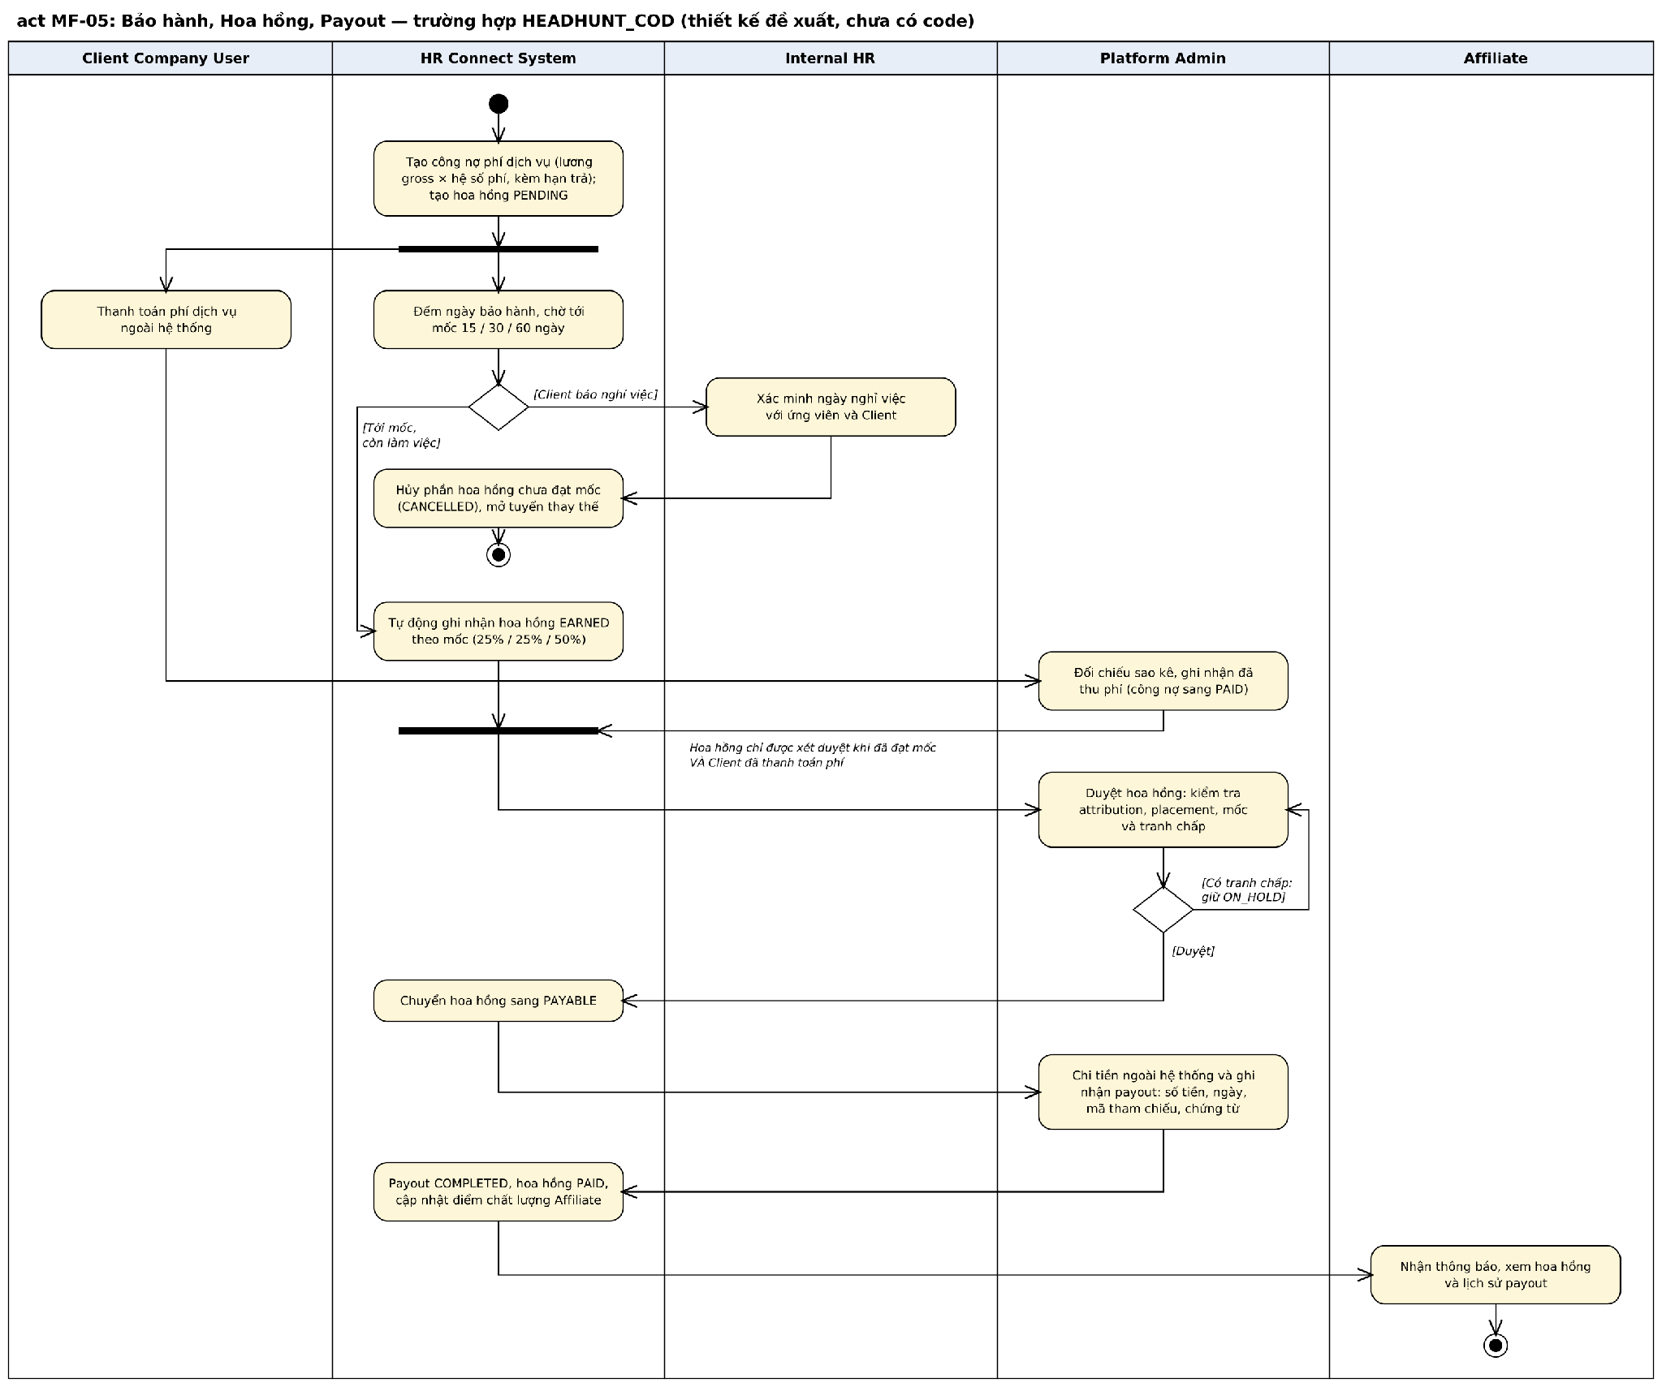
Figure 3.7. Activity Diagram: Warranty, Commission and Payout (Headhunt COD)
3.7.1 Record Service Fee Payment
Item | Specification
Trigger | A fee trigger occurs; later the Client Company pays.
Actors | Platform Admin, Client Company User
Description | Tracks the service fee owed by the Client Company.
Preconditions | A fee trigger has occurred for the Job's Service Type.
Main processing | 1. The system creates a service fee receivable with amount and due date and notifies the Client.  2. The Client pays outside the system.  3. Platform Admin reconciles the bank statement and records the payment.
Validation and business rules | - Fee basis and trigger depend on the Service Type (BR-22, BR-23, BR-24). - A payment can be recorded only with a payment reference. - The Candidate never pays a fee (BR-25).
Result | The receivable is PAID, or OVERDUE after the due date.
Status | Implemented in backend

3.7.2 Track Warranty
Item | Specification
Trigger | A Placement is created for a Headhunt COD Job.
Actors | System, Client Company User, Internal HR
Description | Tracks the warranty period and early leave.
Preconditions | A Placement exists.
Main processing | 1. The system starts the warranty countdown from the actual start date. 2. If the Candidate leaves, the Client reports it; the Commission is put ON_HOLD. 3. Internal HR confirms or dismisses the report. A dismissed report returns the warranty to ACTIVE. 4. A confirmed resignation makes the warranty VOID, cancels the Commission and opens a replacement slot; a replacement hired into the slot creates no new service fee, and a second hire into a filled slot is charged as a new hire.
Validation and business rules | - The warranty period is 30 days by default and agreed per Job (BR-27). - Probation is out of scope.
Result | The warranty is completed or the Candidate is recorded as having left.
Status | Implemented in backend

3.7.3 Earn and Approve Commission
Item | Specification
Trigger | The Warranty of a Placement is completed (Headhunt COD) or a CV is accepted (CV Sourcing).
Actors | System, Platform Admin
Description | Recognizes and approves Affiliate Commission.
Preconditions | The Application has a valid Attribution and a Placement.
Main processing | 1. The system creates the Commission as IN_WARRANTY at Placement. 2. When the Warranty ends without a confirmed resignation, the Commission becomes EARNED in full. 3. When the Client has paid the service fee, the earned Commission is presented for approval. 4. Platform Admin approves (PAYABLE), or holds, adjusts or cancels it with a reason.
Validation and business rules | - Headhunt COD Commission is earned in full at the end of the Warranty; nothing is earned earlier (BR-28). - Commission is approved only after the Client has paid; Commission under an open dispute cannot be approved (BR-26). - When an Affiliate is locked, Commission not yet earned goes ON_HOLD, while EARNED and PAYABLE Commission can still be paid. - Commission is managed per Placement, not per Job. - Any amount adjustment stores the old amount, new amount, reason and actor.
Result | The Commission is PAYABLE, ON_HOLD or CANCELLED.
Status | Implemented in backend

3.7.4 Record Payout
Item | Specification
Trigger | A Commission is PAYABLE.
Actors | Platform Admin, Affiliate
Description | Records the payment of Commission to the Affiliate.
Preconditions | The Commission is PAYABLE and the Affiliate has bank account information.
Main processing | 1. Platform Admin transfers the money outside the system. 2. Platform Admin records amount, date, transaction reference and evidence, or records a failed transfer to retry later. 3. The system marks a successful Payout COMPLETED and the Commission PAID and updates the Affiliate quality rating. 4. The Affiliate sees the Payout in the history.
Validation and business rules | - HR Connect records payouts and does not execute transfers (BR-29).  - Affiliate quality rating is based on submission-to-hire conversion, not volume.
Result | The Payout is COMPLETED, FAILED or CANCELLED.
Status | Implemented in backend

3.8 Administration
3.8.1 Manage Users
Item | Specification
Trigger | Platform Admin opens User Management.
Actors | Platform Admin
Description | Views and controls user accounts.
Preconditions | The user has the Platform Admin role.
Main processing | 1. Platform Admin searches and views accounts.  2. Platform Admin suspends or reactivates an account with a reason.  3. Platform Admin unlocks a login locked by failed attempts.
Validation and business rules | - Protected administrator accounts cannot be suspended by another administrator.  - Every change is audited (BR-30).
Result | The account status is updated.
Status | Implemented in backend

3.8.2 Review Affiliate Application
Item | Specification
Trigger | An Affiliate registration is waiting for approval.
Actors | Platform Admin
Description | Approves or rejects an Affiliate.
Preconditions | The Affiliate has verified the email.
Main processing | 1. Platform Admin reviews the Affiliate information.  2. Platform Admin approves or rejects with a reason.  3. The system activates the Affiliate role on approval and emails the result.
Validation and business rules | - Only an approved Affiliate can submit Candidates (BR-02).
Result | The Affiliate is ACTIVE or REJECTED.
Status | Implemented in backend

3.8.3 Manage Service Types and Commission Rules
Item | Specification
Trigger | Platform Admin opens System Configuration.
Actors | Platform Admin
Description | Maintains business configuration.
Preconditions | The user has the Platform Admin role.
Main processing | 1. Platform Admin creates or updates a Service Type and the Roles allowed to submit for it.  2. Platform Admin creates, updates, activates or deactivates Commission Rules per Service Type and milestone.
Validation and business rules | - Fee multipliers, warranty periods, share rates and package prices are configuration values, not fixed in code (BR-31).  - A rule in use is deactivated, not deleted.
Result | The configuration is updated for subsequent Jobs and Commissions.
Status | Implemented in backend

3.8.4 View Audit Log
Item | Specification
Trigger | Platform Admin opens Audit Trail.
Actors | Platform Admin
Description | Searches and views audit records.
Preconditions | The user has the Platform Admin role.
Main processing | 1. Platform Admin filters by time, actor, action or entity.  2. The system lists matching records and shows details on selection.
Validation and business rules | - Audit records are read-only (BR-30).
Result | The audit records are displayed.
Status | Implemented in backend

4. Non-Functional Requirements
4.1 External Interfaces
User interfaces. HR Connect is a responsive web application: a public site (home, job search, job detail, service pages) and an authenticated dashboard per Role. It supports current versions of Chrome, Edge, Firefox and Safari on desktop and mobile widths. The interface is in Vietnamese; the public pages also offer English.
Software interfaces:
Table 4.1. Software Interfaces
Interface | Counterpart | Purpose | Protocol / Format
REST API | Web frontend | All client operations, versioned under /api/v1 | HTTPS, JSON, JWT bearer token
Internal AI interface | AI Matching Service (internal subsystem) | Send CV and Job data for evaluation; receive score, tier and evidence | HTTPS, JSON, service credential
Email | External Email Service | OTP, password reset, consent requests, notifications | HTTPS API
Object storage | External S3-compatible storage | Store and retrieve CV files and images | HTTPS, signed URLs
Database | PostgreSQL | Transactional data | SQL through the data-access layer
Real-time channel | Web frontend | Push new notifications to signed-in users | WebSocket (SignalR) over HTTPS, JWT

Communications interfaces. All traffic between browser, API, AI service and external services uses HTTPS. No hardware interfaces are required.
4.2 Quality Attributes
4.2.1 Usability
- A new Candidate can register, upload a CV and apply to a Job in 5 minutes or less without training.
- A Client Company User can create and submit a Job in 10 minutes or less after a 30-minute introduction.
- Every validation error is shown next to the field concerned with a message stating how to correct it.
- Match Tiers are shown with a text label in addition to colour, so that they do not rely on colour alone.
4.2.2 Reliability
- Availability of at least 99% during business hours (08:00 to 18:00, Monday to Saturday), excluding announced maintenance.
- The duplicate check runs synchronously before a CV is accepted and is exact on normalized email and phone matches.
- A failure of the AI Matching Service or the Email Service does not block submissions: evaluations and emails are queued and retried.
- No acknowledged transaction is lost on restart; status changes and their history are saved in one database transaction.
- Daily database backup, with recovery to the previous day's state within 4 hours.
4.2.3 Performance
- Job search and filtering return within 2 seconds for 95% of requests with a Candidate pool of at least 50,000 profiles.
- Other interactive API requests respond within 1 second for 95% of requests under 100 concurrent users.
- The AI Match Score for one CV and Job pair is computed within 5 seconds on average; an evaluation is treated as timed out after 15 minutes.
- A CV upload of up to 5 MB completes within 10 seconds on a 10 Mbps connection.
4.2.4 Security
- Role-based access control separates Guest, Candidate, Affiliate, Client Company User, Internal HR and Platform Admin data and functions.
- Passwords are stored only as salted hashes; access tokens are short-lived and refresh tokens are revocable.
- Personal data of Candidates (CV files, salary, contact details) is stored and transmitted encrypted, in line with Vietnam's personal data protection regulations.
- CV files are accessed only through temporary signed URLs, and each access is audited.
- Authentication endpoints are rate-limited, and logins are locked after repeated failures.
4.2.5 Maintainability
- Requirement keyword sets, Match Tier thresholds, Service Types, Commission Rules and the industry taxonomy can be changed without code changes.
- The backend follows a layered architecture with one handler per command or query; business handlers are covered by automated unit tests.
- Database schema changes are delivered as versioned migrations.
4.2.6 Scalability
- The AI Matching Service can be scaled horizontally and independently of the transactional backend.
- Evaluation requests are queued so that peaks in submissions do not slow down interactive requests.
4.2.7 Auditability
- Every Attribution, Commission calculation, approval, status change and dispute decision is logged with actor, server timestamp and reason, and is reviewable by Platform Admin.
- Audit records cannot be edited or deleted through the application.
5. Requirement Appendix
5.1 Business Rules
All rules below are confirmed by the team; rules marked [Planned] describe behaviour that is designed but not yet implemented.
Table 5.1. Business Rules
ID | Rule Definition
BR-01 | Platform Admin and Internal HR are separate roles. Platform Admin administers the platform; Internal HR operates recruitment on behalf of the platform operator.
BR-02 | An Affiliate account and a Client Company must be approved by Platform Admin before role-specific functions can be used.
BR-03 | A password must be at least 8 characters and contain at least one lowercase letter, one uppercase letter, one digit and one special character.
BR-04 | A login is locked for 15 minutes after 5 consecutive failed attempts. Platform Admin can unlock it earlier.
BR-05 | Only a verified Company can submit a Job for review.
BR-06 | The Service Type is selected on the Job. A person submitting a Candidate does not choose the Service Type.
BR-07 | Who can view and who can submit to a Job is set per Service Type and Role (view and submit permissions configurable by Platform Admin): Guests and Candidates view CV_APPLICATION Jobs; Affiliates view HEADHUNT_COD and CV_SOURCING Jobs.
BR-08 | Job status transitions: DRAFT to PENDING_REVIEW; PENDING_REVIEW to ACTIVE, PENDING_PAYMENT or REJECTED; PENDING_PAYMENT to ACTIVE when the posting fee or deposit is recorded; REJECTED to PENDING_REVIEW; ACTIVE to PAUSED or CLOSED; PAUSED to ACTIVE or CLOSED. CLOSED is final.
BR-09 | A Candidate can apply only to an ACTIVE CV_APPLICATION Job. An Affiliate can submit only to an ACTIVE Job whose Service Type allows the Affiliate role to submit. Internal HR does not submit on behalf of Candidates.
BR-10 | A Candidate is identified by an exact match on normalized email or normalized phone number.
BR-11 | A duplicate submission is the same identified Candidate for the same Job. It is recorded as BLOCKED_DUPLICATE, creates no Application and does not depend on the quality of the new CV.
BR-12 | A submission by an Affiliate enters the pipeline only after the Candidate confirms it. A consent request expires after 48 hours by default (configurable).
BR-13 | While a consent request is pending for a Candidate and Job, another submission of that Candidate to that Job is rejected.
BR-14 | Attribution is recorded for the Affiliate whose submission is the first to be confirmed by the Candidate. The timestamp is generated by the server and cannot be entered or changed by users.
BR-15 | A self-applied Application has no Attribution and generates no Commission.
BR-16 | AI is decision support only. AI does not shortlist, reject, hire, or decide Interview Results or Offers.
BR-17 | A failed AI evaluation is retried automatically with increasing delay, is visible to Internal HR, and never changes the Application status.
BR-18 | Match Tiers by score: 80 and above; 70 to 79; 60 to 69; below 60. Thresholds and colours are configurable.
BR-19 | Screening is performed by the Client Company User for CV_APPLICATION Jobs and by Internal HR for HEADHUNT_COD and CV_SOURCING Jobs.
BR-20 | For HEADHUNT_COD and CV_SOURCING Jobs, a Client Company User sees only shortlisted or delivered Candidates, and Candidate contact details are masked.
BR-21 | There is one Application per Candidate and Job. Final Application statuses are REJECTED, INTERVIEW_FAILED, BACKUP_NOT_SELECTED, OFFER_DECLINED, NOT_STARTED, WITHDRAWN and CLOSED.
BR-22 | HEADHUNT_COD service fee = agreed gross monthly salary x fee multiplier (default 1.5, confirmed per Job by Internal HR), calculated per Placement and triggered by actual Start Work. A Job with quantity above 1 generates one fee per Placement.
BR-23 | CV_SOURCING is charged per CV accepted, or accepted automatically after the review period, up to the sourcing target. A deposit (default 50%) is required before the Job opens; an unused deposit is refunded. Hiring quantity and sourcing target are independent values.
BR-24 | CV_APPLICATION service fee is a job-posting package per Job and period, independent of the number of Applications. A free-tier Company has a limited number of open Jobs and a reopen cycle (configurable).
BR-25 | A Candidate never pays a recruitment fee.
BR-26 | Commission is approved only after it is earned and the Client Company has paid the service fee. Commission related to an open dispute cannot be approved.
BR-27 | The default warranty period for HEADHUNT_COD is 30 days from the actual start date; it is agreed per Job and configurable.
BR-28 | HEADHUNT_COD Commission is earned in full when the Candidate has worked through the Warranty period; nothing is earned earlier. If a resignation within the Warranty is confirmed, the Commission is cancelled and a replacement slot is opened.
BR-29 | HR Connect records service fee payments and Payouts (amount, date, reference, evidence). Money transfers are performed outside the system.
BR-30 | Every status change, approval, Attribution, Commission calculation and dispute decision is logged with actor, server timestamp and reason. Audit records are read-only.
BR-31 | Fee multipliers, warranty periods, share rates, package prices, Match Tier thresholds and Commission Rules are configuration values and are not fixed in code.
BR-32 | The Client Company owns hiring decisions: scheduling Interviews, recording results, creating Offers and confirming Start Work. Internal HR does not perform these actions.
BR-33 | CV_SOURCING Commission per accepted CV = price per CV x Affiliate share rate (default 60%), paid after the Client has paid and the dispute window has closed. CV_APPLICATION generates no Commission.
BR-34 | A user can access only data within their scope: a Candidate their own data; an Affiliate their own Submissions and Candidates; a Client Company User their own Company's Jobs and Applications.
BR-35 | A replacement hired into an open replacement slot creates no new service fee. Once the slot is filled, a further hire is charged as a new hire.
BR-36 | When an Affiliate is locked, Commission not yet earned is put ON_HOLD for Platform Admin; EARNED and PAYABLE Commission can still be paid.
BR-37 | Probation is out of scope; Commission and fees depend only on Start Work and the Warranty.
BR-38 | [Planned] A HEADHUNT_COD or CV_SOURCING Job is activated only after the Client's primary contact signs the current Service Agreement with a one-time password; the signed PDF is immutable and amendments create a new version.

5.2 Common Requirements
- Dates and times are stored in UTC and displayed in the user's local time zone in the format dd/MM/yyyy HH:mm.
- Monetary amounts are displayed in Vietnamese number format with the currency, for example 45.000.000 đ.
- Lists are paginated with a default of 20 items per page and support sorting and filtering where relevant.
- Required fields are marked with an asterisk; validation runs on the client for format and on the server for all rules.
- CV uploads accept PDF files up to 5 MB.
- Every data-changing request requires a valid access token and is checked for Role, Permission and data scope.
- When two users edit the same Job, Application, Offer or Interview, the later save is rejected and the user is asked to reload.
- User-facing text is in Vietnamese; the public pages also offer English.
- Destructive or irreversible actions (close Job, reject, withdraw Offer, mark Not Started) require a confirmation and a reason.
5.3 Application Messages List
Table 5.3. Application Messages
# | Message code | Message Type | Context | Content
1 | MSG01 | In line | A search returns no result | No results found.
2 | MSG02 | In red, under the field | A required field is empty | This field is required.
3 | MSG03 | In red, under the field | Input exceeds the maximum length | Maximum length is {max_length} characters.
4 | MSG04 | In line | Email or password is incorrect at login | Incorrect email or password. Please try again.
5 | MSG05 | In red, under the field | OTP is incorrect or expired | The code is invalid or has expired. Please request a new code.
6 | MSG06 | Toast message | OTP email sent | A verification code has been sent to {email_address}.
7 | MSG07 | In line | Login locked after 5 failed attempts. | Your account is locked for 15 minutes. Please try again later or contact support.
8 | MSG08 | In line | Suspended account attempts to log in | Your account has been suspended. Please contact support.
9 | MSG09 | Toast message | Registration succeeds for Affiliate or Client | Registration received. Your account will be activated after approval.
10 | MSG10 | Toast message | Data saved successfully | Saved successfully.
11 | MSG11 | In line | User lacks permission for the action | You do not have permission to perform this action.
12 | MSG12 | Dialog | Record was changed by another user | This record was changed by another user. Please reload and try again.
13 | MSG13 | In line | Job is not accepting submissions | This job is not currently accepting applications.
14 | MSG14 | In red, under the field | No CV, or more than one CV source, provided | Please provide exactly one CV: upload a PDF or select an existing CV.
15 | MSG15 | In red, under the field | Affiliate submits a Candidate without email | The candidate must have an email address to confirm the submission.
16 | MSG16 | In line | Email and phone belong to different Candidates | The email and phone number belong to two different candidates.
17 | MSG17 | In line | Duplicate submission detected | This candidate has already been submitted to this job.
18 | MSG18 | In red, under the field | Rejection without a reason | Please enter a reason.
19 | MSG19 | In red, under the field | Interview time is in the past or duration is invalid | The interview time must be in the future and the duration between 1 and 480 minutes.
20 | MSG20 | In line | Application already has a pending Interview | This application already has a pending interview. Reschedule, cancel or record its result first.
21 | MSG21 | In line | Attempt to withdraw an accepted Offer | An accepted offer cannot be withdrawn.
22 | MSG22 | Toast message | Submission created and consent email sent | Submission received. A confirmation request has been sent to the candidate.
23 | MSG23 | In line | Consent request has expired | This confirmation request has expired. The affiliate needs to submit again.
24 | MSG24 | Toast message | Application submitted successfully | Your application has been submitted.
25 | MSG25 | In line | Action not allowed in the current status | This action is not available in the current status ({status}).

5.4 Other Requirements
No other requirements have been identified at this stage.

