

Capstone Project Report
Report 4 – Software Design Document

– Ho Chi Minh City, October 2026 –

Table of Contents
I. Record of Changes 3
II. Software Design Document 4
1. System Design 4
1.1 System Architecture 4
1.2 Package Diagram 5
2. Database Design 8
3. Detailed Design 14
3.1 MF-01 Create, Approve and Publish Job 14
3.2 MF-02 Candidate Submission, Consent, Duplicate Check and Attribution 16
3.3 MF-03 AI Matching and Screening 18
3.4 MF-04 Interview, Offer and Start Work 20
3.5 MF-05 Fee, Warranty, Commission and Payout 22

I. Record of Changes
Date | A*  M, D | In charge | Change Description
22/10/2026 | A | Trương Hoàng Quí | First version: system architecture, package diagram, database design (3 ERDs, table descriptions) and detailed design of MF-01 to MF-05 (class and sequence diagrams) based on the implemented code; planned MF-01 Service Agreement marked as [Planned].
*A - Added M - Modified D - Deleted

II. Software Design Document

1. System Design

1.1 System Architecture
HR Connect is a recruitment platform that links Client companies, Candidates and Affiliates (independent headhunters) through three service types: CV_APPLICATION (job posting where candidates apply), HEADHUNT_COD (headhunting paid on success, with a 30-day warranty) and CV_SOURCING (Client buys a target number of CVs, gated by a deposit). The system is split into three sub-systems and four external systems, as shown in Figure 1.
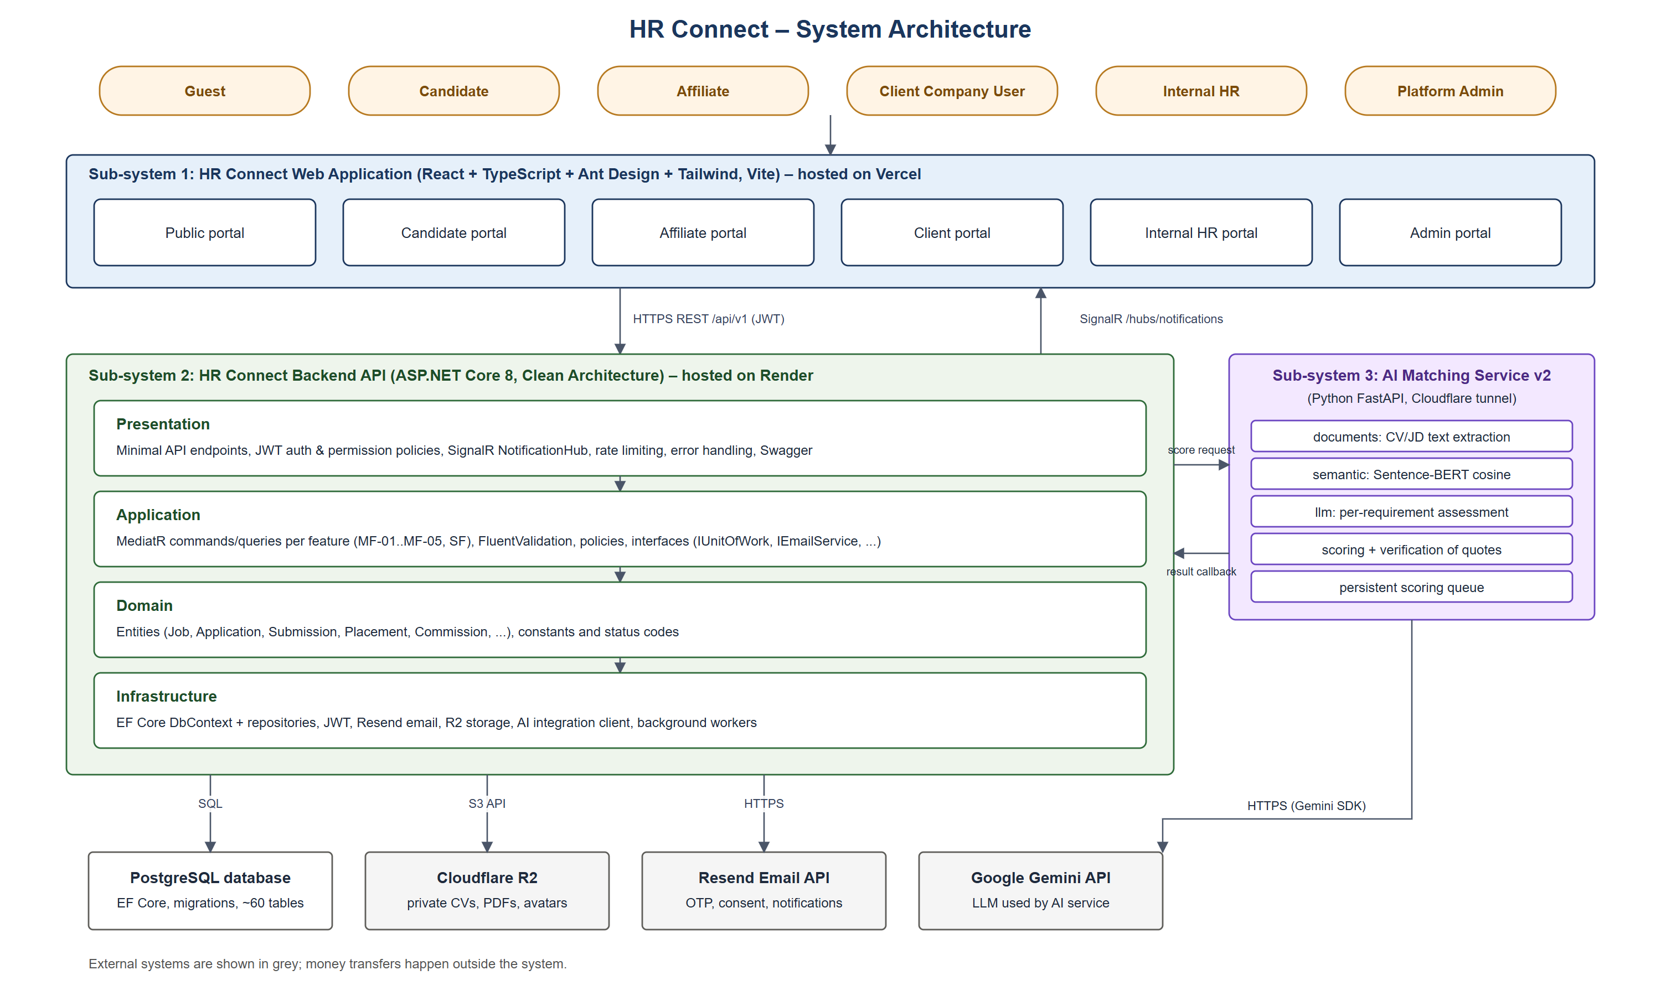
Figure 1. HR Connect system architecture
Components of the architecture:
• Users: Guest, Candidate, Affiliate, Client Company User, Internal HR and Platform Admin. Every request is made from a browser; each role has its own portal and permissions.
• Sub-system 1 – Web Application: Single-page application built with React, TypeScript, Ant Design and Tailwind CSS (Vite), deployed on Vercel. It contains six portals (public, candidate, affiliate, client, internal HR, admin), calls the backend through HTTPS REST /api/v1 with a JWT access token, and receives real-time notifications through a SignalR connection.
• Sub-system 2 – Backend API: ASP.NET Core 8 application deployed on Render and organised with Clean Architecture: Presentation (minimal API endpoints, authorization policies, SignalR hub, rate limiting), Application (MediatR commands and queries per feature, validators, business policies), Domain (entities and constants) and Infrastructure (EF Core persistence, external service adapters and background workers).
• Sub-system 3 – AI Matching Service v2: Python FastAPI service reached through a Cloudflare tunnel. It extracts CV and job description text, computes Sentence-BERT cosine similarity, asks the LLM to assess every job requirement with evidence quotes, verifies that quotes exist in the CV, calculates the match score and tier, and posts the result back to the backend (/internal/ai-results). Scoring is asynchronous and queued.
• PostgreSQL database: Single relational database accessed only by the backend through EF Core with versioned migrations (about 60 tables).
• Cloudflare R2 (external): Private object storage for CV files, generated CV PDFs, masked CVs, avatars and, in the planned MF-01 flow, signed agreement PDFs. Files are served through short-lived signed URLs.
• Resend Email API (external): Sends OTP, password reset, candidate consent requests and notification e-mails; e-mails are written to an outbox table first and retried by a worker.
• Google Gemini API (external): Large language model used only by the AI service to assess requirements. The provider is configurable (OpenAI and Anthropic are also supported).
Money transfers (posting fees, service fees, deposits and payouts) happen outside the system; Platform Admin records the payment reference in HR Connect.

1.2 Package Diagram
Figure 2 shows the packages of the three sub-systems. The backend follows the Clean Architecture dependency rule: Presentation depends on Application, Application depends on Domain, and Infrastructure implements the interfaces declared in Application. Features are grouped by business area (vertical slices), each with Commands, Queries, validators and DTOs.
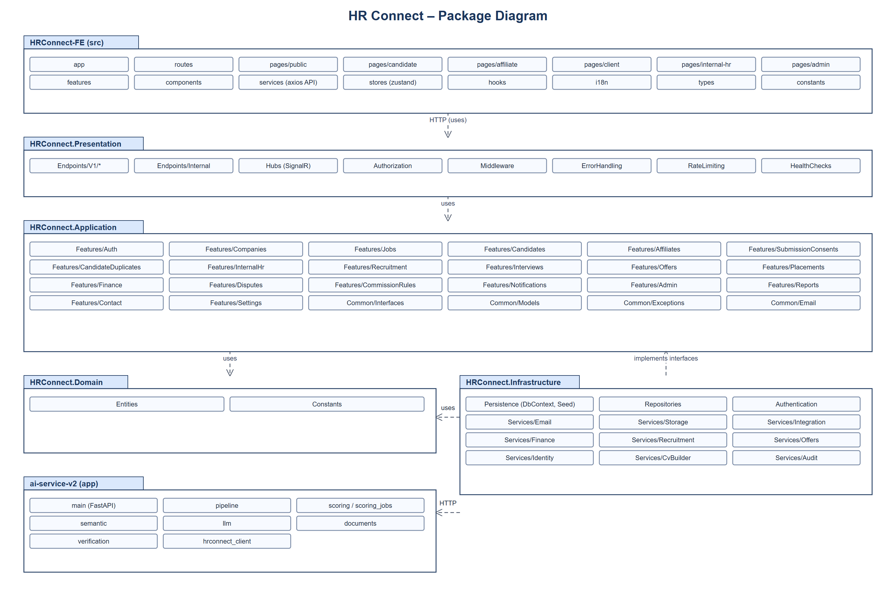
Figure 2. HR Connect package diagram
Package Descriptions
No | Package | Description
01 | HRConnect-FE / pages, routes, app | React pages for each portal (public, candidate, affiliate, client, internal-hr, admin), route guards by role and the application shell.
02 | HRConnect-FE / features, components | Reusable feature modules (application workbench, job forms, finance tables, notification bell) and shared UI components.
03 | HRConnect-FE / services, stores, hooks | Axios API clients per backend resource, Zustand stores (auth session, notifications), SignalR client and React hooks.
04 | HRConnect-FE / i18n, types, constants | Vietnamese/English texts, TypeScript types mirroring API DTOs, status labels and colours.
05 | HRConnect.Presentation / Endpoints | Minimal API endpoint groups under /api/v1 (Auth, Companies, Jobs, Candidates, Affiliates, Recruitment, Finance, Disputes, Admin, Reports, ...) and /internal for the AI callback.
06 | HRConnect.Presentation / Hubs, Authorization, Middleware | SignalR NotificationHub, permission-based authorization policies, request context, rate limiting, global error handling (ProblemDetails, 409 conflict responses), health checks and Swagger.
07 | HRConnect.Application / Features/Auth, Users, Admin | Registration, login, OTP, refresh token, password reset; user, role, permission and approval management (SF-01, SF-02).
08 | HRConnect.Application / Features/Companies, Jobs | MF-01: company profile and verification, job templates, job create/update/submit/approve/reject/pause/resume/close, posting packages and posting fees, job access policy per service type.
09 | HRConnect.Application / Features/Candidates, Affiliates, SubmissionConsents, CandidateDuplicates | MF-02: candidate profile, CVs and CV builder, job application, affiliate referral, candidate consent, duplicate identification and attribution.
10 | HRConnect.Application / Features/InternalHr, Recruitment | MF-03: AI scoring retry, screening status changes (SHORTLISTED, BACKUP, REJECTED), CV Sourcing deliveries, masked CV and application timeline.
11 | HRConnect.Application / Features/Interviews, Offers, Placements | MF-04: interview scheduling and results, offer drafts, sending, responses and withdrawal, planned and actual start dates, placements.
12 | HRConnect.Application / Features/Finance, CommissionRules, Disputes | MF-05: service fees, warranty, resignation claims, replacement slots, commission approval/adjustment/hold, payouts, Sourcing settlement; source disputes (SF-04).
13 | HRConnect.Application / Features/Notifications, Reports, Contact, Settings | In-app notifications, reports for admin and affiliates, contact form and configurable business settings.
14 | HRConnect.Application / Common | Interfaces (IUnitOfWork, IEmailService, IFileStorageService, IMf03ScoringTrigger, INotificationPublisher, ...), shared models, exceptions and e-mail templates.
15 | HRConnect.Domain | Entity classes (Job, Application, Submission, Placement, Commission, ...) and constants for statuses, reason codes and service types. No dependency on other projects.
16 | HRConnect.Infrastructure / Persistence, Repositories | EF Core DbContext, entity configurations, migrations, seed data and repository implementations.
17 | HRConnect.Infrastructure / Services | Adapters and workers: JWT, password hashing, Resend e-mail and outbox worker, Cloudflare R2 storage, CV PDF rendering and masking, AI integration client and dispatcher, offer expiry, consent expiry, Sourcing auto-accept, warranty progress, commission hold and affiliate performance workers.
18 | ai-service-v2 / app | main (FastAPI routes), pipeline and scoring_jobs (queue), documents (text extraction), semantic (Sentence-BERT), llm (provider client), verification (evidence checks), hrconnect_client (callback).

2. Database Design
HR Connect stores all business data in one PostgreSQL database managed by EF Core migrations. Primary keys are UUIDs; tables that can be changed by two users at the same time carry a ConcurrencyToken so that the second writer receives HTTP 409. Status changes are kept in history tables and every important action is written to AuditLog. CV and document files are not stored in the database: the database keeps only the R2 object key, file hash and metadata. The relationships are shown in three ERDs (Figures 3–5) grouped by business area.
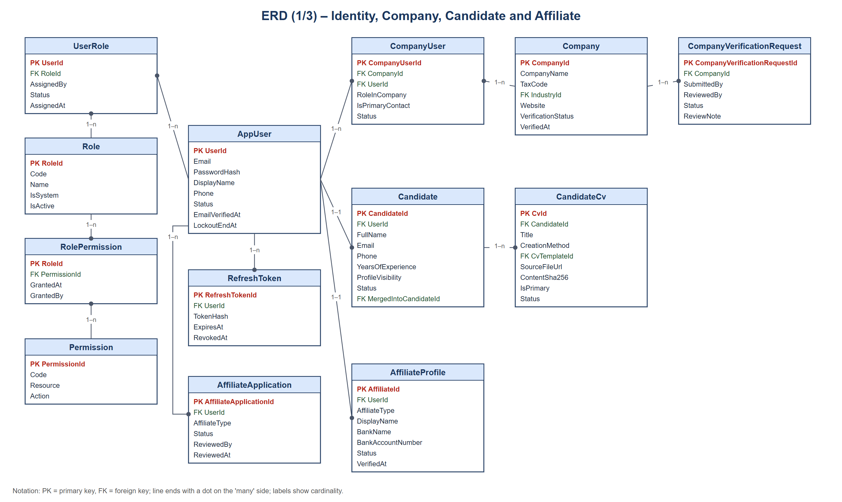
Figure 3. ERD – identity, company, candidate and affiliate
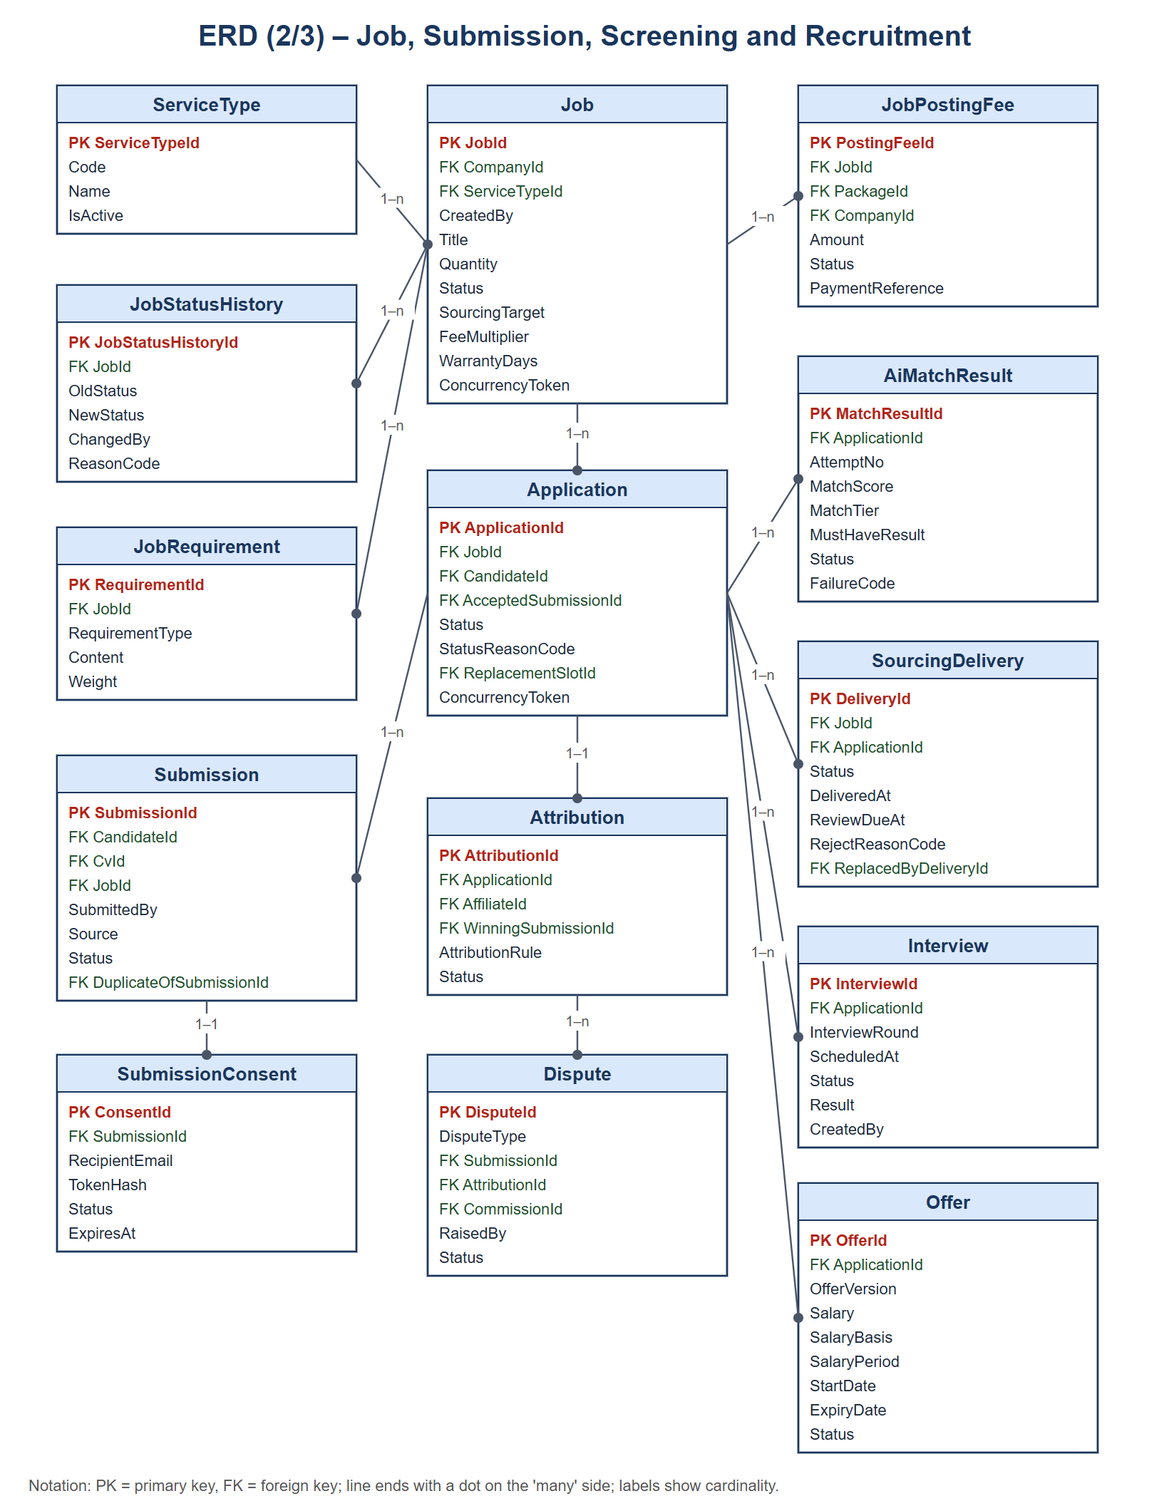
Figure 4. ERD – job, submission, screening and recruitment
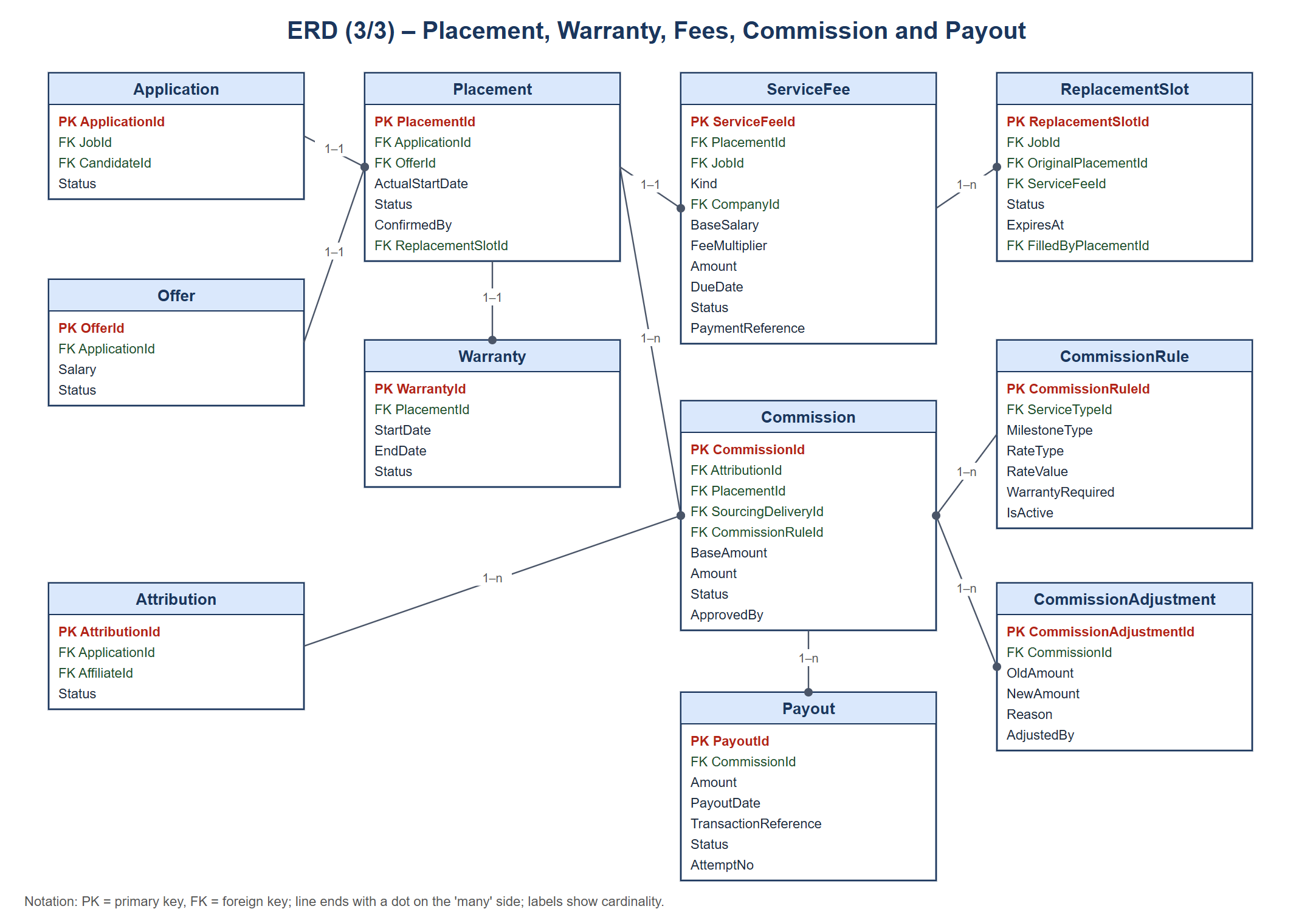
Figure 5. ERD – placement, warranty, fees, commission and payout
Table Descriptions
No | Table | Description
01 | AppUser | Account of every user (all roles).  - Primary keys: UserId  - Foreign keys: –
02 | Role, Permission, UserRole, RolePermission | Role-based access control; permissions are granted to roles and roles to users.  - Primary keys: RoleId; PermissionId; (UserId, RoleId); (RoleId, PermissionId)  - Foreign keys: UserRole.UserId → AppUser, UserRole.RoleId → Role, RolePermission.PermissionId → Permission
03 | RefreshToken, UserToken | Refresh tokens and one-time tokens (OTP, password reset), stored as hashes.  - Primary keys: RefreshTokenId; TokenId  - Foreign keys: UserId → AppUser
04 | Company | Client company profile and verification status.  - Primary keys: CompanyId  - Foreign keys: IndustryId → Industry, CompanySizeId → CompanySize
05 | CompanyUser | Membership of a user in a company, including the primary contact.  - Primary keys: CompanyUserId  - Foreign keys: CompanyId → Company, UserId → AppUser
06 | CompanyVerificationRequest | Verification request reviewed by Platform Admin (SF-01).  - Primary keys: CompanyVerificationRequestId  - Foreign keys: CompanyId → Company
07 | Candidate | Candidate profile; also created by an affiliate referral before the candidate has an account.  - Primary keys: CandidateId  - Foreign keys: UserId → AppUser (nullable), MergedIntoCandidateId → Candidate
08 | CandidateCv | Uploaded or builder-generated CV with file hash and text fingerprint.  - Primary keys: CvId  - Foreign keys: CandidateId → Candidate, CvTemplateId → CvTemplate
09 | AffiliateProfile, AffiliateApplication | Approved affiliate profile with bank account; application reviewed by Admin (SF-02).  - Primary keys: AffiliateId; AffiliateApplicationId  - Foreign keys: UserId → AppUser
10 | ServiceType, ServiceTypeAllowedRole | Service types and which roles can view or submit to them (can_view / can_submit).  - Primary keys: ServiceTypeId; (ServiceTypeId, RoleId)  - Foreign keys: RoleId → Role
11 | Job | Job posting with service type, quantity, status, commercial terms (fee multiplier, warranty days, Sourcing target and price per CV).  - Primary keys: JobId  - Foreign keys: CompanyId → Company, ServiceTypeId → ServiceType, CreatedBy → AppUser
12 | JobRequirement | MUST_HAVE / SHOULD_HAVE requirements used by AI matching.  - Primary keys: RequirementId  - Foreign keys: JobId → Job
13 | JobTemplate, JobTemplateRequirement | Job description templates managed by Internal HR.  - Primary keys: TemplateId; TemplateRequirementId  - Foreign keys: TemplateId → JobTemplate
14 | JobStatusHistory | History of job status changes with reason codes.  - Primary keys: JobStatusHistoryId  - Foreign keys: JobId → Job, ChangedBy → AppUser
15 | JobPostingPackage, JobPostingFee | Posting packages and the fee recorded for a job.  - Primary keys: PackageId; PostingFeeId  - Foreign keys: JobId → Job, PackageId → JobPostingPackage, CompanyId → Company
16 | Submission | One attempt to submit a candidate to a job by the candidate or an affiliate.  - Primary keys: SubmissionId  - Foreign keys: CandidateId → Candidate, CvId → CandidateCv, JobId → Job, DuplicateOfSubmissionId → Submission
17 | SubmissionConsent | Consent request sent to the candidate for an affiliate referral (hashed token, expiry).  - Primary keys: ConsentId  - Foreign keys: SubmissionId → Submission
18 | SubmissionIdentitySnapshot, CandidateDuplicateCase, CandidateDuplicateSignal | Hashed identity evidence and duplicate cases used for duplicate identification.  - Primary keys: SubmissionId; DuplicateCaseId; DuplicateSignalId  - Foreign keys: SubmissionId → Submission, CandidateAId/CandidateBId → Candidate
19 | Application | The accepted candidate–job pair that moves through the recruitment pipeline.  - Primary keys: ApplicationId  - Foreign keys: JobId → Job, CandidateId → Candidate, AcceptedSubmissionId → Submission, ReplacementSlotId → ReplacementSlot
20 | ApplicationStatusHistory | History of application status changes with reason codes.  - Primary keys: ApplicationStatusHistoryId  - Foreign keys: ApplicationId → Application
21 | Attribution | Which affiliate owns the application (first valid source).  - Primary keys: AttributionId  - Foreign keys: ApplicationId → Application, AffiliateId → AffiliateProfile, WinningSubmissionId → Submission
22 | AiMatchResult | Each AI scoring attempt with score, tier, per-requirement results and failure code.  - Primary keys: MatchResultId  - Foreign keys: ApplicationId → Application
23 | MatchTierConfig | Score ranges and colours of match tiers.  - Primary keys: TierCode  - Foreign keys: –
24 | SourcingDelivery | CV delivered to the Client of a CV_SOURCING job and the Client decision.  - Primary keys: DeliveryId  - Foreign keys: JobId → Job, ApplicationId → Application, ReplacedByDeliveryId → SourcingDelivery
25 | Interview, InterviewParticipant, InterviewStatusHistory | Interview rounds, participants and schedule changes.  - Primary keys: InterviewId; InterviewParticipantId; InterviewStatusHistoryId  - Foreign keys: ApplicationId → Application, InterviewId → Interview
26 | Offer | Versioned job offer with salary basis and period, expiry and response.  - Primary keys: OfferId  - Foreign keys: ApplicationId → Application, CreatedBy → AppUser
27 | Placement | Confirmed start of work.  - Primary keys: PlacementId  - Foreign keys: ApplicationId → Application, OfferId → Offer, ReplacementSlotId → ReplacementSlot
28 | Warranty | Warranty period of a Headhunt placement.  - Primary keys: WarrantyId  - Foreign keys: PlacementId → Placement
29 | ServiceFee | Fee charged to the Client (placement fee, Sourcing deposit or settlement) with due date and payment reference.  - Primary keys: ServiceFeeId  - Foreign keys: PlacementId → Placement, JobId → Job, CompanyId → Company
30 | ReplacementSlot | Free replacement opened after a confirmed resignation during warranty.  - Primary keys: ReplacementSlotId  - Foreign keys: JobId → Job, OriginalPlacementId → Placement, ServiceFeeId → ServiceFee, FilledByPlacementId → Placement
31 | CommissionRule, CommissionMilestone | Configurable commission rates per service type and milestone.  - Primary keys: CommissionRuleId; MilestoneCode  - Foreign keys: ServiceTypeId → ServiceType
32 | Commission | Affiliate commission with rule and calculation snapshots and status.  - Primary keys: CommissionId  - Foreign keys: AttributionId → Attribution, PlacementId → Placement, SourcingDeliveryId → SourcingDelivery, CommissionRuleId → CommissionRule
33 | CommissionAdjustment | Audit of manual commission amount changes.  - Primary keys: CommissionAdjustmentId  - Foreign keys: CommissionId → Commission
34 | Payout | Payout attempt to an affiliate with transaction reference.  - Primary keys: PayoutId  - Foreign keys: CommissionId → Commission
35 | Dispute | Source or commission dispute raised by an affiliate and resolved by Admin.  - Primary keys: DisputeId  - Foreign keys: SubmissionId → Submission, AttributionId → Attribution, CommissionId → Commission
36 | AffiliatePerformance | Calculated affiliate quality metrics per period.  - Primary keys: AffiliatePerformanceId  - Foreign keys: AffiliateId → AffiliateProfile
37 | Notification | In-app notification pushed through SignalR.  - Primary keys: NotificationId  - Foreign keys: UserId → AppUser
38 | EmailOutbox | E-mails waiting to be sent or retried.  - Primary keys: EmailOutboxId  - Foreign keys: UserId → AppUser
39 | AuditLog | Who did what to which entity, with old and new values.  - Primary keys: AuditLogId  - Foreign keys: ActorUserId → AppUser
40 | SystemSetting, ContactRequest, Industry, Skill, CvTemplate | Configurable business settings, contact form requests and reference data.  - Primary keys: SettingKey; ContactRequestId; IndustryId; SkillId; CvTemplateId  - Foreign keys: –
41 | ServiceAgreement, ServiceAgreementSignatureChallenge [Planned] | Planned MF-01: versioned agreement between HR Connect and the Client and its OTP signing challenge.  - Primary keys: AgreementId; ChallengeId  - Foreign keys: JobId → Job, CompanyId → Company

3. Detailed Design
This section describes the five main flows. All features use the same request pipeline: the web application calls an endpoint, the endpoint sends a MediatR command or query, a validator checks the input, the handler applies the business policy, saves the changes through EF Core in one transaction and writes the audit log; notifications are published to SignalR only after the transaction commits.

3.1 MF-01 Create, Approve and Publish Job
Client Company Users create jobs for one of the three service types; Internal HR reviews them; the job becomes ACTIVE after the posting fee or the Sourcing deposit is recorded. Commercial terms (fee multiplier, warranty days, Sourcing target and price per CV) are proposed by the Client and confirmed by HR. [Planned] For HEADHUNT_COD and CV_SOURCING, a Service Agreement step will be added after approval (PENDING_AGREEMENT): HR sends a versioned agreement, the Client's primary contact signs it with an e-mail OTP, the signed PDF is stored in R2, then a Headhunt job becomes ACTIVE and a Sourcing job creates its deposit (PENDING_PAYMENT).

3.1.1 Class Diagram
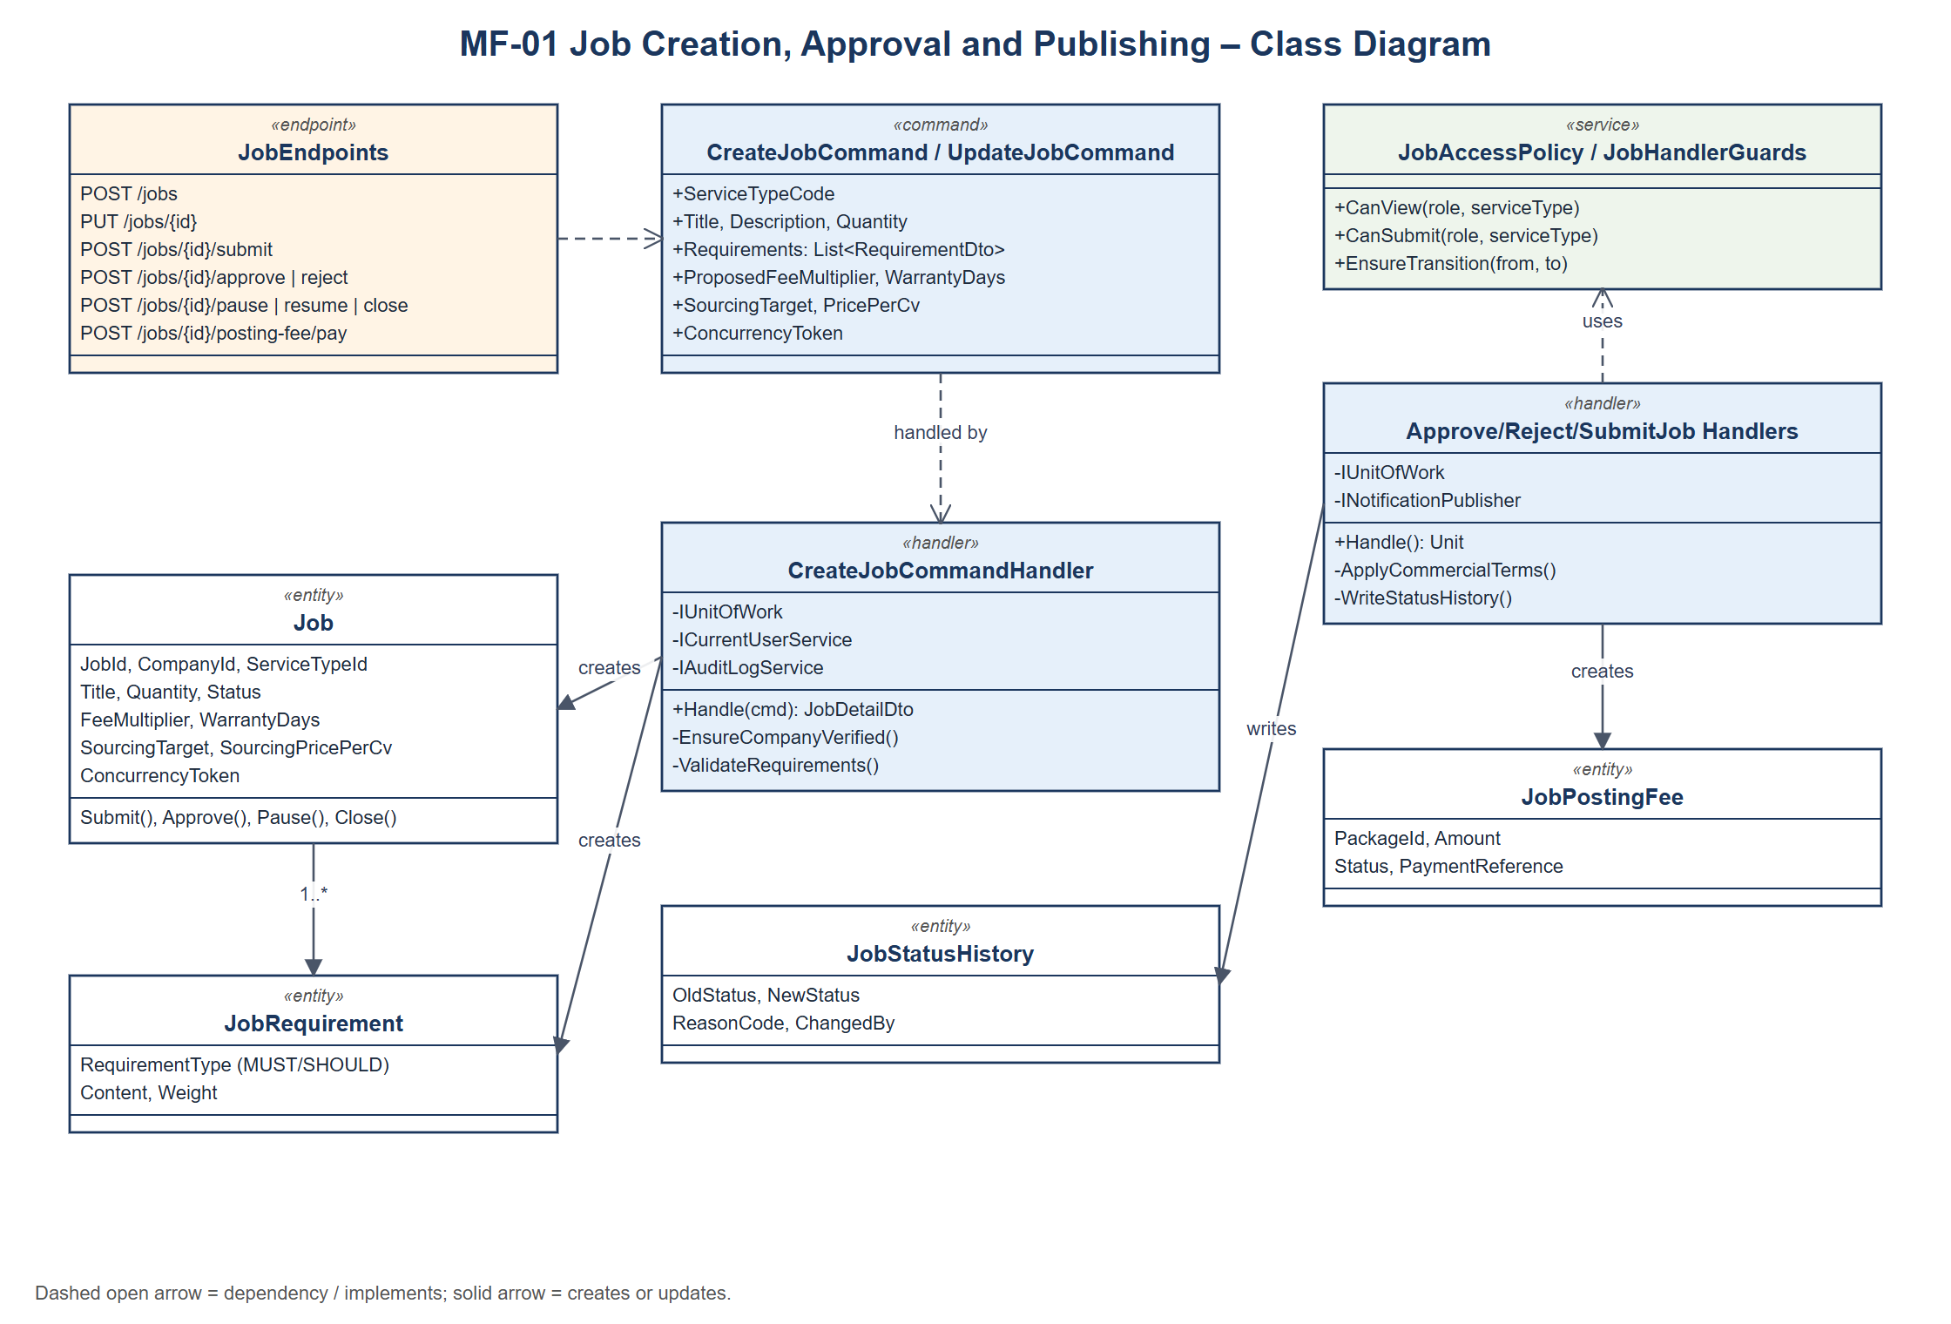
Class diagram – MF-01 Create, Approve and Publish Job
Class specifications:
• JobEndpoints: Maps the job routes and checks the permission policy of the caller.
• CreateJobCommandHandler / UpdateJobCommandHandler: Validate that the company is verified and the service type allows the caller to submit, save the Job and its JobRequirements; updates check the ConcurrencyToken.
• Submit/Approve/Reject/Pause/Resume/CloseJob handlers: Apply the allowed status transition, require reason codes for reject/close, write JobStatusHistory and AuditLog, notify the Client.
• JobAccessPolicy: Decides who can view or submit to a job by service type (ServiceTypeAllowedRole).
• RecordJobPostingFeePaymentCommand: Admin records the posting fee reference; the job becomes ACTIVE.

3.1.2 Sequence Diagram – Client creates and submits a job
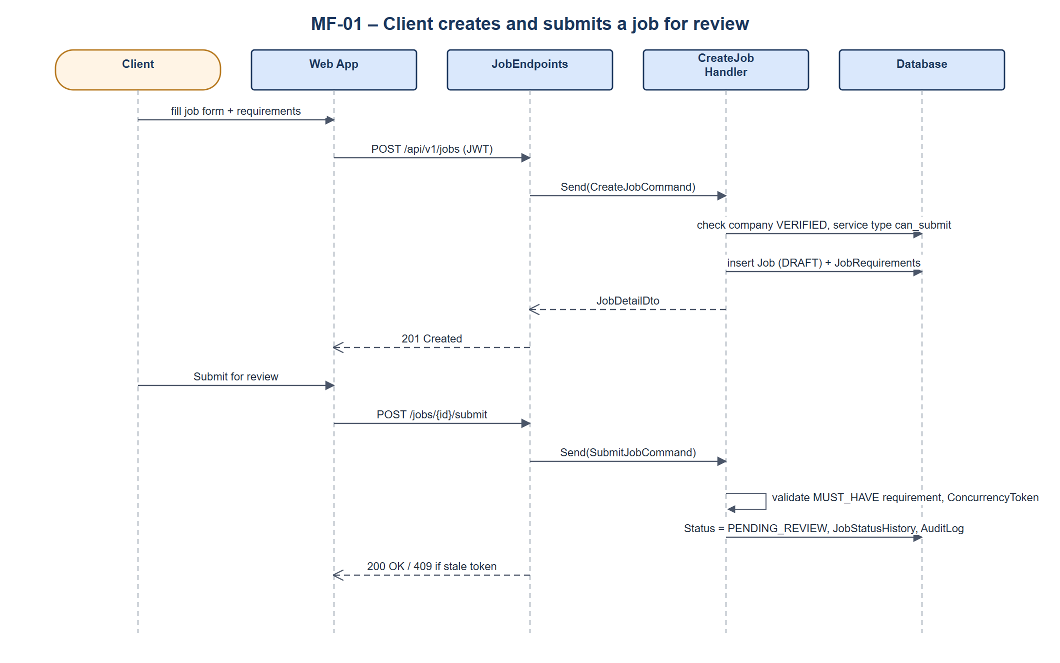
Sequence diagram – Client creates and submits a job

3.1.3 Sequence Diagram – Internal HR approves and the job is published
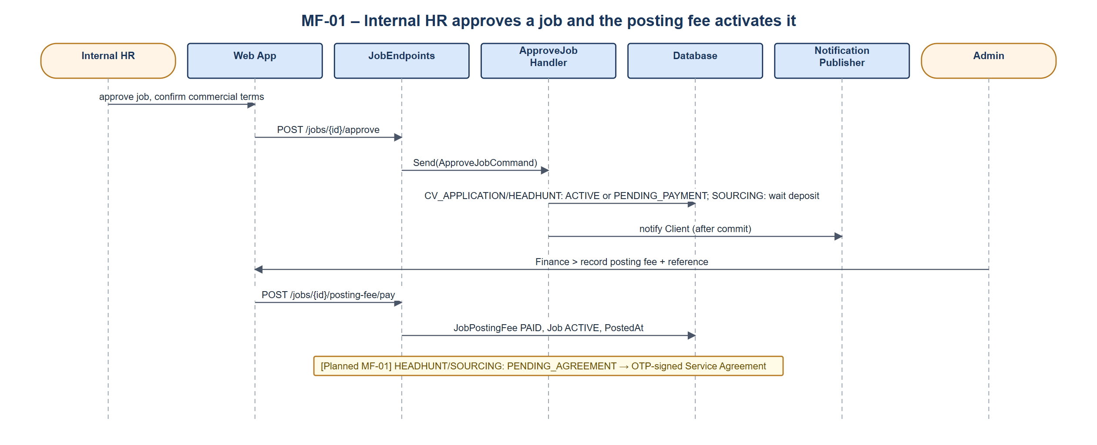
Sequence diagram – Internal HR approves and the job is published

3.2 MF-02 Candidate Submission, Consent, Duplicate Check and Attribution
Candidates apply to CV_APPLICATION jobs; Affiliates refer candidates to HEADHUNT_COD and CV_SOURCING jobs. An affiliate referral needs the candidate's consent by e-mail. The system normalises e-mail and phone, blocks duplicate submissions for the same job (BLOCKED_DUPLICATE) and keeps the first valid source as the Attribution.

3.2.1 Class Diagram
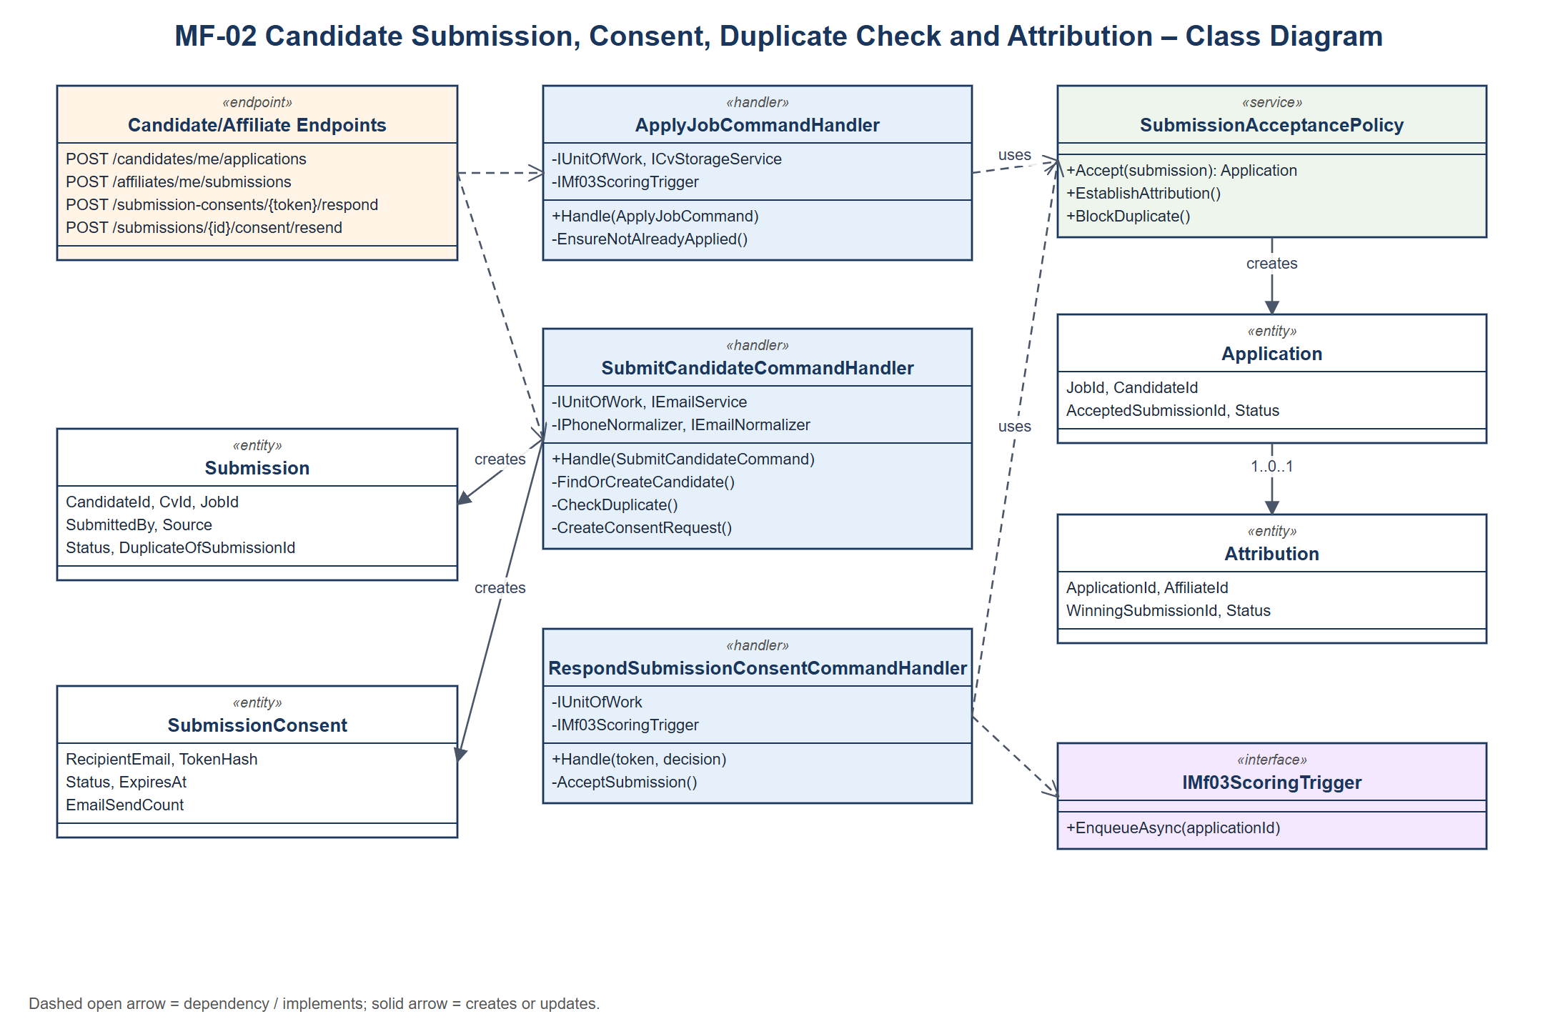
Class diagram – MF-02 Candidate Submission, Consent, Duplicate Check and Attribution
Class specifications:
• ApplyJobCommandHandler: Candidate applies with an uploaded or existing CV; creates the Submission and Application and triggers AI scoring.
• SubmitCandidateCommandHandler: Finds or creates the Candidate, checks duplicates and pending consents, creates the Submission and SubmissionConsent and queues the consent e-mail.
• RespondSubmissionConsentCommandHandler: Verifies the hashed token and expiry, accepts or rejects the submission and notifies the affiliate.
• SubmissionAcceptancePolicy: Creates the Application and Attribution or marks the submission as duplicate.
• ResendSubmissionConsentCommand: Resends the consent e-mail with a cool-down and a maximum count.

3.2.2 Sequence Diagram – Affiliate refers a candidate
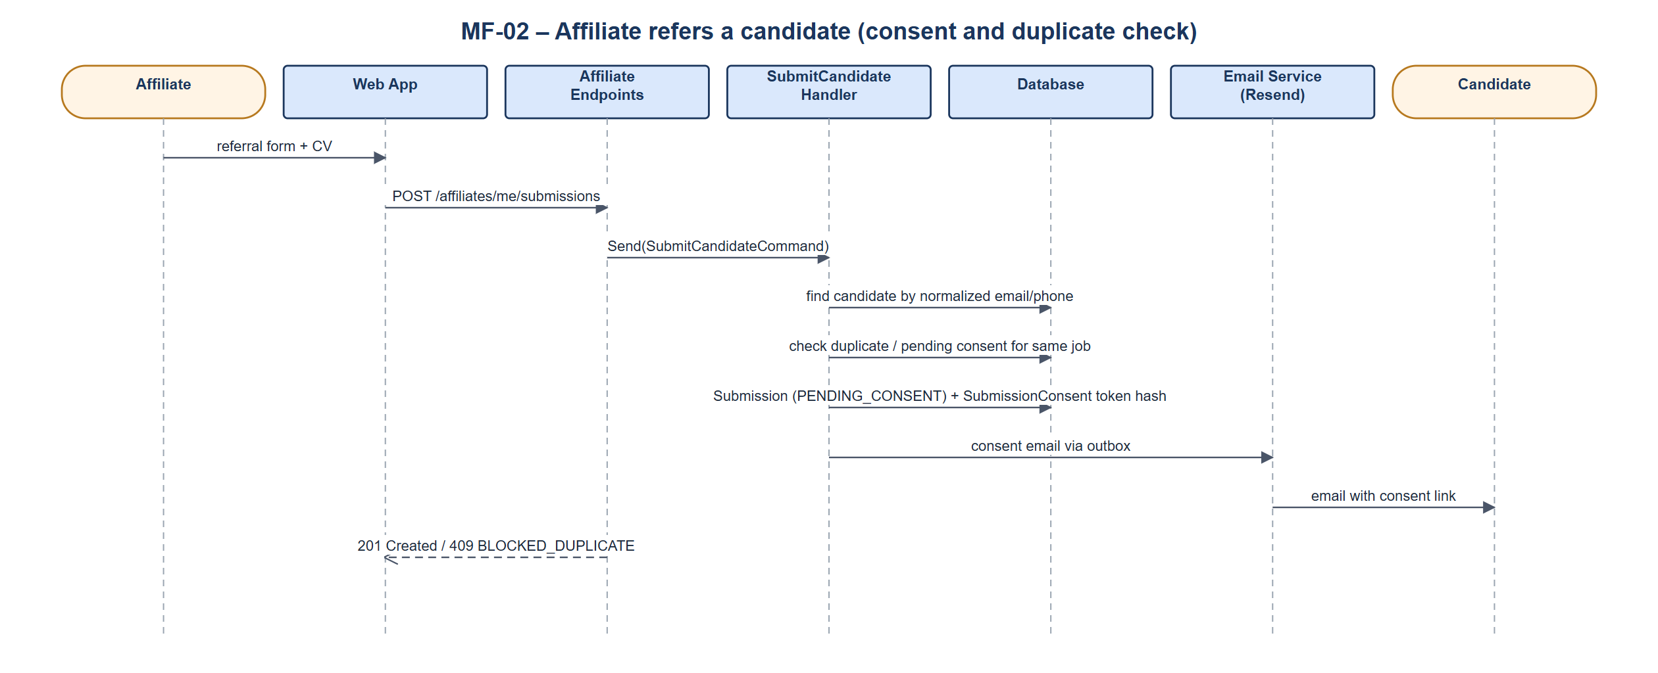
Sequence diagram – Affiliate refers a candidate

3.2.3 Sequence Diagram – Candidate accepts consent
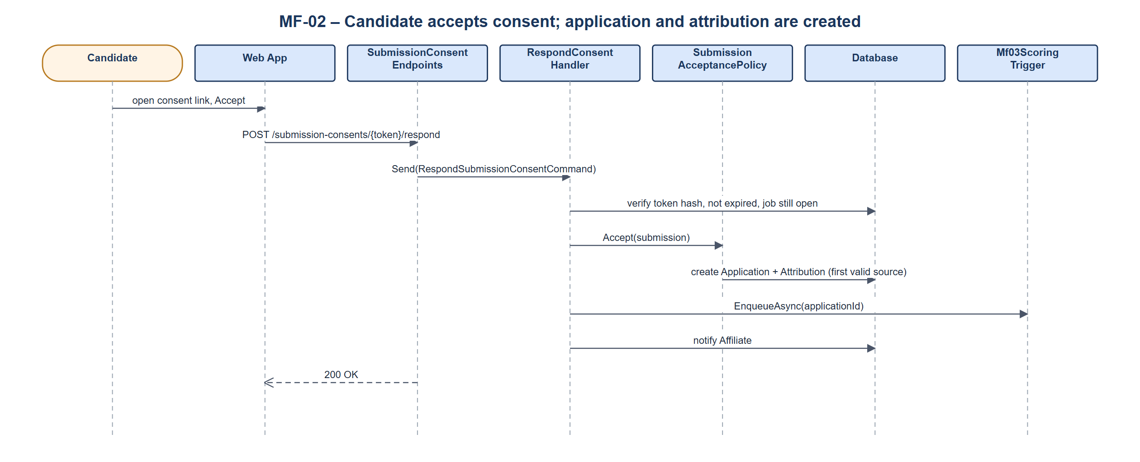
Sequence diagram – Candidate accepts consent

3.3 MF-03 AI Matching and Screening
Every new application is scored asynchronously by the AI Matching Service. Internal HR screens Headhunt and Sourcing applications using the score, tier and evidence; Clients screen CV_APPLICATION jobs themselves. For CV_SOURCING, HR delivers CVs to the Client, who accepts or rejects them within the review period (auto-accepted after the deadline).

3.3.1 Class Diagram
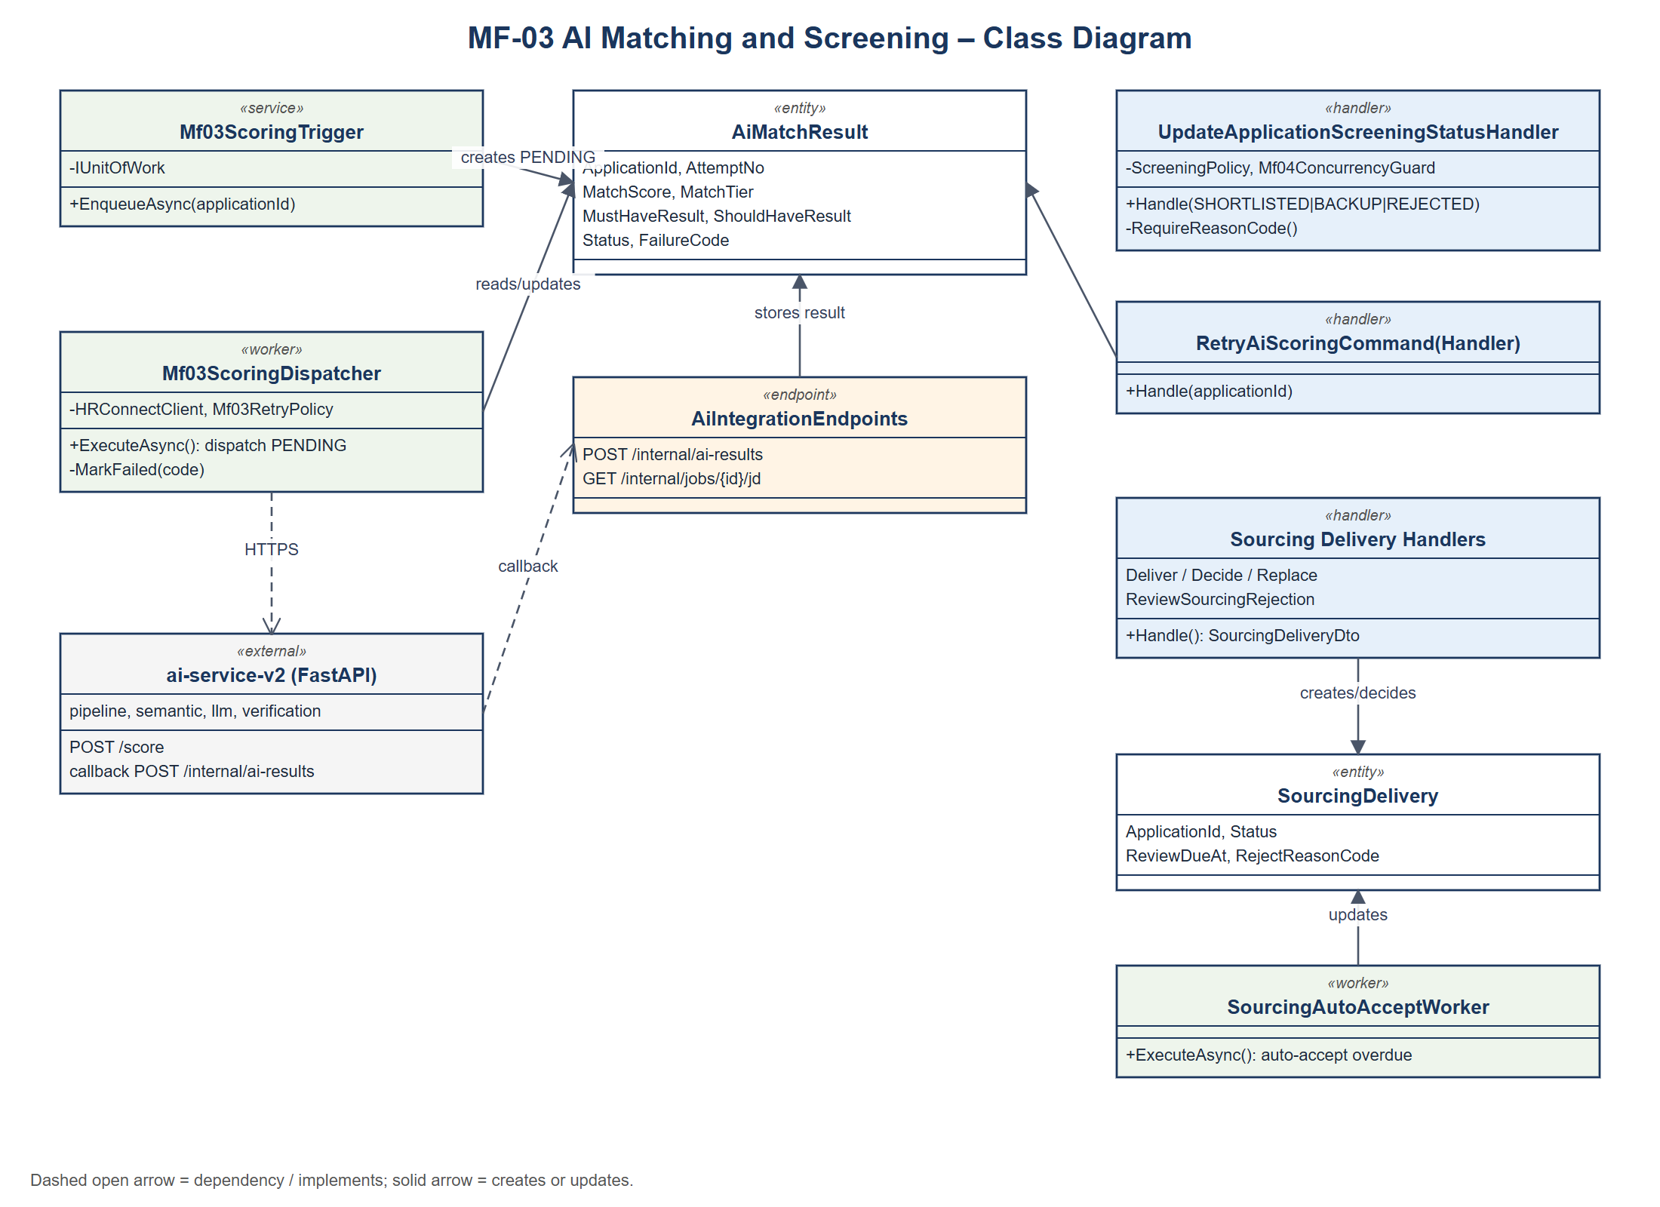
Class diagram – MF-03 AI Matching and Screening
Class specifications:
• Mf03ScoringTrigger / Mf03ScoringDispatcher: Create a PENDING AiMatchResult and dispatch it to the AI service with retry and back-off.
• AiIntegrationEndpoints: Internal callback that stores the score, tier and per-requirement results, or the failure code.
• RetryAiScoringCommand: Internal HR starts a new scoring attempt for a FAILED result.
• UpdateApplicationScreeningStatusCommandHandler: Moves an application to SHORTLISTED, BACKUP or REJECTED with a reason code, using the ConcurrencyToken.
• Sourcing delivery handlers: Deliver, decide, replace and review rejections of Sourcing CVs; SourcingAutoAcceptWorker accepts overdue deliveries.

3.3.2 Sequence Diagram – Asynchronous AI scoring
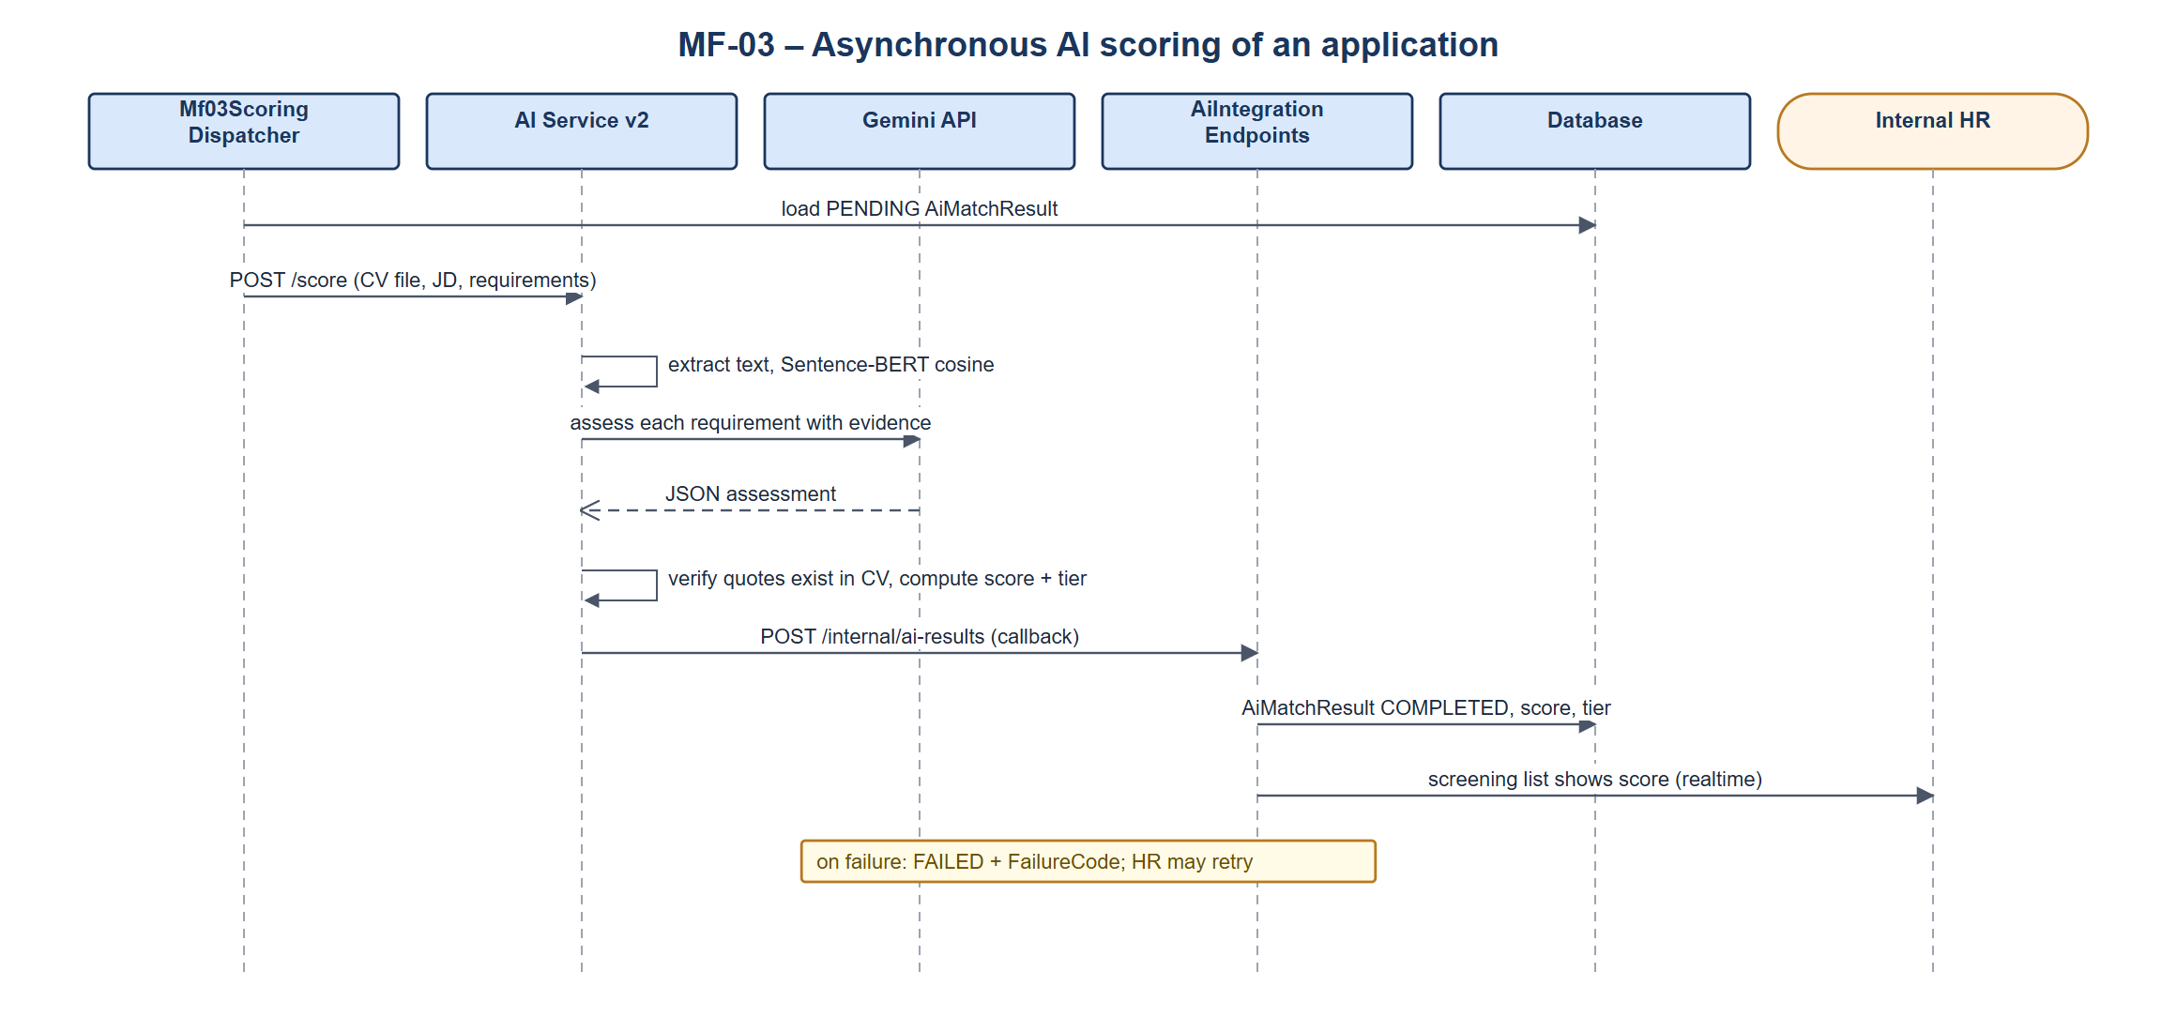
Sequence diagram – Asynchronous AI scoring

3.3.3 Sequence Diagram – Internal HR screens an application
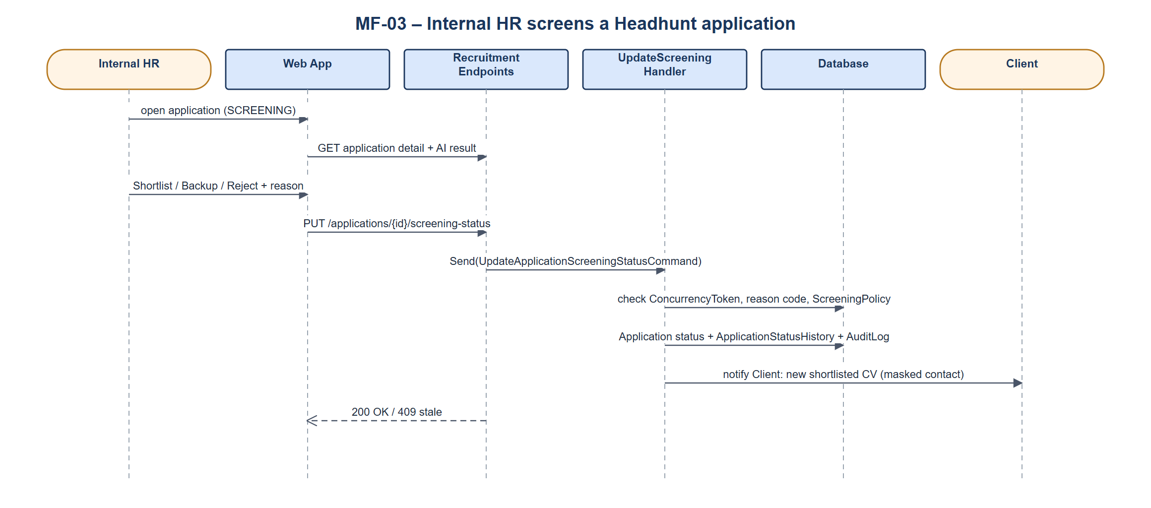
Sequence diagram – Internal HR screens an application

3.4 MF-04 Interview, Offer and Start Work
The Client schedules interviews, records results, sends offers and confirms the start of work. Headhunt offers must use gross monthly salary. When the candidate starts work, a Placement is created and the finance records of MF-05 are initialised.

3.4.1 Class Diagram
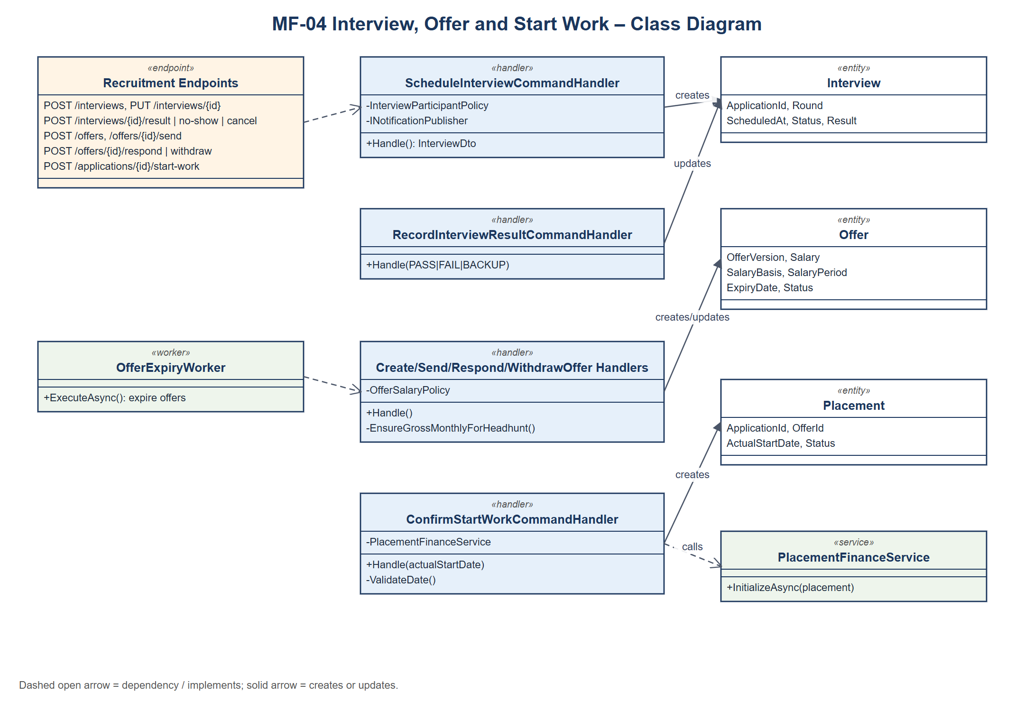
Class diagram – MF-04 Interview, Offer and Start Work
Class specifications:
• ScheduleInterviewCommandHandler, Update/Reschedule/Cancel handlers: Manage interview rounds, participants and schedule history; notify the candidate in real time.
• RecordInterviewResult / RecordInterviewNoShow handlers: Record PASS, FAIL, BACKUP or NO_SHOW and move the application.
• Create/Update/Send/Respond/WithdrawOffer handlers: Manage offer versions; OfferSalaryPolicy checks the salary basis; withdrawal needs a reason; OfferExpiryWorker expires old offers.
• ConfirmStartWorkCommandHandler: Validates the actual start date, creates the Placement and calls PlacementFinanceService.
• MarkNotStartedCommandHandler: Closes an accepted offer when the candidate does not start; no fee is created.

3.4.2 Sequence Diagram – Client schedules an interview
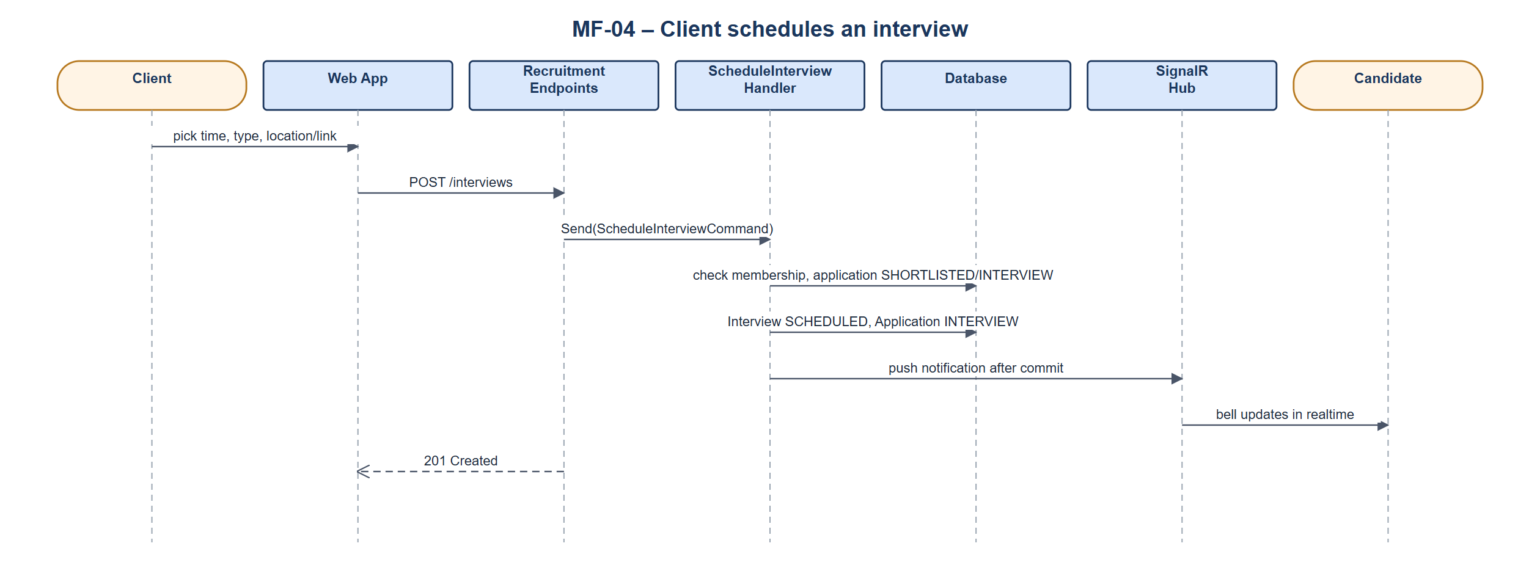
Sequence diagram – Client schedules an interview

3.4.3 Sequence Diagram – Offer, acceptance and start work
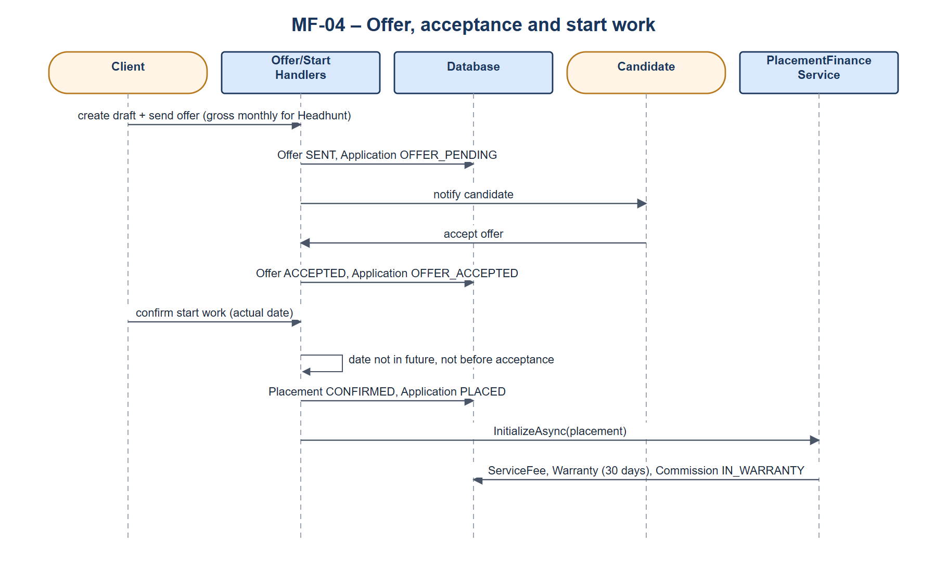
Sequence diagram – Offer, acceptance and start work

3.5 MF-05 Fee, Warranty, Commission and Payout
After placement the Client owes the service fee (fee multiplier × gross monthly salary). A Headhunt placement has a 30-day warranty; the affiliate commission is earned at the end of the warranty and becomes payable after the Client pays. A confirmed resignation during the warranty cancels the commission and opens a free replacement slot. Sourcing jobs pay a commission per accepted CV and are settled against the deposit.

3.5.1 Class Diagram
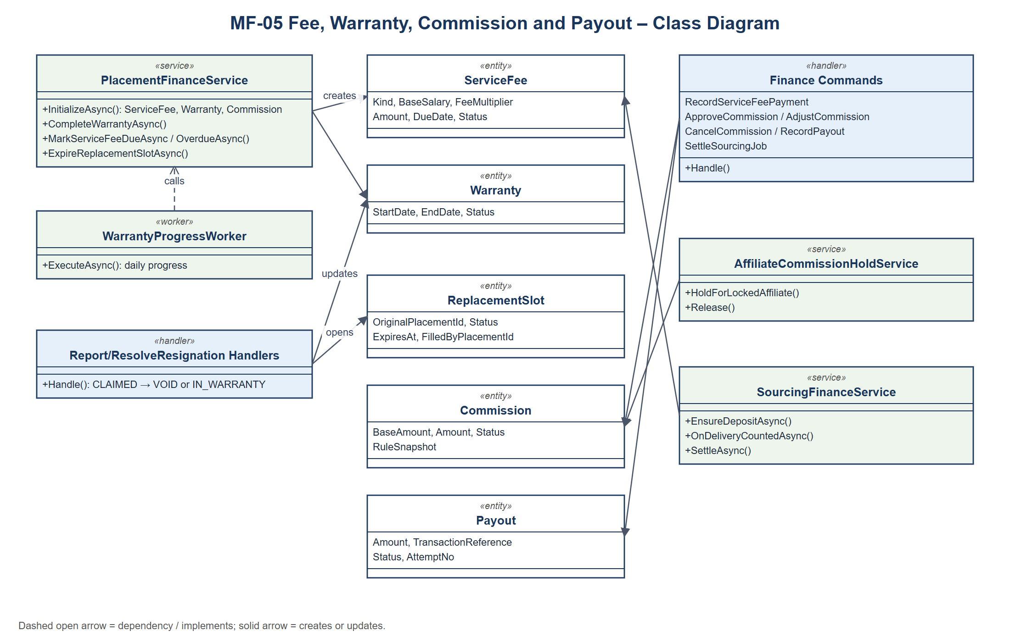
Class diagram – MF-05 Fee, Warranty, Commission and Payout
Class specifications:
• PlacementFinanceService: Creates ServiceFee, Warranty and Commission for a placement; completes warranties and marks fees DUE/OVERDUE (called by WarrantyProgressWorker).
• Report/ResolveResignation handlers: Client reports a resignation (warranty CLAIMED, commission ON_HOLD); Internal HR confirms or rejects it.
• Finance commands: RecordServiceFeePayment, ApproveCommission, AdjustCommission, CancelCommission, RecordPayout and SettleSourcingJob, used by Platform Admin.
• AffiliateCommissionHoldService: Puts unearned commissions of a locked affiliate ON_HOLD.
• SourcingFinanceService: Creates the Sourcing deposit, counts accepted CVs and settles the job.

3.5.2 Sequence Diagram – Warranty completion, fee payment and payout
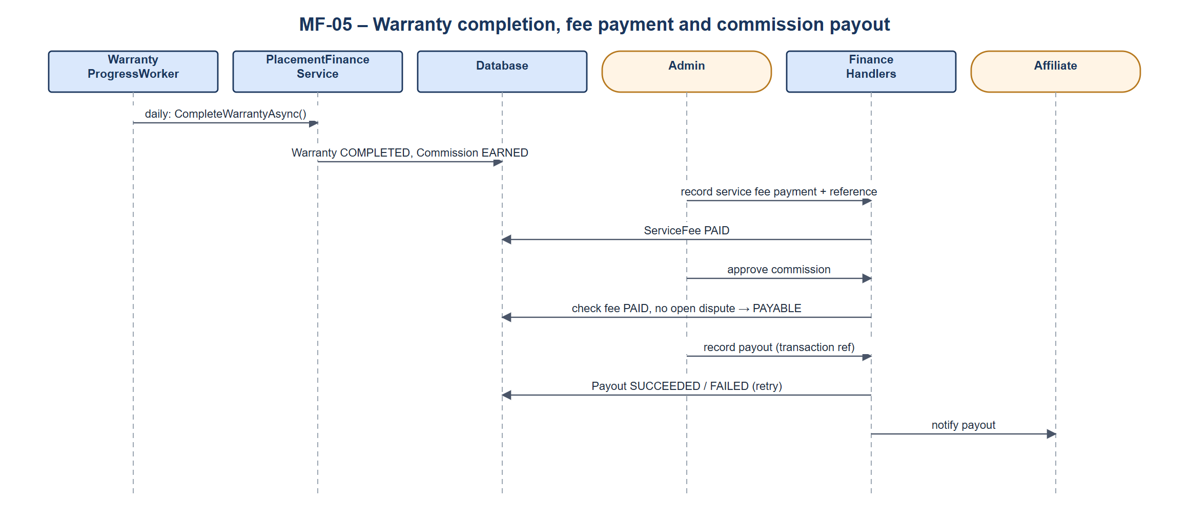
Sequence diagram – Warranty completion, fee payment and payout

3.5.3 Sequence Diagram – Resignation during warranty
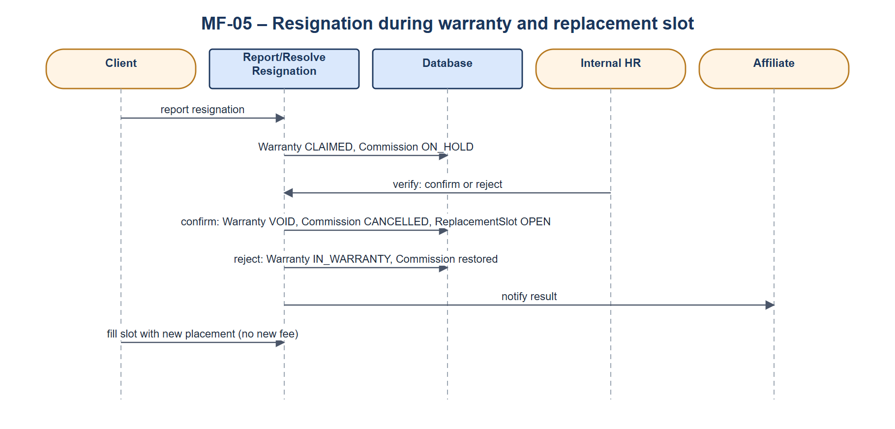
Sequence diagram – Resignation during warranty

