

CAPSTONE PROJECT REPORT
Report 1 – Project Introduction

– Ho Chi Minh, October 2026 –
Table of Contents
I. Record of Changes 3
II. Project Introduction 4
1. Overview 4
1.1 Project Information 4
1.2 Project Team 4
2. Product Background 4
3. Existing Systems 5
3.1 System Aniday 5
3.2 System Workable 6
4. Business Opportunity 6
5. Software Product Vision 7
6. Project Scope & Limitations 7
6.1 Major Features 8
6.2 Limitations & Exclusions 9

I. Record of Changes
Date | A*  M, D | In charge | Change Description
11/09/2026 | A | Lê Thị Trà Mi | Created the initial draft for Chapter 1: Project Introduction (Sections 1 to 6)
12/09/2026 | M | Trương Hoàng Quí | Revised Product Background, Existing Systems, Business Opportunity, Product Vision, Major Features, and Limitations
12/09/2026 | M | Cao Hữu Trí | Updated Candidate/Submission-related content, duplicate handling, attribution wording, and Major Features to align with the current business baseline.
22/09/2026 | M | Lê Thị Trà Mi | Added a caption/source note for the feature map and updated the Aniday/Workable reference links.
21/10/2026 | M | Trương Hoàng Quí | Aligned Chapter 1 with the implemented system: removed probation, added Candidate consent, BLOCKED_DUPLICATE handling and source disputes, Client service fees, CV Sourcing deposits and replacement slots, the planned Service Agreement flow in FE-01, new FE-07 and FE-08, and LI-08.
*A - Added M - Modified D - Deleted

II. Project Introduction

1. Overview

1.1 Project Information
- Project name: HR Connect: AI-Powered Recruitment & Affiliate Headhunting Platform
- Project code: FA26SE153
- Group name: GFA26SE18
- Software type: Web

1.2 Project Team
Full Name | Role | Email | Mobile
Pham Minh Tri | Lecturer | tripm14@fpt.edu.vn
Truong Hoang Qui | Leader | QuiTHSE184355@fpt.edu.vn | 0862358874
Cao Huu Tri | Member | TriCHSE184047@fpt.edu.vn | 0356702429
Khuc Ngoc Son | Member | SonKNSE184040@fpt.edu.vn | 0981761545
Le Thi Tra Mi | Member | MiLTTSE184379@fpt.edu.vn | 0388278354
Nguyen Van Sang | Member | SangNVSE183276@fpt.edu.vn | 0983135379

2. Product Background
Currently, recruitment operations involving agency HR staff, client companies, candidates, and recruitment affiliates cover three main service lines: Headhunt COD, CV Sourcing, and CV Application. In practice, these operations are still coordinated manually through spreadsheets, Zalo groups, and email. Because recruitment information and updates are distributed across these fragmented channels, HR staff must spend considerable time consolidating data when reviewing applications and monitoring recruitment progress.
This manual recruitment process creates operational difficulties in identifying duplicate candidate submissions and verifying referral sources, especially when multiple recruiters or affiliates introduce the same candidate. Unclear referral attribution may lead to commission disputes over who should receive the commission. Meanwhile, manually reviewing CVs against job descriptions requires considerable effort and may produce inconsistent assessments across reviewers. Tracking applications through screening, interview, offer, start of work, and warranty stages also requires information to be collected and updated across multiple parties. As a result, affiliates have limited visibility into current job availability, while agencies lack sufficient data to assess the historical quality and recruitment outcomes of affiliate submissions.
These identified business needs provide the basis for the proposed HR Connect platform. The project aims to support coordinated recruitment operations through centralized candidate information, traceable application progress, and transparent referral and commission records. This provides agency staff, client companies, and recruitment affiliates with a more consistent basis for managing and monitoring recruitment activities.

3. Existing Systems
To identify existing solutions that can support the analysis and design of HR Connect, the team reviewed two recruitment platforms: Aniday and Workable. Aniday was selected as a reference for recruiter-based Candidate referrals and reward management, while Workable was selected as a reference for applicant tracking, External Recruiter collaboration, duplicate handling, and AI-assisted screening.
Based on the public documentation reviewed by the team, both platforms provide relevant features. However, there is insufficient public evidence that either platform supports the complete combination of the three recruitment Service Types defined for HR Connect, centralized Master Candidate management, the project’s Candidate attribution rules, and Affiliate performance and Commission/Payout management.

3.1 System Aniday
Description: Aniday is a recruitment platform that connects employers with recruiters, referrers, and Candidates. Recruiters can refer Candidates to available Jobs and may receive rewards when their referrals satisfy the applicable recruitment conditions.
Link: https://aniday.com/en
System actors: Employer, Recruiter/Referrer, Candidate.
Features: Aniday displays active Jobs together with their referral rewards and allows Recruiters to submit Candidate information, CVs, and recommendations. The platform requires Candidates to confirm referrals and enables a Candidate to select one accepted referrer when multiple referrals occur. Recruiters can track the status of their referred Candidates through a dashboard. Aniday also provides milestone-based referral rewards, scheduled payments, and warranty conditions. In addition, the Aniday Recruiter application advertises AI-powered Candidate recommendations.
Pros: Aniday connects Employers, Recruiters, and Candidates through a shared recruitment platform. It allows Recruiters to view available Jobs, submit Candidates, and monitor recruitment progress. Candidate confirmation provides a mechanism for validating a referral and determining the accepted referrer. The connection between recruitment outcomes, reward milestones, warranty conditions, and payments also provides a useful reference for the Affiliate and Commission processes of HR Connect.
Cons: Based on the reviewed public documentation, support for the complete combination of the three recruitment Service Types defined for HR Connect—Headhunt COD, CV Sourcing, and CV Application—remains unverified. The team also found insufficient public evidence of a centralized Master Candidate model, detailed CV–JD matching based on Must-have and Should-have requirements, or historical Affiliate performance analytics. Aniday prevents later referrals after a Candidate has accepted one referrer. This differs from HR Connect’s proposed approach, in which later Submission attempts are retained for traceability, marked as duplicates, and linked to the same Master Candidate. Furthermore, Aniday’s terms mention self-nomination; therefore, Candidate–Referrer dual participation should not be presented as an exclusive feature of HR Connect. Referral Terms

3.2 System Workable
Description: Workable is an Applicant Tracking System that supports recruitment activities from Candidate sourcing and screening to interviews and Offers. It enables organizations to manage Jobs, Candidates, evaluations, and recruitment progress through centralized hiring pipelines.
Link :https://www.workable.com
System actors: Super Administrator, Recruiting Administrator, Internal Hiring Team Member, External Recruiter, and Candidate.
Features: Workable supports Job and Candidate management, configurable recruitment pipelines, Candidate evaluations, interview scheduling, Offer management, and recruitment reporting. External Recruiters can be invited to assigned Jobs and can upload Candidates directly to those Jobs with restricted permissions. Workable detects duplicate Candidate applications primarily by email within each Job. The platform also provides AI-assisted screening features, including AI-generated Candidate summaries, match scores, and requirement assessments to support the hiring team. Workable — Product Features, External Recruiters
Pros: Workable provides a centralized environment for managing Candidate information and recruitment progress. It supports collaboration between Internal Hiring Teams and External Recruiters while limiting External Recruiters to authorized Jobs and the Candidates they submitted. Its structured evaluation tools can help reviewers assess Candidates according to consistent criteria. Its AI-generated screening results also provide supporting information while authorized users retain control over recruitment decisions.
Cons: Workable detects duplicate Candidates primarily by email within a specific Job rather than maintaining one universal Master Candidate record for the entire account. When the same Candidate applies to different Jobs, separate Job-specific Candidate profiles are created, and Workable does not support merging two Candidate profiles into a single profile. When an External Recruiter submits a Candidate who already exists in the same Job, the later Candidate submission may be skipped or ignored. This differs from HR Connect’s proposed approach of retaining the Submission attempt, marking it as duplicate, preserving its source and timestamp, and linking it to the same Master Candidate. Support for the complete combination of the three recruitment Service Types defined for HR Connect, the Candidate–OPR dual-access model, Affiliate attribution rules, warranty-based Commission eligibility, historical Affiliate quality assessment, and an Affiliate-facing Payout Ledger remains unverified based on the reviewed public documentation. Duplicate and Multiple Applications

4. Business Opportunity
The simultaneous operation of Headhunt COD, CV Sourcing, and CV Application services creates an opportunity to replace fragmented recruitment coordination with a unified digital workflow through HR Connect. As the recruitment process involves Agency HR staff, Client Companies, Candidates, and Affiliate/OPR Recruiters, the value of the platform depends not only on storing Candidate information but also on connecting Job requirements, Candidate Submissions, recruitment progress, referral attribution, and Commission eligibility within the same operational environment.
Existing platforms provide useful but partial references. Aniday demonstrates how Recruiters can refer Candidates, monitor recruitment progress, and receive rewards, while Workable demonstrates centralized applicant tracking, controlled collaboration with External Recruiters, and AI-assisted screening. However, based on the public documentation reviewed by the team, neither platform has been verified as supporting the complete combination of the three recruitment Service Types defined for HR Connect, centralized Master Candidate management, the project’s duplicate and attribution rules, and Affiliate performance and Commission/Payout tracking. This gap creates an opportunity for HR Connect to provide a solution tailored to the recruitment operating model defined within the project instead of directly replicating an existing recruitment platform.
HR Connect is therefore proposed as a centralized web-based platform that maintains unified Candidate records while preserving the source and history of each Submission. Duplicate detection can identify repeated Submissions without losing traceability, while AI-assisted CV–JD matching can help HR staff review and prioritize Candidate profiles according to Job requirements. Shared Job and Application statuses can provide Agency staff, Clients, and Affiliates with more consistent and timely recruitment information. Traceable referral records, defined attribution rules, and Commission/Payout records can also provide a clearer basis for determining Affiliate entitlements and monitoring payment status.
The proposed platform is attractive because it combines recruitment workflow management, Affiliate collaboration, AI-assisted screening, and Commission traceability within a single system designed around the business rules defined for HR Connect. These capabilities are expected to reduce dependence on spreadsheets, Zalo groups, email, and manual reconciliation; improve operational visibility; and provide structured data for evaluating Affiliate contributions and recruitment outcomes. In the longer term, this centralized data foundation can support the development of the Affiliate/OPR network and the future expansion of recruitment analytics and automation.

5. Software Product Vision
For small and medium-sized recruitment agencies that coordinate recruitment activities among Internal HR staff, Client Companies, Candidates, and Affiliate/OPR Recruiters, HR Connect is a centralized, role-based web platform designed to support Headhunt COD, CV Sourcing, and CV Application services.
Unlike recruitment operations coordinated through separate spreadsheets, Zalo groups, and email, HR Connect brings together Master Candidate records, Candidate Submissions, recruitment progress, AI-assisted CV–JD matching, referral attribution, and Commission/Payout records within a shared and traceable workflow.
HR Connect aims to reduce dependence on manual coordination, improve visibility into recruitment progress, support more consistent Candidate screening, and provide reliable records for handling referral attribution and Commission disputes. The product’s vision is to enable transparent and coordinated recruitment operations while ensuring that screening and hiring decisions remain under human oversight.

6. Project Scope & Limitations
HR Connect focuses on the core recruitment workflows required to coordinate Internal HR/Recruiters, Client Companies, Candidates, and Affiliate/OPR Recruiters. The project covers Company and Job management; Candidate, CV, Submission, and Attribution management; AI-assisted screening; recruitment pipeline tracking; and Affiliate Commission/Payout record management across the three Service Types: Headhunt COD, CV Sourcing, and CV Application.
The project is developed within the time and resource constraints of the Capstone. Therefore, HR Connect is intended to support the core recruitment operations defined within the project scope and is not designed to replace a complete Human Resource Management, accounting, payroll, or banking system.

6.1 Major Features
FE-01: Company and Job Management
Manage Client Company information and support authorized users in creating, reviewing, approving or rejecting, publishing, updating, and closing Jobs. Each Job is associated with a Service Type and recruitment requirements, including Must-have and Should-have criteria. The system may also provide public Job listing, search, filtering, and Job detail access for Guest and Candidate users where applicable. For CV Application, the Client must explicitly select a posting package and accept its terms. For Headhunt COD and CV Sourcing, HR Connect proposes a versioned Service Agreement based on the terms requested by the Client (such as the fee multiplier, Warranty period, payment term, or price per qualified CV); the Client accepts it or requests changes, the Client's primary contact signs it with a one-time password, and the signed agreement is stored as a private PDF. Only then is a Headhunt COD Job activated, while a CV Sourcing Job moves to deposit payment.
FE-02: Candidate, CV, Submission, Application, and Attribution Management
Manage Master Candidate records, Candidate profiles, multiple CV versions, Submissions, Applications, Submission Source, and Attribution. HR Connect follows the principle of one human being represented by one Master Candidate record. Candidate identity can be supported by normalized information such as Email, Phone, LinkedIn, and other identifying data. A Candidate who already exists in the system may still participate in another Job. When the same Master Candidate is submitted again to the same Job, the Submission attempt is retained and marked as BLOCKED_DUPLICATE for traceability, linked to the existing Master Candidate, and must not create another primary Application for the same Candidate and Job. Duplicate Submissions do not automatically replace the current Attribution. A Submission made by an Affiliate becomes an Application only after the Candidate confirms consent, either in the Candidate portal or through a secure email link, and the Attribution is recorded at that moment. An Affiliate whose Submission is blocked as a duplicate may raise a source dispute, which Platform Admin reviews and resolves with a recorded outcome.
FE-03: AI-Assisted CV–JD Matching and Screening
Analyze Candidate CV/Profile information against Job requirements, including Must-have and Should-have criteria, to generate Match Scores, Match Tiers, Candidate Highlights, and supporting matching information. AI results are used as decision-support information for Human Review and Candidate prioritization. Shortlist, Reject, Interview, Offer, Hire, and other recruitment decisions remain under the control of authorized human users.
FE-04: Recruitment Pipeline, Interview, Offer, and Placement Management
Track valid Candidate Applications through the recruitment pipeline, including Screening, Shortlist, Backup, CV Sourcing delivery and Client acceptance or rejection, Interview Scheduling, Interview Result, Offer drafting, sending and withdrawal, Candidate Accept/Decline, Start Work, and Placement. The system records status history, relevant feedback and outcomes, and applicable unsuccessful or exception states such as rejection, interview failure, offer decline, Candidate withdrawal, or not-started cases.
FE-05: Service Fee, Warranty, Commission, and Payout Record Management
Record the Client-side charges of each Service Type: the posting fee of the selected CV Application package, the Headhunt COD service fee calculated from the agreed fee multiplier and the gross monthly salary with a payment due date, and the CV Sourcing deposit required before the Job is activated. Track the Warranty period after a Candidate starts work, handle resignations reported during the Warranty, and open a replacement slot when a resignation is confirmed. Support the determination of Commission eligibility based on Service Type, recorded Affiliate Attribution, the completed Warranty period, the Client's service fee payment, and applicable business rules. The system supports Commission calculation, holding, adjustment or cancellation with a reason, review and approval, payable status, and Payout history, including failed and retried Payouts. Actual transfer of funds may be performed outside HR Connect unless a payment integration is separately approved within the project scope.
FE-06: Affiliate Collaboration, Visibility, and Recruitment Reporting
Allow authorized Affiliate/OPR users to view Jobs available for sourcing, submit Candidates and CVs, and monitor the permitted status of their Submissions, referred Candidates, Attribution, Commission, and Payout records. The system provides basic operational reports based on Jobs, Submissions, recruitment pipeline outcomes, Placements, Commission, Payout, and conversion data to support recruitment monitoring and Affiliate contribution assessment.
FE-07: System Administration and Configuration
Allow Platform Admin to manage user accounts (including locking and unlocking), roles and permissions, Company verification and Affiliate approval, Service Types and Commission rules, and configurable business settings such as consent, dispute, and warranty periods. Important operations, including Job approval, fee and Payout recording, dispute resolution, and Commission changes, are recorded in an audit trail.
FE-08: Supporting Features
Provide real-time in-app notifications with a polling fallback, a CV Builder that exports Vietnamese PDF CVs, AI-based Job suggestions for Candidates with a public profile, merging of duplicate Candidate identities through verified email identities, and a public contact form whose requests are handled by Internal HR.

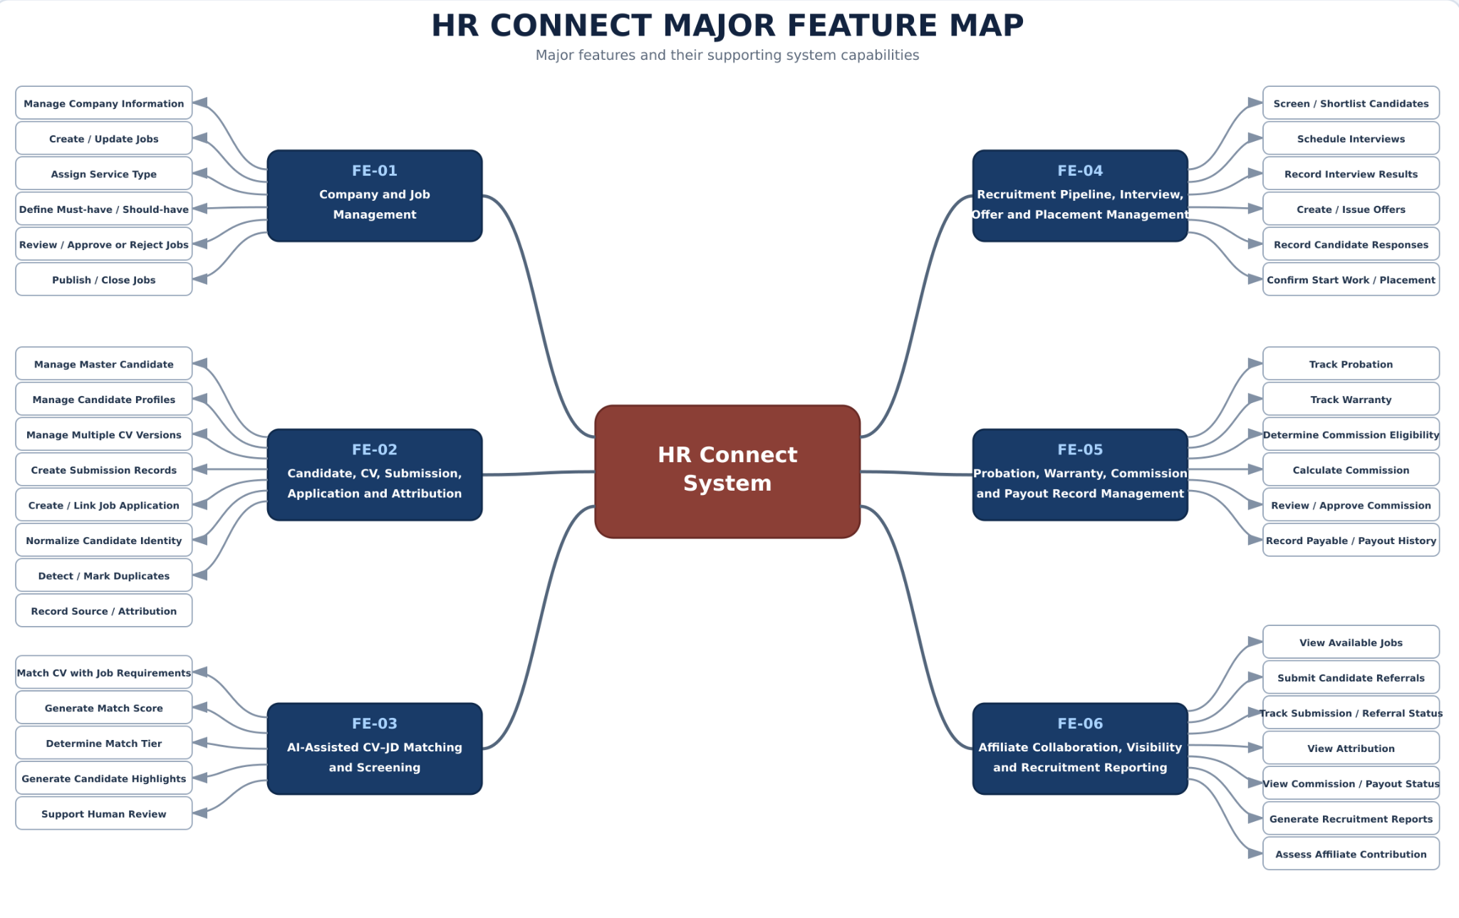
Figure 6.1. HR Connect Major Feature Map showing the eight major functional areas of
the proposed system.

6.2 Limitations & Exclusions
LI-01: AI Decision Limitation
AI functions provide CV–JD matching and screening support only. The system does not allow AI to independently reject, hire, interview, or issue Offers to Candidates.
LI-02: Payment Integration Limitation
HR Connect records Commission eligibility, approval, payable status, and Payout history. Direct integration with banks or external payment gateways is not included in the current project scope unless separately approved.
LI-03: HRM and Payroll Limitation
The system does not provide complete employee-management functions such as attendance, payroll, leave management, internal performance appraisal, or employee lifecycle management after the applicable recruitment and warranty processes are completed.
LI-04: Accounting Limitation
HR Connect does not replace an accounting or ERP system. General ledger, tax accounting, full invoice management, and enterprise-wide financial management are outside the current scope.
LI-05: External Integration Limitation
Automatic integration with external Job Boards, Client ATS/HRM systems, accounting systems, and other third-party platforms is not included in the initial version.
LI-06: Advanced AI Limitation
Advanced AI functions such as automated interviews, video or emotion analysis, personality assessment, salary negotiation, and fully autonomous hiring decisions are outside the current scope.
LI-07: Platform Limitation
The initial version is implemented as a web-based platform. A native mobile application is not included in the current Capstone scope.
LI-08: Electronic Confirmation Limitation
Confirmations recorded by HR Connect, such as Candidate consent and the planned OTP-based confirmation of Service Agreements, store the confirming user, time, and supporting evidence for traceability. They are not certified digital signatures issued through a licensed certification authority.

