

CAPSTONE PROJECT REPORT
Report 4 – Software Design Document

– Ho Chi Minh, October 2026 –

Table of Contents
I. Record of Changes 3
II. Software Design Document 4
1. System Design 4
1.1 System Architecture 4
1.2 Package Diagram 5
1.3 Technology Declaration 7
2. Database Design 8
2.1 State Machine Diagrams 18
3. Detailed Design 23
3.1 MF-01 Create, Approve and Publish Job 23
3.1.1 Class Diagram 23
3.1.2 Sequence Diagram – Client creates and submits a job 24
3.1.3 Sequence Diagram – Internal HR approves, agreement signing and job publishing 25
3.2 MF-02 Candidate Submission, Consent, Duplicate Check and Attribution 26
3.2.1 Class Diagram 26
3.2.2 Sequence Diagram – Affiliate refers a candidate 27
3.2.3 Sequence Diagram – Candidate accepts consent 27
3.2.4 Sequence Diagram – Candidate applies to a job 27
3.3 MF-03 AI Matching and Screening 28
3.3.1 Class Diagram 28
3.3.2 Sequence Diagram – Asynchronous AI scoring 29
3.3.3 Sequence Diagram – Internal HR screens an application 29
3.4 MF-04 Interview, Offer and Start Work 30
3.4.1 Class Diagram 30
3.4.2 Sequence Diagram – Client schedules an interview 31
3.4.3 Sequence Diagram – Offer, acceptance and start work 31
3.5 MF-05 Fee, Warranty, Commission and Payout 32
3.5.1 Class Diagram 32
3.5.2 Sequence Diagram – Warranty completion, fee payment and payout 33
3.5.3 Sequence Diagram – Resignation during warranty 33

I. Record of Changes
Date | A*  M, D | In charge | Change Description
06/10/2026 | A | Trương Hoàng Quí | Initial Software Design Document: architecture, package diagram, database design and detailed design of MF-01 to MF-05.
23/10/2026 | M | Trương Hoàng Quí | Added Service Agreement step (MF-01), redrew class and sequence diagrams, updated table descriptions.
27/10/2026 | M | Trương Hoàng Quí | Aligned with current code: 72 entities/tables, 12 background workers, core ERD (Figures 3–8), PlacementReconciliation, CompanySizeOption; added 3.2.4, Class Specifications, state machine diagrams and technology declaration; corrected captions, figure numbers and heading format to the template.
*A - Added, M - Modified, D - Deleted

II. Software Design Document

1. System Design

1.1 System Architecture
HR Connect is a recruitment platform that links Client companies, Candidates and Affiliates (independent headhunters) through three service types: CV_APPLICATION (job posting where candidates apply), HEADHUNT_COD (headhunting paid on success, with a 30-day warranty) and CV_SOURCING (Client buys a target number of CVs, gated by a deposit). The system is split into three sub-systems and four external systems, as shown in Figure 1.
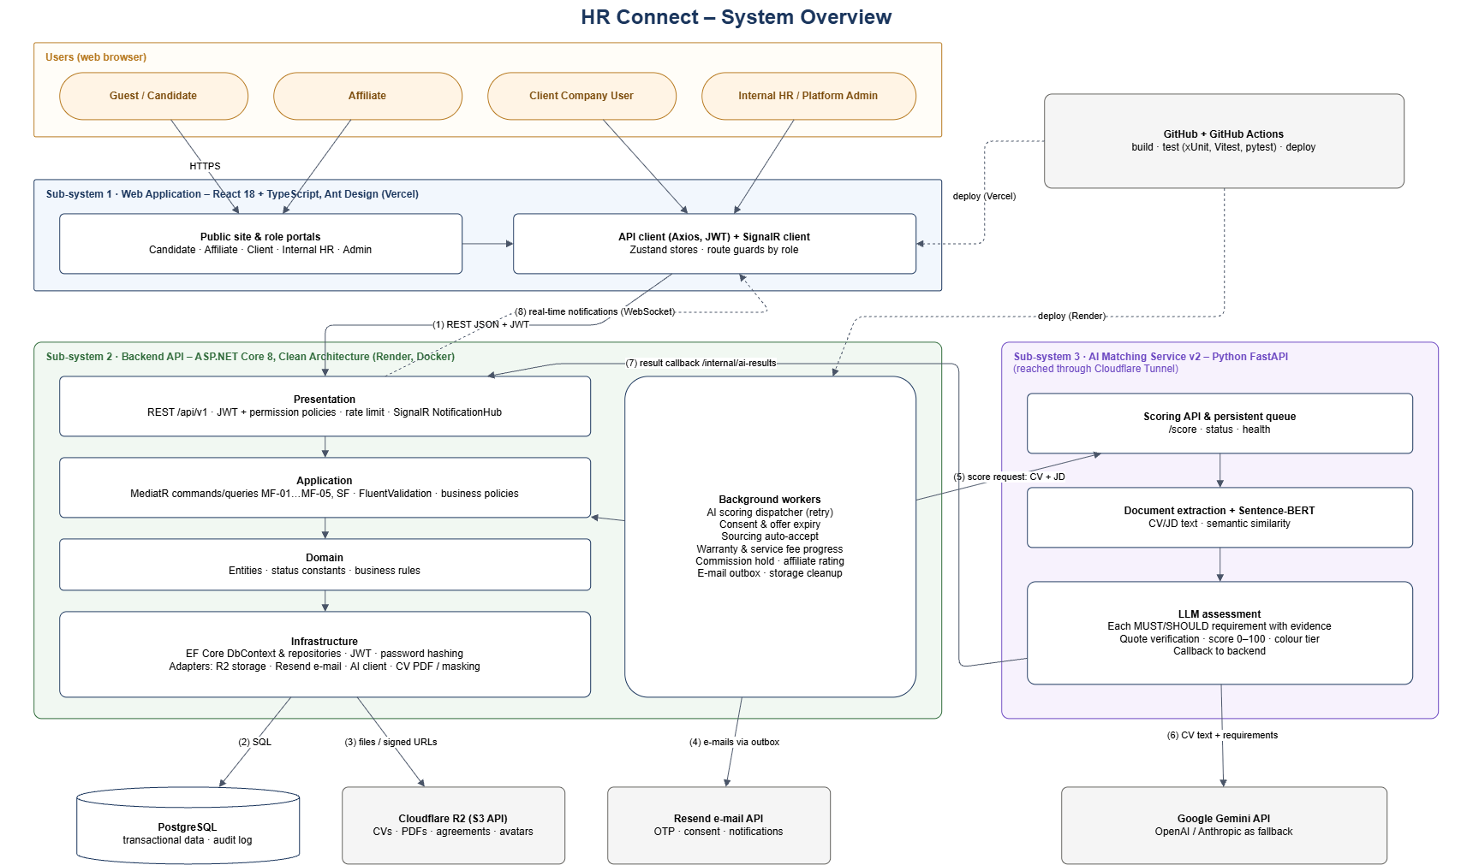
Figure 1. HR Connect System Architecture
Table 1.1. Architecture Components
Component | Technology | Description
Web Frontend | React, TypeScript, Vite, Ant Design, Tailwind CSS, Zustand | Single-page application. Contains the public job site and a dashboard for each role. Calls the backend through REST and sends the JWT access token in each request.
Backend - Presentation | ASP.NET Core Minimal APIs | Defines all routes under /api/v1, checks authentication and permissions, applies rate limiting, converts errors to a standard response and exposes Swagger.
Backend - Application | C#, CQRS (commands, queries, handlers), FluentValidation | Contains the business logic. Each use case is one command or query with one handler. Defines the interfaces that the Infrastructure layer must implement.
Backend - Domain | C# | Entities (72 classes) and constants such as status codes, role codes and service type codes. Does not depend on any other layer.
Backend - Infrastructure | EF Core, Npgsql | Database context, repositories, migrations and adapters for external systems (email, CV storage, JWT, password hashing, OTP).
Background workers | .NET BackgroundService | Twelve hosted workers: dispatch AI scoring jobs and retry failed ones; expire submission consents after 48 hours; expire offers and jobs; auto-accept overdue Sourcing CVs; progress warranties and mark fees DUE/OVERDUE; put commissions of locked affiliates ON_HOLD; Sourcing finance and settlement; calculate affiliate performance; send profile-based job matches; send queued e-mails; clean up unused avatar files.
AI Matching Service | Python 3.11, FastAPI, sentence-transformers, PyMuPDF | Receives scoring jobs, extracts the CV text (OCR when needed), asks the LLM to assess every MUST_HAVE / SHOULD_HAVE requirement with evidence quotes that are verified against the CV, combines this with Sentence-BERT similarity and returns a score, a tier and an explanation. Also serves semantic job matching for recommendations.
Database | PostgreSQL | Stores all business data in 72 tables (32 core tables and supporting history, configuration and reference tables). Only the backend connects to it.
Email Service (external) | Resend (HTTPS API) | Sends OTP, consent request, notification and offer emails.
Object Storage (external) | Cloudflare R2 (S3-compatible) | Stores CV PDFs, signed service agreements, company logos and avatars. The backend creates short-lived signed URLs so that users and the AI service can download a file.
LLM Provider (external) | Google Gemini API (OpenAI / Anthropic as configurable fallback) | Called only by the AI service to assess CV requirements. Receives the job requirements and CV text; returns a structured assessment.

Communication between the backend and the AI service is asynchronous. The backend sends a scoring job and continues. The AI service calls the internal endpoints of the backend to read the job description and the CV, and sends the result back with a callback. Internal endpoints are protected with a service key and are not available to users.

1.2 Package Diagram
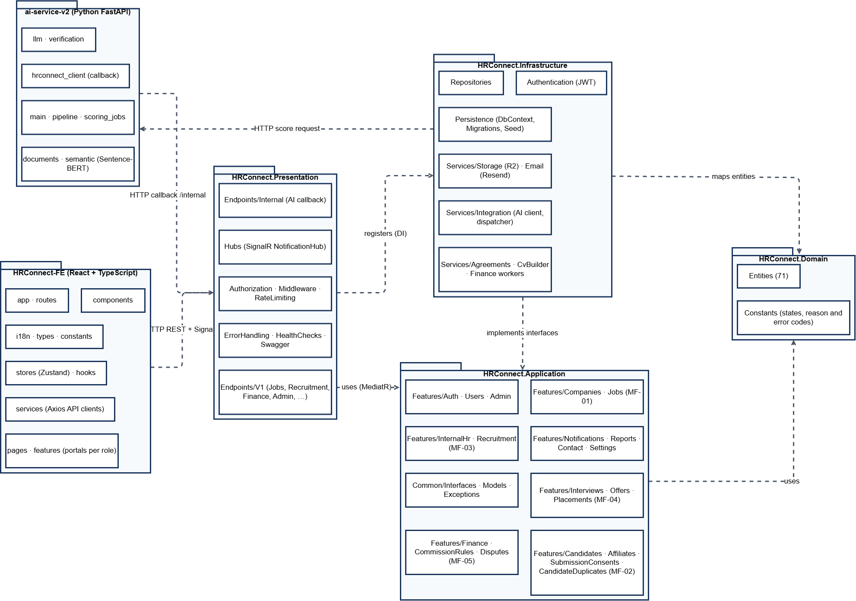
Figure 2. HR Connect Package Diagram

Table 1.2. Package Descriptions
No | Package | Description
01 | HRConnect-FE / pages, routes, app | React pages for each portal (public, candidate, affiliate, client, internal-hr, admin), route guards by role and the application shell.
02 | HRConnect-FE / features, components | Reusable feature modules (application workbench, job forms, finance tables, notification bell) and shared UI components.
03 | HRConnect-FE / services, stores, hooks | Axios API clients per backend resource, Zustand stores (auth session, notifications), SignalR client and React hooks.
04 | HRConnect-FE / i18n, types, constants | Vietnamese/English texts, TypeScript types mirroring API DTOs, status labels and colours.
05 | HRConnect.Presentation / Endpoints | Minimal API endpoint groups under /api/v1 (Auth, Companies, Jobs, Candidates, Affiliates, Recruitment, Finance, Disputes, Admin, Reports, ...) and /internal for the AI callback.
06 | HRConnect.Presentation / Hubs, Authorization, Middleware | SignalR NotificationHub, permission-based authorization policies, request context, rate limiting, global error handling (ProblemDetails, 409 conflict responses), health checks and Swagger.
07 | HRConnect.Application / Features/Auth, Users, Admin | Registration, login, OTP, refresh token, password reset; user, role, permission and approval management (SF-01, SF-02).
08 | HRConnect.Application / Features/Companies, Jobs | MF-01: company profile and verification, job templates, job create/update/submit/approve/reject/pause/resume/close, posting packages and posting fees, job access policy per service type.
09 | HRConnect.Application / Features/Candidates, Affiliates, SubmissionConsents, CandidateDuplicates | MF-02: candidate profile, CVs and CV builder, job application, affiliate referral, candidate consent, duplicate identification and attribution.
10 | HRConnect.Application / Features/InternalHr, Recruitment | MF-03: AI scoring retry, screening status changes (SHORTLISTED, BACKUP, REJECTED), CV Sourcing deliveries, masked CV and application timeline.
11 | HRConnect.Application / Features/Interviews, Offers, Placements | MF-04: interview scheduling and results, offer drafts, sending, responses and withdrawal, planned and actual start dates, placements.
12 | HRConnect.Application / Features/Finance, CommissionRules, Disputes | MF-05: service fees, warranty, resignation claims, replacement slots, commission approval/adjustment/hold, payouts, Sourcing settlement; source disputes (SF-04).
13 | HRConnect.Application / Features/Notifications, Reports, Contact, Settings | In-app notifications, reports for admin and affiliates, contact form and configurable business settings.
14 | HRConnect.Application / Common | Interfaces (IUnitOfWork, IEmailService, IFileStorageService, IMf03ScoringTrigger, INotificationPublisher, ...), shared models, exceptions and e-mail templates.
15 | HRConnect.Domain | Entity classes (Job, Application, Submission, Placement, Commission, ...) and constants for statuses, reason codes and service types. No dependency on other projects.
16 | HRConnect.Infrastructure / Persistence, Repositories | EF Core DbContext, entity configurations, migrations, seed data and repository implementations.
17 | HRConnect.Infrastructure / Services | Adapters and workers: JWT, password hashing, Resend e-mail and outbox worker, Cloudflare R2 storage, CV PDF rendering and masking, AI integration client and dispatcher, offer expiry, consent expiry, Sourcing auto-accept, warranty progress, commission hold and affiliate performance workers.
18 | ai-service-v2 / app | main (FastAPI routes), pipeline and scoring_jobs (queue), documents (text extraction), semantic (Sentence-BERT), LLM(provider client), verification (evidence checks), hrconnect_client (callback).

1.3 Technology Declaration
Table 1.3 declares the third-party services, technologies, source control, environments and AI tools used by the project, as required for Review 2.
Table 1.3. Technology Declaration
Group | Item | Purpose / details
Third-party service | Resend | Transactional e-mail: OTP, consent requests, offers and notifications. Sends recipient e-mail, name and message content.
Third-party service | Cloudflare R2 | Object storage for CVs, signed agreements, logos and avatars. Stores the files; the database keeps only object key, hash and metadata.
Third-party service | Google Gemini API | LLM assessment of CV requirements. Sends job requirements and CV text; no passwords or payment data.
Third-party service | Cloudflare Tunnel | Development only: exposes the AI service running on a team machine to the deployed backend.
Development technology | Back-end | .NET 8 (ASP.NET Core Minimal APIs), EF Core 8 with Npgsql 8.0.11, MediatR 14, FluentValidation, SignalR.
Development technology | Front-end | React 18.3, TypeScript 5.4, Vite 5.3, Ant Design 5.18, Tailwind CSS 3.4, Zustand 4.5, TanStack Query 5, @microsoft/signalr; Node.js 22.
Development technology | AI service | Python 3.11, FastAPI, sentence-transformers, PyMuPDF, google-genai.
Development technology | Database | PostgreSQL (managed on Render), schema managed by EF Core migrations.
Source code & DevOps | Repository and CI/CD | GitHub (hoangqui794/hr-connect). GitHub Actions "CI — Quality Gates": backend build and tests, frontend lint/test/build, AI service tests, production image validation. "CD — Backend on Render" deploys only after CI passes on main.
Source code & DevOps | Branch rules
Deployment environment | Dev | Local machines with PostgreSQL and the AI service; AI v2 can be exposed through a Cloudflare Tunnel.
Deployment environment | Production | Backend Docker image on Render (Singapore), front-end on Vercel, database on Render PostgreSQL. Migrations run on start-up; health checks /health and /health/ready. Rollback: redeploy the previous successful Render deploy / Vercel deployment.
AI tools | Claude Code (Anthropic), Codex | Used for requirement analysis, diagram drafting (Mermaid/PlantUML/draw.io), code generation and refactoring, test writing and document review. All output is reviewed and tested by the owning member before merging.

2. Database Design
HR Connect stores all business data in one PostgreSQL database managed by EF Core migrations. Primary keys are UUIDs; tables that can be changed by two users at the same time carry a ConcurrencyToken so that the second writer receives HTTP 409. Status changes are kept in history tables and every important action is written to AuditLog. CV and document files are not stored in the database: the database keeps only the R2 object key, file hash and metadata. The database has 72 tables. Figure 3 shows the 32 core tables; Figures 4–8 show the same core tables grouped by business area, with only primary keys, foreign keys and the main business columns. History, configuration and reference tables are listed in Table Descriptions; the full 72-table ERD is kept in the repository (docs/diagrams/erd/full).
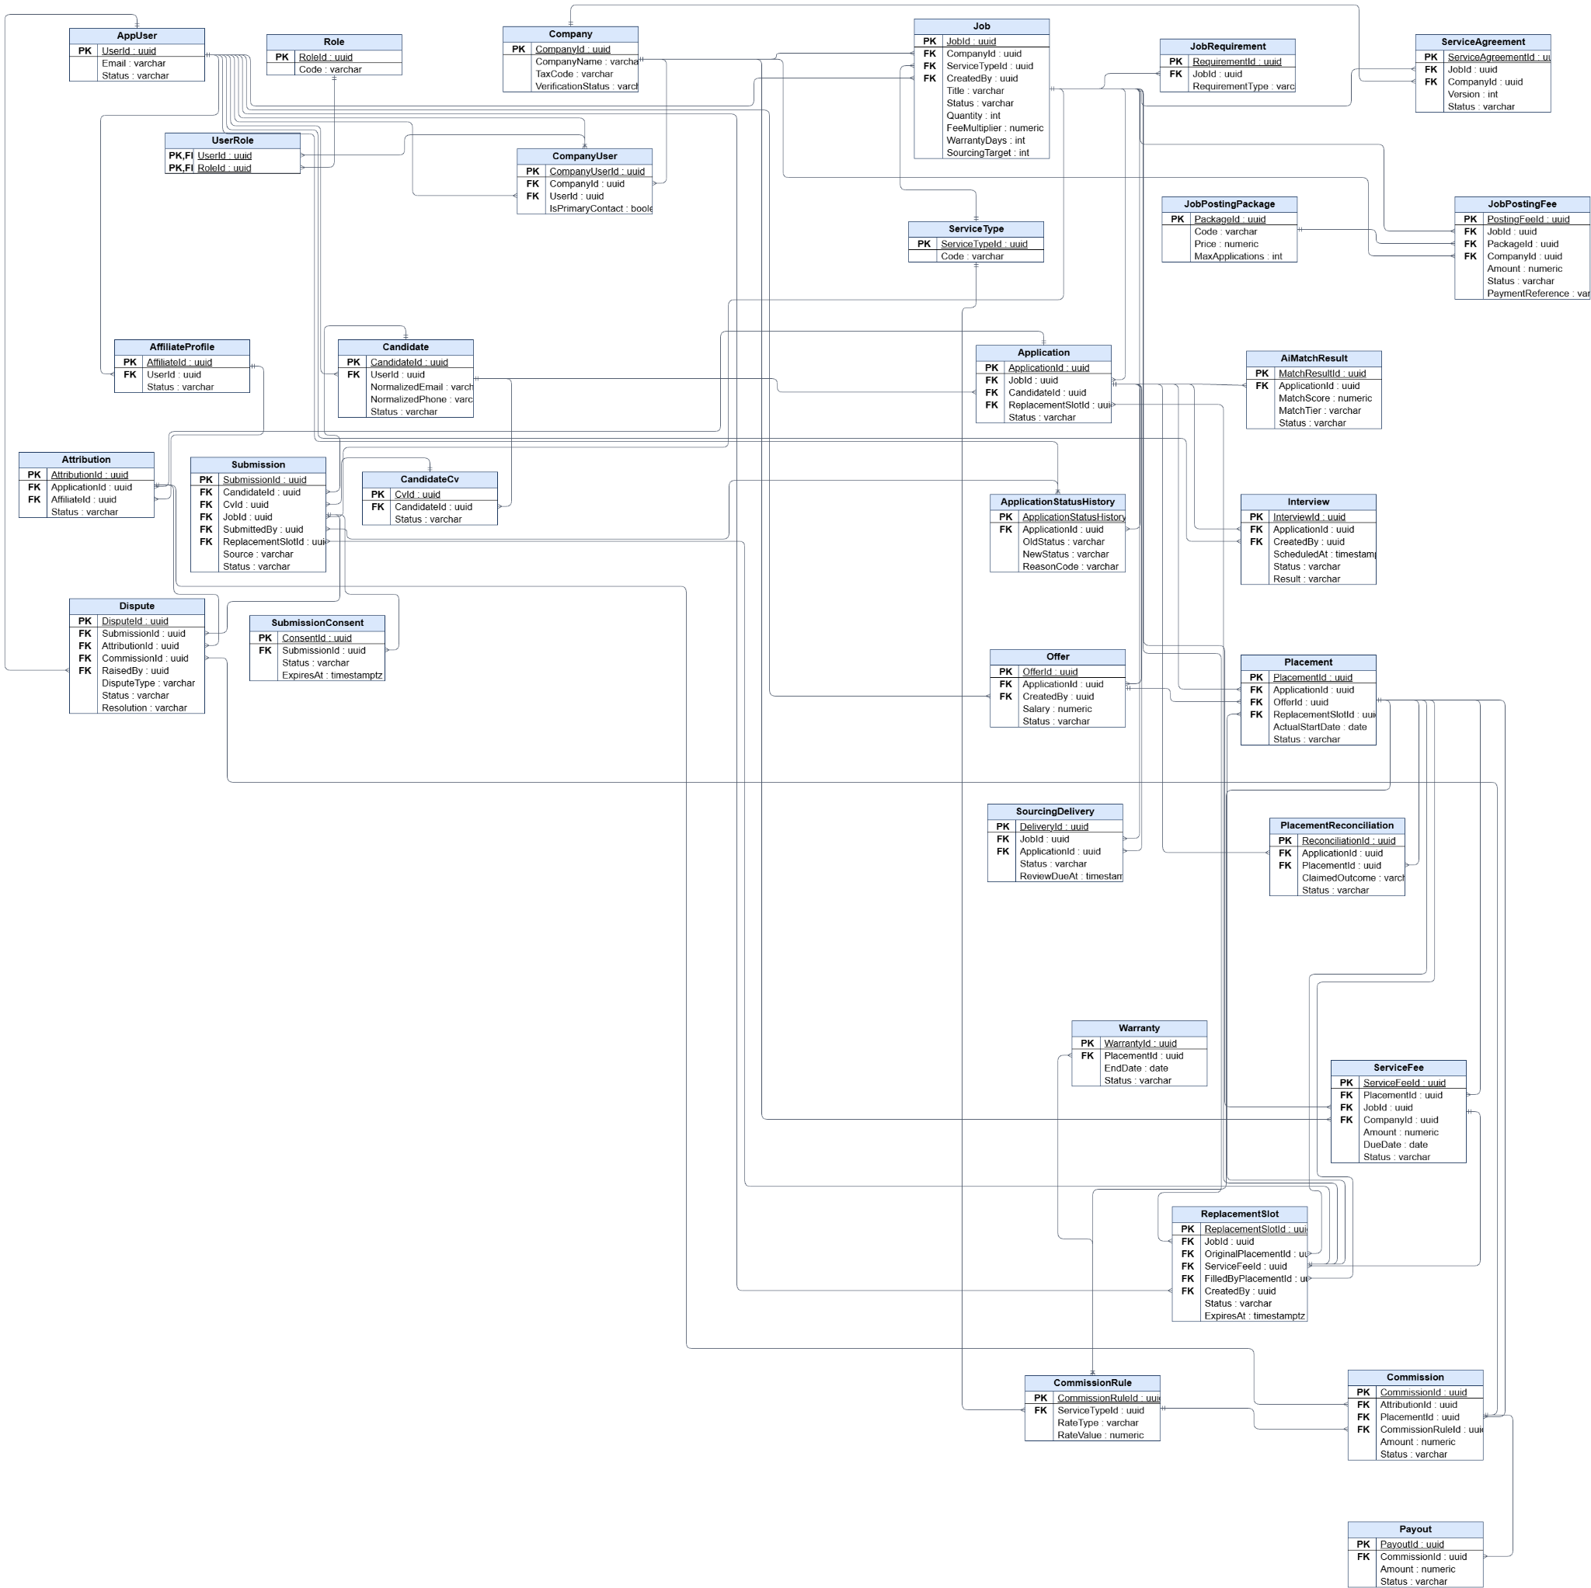

Figure 3. ERD – Core overview (32 core tables)

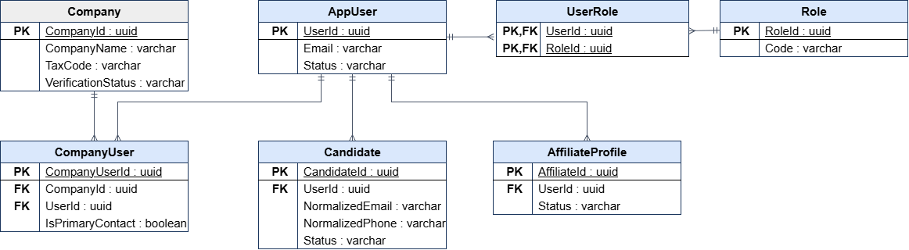
Figure 4. ERD – Identity and access

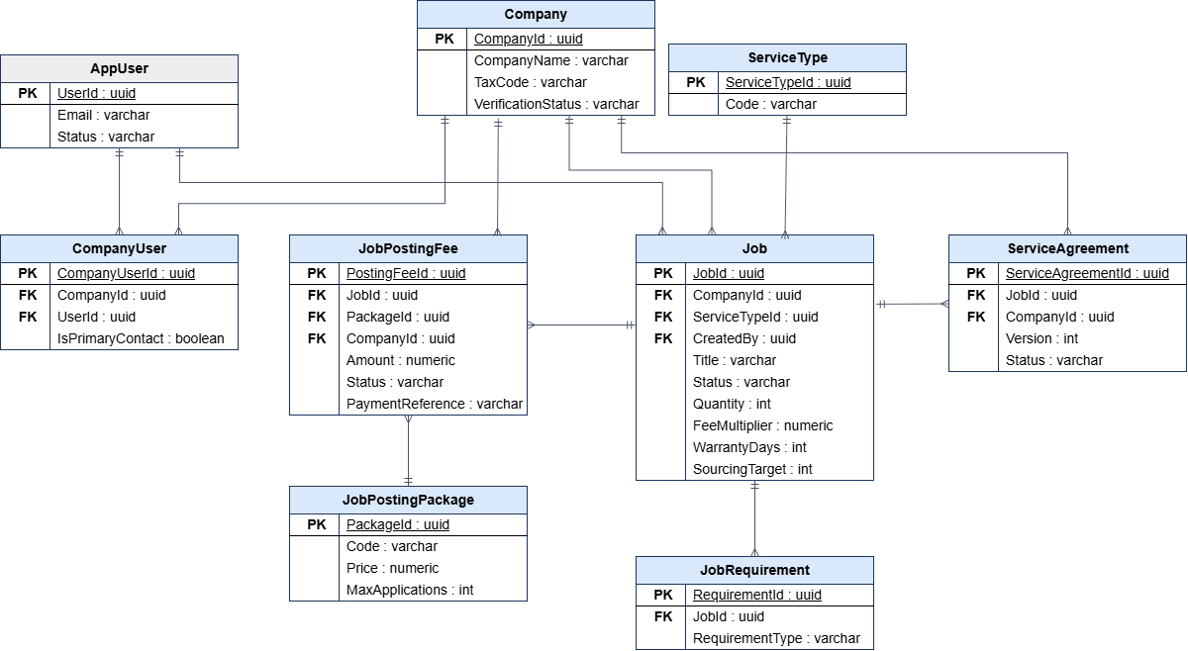
Figure 5. ERD – Company, job and service agreement

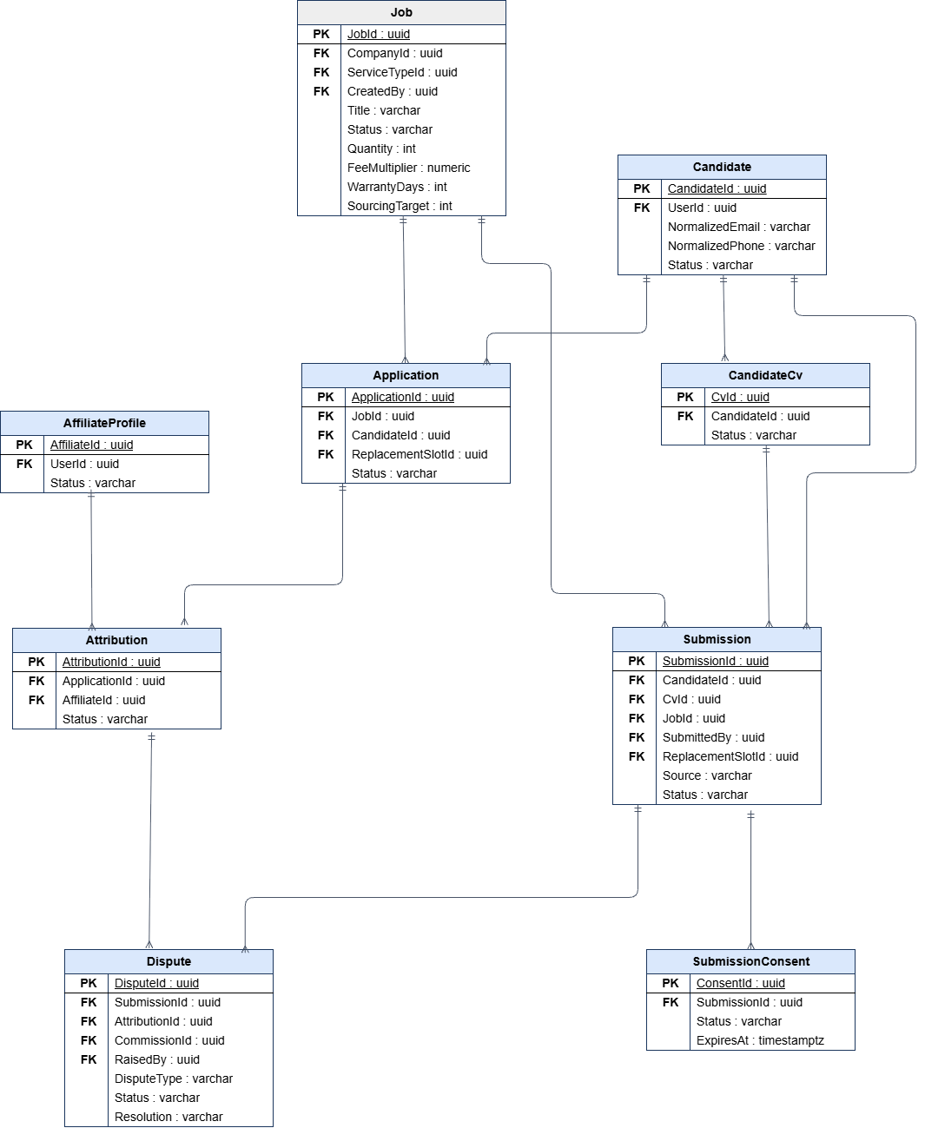
Figure 6. ERD – Candidate, submission and attribution

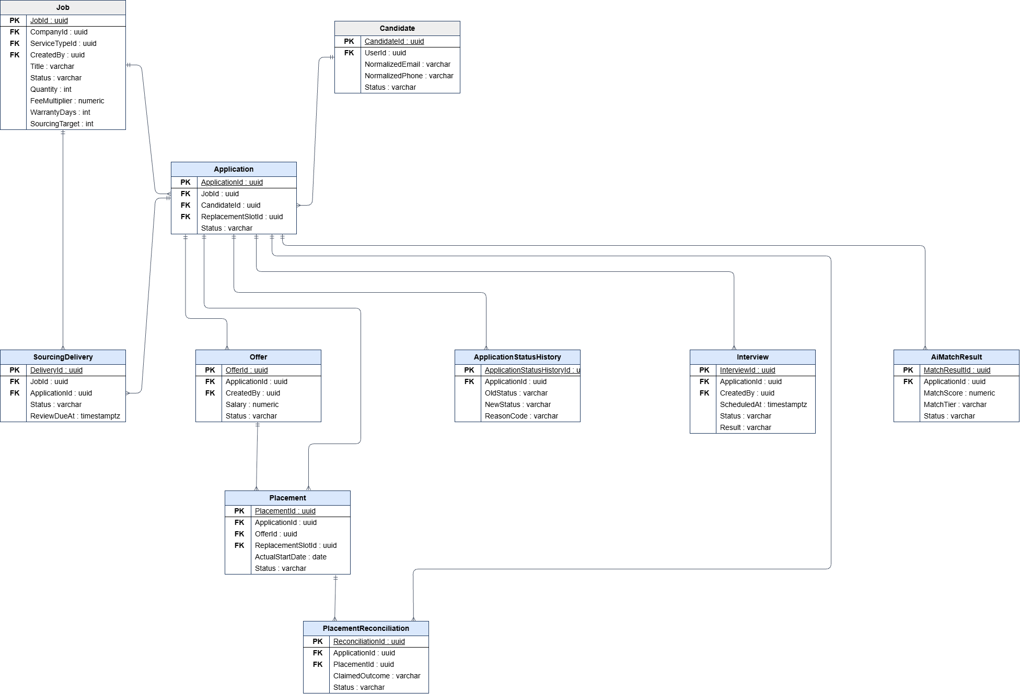
Figure 7. ERD – Screening, interview, offer and placement

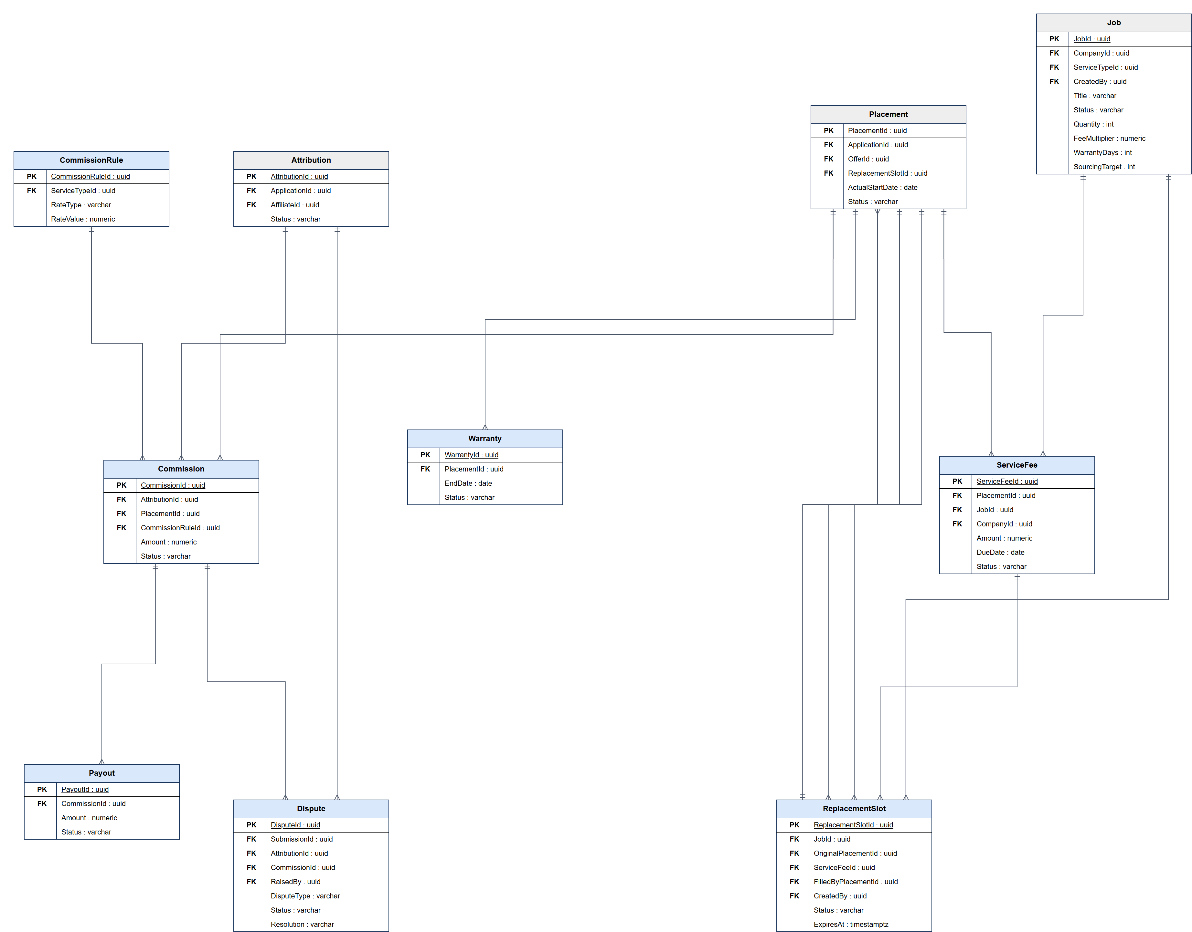
Figure 8. ERD – Fee, warranty, commission and payout

Table Descriptions
Table 2. System Database Tables, Primary Keys, and Foreign Key Constraints.
No | Table | Description
01 | AppUser | Account of every user (all roles).  - Primary keys: UserId  - Foreign keys: –
02 | Role, Permission, UserRole, RolePermission | Role-based access control; permissions are granted to roles and roles to users.  - Primary keys: RoleId; PermissionId; (UserId, RoleId); (RoleId, PermissionId)  - Foreign keys: UserRole.UserId → AppUser, UserRole.RoleId → Role, RolePermission.PermissionId → Permission
03 | RefreshToken, UserToken | Refresh tokens and one-time tokens (OTP, password reset), stored as hashes.  - Primary keys: RefreshTokenId; TokenId  - Foreign keys: UserId → AppUser
04 | Company | Client company profile and verification status.  - Primary keys: CompanyId  - Foreign keys: IndustryId → Industry, CompanySizeId → CompanySizeOption
05 | CompanyUser | Membership of a user in a company, including the primary contact.  - Primary keys: CompanyUserId  - Foreign keys: CompanyId → Company, UserId → AppUser
06 | CompanyVerificationRequest | Verification request reviewed by Platform Admin (SF-01).  - Primary keys: CompanyVerificationRequestId  - Foreign keys: CompanyId → Company
07 | Candidate | Candidate profile; also created by an affiliate referral before the candidate has an account.  - Primary keys: CandidateId  - Foreign keys: UserId → AppUser (nullable), MergedIntoCandidateId → Candidate
08 | CandidateCv | Uploaded or builder-generated CV with file hash and text fingerprint.  - Primary keys: CvId  - Foreign keys: CandidateId → Candidate, CvTemplateId → CvTemplate
09 | AffiliateProfile, AffiliateApplication | Approved affiliate profile with bank account; application reviewed by Admin (SF-02).  - Primary keys: AffiliateId; AffiliateApplicationId  - Foreign keys: UserId → AppUser
10 | ServiceType, ServiceTypeAllowedRole | Service types and which roles can view or submit to them (can_view / can_submit).  - Primary keys: ServiceTypeId; (ServiceTypeId, RoleId)  - Foreign keys: RoleId → Role
11 | Job | Job posting with service type, quantity, status, commercial terms (fee multiplier, warranty days, Sourcing target and price per CV).  - Primary keys: JobId  - Foreign keys: CompanyId → Company, ServiceTypeId → ServiceType, CreatedBy → AppUser
12 | JobRequirement | MUST_HAVE / SHOULD_HAVE requirements used by AI matching.  - Primary keys: RequirementId  - Foreign keys: JobId → Job
13 | JobTemplate, JobTemplateRequirement | Job description templates managed by Internal HR.  - Primary keys: TemplateId; TemplateRequirementId  - Foreign keys: TemplateId → JobTemplate
14 | JobStatusHistory | History of job status changes with reason codes.  - Primary keys: JobStatusHistoryId  - Foreign keys: JobId → Job, ChangedBy → AppUser
15 | JobPostingPackage, JobPostingFee | Posting packages and the fee recorded for a job.  - Primary keys: PackageId; PostingFeeId  - Foreign keys: JobId → Job, PackageId → JobPostingPackage, CompanyId → Company
16 | Submission | One attempt to submit a candidate to a job by the candidate or an affiliate.  - Primary keys: SubmissionId  - Foreign keys: CandidateId → Candidate, CvId → CandidateCv, JobId → Job, DuplicateOfSubmissionId → Submission
17 | SubmissionConsent | Consent request sent to the candidate for an affiliate referral (hashed token, expiry).  - Primary keys: ConsentId  - Foreign keys: SubmissionId → Submission
18 | SubmissionIdentitySnapshot, CandidateDuplicateCase, CandidateDuplicateSignal | Hashed identity evidence and duplicate cases used for duplicate identification.  - Primary keys: SubmissionId; DuplicateCaseId; DuplicateSignalId  - Foreign keys: SubmissionId → Submission, CandidateAId/CandidateBId → Candidate
19 | Application | The accepted candidate–job pair that moves through the recruitment pipeline.  - Primary keys: ApplicationId  - Foreign keys: JobId → Job, CandidateId → Candidate, AcceptedSubmissionId → Submission, ReplacementSlotId → ReplacementSlot
20 | ApplicationStatusHistory | History of application status changes with reason codes.  - Primary keys: ApplicationStatusHistoryId  - Foreign keys: ApplicationId → Application
21 | Attribution | Which affiliate owns the application (first valid source).  - Primary keys: AttributionId  - Foreign keys: ApplicationId → Application, AffiliateId → AffiliateProfile, WinningSubmissionId → Submission
22 | AiMatchResult | Each AI scoring attempt with score, tier, per-requirement results and failure code.  - Primary keys: MatchResultId  - Foreign keys: ApplicationId → Application
23 | MatchTierConfig | Score ranges and colours of match tiers.  - Primary keys: TierCode  - Foreign keys: –
24 | SourcingDelivery | CV delivered to the Client of a CV_SOURCING job and the Client decision.  - Primary keys: DeliveryId  - Foreign keys: JobId → Job, ApplicationId → Application, ReplacedByDeliveryId → SourcingDelivery
25 | Interview, InterviewParticipant, InterviewStatusHistory | Interview rounds, participants and schedule changes.  - Primary keys: InterviewId; InterviewParticipantId; InterviewStatusHistoryId  - Foreign keys: ApplicationId → Application, InterviewId → Interview
26 | Offer | Versioned job offer with salary basis and period, expiry and response.  - Primary keys: OfferId  - Foreign keys: ApplicationId → Application, CreatedBy → AppUser
27 | Placement | Confirmed start of work.  - Primary keys: PlacementId  - Foreign keys: ApplicationId → Application, OfferId → Offer, ReplacementSlotId → ReplacementSlot
28 | Warranty | Warranty period of a Headhunt placement.  - Primary keys: WarrantyId  - Foreign keys: PlacementId → Placement
29 | ServiceFee | Fee charged to the Client (placement fee, Sourcing deposit or settlement) with due date and payment reference.  - Primary keys: ServiceFeeId  - Foreign keys: PlacementId → Placement, JobId → Job, CompanyId → Company
30 | ReplacementSlot | Free replacement opened after a confirmed resignation during warranty.  - Primary keys: ReplacementSlotId  - Foreign keys: JobId → Job, OriginalPlacementId → Placement, ServiceFeeId → ServiceFee, FilledByPlacementId → Placement
31 | CommissionRule, CommissionMilestone | Configurable commission rates per service type and milestone.  - Primary keys: CommissionRuleId; MilestoneCode  - Foreign keys: ServiceTypeId → ServiceType
32 | Commission | Affiliate commission with rule and calculation snapshots and status.  - Primary keys: CommissionId  - Foreign keys: AttributionId → Attribution, PlacementId → Placement, SourcingDeliveryId → SourcingDelivery, CommissionRuleId → CommissionRule
33 | CommissionAdjustment | Audit of manual commission amount changes.  - Primary keys: CommissionAdjustmentId  - Foreign keys: CommissionId → Commission
34 | Payout | Payout attempt to an affiliate with transaction reference.  - Primary keys: PayoutId  - Foreign keys: CommissionId → Commission
35 | Dispute | Source or commission dispute raised by an affiliate and resolved by Admin.  - Primary keys: DisputeId  - Foreign keys: SubmissionId → Submission, AttributionId → Attribution, CommissionId → Commission
36 | AffiliatePerformance | Calculated affiliate quality metrics per period.  - Primary keys: AffiliatePerformanceId  - Foreign keys: AffiliateId → AffiliateProfile
37 | Notification | In-app notification pushed through SignalR.  - Primary keys: NotificationId  - Foreign keys: UserId → AppUser
38 | EmailOutbox | E-mails waiting to be sent or retried.  - Primary keys: EmailOutboxId  - Foreign keys: UserId → AppUser
39 | AuditLog | Who did what to which entity, with old and new values.  - Primary keys: AuditLogId  - Foreign keys: ActorUserId → AppUser
40 | SystemSetting, ContactRequest, Industry, Skill, CvTemplate | Configurable business settings, contact form requests and reference data.  - Primary keys: SettingKey; ContactRequestId; IndustryId; SkillId; CvTemplateId  - Foreign keys: –
41 | ServiceAgreement, ServiceAgreementSignatureChallenge | MF-01: versioned agreement between HR Connect and the Client and its OTP signing challenge.  - Primary keys: AgreementId; ChallengeId  - Foreign keys: JobId → Job, CompanyId → Company
42 | PlacementReconciliation | MF-04/MF-05: Internal HR verification of the start-work outcome reported by the Client for a HEADHUNT_COD application (PENDING, CONFIRMED, FLAGGED). The service fee moves to DUE only after it is CONFIRMED; FLAGGED cases are resolved by Platform Admin.  - Primary keys: ReconciliationId  - Foreign keys: ApplicationId → Application, PlacementId → Placement (nullable), ReviewedBy → AppUser

2.1 State Machine Diagrams
Each main entity has a lifecycle enforced by its command handlers. Invalid transitions are rejected with HTTP 409 and every transition is written to the history table or AuditLog.
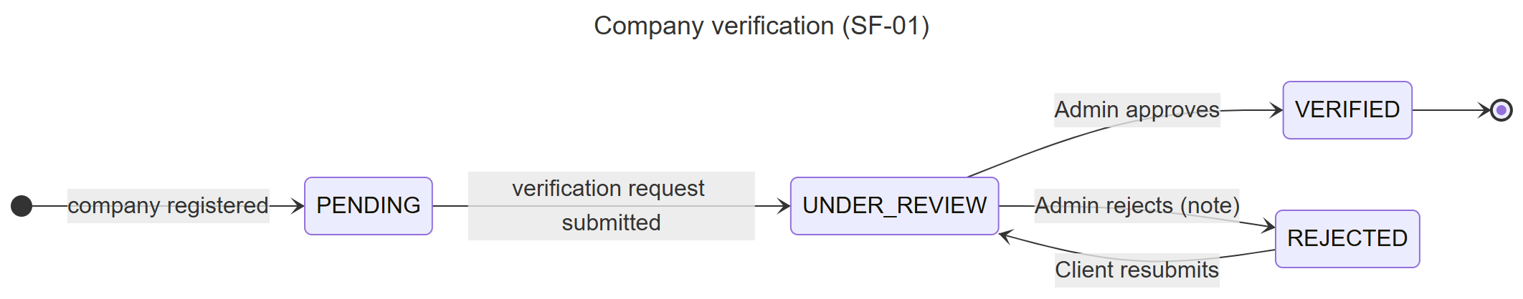
Figure 9. State machine – Company verification
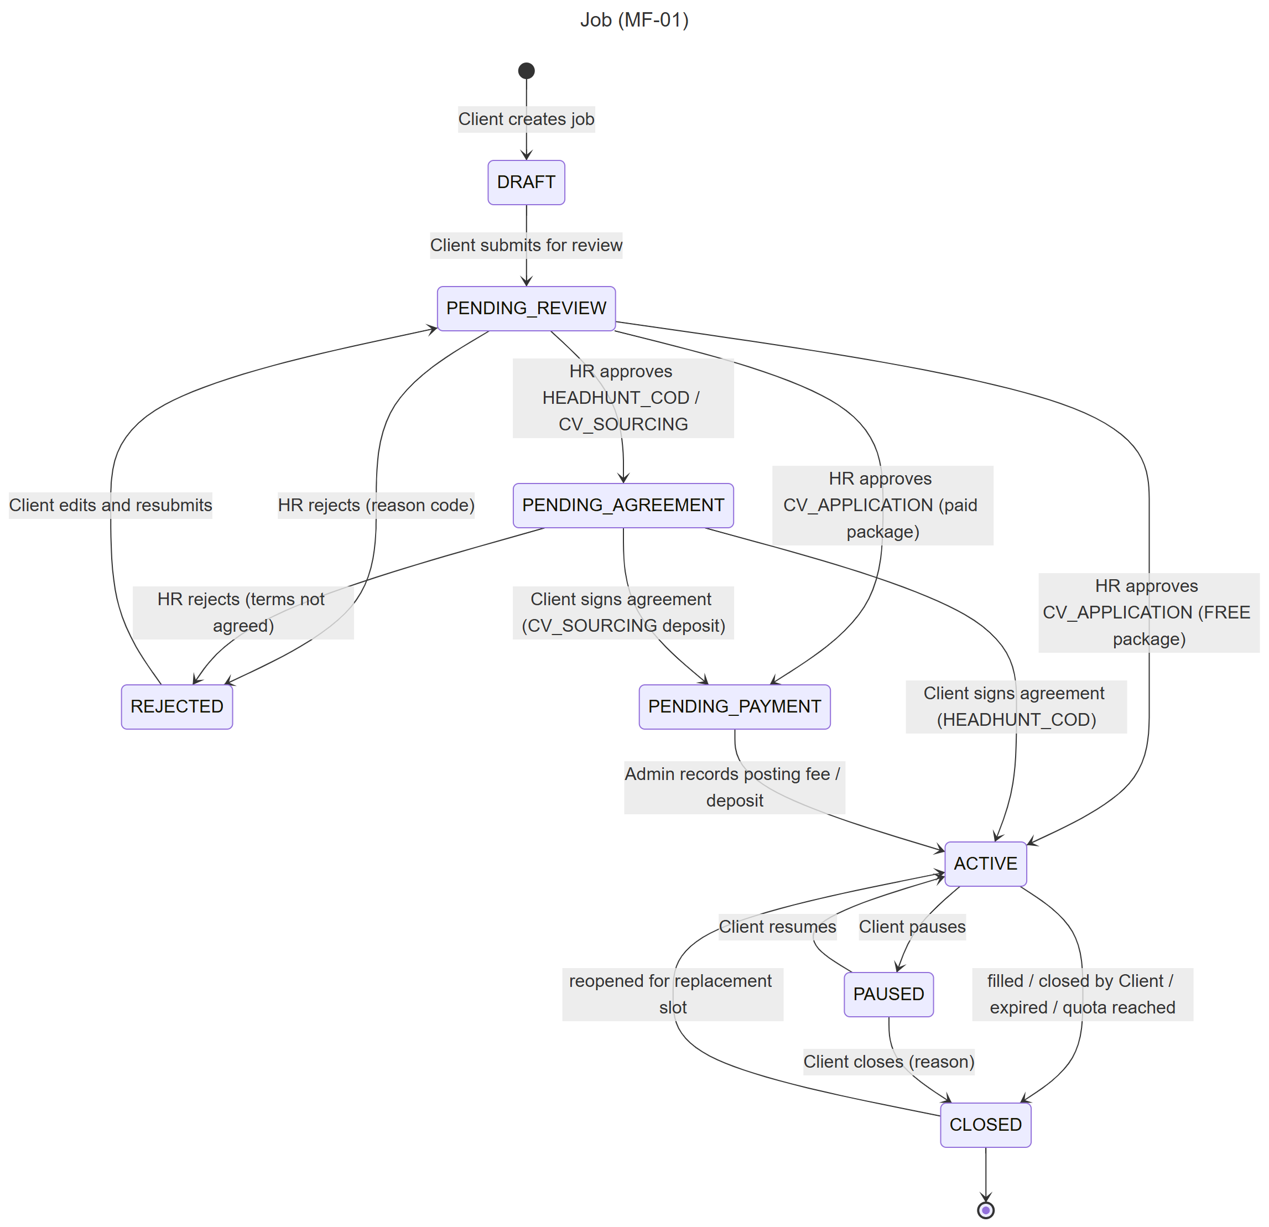
Figure 10. State machine – Job
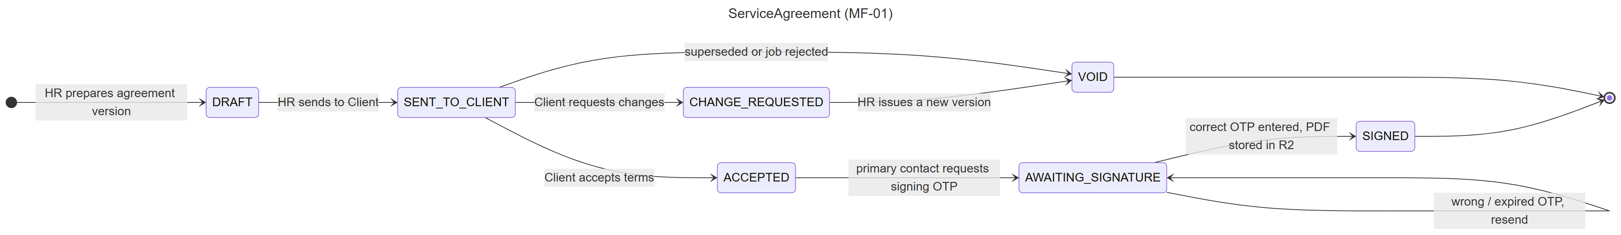
Figure 11. State machine – Service Agreement
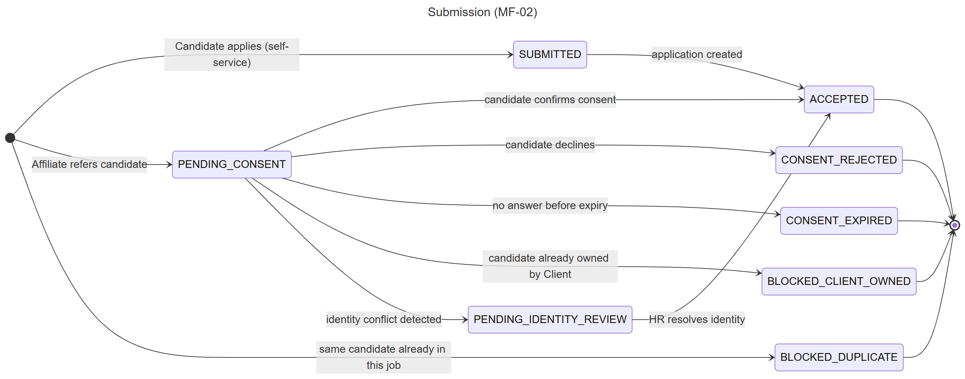
Figure 12. State machine – Submission
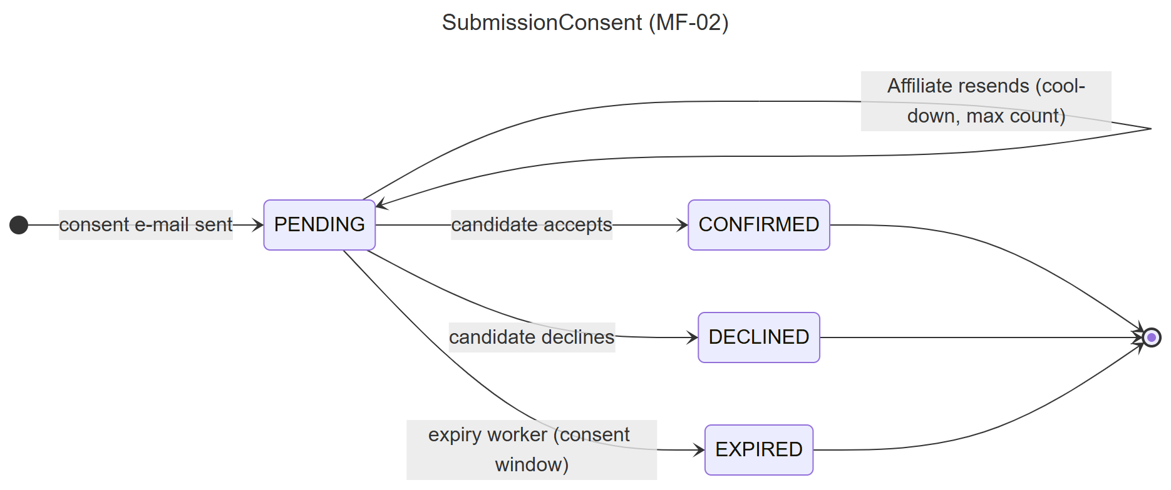
Figure 13. State machine – Submission consent
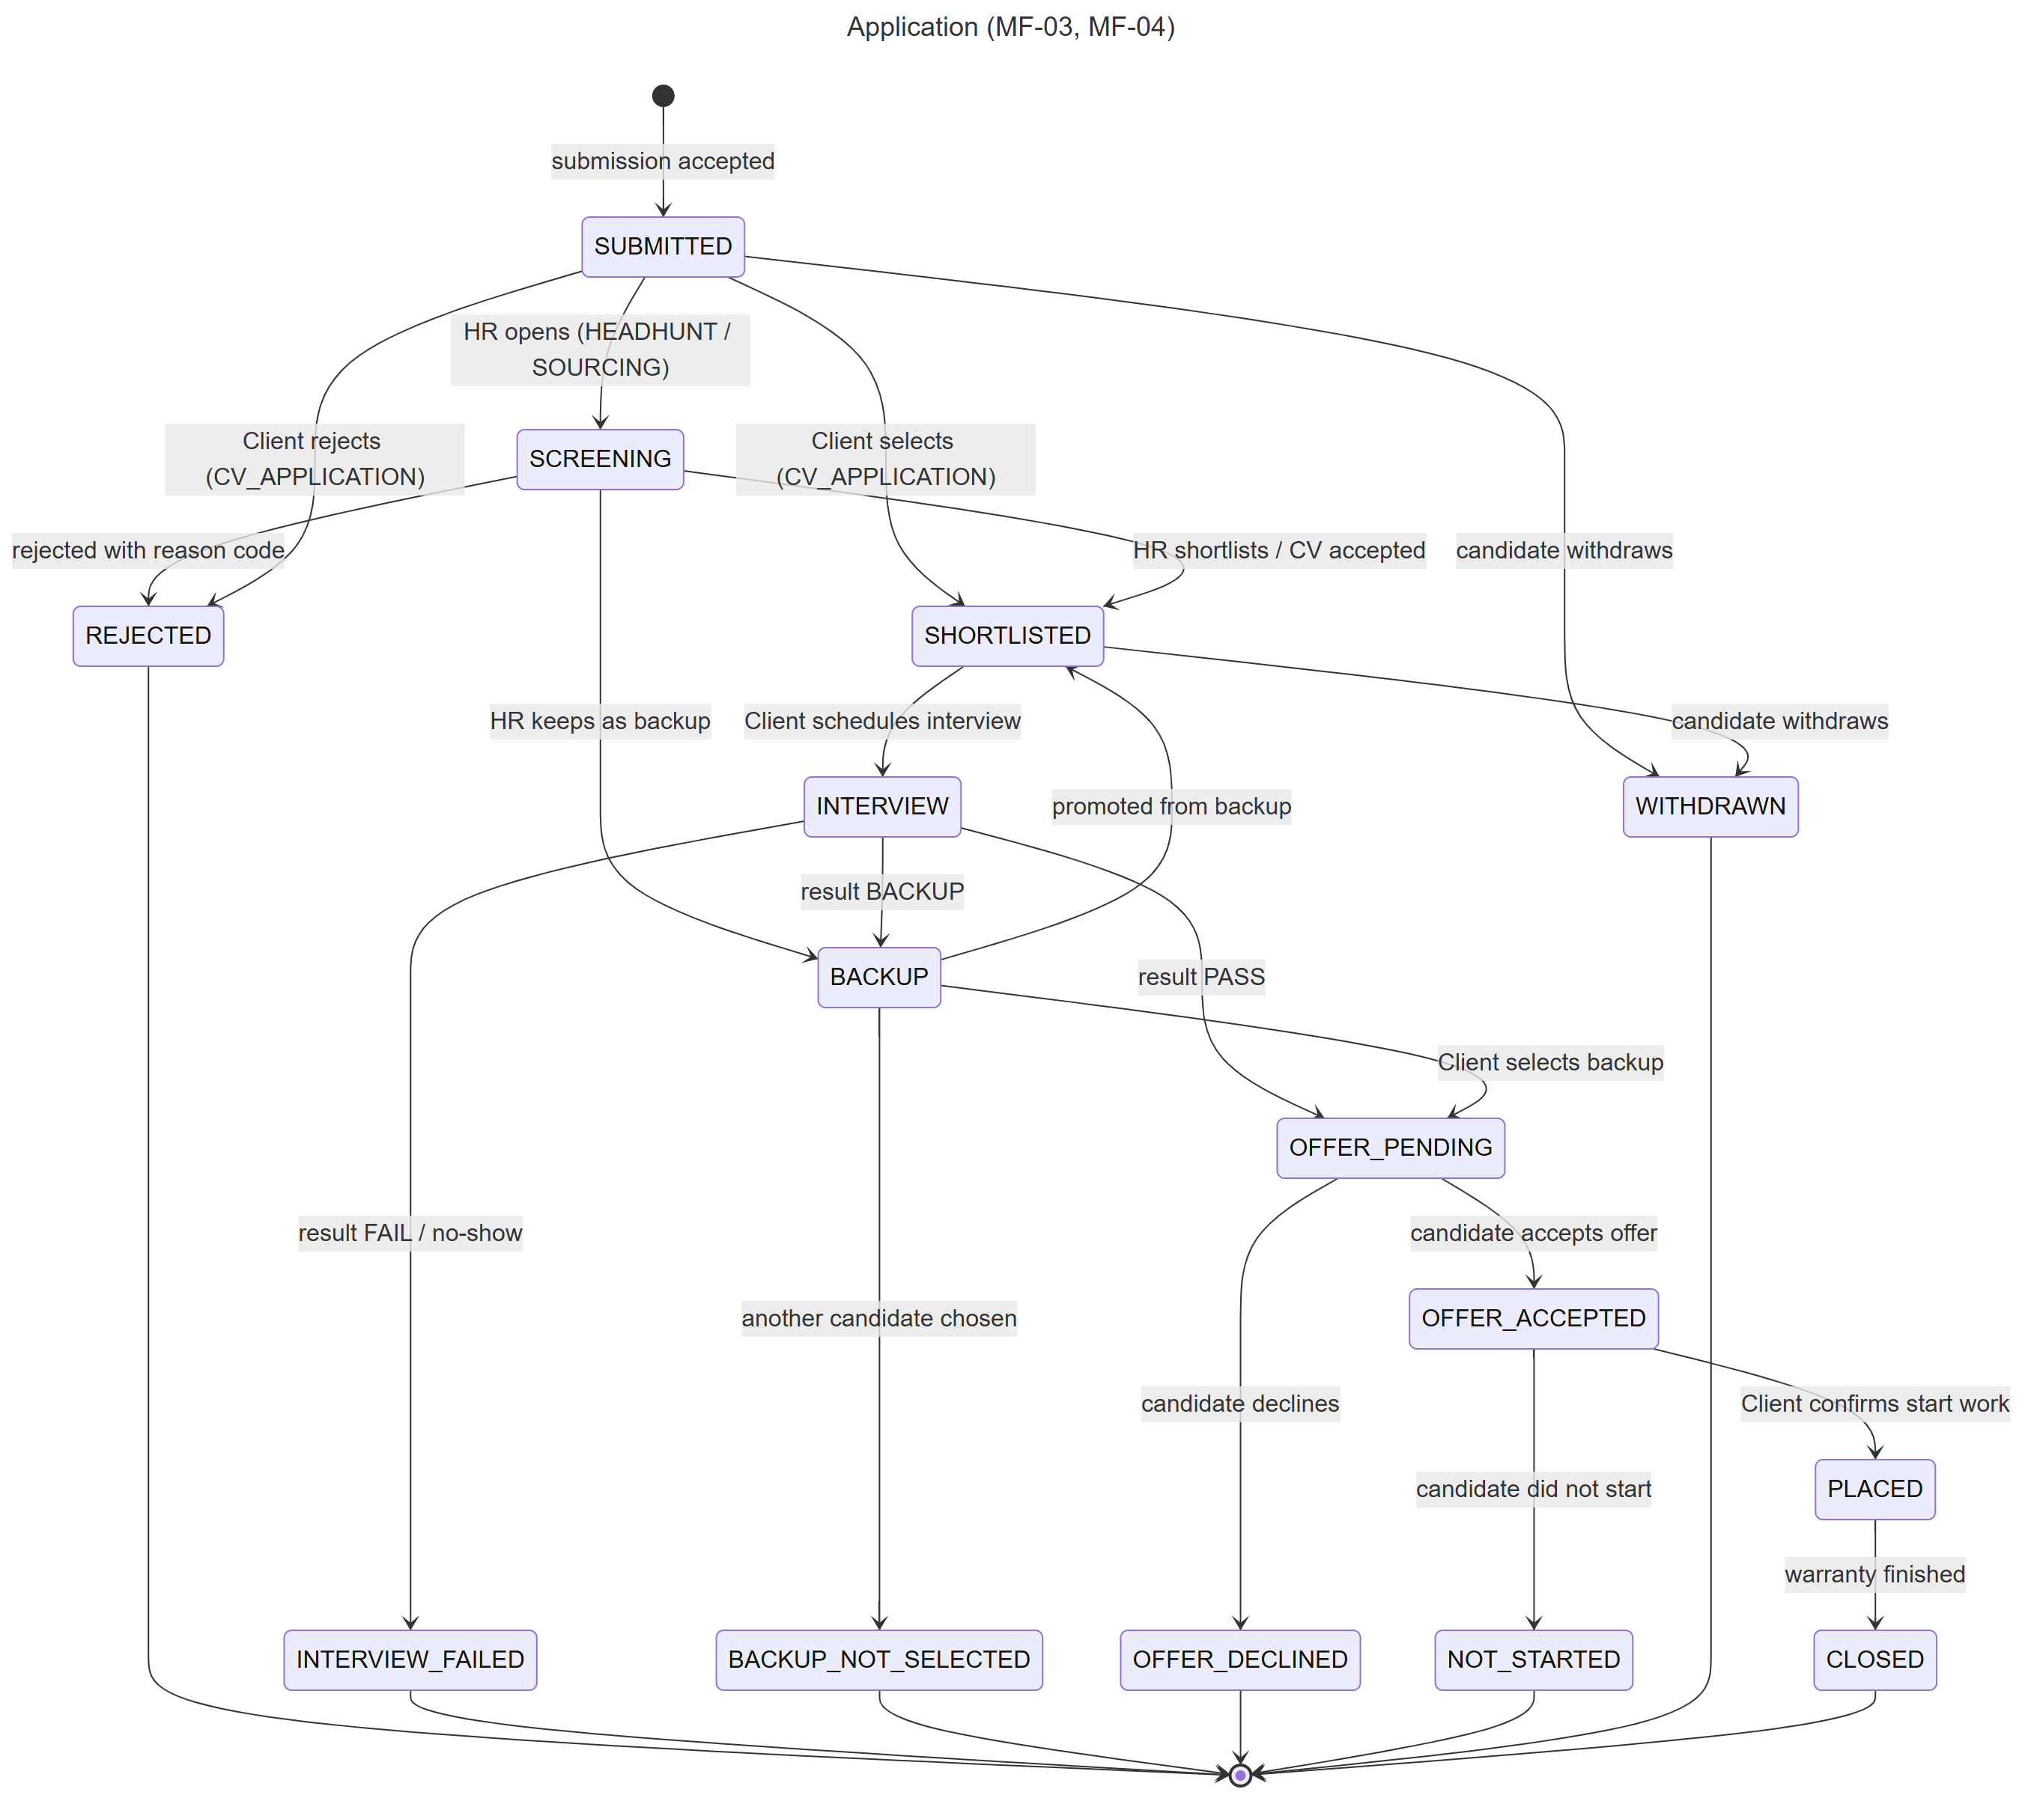
Figure 14. State machine – Application
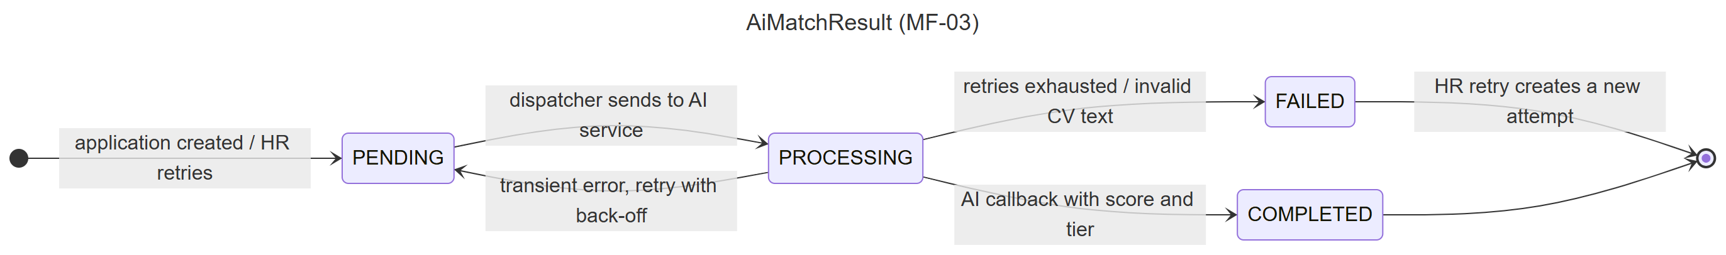
Figure 15. State machine – AI match result
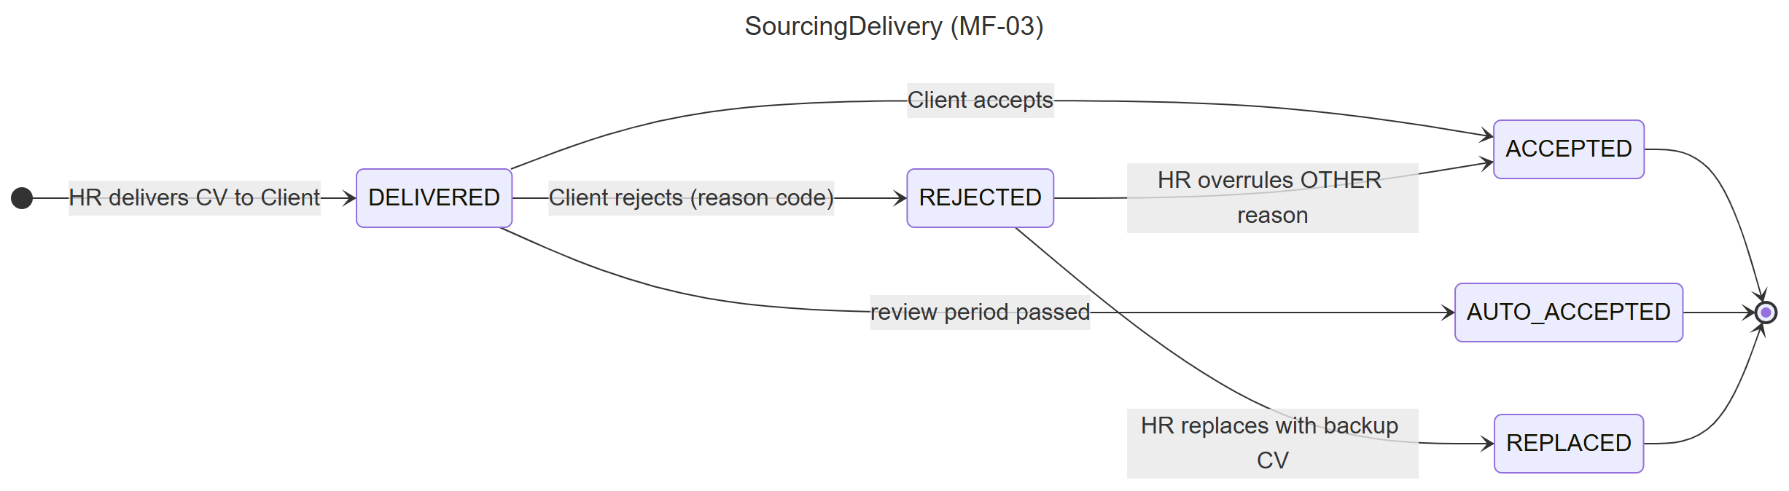
Figure 16. State machine – Sourcing delivery
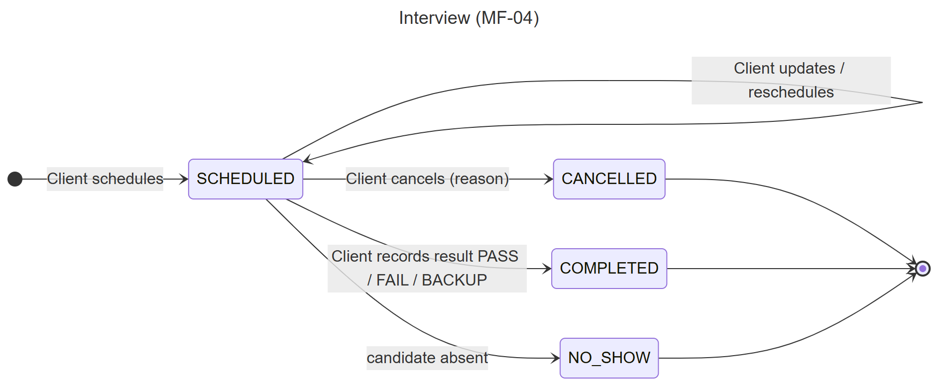
Figure 17. State machine – Interview
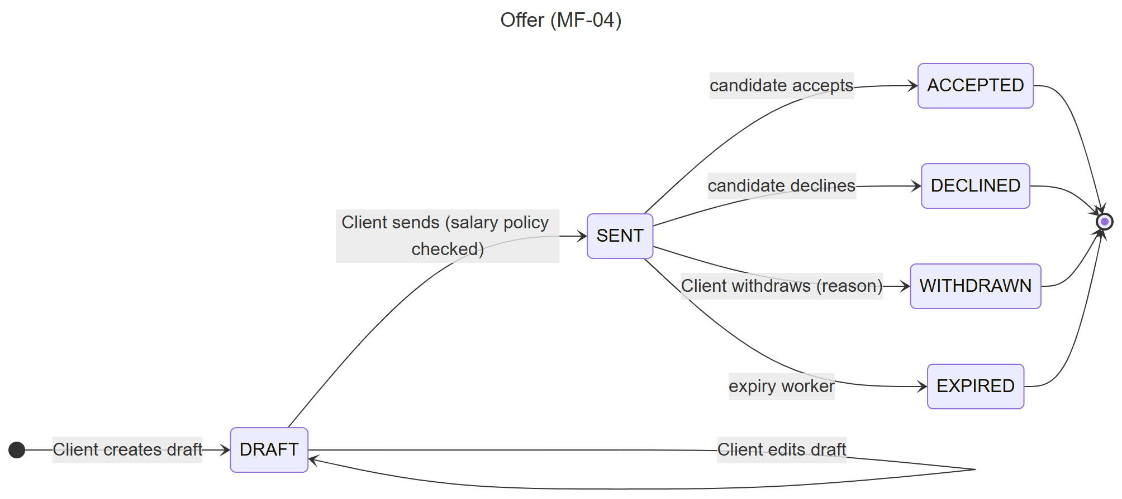
Figure 18. State machine – Offer
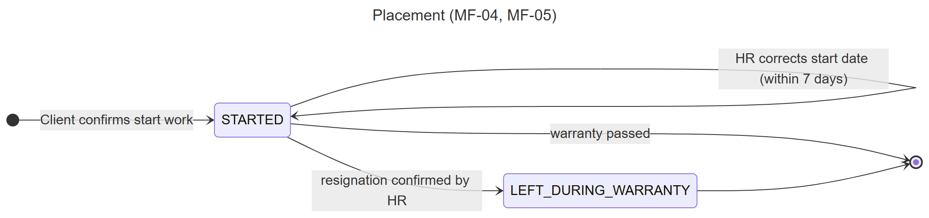
Figure 19. State machine – Placement
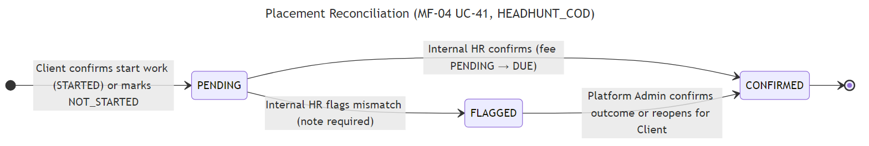
Figure 20. State machine – Placement reconciliation
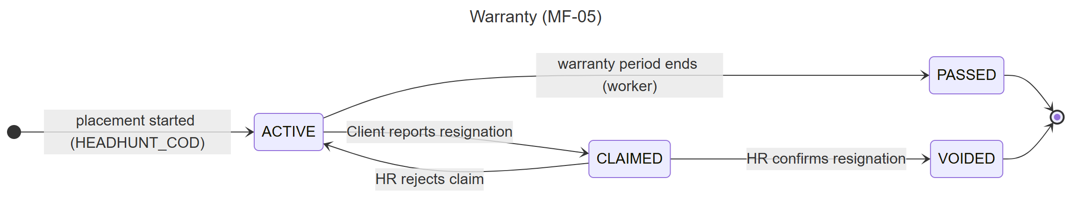
Figure 21. State machine – Warranty
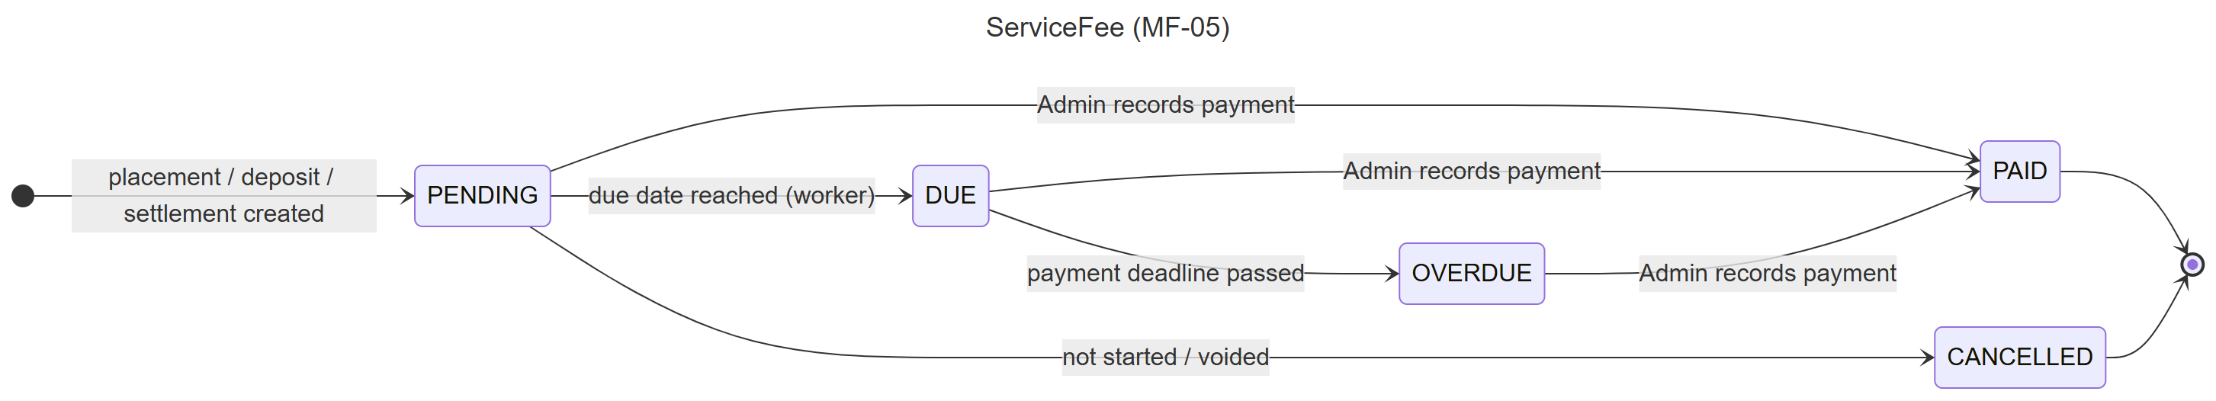
Figure 22. State machine – Service fee
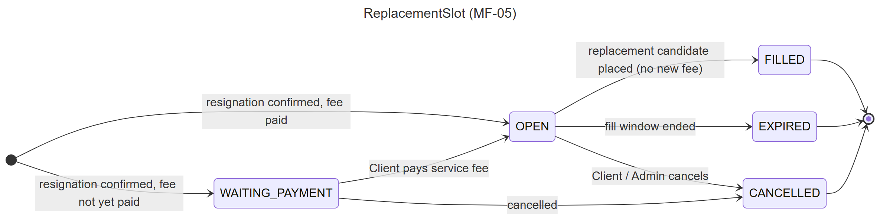
Figure 23. State machine – Replacement slot
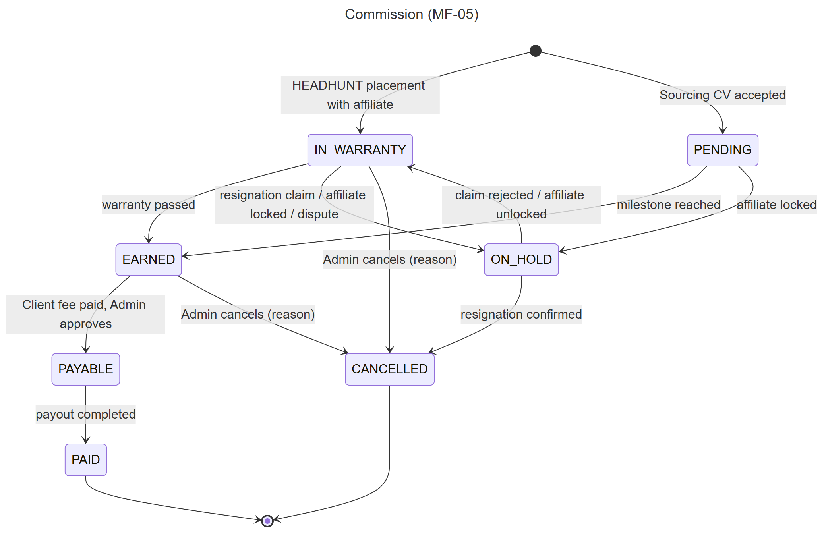
Figure 24. State machine – Commission
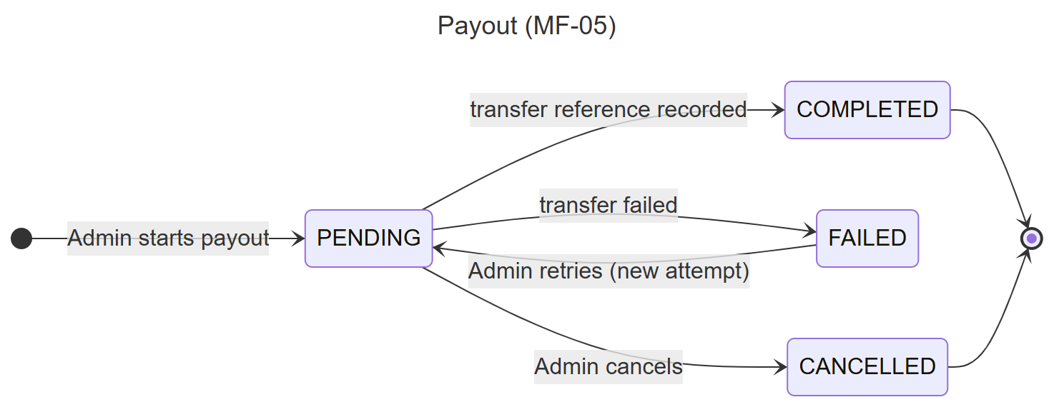
Figure 25. State machine – Payout
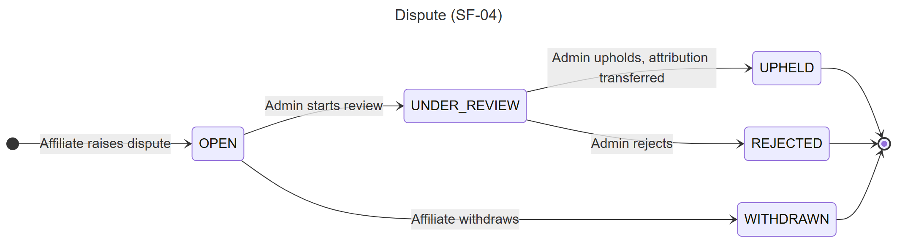
Figure 26. State machine – Dispute

3. Detailed Design
This section describes the five main flows. All features use the same request pipeline: the web application calls an endpoint, the endpoint sends a MediatR command or query, a validator checks the input, the handler applies the business policy, saves the changes through EF Core in one transaction and writes the audit log; notifications are published to SignalR only after the transaction commits.

3.1 MF-01 Create, Approve and Publish Job
Client Company Users create jobs for one of the three service types; Internal HR reviews them; a CV_APPLICATION job becomes ACTIVE after the posting fee is recorded, a HEADHUNT_COD job after its Service Agreement is signed, and a CV_SOURCING job after its deposit is recorded. Commercial terms (fee multiplier, warranty days, Sourcing target and price per CV) are proposed by the Client and confirmed by HR. For HEADHUNT_COD and CV_SOURCING, a Service Agreement step follows approval (PENDING_AGREEMENT): HR sends a versioned agreement, the Client's primary contact accepts and signs it with an e-mail OTP, the signed PDF is stored in R2, then a Headhunt job becomes ACTIVE and a Sourcing job creates its deposit (PENDING_PAYMENT).

3.1.1 Class Diagram
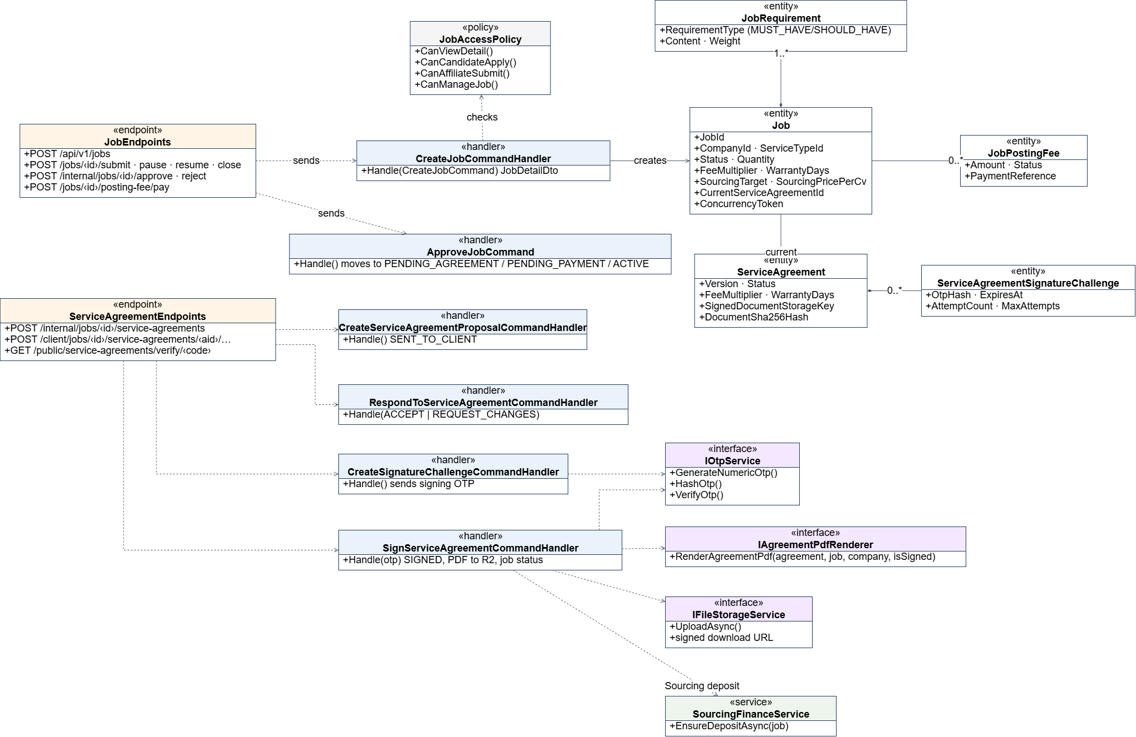
Figure 27. Class diagram – MF-01 Create, Approve and Publish Job
Class Specifications:
• JobEndpoints: Maps the job routes and checks the permission policy of the caller.
• CreateJobCommandHandler / UpdateJobCommandHandler: Validate that the company is verified and the service type allows the caller to submit, save the Job and its JobRequirements; updates check the ConcurrencyToken.
• Submit/Approve/Reject/Pause/Resume/CloseJob handlers: Apply the allowed status transition, require reason codes for reject/close, write JobStatusHistory and AuditLog, notify the Client.
• Create/Respond/Sign/Upload/VoidServiceAgreement handlers: HR sends a versioned agreement; the Client accepts it and signs with an e-mail OTP (ServiceAgreementSignatureChallenge); the signed PDF is stored in R2.
• JobAccessPolicy: Decides who can view or submit to a job by service type (ServiceTypeAllowedRole).
• RecordJobPostingFeePaymentCommand: Platform Admin records the posting fee or Sourcing deposit reference; the job becomes ACTIVE.

3.1.2 Sequence Diagram – Client creates and submits a job

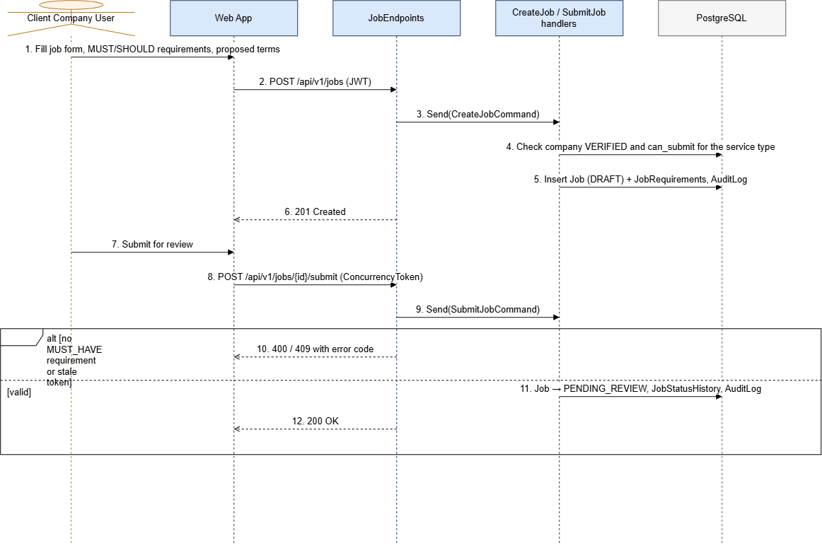
Figure 28. Sequence diagram – Client creates and submits a job

3.1.3 Sequence Diagram – Internal HR approves, agreement signing and job publishing
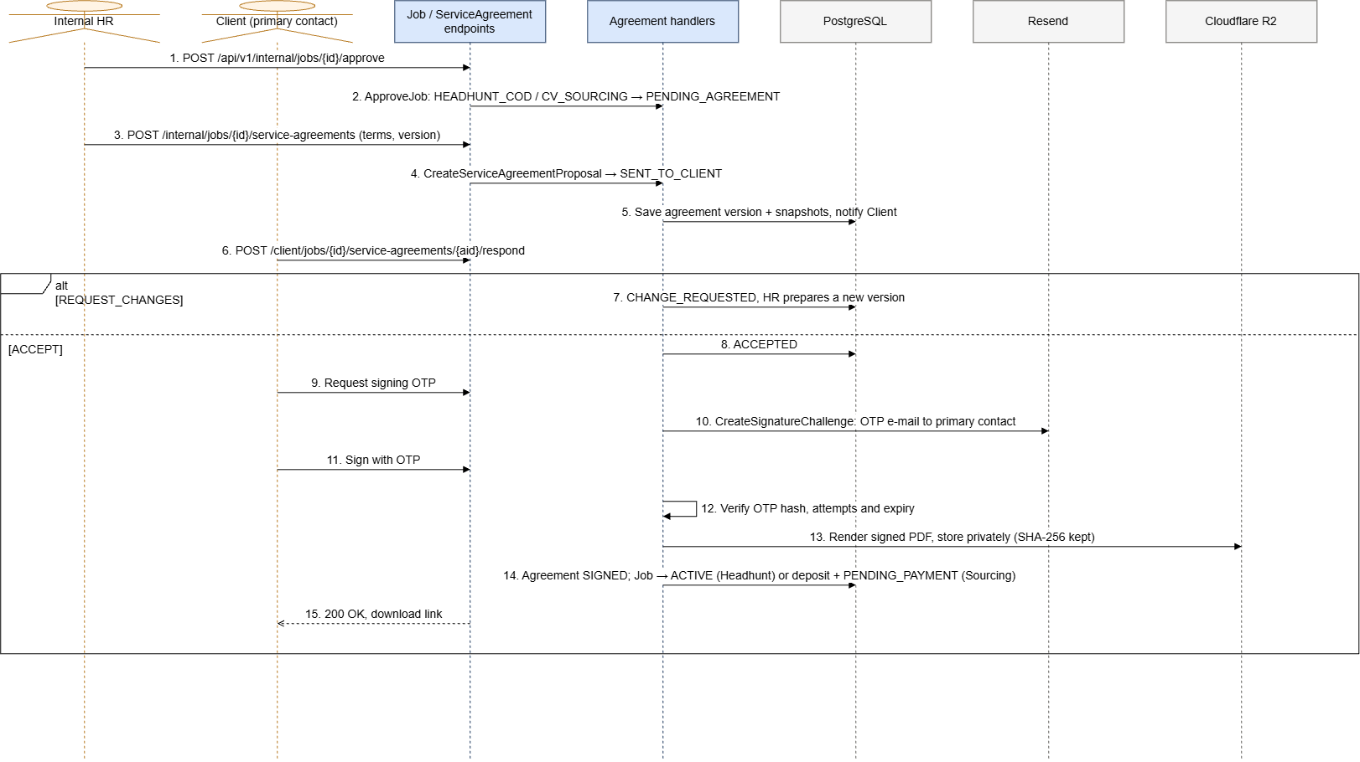
Figure 29. Sequence diagram – Internal HR approves and the Client signs the Service Agreement

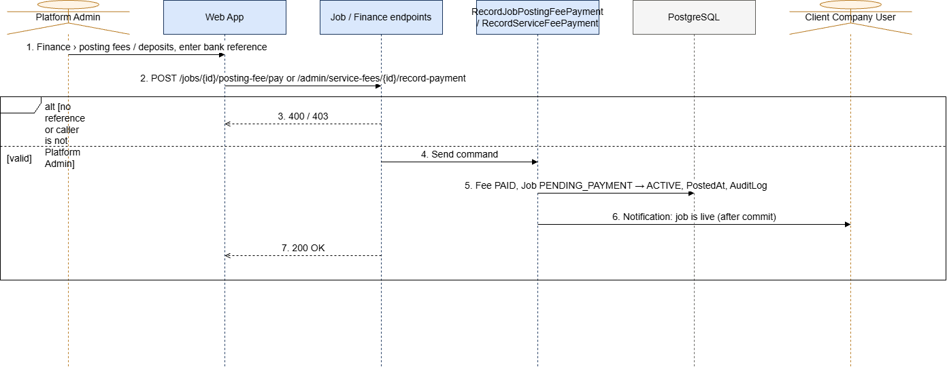
Figure 30. Sequence diagram – Posting fee or deposit is recorded and the job is published

3.2 MF-02 Candidate Submission, Consent, Duplicate Check and Attribution
Candidates apply to CV_APPLICATION jobs; Affiliates refer candidates to HEADHUNT_COD and CV_SOURCING jobs. An affiliate referral needs the candidate's consent by e-mail. The system normalises e-mail and phone, blocks duplicate submissions for the same job (BLOCKED_DUPLICATE) and keeps the first valid source as the Attribution.

3.2.1 Class Diagram
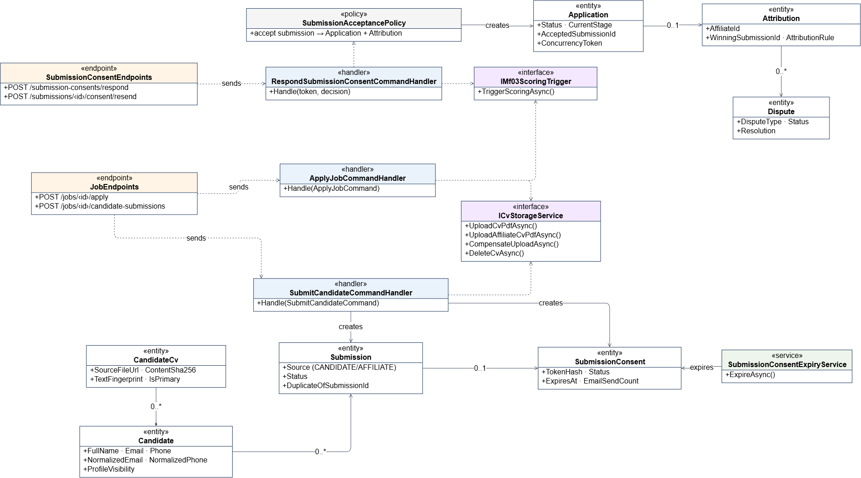
Figure 31. Class diagram – MF-02 Candidate Submission, Consent, Duplicate Check and Attribution
Class Specifications:
• ApplyJobCommandHandler: Candidate applies with an uploaded or existing CV; creates the Submission and Application and triggers AI scoring.
• SubmitCandidateCommandHandler: Finds or creates the Candidate, checks duplicates, pending consents and client ownership (CANDIDATE_OWNED_BY_CLIENT), creates the Submission and SubmissionConsent and sends the consent e-mail.
• RespondSubmissionConsentCommandHandler: Verifies the hashed token and expiry, accepts or rejects the submission and notifies the affiliate.
• SubmissionAcceptancePolicy: Creates the Application and Attribution or marks the submission as duplicate.
• ResendSubmissionConsentCommand: Resends the consent e-mail with a cool-down and a maximum count.

3.2.2 Sequence Diagram – Affiliate refers a candidate
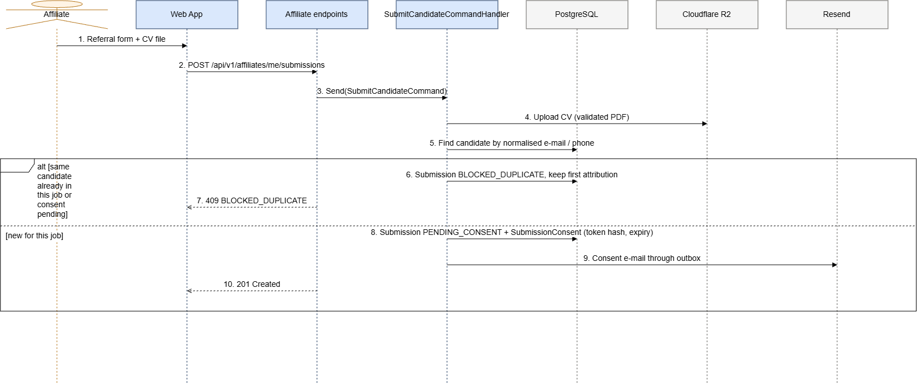
Figure 32. Sequence diagram – Affiliate refers a candidate

3.2.3 Sequence Diagram – Candidate accepts consent
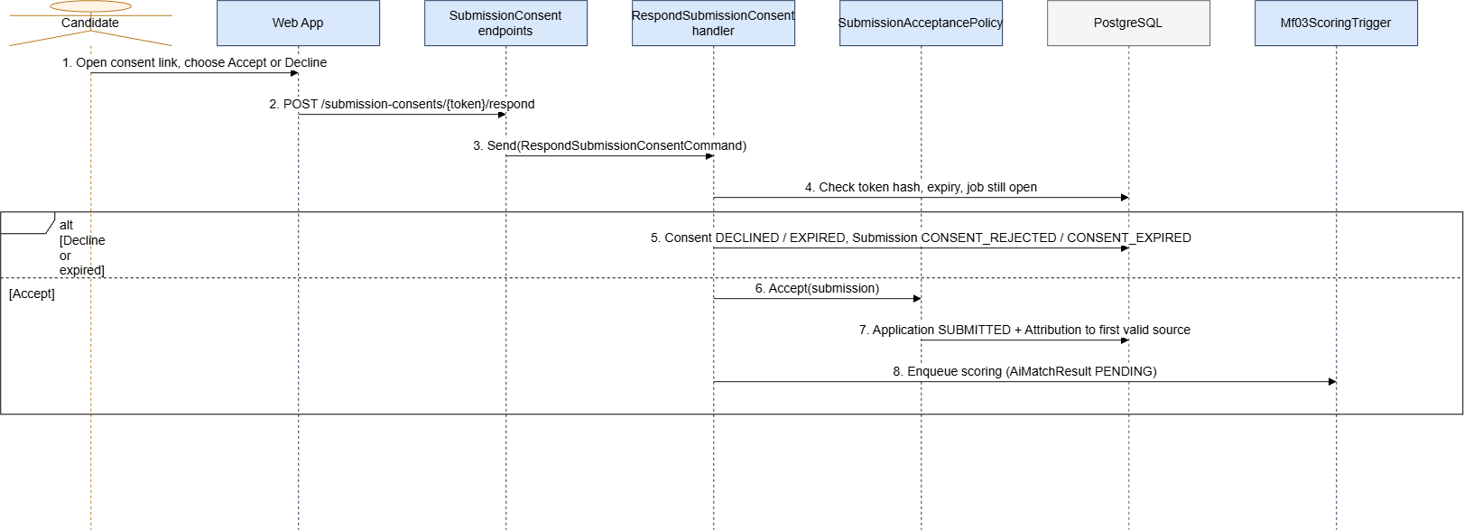
Figure 33. Sequence diagram – Candidate accepts consent

3.2.4 Sequence Diagram – Candidate applies to a job
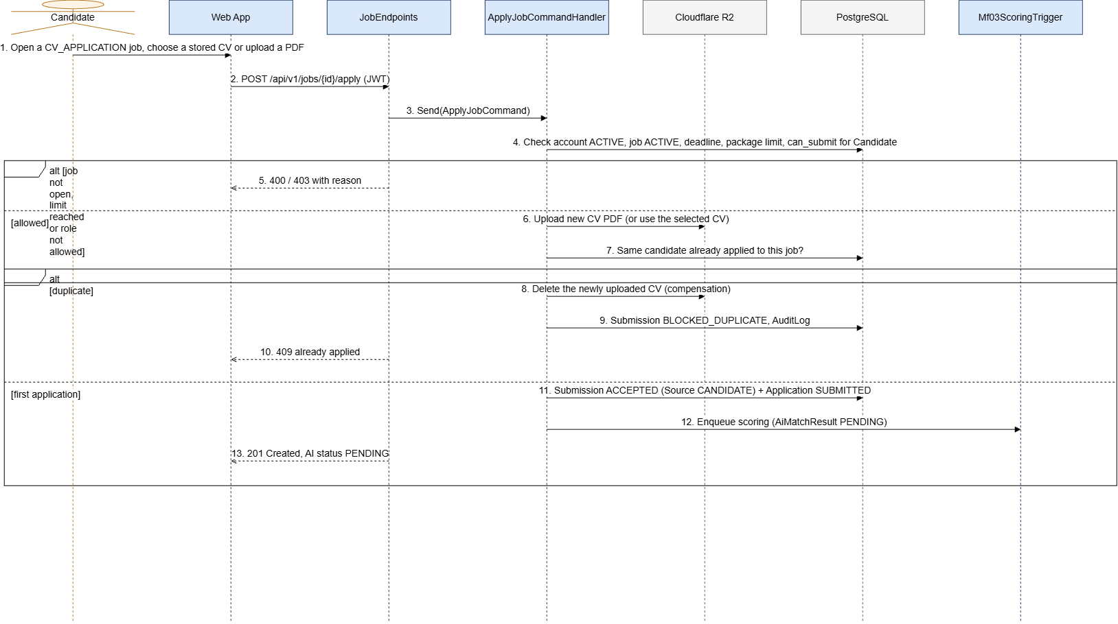
Figure 34. Sequence diagram – Candidate applies to a job

3.3 MF-03 AI Matching and Screening
Every new application is scored asynchronously by the AI Matching Service. Internal HR screens Headhunt and Sourcing applications using the score, tier and evidence; Clients screen CV_APPLICATION jobs themselves. For CV_SOURCING, HR delivers CVs to the Client, who accepts or rejects them within the review period (auto-accepted after the deadline).

3.3.1 Class Diagram
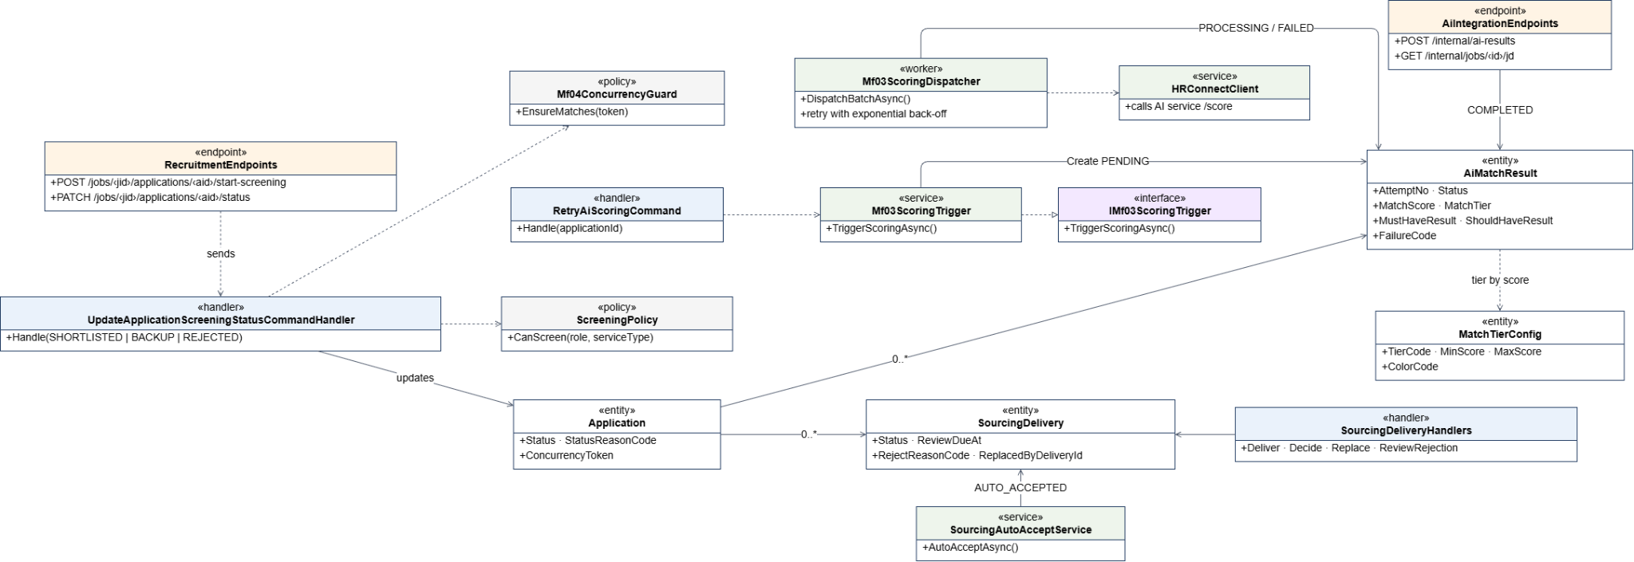
Figure 35. Class diagram – MF-03 AI Matching and Screening
Class Specifications:
• Mf03ScoringTrigger / Mf03ScoringDispatcher: Create a PENDING AiMatchResult and dispatch it to the AI service with retry and back-off.
• AiIntegrationEndpoints: Internal callback that stores the score, tier and per-requirement results, or the failure code.
• RetryAiScoringCommand: Internal HR starts a new scoring attempt for a FAILED result.
• UpdateApplicationScreeningStatusCommandHandler: Moves an application to SHORTLISTED, BACKUP or REJECTED with a reason code, using the ConcurrencyToken.
• Sourcing delivery handlers: Deliver, decide, replace and review rejections of Sourcing CVs; SourcingAutoAcceptWorker accepts overdue deliveries.

3.3.2 Sequence Diagram – Asynchronous AI scoring
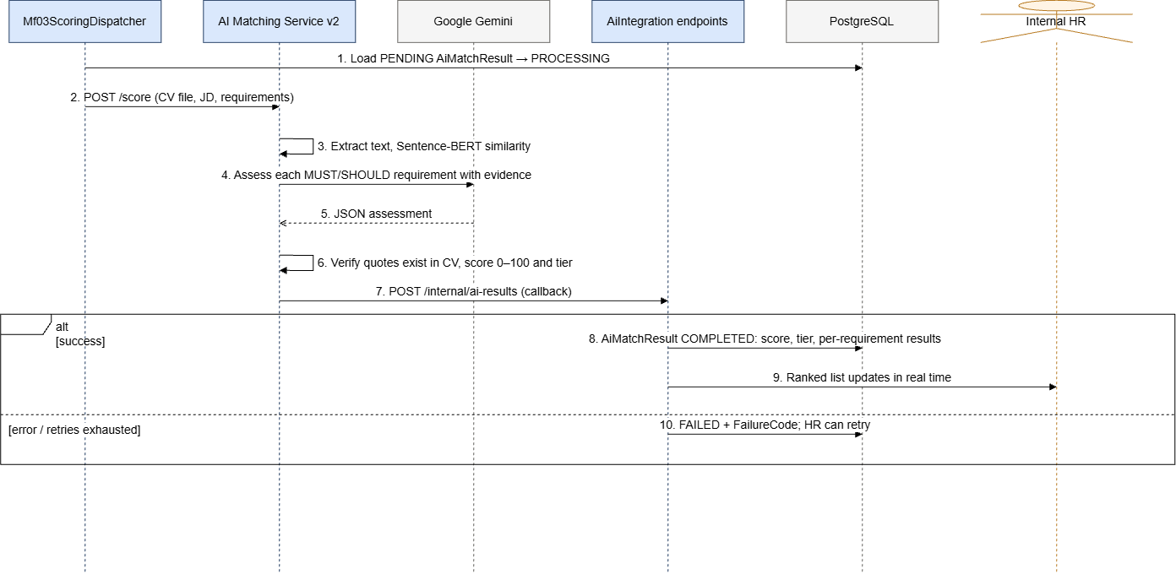
Figure 36. Sequence diagram – Asynchronous AI scoring

3.3.3 Sequence Diagram – Internal HR screens an application
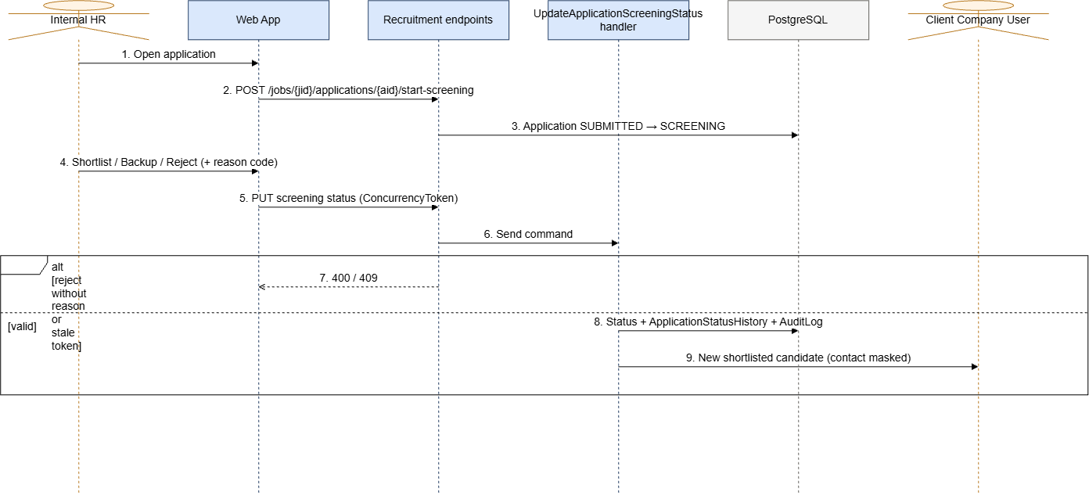
Figure 37. Sequence diagram – Internal HR screens an application

3.4 MF-04 Interview, Offer and Start Work
The Client schedules interviews, records results, sends offers and confirms the start of work. Headhunt offers must use gross monthly salary. When the candidate starts work, a Placement is created and the finance records of MF-05 are initialised. For HEADHUNT_COD, Internal HR reconciles the reported start-work outcome (PlacementReconciliation) before the fee can become due.

3.4.1 Class Diagram
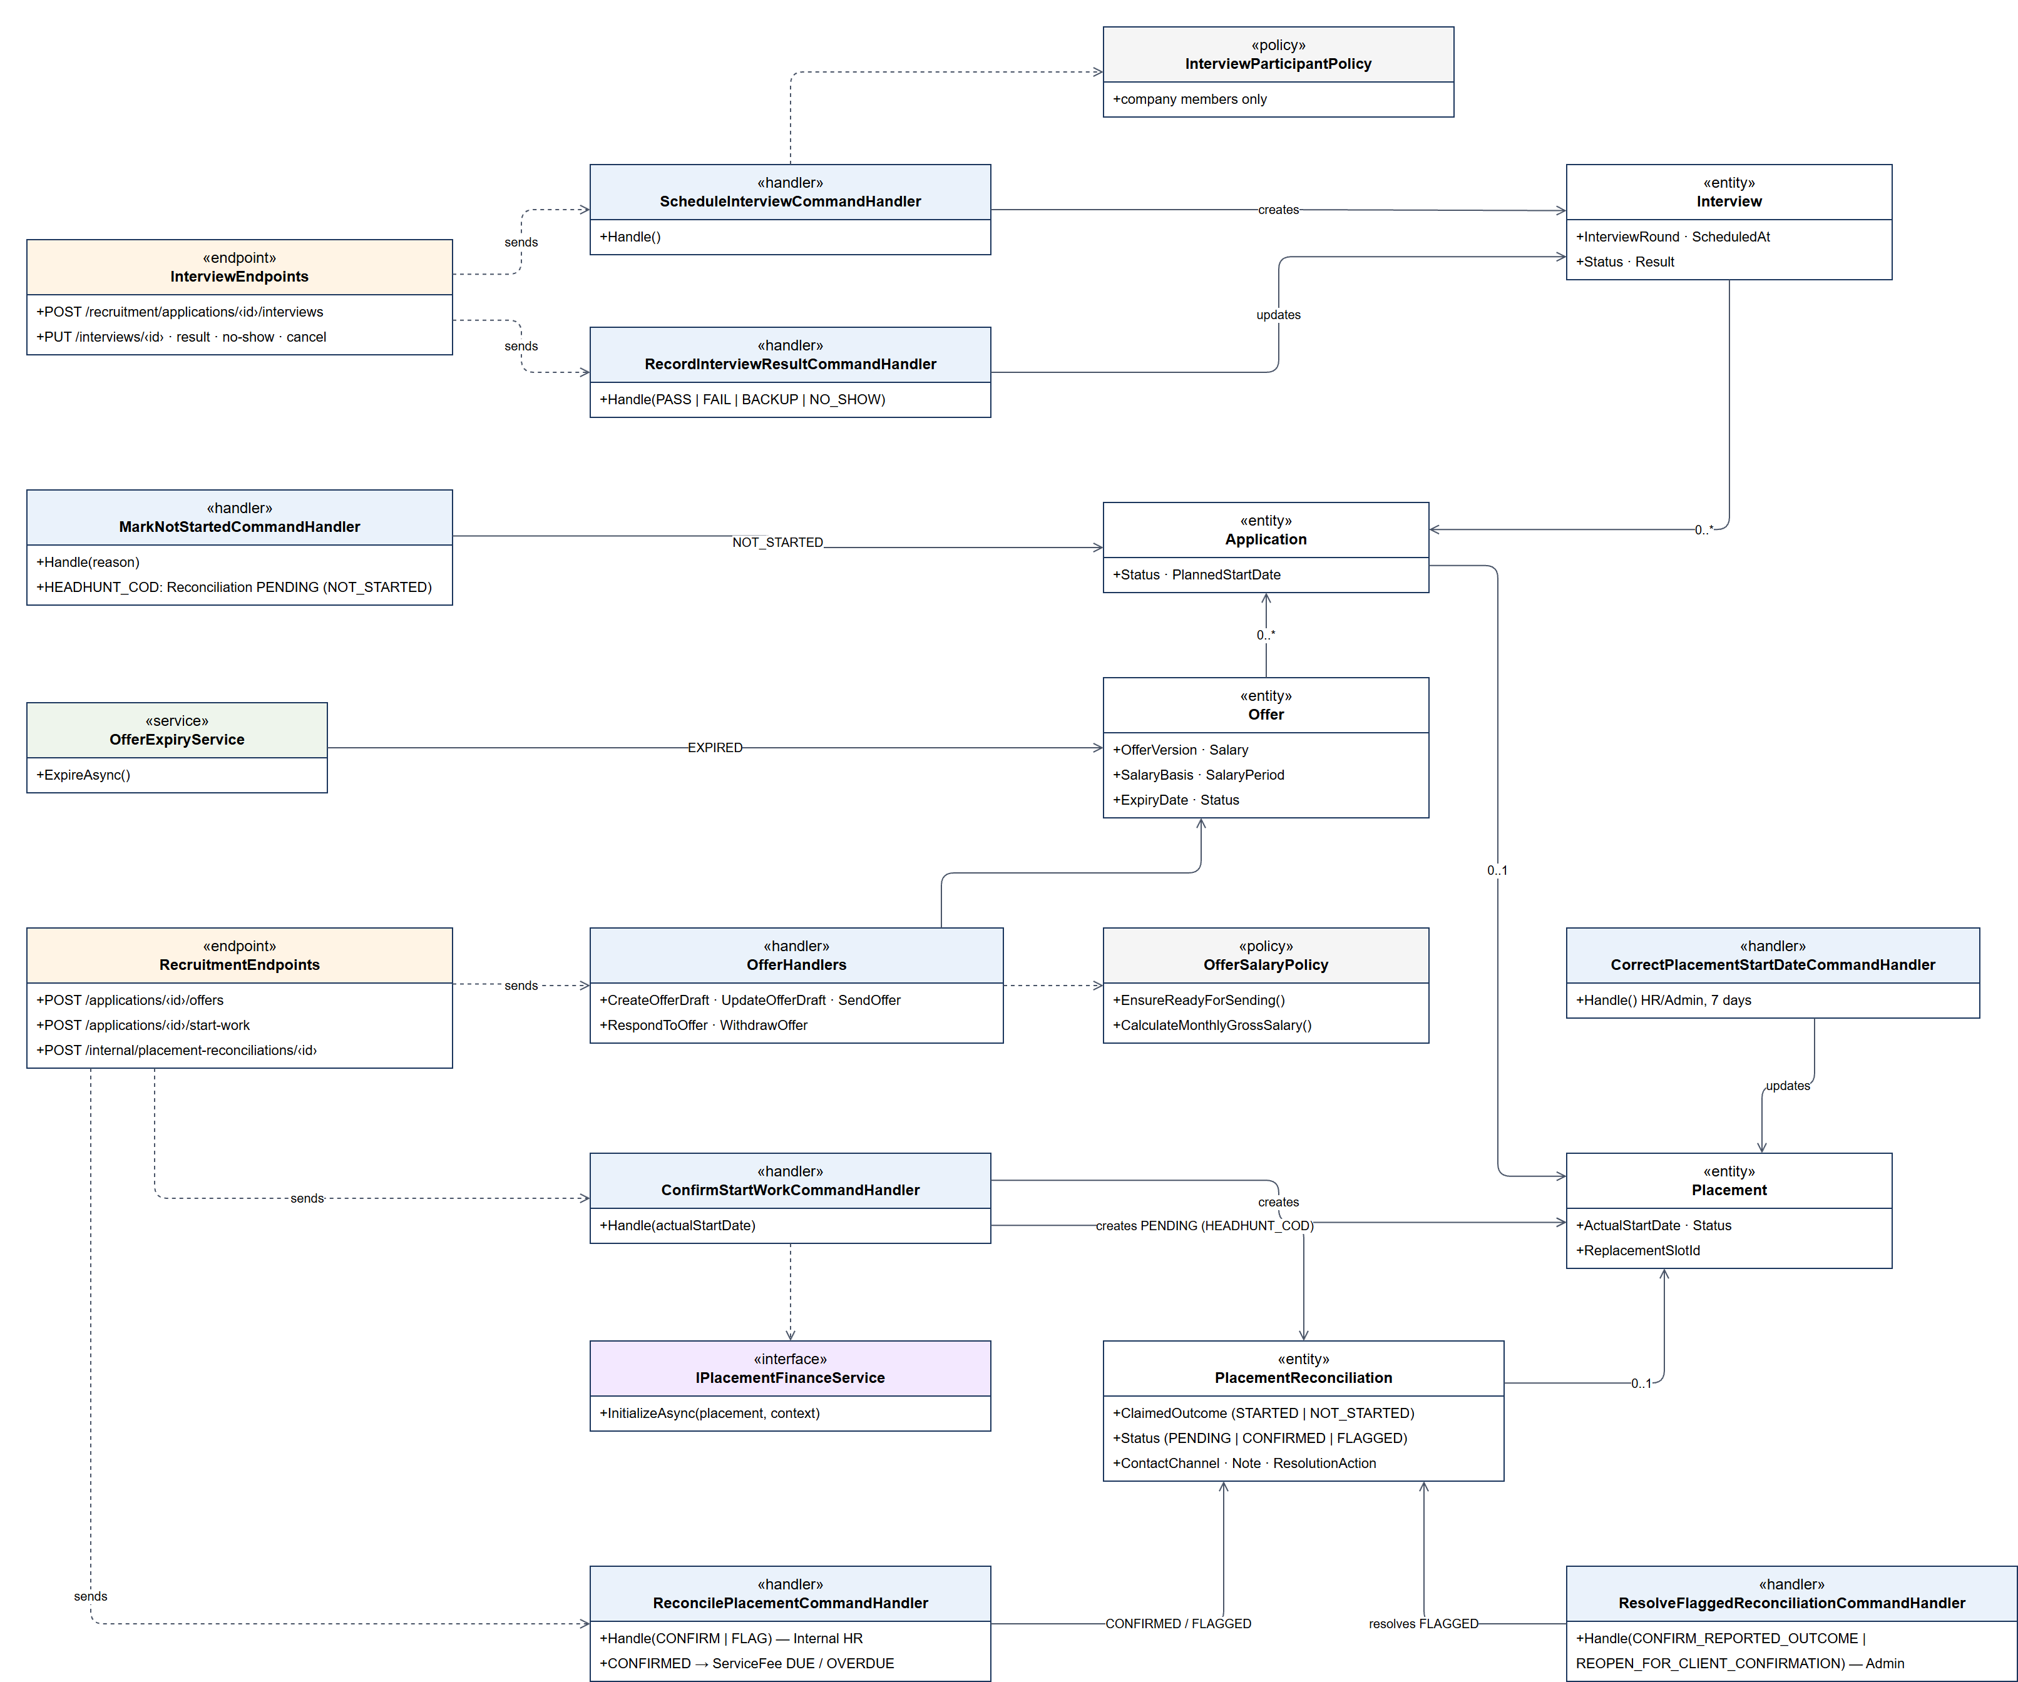
Figure 38. Class diagram – MF-04 Interview, Offer and Start Work
Class Specifications:
• ScheduleInterviewCommandHandler, Update/Reschedule/Cancel handlers: Manage interview rounds, participants and schedule history; notify the candidate in real time.
• RecordInterviewResult / RecordInterviewNoShow handlers: Record PASS, FAIL, BACKUP or NO_SHOW and move the application.
• Create/Update/Send/Respond/WithdrawOffer handlers: Manage offer versions; OfferSalaryPolicy checks the salary basis; withdrawal needs a reason; OfferExpiryWorker expires old offers.
• ConfirmStartWorkCommandHandler: Validates the actual start date, creates the Placement and, for HEADHUNT_COD, a PENDING PlacementReconciliation; calls PlacementFinanceService.
• ReconcilePlacementCommandHandler / ResolveFlaggedReconciliationCommandHandler: Internal HR confirms or flags the start-work outcome; Platform Admin resolves flagged cases.
• MarkNotStartedCommandHandler: Closes an accepted offer when the candidate does not start; no fee is created.

3.4.2 Sequence Diagram – Client schedules an interview
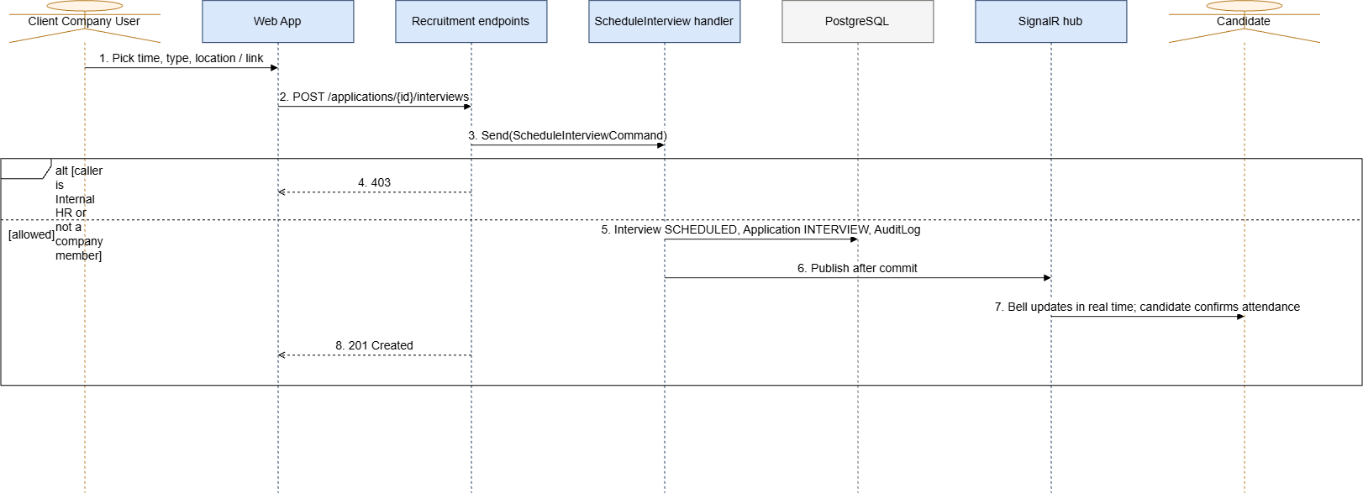
Figure 39. Sequence diagram – Client schedules an interview

3.4.3 Sequence Diagram – Offer, acceptance and start work
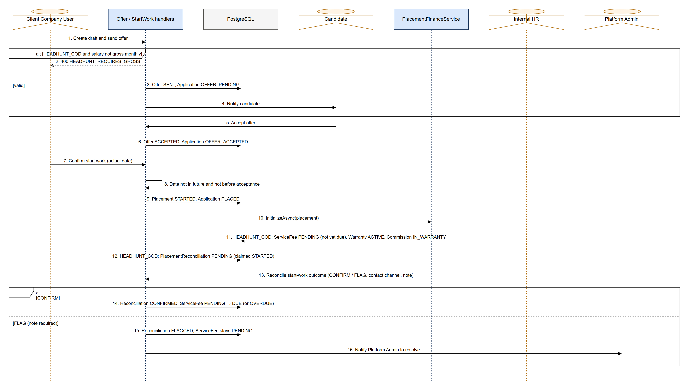
Figure 40. Sequence diagram – Offer, acceptance and start work

3.5 MF-05 Fee, Warranty, Commission and Payout
After placement the Client owes the service fee (fee multiplier × gross monthly salary). A Headhunt placement has a 30-day warranty; the affiliate commission is earned at the end of the warranty and becomes payable after the Client pays. A confirmed resignation during the warranty cancels the commission and opens a free replacement slot. Sourcing jobs pay a commission per accepted CV and are settled against the deposit.

3.5.1 Class Diagram
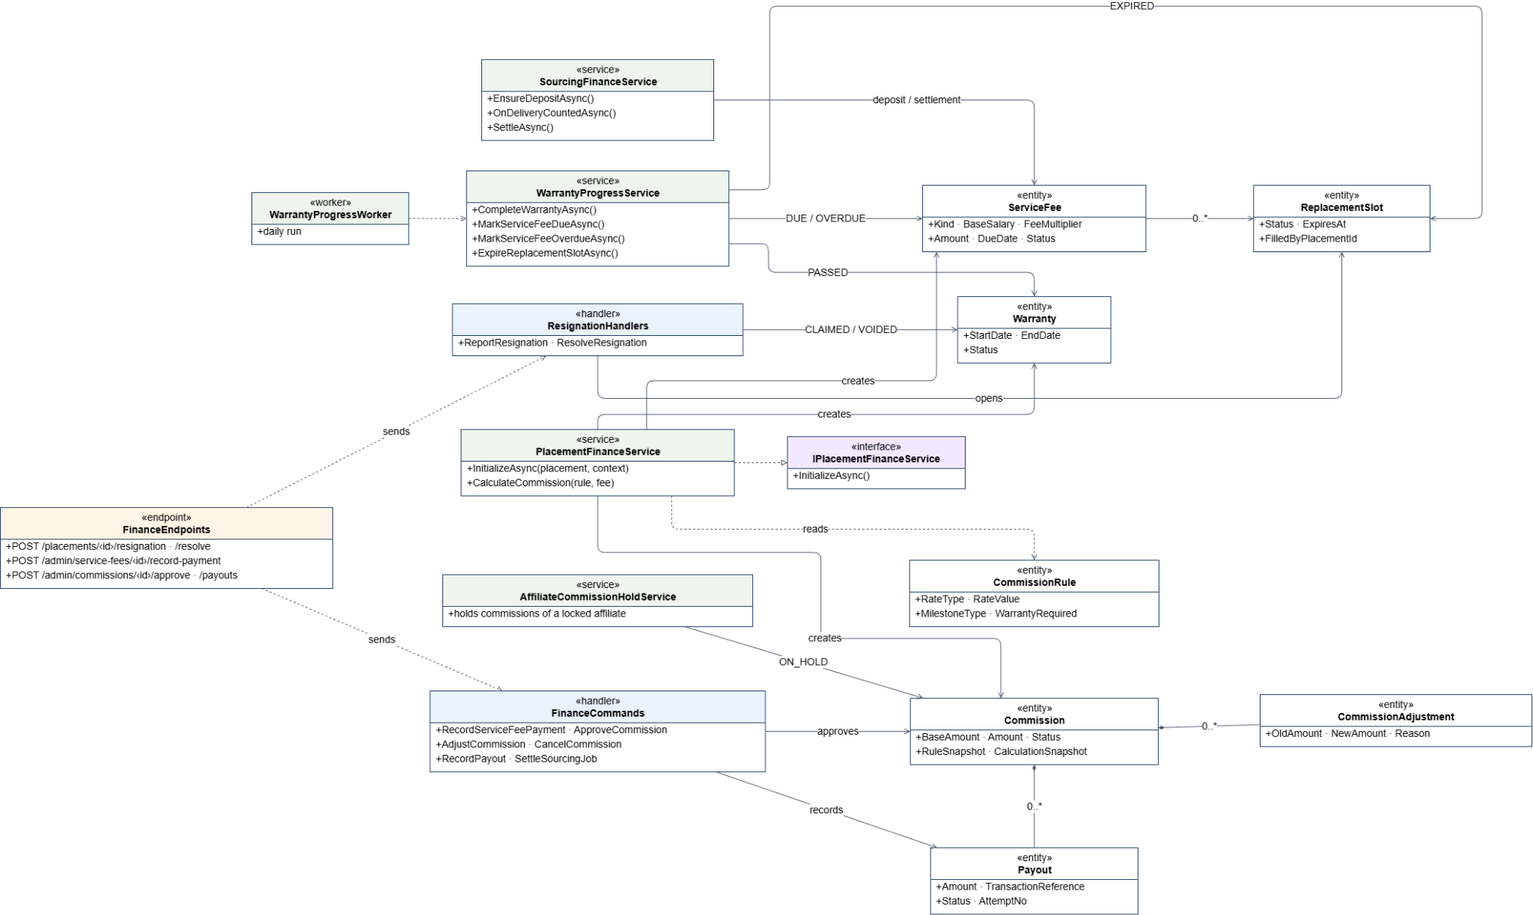
Figure 41. Class diagram – MF-05 Fee, Warranty, Commission and Payout
Class Specifications:
• PlacementFinanceService / WarrantyProgressService: Create ServiceFee, Warranty and Commission for a placement; complete warranties and mark fees DUE/OVERDUE only when the PlacementReconciliation is CONFIRMED (called by WarrantyProgressWorker).
• Report/ResolveResignation handlers: Client reports a resignation (warranty CLAIMED, commission ON_HOLD); Internal HR confirms (warranty VOID, commission CANCELLED, ReplacementSlot opened) or rejects it.
• Finance commands: RecordServiceFeePayment, ApproveCommission, AdjustCommission, CancelCommission, RecordPayout and SettleSourcingJob, used by Platform Admin.
• AffiliateCommissionHoldService: Puts unearned commissions of a locked affiliate ON_HOLD.
• SourcingFinanceService: Creates the Sourcing deposit, counts accepted CVs and settles the job.

3.5.2 Sequence Diagram – Warranty completion, fee payment and payout
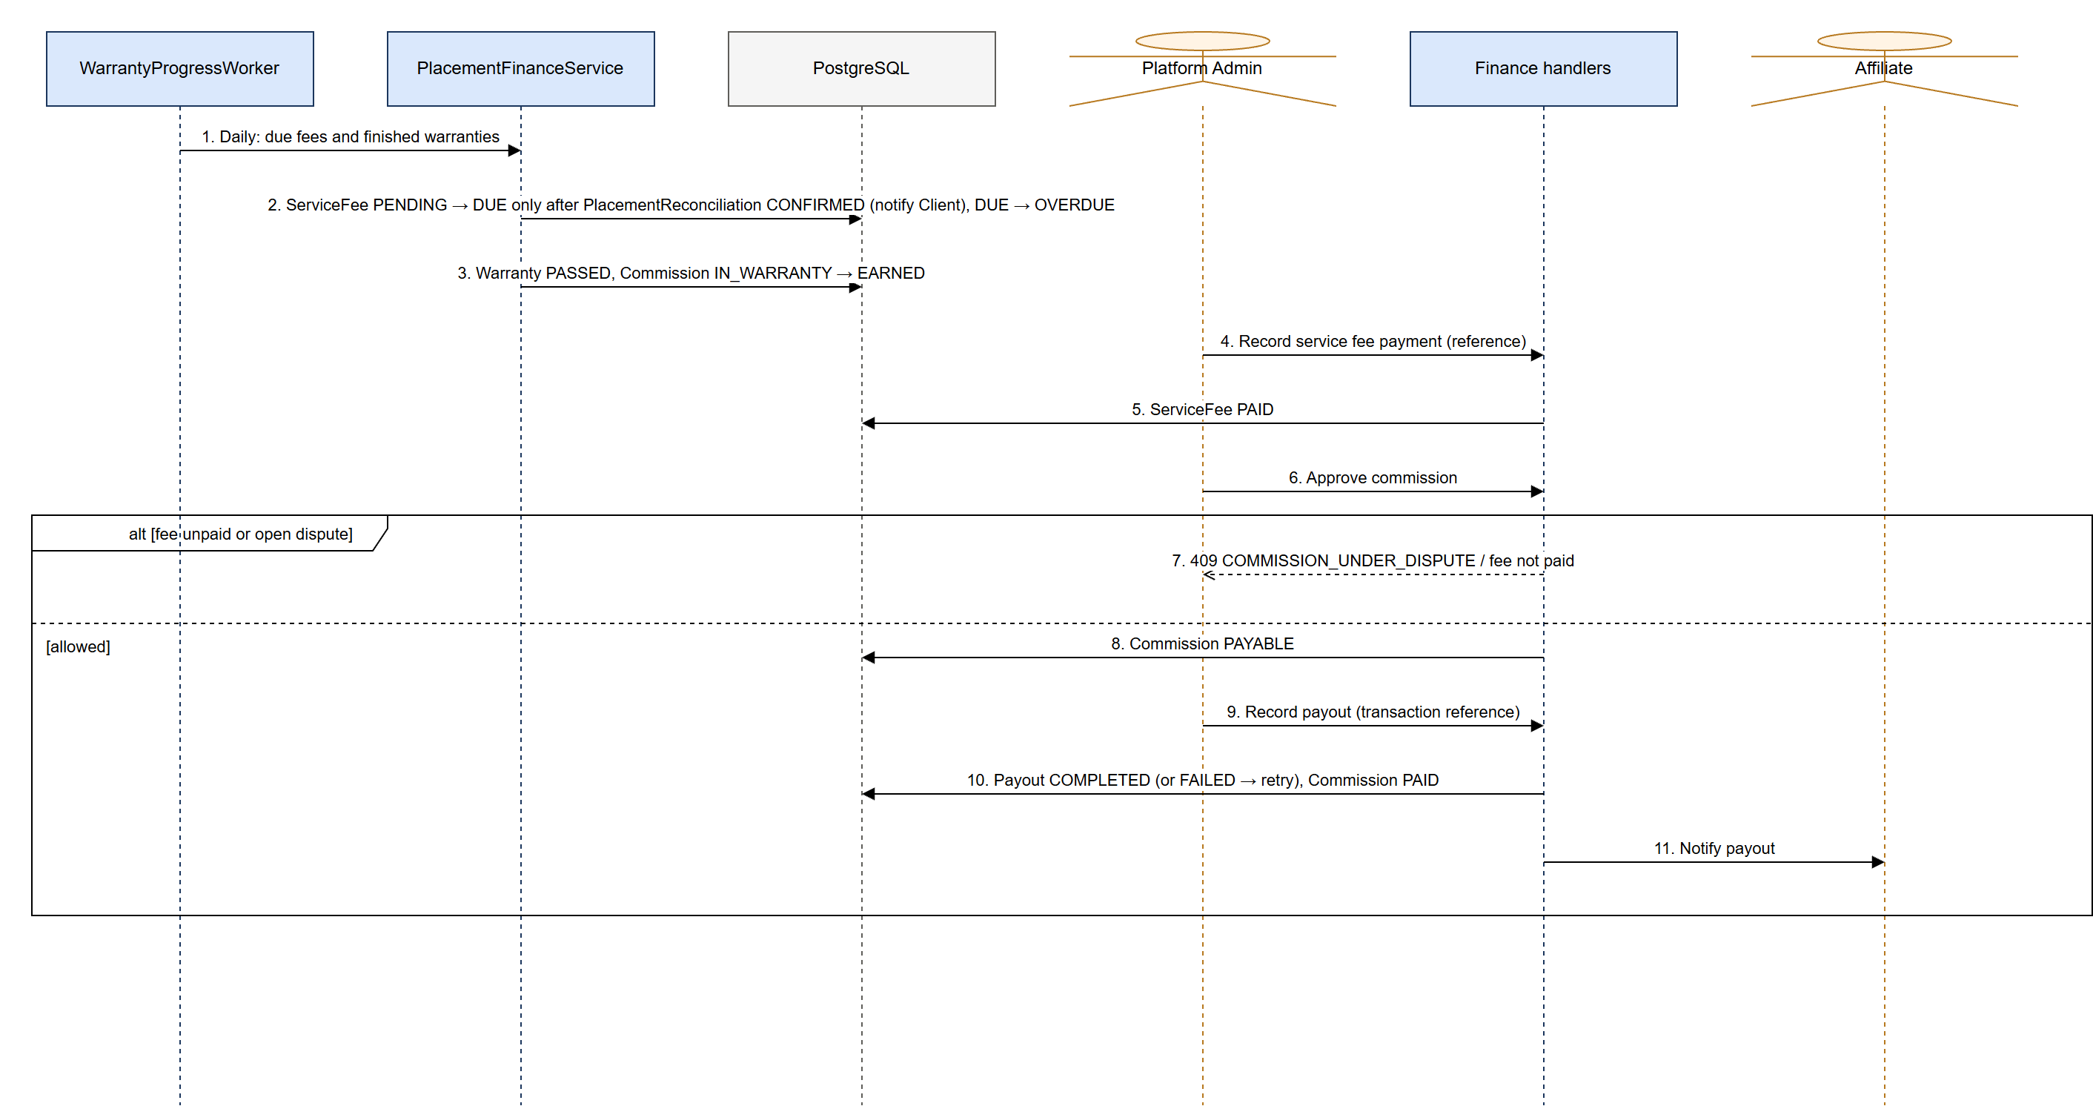
Figure 42. Sequence diagram – Warranty completion, fee payment and payout

3.5.3 Sequence Diagram – Resignation during warranty
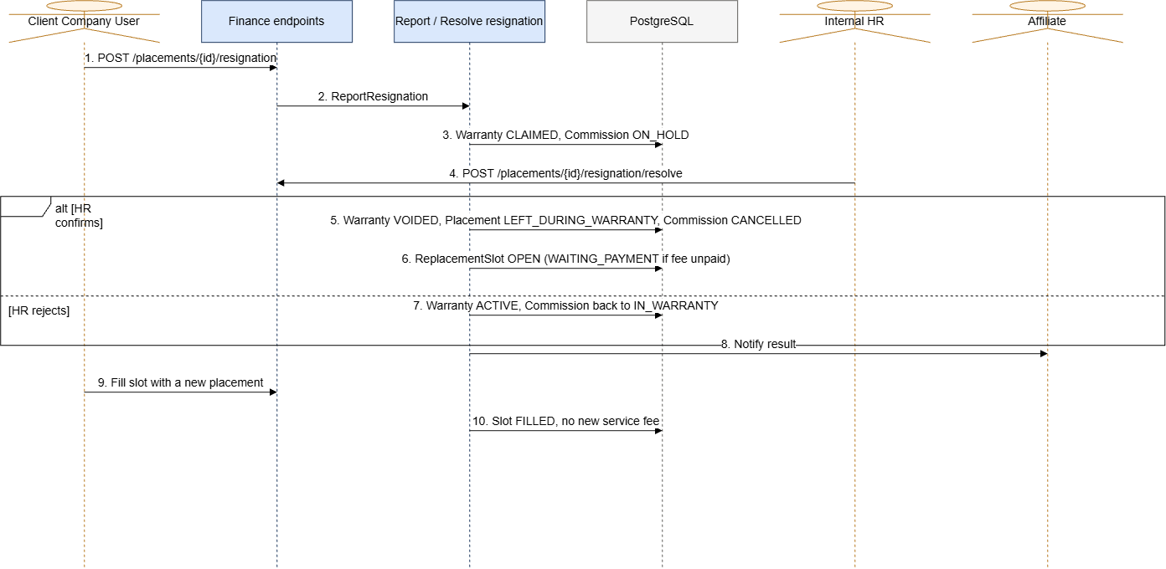
Figure 43. Sequence diagram – Resignation during warranty

