# Config

* MySql : mysql-installer-community-5.7.22.1
* Java : 1.8
* Tomcat : 8
* Database :
  + Schemal : soccerdb
  + User /Password : root/admin

# Backup

## Step1 : Login

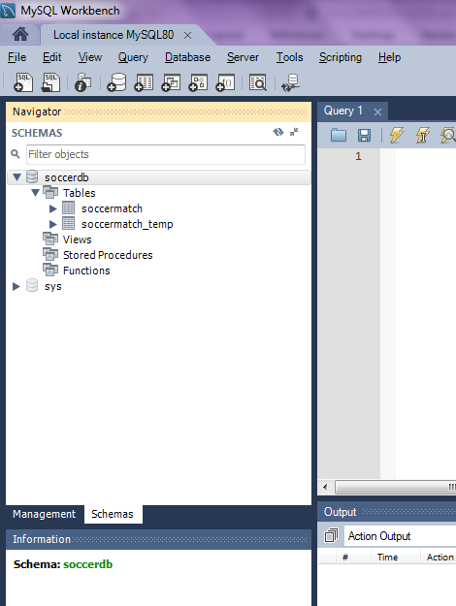

## Step 2 : Export

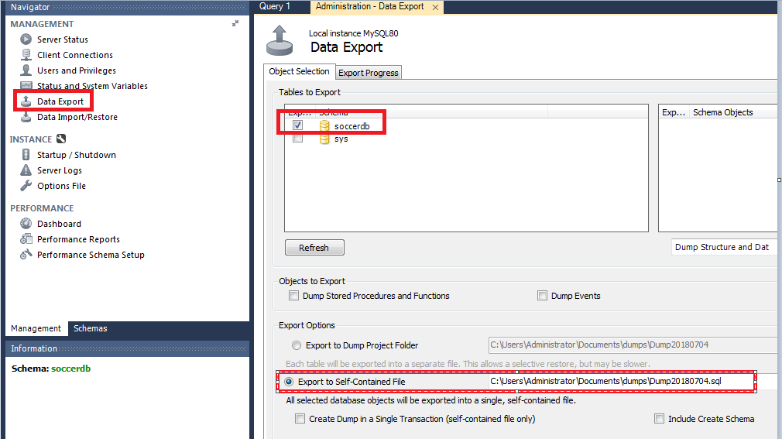

## Step 3 : Import

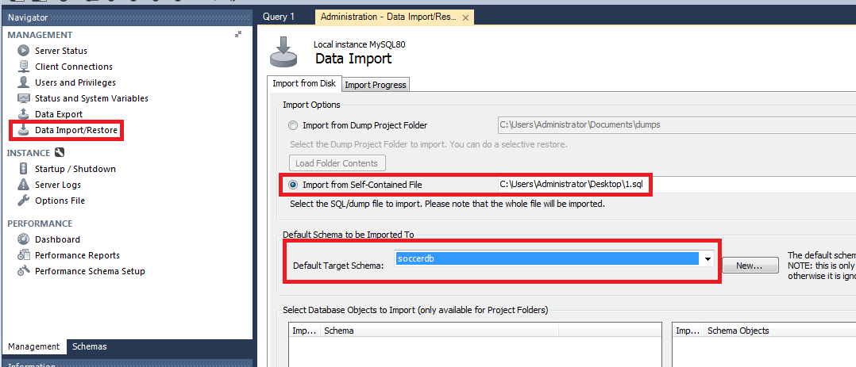

Note :

* If don’t have schema , should create new schemal with correct name : **soccerdb**