DATABASE PROJECT REPORT
Gym Membership & Personal Training Planner
(Project ID: #9)
____________________________________________________
A. PROJECT IDENTITY

Team Name | Dong Vui
Project ID & Title | #9: Gym Membership & Personal Training Planner
Course | INT1313 - Database Basics
Instructor | Lê Hà Thanh
Academic Year | 2026-2027 (Semester 1)

Full Name | Student ID | Class | Domain Responsibility
Nguyễn Văn Hoàng Te  n24dccn071@student.ptithcm.edu.vn | N24DCCN071

B. REPORT STRUCTURE

1. Introduction and Project Scope (adapted from ISO/IEC/IEEE 29148)

1.1 System Objective and Requirements
The Gym Membership & Personal Training Planner is a relational database for the main work of a gym. It covers three areas: members and membership billing, trainer scheduling and booking, and equipment maintenance. The database stores data about members, staff, schedules and payments. It keeps the data correct with primary key, foreign key, CHECK and UNIQUE constraints, and it uses triggers for rules that these constraints cannot check, such as schedule conflicts.
The requirements below are divided into Functional Requirements (FR) and Non-Functional Requirements (NFR), following the requirement structure of ISO/IEC/IEEE 29148:
- Functional Requirements:
  - FR-MEM (Member & Billing Domain): Record member registrations, daily passes, membership plans, membership contracts with start and end dates, and the bills of each visitor.
  - FR-SCH (Trainer & Session Scheduling): Manage group class schedules, private 1-on-1 PT bookings and room assignments, and use triggers to reject room or trainer schedule conflicts.
  - FR-FAC (Facility & Asset Maintenance): Record equipment, keep a repair log for each machine (weak entity), and record which staff member signed each log.
- Non-Functional Requirements:
  - NFR-INT (Data Integrity): Keep the links between all 17 tables valid with primary and foreign keys, and use ON DELETE RESTRICT on the two foreign keys of BILLING_LOG so that no billing record is lost or left without its owner.
  - NFR-PER (Query Performance): Speed up frequent schedule lookups with indexes on the columns used for searching and for time ranges (e.g., Room_ID, Trainer_ID, Start_Time).
  - NFR-SEC (Data Protection): Prevent duplicate accounts with UNIQUE constraints on phone and email, and keep member photos inside the database (VARBINARY), so they are covered by the same backups and permissions as the other data. Database roles also limit who can read or change each table (Section 5.2).
NFR-AVA (Recoverability): The database can be restored from regular SQL Server backups; setting up the backup schedule is left to the gym's administrator (Section 6.3).
1.1.1 Main Entities and Their Meaning
- Visitor: The superclass for every person who enters the gym. Identified by Visitor_ID. Stores the name and contact data that all visitors share (First_Name, Last_Name, Phone).
- Member: A subclass of Visitor for registered members with long-term contracts. Inherits Visitor_ID (PK/FK) and adds Email, Birth_Date, Photo and Registration_Date.
- Daily Pass Ticket: A subclass of Visitor for customers who buy a single-day pass. Inherits Visitor_ID (PK/FK) and adds Visit_Date and Daily_Rate.
- Membership Plan: The packages that the gym sells (e.g., Monthly, Quarterly, Annual). Attributes: Plan_ID, Plan_Name (UNIQUE), Duration_Months (CHECK > 0), Price (CHECK >= 0.00) and Description.
- Membership: A contract that links a registered member (Visitor_ID) to a membership plan (Plan_ID). Identified by Membership_ID.
- Billing Log: Records each payment. Linked to Visitor through Visitor_ID [FK, NOT NULL], so every payment belongs to a known visitor; Membership_ID is filled only for membership payments.
- Staff: The superclass for all gym employees. Identified by Staff_ID; stores Full_Name, Phone, Role ('Trainer', 'Receptionist', 'Manager'), Hire_Date and monthly Salary (CHECK > 0).
- Trainer / PT: A subclass of Staff for personal trainers, with the attributes Specialty and Certification. Trainers lead group classes and coach 1-on-1 PT sessions.
- Receptionist: A subclass of Staff for front-desk staff, with the attribute Shift_Type (Morning, Evening, Night). Receptionists may sign equipment maintenance logs.
- Manager: A staff member with Role = 'Manager'. Managers have no attributes beyond those in Staff, so they have no subclass table; for this reason the specialization of Staff is partial. Managers may sign maintenance logs (BR-FAC-05).
- Room: A training room. Identified by Room_ID; stores Room_Name (UNIQUE), Capacity (CHECK > 0) and Floor_Location.
- Session: The superclass for every scheduled use of a room by a trainer. Identified by Session_ID; stores Session_Type ('Class' or 'PT'), Room_ID, Trainer_ID, Start_Time and End_Time, which both kinds of session share.
- Class: A subclass of Session for group classes (e.g., Zumba, Yoga, HIIT) scheduled by the gym. Inherits Session_ID (PK/FK) and adds Class_Name and Max_Capacity.
- Class Registration: An associative entity for the M:N relationship between members and group classes; it records which member is registered for which class (linked to Member through Visitor_ID).
- PT Booking: A subclass of Session for private 1-on-1 coaching. Inherits Session_ID (PK/FK) and adds the member who made the booking (Visitor_ID) and Booking_Status; the trainer and the room are stored in Session.
- Equipment: A workout machine. Identified by Equipment_ID; stores Equipment_Name, Room_ID, Purchase_Date and Operational_Status ('Active', 'Under Maintenance', 'Broken').
- Maintenance Log: A weak entity that records the service and repair history of one machine. Identified by the composite key {Equipment_ID, Log_no}, where Log_no is the partial key. Stores Maintenance_Date, Cost (CHECK >= 0), Description and Logged_By (the receptionist or manager who signed the log).
- Session Equipment Usage: An associative entity that records which machine is reserved for which session (a group class or a PT booking). Identified by Usage_ID; each row refers to exactly one session through Session_ID [FK, NOT NULL].
1.1.2 Technical Terms
- Entity & Attribute: An entity is a real-world object or concept that the database stores data about (e.g., MEMBER, EQUIPMENT). An attribute is one property of that entity (e.g., Phone, Email).
- Enhanced Entity-Relationship (EER): An extension of the ER model that adds superclasses and subclasses (specialization), attribute inheritance and weak entities.
- Disjoint Specialization (d): Each STAFF row can belong to at most one subclass (TRAINER or RECEPTIONIST). The same rule is used for VISITOR (MEMBER or DAILY_PASS_TICKET) and SESSION (CLASS or PT_BOOKING).
- Total & Partial Participation: Total participation (double line) means that every entity must take part in the relationship (e.g., every MAINTENANCE_LOG must belong to an EQUIPMENT). Partial participation (single line) means that some entities may not take part (e.g., a new machine with no logs).
- Strong Entity vs Weak Entity: A strong entity has its own primary key. A weak entity (MAINTENANCE_LOG) cannot exist without its owner entity (EQUIPMENT); it is identified by its partial key (Log_no) together with the owner's primary key.
- Composite Primary Identifier: A key made of two or more attributes that together identify one row (e.g., {Session_ID, Visitor_ID} in CLASS_REGISTRATION).
- Primary Key (PK) & Foreign Key (FK): A primary key uniquely identifies each row of a table and cannot be NULL. A foreign key is a column whose value must match a primary key value in the referenced table (or be NULL when the column allows NULL).
- CHECK & UNIQUE Constraints: A CHECK constraint accepts a row only if a condition on that row's own columns is true (e.g., Price >= 0.00). A UNIQUE constraint rejects two rows with the same value in a column (e.g., Phone).
- Trigger: SQL code stored in the database that SQL Server runs automatically after an INSERT, UPDATE or DELETE on a table. This project uses AFTER triggers: the trigger checks a rule and, if the rule is broken, raises an error and rolls back the whole transaction that contains the statement. Triggers are used for rules that involve other rows or other tables, which a CHECK constraint cannot test.
- Referential Actions (ON DELETE): What happens to the child rows when a parent row is deleted. CASCADE deletes the child rows with the parent; NO ACTION (RESTRICT) rejects the delete while child rows exist; SET NULL keeps the child rows and sets their foreign key to NULL.
- Filtered Unique Index: A unique index that applies only to the rows that meet a condition. BR-MEM-10 uses one on MEMBERSHIP(Visitor_ID) WHERE Status = 'Active', so each member can have at most one active membership.
1.1.3 Schedule Conflicts and Scope
A schedule assigns rooms, trainers and time slots. There are two kinds: the public class timetable published by the gym, and the private 1-on-1 PT slots of each trainer. A schedule conflict occurs when two sessions use the same room, or the same trainer, in overlapping time intervals [Start_Time, End_Time). Design note: group classes and PT sessions are generalized into one superclass SESSION, which holds the attributes both share (Room_ID, Trainer_ID, Start_Time, End_Time); CLASS and PT_BOOKING are its disjoint subclasses. Room and trainer conflicts are therefore checked in one table (SESSION) by the triggers of Phase 3.
1.2 Business Rules and Constraints
Note: Codes such as V001, C101 or MEM-501 in the examples are labels for easier reading; the stored keys are INT IDENTITY numbers. A member's ID is his or her Visitor_ID (e.g., "Member M001" and "Visitor V001" are the same person). The meaning of every status and type value used in the rules (e.g., 'Active', 'Attended', 'Under Maintenance') is defined in Section 3.2 (Value Definitions).
1.2.1 Member and Membership Domain
BR-MEM-01 (Visitor Types: Total, Disjoint Specialization)
- Rule Statement: Every person who enters the gym is stored as a VISITOR. At any time, a VISITOR is either a MEMBER or a DAILY_PASS_TICKET holder, never both (total and disjoint: VISITOR = MEMBER ∪ DAILY_PASS_TICKET and MEMBER ∩ DAILY_PASS_TICKET = ∅).
- Technical & EER Mapping: A total, disjoint specialization (d) of the superclass VISITOR(Visitor_ID) into the subclasses MEMBER(Visitor_ID) and DAILY_PASS_TICKET(Visitor_ID). Both subclasses inherit Visitor_ID as PK/FK. (The mapping to tables with Option 8A is shown in Section 2.2.1.)
Concrete Example: Visitor "Nguyen Van A" buys a 1-year package and receives Visitor_ID = V001, stored in VISITOR and MEMBER. Guest "Tran Thi B" buys a single-day pass and receives Visitor_ID = V002, stored in VISITOR and DAILY_PASS_TICKET. A trigger keeps the subclasses disjoint: V001 cannot also be inserted into DAILY_PASS_TICKET.

BR-MEM-02 (Daily Pass Restrictions)
- Rule Statement: A DAILY_PASS_TICKET holder visits for one day only. Daily pass holders may use only the general workout area; they cannot register for group classes (CLASS_REGISTRATION) or book personal trainers (PT_BOOKING).
- Technical & EER Mapping: The foreign keys Visitor_ID of CLASS_REGISTRATION and PT_BOOKING reference MEMBER(Visitor_ID), so the schema itself rejects a daily pass holder.
Concrete Example: Guest "Tran Thi B" (Visitor_ID = V002) tries to register for Zumba class C101. The registration is rejected because V002 does not exist in MEMBER.

BR-MEM-03 (Member Photo Required)
- Rule Statement: A member must have a profile photo on file before buying a membership, registering for a class or booking a PT session.
- Technical & EER Mapping: Email is NOT NULL in MEMBER. Photo (VARBINARY(MAX)) may be NULL at registration; a trigger rejects new MEMBERSHIP, CLASS_REGISTRATION and PT_BOOKING rows for members whose Photo is NULL.
Concrete Example: Member M001 has no photo and tries to book a Yoga class. The booking is rejected until the front desk uploads M001's photo.

BR-MEM-04 (Daily Pass Guests)
- Rule Statement: A guest with a daily pass may enter the gym only on the recorded Visit_Date and cannot buy a long-term membership or book a PT session in advance.
- Technical & EER Mapping: Daily pass holders do not exist in MEMBER, so the foreign keys of MEMBERSHIP, CLASS_REGISTRATION and PT_BOOKING (all referencing MEMBER) reject them. Because DAILY_PASS_TICKET uses Visitor_ID as its PK, a returning guest keeps the same row and Visit_Date is updated to the new visit; the payment of each visit is kept as a separate row in BILLING_LOG. If a guest later becomes a member, the DAILY_PASS_TICKET row is removed and a MEMBER row is created (disjointness).
Concrete Example: Guest V002 (daily pass) tries to book a PT session for tomorrow. The insert into PT_BOOKING fails because V002 does not exist in MEMBER.

BR-MEM-05 (Membership Plans)
- Rule Statement: A membership plan (Membership_Plan) is a ready-made package (e.g., Monthly, Annual, VIP) with a fixed price and duration.
- Technical & EER Mapping: Each plan is defined once in MEMBERSHIP_PLAN. Attributes: Plan_ID (PK), Plan_Name (UNIQUE), Price (CHECK >= 0.00), Duration_Months (CHECK > 0), Description.
Concrete Example: Plan 'VIP Gold' (Plan_ID = P03) costs $100.00 and has Duration_Months = 12. Every membership of P03 refers to this one price record.

BR-MEM-06 (Memberships)
- Rule Statement: A membership (Membership) links a registered member to a Membership_Plan for a set period (Start_Date to End_Date).
- Technical & EER Mapping: A time-bound link between Member and Membership_Plan. Status is 'Active', 'Expired' or 'Cancelled'.
Concrete Example: Member M001 buys 'VIP Gold' on 2026-01-01. The system creates Membership_ID = MEM-501 with Start_Date = 2026-01-01, End_Date = 2027-01-01, and Status = 'Active'.

BR-MEM-07 (One Billing Table Linked by Visitor_ID)
- Rule Statement: Every payment in BILLING_LOG is linked to a VISITOR through Visitor_ID [FK, NOT NULL]. This lets one billing table record payments from both members and daily pass holders.
- Technical & EER Mapping: BILLING_LOG has the foreign key Visitor_ID, which references VISITOR(Visitor_ID) and is NOT NULL, so the table does not need two nullable foreign keys (one for members and one for daily passes). When Membership_ID is filled, a trigger checks that Visitor_ID is the owner of that membership.
Concrete Example: Invoice INV-101 records $15.00 paid by Visitor_ID = V002 (Daily Pass, Membership_ID = NULL). Invoice INV-102 records $100.00 paid by Visitor_ID = V001 (Membership_ID = MEM-501).

BR-MEM-08 (Financial Record Retention)
- Rule Statement: Billing records are accounting history and must not be deleted when a membership or a daily pass ends.
- Technical & EER Mapping: The foreign keys Visitor_ID and Membership_ID of BILLING_LOG use ON DELETE RESTRICT (implemented as NO ACTION in SQL Server, see Section 2.2.3) instead of CASCADE. When a customer stops coming to the gym, the records are kept and the membership Status is set to 'Expired' or 'Cancelled'; the customer is not deleted.
Concrete Example: If someone tries to delete visitor V001, SQL Server blocks the DELETE because BILLING_LOG rows still reference Visitor_ID = V001. A visitor entered by mistake, with no billing, membership or booking records, can still be deleted.

BR-MEM-09 (Payment Status)
- Rule Statement: Each billing record stores Amount_Paid, Billing_Status ('Pending', 'Paid', 'Failed'), Invoice_Date, Due_Date, and Payment_Date.
- Technical & EER Mapping: Tracks the life of an invoice. Schema constraints: CHECK (Amount_Paid >= 0.00) and CHECK (Billing_Status IN ('Pending', 'Paid', 'Failed')). Payment_Date stays NULL until the invoice is paid.
Concrete Example: Invoice INV-801 is created on 2026-12-28 (Due_Date = 2027-01-01) with Billing_Status = 'Pending' and Payment_Date = NULL. On 2026-12-30 the member pays $100; Billing_Status is updated to 'Paid' and Payment_Date = 2026-12-30.

BR-MEM-10 (One Active Membership per Member)
- Rule Statement: A member can have at most one membership with Status = 'Active' at a time.
- Technical & EER Mapping: Enforced by a filtered unique index on MEMBERSHIP(Visitor_ID) WHERE Status = 'Active', so SQL Server rejects a second active membership for the same member.
Concrete Example: Member M001 has the active membership MEM-501. If M001 tries to activate a second membership MEM-502 while MEM-501 is still 'Active', MEM-502 is rejected.

1.2.2 Training and Scheduling Domain
Domain Requirements Analysis:
Guiding Questions: To define the scheduling rules, the team analyzed the following questions:
- Question for Personal Trainers: "Have you ever experienced schedule overlaps between group classes and 1-on-1 personal training sessions?"
- Question for Gym Managers: "How do room conflicts or workout equipment shortages affect customer satisfaction?"
Problem Analysis: Based on common gym scheduling situations, two types of conflict were identified for peak hours (17:00 - 20:00): (1) the same room booked by a group class and a PT session at the same time, and (2) a trainer assigned to overlapping sessions. These situations led to rules BR-SCH-01 to BR-SCH-08 below.

BR-SCH-01 (Trainer and Receptionist Subclasses)
- Rule Statement: STAFF covers all employees. A staff member who coaches is modeled in the subclass TRAINER, and a front-desk staff member in the subclass RECEPTIONIST. A staff member's Role must match the subclass table that holds the row.
- Technical & EER Mapping: Disjoint, partial specialization STAFF (d) -> TRAINER / RECEPTIONIST, mapped with Option 8A. Shared attributes (name, salary) are in STAFF; trainer attributes (Specialty, Certification) are in TRAINER. The specialization is partial because a staff member with Role = 'Manager' has no extra attributes and therefore no subclass row. A trigger on TRAINER and RECEPTIONIST checks that STAFF.Role matches the subclass ('Trainer' for TRAINER, 'Receptionist' for RECEPTIONIST), and a trigger on STAFF rejects a change of Role that no longer matches an existing subclass row.
Concrete Example: Staff member S01 ('Le Van C') has Salary = $800 and Role = 'Trainer', and is stored in TRAINER as T01 with Specialty = 'Yoga' and Certification = 'NASM-CPT'. Inserting S01 into RECEPTIONIST is rejected, both because S01 is already a trainer (disjointness) and because S01's Role is 'Trainer'. A staff member with Role = 'Manager' cannot be inserted into TRAINER or RECEPTIONIST.

BR-SCH-02 (Room and Class Capacity)
- Rule Statement: Every group class (CLASS) and PT booking (PT_BOOKING) takes place in one ROOM during a set time interval. A class's Max_Capacity cannot exceed its room's Capacity, and the number of registrations holding a seat cannot exceed the class's Max_Capacity.
- Technical & EER Mapping: SESSION.Room_ID is a foreign key referencing ROOM(Room_ID), so classes and PT bookings use the same link to a room. CHECK (Capacity > 0) is declared on ROOM and CHECK (Max_Capacity > 0) on CLASS. Triggers on CLASS, SESSION and ROOM reject any insert or update that leaves a class's Max_Capacity above the Capacity of its session's room (SESSION.Room_ID). An AFTER INSERT/UPDATE trigger on CLASS_REGISTRATION counts the class's registrations whose Attendance_Status is not 'Cancelled' ('Confirmed' and 'Attended' both hold a seat) and rolls back the change if the count exceeds CLASS.Max_Capacity.
Concrete Example: Studio A (Room_ID = R101) has Capacity = 20. Zumba class C101 is scheduled in R101 with Max_Capacity = 20. When member M021 submits the 21st registration for C101, the trigger rolls back the insert with the error 'BR-SCH-02: registration failed, class capacity reached.'

BR-SCH-03 (No Room Double-Booking)
- Rule Statement: A room cannot hold more than one session (class or PT booking) at overlapping times.
- Technical & EER Mapping: A trigger on SESSION compares the proposed interval [Start_Time, End_Time) with all other sessions in the same Room_ID, using the overlap condition (S1 < E2 AND S2 < E1). Because classes and PT bookings are both stored in SESSION, only one table is checked. If an overlap is found, the insert or update is rolled back. Sessions whose PT_BOOKING row has Booking_Status = 'Cancelled' are ignored; the check runs again when a booking's status changes back from 'Cancelled'. A cancelled class is deleted, which frees its time slot.
Concrete Example: Studio A is booked for Zumba class C101 from 09:00 to 10:30. An attempt to schedule PT booking B201 in Studio A from 10:00 to 11:00 is rejected.

BR-SCH-04 (No Trainer Double-Booking)
- Rule Statement: A trainer cannot lead a class and coach a PT session at overlapping times, and cannot take two PT bookings at the same time.
- Technical & EER Mapping: A trigger on SESSION compares the proposed interval [Start_Time, End_Time) with all other sessions of the same Trainer_ID, using (S1 < E2 AND S2 < E1). If an overlap is found, the change is rolled back with the error 'Trainer Schedule Conflict'. Sessions whose PT_BOOKING row has Booking_Status = 'Cancelled' are ignored; the check runs again when a booking's status changes back from 'Cancelled'.
Concrete Example: Trainer T01 leads Zumba class C102 from 17:00 to 18:30. Member M002 asks for a PT session with T01 at 18:00. The booking is rejected because the trainer is already busy.

BR-SCH-05 (Who Can Register for a Class)
- Rule Statement: Only members with an active membership (Status = 'Active' and today between Start_Date and End_Date) can register for a class.
- Technical & EER Mapping: The foreign key CLASS_REGISTRATION.Visitor_ID references MEMBER(Visitor_ID). An AFTER INSERT trigger checks that the member has a row in MEMBERSHIP with Status = 'Active' and today's date between Start_Date and End_Date; otherwise the insert is rolled back.
Concrete Example: Member M001 has the active membership MEM-501 and registers for Zumba class C101 successfully. Daily pass holder V002 tries to register for C101; the foreign key rejects it because V002 does not exist in MEMBER. Member M099, whose membership has expired, tries to register; the trigger rejects the insert because M099 has no membership with Status = 'Active' that covers today's date.

BR-SCH-06 (Session Types and Equipment Reservations)
- Rule Statement: Every session (SESSION) is either a group class (CLASS) or a PT booking (PT_BOOKING), never both (total and disjoint: SESSION = CLASS ∪ PT_BOOKING and CLASS ∩ PT_BOOKING = ∅). When a session reserves equipment, the reservation is stored in SESSION_EQUIPMENT_USAGE and refers to that one session.
- Technical & EER Mapping: A total, disjoint specialization (d) of the superclass SESSION(Session_ID) into the subclasses CLASS(Session_ID) and PT_BOOKING(Session_ID), mapped with Option 8A. Session_Type ('Class' or 'PT') records the subclass of each session. A trigger checks that a CLASS row refers to a session with Session_Type = 'Class' and a PT_BOOKING row to a session with Session_Type = 'PT', so a session cannot appear in both subclasses; an UPDATE trigger on SESSION blocks changes to Session_Type once the subclass row exists. Each SESSION row and its subclass row are inserted in the same transaction (total participation). SESSION_EQUIPMENT_USAGE links Equipment_ID to one Session_ID [FK -> SESSION, NOT NULL], so it needs no nullable foreign keys.
Concrete Example: Pilates class C105 is stored as SESSION C105 (Session_Type = 'Class') and CLASS C105. It reserves the Pilates Reformer machine E501, so the reservation row stores Session_ID = C105. An attempt to also insert C105 into PT_BOOKING is rejected by the trigger.

BR-SCH-07 (Equipment Must Be Working)
- Rule Statement: If a machine's Operational_Status is 'Broken' or 'Under Maintenance', new reservations of that machine are rejected.
- Technical & EER Mapping: A trigger on SESSION_EQUIPMENT_USAGE rejects any INSERT whose Equipment_ID refers to a machine with Operational_Status <> 'Active'.
Concrete Example: Treadmill E101 is set to 'Broken' at 14:00. An attempt to reserve E101 for a PT booking at 15:00 is rejected; staff must choose another machine (e.g., E102).

BR-SCH-08 (Equipment Reservation Times)
- Rule Statement: A machine cannot be reserved for two overlapping time intervals, and every reservation must lie within the time of its session.
- Technical & EER Mapping: Triggers on SESSION_EQUIPMENT_USAGE (INSERT and UPDATE) check two conditions. (a) The interval [Reserved_From, Reserved_To) lies within [Start_Time, End_Time) of the session in Session_ID. (b) No other reservation of the same Equipment_ID overlaps it, using (S1 < E2 AND S2 < E1). Reservations of sessions whose PT_BOOKING row has Booking_Status = 'Cancelled' are ignored. A trigger on SESSION rejects a change of Start_Time or End_Time that would leave a reservation outside the session.
Concrete Example: Class C102 runs from 17:00 to 18:30 and reserves treadmill E101 for that time. PT booking B202 (17:30 to 18:30, in another room) asks for E101 and is rejected because the two reservations overlap. A reservation of E101 for C102 from 16:30 to 17:30 is rejected because it starts before the session.

1.2.3 Detecting Schedule Conflicts: Boundary Cases
Interval Overlap Condition: Two time intervals [S1, E1) and [S2, E2) overlap if and only if (S1 < E2 AND S2 < E1).
Boundary Case A (Adjacent Non-Overlapping Sessions): Session 1 runs from 09:00:00 to 10:30:00 (E1 = 10:30). Session 2 is requested from 10:30:00 to 11:30:00 (S2 = 10:30). Checking the condition: (09:00 < 11:30) is TRUE, but (10:30 < 10:30) is FALSE. Both parts must be true, so Overlap = FALSE. Session 2 is ACCEPTED.
Boundary Case B (1-Minute Overlap Conflict): Session 1 runs from 09:00:00 to 10:30:00. Session 2 is requested from 10:29:00 to 11:30:00. Checking: (09:00 < 11:30) is TRUE, and (10:29 < 10:30) is TRUE. Overlap = TRUE. Session 2 is REJECTED.
1.2.4 Facility and Maintenance Domain
BR-FAC-01 (Equipment Records)
- Rule Statement: Each machine (Equipment) is a strong entity identified by Equipment_ID, with Equipment_Name, Purchase_Date and Operational_Status ('Active', 'Under Maintenance', 'Broken').
- Technical & EER Mapping: Attributes: Equipment_ID (PK), Equipment_Name, Room_ID (FK, NULL), Purchase_Date, Operational_Status (CHECK Operational_Status IN ('Active', 'Under Maintenance', 'Broken')).
Concrete Example: A NordicTrack treadmill is stored with Equipment_ID = E101 and Operational_Status = 'Active' in room R102.

BR-FAC-02 (Maintenance Log Is a Weak Entity)
- Rule Statement: A maintenance log (Maintenance_Log) cannot exist without its machine; it is a weak entity with the partial key Log_no.
- Technical & EER Mapping: The logs of one machine are numbered 1, 2, 3, ... and depend on that machine. In the EER diagram the weak entity is drawn as a double rectangle.
Concrete Example: Log #1 of treadmill E101 is identified together with E101 and cannot exist without it. (Log_no has no DEFAULT value, so the application must give each log its number; the primary key {Equipment_ID, Log_no} rejects a second log with the same number for the same machine.)

BR-FAC-03 (Composite Key of the Log)
- Rule Statement: The key of Maintenance_Log combines the owner's key and the partial key: {Equipment_ID, Log_no}.
- Technical & EER Mapping: The primary key {Equipment_ID, Log_no} lets the same machine have many repair records without duplicate keys.
Concrete Example: Treadmill E101 is repaired in January, May and August. The records are {E101, 1}, {E101, 2} and {E101, 3}. (Log_no has no DEFAULT; the application sets it to MAX(Log_no) + 1 for that machine when a new log is added.)

BR-FAC-04 (Participation)
- Rule Statement: The relationship LOGGED_FOR between Equipment and Maintenance_Log has total participation (double line) on the Maintenance_Log side and partial participation (single line) on the Equipment side.
- Technical & EER Mapping: Total participation of Maintenance_Log means that every log must reference an existing Equipment_ID. Partial participation of Equipment allows a new machine to have no logs.
Concrete Example: A newly bought Cable Crossover machine E205 has no maintenance logs, which is valid. An attempt to insert a maintenance log for Equipment_ID = E999, which does not exist, is rejected.

BR-FAC-05 (Who Signs a Maintenance Log)
- Rule Statement: Every maintenance log is signed by exactly one staff member, who must be a Receptionist or a Manager, through the foreign key Logged_By.
- Technical & EER Mapping: Logged_By references STAFF(Staff_ID). A trigger checks that the signing staff member has Role IN ('Receptionist', 'Manager').
Concrete Example: Receptionist R01 (Staff_ID = S02) signs maintenance log {E101, 1} after the technician replaces the belt, so Logged_By = S02.

BR-FAC-06 (Out-of-Service Equipment)
- Rule Statement: A machine whose status is 'Broken' or 'Under Maintenance' cannot be reserved for new sessions.
- Technical & EER Mapping: Enforced by the same trigger as BR-SCH-07. Future reservations that already use the machine are not changed automatically; staff can list them with a query and move them to another machine.
Concrete Example: Leg press E301 is set to 'Broken'. New reservations of E301 are rejected, and a query on SESSION_EQUIPMENT_USAGE lists the future sessions that still use E301.

BR-FAC-07 (Maintenance Cost)
- Rule Statement: The Cost in each maintenance log cannot be negative (CHECK (Cost >= 0.00)).
- Technical & EER Mapping: Cost has the default value 0.00, which is used for repairs covered by the manufacturer's warranty.
Concrete Example: Routine lubrication of treadmill E101 under warranty is recorded with Cost = 0.00. Entering Cost = -50.00 violates the CHECK constraint.

2. Database Design (ISO/IEC 19505 / IE Standards)
This section describes the database design in three steps: the conceptual EER model (Section 2.1), its mapping to a relational schema (Section 2.2), and the normalization proofs (Section 2.3). The course template names ISO/IEC 19505 (UML) and Information Engineering (IE) notation for the design diagrams. This report draws the conceptual model in EER notation (Elmasri and Navathe, 7th ed.) and the physical schema in IE crow's foot notation.

2.1 Conceptual Model (ER/EER Diagram)
The conceptual model uses Enhanced Entity-Relationship (EER) notation. Its main features are:
- VISITOR Superclass with Total Disjoint Specialization (d): Drawn with a double line from VISITOR to the specialization circle, so every visitor is either a MEMBER or a DAILY_PASS_TICKET holder, and both share one Visitor_ID.
- STAFF Superclass with Disjoint Specialization (d): Divided into the TRAINER and RECEPTIONIST subclasses, which hold the attributes of each role.
- Billing Table (BILLING_LOG): Linked to VISITOR through Visitor_ID [FK, NOT NULL] and, when needed, to MEMBERSHIP through Membership_ID, so one table records payments for both memberships and daily passes.
- Weak Entity Relationship (EQUIPMENT & MAINTENANCE_LOG): EQUIPMENT (strong entity) is linked to MAINTENANCE_LOG (weak entity) through the identifying relationship LOGGED_FOR (double diamond), with total participation of MAINTENANCE_LOG.
- SESSION Superclass with Total Disjoint Specialization (d): CLASS and PT_BOOKING are subclasses of SESSION and share one Session_ID, so SESSION_EQUIPMENT_USAGE refers to a class or a PT booking through a single mandatory foreign key (Session_ID).

EER Figure: conceptual EER model of the gym database.
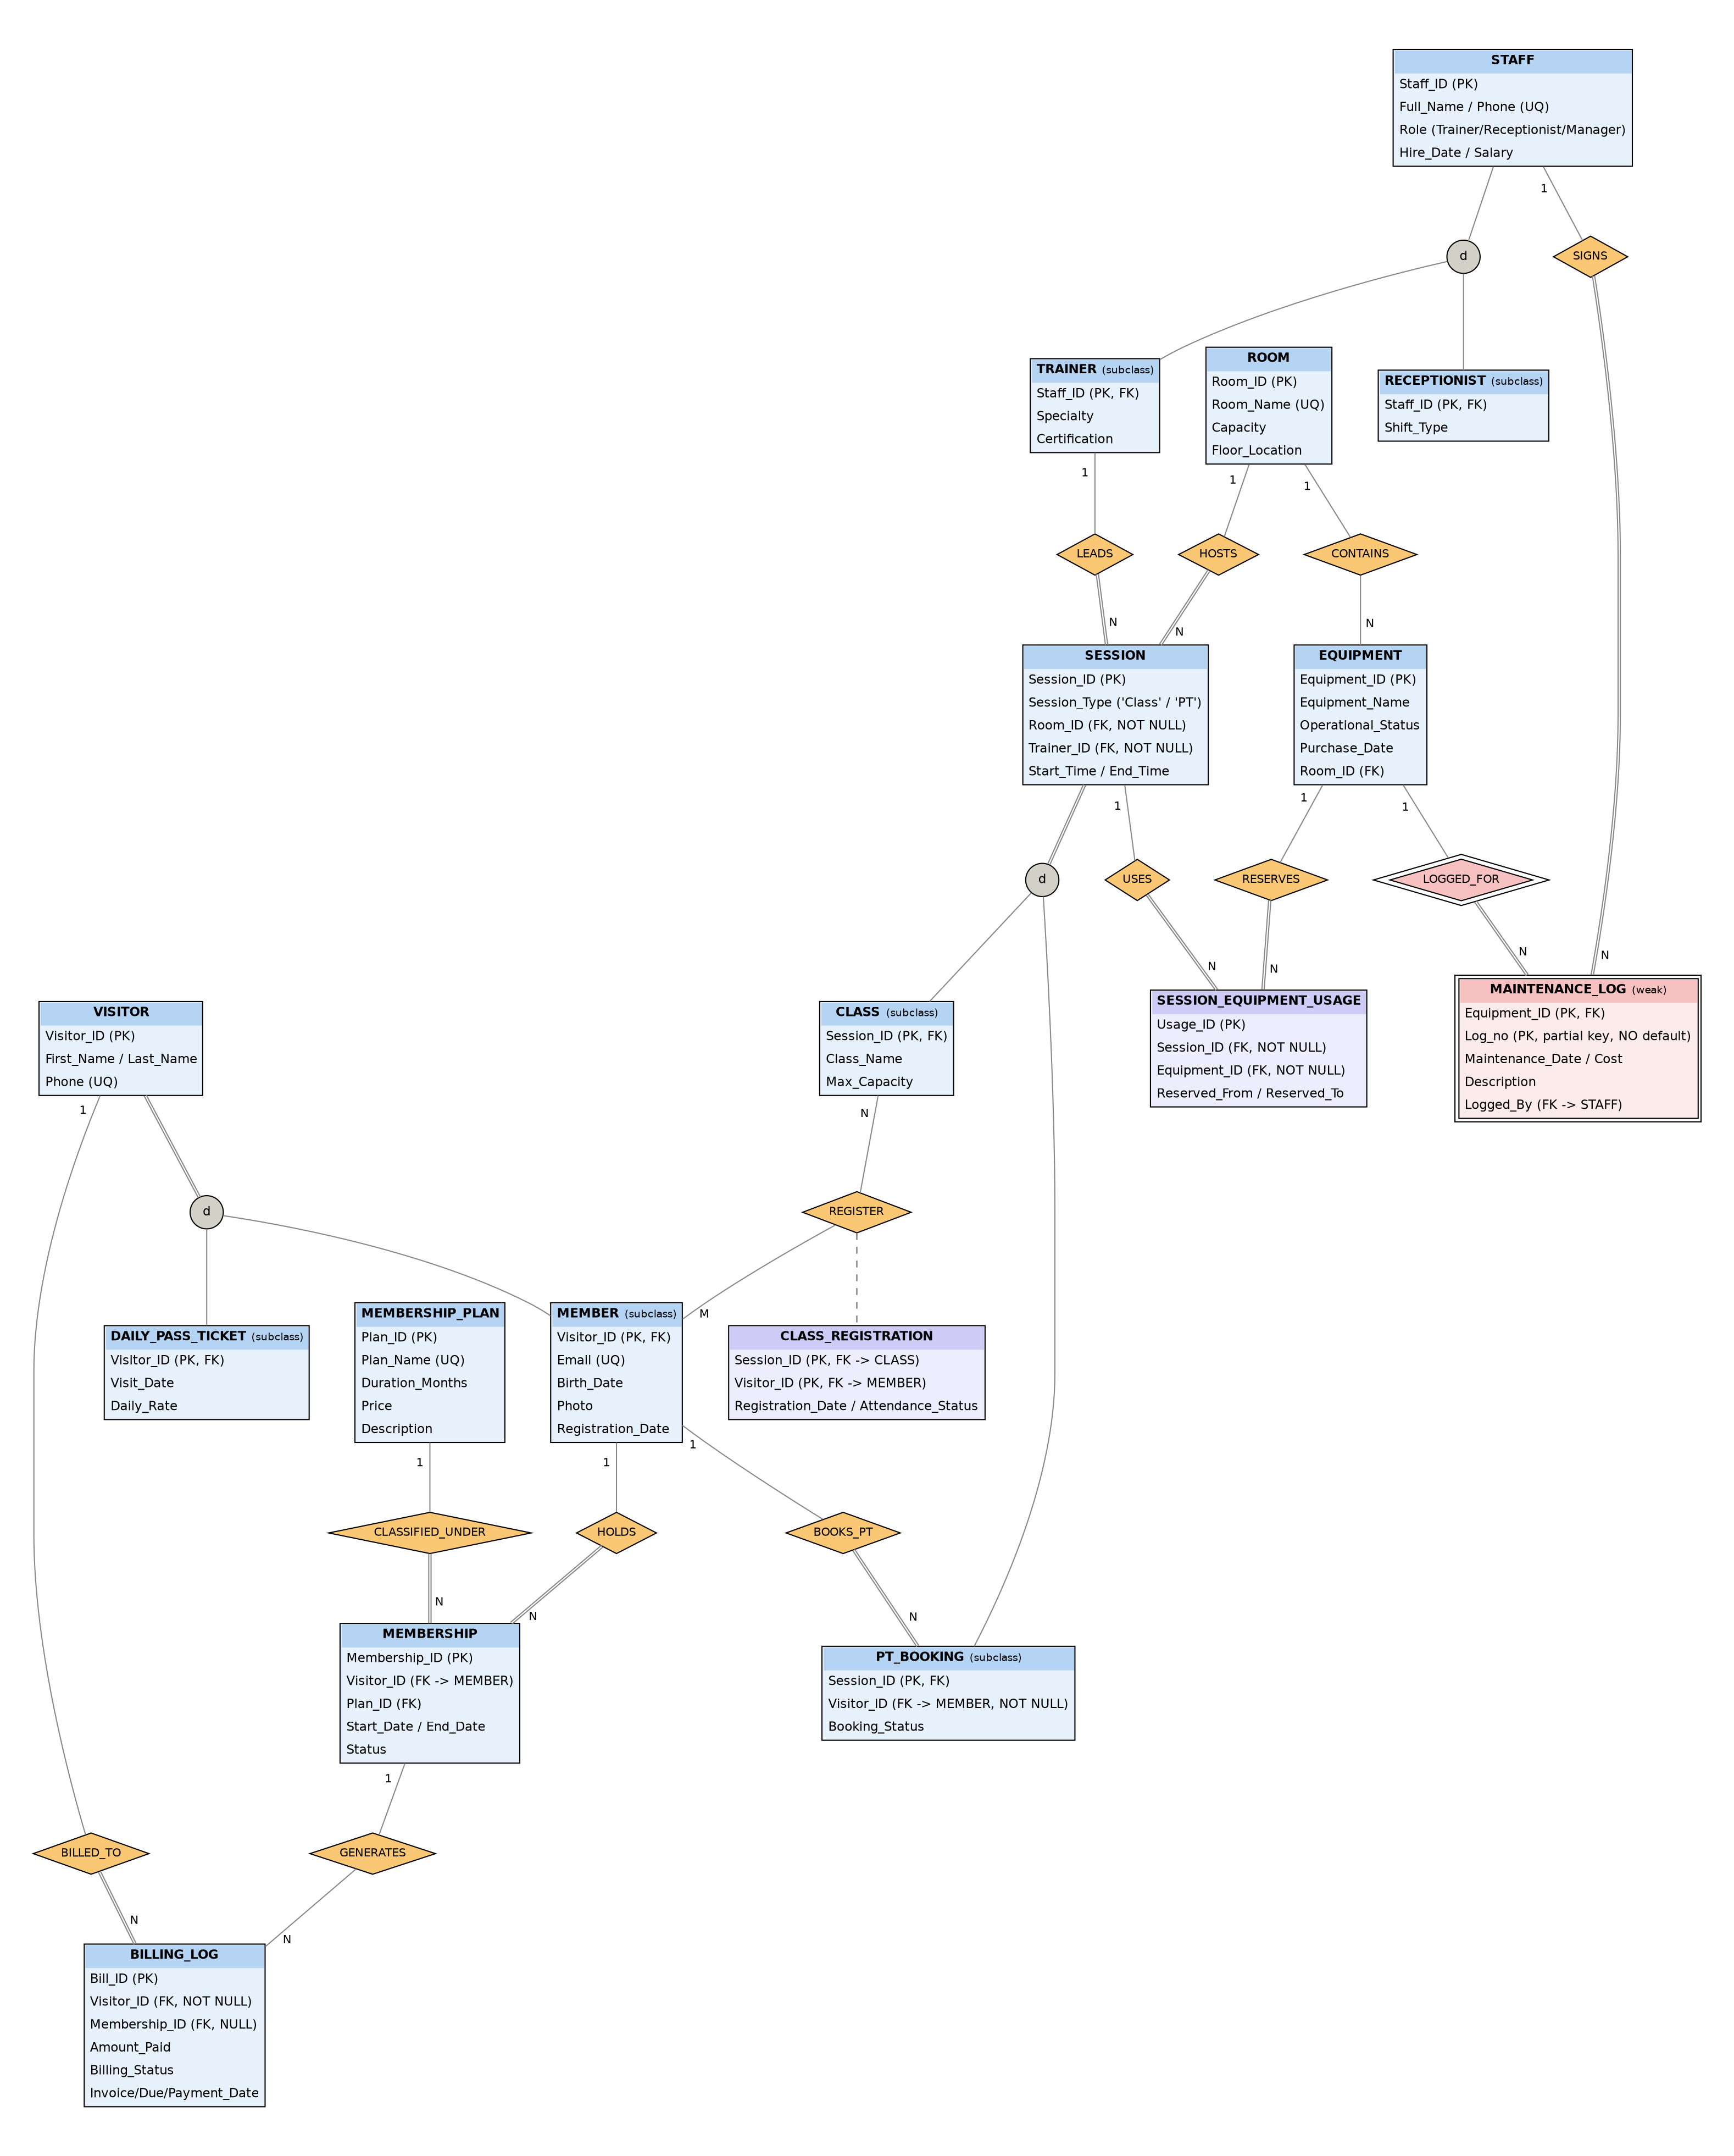

2.2 Logical Schema Mapping

2.2.1 Mapping the EER Model to Tables (Elmasri & Navathe, Chapter 9: Steps 1-9)
- Step 1: Map strong entity types: Create a table R for each strong entity type E with all of its simple attributes, and choose one candidate key as the primary key (PK). Other candidate keys become UNIQUE columns [UQ]. Foreign keys are not added yet; they are added in Steps 4 and 5:
  - VISITOR(Visitor_ID [PK], First_Name, Last_Name, Phone [UQ])
  - MEMBERSHIP_PLAN(Plan_ID [PK], Plan_Name [UQ], Duration_Months, Price, Description)
  - STAFF(Staff_ID [PK], Full_Name, Phone [UQ], Role, Hire_Date, Salary)
  - ROOM(Room_ID [PK], Room_Name [UQ], Capacity, Floor_Location)
  - SESSION(Session_ID [PK], Session_Type, Start_Time, End_Time)
  - EQUIPMENT(Equipment_ID [PK], Equipment_Name, Operational_Status, Purchase_Date)
  - MEMBERSHIP(Membership_ID [PK], Start_Date, End_Date, Status)
  - BILLING_LOG(Bill_ID [PK], Invoice_Date, Due_Date, Payment_Date, Amount_Paid, Billing_Status)
  - SESSION_EQUIPMENT_USAGE(Usage_ID [PK], Reserved_From, Reserved_To)
- Step 2: Map weak entity types: Create a table R for each weak entity type W with owner entity type E. Include all simple attributes of W and the PK of E as a foreign key (FK). The PK of R combines the PK of E and the partial key of W. Elmasri and Navathe recommend the CASCADE option on this foreign key, because a weak entity cannot exist without its owner (FK_MLOG_EQUIPMENT in Section 2.2.3; see Mapping Figure 4):
  - MAINTENANCE_LOG({Equipment_ID [FK -> EQUIPMENT], Log_no} [PK], Maintenance_Date, Cost, Description)
- Step 3: Map binary 1:1 relationship types: The book gives three options: a foreign key in one of the two tables (preferred), merging the two tables, or a separate relationship table. This design has no binary 1:1 relationship type: the link between a superclass and its subclass is handled in Step 8, and every other relationship type is 1:N or M:N.
- Step 4: Map binary 1:N relationship types: For each 1:N relationship type, add the PK of the table on the 1-side to the table on the N-side as a foreign key (the foreign-key approach, which the book prefers because it needs no extra table). Each foreign key is added to a table created in Step 1 or Step 2:
  - MEMBERSHIP: add Visitor_ID [FK -> MEMBER] (1:N HOLDS) and Plan_ID [FK -> MEMBERSHIP_PLAN] (1:N CLASSIFIED_UNDER)
  - BILLING_LOG: add Visitor_ID [FK -> VISITOR, NOT NULL] (1:N BILLED_TO) and Membership_ID [FK -> MEMBERSHIP, NULLABLE] (1:N GENERATES)
  - SESSION: add Room_ID [FK -> ROOM] (1:N HOSTS) and Trainer_ID [FK -> TRAINER] (1:N LEADS)
  - PT_BOOKING (subclass, see Step 8): add Visitor_ID [FK -> MEMBER] (1:N BOOKS_PT)
  - EQUIPMENT: add Room_ID [FK -> ROOM, NULLABLE] (1:N CONTAINS)
  - MAINTENANCE_LOG: add Logged_By [FK -> STAFF] (1:N SIGNS)
  - SESSION_EQUIPMENT_USAGE: add Session_ID [FK -> SESSION, NOT NULL] (1:N USES) and Equipment_ID [FK -> EQUIPMENT, NOT NULL] (1:N RESERVES). This table is an associative entity with its own key Usage_ID, not the pair (Equipment_ID, Session_ID): the same machine can be reserved more than once in one session, at different times, so the pair is not unique.
- Step 5: Map binary M:N relationship types: Create a new table R for each M:N relationship type. Include the PKs of the participating tables as FKs in R; together they form the composite PK of R. The attributes of the relationship become columns of R, and the foreign keys use ON DELETE CASCADE (see Mapping Figure 5):
  - CLASS_REGISTRATION({Session_ID [FK -> CLASS], Visitor_ID [FK -> MEMBER]} [PK], Registration_Date, Attendance_Status)
- Step 6: Map multivalued attributes: Create a new table for each multivalued attribute. (The design has no multivalued attributes: each visitor has one Phone and each member one Email, stored as single-valued UNIQUE columns.)
- Step 7: Map N-ary relationship types: Create a table R for each relationship type that joins three or more entity types. This design has none: every relationship type is binary (Steps 3 to 5), so no table is created in this step.
- Step 8: Map specialization/generalization hierarchies (EER): Map the disjoint specializations with Option 8A (one table for the superclass and one for each subclass, sharing the same PK):
  - 1) STAFF (d) -> TRAINER / RECEPTIONIST:
    - TRAINER(Staff_ID [PK, FK -> STAFF], Specialty, Certification)
    - RECEPTIONIST(Staff_ID [PK, FK -> STAFF], Shift_Type)
  - 2) VISITOR (d) -> MEMBER / DAILY_PASS_TICKET:
    - MEMBER(Visitor_ID [PK, FK -> VISITOR], Email [UQ], Birth_Date, Photo, Registration_Date)
    - DAILY_PASS_TICKET(Visitor_ID [PK, FK -> VISITOR], Visit_Date, Daily_Rate)
  - 3) SESSION (d) -> CLASS / PT_BOOKING:
    - CLASS(Session_ID [PK, FK -> SESSION], Class_Name, Max_Capacity)
    - PT_BOOKING(Session_ID [PK, FK -> SESSION], Visitor_ID [FK -> MEMBER], Booking_Status)
Mapping Figure 1: STAFF specialization mapped with Option 8A (partial, disjoint). STAFF, TRAINER, and RECEPTIONIST each get one relation; the subclass key Staff_ID is also a foreign key to STAFF.
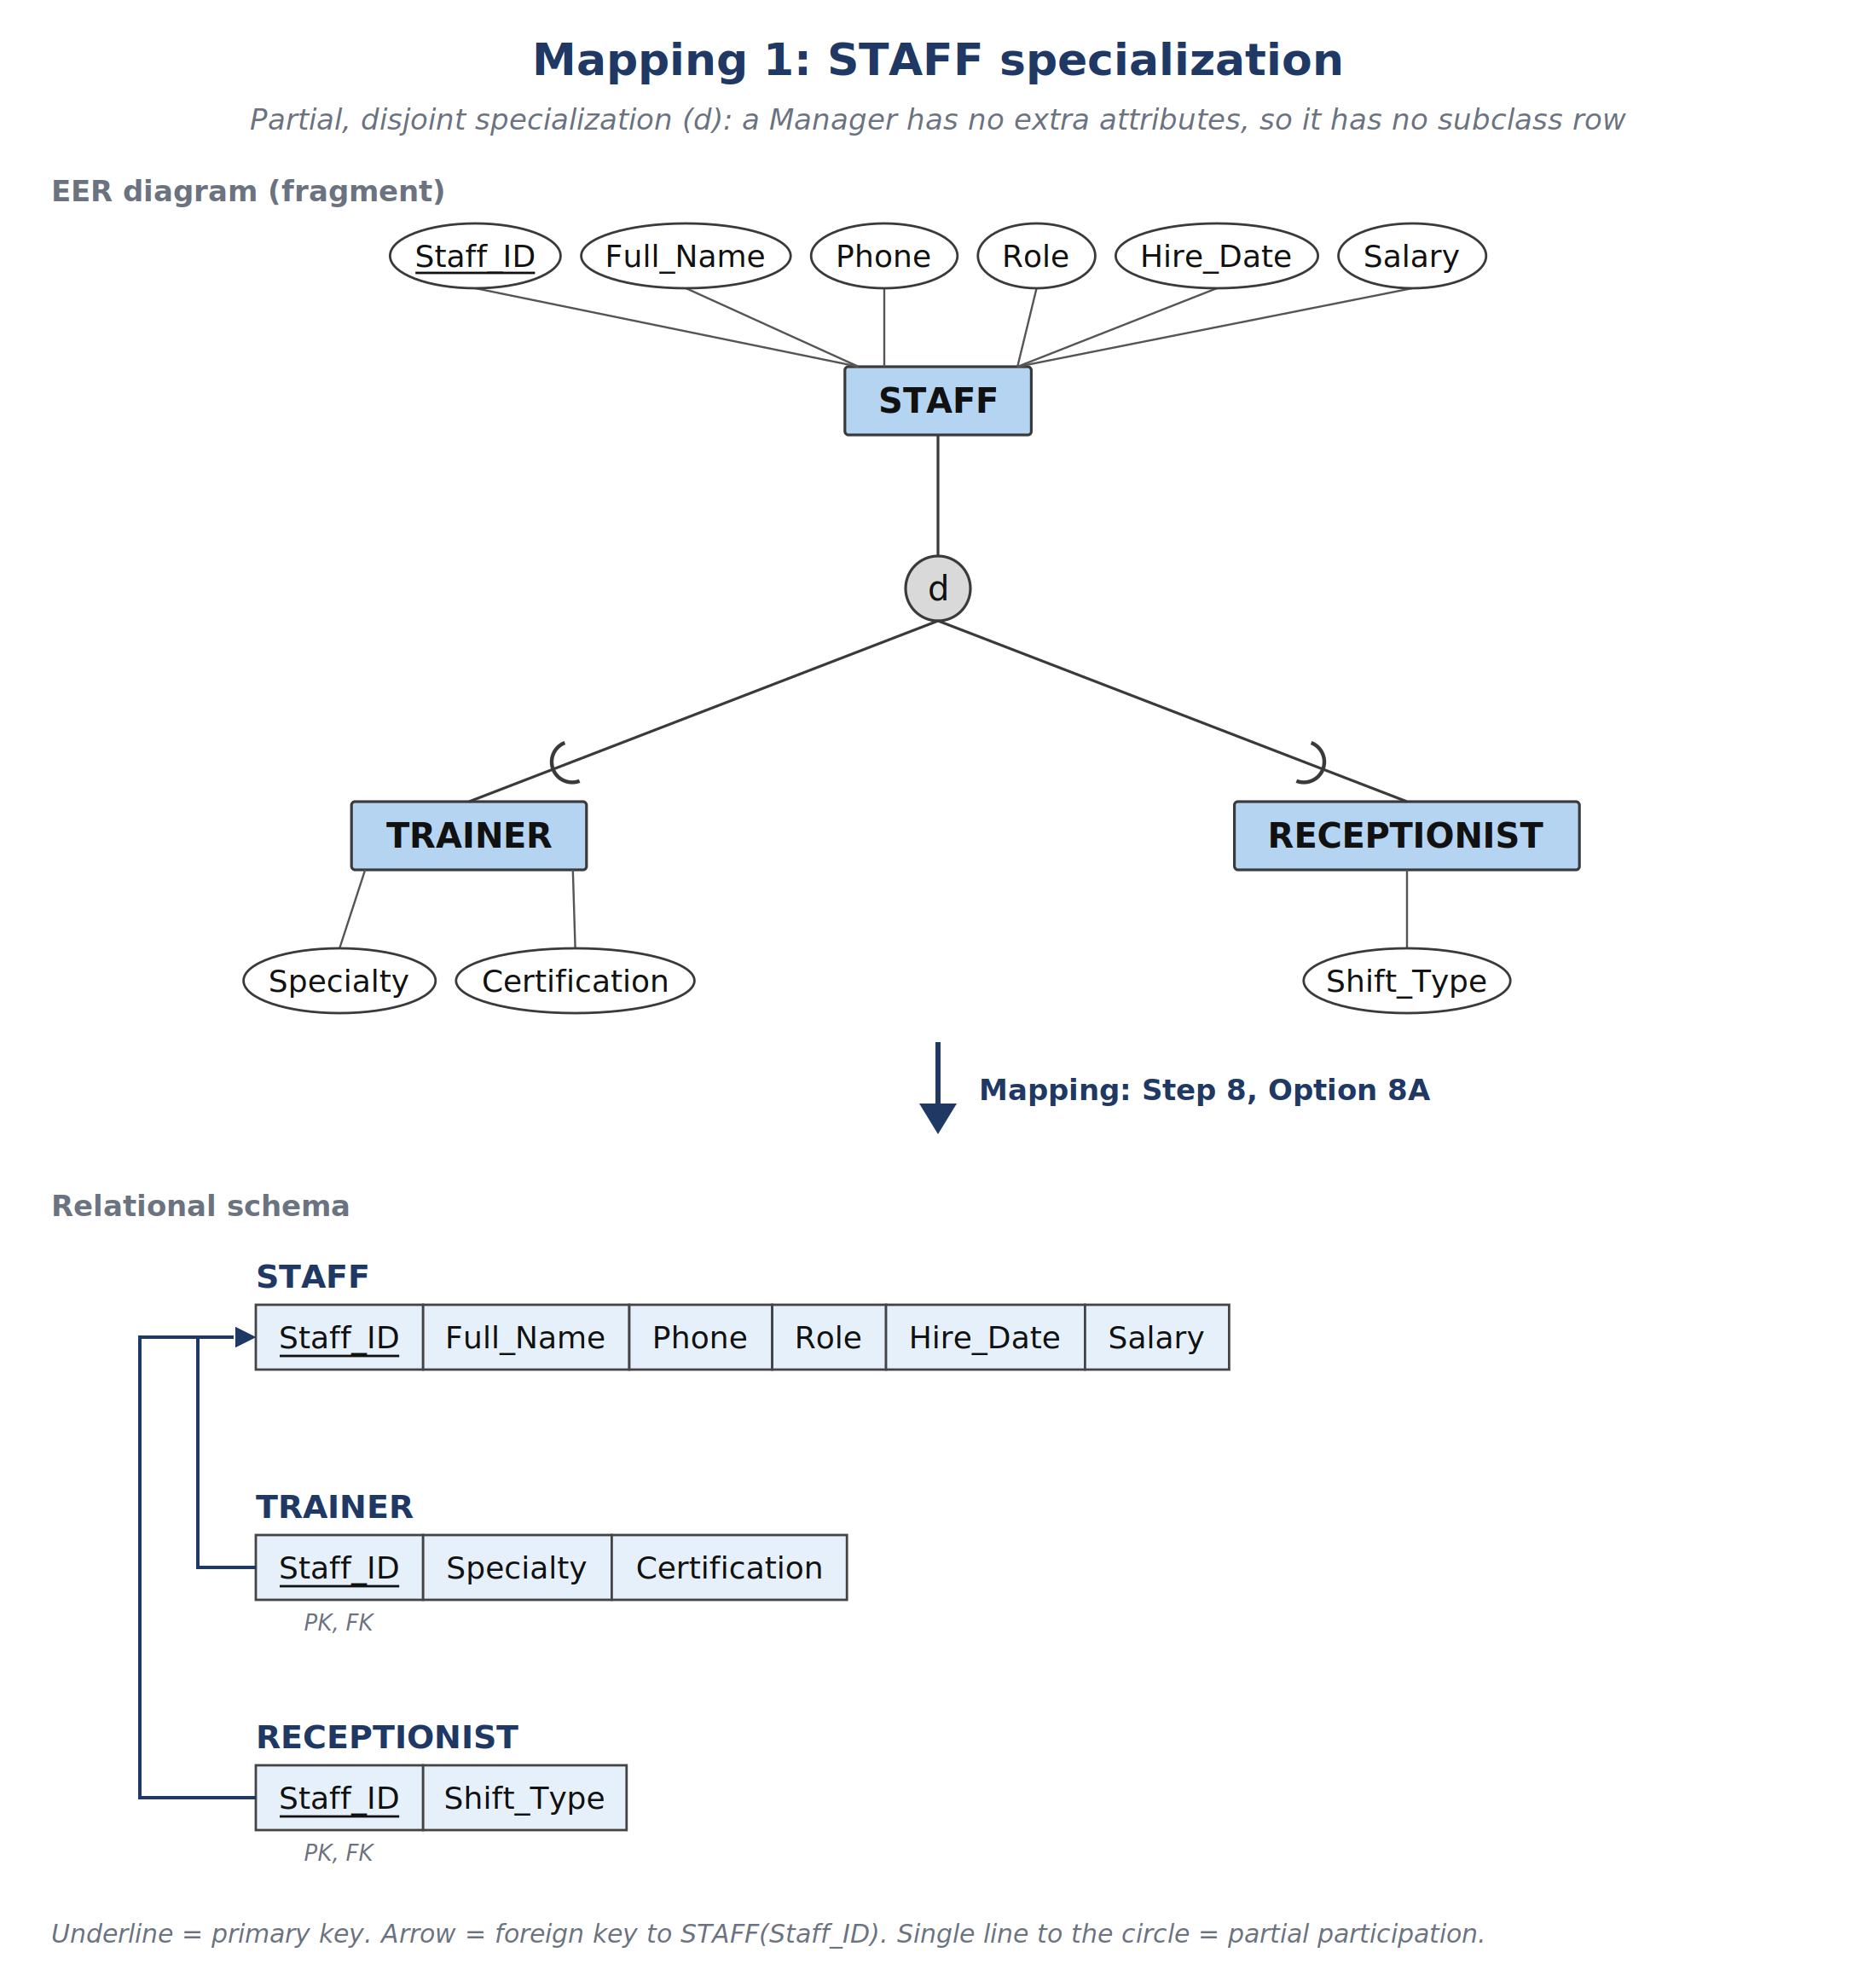
Mapping Figure 2: VISITOR specialization mapped with Option 8A (total, disjoint). MEMBER and DAILY_PASS_TICKET share Visitor_ID with VISITOR as primary key and foreign key.
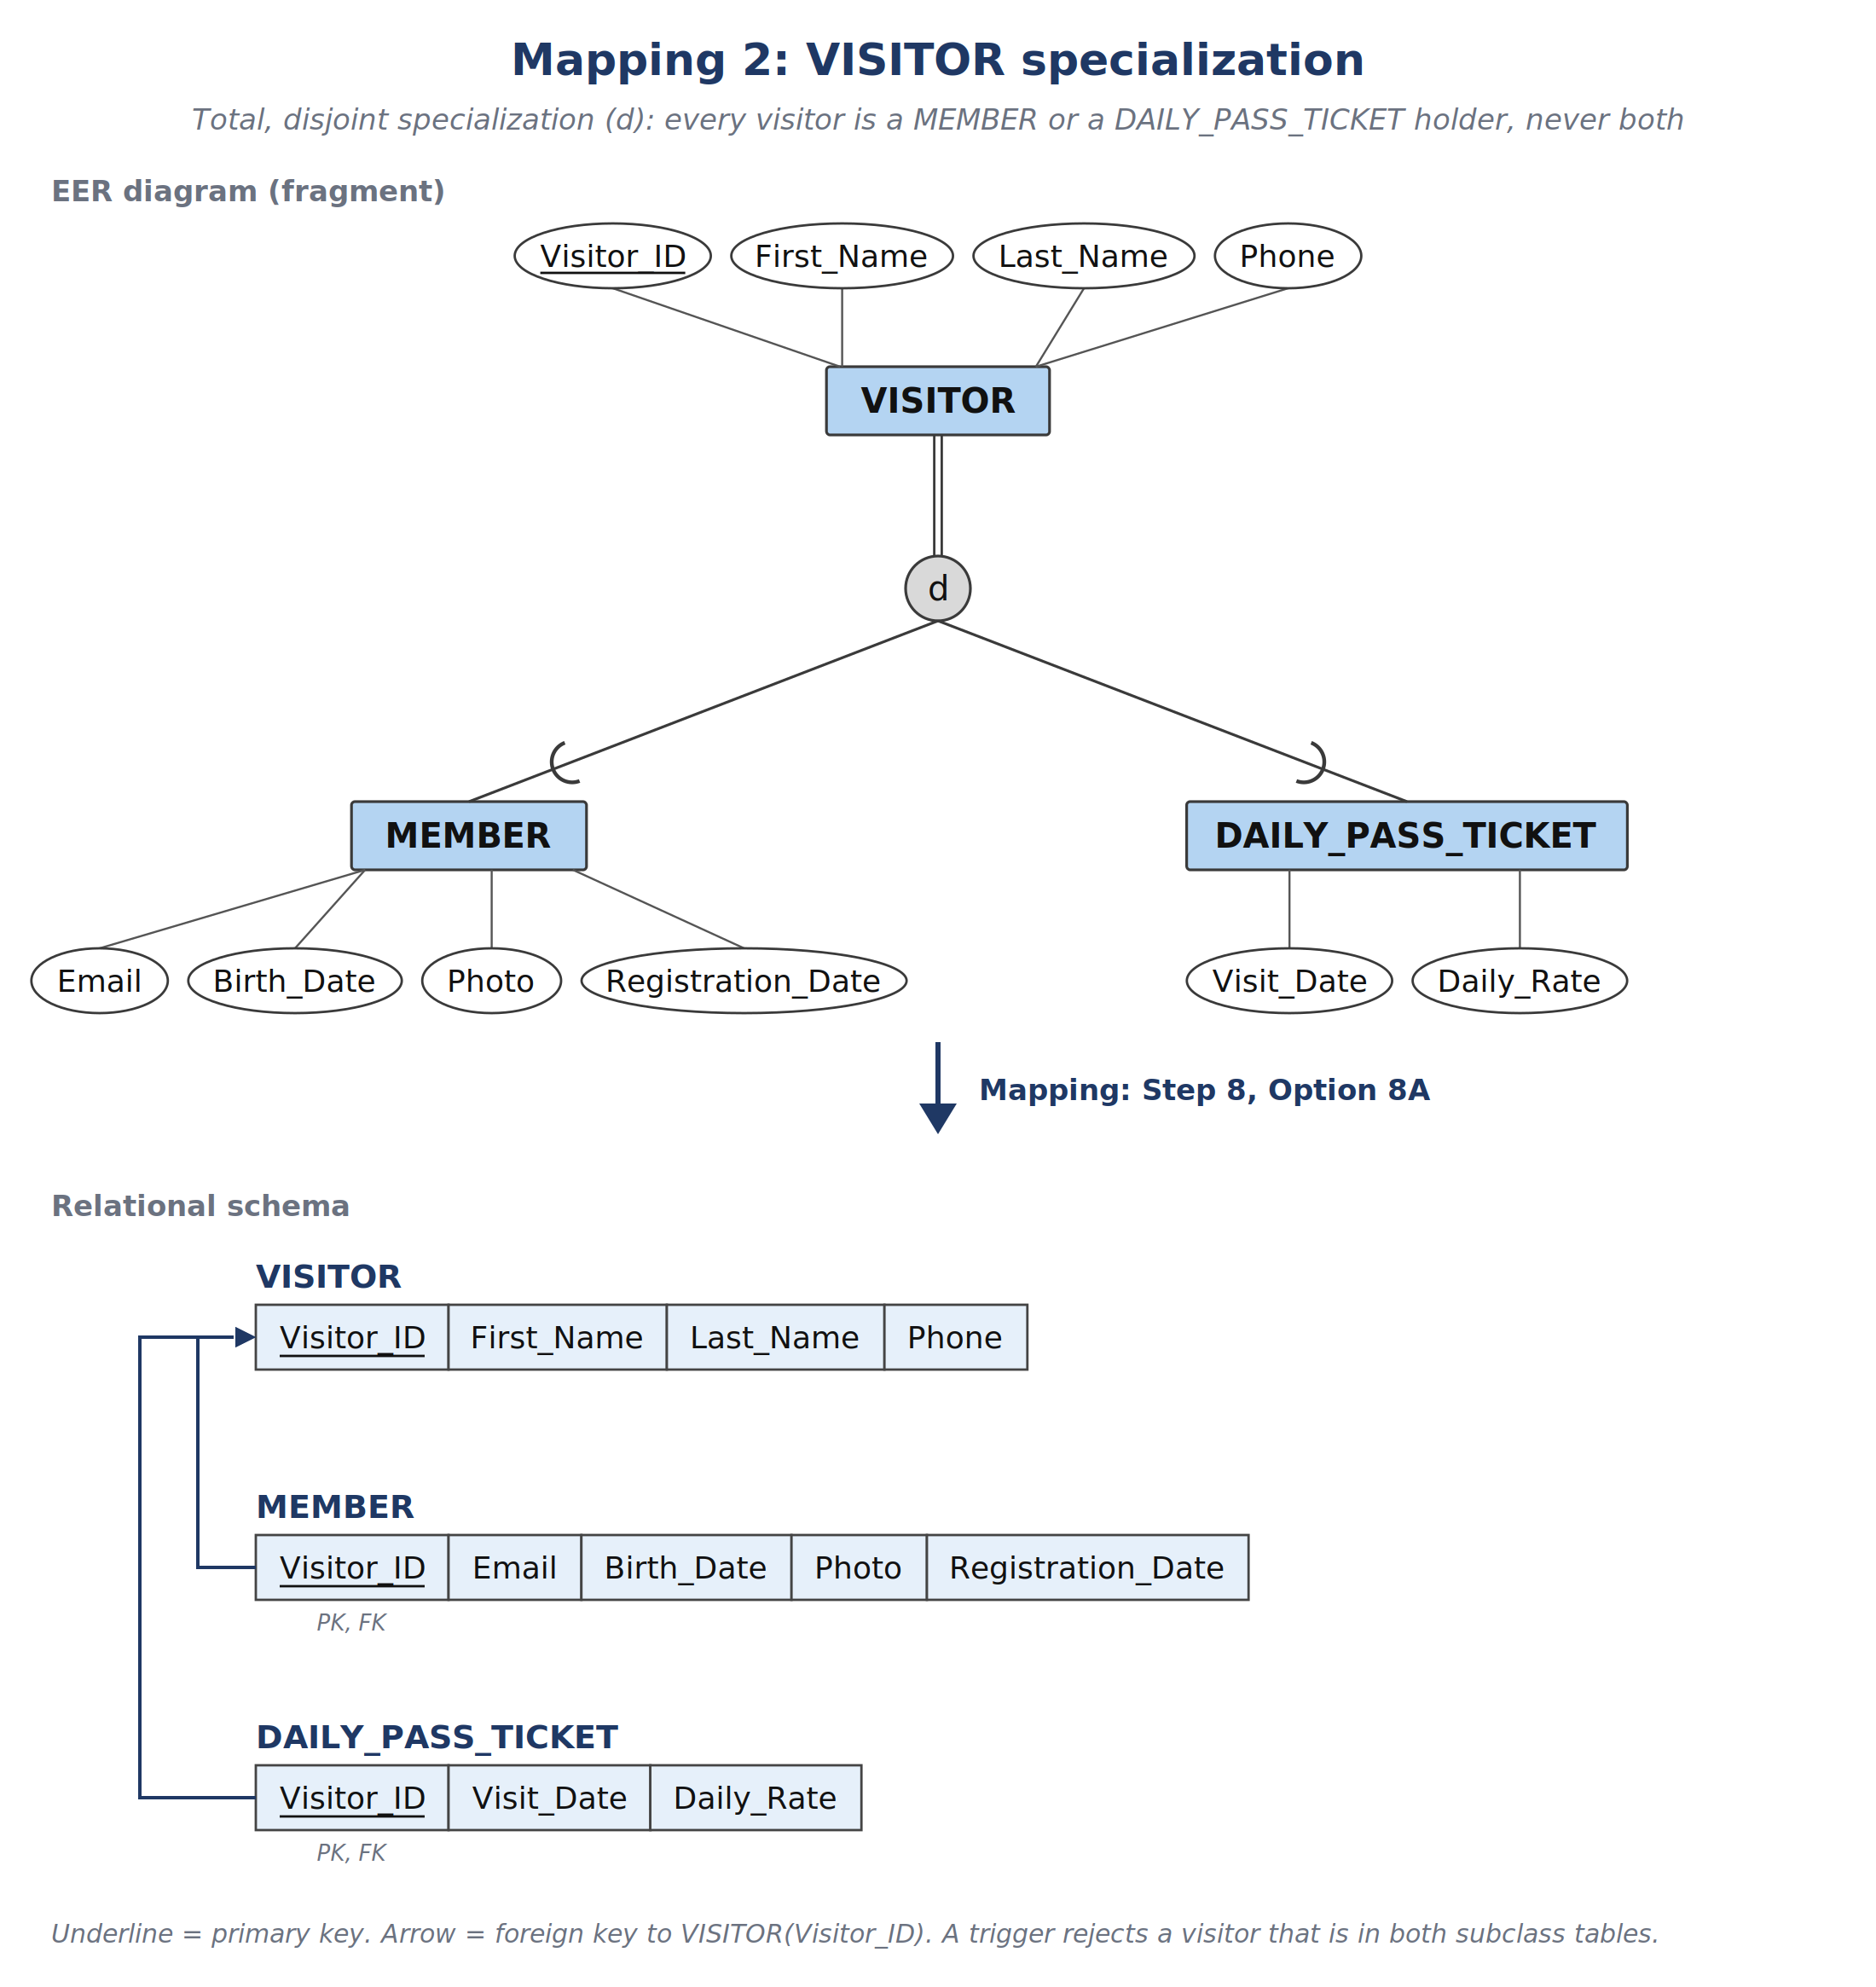
Mapping Figure 3: SESSION specialization mapped with Option 8A (total, disjoint). CLASS and PT_BOOKING share Session_ID with SESSION; Session_Type records which subclass table holds each session; BOOKS_PT becomes the foreign key Visitor_ID.
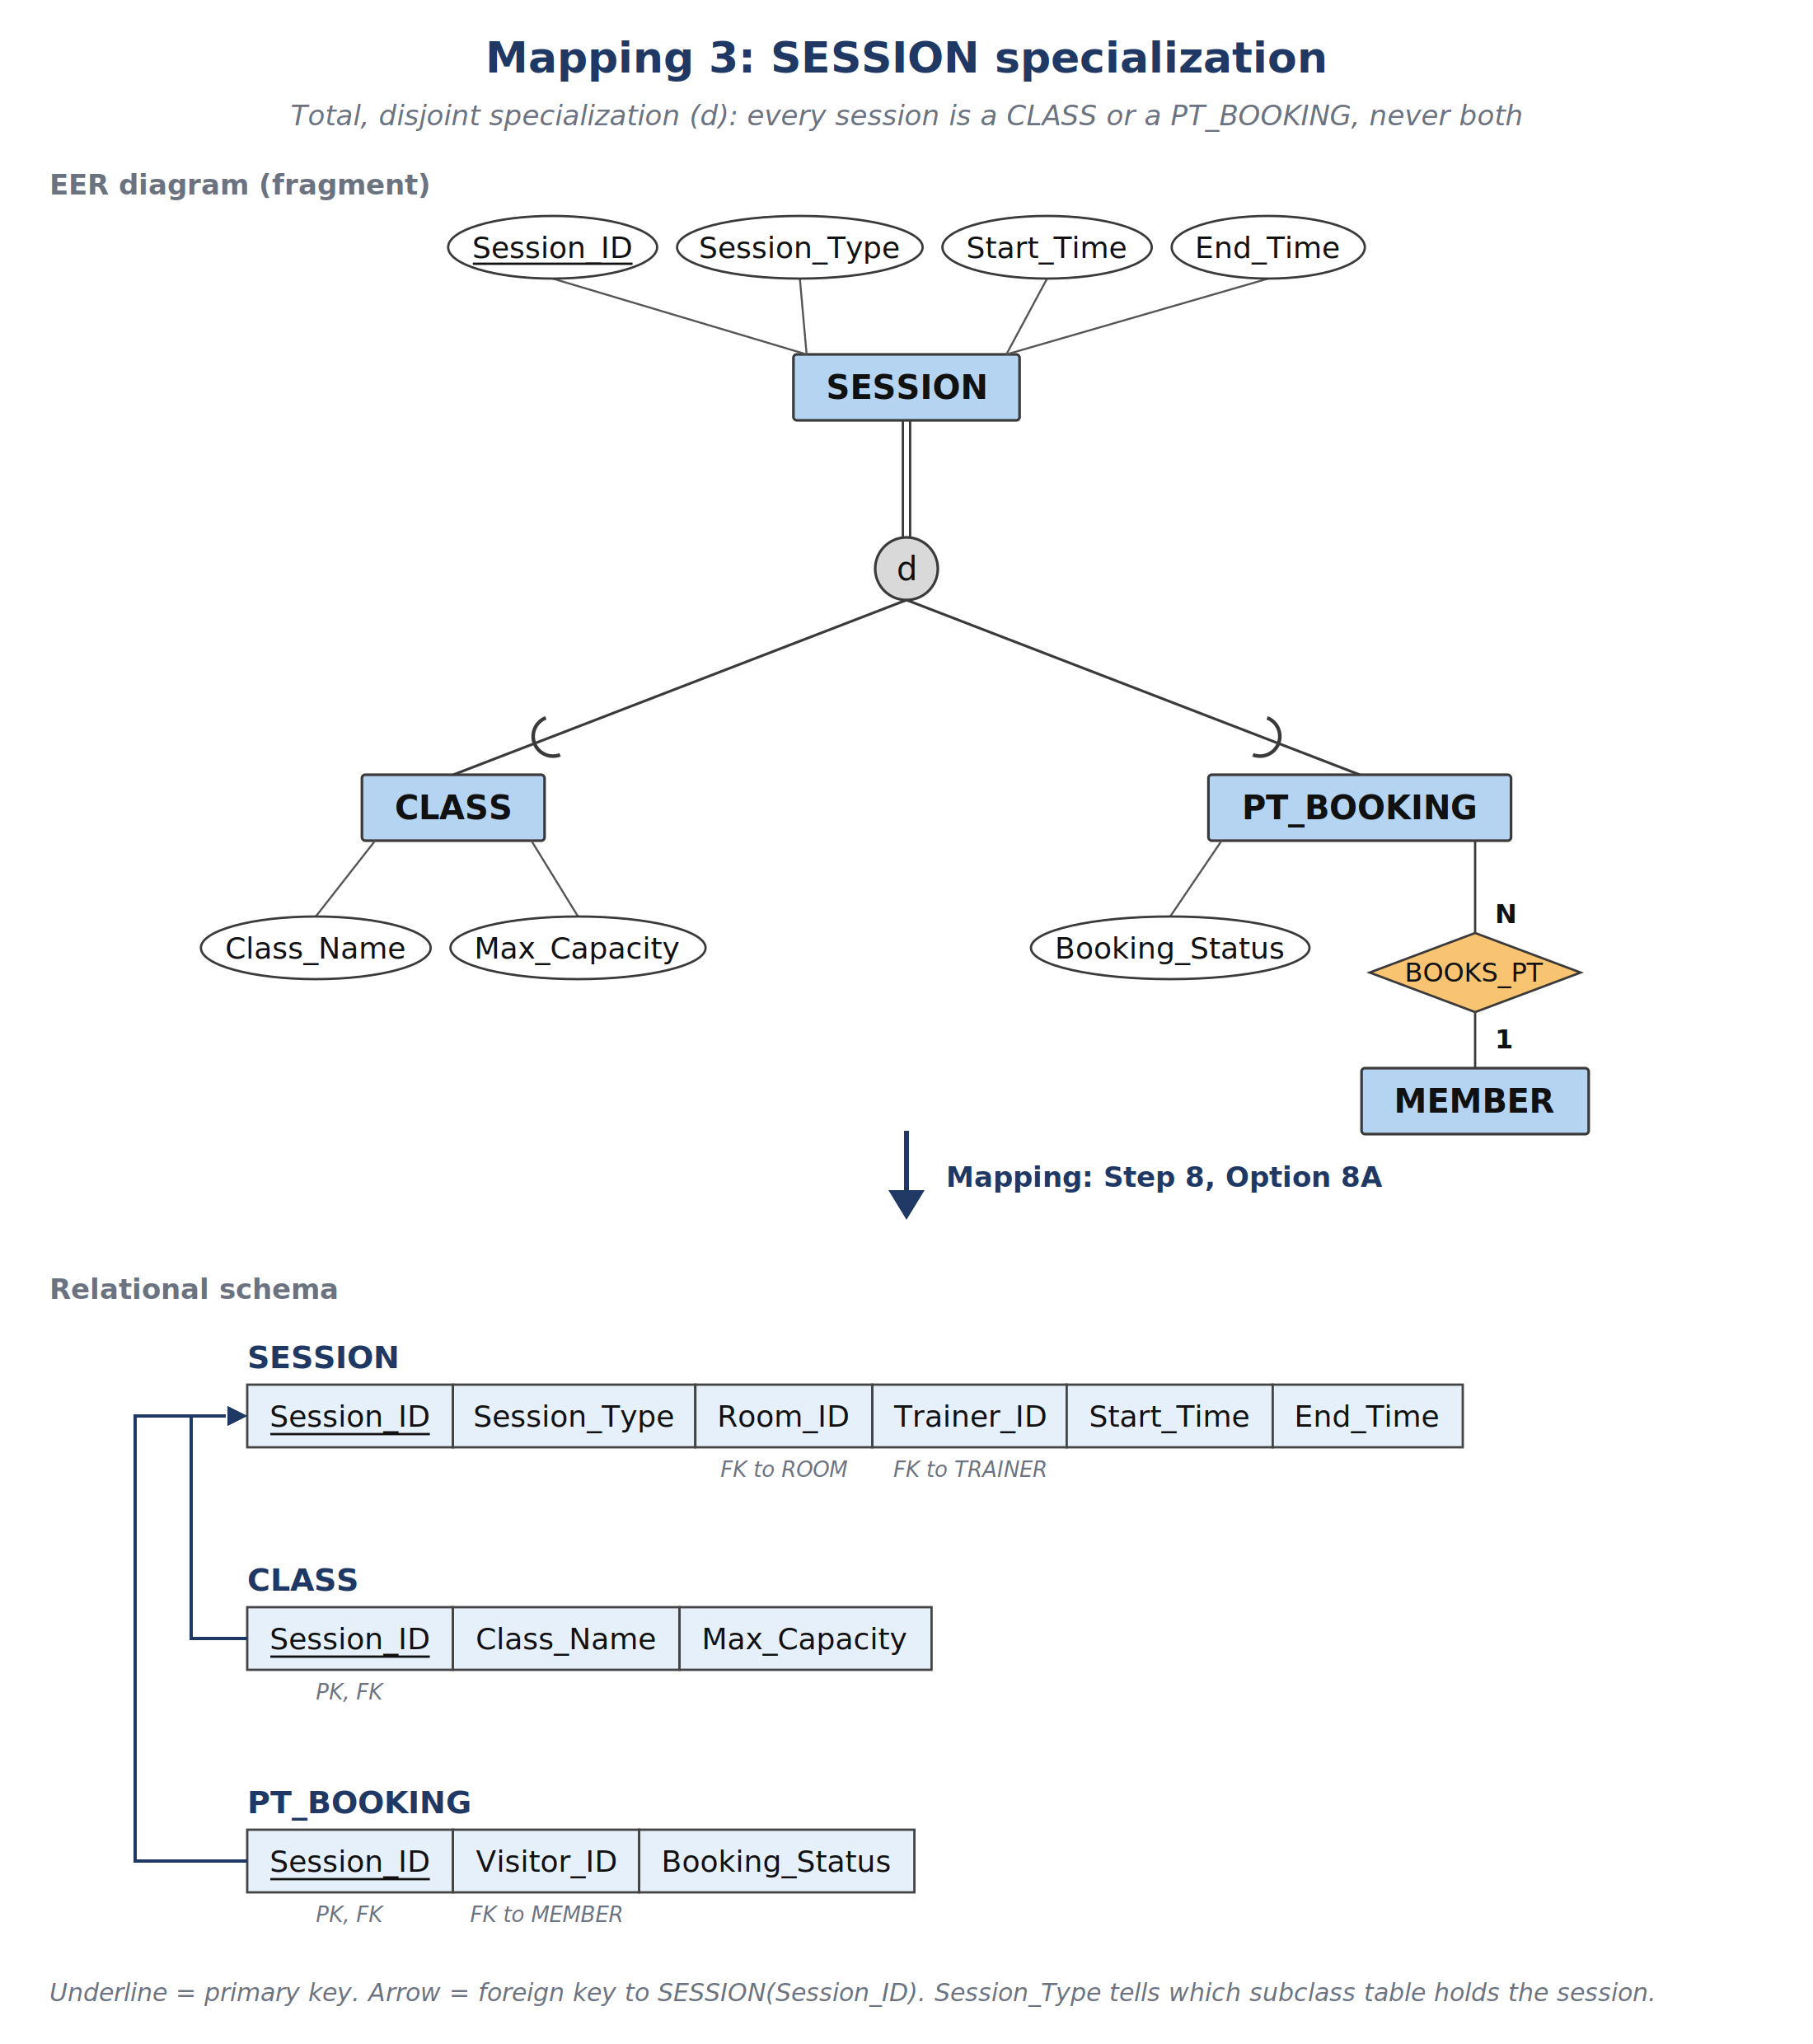
Mapping Figure 4: Weak entity MAINTENANCE_LOG mapped in Step 2. The primary key combines the owner key Equipment_ID (also a foreign key to EQUIPMENT) with the partial key Log_no.
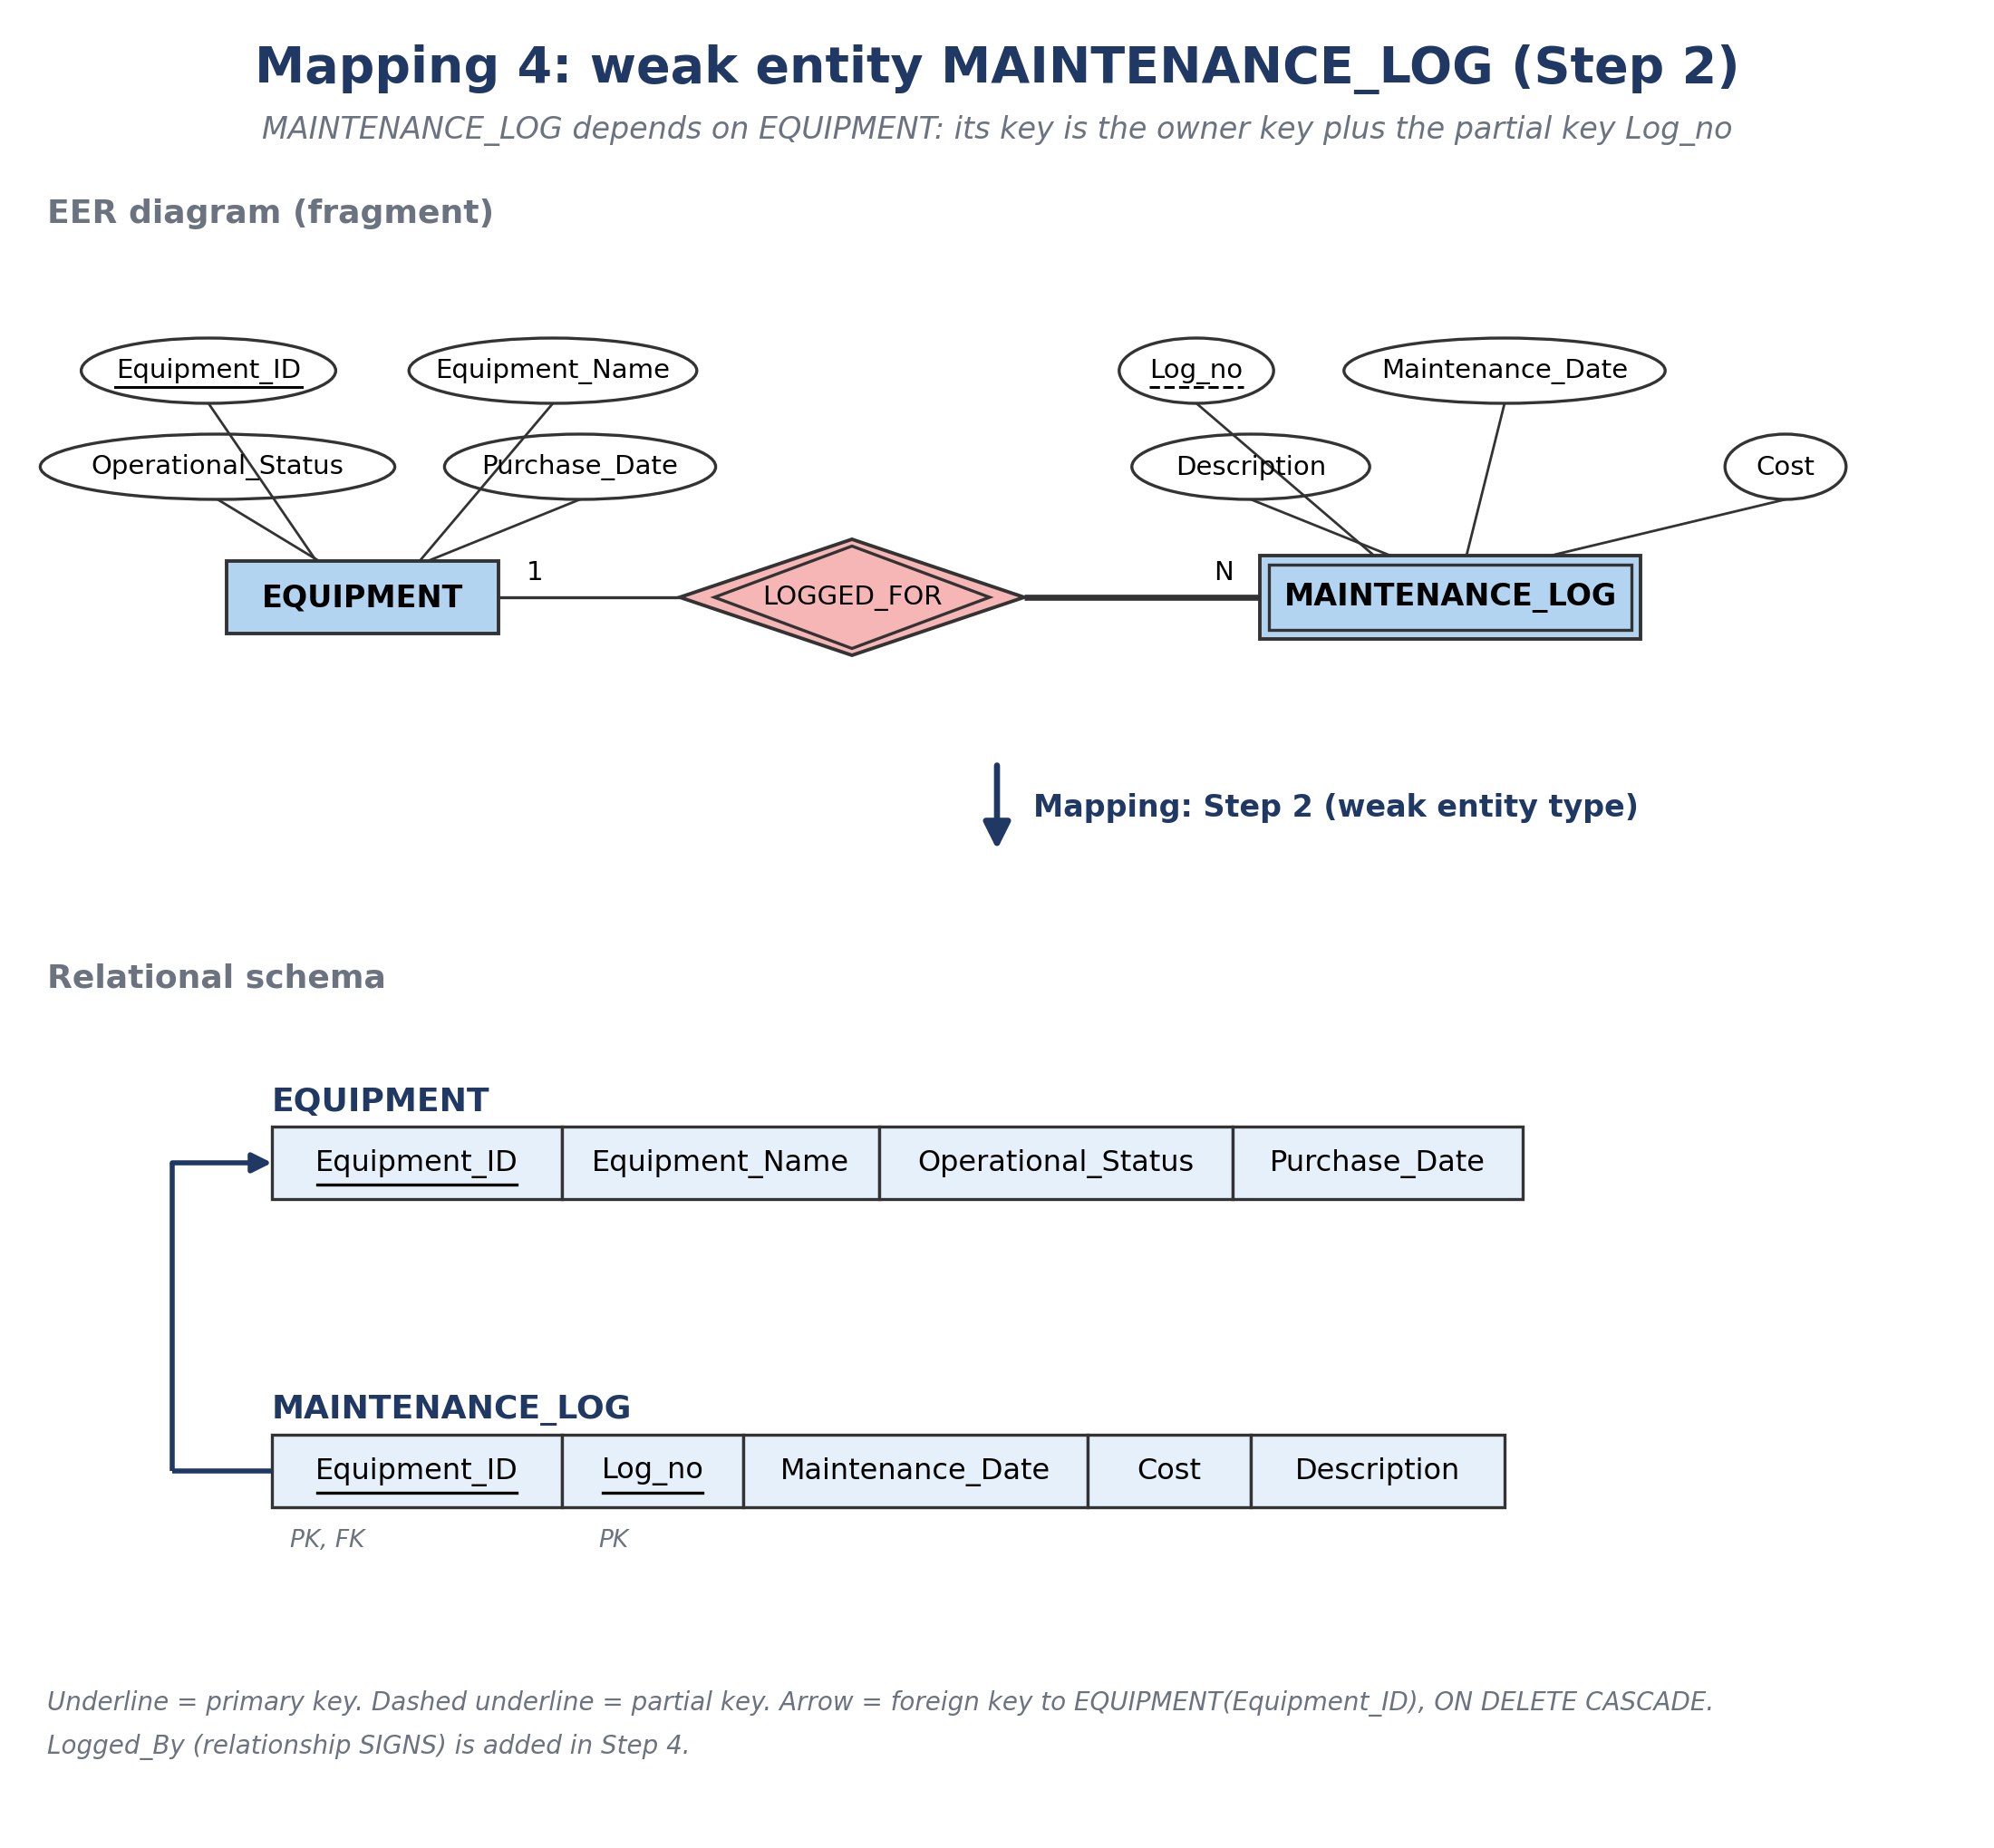
Mapping Figure 5: M:N relationship REGISTER mapped in Step 5. CLASS_REGISTRATION has one foreign key to CLASS and one to MEMBER; together they form the primary key.
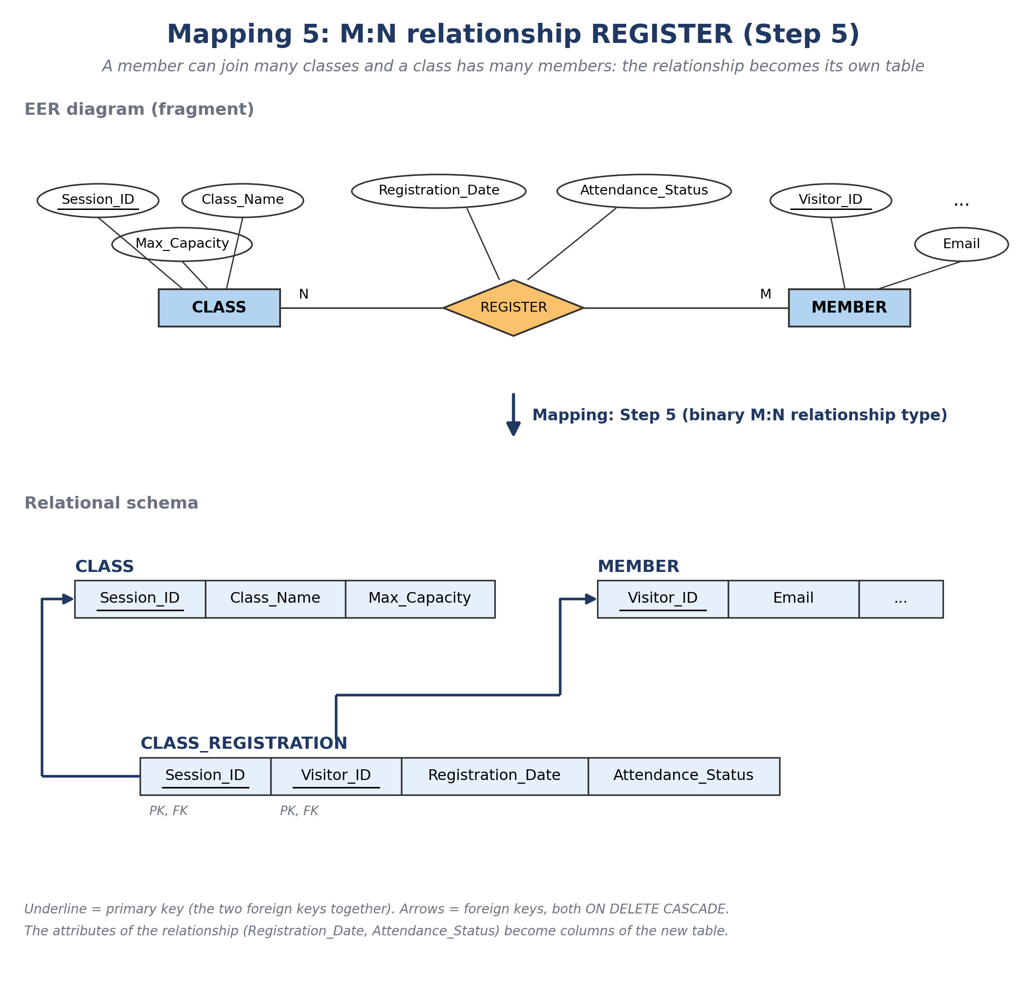
- Why Option 8A: Elmasri and Navathe describe four options (8A to 8D). Option 8B removes the superclass table, which does not fit here: STAFF is a partial specialization (a Manager belongs to no subclass and would have no row), and other tables refer to a superclass (BILLING_LOG to VISITOR, SESSION_EQUIPMENT_USAGE to SESSION). Options 8C and 8D put the whole specialization in one table; the book prefers them only when the subclasses have few local attributes. Here they would leave many NULL values (a daily-pass visitor would carry the Email and Photo columns of a member), and the subclasses have their own relationships (MEMBER is referenced by MEMBERSHIP, CLASS_REGISTRATION and PT_BOOKING), which need a table of their own. Option 8A works for any specialization, so it is used for all three.
- Type attributes: Option 8A as the book describes it has no type column in the superclass. This design keeps STAFF.Role and SESSION.Session_Type, which work like the type attribute t of Option 8C: triggers use them to check that a row is in the right subclass table (BR-SCH-01, BR-SCH-06). VISITOR has no type column; BR-MEM-01 is checked by triggers on MEMBER and DAILY_PASS_TICKET.
- Step 9: Map categories (union types): Not needed. A category is a subclass of the union of several superclasses that can have different keys. Every subclass here has exactly one superclass and shares its key, so no surrogate key is added.
- Referential actions: The book suggests CASCADE for both ON UPDATE and ON DELETE on weak entities, M:N tables and multivalued attributes. This design uses ON DELETE CASCADE on these tables (MAINTENANCE_LOG, CLASS_REGISTRATION, SESSION_EQUIPMENT_USAGE) but ON UPDATE NO ACTION, because key values are never changed once they are created (Section 2.2.3).

2.2.2 Relational Schema (17 Normalized Tables)
- VISITOR: (Visitor_ID [PK], First_Name, Last_Name, Phone [UQ])
  - MEMBER: (Visitor_ID [PK/FK->VISITOR], Email [UQ], Birth_Date, Photo, Registration_Date)
  - DAILY_PASS_TICKET: (Visitor_ID [PK/FK->VISITOR], Visit_Date, Daily_Rate)
- MEMBERSHIP_PLAN: (Plan_ID [PK], Plan_Name [UQ], Duration_Months, Price, Description)
- MEMBERSHIP: (Membership_ID [PK], Visitor_ID [FK->MEMBER], Plan_ID [FK->MEMBERSHIP_PLAN], Start_Date, End_Date, Status)
- BILLING_LOG: (Bill_ID [PK], Visitor_ID [FK->VISITOR], Membership_ID [FK->MEMBERSHIP, NULL], Invoice_Date, Due_Date, Payment_Date, Amount_Paid, Billing_Status)
- STAFF: (Staff_ID [PK], Full_Name, Phone [UQ], Role, Hire_Date, Salary)
  - TRAINER: (Staff_ID [PK/FK->STAFF], Specialty, Certification)
  - RECEPTIONIST: (Staff_ID [PK/FK->STAFF], Shift_Type)
- ROOM: (Room_ID [PK], Room_Name [UQ], Capacity, Floor_Location)
- SESSION: (Session_ID [PK], Session_Type, Room_ID [FK->ROOM], Trainer_ID [FK->TRAINER], Start_Time, End_Time)
  - CLASS: (Session_ID [PK/FK->SESSION], Class_Name, Max_Capacity)
  - PT_BOOKING: (Session_ID [PK/FK->SESSION], Visitor_ID [FK->MEMBER], Booking_Status)
- CLASS_REGISTRATION: (Session_ID [PK/FK->CLASS], Visitor_ID [PK/FK->MEMBER], Registration_Date, Attendance_Status)
- EQUIPMENT: (Equipment_ID [PK], Equipment_Name, Room_ID [FK->ROOM], Operational_Status, Purchase_Date)
  - MAINTENANCE_LOG: (Equipment_ID [PK/FK->EQUIPMENT], Log_no [PK], Maintenance_Date, Cost, Description, Logged_By [FK->STAFF])
- SESSION_EQUIPMENT_USAGE: (Usage_ID [PK], Equipment_ID [FK->EQUIPMENT], Session_ID [FK->SESSION], Reserved_From, Reserved_To)

2.2.3 Foreign Keys and Delete Rules

Referencing Table (FK) | Referenced Table (PK) | ON DELETE | ON UPDATE | Reason
MEMBER (Visitor_ID) | VISITOR (Visitor_ID) | CASCADE | NO ACTION | Subclass row removed when the visitor is deleted (blocked while membership, PT booking or billing rows exist)
DAILY_PASS_TICKET (Visitor_ID) | VISITOR (Visitor_ID) | CASCADE | NO ACTION | Subclass row removed when the visitor is deleted (blocked while billing rows exist)
MEMBERSHIP(Visitor_ID) | MEMBER (Visitor_ID) | RESTRICT | NO ACTION | Prevents deleting a member who has membership records
MEMBERSHIP(Plan_ID) | MEMBERSHIP_PLAN (Plan_ID) | RESTRICT | NO ACTION | Prevents deleting a plan that is in use
BILLING_LOG (Visitor_ID) | VISITOR (Visitor_ID) | RESTRICT | NO ACTION | Keeps the customer's payment history
BILLING_LOG (Membership_ID) | MEMBERSHIP(Membership_ID) | RESTRICT | NO ACTION | Keeps the billing history of each membership
TRAINER (Staff_ID) | STAFF (Staff_ID) | CASCADE | NO ACTION | Subclass row removed when the staff member is deleted
RECEPTIONIST (Staff_ID) | STAFF (Staff_ID) | CASCADE | NO ACTION | Subclass row removed when the staff member is deleted
SESSION (Room_ID) | ROOM (Room_ID) | RESTRICT | NO ACTION | Prevents deleting a room that has scheduled sessions
SESSION (Trainer_ID) | TRAINER (Staff_ID) | RESTRICT | NO ACTION | Prevents deleting a trainer who has scheduled sessions
CLASS (Session_ID) | SESSION (Session_ID) | CASCADE | NO ACTION | Subclass row removed when the session is deleted
PT_BOOKING (Session_ID) | SESSION (Session_ID) | CASCADE | NO ACTION | Subclass row removed when the session is deleted
CLASS_REGISTRATION (Session_ID) | CLASS (Session_ID) | CASCADE | NO ACTION | Registrations removed when the class is cancelled
CLASS_REGISTRATION (Visitor_ID) | MEMBER (Visitor_ID) | CASCADE | NO ACTION | Registrations removed when the member is deleted
PT_BOOKING (Visitor_ID) | MEMBER (Visitor_ID) | RESTRICT | NO ACTION | Keeps the member's PT booking history
EQUIPMENT (Room_ID) | ROOM (Room_ID) | SET NULL | NO ACTION | Machine kept, but its room is cleared when the room is deleted
MAINTENANCE_LOG (Equipment_ID) | EQUIPMENT (Equipment_ID) | CASCADE | NO ACTION | Logs of the weak entity deleted with the machine
MAINTENANCE_LOG (Logged_By) | STAFF (Staff_ID) | RESTRICT | NO ACTION | Keeps a record of who signed each log
SESSION_EQUIPMENT_USAGE (Equipment_ID) | EQUIPMENT (Equipment_ID) | CASCADE | NO ACTION | Reservations deleted when the machine is removed
SESSION_EQUIPMENT_USAGE (Session_ID) | SESSION (Session_ID) | CASCADE | NO ACTION | Reservations deleted when the session is deleted

Implementation note (SQL Server): SQL Server has no RESTRICT keyword; RESTRICT is implemented as NO ACTION, which also blocks the delete. ON UPDATE is NO ACTION for all foreign keys because every PK is an IDENTITY key that is never updated; this also avoids SQL Server error 1785 (multiple cascade paths), e.g., ROOM -> SESSION -> SESSION_EQUIPMENT_USAGE and ROOM -> EQUIPMENT -> SESSION_EQUIPMENT_USAGE.
How deletes work: A NO ACTION foreign key blocks deleting a parent row while any child row still references it; when no child row references it, the delete succeeds. A CASCADE foreign key deletes the child rows together with the parent, but if any row in that chain is still referenced through a NO ACTION foreign key, SQL Server rejects the whole DELETE statement (error 547) and no row is removed. Example: deleting a visitor entered by mistake, with no billing, membership, or booking records, also removes the MEMBER or DAILY_PASS_TICKET row; deleting visitor V001, who has MEMBERSHIP and BILLING_LOG rows, is rejected and all rows are kept.

2.2.4 Physical Database Schema (Crow's Foot Notation)
Schema Figure 1: physical schema of the 17 tables in crow's foot notation.
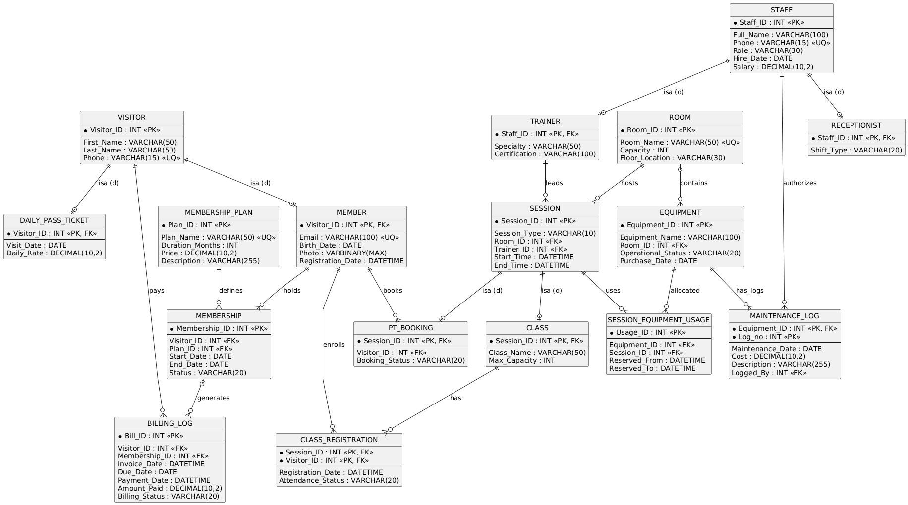
Schema Figure 2 below is the database diagram that SQL Server Management Studio generated from the GymPlanner database after scripts 01 to 03 were run. It shows the 17 tables and the foreign keys that actually exist in the database, and it matches Schema Figure 1: a key symbol marks the "one" side of a relationship and an infinity symbol marks the "many" side.
Schema Figure 2: database diagram of GymPlanner, generated by SQL Server Management Studio (SSMS).
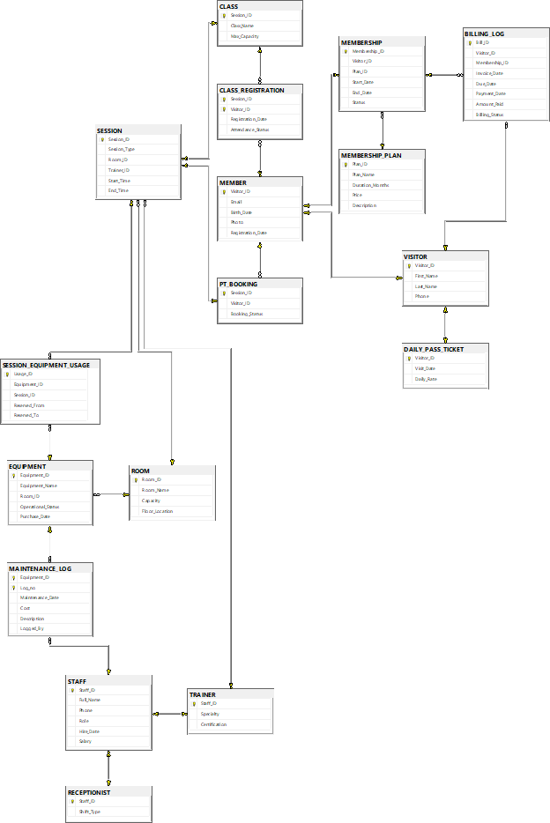

2.3 Normalization Verification (1NF -> 2NF -> 3NF / BCNF -> 4NF)

Formal Definitions:
- Functional Dependency (FD): X → Y holds in R if, for any two tuples t1 and t2 in R, t1[X] = t2[X] implies t1[Y] = t2[Y].
- Attribute Closure (X+): The set of all attributes of R that X determines under the FD set F.
- Superkey Test for BCNF: A relation R is in BCNF if, for every non-trivial FD X → Y, X is a superkey of R (i.e., X+ = R).
- Superkey Test for 3NF: A relation R is in 3NF if, for every non-trivial FD X → Y, EITHER X is a superkey of R, OR every attribute A in (Y - X) is a prime attribute (part of a candidate key).

2.3.1 Functional Dependencies and Normal Form Checks
• Relation 1: VISITOR
- Candidate Key(s): {Visitor_ID}, {Phone}
FD Set: Visitor_ID -> {First_Name, Last_Name, Phone}; Phone -> Visitor_ID
Proof & Verdict: {Visitor_ID}+ = VISITOR and {Phone}+ = VISITOR (all attributes). Both left sides are superkeys. In BCNF (and 3NF).
• Relation 2: MEMBER
- Candidate Key(s): {Visitor_ID}, {Email}
FD Set: Visitor_ID -> {Email, Birth_Date, Photo, Registration_Date}; Email -> Visitor_ID
Proof & Verdict: {Visitor_ID}+ = MEMBER and {Email}+ = MEMBER (all attributes). Both left sides are superkeys. In BCNF (and 3NF).
• Relation 3: DAILY_PASS_TICKET
- Candidate Key(s): {Visitor_ID}
FD Set: Visitor_ID -> {Visit_Date, Daily_Rate}
Proof & Verdict: {Visitor_ID}+ = DAILY_PASS_TICKET (all attributes). The left side Visitor_ID is a superkey. In BCNF (and 3NF).
• Relation 4: MEMBERSHIP_PLAN
- Candidate Key(s): {Plan_ID}, {Plan_Name}
FD Set: Plan_ID -> {Plan_Name, Duration_Months, Price, Description}; Plan_Name -> Plan_ID
Proof & Verdict: {Plan_ID}+ = MEMBERSHIP_PLAN and {Plan_Name}+ = MEMBERSHIP_PLAN (all attributes). Both left sides are superkeys. In BCNF (and 3NF).
• Relation 5: MEMBERSHIP
- Candidate Key(s): {Membership_ID}
FD Set: Membership_ID -> {Visitor_ID, Plan_ID, Start_Date, End_Date, Status}
Proof & Verdict: {Membership_ID}+ = MEMBERSHIP (all attributes). The left side Membership_ID is a superkey. In BCNF (and 3NF).
• Relation 6: BILLING_LOG
- Candidate Key(s): {Bill_ID}
FD Set: Bill_ID -> {Visitor_ID, Membership_ID, Invoice_Date, Due_Date, Payment_Date, Amount_Paid, Billing_Status}
Proof & Verdict: {Bill_ID}+ = BILLING_LOG (all attributes). Bill_ID is a superkey, but the table keeps one controlled redundancy (see the note below).
- Note: For rows where Membership_ID is not NULL, Membership_ID -> Visitor_ID also holds (through MEMBERSHIP), so Visitor_ID is partly redundant and, strictly speaking, BILLING_LOG is not in 3NF. This is a deliberate choice: Visitor_ID must be NOT NULL so that daily pass payments (Membership_ID = NULL) are still linked to the person who paid. A trigger controls the redundancy by requiring BILLING_LOG.Visitor_ID = MEMBERSHIP.Visitor_ID whenever Membership_ID is not NULL.
• Relation 7: STAFF
- Candidate Key(s): {Staff_ID}, {Phone}
FD Set: Staff_ID -> {Full_Name, Phone, Role, Hire_Date, Salary}; Phone -> Staff_ID
Proof & Verdict: {Staff_ID}+ = STAFF and {Phone}+ = STAFF (all attributes). Both left sides are superkeys. In BCNF (and 3NF).
• Relation 8: TRAINER
- Candidate Key(s): {Staff_ID}
FD Set: Staff_ID -> {Specialty, Certification}
Proof & Verdict: {Staff_ID}+ = TRAINER (all attributes). The left side Staff_ID is a superkey. In BCNF (and 3NF).
• Relation 9: RECEPTIONIST
- Candidate Key(s): {Staff_ID}
FD Set: Staff_ID -> {Shift_Type}
Proof & Verdict: {Staff_ID}+ = RECEPTIONIST (all attributes). The left side Staff_ID is a superkey. In BCNF (and 3NF).
• Relation 10: ROOM
- Candidate Key(s): {Room_ID}, {Room_Name}
FD Set: Room_ID -> {Room_Name, Capacity, Floor_Location}; Room_Name -> Room_ID
Proof & Verdict: {Room_ID}+ = ROOM and {Room_Name}+ = ROOM (all attributes). Both left sides are superkeys. In BCNF (and 3NF).
• Relation 11: SESSION
- Candidate Key(s): {Session_ID}
FD Set: Session_ID -> {Session_Type, Room_ID, Trainer_ID, Start_Time, End_Time}
Proof & Verdict: {Session_ID}+ = SESSION (all attributes). The left side Session_ID is a superkey. In BCNF (and 3NF). ({Room_ID, Start_Time} is not a key: a cancelled PT booking may keep the same room and time.)
• Relation 12: CLASS
- Candidate Key(s): {Session_ID}
FD Set: Session_ID -> {Class_Name, Max_Capacity}
Proof & Verdict: {Session_ID}+ = CLASS (all attributes). The left side Session_ID is a superkey. In BCNF (and 3NF).
• Relation 13: CLASS_REGISTRATION
- Candidate Key(s): {Session_ID, Visitor_ID}
FD Set: {Session_ID, Visitor_ID} -> {Registration_Date, Attendance_Status}
Proof & Verdict: {Session_ID, Visitor_ID}+ = CLASS_REGISTRATION (all attributes). The composite key is a superkey. In BCNF (and 3NF).
• Relation 14: PT_BOOKING
- Candidate Key(s): {Session_ID}
FD Set: Session_ID -> {Visitor_ID, Booking_Status}
Proof & Verdict: {Session_ID}+ = PT_BOOKING (all attributes). The left side Session_ID is a superkey. In BCNF (and 3NF).
• Relation 15: EQUIPMENT
- Candidate Key(s): {Equipment_ID}
FD Set: Equipment_ID -> {Equipment_Name, Room_ID, Operational_Status, Purchase_Date}
Proof & Verdict: {Equipment_ID}+ = EQUIPMENT (all attributes). The left side Equipment_ID is a superkey. In BCNF (and 3NF).
• Relation 16: MAINTENANCE_LOG
- Candidate Key(s): {Equipment_ID, Log_no}
FD Set: {Equipment_ID, Log_no} -> {Maintenance_Date, Cost, Description, Logged_By}
Proof & Verdict: {Equipment_ID, Log_no}+ = MAINTENANCE_LOG (all attributes). The composite key on the left side is a superkey. In BCNF (and 3NF).
• Relation 17: SESSION_EQUIPMENT_USAGE
- Candidate Key(s): {Usage_ID}
- FD Set: Usage_ID -> {Equipment_ID, Session_ID, Reserved_From, Reserved_To}
- Proof & Verdict: {Usage_ID}+ = SESSION_EQUIPMENT_USAGE (all attributes). The left side Usage_ID is a superkey. In BCNF (and 3NF).

2.3.2 Normal Forms Step by Step (1NF -> 2NF -> 3NF / BCNF)
- 1NF: All attributes in the 17 relations hold single, atomic values of simple types (INT, VARCHAR, VARBINARY, DATETIME, DECIMAL, DATE). There are no multivalued attributes or repeating groups.
- 2NF: Every non-prime attribute in every table depends on the whole primary key. In MAINTENANCE_LOG, with the composite key {Equipment_ID, Log_no}, Cost and Maintenance_Date depend on the whole key, not on Equipment_ID alone.
3NF and BCNF: For every non-trivial functional dependency X → Y in the 17 tables, X is a superkey, with one documented exception: BILLING_LOG keeps a controlled redundancy (Membership_ID -> Visitor_ID, see Relation 6) to support daily pass payments. All other relations are in BCNF.

2.3.3 Normalization Shown with FD Diagrams
Sections 2.3.1 and 2.3.2 list the functional dependencies as text. This section draws them in the notation used in the course: each relation is a row of cells with the primary key underlined, and each FD is a line that starts under its left side and ends in arrowheads under its right side. Normalization Figures 1 and 2 use combined tables made up for this illustration (CLASS_REG_WIDE and MEMBERSHIP_WIDE). They are not an earlier version of the team's design; they show which dependency a combined table would break and how the final tables avoid it. Normalization Figures 3 to 6 draw 16 of the 17 final relations in four groups, and Normalization Figure 7 draws BILLING_LOG, so together the figures cover all 17 relations.
Normalization Figure 1: a combined registration table that is in 1NF but not in 2NF, decomposed into CLASS_REGISTRATION and CLASS.
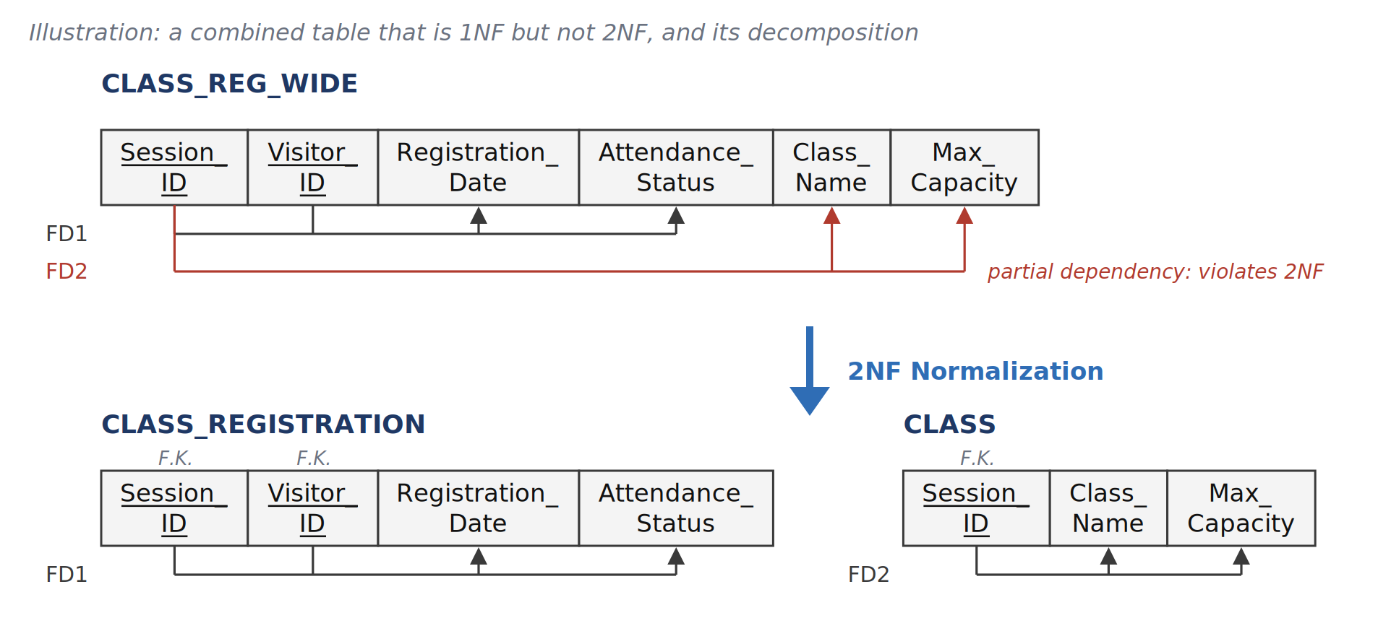
2NF: In CLASS_REG_WIDE the key is {Session_ID, Visitor_ID}. FD1 needs the whole key: a registration date and an attendance status belong to one member in one class. FD2 needs only Session_ID: the class name and capacity are the same for every member of the class. A non-prime attribute that depends on part of the key is a partial dependency, so the table is in 1NF but not in 2NF. If 30 members join one class, its name and capacity are stored 30 times; changing the capacity needs 30 updates, and a new class with no members cannot be stored at all, because Visitor_ID is part of the key and cannot be NULL. Moving FD2 into its own relation gives CLASS(Session_ID, Class_Name, Max_Capacity) and CLASS_REGISTRATION(Session_ID, Visitor_ID, Registration_Date, Attendance_Status), the two tables used in the design.
Normalization Figure 2: a combined membership table that is in 2NF but not in 3NF, decomposed into MEMBERSHIP and MEMBERSHIP_PLAN.
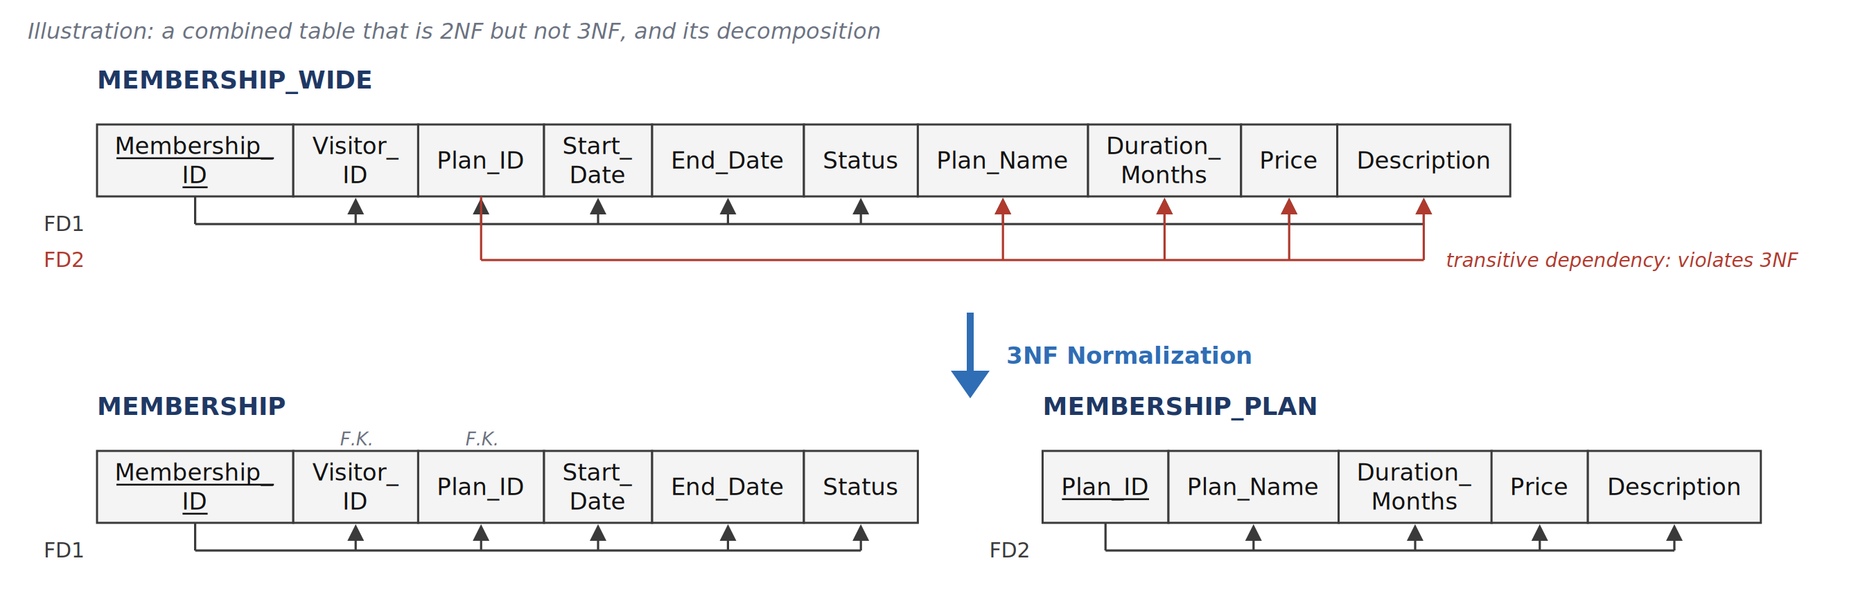
3NF: MEMBERSHIP_WIDE has the single-attribute key Membership_ID, so it cannot have a partial dependency and is in 2NF. FD2 (Plan_ID -> Plan_Name, Duration_Months, Price, Description) has a left side that is not a superkey, and Membership_ID -> Plan_ID -> Price is a transitive dependency, so the table is not in 3NF. If 100 memberships use the same plan, its price is stored 100 times; a price change must update all of them, and deleting the last membership of a plan also deletes the only record of the plan. Moving FD2 into MEMBERSHIP_PLAN leaves MEMBERSHIP with Plan_ID as a foreign key, which is the design in Section 2.2.2.
Normalization Figure 3: FD diagrams of the person relations (VISITOR, MEMBER, DAILY_PASS_TICKET, STAFF, TRAINER, RECEPTIONIST).
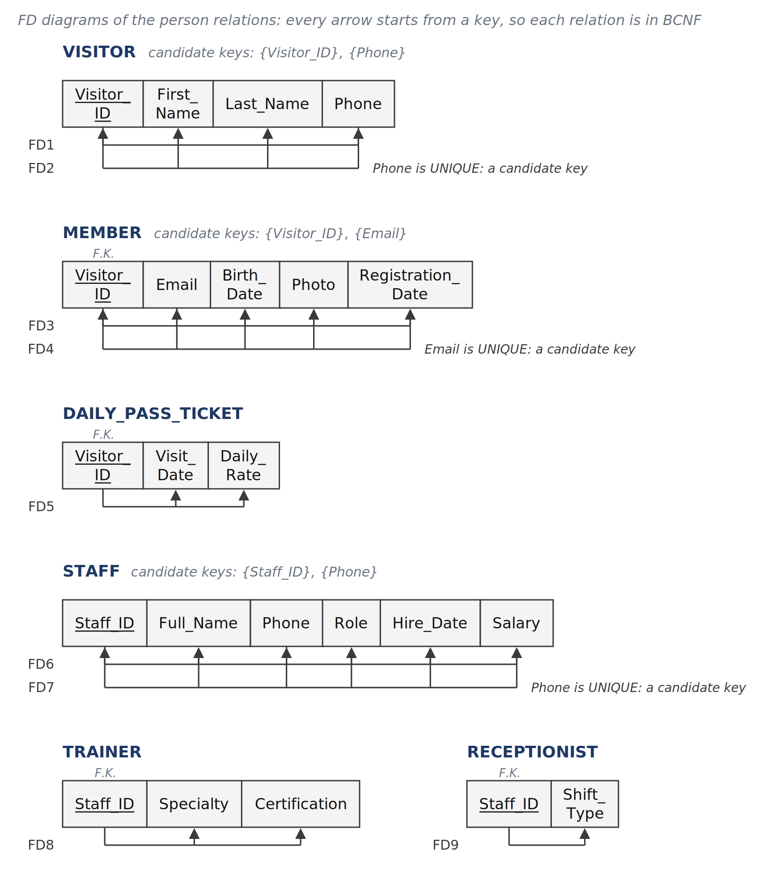
Person relations: VISITOR, MEMBER and STAFF each have two candidate keys: an ID and a UNIQUE column (Phone for VISITOR and STAFF, Email for MEMBER). So each has two FDs, and both start from a key (FD1 and FD2, FD3 and FD4, FD6 and FD7). Section 2.3.1 writes the second FD in its shortest form (for example Phone -> Visitor_ID); the figures draw it with the full right side (Phone -> Visitor_ID, First_Name, Last_Name), which follows from the two FDs by transitivity. DAILY_PASS_TICKET, TRAINER and RECEPTIONIST are subclass relations. Their primary key (Visitor_ID or Staff_ID) is also a foreign key to the superclass, and each has one FD that starts from that key (FD5, FD8, FD9). No non-key attribute decides another attribute, so all six relations are in BCNF.
Normalization Figure 4: FD diagrams of MEMBERSHIP_PLAN and MEMBERSHIP.
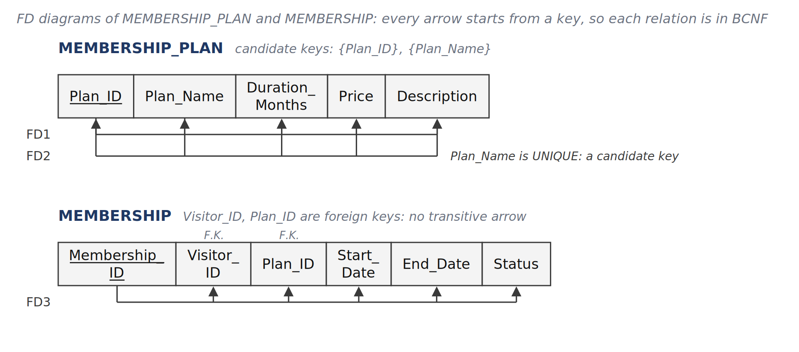
Membership relations: MEMBERSHIP_PLAN has two candidate keys, Plan_ID and Plan_Name (UNIQUE), so FD1 and FD2 both start from a key. MEMBERSHIP has one key, Membership_ID. It holds the foreign keys Visitor_ID and Plan_ID, but the name, length and price of the plan are not stored in it; they stay in MEMBERSHIP_PLAN, as in Normalization Figure 2. So there is no transitive arrow and both relations are in BCNF. The bills of a membership are in BILLING_LOG (Normalization Figure 7).
Normalization Figure 5: FD diagrams of ROOM, SESSION, CLASS, PT_BOOKING and CLASS_REGISTRATION.
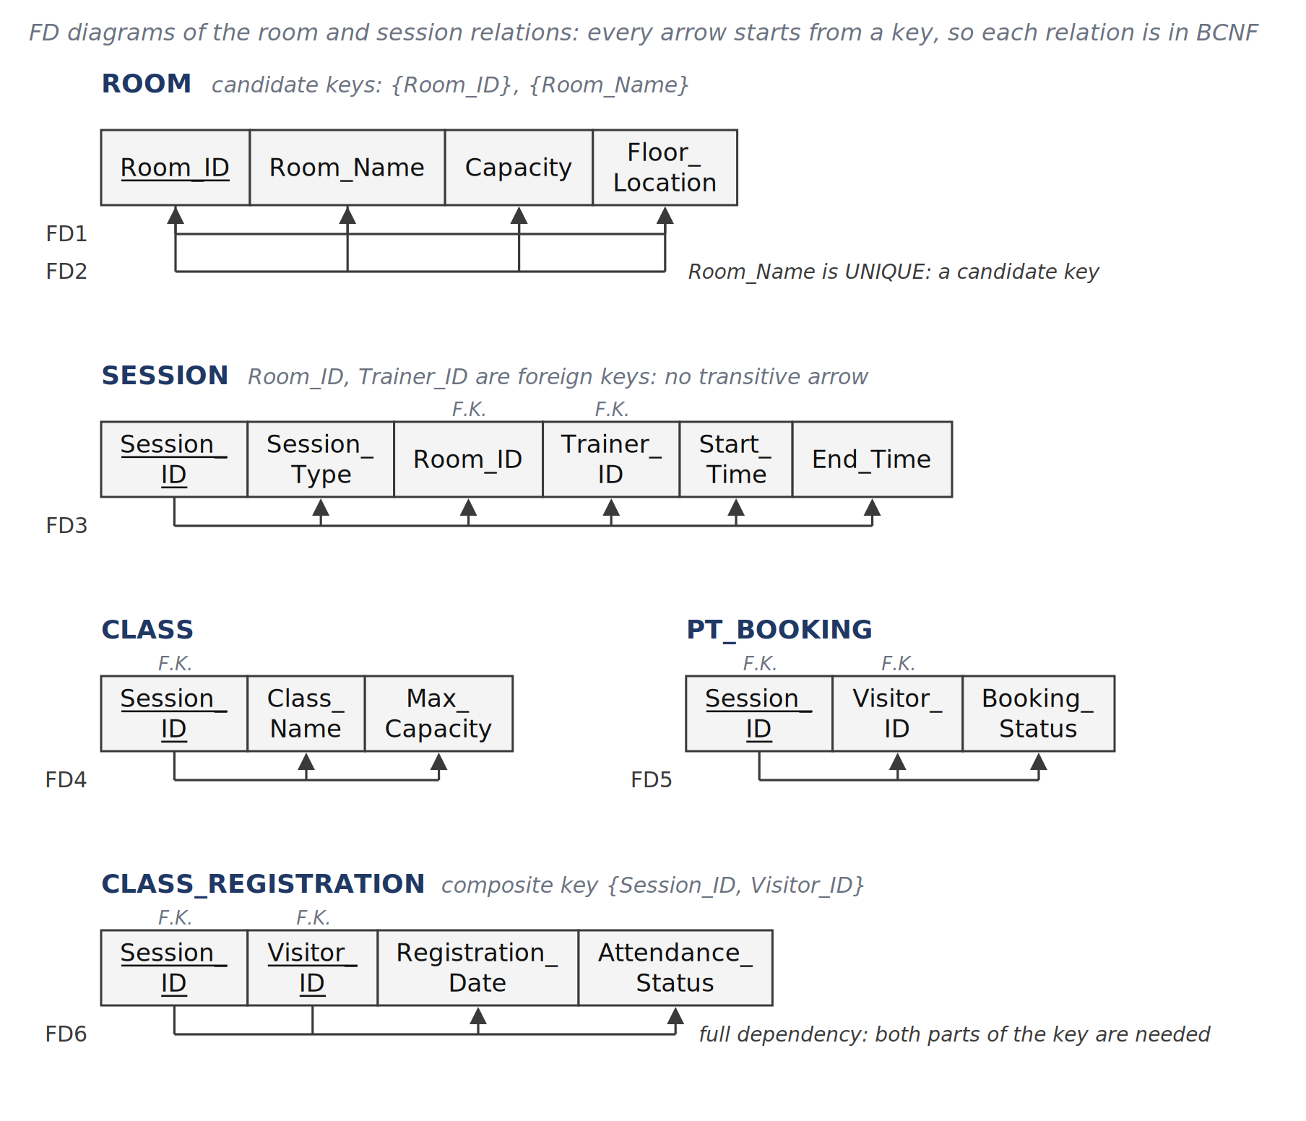
Room and session relations: ROOM has two candidate keys, Room_ID and Room_Name (UNIQUE). SESSION has two foreign keys (Room_ID, Trainer_ID), but no attribute inside SESSION depends on them: room capacity and trainer details are stored in ROOM and TRAINER, so there is no transitive arrow. CLASS and PT_BOOKING are the two subclasses of SESSION, and their primary key Session_ID is also a foreign key to SESSION. CLASS_REGISTRATION has the composite key {Session_ID, Visitor_ID}: the registration date and the attendance status belong to one member in one class, so they depend on the whole key. This is the result of the 2NF step in Normalization Figure 1. In all five relations every FD starts from a key, so they are in BCNF.
Normalization Figure 6: FD diagrams of EQUIPMENT, MAINTENANCE_LOG and SESSION_EQUIPMENT_USAGE.
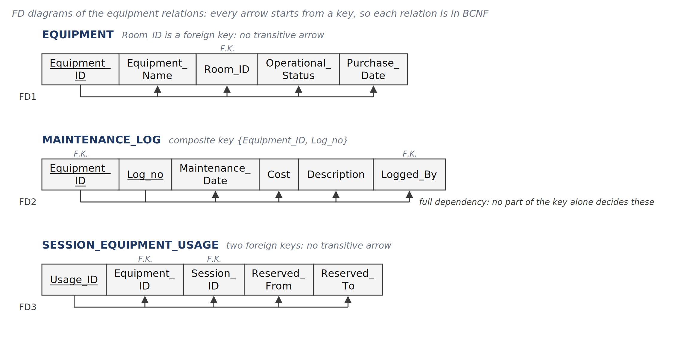
Equipment relations: EQUIPMENT holds the foreign key Room_ID, but the room details stay in ROOM. MAINTENANCE_LOG has the composite key {Equipment_ID, Log_no}; the date, cost, description and signer of a service record depend on the pair, not on Equipment_ID alone, because one machine has many service records. SESSION_EQUIPMENT_USAGE has its own single-attribute key Usage_ID, so it cannot have a partial dependency. In all three relations every FD starts from a key, which is the BCNF condition.

2.3.4 BILLING_LOG: The Documented 3NF Exception
Normalization Figure 7: FD diagram of BILLING_LOG. FD2 does not meet 3NF and is kept on purpose.
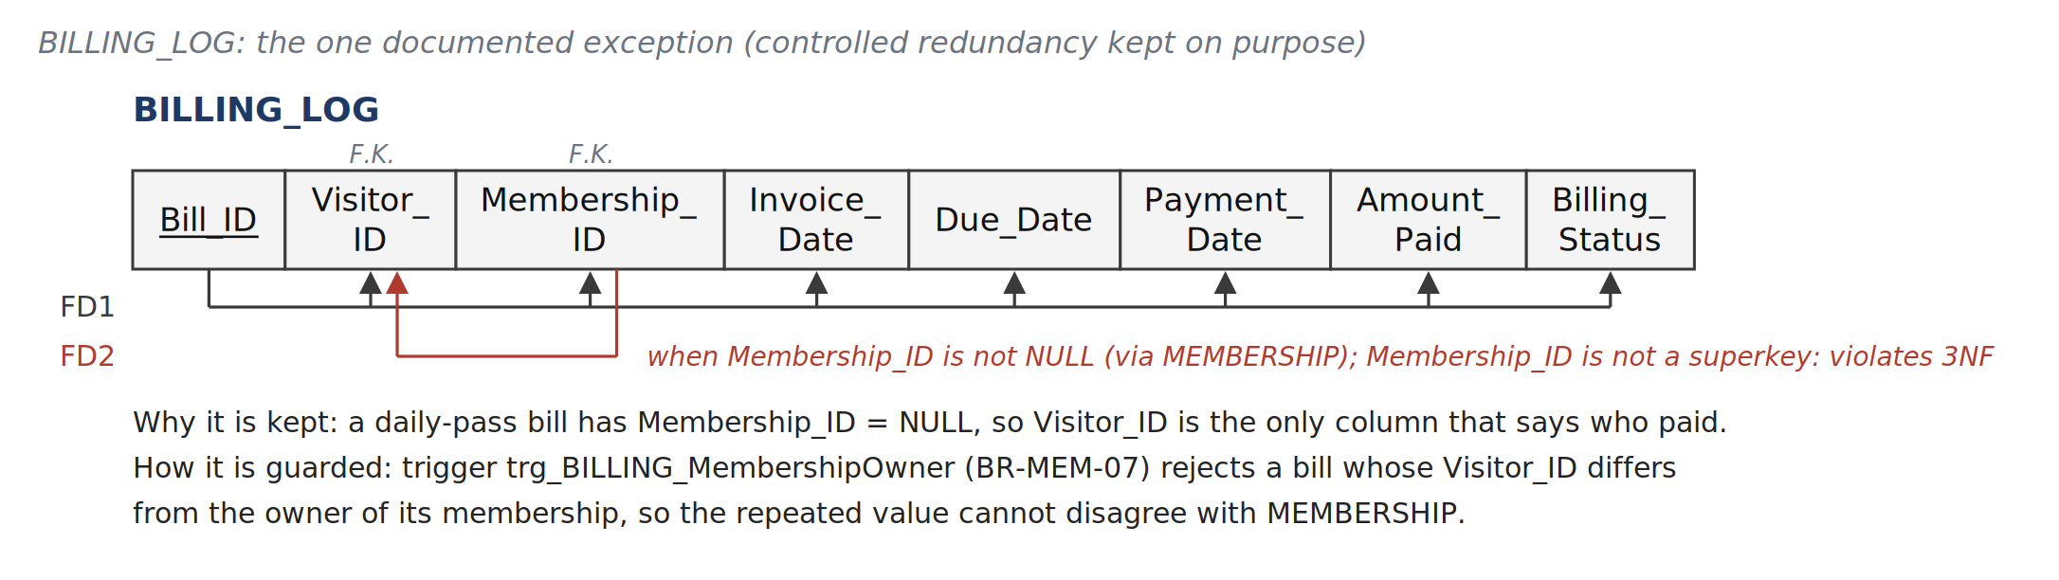
BILLING_LOG holds the bills for both memberships and daily passes. FD1 starts from the key Bill_ID. FD2 (Membership_ID -> Visitor_ID) holds for every bill that has a membership, because MEMBERSHIP already records who owns it. Membership_ID is not a superkey of BILLING_LOG and Visitor_ID is not a prime attribute, so FD2 breaks 3NF.
Alternative considered: split the table into a membership-bill table (Membership_ID only) and a daily-pass-bill table (Visitor_ID only). Both parts would be in BCNF, but every billing report would have to combine two tables, and Bill_ID would no longer be one numbering for all invoices. The team kept one table and kept Visitor_ID, because a daily-pass bill has Membership_ID = NULL and Visitor_ID is then the only column that records who paid. To stop the repeated value from disagreeing with MEMBERSHIP, trigger trg_BILLING_MembershipOwner (BR-MEM-07) rejects any bill whose Visitor_ID is not the owner of its membership; the BR-MEM-07 test in script 05 checks this.

2.3.5 Fourth Normal Form (4NF)
Definition: a relation R is in 4NF if, for every non-trivial multivalued dependency (MVD) X ->> Y, X is a superkey of R. A non-trivial MVD appears when one table stores two independent lists about the same thing, so every combination of the two lists has to be stored.
Check: Fourteen relations (all except BILLING_LOG, CLASS_REGISTRATION and MAINTENANCE_LOG) are in BCNF and every candidate key they have is a single attribute. Date and Fagin (1992) showed that a relation in 3NF whose candidate keys are all single attributes is also in 5NF, and therefore in 4NF. CLASS_REGISTRATION and MAINTENANCE_LOG have composite keys and were checked directly. For example, if Session_ID ->> Visitor_ID held in CLASS_REGISTRATION, then for two members of the same session each member would also have to appear with the other member's Registration_Date and Attendance_Status. Because {Session_ID, Visitor_ID} is the key, a member appears only once per session, so the MVD would force all members of a session to share one date and one status, which is not a rule of the gym. The same reasoning applies to {Equipment_ID, Log_no}. These 16 relations are therefore in 4NF. BILLING_LOG is not in 4NF: every FD is also an MVD, so FD2 gives the MVD Membership_ID ->> Visitor_ID, whose left side is not a superkey. This is the same exception as in Section 2.3.4.
Normalization Figure 8: illustration of a 4NF violation (not part of the design) and its decomposition.
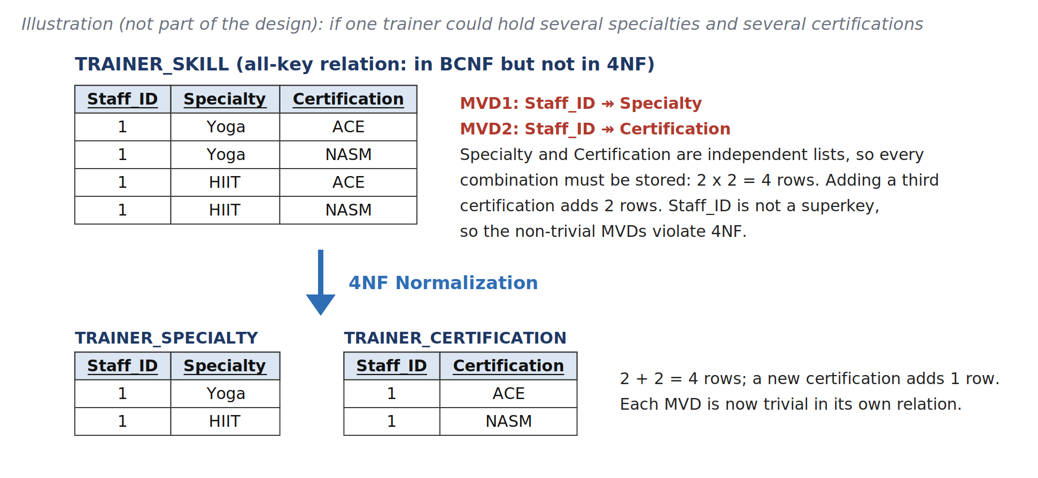
Normalization Figure 8 shows what a 4NF violation would look like in this domain. In the design, TRAINER stores one Specialty and one Certification per trainer, so it has no MVD. If the gym later records several specialties and several certifications per trainer, the 4NF form is two separate relations, TRAINER_SPECIALTY and TRAINER_CERTIFICATION, not one combined table.

2.3.6 Nullable Columns (NULL Policy)
Nine columns in the 17 tables accept NULL; every other column is NOT NULL. Three design choices keep NULLs low. (1) Subclass tables instead of one wide table (Step 8, Option 8A): if Specialty, Certification and Shift_Type were columns of STAFF, every Manager row would hold three NULLs and every Receptionist row two. (2) DEFAULT values for columns that always have a value when a row is inserted, for example MEMBERSHIP.Status = 'Active', BILLING_LOG.Amount_Paid = 0.00 and BILLING_LOG.Invoice_Date = current time. (3) Optional facts stored as separate rows: a machine without service history has no MAINTENANCE_LOG row instead of empty service columns. The table lists each nullable column and what NULL means.
Table | Column | Why NULL is allowed | Meaning of NULL / rule that applies
MEMBER | Birth_Date | Optional personal data; the member may choose not to give it. | Not provided.
MEMBER | Photo | The photo is uploaded after the member record is created. | Not uploaded yet. BR-MEM-03 blocks a membership, a class registration and a PT booking until a photo exists.
MEMBERSHIP_PLAN | Description | Free-text summary; not needed to sell a plan. | No description written.
BILLING_LOG | Membership_ID | A daily-pass bill has no membership. | Daily-pass bill. When not NULL, BR-MEM-07 checks that Visitor_ID owns the membership.
BILLING_LOG | Payment_Date | An invoice exists before it is paid. | Not paid yet (Billing_Status is 'Pending' or 'Failed').
TRAINER | Certification | The qualification may not be recorded when the trainer is hired. | No certification recorded.
ROOM | Floor_Location | Has the default 'Floor 1'; NULL only if the location is not recorded. | Location not recorded.
EQUIPMENT | Room_ID | A machine can be in storage; ON DELETE SET NULL clears it when its room is removed. | Not assigned to a room.
EQUIPMENT | Purchase_Date | May be unknown for older equipment. | Date unknown.

3. Data Dictionary (adapted from ISO/IEC 11179)
ISO/IEC 11179 describes each data element by a name, a definition, a data type and the values it may hold. The tables below use this idea in a simplified form. For every attribute they give the name (Attribute Name), the data type, the key type, whether NULL is allowed, the default value, and the definition with its constraints (Business Rules / Constraints). The permitted values of the status and type columns are listed in Section 3.2. Naming rules: a table name is a singular word in capital letters, joined with underscores (VISITOR, MEMBERSHIP_PLAN); a column name is made of capitalised words joined with underscores (First_Name); a column that holds an artificial key ends with _ID (Visitor_ID, Bill_ID).

3.1 Attribute Tables (17 Tables)

Table 1: VISITOR (Superclass)
Attribute Name | Data Type | Key Type | Nullable? | Default Value | Business Rules / Constraints
Visitor_ID | INT | PK | NO | IDENTITY | Visitor identifier
First_Name | VARCHAR(50) | None | NO | None | First name of the visitor
Last_Name | VARCHAR(50) | None | NO | None | Last name of the visitor
Phone | VARCHAR(15) | UNIQUE | NO | None | Contact phone number

Table 2: MEMBER (Subclass of VISITOR)
Attribute Name | Data Type | Key Type | Nullable? | Default Value | Business Rules / Constraints
Visitor_ID | INT | PK, FK -> VISITOR | NO | None | Subclass PK; references VISITOR(Visitor_ID)
Email | VARCHAR(100) | UNIQUE | NO | None | Member's email address
Birth_Date | DATE | None | YES | NULL | Date of birth (optional)
Photo | VARBINARY(MAX) | None | YES | NULL | Member's photo stored as binary data (NULL until uploaded)
Registration_Date | DATETIME | None | NO | CURRENT_TIMESTAMP | Date and time the member registered

Table 3: DAILY_PASS_TICKET (Subclass of VISITOR)
Attribute Name | Data Type | Key Type | Nullable? | Default Value | Business Rules / Constraints
Visitor_ID | INT | PK, FK -> VISITOR | NO | None | Subclass PK; references VISITOR(Visitor_ID)
Visit_Date | DATE | None | NO | CAST(GETDATE() AS DATE) | Date of the visit
Daily_Rate | DECIMAL(10,2) | None | NO | 15.00 | Price of the pass (CHECK Daily_Rate > 0.00)

Table 4: MEMBERSHIP_PLAN (Plan Catalog)
Attribute Name | Data Type | Key Type | Nullable? | Default Value | Business Rules / Constraints
Plan_ID | INT | PK | NO | IDENTITY | Plan identifier
Plan_Name | VARCHAR(50) | UNIQUE | NO | None | Plan name (Monthly, Annual, VIP)
Duration_Months | INT | None | NO | 1 | Length of the plan in months (CHECK Duration_Months > 0)
Price | DECIMAL(10,2) | None | NO | 0.00 | Price of the plan (CHECK Price >= 0.00)
Description | VARCHAR(255) | None | YES | NULL | Short description of the plan

Table 5: MEMBERSHIP (Member Contracts)
Attribute Name | Data Type | Key Type | Nullable? | Default Value | Business Rules / Constraints
Membership_ID | INT | PK | NO | IDENTITY | Membership identifier
Visitor_ID | INT | FK -> MEMBER | NO | None | Refers to the member, MEMBER(Visitor_ID)
Plan_ID | INT | FK -> MEMBERSHIP_PLAN | NO | None | Refers to the chosen plan, MEMBERSHIP_PLAN(Plan_ID)
Start_Date | DATE | None | NO | None | Start date of the membership
End_Date | DATE | None | NO | None | End date of the membership (CHECK End_Date > Start_Date)
Status | VARCHAR(20) | None | NO | 'Active' | Status: CHECK (Status IN ('Active','Expired','Cancelled'))

Table 6: BILLING_LOG (Bills)
Attribute Name | Data Type | Key Type | Nullable? | Default Value | Business Rules / Constraints
Bill_ID | INT | PK | NO | IDENTITY | Bill number
Visitor_ID | INT | FK -> VISITOR | NO | None | Refers to the visitor who pays, VISITOR(Visitor_ID)
Membership_ID | INT | FK -> MEMBERSHIP | YES | NULL | Refers to the membership (NULL for a daily pass). When filled, it must belong to the same Visitor_ID (checked by trigger)
Invoice_Date | DATETIME | None | NO | CURRENT_TIMESTAMP | Date and time the invoice was issued
Due_Date | DATE | None | NO | None | Last day to pay
Payment_Date | DATETIME | None | YES | NULL | Date and time of payment
Amount_Paid | DECIMAL(10,2) | None | NO | 0.00 | Amount paid (CHECK Amount_Paid >= 0.00)
Billing_Status | VARCHAR(20) | None | NO | 'Pending' | Status: CHECK (Billing_Status IN ('Pending','Paid','Failed'))

Table 7: STAFF (Superclass)
Attribute Name | Data Type | Key Type | Nullable? | Default Value | Business Rules / Constraints
Staff_ID | INT | PK | NO | IDENTITY | Staff identifier
Full_Name | VARCHAR(100) | None | NO | None | Full name of the staff member
Phone | VARCHAR(15) | UNIQUE | NO | None | Phone number of the staff member
Role | VARCHAR(30) | None | NO | 'Receptionist' | Role: CHECK (Role IN ('Trainer','Receptionist','Manager')); must match the subclass table (BR-SCH-01)
Hire_Date | DATE | None | NO | CAST(GETDATE() AS DATE) | Date the staff member was hired
Salary | DECIMAL(10,2) | None | NO | 500.00 | Monthly salary (CHECK Salary > 0.00)

Table 8: TRAINER (Subclass of STAFF)
Attribute Name | Data Type | Key Type | Nullable? | Default Value | Business Rules / Constraints
Staff_ID | INT | PK, FK -> STAFF | NO | None | Subclass PK; references STAFF(Staff_ID); STAFF.Role must be 'Trainer' (BR-SCH-01)
Specialty | VARCHAR(50) | None | NO | 'General' | Coaching field (Yoga, Strength, HIIT)
Certification | VARCHAR(100) | None | YES | NULL | Name of the trainer's qualification

Table 9: RECEPTIONIST (Subclass of STAFF)
Attribute Name | Data Type | Key Type | Nullable? | Default Value | Business Rules / Constraints
Staff_ID | INT | PK, FK -> STAFF | NO | None | Subclass PK; references STAFF(Staff_ID); STAFF.Role must be 'Receptionist' (BR-SCH-01)
Shift_Type | VARCHAR(20) | None | NO | 'Morning' | Shift: CHECK (Shift_Type IN ('Morning','Evening','Night'))

Table 10: ROOM (Training Rooms)
Attribute Name | Data Type | Key Type | Nullable? | Default Value | Business Rules / Constraints
Room_ID | INT | PK | NO | IDENTITY | Room identifier
Room_Name | VARCHAR(50) | UNIQUE | NO | None | Room name (Studio A, Pilates Room)
Capacity | INT | None | NO | 20 | Maximum number of people (CHECK Capacity > 0)
Floor_Location | VARCHAR(30) | None | YES | 'Floor 1' | Floor where the room is

Table 11: SESSION (Superclass)
Attribute Name | Data Type | Key Type | Nullable? | Default Value | Business Rules / Constraints
Session_ID | INT | PK | NO | IDENTITY | Session identifier (class or PT booking)
Session_Type | VARCHAR(10) | None | NO | None | Subclass of the session: CHECK (Session_Type IN ('Class','PT'))
Room_ID | INT | FK -> ROOM | NO | None | Refers to the room
Trainer_ID | INT | FK -> TRAINER | NO | None | Refers to the assigned trainer
Start_Time | DATETIME | None | NO | None | Planned start date and time
End_Time | DATETIME | None | NO | None | Planned end date and time (CHECK End_Time > Start_Time)

Table 12: CLASS (Subclass of SESSION)
Attribute Name | Data Type | Key Type | Nullable? | Default Value | Business Rules / Constraints
Session_ID | INT | PK, FK -> SESSION | NO | None | Subclass PK; references SESSION(Session_ID); Session_Type = 'Class'
Class_Name | VARCHAR(50) | None | NO | None | Name of the class (Zumba, Yoga, HIIT)
Max_Capacity | INT | None | NO | 20 | Maximum number of attendees (CHECK Max_Capacity > 0; not more than ROOM.Capacity, checked by trigger)

Table 13: CLASS_REGISTRATION (Class Registrations)
Attribute Name | Data Type | Key Type | Nullable? | Default Value | Business Rules / Constraints
Session_ID | INT | PK, FK -> CLASS | NO | None | Part 1 of the composite PK (the class)
Visitor_ID | INT | PK, FK -> MEMBER | NO | None | Part 2 of the composite PK (a member registers once per class)
Registration_Date | DATETIME | None | NO | CURRENT_TIMESTAMP | Date and time of registration
Attendance_Status | VARCHAR(20) | None | NO | 'Confirmed' | Status: CHECK (Attendance_Status IN ('Confirmed','Attended','Cancelled'))

Table 14: PT_BOOKING (Subclass of SESSION)
Attribute Name | Data Type | Key Type | Nullable? | Default Value | Business Rules / Constraints
Session_ID | INT | PK, FK -> SESSION | NO | None | Subclass PK; references SESSION(Session_ID); Session_Type = 'PT'
Visitor_ID | INT | FK -> MEMBER | NO | None | Refers to the member, MEMBER(Visitor_ID)
Booking_Status | VARCHAR(20) | None | NO | 'Scheduled' | Status: CHECK (Booking_Status IN ('Scheduled','Completed','Cancelled'))

Table 15: EQUIPMENT (Machines)
Attribute Name | Data Type | Key Type | Nullable? | Default Value | Business Rules / Constraints
Equipment_ID | INT | PK | NO | IDENTITY | Machine identifier
Equipment_Name | VARCHAR(100) | None | NO | None | Machine name (brand/model)
Room_ID | INT | FK -> ROOM | YES | NULL | Refers to the room
Operational_Status | VARCHAR(20) | None | NO | 'Active' | Status: CHECK (Operational_Status IN ('Active','Under Maintenance','Broken'))
Purchase_Date | DATE | None | YES | NULL | Date the machine was bought

Table 16: MAINTENANCE_LOG (Weak Entity: Service History)
Attribute Name | Data Type | Key Type | Nullable? | Default Value | Business Rules / Constraints
Equipment_ID | INT | PK, FK -> EQUIPMENT | NO | None | Part 1 of the composite PK; refers to the machine
Log_no | INT | PK (partial key) | NO | None | Part 2 of the composite PK (log number for each machine)
Maintenance_Date | DATE | None | NO | CAST(GETDATE() AS DATE) | Date of the service
Cost | DECIMAL(10,2) | None | NO | 0.00 | Cost of the repair (CHECK Cost >= 0.00)
Description | VARCHAR(255) | None | NO | None | Short description of the work done
Logged_By | INT | FK -> STAFF | NO | None | Refers to the staff member who signed the log; Role must be 'Receptionist' or 'Manager' (BR-FAC-05, checked by trigger)

Table 17: SESSION_EQUIPMENT_USAGE (Equipment Reservations)
Attribute Name | Data Type | Key Type | Nullable? | Default Value | Business Rules / Constraints
Usage_ID | INT | PK | NO | IDENTITY | Reservation identifier
Equipment_ID | INT | FK -> EQUIPMENT | NO | None | Refers to the reserved machine
Session_ID | INT | FK -> SESSION | NO | None | Refers to the class or PT session that uses the machine
Reserved_From | DATETIME | None | NO | None | Start of the reservation; not before the session's Start_Time (BR-SCH-08)
Reserved_To | DATETIME | None | NO | None | End of the reservation (CHECK Reserved_To > Reserved_From); not after the session's End_Time, and no overlap with another reservation of the same machine (BR-SCH-08)

3.2 Value Definitions for Status and Type Columns
Eight columns accept only a fixed list of values (enforced by the CHECK constraints in Section 4.1.2). The table below defines each value, so that the business rules, triggers and queries all use it with the same meaning.
Table | Column | Value | Default? | Used by | Meaning
MEMBERSHIP | Status | Active | Yes | BR-MEM-10, BR-SCH-05 | The membership is in force. The member may register for classes while today's date is between Start_Date and End_Date.
MEMBERSHIP | Status | Expired | No | BR-SCH-05 | End_Date has passed. The row is kept as history. If staff forget to change Status from 'Active' to 'Expired', the member still cannot register for classes, because BR-SCH-05 also checks the dates.
MEMBERSHIP | Status | Cancelled | No | BR-MEM-06 | The membership ended before End_Date at the request of the member or the gym. The row is kept as history.
BILLING_LOG | Billing_Status | Pending | Yes | BR-MEM-09 | Invoice issued but not paid yet; Payment_Date is NULL.
BILLING_LOG | Billing_Status | Paid | No | BR-MEM-09 | Payment received; Payment_Date records when it was paid.
BILLING_LOG | Billing_Status | Failed | No | BR-MEM-09 | A payment attempt was rejected (e.g., the card was declined); the invoice is not settled.
STAFF | Role | Trainer | No | BR-SCH-01 | Leads group classes or coaches PT sessions; has a row in TRAINER (BR-SCH-01 rejects a TRAINER row for any other role).
STAFF | Role | Receptionist | Yes | BR-SCH-01, BR-FAC-05 | Front-desk staff; has a row in RECEPTIONIST (BR-SCH-01 rejects a RECEPTIONIST row for any other role); may sign maintenance logs.
STAFF | Role | Manager | No | BR-FAC-05 | Runs the gym; has no subclass row (a TRAINER or RECEPTIONIST row for a Manager is rejected); may sign maintenance logs.
RECEPTIONIST | Shift_Type | Morning / Evening / Night | Yes | 1.1.1 | Name of the receptionist's regular shift; the default is 'Morning'. The hours of each shift are set by the gym's staff roster and are not stored in the database.
SESSION | Session_Type | Class | No | BR-SCH-06 | The session is a group class; its details are in CLASS.
SESSION | Session_Type | PT | No | BR-SCH-06 | The session is a private 1-on-1 PT booking; its details are in PT_BOOKING.
CLASS_REGISTRATION | Attendance_Status | Confirmed | Yes | BR-SCH-02 | Member registered and holds a seat; has not checked in yet.
CLASS_REGISTRATION | Attendance_Status | Attended | No | BR-SCH-02 | Member checked in at the front desk when the class took place. Still counts as a seat.
CLASS_REGISTRATION | Attendance_Status | Cancelled | No | BR-SCH-02 | Registration cancelled; the seat is released. The row is kept as history.
PT_BOOKING | Booking_Status | Scheduled | Yes | BR-SCH-03, BR-SCH-04, BR-SCH-08 | Upcoming booking; holds the room, the trainer and any reserved equipment for its time slot.
PT_BOOKING | Booking_Status | Completed | No | BR-SCH-03, BR-SCH-04, BR-SCH-08 | The session took place. Kept as history; still counted in overlap checks.
PT_BOOKING | Booking_Status | Cancelled | No | BR-SCH-03, BR-SCH-04, BR-SCH-08 | Booking cancelled; the room, the trainer's time slot and the equipment reservations of the session are released (not counted in overlap checks).
EQUIPMENT | Operational_Status | Active | Yes | BR-SCH-07, BR-FAC-06 | The machine works and can be reserved.
EQUIPMENT | Operational_Status | Under Maintenance | No | BR-SCH-07, BR-FAC-06 | The machine is being serviced; new reservations are rejected.
EQUIPMENT | Operational_Status | Broken | No | BR-SCH-07, BR-FAC-06 | The machine is out of order; new reservations are rejected until it is repaired.

4. Database Implementation (SQL Style Guide Compliant)
The design of Section 2 is implemented in SQL Server (database GymPlanner) by twelve scripts. They need SQL Server 2016 SP1 or newer, because they use CREATE OR ALTER. Section 4.1 describes the scripts that create the database objects (tables, views, indexes, triggers). Section 4.2 describes the advanced queries and the performance tests.

4.1 DDL Scripts (Tables, Views, Indexes, Triggers)

4.1.1 SQL Style Conventions
Layout: Every script starts with a header comment (purpose, run order). SQL keywords are written in capital letters, indentation uses four spaces (no tabs), each statement ends with a semicolon, and batches are separated by GO. Scripts 08 to 11 also put one column on each line, write every table alias with AS, and indent the JOIN conditions under the JOIN. The triggers of script 02 use the shorter form (alias without AS).
Names: Constraints and objects have a fixed prefix: PK_ (primary key), FK_ (foreign key), UQ_ (UNIQUE), CK_ (CHECK), DF_ (DEFAULT), IX_ and UX_ (index and unique index), trg_ (trigger), vw_ (view) and role_ (database role). Tables are always written with their schema (dbo.VISITOR).
Running again: Scripts 02, 08 and 10 can be run again without error (CREATE OR ALTER, IF NOT EXISTS). Script 01 creates the database only if it does not exist yet; to rebuild the tables, the DROP lines at its top are used.
Dates and errors: Dates are written as yyyy-mm-dd, and the scripts that load or test data start with SET DATEFORMAT ymd, so they give the same result on any language setting of the server. Business-rule errors use the THROW numbers 50001 to 50029.
Style guide: These choices follow the SQL Style Guide of Simon Holywell (sqlstyle.guide) where it fits T-SQL. The main difference is that table and column names keep capital letters, to match the data dictionary and this report.

4.1.2 Tables
Script 01 creates the database and the 17 tables of Section 2.2.2, with 17 primary keys, 20 foreign keys (delete rules in Section 2.2.3), 5 UNIQUE constraints, 19 CHECK constraints and 23 DEFAULT values. As an example, this is the table MEMBERSHIP:
CREATE TABLE dbo.MEMBERSHIP (
Membership_ID INT IDENTITY(1,1) NOT NULL,
Visitor_ID INT NOT NULL,
Plan_ID INT NOT NULL,
Start_Date DATE NOT NULL,
End_Date DATE NOT NULL,
Status VARCHAR(20) NOT NULL
CONSTRAINT DF_MEMBERSHIP_Status DEFAULT 'Active',
CONSTRAINT PK_MEMBERSHIP PRIMARY KEY (Membership_ID),
CONSTRAINT FK_MEMBERSHIP_MEMBER FOREIGN KEY (Visitor_ID)
REFERENCES dbo.MEMBER (Visitor_ID)
ON DELETE NO ACTION ON UPDATE NO ACTION,
CONSTRAINT FK_MEMBERSHIP_PLAN FOREIGN KEY (Plan_ID)
REFERENCES dbo.MEMBERSHIP_PLAN (Plan_ID)
ON DELETE NO ACTION ON UPDATE NO ACTION,
CONSTRAINT CK_MEMBERSHIP_Dates CHECK (End_Date > Start_Date),
CONSTRAINT CK_MEMBERSHIP_Status CHECK (Status IN ('Active','Expired','Cancelled'))
);

4.1.3 Views
Script 08 creates five views. A view is a saved SELECT. The application and the reports read a view instead of repeating a long query, and a view can hide columns: script 10 lets some roles read vw_Trainer_Public but not the table STAFF, which holds the salaries.
View | What it shows | Tables read
vw_Active_Membership | Members with a membership whose Status is 'Active', and the days left (counted from the day the view is read) | MEMBERSHIP, MEMBER, VISITOR, MEMBERSHIP_PLAN
vw_Class_Schedule | Every class with its room, trainer, seats taken and seats left | CLASS, SESSION, ROOM, STAFF, CLASS_REGISTRATION
vw_Member_Billing_Summary | Per member: number of bills, total paid, and bills still 'Pending' or 'Failed' | MEMBER, VISITOR, BILLING_LOG
vw_Trainer_Public | Trainers without Salary and Phone, safe to show to members | TRAINER, STAFF
vw_Equipment_Status | Equipment with its room, last maintenance date, number of logs and total cost | EQUIPMENT, ROOM, MAINTENANCE_LOG

The definitions of the five views:
CREATE OR ALTER VIEW dbo.vw_Active_Membership
AS
SELECT
ms.Membership_ID,
v.Visitor_ID,
v.First_Name + ' ' + v.Last_Name AS Member_Name,
p.Plan_Name,
ms.Start_Date,
ms.End_Date,
DATEDIFF(DAY, CAST(GETDATE() AS DATE), ms.End_Date) AS Days_Left
FROM dbo.MEMBERSHIP AS ms
INNER JOIN dbo.MEMBER AS m
ON m.Visitor_ID = ms.Visitor_ID
INNER JOIN dbo.VISITOR AS v
ON v.Visitor_ID = m.Visitor_ID
INNER JOIN dbo.MEMBERSHIP_PLAN AS p
ON p.Plan_ID = ms.Plan_ID
WHERE ms.Status = 'Active';

CREATE OR ALTER VIEW dbo.vw_Class_Schedule
AS
SELECT
c.Session_ID,
c.Class_Name,
s.Start_Time,
s.End_Time,
r.Room_Name,
st.Full_Name AS Trainer_Name,
c.Max_Capacity,
COUNT(cr.Visitor_ID) AS Seats_Taken,
c.Max_Capacity - COUNT(cr.Visitor_ID) AS Seats_Left
FROM dbo.CLASS AS c
INNER JOIN dbo.[SESSION] AS s
ON s.Session_ID = c.Session_ID
INNER JOIN dbo.ROOM AS r
ON r.Room_ID = s.Room_ID
INNER JOIN dbo.STAFF AS st
ON st.Staff_ID = s.Trainer_ID
LEFT JOIN dbo.CLASS_REGISTRATION AS cr
ON cr.Session_ID = c.Session_ID
AND cr.Attendance_Status <> 'Cancelled'
GROUP BY
c.Session_ID,
c.Class_Name,
s.Start_Time,
s.End_Time,
r.Room_Name,
st.Full_Name,
c.Max_Capacity;

CREATE OR ALTER VIEW dbo.vw_Member_Billing_Summary
AS
SELECT
v.Visitor_ID,
v.First_Name + ' ' + v.Last_Name AS Member_Name,
COUNT(b.Bill_ID) AS Bills,
COALESCE(SUM(CASE WHEN b.Billing_Status = 'Paid'
THEN b.Amount_Paid END), 0.00) AS Total_Paid,
COALESCE(SUM(CASE WHEN b.Billing_Status IN ('Pending', 'Failed')
THEN 1 END), 0) AS Open_Bills
FROM dbo.MEMBER AS m
INNER JOIN dbo.VISITOR AS v
ON v.Visitor_ID = m.Visitor_ID
LEFT JOIN dbo.BILLING_LOG AS b
ON b.Visitor_ID = v.Visitor_ID
GROUP BY
v.Visitor_ID,
v.First_Name,
v.Last_Name;

CREATE OR ALTER VIEW dbo.vw_Trainer_Public
AS
SELECT
st.Staff_ID,
st.Full_Name,
t.Specialty,
t.Certification
FROM dbo.TRAINER AS t
INNER JOIN dbo.STAFF AS st
ON st.Staff_ID = t.Staff_ID;

CREATE OR ALTER VIEW dbo.vw_Equipment_Status
AS
SELECT
e.Equipment_ID,
e.Equipment_Name,
r.Room_Name,
e.Operational_Status,
MAX(ml.Maintenance_Date) AS Last_Maintenance,
COUNT(ml.Log_no) AS Maintenance_Count,
COALESCE(SUM(ml.Cost), 0.00) AS Total_Cost
FROM dbo.EQUIPMENT AS e
LEFT JOIN dbo.ROOM AS r
ON r.Room_ID = e.Room_ID
LEFT JOIN dbo.MAINTENANCE_LOG AS ml
ON ml.Equipment_ID = e.Equipment_ID
GROUP BY
e.Equipment_ID,
e.Equipment_Name,
r.Room_Name,
e.Operational_Status;

Example: reading vw_Class_Schedule on the sample data (times without seconds):
Class_Name | Start_Time | Room_Name | Trainer_Name | Max_Capacity | Seats_Taken | Seats_Left
Yoga Flow | 2026-10-05 07:00 | Yoga Room | Khoa Nguyen Minh | 15 | 2 | 13
Yoga Flow | 2026-10-12 07:00 | Yoga Room | Khoa Nguyen Minh | 15 | 3 | 12
HIIT Burn | 2026-10-12 18:00 | Cardio Zone | Ha Tran Thu | 3 | 3 | 0
Yoga Flow | 2026-10-13 07:00 | Yoga Room | Khoa Nguyen Minh | 15 | 1 | 14
Spinning | 2026-10-14 18:00 | Cardio Zone | Duc Hoang Anh | 25 | 2 | 23

4.1.4 Indexes
Script 03 creates six indexes in addition to the indexes that the PRIMARY KEY and UNIQUE constraints already create. The filtered unique index enforces BR-MEM-10. The other five speed up the overlap checks of the triggers and the lookups by member or by session (NFR-PER). Their effect is measured in Section 4.2.2.
Index | Table | Columns | Purpose
UX_MEMBERSHIP_One_Active | MEMBERSHIP | (Visitor_ID) WHERE Status = 'Active' | BR-MEM-10: one active membership per member
IX_SESSION_Room_Time | SESSION | (Room_ID, Start_Time, End_Time) | Overlap check of BR-SCH-03 (room)
IX_SESSION_Trainer_Time | SESSION | (Trainer_ID, Start_Time, End_Time) | Overlap check of BR-SCH-04 (trainer)
IX_CLASS_REG_Visitor | CLASS_REGISTRATION | (Visitor_ID) | Classes of a member
IX_PT_BOOKING_Visitor | PT_BOOKING | (Visitor_ID) | PT bookings of a member
IX_SEU_Session | SESSION_EQUIPMENT_USAGE | (Session_ID) | Equipment reservations of a session

CREATE UNIQUE NONCLUSTERED INDEX UX_MEMBERSHIP_One_Active
ON dbo.MEMBERSHIP (Visitor_ID)
WHERE Status = 'Active';

CREATE NONCLUSTERED INDEX IX_SESSION_Room_Time
ON dbo.[SESSION] (Room_ID, Start_Time, End_Time);

CREATE NONCLUSTERED INDEX IX_SESSION_Trainer_Time
ON dbo.[SESSION] (Trainer_ID, Start_Time, End_Time);

CREATE NONCLUSTERED INDEX IX_CLASS_REG_Visitor
ON dbo.CLASS_REGISTRATION (Visitor_ID);

CREATE NONCLUSTERED INDEX IX_PT_BOOKING_Visitor
ON dbo.PT_BOOKING (Visitor_ID);

CREATE NONCLUSTERED INDEX IX_SEU_Session
ON dbo.SESSION_EQUIPMENT_USAGE (Session_ID);

4.1.5 Triggers
Script 02 creates 25 AFTER triggers for the rules that a CHECK constraint cannot test, because they involve other rows or other tables (Section 1.2). SQL Server has no BEFORE trigger, so a trigger lets the change happen, tests the result, and if a rule is broken it runs ROLLBACK TRANSACTION and raises an error with THROW. The error message starts with the rule code, for example BR-SCH-02.
Trigger | Table | Event | Rule | Error no.
trg_MEMBER_Disjoint | MEMBER | INSERT, UPDATE | BR-MEM-01 | 50001
trg_DAILY_PASS_Disjoint | DAILY_PASS_TICKET | INSERT, UPDATE | BR-MEM-01 | 50002
trg_MEMBERSHIP_PhotoRequired | MEMBERSHIP | INSERT | BR-MEM-03 | 50003
trg_CLASS_REG_PhotoRequired | CLASS_REGISTRATION | INSERT | BR-MEM-03 | 50004
trg_PT_BOOKING_PhotoRequired | PT_BOOKING | INSERT | BR-MEM-03 | 50005
trg_BILLING_MembershipOwner | BILLING_LOG | INSERT, UPDATE | BR-MEM-07 | 50006
trg_TRAINER_Disjoint | TRAINER | INSERT, UPDATE | BR-SCH-01 | 50007
trg_RECEPTIONIST_Disjoint | RECEPTIONIST | INSERT, UPDATE | BR-SCH-01 | 50008
trg_TRAINER_RoleMatch | TRAINER | INSERT, UPDATE | BR-SCH-01 | 50026
trg_RECEPTIONIST_RoleMatch | RECEPTIONIST | INSERT, UPDATE | BR-SCH-01 | 50027
trg_STAFF_RoleMatch | STAFF | UPDATE | BR-SCH-01 | 50028
trg_CLASS_RoomCapacity | CLASS | INSERT, UPDATE | BR-SCH-02 | 50009
trg_SESSION_RoomCapacity | SESSION | UPDATE | BR-SCH-02 | 50010
trg_ROOM_RoomCapacity | ROOM | UPDATE | BR-SCH-02 | 50011
trg_CLASS_REG_SeatLimit | CLASS_REGISTRATION | INSERT, UPDATE | BR-SCH-02 | 50012
trg_SESSION_NoOverlap | SESSION | INSERT, UPDATE | BR-SCH-03, BR-SCH-04 | 50013 / 50014
trg_PT_BOOKING_RecheckOverlap | PT_BOOKING | UPDATE | BR-SCH-03, BR-SCH-04, BR-SCH-08 | 50015 / 50016 / 50029
trg_CLASS_REG_ActiveMembership | CLASS_REGISTRATION | INSERT | BR-SCH-05 | 50017
trg_CLASS_SessionType | CLASS | INSERT | BR-SCH-06 | 50018
trg_PT_BOOKING_SessionType | PT_BOOKING | INSERT | BR-SCH-06 | 50019
trg_SESSION_TypeLocked | SESSION | UPDATE | BR-SCH-06 | 50020
trg_SEU_EquipmentActive | SESSION_EQUIPMENT_USAGE | INSERT | BR-SCH-07 | 50021
trg_SEU_TimeCheck | SESSION_EQUIPMENT_USAGE | INSERT, UPDATE | BR-SCH-08 | 50023 / 50024
trg_SESSION_ReservationsInside | SESSION | UPDATE | BR-SCH-08 | 50025
trg_MLOG_SignerRole | MAINTENANCE_LOG | INSERT, UPDATE | BR-FAC-05 | 50022

Two examples (the full code is in script 02):
CREATE OR ALTER TRIGGER dbo.trg_MEMBER_Disjoint
ON dbo.MEMBER
AFTER INSERT, UPDATE
AS
BEGIN
SET NOCOUNT ON;
IF EXISTS (SELECT 1 FROM inserted i
JOIN dbo.DAILY_PASS_TICKET d ON d.Visitor_ID = i.Visitor_ID)
BEGIN
ROLLBACK TRANSACTION;
THROW 50001, 'BR-MEM-01: this visitor already holds a daily pass, so cannot also be a member.', 1;
END
END;

CREATE OR ALTER TRIGGER dbo.trg_CLASS_REG_SeatLimit
ON dbo.CLASS_REGISTRATION
AFTER INSERT, UPDATE
AS
BEGIN
SET NOCOUNT ON;
IF EXISTS (SELECT 1
FROM dbo.CLASS c
WHERE c.Session_ID IN (SELECT Session_ID FROM inserted)
AND (SELECT COUNT(*)
FROM dbo.CLASS_REGISTRATION r
WHERE r.Session_ID = c.Session_ID
AND r.Attendance_Status <> 'Cancelled') > c.Max_Capacity)
BEGIN
ROLLBACK TRANSACTION;
THROW 50012, 'BR-SCH-02: registration failed, class capacity reached.', 1;
END
END;

4.1.6 Script List and Run Order
Run order: 01 -> 04 -> 02 -> 03 -> 08 -> 05 -> 09 -> 10 -> 11. Scripts 06, 06b and 07 are optional (large data set). Run script 09 on the sample data only (before script 06, or after script 06b), because the results in Section 4.2.1 belong to the sample data.
Script | Content
01_create_tables.sql | Creates the database and the 17 tables with their primary key, foreign key, UNIQUE, CHECK and DEFAULT constraints.
04_sample_data.sql | Inserts sample rows into every table, consistent with the business rules.
02_triggers.sql | Creates the 25 triggers for the rules in Section 1.2.
03_indexes.sql | Creates the filtered unique index for BR-MEM-10 and five indexes for the overlap and lookup queries.
08_views.sql | Creates the 5 views of Section 4.1.3.
05_trigger_tests.sql | Runs 30 tests of the business rules (triggers, the filtered index, keys and CHECK constraints). Each test runs inside a transaction that is rolled back and prints its result: 28 invalid changes must be blocked and 2 valid changes must be accepted.
09_advanced_queries.sql | Runs the 13 advanced queries of Section 4.2.1 on the sample data.
10_security_rbac.sql | Creates 4 demo logins, users and roles, and the GRANT, DENY and REVOKE statements of Section 5.2.
11_security_tests.sql | Runs 19 access tests as the demo users (Section 5.2.4). Each test is rolled back.
06_bulk_data.sql | Adds about 38,800 generated rows (IDs from 1001) to test the rules and indexes with a larger data set (Section 4.2.2).
07_scale_checks.sql | Repeats six rule tests on the large data set, compares queries with and without indexes, and times a 200-row insert (Section 4.2.2).
06b_remove_bulk_data.sql | Deletes the rows added by script 06 (IDs from 1001); the sample data of script 04 is kept.

4.2 Advanced Queries and Performance Test Cases

4.2.1 Advanced Queries
Script 09 contains 13 queries that use the main techniques of the course: joins of several tables, GROUP BY with HAVING, subqueries, common table expressions (CTE), CASE, window functions and a self-join. They run on the sample data of script 04. That data was written for "today" = 2026-10-07, so the queries use the variable @today instead of GETDATE(); the results below are therefore the same on any day. The results are shown as SSMS returns them, except that times are written without seconds.
All queries run in one batch after this line:
SET DATEFORMAT ymd;
GO

DECLARE @today DATE = '2026-10-07';

Q1. Upcoming classes with seats taken
Classes that start on or after @today: when, in which room, who teaches, and how many seats are taken. A seat is taken by every registration that is not 'Cancelled'.
Technique: 4 INNER JOINs, LEFT JOIN, GROUP BY, COUNT.
SELECT
c.Session_ID,
c.Class_Name,
s.Start_Time,
r.Room_Name,
st.Full_Name AS Trainer_Name,
c.Max_Capacity,
COUNT(cr.Visitor_ID) AS Seats_Taken
FROM dbo.CLASS AS c
INNER JOIN dbo.[SESSION] AS s
ON s.Session_ID = c.Session_ID
INNER JOIN dbo.ROOM AS r
ON r.Room_ID = s.Room_ID
INNER JOIN dbo.STAFF AS st
ON st.Staff_ID = s.Trainer_ID
LEFT JOIN dbo.CLASS_REGISTRATION AS cr
ON cr.Session_ID = c.Session_ID
AND cr.Attendance_Status <> 'Cancelled'
WHERE s.Start_Time >= @today
GROUP BY
c.Session_ID,
c.Class_Name,
s.Start_Time,
r.Room_Name,
st.Full_Name,
c.Max_Capacity
ORDER BY s.Start_Time;

Result: 4 rows
Session_ID | Class_Name | Start_Time | Room_Name | Trainer_Name | Max_Capacity | Seats_Taken
1 | Yoga Flow | 2026-10-12 07:00 | Yoga Room | Khoa Nguyen Minh | 15 | 3
2 | HIIT Burn | 2026-10-12 18:00 | Cardio Zone | Ha Tran Thu | 3 | 3
3 | Yoga Flow | 2026-10-13 07:00 | Yoga Room | Khoa Nguyen Minh | 15 | 1
6 | Spinning | 2026-10-14 18:00 | Cardio Zone | Duc Hoang Anh | 25 | 2

Q2. Members with an active membership today
Members whose membership is active today, with the days left. "Active" follows BR-SCH-05: Status = 'Active' and today lies between Start_Date and End_Date.
Technique: 4 INNER JOINs, BETWEEN, DATEDIFF.
SELECT
v.Visitor_ID,
v.First_Name + ' ' + v.Last_Name AS Member_Name,
p.Plan_Name,
ms.End_Date,
DATEDIFF(DAY, @today, ms.End_Date) AS Days_Left
FROM dbo.MEMBERSHIP AS ms
INNER JOIN dbo.MEMBER AS m
ON m.Visitor_ID = ms.Visitor_ID
INNER JOIN dbo.VISITOR AS v
ON v.Visitor_ID = m.Visitor_ID
INNER JOIN dbo.MEMBERSHIP_PLAN AS p
ON p.Plan_ID = ms.Plan_ID
WHERE ms.Status = 'Active'
AND @today BETWEEN ms.Start_Date AND ms.End_Date
ORDER BY Days_Left, v.Visitor_ID;

Result: 4 rows
Visitor_ID | Member_Name | Plan_Name | End_Date | Days_Left
4 | Dung Pham | Monthly | 2026-10-15 | 8
3 | Cuong Le | Monthly | 2026-10-20 | 13
2 | Binh Tran | Quarterly | 2026-11-01 | 25
1 | An Nguyen | Annual | 2027-09-01 | 329

Q3. Plans with paid revenue above 70.00
Plans that earned more than 70.00 from paid membership bills. WHERE keeps only the 'Paid' bills (filter on rows); HAVING keeps only the plans with a large total (filter on groups).
Technique: Join of 3 tables, GROUP BY, HAVING, SUM, COUNT.
SELECT
p.Plan_Name,
COUNT(b.Bill_ID) AS Paid_Bills,
SUM(b.Amount_Paid) AS Revenue
FROM dbo.BILLING_LOG AS b
INNER JOIN dbo.MEMBERSHIP AS ms
ON ms.Membership_ID = b.Membership_ID
INNER JOIN dbo.MEMBERSHIP_PLAN AS p
ON p.Plan_ID = ms.Plan_ID
WHERE b.Billing_Status = 'Paid'
GROUP BY p.Plan_Name
HAVING SUM(b.Amount_Paid) > 70.00
ORDER BY Revenue DESC;

Result: 2 rows
Plan_Name | Paid_Bills | Revenue
Annual | 1 | 280.00
Quarterly | 1 | 80.00

Q4. Members who never booked a PT session
Members who have never booked a personal-training (PT) session. The same result can be written as a LEFT JOIN with WHERE pt.Session_ID IS NULL.
Technique: NOT EXISTS (correlated subquery).
SELECT
v.Visitor_ID,
v.First_Name + ' ' + v.Last_Name AS Member_Name,
m.Registration_Date
FROM dbo.MEMBER AS m
INNER JOIN dbo.VISITOR AS v
ON v.Visitor_ID = m.Visitor_ID
WHERE NOT EXISTS (SELECT 1
FROM dbo.PT_BOOKING AS pt
WHERE pt.Visitor_ID = m.Visitor_ID)
ORDER BY v.Visitor_ID;

Result: 3 rows
Visitor_ID | Member_Name | Registration_Date
4 | Dung Pham | 2026-06-25
5 | Em Vo | 2026-05-28
6 | Giang Dang | 2026-10-01

Q5. Fill rate of each class
How full each class is: the percent of seats taken and a label (Full, Almost full, Seats available).
Technique: CTE (WITH), CASE, CAST.
WITH seats AS (
SELECT
c.Session_ID,
c.Class_Name,
c.Max_Capacity,
COUNT(cr.Visitor_ID) AS Seats_Taken
FROM dbo.CLASS AS c
LEFT JOIN dbo.CLASS_REGISTRATION AS cr
ON cr.Session_ID = c.Session_ID
AND cr.Attendance_Status <> 'Cancelled'
GROUP BY
c.Session_ID,
c.Class_Name,
c.Max_Capacity
)
SELECT
Session_ID,
Class_Name,
Seats_Taken,
Max_Capacity,
CAST(100.0 * Seats_Taken / Max_Capacity AS DECIMAL(5, 1)) AS Percent_Full,
CASE
WHEN Seats_Taken >= Max_Capacity THEN 'Full'
WHEN Seats_Taken >= 0.8 * Max_Capacity THEN 'Almost full'
ELSE 'Seats available'
END AS Class_Status
FROM seats
ORDER BY Percent_Full DESC, Session_ID;

Result: 5 rows
Session_ID | Class_Name | Seats_Taken | Max_Capacity | Percent_Full | Class_Status
2 | HIIT Burn | 3 | 3 | 100.0 | Full
1 | Yoga Flow | 3 | 15 | 20.0 | Seats available
7 | Yoga Flow | 2 | 15 | 13.3 | Seats available
6 | Spinning | 2 | 25 | 8.0 | Seats available
3 | Yoga Flow | 1 | 15 | 6.7 | Seats available

Q6. Workload of each trainer
Sessions of every trainer by type, and the teaching hours. The LEFT JOIN keeps a trainer who has no session (shown with 0).
Technique: LEFT JOIN, SUM(CASE ...), DATEDIFF.
SELECT
st.Staff_ID,
st.Full_Name,
COUNT(s.Session_ID) AS Sessions,
SUM(CASE WHEN s.Session_Type = 'Class' THEN 1 ELSE 0 END) AS Class_Sessions,
SUM(CASE WHEN s.Session_Type = 'PT' THEN 1 ELSE 0 END) AS PT_Sessions,
CAST(COALESCE(SUM(DATEDIFF(MINUTE, s.Start_Time, s.End_Time)), 0) / 60.0
AS DECIMAL(6, 1)) AS Teaching_Hours
FROM dbo.TRAINER AS t
INNER JOIN dbo.STAFF AS st
ON st.Staff_ID = t.Staff_ID
LEFT JOIN dbo.[SESSION] AS s
ON s.Trainer_ID = t.Staff_ID
GROUP BY
st.Staff_ID,
st.Full_Name
ORDER BY Teaching_Hours DESC, st.Staff_ID;

Result: 3 rows
Staff_ID | Full_Name | Sessions | Class_Sessions | PT_Sessions | Teaching_Hours
1 | Khoa Nguyen Minh | 4 | 3 | 1 | 4.0
2 | Ha Tran Thu | 3 | 1 | 2 | 3.0
6 | Duc Hoang Anh | 1 | 1 | 0 | 1.0

Q7. Overdue bills
Bills that are not 'Paid' and whose due date is before @today, with a suggested action.
Technique: INNER JOIN, CASE, date arithmetic.
SELECT
b.Bill_ID,
v.First_Name + ' ' + v.Last_Name AS Member_Name,
b.Billing_Status,
b.Due_Date,
DATEDIFF(DAY, b.Due_Date, @today) AS Days_Overdue,
CASE
WHEN DATEDIFF(DAY, b.Due_Date, @today) > 30 THEN 'Contact the member'
ELSE 'Send a reminder'
END AS Suggested_Action
FROM dbo.BILLING_LOG AS b
INNER JOIN dbo.VISITOR AS v
ON v.Visitor_ID = b.Visitor_ID
WHERE b.Billing_Status <> 'Paid'
AND b.Due_Date < @today
ORDER BY Days_Overdue DESC;

Result: 2 rows
Bill_ID | Member_Name | Billing_Status | Due_Date | Days_Overdue | Suggested_Action
5 | Em Vo | Failed | 2026-06-08 | 121 | Contact the member
3 | Cuong Le | Pending | 2026-09-27 | 10 | Send a reminder

Q8. Members who joined a class in every room
Members who joined a class (not cancelled) in every room that hosts classes. This is relational division: "there is no room with classes in which the member has no registration".
Technique: Double NOT EXISTS.
SELECT
v.Visitor_ID,
v.First_Name + ' ' + v.Last_Name AS Member_Name
FROM dbo.MEMBER AS m
INNER JOIN dbo.VISITOR AS v
ON v.Visitor_ID = m.Visitor_ID
WHERE NOT EXISTS (
SELECT 1
FROM dbo.ROOM AS r
WHERE EXISTS (SELECT 1
FROM dbo.CLASS AS c
INNER JOIN dbo.[SESSION] AS s
ON s.Session_ID = c.Session_ID
WHERE s.Room_ID = r.Room_ID)
AND NOT EXISTS (SELECT 1
FROM dbo.CLASS_REGISTRATION AS cr
INNER JOIN dbo.[SESSION] AS s2
ON s2.Session_ID = cr.Session_ID
WHERE cr.Visitor_ID = m.Visitor_ID
AND cr.Attendance_Status <> 'Cancelled'
AND s2.Room_ID = r.Room_ID)
)
ORDER BY v.Visitor_ID;

Result: 3 rows
Visitor_ID | Member_Name
1 | An Nguyen
2 | Binh Tran
4 | Dung Pham

Q9. Equipment that is not Active
Equipment that is not 'Active', with its room, the date of the last maintenance and the total maintenance cost.
Technique: Two LEFT JOINs, MAX, SUM, GROUP BY.
SELECT
e.Equipment_ID,
e.Equipment_Name,
e.Operational_Status,
r.Room_Name,
MAX(ml.Maintenance_Date) AS Last_Maintenance,
COALESCE(SUM(ml.Cost), 0.00) AS Total_Cost
FROM dbo.EQUIPMENT AS e
LEFT JOIN dbo.ROOM AS r
ON r.Room_ID = e.Room_ID
LEFT JOIN dbo.MAINTENANCE_LOG AS ml
ON ml.Equipment_ID = e.Equipment_ID
WHERE e.Operational_Status <> 'Active'
GROUP BY
e.Equipment_ID,
e.Equipment_Name,
e.Operational_Status,
r.Room_Name
ORDER BY e.Equipment_ID;

Result: 2 rows
Equipment_ID | Equipment_Name | Operational_Status | Room_Name | Last_Maintenance | Total_Cost
4 | Cable Machine C-01 | Under Maintenance | PT Studio | 2026-10-02 | 120.00
5 | Rowing Machine R-01 | Broken | Cardio Zone | 2026-09-28 | 0.00

Q10. Ranking of members by activity
Members ranked by activity: classes joined plus PT bookings, cancelled ones not counted. DENSE_RANK gives the same rank to ties and does not skip rank numbers.
Technique: CTE, UNION ALL, LEFT JOIN, DENSE_RANK.
WITH activity AS (
SELECT Visitor_ID
FROM dbo.CLASS_REGISTRATION
WHERE Attendance_Status <> 'Cancelled'
UNION ALL
SELECT Visitor_ID
FROM dbo.PT_BOOKING
WHERE Booking_Status <> 'Cancelled'
)
SELECT
v.Visitor_ID,
v.First_Name + ' ' + v.Last_Name AS Member_Name,
COUNT(a.Visitor_ID) AS Activities,
DENSE_RANK() OVER (ORDER BY COUNT(a.Visitor_ID) DESC) AS Activity_Rank
FROM dbo.MEMBER AS m
INNER JOIN dbo.VISITOR AS v
ON v.Visitor_ID = m.Visitor_ID
LEFT JOIN activity AS a
ON a.Visitor_ID = m.Visitor_ID
GROUP BY
v.Visitor_ID,
v.First_Name,
v.Last_Name
ORDER BY Activity_Rank, v.Visitor_ID;

Result: 6 rows
Visitor_ID | Member_Name | Activities | Activity_Rank
1 | An Nguyen | 5 | 1
2 | Binh Tran | 5 | 1
3 | Cuong Le | 2 | 2
4 | Dung Pham | 2 | 2
5 | Em Vo | 0 | 3
6 | Giang Dang | 0 | 3

Q11. Monthly revenue with a running total
Revenue per month (paid bills, by the month of the invoice) with a running total.
Technique: CTE, DATEFROMPARTS, SUM() OVER.
WITH monthly AS (
SELECT
DATEFROMPARTS(YEAR(Invoice_Date), MONTH(Invoice_Date), 1) AS Revenue_Month,
SUM(Amount_Paid) AS Revenue
FROM dbo.BILLING_LOG
WHERE Billing_Status = 'Paid'
GROUP BY DATEFROMPARTS(YEAR(Invoice_Date), MONTH(Invoice_Date), 1)
)
SELECT
Revenue_Month,
Revenue,
SUM(Revenue) OVER (ORDER BY Revenue_Month
ROWS UNBOUNDED PRECEDING) AS Running_Total
FROM monthly
ORDER BY Revenue_Month;

Result: 4 rows
Revenue_Month | Revenue | Running_Total
2026-07-01 | 30.00 | 30.00
2026-08-01 | 80.00 | 110.00
2026-09-01 | 310.00 | 420.00
2026-10-01 | 30.00 | 450.00

Q12. Members who paid more than the average
Members who paid more than the average member. Members who paid nothing count as 0 in the average, which is 70.00 here (420.00 paid by 6 members).
Technique: CTE used twice, scalar subquery with AVG.
WITH member_paid AS (
SELECT
v.Visitor_ID,
v.First_Name + ' ' + v.Last_Name AS Member_Name,
COALESCE(SUM(CASE WHEN b.Billing_Status = 'Paid'
THEN b.Amount_Paid END), 0.00) AS Total_Paid
FROM dbo.MEMBER AS m
INNER JOIN dbo.VISITOR AS v
ON v.Visitor_ID = m.Visitor_ID
LEFT JOIN dbo.BILLING_LOG AS b
ON b.Visitor_ID = v.Visitor_ID
GROUP BY
v.Visitor_ID,
v.First_Name,
v.Last_Name
)
SELECT
Visitor_ID,
Member_Name,
Total_Paid
FROM member_paid
WHERE Total_Paid > (SELECT AVG(Total_Paid) FROM member_paid)
ORDER BY Total_Paid DESC;

Result: 2 rows
Visitor_ID | Member_Name | Total_Paid
1 | An Nguyen | 280.00
2 | Binh Tran | 80.00

Q13. Audit: overlapping sessions
Two sessions that overlap in the same room or with the same trainer. BR-SCH-03 and BR-SCH-04 forbid this, so the result must be empty.
Technique: Self-join.
SELECT
s1.Session_ID AS Session_A,
s2.Session_ID AS Session_B,
s1.Room_ID,
s1.Trainer_ID
FROM dbo.[SESSION] AS s1
INNER JOIN dbo.[SESSION] AS s2
ON s1.Session_ID < s2.Session_ID
AND s1.Start_Time < s2.End_Time
AND s2.Start_Time < s1.End_Time
WHERE s1.Room_ID = s2.Room_ID
OR s1.Trainer_ID = s2.Trainer_ID;

Result: 0 rows (empty), as required.

4.2.2 Performance Test Cases: Larger Data Set and Index Effect
Performance is tested on the large data set of script 06 (about 38,800 rows) with script 07. For any query of Section 4.2.1, SET STATISTICS IO ON and SET STATISTICS TIME ON show the pages read ("logical reads") and the time in milliseconds on the Messages tab; script 09 ends with these two commands as a comment.
The sample data of script 04 has fewer than 100 rows. To check that the rules and indexes still work with more data, script 06 adds 38,790 rows generated with a fixed random seed: 1,800 visitors (1,500 members and 300 daily-pass holders), 1,819 memberships, 2,119 bills, 35 staff (25 trainers, 8 receptionists and 2 managers), 12 rooms, 96 machines with 134 maintenance logs, 4,100 sessions (2,600 classes and 1,500 PT bookings), 20,347 class registrations and 2,395 equipment reservations. All 25 triggers and the filtered unique index were enabled during the load, and no row was rejected. After the load the database held 1,808 visitors, 4,108 sessions and 20,360 class registrations.
Script 07 then repeats six rule tests on the large data set. Each test runs inside a transaction that is rolled back, so no data is changed. All six changes were blocked with the expected error:
Test | Rule | Attempted change | Result
A1 | BR-SCH-03 | New session in a room that is already used at that time | Blocked, error 50013
A2 | BR-MEM-10 | Second Active membership for the same member | Blocked, error 2601 (filtered unique index)
A3 | BR-SCH-02 | Registration in a class whose seats are all taken | Blocked, error 50012
A4 | BR-SCH-05 | Registration by a member with no active membership | Blocked, error 50017
A5 | BR-MEM-03 | Membership for a member with no photo | Blocked, error 50003
A6 | BR-SCH-07 | Reservation of a Broken machine | Blocked, error 50021
In the first run, test A4 picked a member who also had no photo, so BR-MEM-03 (error 50004) stopped the insert before BR-SCH-05 was checked. The test was changed to pick a member with a photo, and the second run returned error 50017.
Script 07 also runs three common queries twice: once with the index and once with the hint WITH (INDEX(0)), which makes SQL Server scan the whole table. The numbers are logical reads from SET STATISTICS IO (one read = one 8 KB page):
Query | Index used | With index | Without index
Timetable of one room for one week | IX_SESSION_Room_Time | 22 to 25 | 25
Schedule of one trainer for one week | IX_SESSION_Trainer_Time | 12 | 25
All classes of one member | IX_CLASS_REG_Visitor | 26 | 157
With 4,108 rows the SESSION table fills only about 25 pages, so a full scan is already cheap and the room index gives no real gain for that query. The gain is larger on CLASS_REGISTRATION (20,360 rows), where the index reads about six times fewer pages. Every query in the script finished in under 15 ms. Inserting 200 new sessions in one statement, while the triggers checked room and trainer overlaps against the existing sessions, took 124 ms. These figures come from one computer and one user; they do not test many users booking at the same time (Section 6.3).

5. Verification and Security
This section shows that the database rejects bad data (Section 5.1) and that access to the data is limited by role (Section 5.2).

5.1 Test Cases: Constraints Prevent Bad Data
Script 05 runs 30 tests on the sample data. Each test tries one change that breaks a rule (for two tests, a valid change) inside BEGIN TRAN ... ROLLBACK, so the data is not changed, and prints "Blocked" or "Accepted". The expected result is 28 blocked changes and 2 accepted changes. Of the 28, 23 are blocked by triggers, 2 by foreign keys, and one each by the filtered unique index, a primary key and a CHECK constraint.
No. | Rule | Change tried | Expected result
1 | BR-MEM-01 | Make daily-pass visitor 7 a member | Blocked: trg_MEMBER_Disjoint (50001)
2 | BR-MEM-01 | Give member 1 a daily pass | Blocked: trg_DAILY_PASS_Disjoint (50002)
3 | BR-MEM-02 | Daily-pass visitor 7 registers for class 1 | Blocked: foreign key FK_CREG_MEMBER (547)
4 | BR-MEM-03 | Member 6 (no photo) buys a membership | Blocked: trg_MEMBERSHIP_PhotoRequired (50003)
5 | BR-MEM-07 | Bill of visitor 2 points to the membership of visitor 1 | Blocked: trg_BILLING_MembershipOwner (50006)
6 | BR-MEM-08 | Delete visitor 1, who has bills and a membership | Blocked: foreign keys with NO ACTION (547)
7 | BR-MEM-08 | Delete a visitor entered by mistake (no other records) | Accepted
8 | BR-MEM-10 | Second 'Active' membership for member 1 | Blocked: unique index UX_MEMBERSHIP_One_Active (2601)
9 | BR-SCH-01 | Add a RECEPTIONIST row for trainer (staff 1) | Blocked: trigger (50008 or 50027)
10 | BR-SCH-01 | Add a TRAINER row for receptionist (staff 3) | Blocked: trigger (50007 or 50026)
11 | BR-SCH-01 | Add the manager (staff 5) as a trainer | Blocked: trg_TRAINER_RoleMatch (50026)
12 | BR-SCH-01 | Change Role of trainer 1 to 'Manager' | Blocked: trg_STAFF_RoleMatch (50028)
13 | BR-SCH-02 | Class of 25 seats in the Yoga Room (capacity 20) | Blocked: trg_CLASS_RoomCapacity (50009)
14 | BR-SCH-02 | Cancelled member re-confirms in a full class (3 of 3 seats) | Blocked: trg_CLASS_REG_SeatLimit (50012)
15 | BR-SCH-02 | Member 1 registers for class 3 (2 of 15 seats used after this) | Accepted
16 | BR-SCH-03 | New session in the Yoga Room 07:30-08:30 while class 1 uses 07:00-08:00 | Blocked: trg_SESSION_NoOverlap (50013)
17 | BR-SCH-04 | Trainer 1 gets a PT session 07:30-08:30 while leading class 1 | Blocked: trg_SESSION_NoOverlap (50014)
18 | BR-SCH-03 | Cancel PT 4, reuse its slot, then un-cancel PT 4 | Steps 1-2 accepted; step 3 blocked: trg_PT_BOOKING_RecheckOverlap (50015)
19 | BR-SCH-05 | Member 5 (membership 'Cancelled') registers for class 6 | Blocked: trg_CLASS_REG_ActiveMembership (50017)
20 | BR-SCH-06 | Add a CLASS row for PT session 4 | Blocked: trg_CLASS_SessionType (50018)
21 | BR-SCH-06 | Add a PT_BOOKING row for class session 1 | Blocked: trg_PT_BOOKING_SessionType (50019)
22 | BR-SCH-06 | Change Session_Type of session 1 from 'Class' to 'PT' | Blocked: trg_SESSION_TypeLocked (50020)
23 | BR-SCH-07 | Reserve equipment 4 (Under Maintenance) | Blocked: trg_SEU_EquipmentActive (50021)
24 | BR-SCH-07 | Reserve equipment 5 (Broken) | Blocked: trg_SEU_EquipmentActive (50021)
25 | BR-SCH-08 | Reserve the yoga mats for a second class at the same time as class 1 | Step 1 accepted; step 2 blocked: trg_SEU_TimeCheck (50024)
26 | BR-SCH-08 | Reserve a spin bike 09:30-10:30 for PT session 4, which ends at 10:00 | Blocked: trg_SEU_TimeCheck (50023)
27 | BR-SCH-08 | Shorten class 1 to end at 07:30 while the mats are reserved until 08:00 | Blocked: trg_SESSION_ReservationsInside (50025)
28 | BR-FAC-05 | A trainer (staff 1) signs a maintenance log | Blocked: trg_MLOG_SignerRole (50022)
29 | BR-FAC-03 | Second log with Log_no = 1 for equipment 4 | Blocked: primary key PK_MAINTENANCE_LOG (2627)
30 | BR-FAC-07 | Maintenance log with Cost = -50 | Blocked: CHECK constraint CK_MLOG_Cost (547)

How to run: run the scripts in the order of Section 4.1.6, then script 05 in SSMS, and read the Messages tab. A line "NOT BLOCKED - rule failed" means that a rule does not work. A rejected INSERT still uses up an IDENTITY number, so later IDs may skip numbers; this is normal.

5.2 Role-Based Access Control (RBAC)

5.2.1 Roles and Principles
A login is the account that a person uses to connect to SQL Server, a user is that login inside the database GymPlanner, and a role is a named set of permissions. Permissions are given to roles only, so a new employee just joins a role. GRANT gives a permission, DENY forbids it (DENY always wins over GRANT), and REVOKE removes an earlier GRANT or DENY. Each role gets only what its work needs (least privilege).
Role | Who | Permissions in short
role_Manager | Manager | Reads and changes all data. Cannot delete bills (DENY DELETE on BILLING_LOG) and cannot change the design (no CREATE or ALTER).
role_Receptionist | Front desk | Manages visitors, members, memberships, bills, class registrations and PT bookings; reads the schedule and the equipment. Cannot read STAFF (salaries). On bills only the payment columns can change; no deletes.
role_Trainer | Trainers | Reads the schedule, rooms and equipment, and the names (not the phones) of members. Marks attendance and the result of PT bookings. Cannot read bills, memberships or salaries.
role_Member | Members (future portal) | Reads only public information: class schedule, trainer list and membership plans.

Link to the application: the three staff roles have the same names as the values of STAFF.Role (Manager, Receptionist, Trainer). role_Member is for a member portal that does not exist yet.
Demo accounts: script 10 creates one demo login for each role (gym_manager, gym_reception, gym_trainer, gym_member). Their passwords are for this course project only.

5.2.2 Permission Matrix
The matrix shows what each role may do on each table and view. S = SELECT, I = INSERT, U = UPDATE, D = DELETE; an asterisk means that only some columns are allowed (see the notes below the table); "-" means no permission.
Object | Manager | Receptionist | Trainer | Member
VISITOR | SIUD | SIU | S* | -
MEMBER | SIUD | SIU | - | -
DAILY_PASS_TICKET | SIUD | SIU | - | -
MEMBERSHIP_PLAN | SIUD | S | - | S
MEMBERSHIP | SIUD | SIU | - | -
BILLING_LOG | SIU | S I U* | - | -
STAFF | SIUD | - | - | -
TRAINER | SIUD | - | - | -
RECEPTIONIST | SIUD | - | - | -
ROOM | SIUD | S | S | -
SESSION | SIUD | S | S | -
CLASS | SIUD | S | S | -
CLASS_REGISTRATION | SIUD | SIU | S U* | -
PT_BOOKING | SIUD | SIU | S U* | -
EQUIPMENT | SIUD | S U* | S | -
MAINTENANCE_LOG | SIUD | SI | - | -
SESSION_EQUIPMENT_USAGE | SIUD | S | S | -
vw_Active_Membership | S | S | - | -
vw_Class_Schedule | S | S | S | S
vw_Member_Billing_Summary | S | S | - | -
vw_Trainer_Public | S | S | S | S
vw_Equipment_Status | S | S | - | -

- Manager: BILLING_LOG has no D, because of DENY DELETE (a bill is never deleted).
- Trainer, VISITOR (S*): only Visitor_ID, First_Name and Last_Name, not Phone.
- Receptionist, BILLING_LOG (U*): only Payment_Date, Amount_Paid and Billing_Status.
- Receptionist, EQUIPMENT (U*): only Operational_Status (to report a broken machine).
- Trainer, CLASS_REGISTRATION (U*): only Attendance_Status. Trainer, PT_BOOKING (U*): only Booking_Status.
- Views: a role needs only SELECT on a view; it needs no permission on the tables behind the view.

5.2.3 GRANT, DENY and REVOKE Statements
The statements below are taken from script 10 (the CREATE LOGIN statements, which contain the demo passwords, are left out).
IF DATABASE_PRINCIPAL_ID(N'gym_manager') IS NULL
CREATE USER gym_manager FOR LOGIN gym_manager;
IF DATABASE_PRINCIPAL_ID(N'gym_reception') IS NULL
CREATE USER gym_reception FOR LOGIN gym_reception;
IF DATABASE_PRINCIPAL_ID(N'gym_trainer') IS NULL
CREATE USER gym_trainer FOR LOGIN gym_trainer;
IF DATABASE_PRINCIPAL_ID(N'gym_member') IS NULL
CREATE USER gym_member FOR LOGIN gym_member;
GO

IF DATABASE_PRINCIPAL_ID(N'role_Manager') IS NULL
CREATE ROLE role_Manager;
IF DATABASE_PRINCIPAL_ID(N'role_Receptionist') IS NULL
CREATE ROLE role_Receptionist;
IF DATABASE_PRINCIPAL_ID(N'role_Trainer') IS NULL
CREATE ROLE role_Trainer;
IF DATABASE_PRINCIPAL_ID(N'role_Member') IS NULL
CREATE ROLE role_Member;
GO

IF IS_ROLEMEMBER(N'role_Manager', N'gym_manager') = 0
ALTER ROLE role_Manager ADD MEMBER gym_manager;
IF IS_ROLEMEMBER(N'role_Receptionist', N'gym_reception') = 0
ALTER ROLE role_Receptionist ADD MEMBER gym_reception;
IF IS_ROLEMEMBER(N'role_Trainer', N'gym_trainer') = 0
ALTER ROLE role_Trainer ADD MEMBER gym_trainer;
IF IS_ROLEMEMBER(N'role_Member', N'gym_member') = 0
ALTER ROLE role_Member ADD MEMBER gym_member;
GO

-- role_Manager: all data, no design changes
GRANT SELECT, INSERT, UPDATE, DELETE ON SCHEMA::dbo TO role_Manager;
-- Bills are never deleted (the foreign keys of BILLING_LOG use ON DELETE
-- RESTRICT for the same reason). DENY wins over the GRANT above.
DENY DELETE ON dbo.BILLING_LOG TO role_Manager;
GO

-- role_Receptionist: front-desk work
GRANT SELECT, INSERT, UPDATE ON dbo.VISITOR TO role_Receptionist;
GRANT SELECT, INSERT, UPDATE ON dbo.MEMBER TO role_Receptionist;
GRANT SELECT, INSERT, UPDATE ON dbo.DAILY_PASS_TICKET TO role_Receptionist;
GRANT SELECT, INSERT, UPDATE ON dbo.MEMBERSHIP TO role_Receptionist;
GRANT SELECT, INSERT, UPDATE ON dbo.BILLING_LOG TO role_Receptionist;
GRANT SELECT, INSERT, UPDATE ON dbo.CLASS_REGISTRATION TO role_Receptionist;
GRANT SELECT, INSERT, UPDATE ON dbo.PT_BOOKING TO role_Receptionist;
GRANT SELECT, INSERT ON dbo.MAINTENANCE_LOG TO role_Receptionist;
GRANT SELECT ON dbo.MEMBERSHIP_PLAN TO role_Receptionist;
GRANT SELECT ON dbo.ROOM TO role_Receptionist;
GRANT SELECT ON dbo.[SESSION] TO role_Receptionist;
GRANT SELECT ON dbo.CLASS TO role_Receptionist;
GRANT SELECT ON dbo.EQUIPMENT TO role_Receptionist;
GRANT SELECT ON dbo.SESSION_EQUIPMENT_USAGE TO role_Receptionist;
GRANT SELECT ON dbo.vw_Active_Membership TO role_Receptionist;
GRANT SELECT ON dbo.vw_Class_Schedule TO role_Receptionist;
GRANT SELECT ON dbo.vw_Member_Billing_Summary TO role_Receptionist;
GRANT SELECT ON dbo.vw_Trainer_Public TO role_Receptionist;
GRANT SELECT ON dbo.vw_Equipment_Status TO role_Receptionist;
-- A receptionist reports a broken machine: only the status column may change.
GRANT UPDATE (Operational_Status) ON dbo.EQUIPMENT TO role_Receptionist;
GO

-- Tighten the permission on bills with REVOKE: the table-wide UPDATE is
-- removed, then only the columns that record a payment are allowed. A
-- receptionist can no longer change the invoice date, due date or owner.
REVOKE UPDATE ON dbo.BILLING_LOG FROM role_Receptionist;
GRANT UPDATE (Payment_Date, Amount_Paid, Billing_Status) ON dbo.BILLING_LOG TO role_Receptionist;
GO

-- role_Trainer: schedule and attendance
GRANT SELECT ON dbo.[SESSION] TO role_Trainer;
GRANT SELECT ON dbo.CLASS TO role_Trainer;
GRANT SELECT ON dbo.PT_BOOKING TO role_Trainer;
GRANT SELECT ON dbo.CLASS_REGISTRATION TO role_Trainer;
GRANT SELECT ON dbo.ROOM TO role_Trainer;
GRANT SELECT ON dbo.EQUIPMENT TO role_Trainer;
GRANT SELECT ON dbo.SESSION_EQUIPMENT_USAGE TO role_Trainer;
GRANT SELECT ON dbo.vw_Class_Schedule TO role_Trainer;
GRANT SELECT ON dbo.vw_Trainer_Public TO role_Trainer;
-- A trainer sees the names of the people in a session, but not their phone.
GRANT SELECT (Visitor_ID, First_Name, Last_Name) ON dbo.VISITOR TO role_Trainer;
-- A trainer marks attendance and the result of a PT booking, nothing else.
GRANT UPDATE (Attendance_Status) ON dbo.CLASS_REGISTRATION TO role_Trainer;
GRANT UPDATE (Booking_Status) ON dbo.PT_BOOKING TO role_Trainer;
GO

-- role_Member: public information only
GRANT SELECT ON dbo.vw_Class_Schedule TO role_Member;
GRANT SELECT ON dbo.vw_Trainer_Public TO role_Member;
GRANT SELECT ON dbo.MEMBERSHIP_PLAN TO role_Member;
GO

5.2.4 Access Tests
Script 11 tests the roles. Each test pretends to be one demo user with EXECUTE AS USER, tries one action inside a transaction, and then rolls everything back. "allowed" means that the action works; "denied" means that SQL Server refuses it with error 229, 230 or 262 (permission denied). The last result grid lists every test with PASS or FAIL, and the expected result is 19 PASS.
No. | User | Action tried | Expected | Why
1 | gym_member | Read the view vw_Class_Schedule | allowed | SELECT on the view
2 | gym_member | Read the view vw_Trainer_Public | allowed | SELECT on the view
3 | gym_member | Read the table MEMBERSHIP_PLAN | allowed | SELECT on the table
4 | gym_member | Read the table STAFF (salaries) | denied | no permission on STAFF
5 | gym_member | Read the table BILLING_LOG | denied | no permission
6 | gym_member | Insert a row into VISITOR | denied | no INSERT permission
7 | gym_reception | Read the table VISITOR | allowed | SELECT on the table
8 | gym_reception | Read the table STAFF (salaries) | denied | no permission on STAFF
9 | gym_reception | Delete from MEMBERSHIP | denied | no DELETE permission
10 | gym_reception | Record a payment: update Billing_Status | allowed | UPDATE on this column
11 | gym_reception | Change the Due_Date of a bill | denied | UPDATE only on the payment columns (REVOKE, then column GRANT)
12 | gym_trainer | Read the table BILLING_LOG | denied | no permission
13 | gym_trainer | Read the column VISITOR.First_Name | allowed | column in the SELECT list
14 | gym_trainer | Read the column VISITOR.Phone | denied | column not in the SELECT list
15 | gym_trainer | Mark attendance: update Attendance_Status | allowed | UPDATE on this column
16 | gym_trainer | Change the member of a PT booking | denied | UPDATE only on Booking_Status
17 | gym_manager | Update a salary in STAFF | allowed | GRANT on the schema dbo
18 | gym_manager | Delete from BILLING_LOG | denied | DENY DELETE wins over the GRANT
19 | gym_manager | Create a table (design change) | denied | no CREATE TABLE permission

5.2.5 Views and the Java Application
Views and permissions: a view and its tables have the same owner (dbo), so SQL Server checks only the permission on the view (ownership chaining). This is how role_Member can read vw_Trainer_Public without any permission on STAFF.
Java application: the application connects with one SQL login (gym_app, created by db/setup_local_sqlserver.ps1 with the db_owner role) and decides what a staff member may do from STAFF.Role in Java code. The four roles of this section protect direct access to the database (for example from SSMS or a report tool). To enforce them in the application, it would connect with one login per role (see Section 6.3).

6. Conclusion

6.1 Summary of the Design
The design has 17 relations, mapped from the EER model with the Elmasri & Navathe algorithm (Steps 1-9, Option 8A for the three disjoint specializations). Section 2.3 shows the functional dependencies of every relation: 16 relations are in BCNF and 4NF, and BILLING_LOG keeps one documented redundancy guarded by a trigger (Section 2.3.4). Nine columns accept NULL, each for a stated reason (Section 2.3.6). Integrity is enforced at three levels: primary key, foreign key, UNIQUE and CHECK constraints in the table definitions; a filtered unique index for BR-MEM-10; and 25 triggers for the rules that involve other rows or other tables, which a CHECK constraint cannot test. Script 08 adds five views and script 09 runs 13 advanced queries on the sample data (Section 4.2). Script 05 tests 30 rule cases (Section 5.1), and scripts 10 and 11 define and test four database roles with GRANT, DENY and REVOKE (Section 5.2).

6.2 Room for Extension
The table shows how some likely future changes fit into the schema. Most of them only add rows or tables; only one (several specialties or certifications per trainer) moves columns out of an existing table.
Future change | What is needed | Existing tables altered?
New membership plan (e.g., 12 months) | INSERT one row into MEMBERSHIP_PLAN. | No
New room, machine or class time | INSERT rows into ROOM, EQUIPMENT, SESSION and CLASS. | No
New staff type with its own attributes | New subclass table with Staff_ID as primary key and foreign key (same pattern as TRAINER), plus Disjoint and RoleMatch triggers like those of TRAINER; trg_STAFF_RoleMatch must also be extended to check the new table. | Only CK_STAFF_Role (add the new value)
Several specialties or certifications per trainer | Two new relations, TRAINER_SPECIALTY and TRAINER_CERTIFICATION (Normalization Figure 8); copy the existing values into them. | TRAINER: Specialty and Certification move out
New session type (e.g., small-group PT) | New subclass table of SESSION and an update of the BR-SCH-06 triggers. | Only CK_SESSION_Type (add the new value)
New status value | Change the CHECK constraint and add the meaning to Section 3.2. | Only the CHECK constraint
The weak point of this approach is that the fixed value lists are kept in CHECK constraints, so a new value needs an ALTER TABLE. A lookup table for each list would avoid that; the team kept the CHECK lists because each list is short and rarely changes.

6.3 Known Limitations
Two bookings at the same moment: the seat-limit and overlap triggers read other rows inside the same transaction as the insert. Under SQL Server's default READ COMMITTED isolation with locking, a second booking for the last seat waits until the first one finishes, or SQL Server ends one of them as a deadlock victim, so the limit still holds. If the database is switched to READ_COMMITTED_SNAPSHOT, both bookings could pass the check. A production system would add locking hints (UPDLOCK, HOLDLOCK) inside the triggers or run bookings at the SERIALIZABLE isolation level; this case was not tested in the project.
Total specialization: every VISITOR row should have a MEMBER or DAILY_PASS_TICKET row, and every SESSION row a CLASS or PT_BOOKING row. A constraint cannot require a row in another table at the moment of the first INSERT, so the application must insert the superclass row and its subclass row in one transaction.
Equipment quantity: each EQUIPMENT row is one physical machine, and the table has no quantity column. BR-SCH-08 stops the same machine (same Equipment_ID) from being reserved for overlapping times, but the database does not limit how many machines of one kind a session reserves, as long as each one is a different free machine. Items kept in sets (e.g., yoga mats) are recorded as one row per set.
Fixed value lists: see Section 6.2.
Roles and the application: the four database roles are defined and tested (Section 5.2), but the Java application connects with one SQL login and checks STAFF.Role itself. A later version could connect with one login per role, so that the database also enforces the permissions of the application.
Outside the scope of this phase: the backup schedule and audit columns such as created and updated time.

7. References
Date, C. J., & Fagin, R. (1992). Simple conditions for guaranteeing higher normal forms in relational databases. ACM Transactions on Database Systems, 17(3), 465-476.
Elmasri, R., & Navathe, S. B. (2016). Fundamentals of Database Systems (7th ed.). Pearson.
Holywell, S. SQL Style Guide. https://www.sqlstyle.guide/
ISO/IEC 11179-1:2015. Information technology - Metadata registries (MDR) - Part 1: Framework.
ISO/IEC/IEEE 29148:2018. Systems and software engineering - Life cycle processes - Requirements engineering.
Microsoft. SQL Server technical documentation (CREATE TRIGGER, filtered indexes, SET STATISTICS IO, CREATE VIEW, GRANT/DENY/REVOKE, ownership chains). Microsoft Learn.

