DATABASE PROJECT REPORT
Gym Membership & Personal Training Planner
(Project ID: #9)
____________________________________________________
A. PROJECT IDENTITY
Team Name | Dong Vui
Project ID & Title | #9: Gym Membership & Personal Training Planner
Course | INT1313 - Database Basics
Instructor | Lê Hà Thanh
Academic Year | 2026-2027 (Semester 1)

Team Members:

Full Name | Student ID | Class | Institutional Email
Tran Duc Phuong | N24DCCN154 | D24CQCN02-N | n24dccn154@student.ptithcm.edu.vn
Nguyen Luu Trieu Quang | N24DCCN158 | D24CQCN02-N mới | n24dccn158@student.ptithcm.edu.vn
Nguyen Van Hoang Te | N24DCCN071 | D24CQCN01-N | n24dccn071@student.ptithcm.edu.vn

Table of Contents
—

B. REPORT STRUCTURE
- Introduction & Project Scope (ISO/IEC/IEEE 29148 Standard)
  - System Objective
- (Content) In the modern fitness industry, managing memberships, tracking personal training schedules, and maintaining equipment manually often lead to data errors, scheduling conflicts, and operational inefficiency.
- (Overall Objective) To address these challenges, the Gym Membership and Personal Training Management System is designed to digitalize and streamline core gym operations.
- (Specific Objectives) The system aims to:

- Manage member profiles, membership plans, and membership records in a centralized database.
- Manage class schedules and personal trainer (PT) bookings while reducing scheduling conflicts among trainers, members, and rooms.
- Maintain fitness equipment and maintenance records to support facility management.
- Maintain accurate membership and billing records for reliable financial and membership tracking.
- Ensure data consistency, integrity, and traceability across the database.

    - Core Entity Definitions & Business Semantics
To establish a common understanding of the system and avoid ambiguity in the requirements, the following key terms are defined:
      - Member: A specialized subtype entity inheriting from VISITOR via a Disjoint Specialization (d) constraint. It represents a registered individual authorized to access gym services. Rather than maintaining an independent identifier, MEMBER inherits Visitor_ID as its combined Primary Key (PK) and Foreign Key (FK) referencing VISITOR(Visitor_ID). Core attributes specific to a Member include Registration_Date, profile/verification photos, and member status tracking. A Member record persists in the system indefinitely, regardless of whether the individual currently holds an active Membership contract.
      - Membership: A transactional entity representing an active or historical contract linking a registered Member to a specific Membership Plan over a defined duration (from Start_Date to End_Date). It tracks the specific lifecycle Status (e.g., 'Active', 'Expired', 'Cancelled'). A Member can hold zero or multiple Membership records over their lifetime, but at any single timestamp, a Member can have at most one active Membership. When a membership expires or is terminated, the record is permanently retained in the database as historical information rather than deleted.
      - Membership Plan: Defines the standardized membership packages pre-set by the gym (e.g., Monthly, Annual, VIP). It includes Plan_ID (Primary Identifier), Plan_Name (UNIQUE), Duration_Months (with constraint CHECK (Duration_Months > 0)), and Price (NOT NULL, with constraint CHECK (Price > 0)).
      - Daily Pass Ticket: A transactional entity representing single-visit daily passes purchased by non-registered walk-in guests. It tracks basic guest contact details (Guest_Name, Phone), the Visit_Date, and the Daily_Rate paid, serving as an auditing log for front-desk cash receipts. Each ticket is uniquely identified by Ticket_ID.
      - Billing Log: An automated financial ledger tracking all cash inflows. It supports both Membership billings (linked to a registered Member through a Membership record) and walk-in ticket sales (linked to a Daily_Pass_Ticket via Ticket_ID). It tracks Billing_Status ('Pending', 'Paid', 'Failed'), Invoice_Date, Due_Date, and Payment_Date (set upon payment), providing a comprehensive audit trail and supporting billing management workflows.
      - Session Equipment Usage: An associative relationship entity representing the many-to-many (M:N) relationship where gym sessions (group Class or private PT Booking) reserve physical Equipment. It tracks specific Equipment_ID reservations for a Class_ID or Booking_ID, ensuring machines are reserved dynamically.
      - Staff: The superclass entity representing all employees working at the gym. It is identified by Staff_ID (Primary Identifier) and tracks Name, Role ('Trainer', 'Receptionist', 'Manager'), and Monthly Salary (with constraint CHECK (Salary > 0)).
      - Trainer / PT: A specialized subclass of Staff representing Personal Trainers. They possess unique attributes such as Specialty (e.g., Yoga, Strength) and Certification. Trainers are directly responsible for leading public group classes or private one-on-one PT bookings.
      - Receptionist: A specialized subclass of Staff responsible for managing front-desk shifts (Shift: Morning, Evening, Night) and signing off on hardware maintenance logs.
      - Room: Manages the physical infrastructure and training spaces of the gym. Identified by Room_ID (Primary Identifier), it tracks Room_Name (UNIQUE), Room Type (e.g., 'Group Studio', 'Open Gym Floor', 'Pilates Room'), and physical Max Capacity (with constraint CHECK (Capacity > 0)).
      - Class: Represents public group classes (Zumba, Yoga, HIIT) scheduled by the gym. Attributes include Class_ID (Primary Identifier), Class_Name, Room_ID (physical room), and Trainer_ID (instructor). It is scheduled with precise Start_Time and End_Time timestamps, utilizing dynamic validation to prevent room and trainer scheduling overlaps.
      - Class Registration: An associative entity representing the many-to-many (M:N) relationship where a registered Member registers for a group Class. It uses a composite primary identifying attribute {Class_ID, Member_ID}. Registrations are restricted to members with active memberships.
      - PT Booking: Manages private one-on-one sessions between a registered Member and an assigned Personal Trainer (PT). Identified by Booking_ID (Primary Identifier), it is scheduled in a physical Room_ID with precise Start_Time and End_Time timestamps, subject to strict overlapping interval constraints.
      - Equipment: Manages physical workout machines and assets. Identified by Equipment_ID (Primary Identifier), it tracks Name, Type (Cardio, Strength, Recovery), and operational Status ('Active', 'Under Maintenance', 'Broken'). If equipment status is broken, the system blocks bookings involving it.
      - Maintenance Log: A weak entity representing the history of service and repairs on a specific equipment. Because it cannot exist without its parent machine, it uses a composite primary identifying attribute {Equipment_ID, Log_no} (where Log_no is a partial key). It tracks Maintenance_Date, Cost (CHECK (Cost >= 0)), Description, and Logged_By (receptionist/manager signing off on the repair).
    - Explanation of Technical Terms
● Entity & Attribute: An entity represents a physical or abstract real-world object with an independent existence (e.g., MEMBER, EQUIPMENT). An attribute represents a specific characteristic describing that entity (e.g., Phone and Email are attributes of a Member).
● Relationship: A business-meaningful association between two or more entities (e.g., the MEMBERSHIP relationship links registered Member and Membership Plan).
● Enhanced Entity-Relationship (EER): An extension of the traditional EER model incorporating object-oriented concepts such as attribute inheritance, specialization, and generalization to model complex real-world business constraints.
● Disjoint & Overlapping Constraints:
- Disjoint Specialization (represented by a "d" in a circle): Specifies that a superclass entity can belong to at most one subclass at a time (e.g., a STAFF can only be a TRAINER or a RECEPTIONIST, but never both simultaneously).
- Overlapping Specialization (represented by an "o" in a circle): Specifies that a superclass entity can belong to multiple subclasses simultaneously.
● Total & Partial Participation Constraints:
- Total Participation (represented by double lines): Specifies that every entity in the entity set must participate in the relationship (e.g., every MAINTENANCE_LOG must be associated with a specific EQUIPMENT).
- Partial Participation (represented by a single line): Specifies that some entities in the entity set may not participate in the relationship (e.g., a newly purchased EQUIPMENT may not have any maintenance logs).
● PT Booking & Billing Log: PT Booking represents a private one-on-one session between a member and a Personal Trainer (PT). Billing Log represents an automated financial transaction record logging successful payments for memberships or guest daily passes.
● Strong Entity (Regular Entity): An entity type that exists independently of other entity types in the schema and possesses its own identifying attribute (primary key) that uniquely distinguishes its occurrences without relying on any owner entity.
● Weak Entity: An entity type that does not have its own sufficient identifying attributes to form a primary key and is structurally dependent on an owner entity (identifying parent entity) for its existence. It is represented by a double-bordered rectangle in the ER diagram and is identified by combining the primary key of its owner entity with its own partial key.
● Composite Primary Identifier (Composite Key): An identifying key that consists of two or more attributes that collectively guarantee uniqueness across all entity occurrences. It is typically used for associative entities (many-to-many relationship mappings) or weak entities to uniquely identify records by combining multiple partial or inherited attributes.
      - Partial Key: An attribute of a weak entity that uniquely identifies its occurrences relative to a specific owner entity occurrence. While it cannot guarantee global uniqueness on its own, it forms a composite primary identifier when paired with the primary key of the identifying parent entity.
      - Disjoint Specialization ('d') Constraint: Specifies that an instance of a generalized supertype entity (e.g., VISITOR) must belong to at most one subtype entity (e.g., MEMBER or DAILY_PASS_TICKET) at any given time, ensuring mutual exclusivity. In the context of billing, this models the Billing Source using a hierarchy where BILLING_LOG links directly via a mandatory Foreign Key without requiring nullable fields or custom CHECK constraints.
    - Schedule & Resource Conflicts
      - Schedule and Classification:
A schedule is a systematic allocation of gym resources and time. The system classifies schedules into two main types:
        - Centralized/Public Gym Schedule: Fixed timeentity sets for group sessions (such as Yoga, Zumba, HIIT) managed and published by the gym. Members do not create private centralized schedules; instead, they register for these public classes, and the system records their attendance.
        - Personal Trainer Schedule: The private working timeentity sets and coaching slots of individual PTs for one-on-one private sessions.
      - Schedule Components: A complete schedule record is composed of three mandatory business components: Workout Location / Equipment (e.g., Studio A, Cardio Area, Running Machine #5), Time Interval (defined by Start_Time and End_Time timestamps), and the assigned Personal Trainer (PT) coaching at that location during that interval.
      - Schedule Conflict: Defined as an error or resource collision state in the system when more than one session is scheduled at:
        - The same Workout Location during overlapping time intervals (e.g., Studio A is assigned to two different classes simultaneously).
        - OR the same Personal Trainer (PT) during overlapping time intervals (causing a double-booking issue).
        - Domain Scope: This definition focuses strictly on resolving physical resource (location) and direct personnel (PT) scheduling conflicts during fitness activities, excluding broader administrative HR management.
      - Design Note on Scheduling Architecture: We selected a two-table model (CLASS and PT_BOOKING) to maintain a clean business separation between public group classes and private personal training sessions. We are fully aware that this architectural choice requires cross-table dynamic validation (to be enforced via Database Triggers in Phase 2) to prevent room and trainer overlaps. An alternative design approach would be merging these two tables into a single unified ScheduledEvent entity, which would simplify schedule conflict constraints at the database level but merge distinct business logics.
  - Functional Requirements
1.2.1. Membership & Billing — Triệu Quang
FR-M01 – Member Registration: The system shall allow authorized staff to create a new Member record with a unique Member_ID, Full_Name, and Phone_Number.

FR-M02 – Member Information Management: The system shall allow authorized staff to view and update registered Member information.

FR-M03 – Membership Plan Management: The system shall allow authorized staff to create, view, update, and manage Membership Plan records, including Plan_ID, Plan_Name, Duration_Months, and Price.

FR-M04 – Membership Creation: The system shall allow authorized staff to create a Membership record by associating one registered Member with one Membership Plan.

FR-M05 – Membership Lifecycle Management: The system shall allow authorized staff to record and update the lifecycle status of a Membership as Active, Expired, or Cancelled.

FR-M06 – Membership History Management: The system shall retain expired and cancelled Membership records for historical tracking and shall not delete them solely because their membership period has ended.

FR-M07 – Active Membership Validation: The system shall prevent a Member from having more than one active Membership at the same time.

FR-M08 – Membership Billing Management: The system shall allow authorized staff to create and manage Billing_Log records associated with a Membership.

FR-M09 – Daily Pass Billing: The system shall allow authorized staff to record billing transactions associated with a Daily_Pass_Ticket.

FR-M10 – Billing Source Validation: The system shall ensure that each Billing_Log record is associated with either one Membership or one Daily_Pass_Ticket, but never both.

FR-M11 – Billing Status Management: The system shall allow billing transactions to be recorded with the appropriate Billing_Status and Payment_Date.

FR-M12 – Billing Record Retention: The system shall retain historical billing records after the associated Membership expires or is cancelled.
1.2.2. Training & Scheduling Domain (Trần Đức Phương)
1.2.3. Facility & Maintenance Domain (Nguyễn Văn Hoàng Te)

  - Business Rules & Constraints
    - Membership & Billing Domain (Triệu Quang)
Four object: Member, Membership_Plan, Membership, Billing_Record/Billing_Log
- BR-M01 (Unique Member Identification): Each member must have a unique member identifier (Member_ID).
Modeled as a surrogate Primary Key (PK) to guarantee global uniqueness and optimize database index lookup performance.
- BR-M02 ((Membership Plan Definition): Each membership plan must have a unique plan identifier (Plan_ID), a defined positive price, and a valid duration.
Plan_ID serves as the PK. Attribute value domains are restricted via schema-level integrity constraints CHECK (Price > 0) and CHECK (Duration_Months > 0).
- BR-M03 (Membership Contract Association): Each membership belongs to exactly one member and is associated with exactly one membership plan.
Represented via two 1:N relationship types connecting MEMBERSHIP with MEMBER and MEMBERSHIP_PLAN. In relational mapping, Member_ID and Plan_ID are migrated as non-nullable Foreign Keys (FKs).
- BR-M04 (Lifecycle Validity & Audit Trail): Each membership record must have a defined start date (Start_Date), end date (End_Date), and lifecycle status (Status).
Tracks contract history with temporal integrity enforced via CHECK (Start_Date < End_Date) to prevent chronological anomalies.
- BR-M05 (Restricted Lifecycle Status Domain): The status of a membership must be strictly one of the following values: 'Active', 'Expired', or 'Cancelled'.
Domain constraint enforced via CHECK (Status IN ('Active', 'Expired', 'Cancelled')) or an ENUM type to guarantee data entry consistency.
- BR-M06 (Membership-Billing Relationship): Each membership may be associated with multiple billing records over its lifecycle.
Modeled as a 1:N relationship type connecting MEMBERSHIP to BILLING_LOG, allowing multiple financial transactions to be associated with a membership without duplicating membership information.
- BR-M07 (Exclusive Billing Source - Disjoint Specialization): Each billing record in BILLING_LOG must be associated with either exactly one membership or exactly one daily pass ticket, but never both.
Modeled as a Disjoint Specialization ('d') hierarchy where VISITOR serves as the generalized supertype entity, with MEMBER and DAILY_PASS_TICKET as mutually exclusive subtypes. Both MEMBER and DAILY_PASS_TICKET inherit Visitor_ID as their Primary Key (PK) and Foreign Key (FK) referencing VISITOR(Visitor_ID). MEMBERSHIP represents the active plan contract belonging to a MEMBER (referencing Visitor_ID as FK). BILLING_LOG maintains referential integrity using a single mandatory Foreign Key, eliminating nullable FKs and custom CHECK constraints.
- BR-M08 (Financial Record Retention): Billing records must be retained as historical financial records and must not be deleted when the associated membership expires or is cancelled.
Enforces referential integrity without cascading deletes (ON DELETE RESTRICT / NO ACTION), preserving historical financial records and auditability.
- BR-M09 (Billing Transaction Fields & Ledger Constraints): Each billing record must store the amount charged (Amount_Paid), billing status (Billing_Status), invoice date, and payment date.
Enforces CHECK (Amount_Paid >= 0). Payment_Date remains NULL while Billing_Status is 'Pending' or 'Failed' and is recorded when the billing transaction is successfully paid.
- BR-M10 (Single Active Membership Enforcement): At any single timestamp, a member may have at most one active membership (Status = 'Active').
A non-graphical dynamic constraint. Implemented in Phase 2/3 via a Partial Unique Index (CREATE UNIQUE INDEX ... WHERE Status = 'Active') or a pre-insert database trigger.
    - Training & Scheduling Domain (Trần Đức Phương)
1. Problem Survey Questions
To identify domain constraints and establish proper scheduling rules, the system requirements were analyzed using the following targeted survey questions:
- For Trainers:
  - Have you ever experienced double-booking conflicts between a group class and a 1-on-1 PT session in your personal schedule?
  - When a member cancels a private session at short notice, how does the current workflow handle fill-ins or schedule updates?
- For Gym Management:
  - How often do resource collisions (overlapping usage of trainers, members, or physical rooms) cause operational issues or customer complaints?
  - What are the primary challenges in tracking equipment maintenance logs and linking facility availability to class schedules?
2. Domain Module Overview
- Scope: Manages group class schedules, private 1-on-1 personal training (PT) bookings, trainer assignments, facility room allocations, and session-level equipment usage.
- Core Entities & Relationships: STAFF/TRAINER, CLASS, PT_BOOKING, MEMBER, ROOM, and SESSION_EQUIPMENT_USE.
- Primary Objective: Maintain schedule integrity, optimize room capacity, and automatically enforce Conflict Detection across all human resources and physical facilities.
3. Business Rules (BR)
Business Rules (BR) are concise, clear, and precise statements that describe the policies, regulations, conditions, or operational constraints of an organization or enterprise.
Trainer:
- BR-TR-01: A trainer can teach multiple group classes (LEADS relationship).
- BR-TR-02: A trainer can conduct multiple 1-on-1 personal training sessions (COACHES relationship).
- BR-TR-03: A trainer cannot teach two classes or PT sessions at the same time.
- BR-TR-04: If a trainer already has a scheduled class or PT booking during a specific time period, they cannot accept another session whose start or end time overlaps with the existing scheduled session (e.g., if a trainer is scheduled from 09:00–10:00, they cannot accept a session from 09:30–10:30).
Class (Group Training Class):
- BR-CL-01: A class must have exactly one trainer (LEADS).
- BR-CL-02: A class must have a specific Start_Time and End_Time.
- BR-CL-03: The Start_Time must be earlier than the End_Time (Start_Time < End_Time).
- BR-CL-04: A class must have a defined maximum capacity (Max_Capacity).
- BR-CL-05: A full class cannot accept additional registrations (REGISTER / CLASS_REG).
- BR-CL-06: A cancelled class cannot accept new registrations.
- BR-CL-07: A class must be hosted in exactly one room (HOSTS_CLASS).
- BR-CL-08: A class can utilize equipment during a session via SESSION_EQUIPMENT_USE (CLASS_USES - Arc XOR constraint).
PT_Booking (Personal Training Session):
- BR-PT-01: A PT booking represents a 1-on-1 session conducted by exactly one trainer (COACHES) and booked by exactly one member (BOOKS_PT).
- BR-PT-02: A PT booking must have a specific Start_Time and End_Time, where Start_Time < End_Time.
- BR-PT-03: A PT booking has a Status (e.g., Confirmed, Cancelled, Completed).
- BR-PT-04: A member cannot book a PT session that has already started or completed.
- BR-PT-05: A PT booking must be hosted in exactly one room (HOSTS_PT).
- BR-PT-06: A PT booking can reserve/use equipment during a session via SESSION_EQUIPMENT_USE (PT_USES - Arc XOR constraint).
- BR-PT-07: An equipment usage instance (SESSION_EQUIPMENT_USE) can be associated with either a Group Class (CLASS_USES) OR a PT Booking (PT_USES), but mutually exclusive (Arc XOR constraint).
4. Scheduling Conflict Detection
Conflict is defined as an error or resource collision state within the system that occurs when more than one session (group class or private PT booking) is scheduled during overlapping time intervals.
- 1. Trainer Conflict:
  - A trainer cannot teach two or more sessions (Classes or PT Bookings) at the same time.
  - Example: If Trainer T01 is assigned to Class 1 (09:00–10:30) and Class 2 (09:30–10:30), these two sessions overlap from 09:30 to 10:30 Conflict: Not Allowed. The system must reject the second assignment.
  - Boundary Case: If Session 1 ends at 10:30 and Session 2 starts at 10:30 No Conflict: Allowed.
- 2. Member Conflict:
  - A member cannot participate in multiple sessions (Classes or PT Bookings) simultaneously.
  - Example: If Member M01 attempts to book PT Session 1 (09:00–10:00) and Class 2 (09:30–10:30), the time overlap (09:30–10:00) causes a collision Conflict: Not Allowed. The system must reject the second booking.
- 3. Room Conflict:
  - A room cannot host more than one session (Class or PT Booking) at the exact same time (HOSTS_CLASS vs HOSTS_PT).
  - Example: If Room R01 hosts Class A from 14:00–15:00, no PT booking can be assigned to Room R01 during 14:00–15:00.

    - Facility & Maintenance Domain (Nguyễn Văn Hoàng Te)

BR-FAC-01 (Asset Identification)
• Rule Statement: Fitness equipment (Equipment) is a strong entity uniquely identified by Equipment_ID, tracking Name, Type ('Cardio', 'Strength', 'Recovery'), and Status ('Active', 'Under Maintenance', 'Broken').
• Technical & EER Mapping: Governs physical assets. Attributes: Equipment_ID (PK), Name, Type (CHECK Type IN ('Cardio', 'Strength', 'Recovery')), Status (CHECK Status IN ('Active', 'Under Maintenance', 'Broken')).
• Concrete Example: NordicTrack Treadmill is registered as Equipment_ID = E101, Type = 'Cardio', Status = 'Active', located in Room R102.

BR-FAC-02 (Weak Entity Constraint)
• Rule Statement: A maintenance log (Maintenance_Log) cannot exist without a parent equipment and is modeled as a weak entity with partial key Log_no.
• Technical & EER Mapping: Maintenance logs are sequential service attempts (1, 2, 3...) dependent on an owner machine. Represented as a double-bordered rectangle in EER.
• Concrete Example: Maintenance Log #1 for Treadmill E101 is identified relative to E101. It cannot exist as an independent orphan record in the database.

BR-FAC-03 (Composite Primary Identifier)
• Rule Statement: The identifying key of Maintenance_Log is a composite key combining owner key and partial key: {Equipment_ID, Log_no}.
• Technical & EER Mapping: Primary key of weak entity is composite {Equipment_ID, Log_no}, allowing the same machine to undergo multiple repairs over time without PK duplication.
• Concrete Example: Treadmill E101 undergoes repairs in Jan, May, and Aug. The records are identified by {E101, 1}, {E101, 2}, and {E101, 3} respectively.

BR-FAC-04 (Participation & Dependency)
• Rule Statement: The relationship LOGGED_FOR between Equipment and Maintenance_Log has Total Participation (double line) on Maintenance_Log and Partial Participation (single line) on Equipment.
• Technical & EER Mapping: Total participation on Maintenance_Log mandates that every log references a valid Equipment_ID. Partial participation on Equipment allows new machines to have 0 logs.
• Concrete Example: A newly purchased Cable Crossover machine E205 has zero maintenance logs (valid). Attempting to insert a maintenance log with non-existent Equipment_ID = E999 is blocked.

BR-FAC-05 (Staff Sign-off Chain)
• Rule Statement: Every maintenance log must be signed off by exactly one Staff member (specifically a Receptionist or Manager) via Foreign Key Logged_By.
• Technical & EER Mapping: Establishes administrative accountability for equipment repairs. Logged_By FK references STAFF(Staff_ID).
• Concrete Example: Receptionist R01 (Staff_ID = S02) signs off on Maintenance Log {E101, 1} after technician completes belt replacement, recording Logged_By = S02.

BR-FAC-06 (Operational Dependency)
• Rule Statement: If a machine's status is changed to 'Broken' or 'Under Maintenance', the database automatically flags future reservations and blocks new schedules.
• Technical & EER Mapping: Operational synchronization between facility status and session scheduling.
• Concrete Example: Leg Press E301 belt snaps. Receptionist updates Status to 'Broken'. Database trigger scans future PT bookings reserving E301 and sends alert to reassign.

BR-FAC-07 (Financial Validation)
• Rule Statement: The maintenance Cost recorded in each log must be a non-negative value (CHECK (Cost >= 0.00)).
• Technical & EER Mapping: Validates financial inputs, defaulting Cost = 0.00 if repair is performed under manufacturer warranty.
• Concrete Example: Routine lubrication on Treadmill E101 under warranty is recorded with Cost = 0.00. Attempting to enter Cost = -50.00 triggers a CHECK constraint violation.

- Database Design (Conceptual ER/EER Modeling)

ER/EER Diagram
Full conceptual EER diagram for the Gym Membership & Personal Training Planner system (see attached ER_drawio.pdf / .drawio source for the editable version).

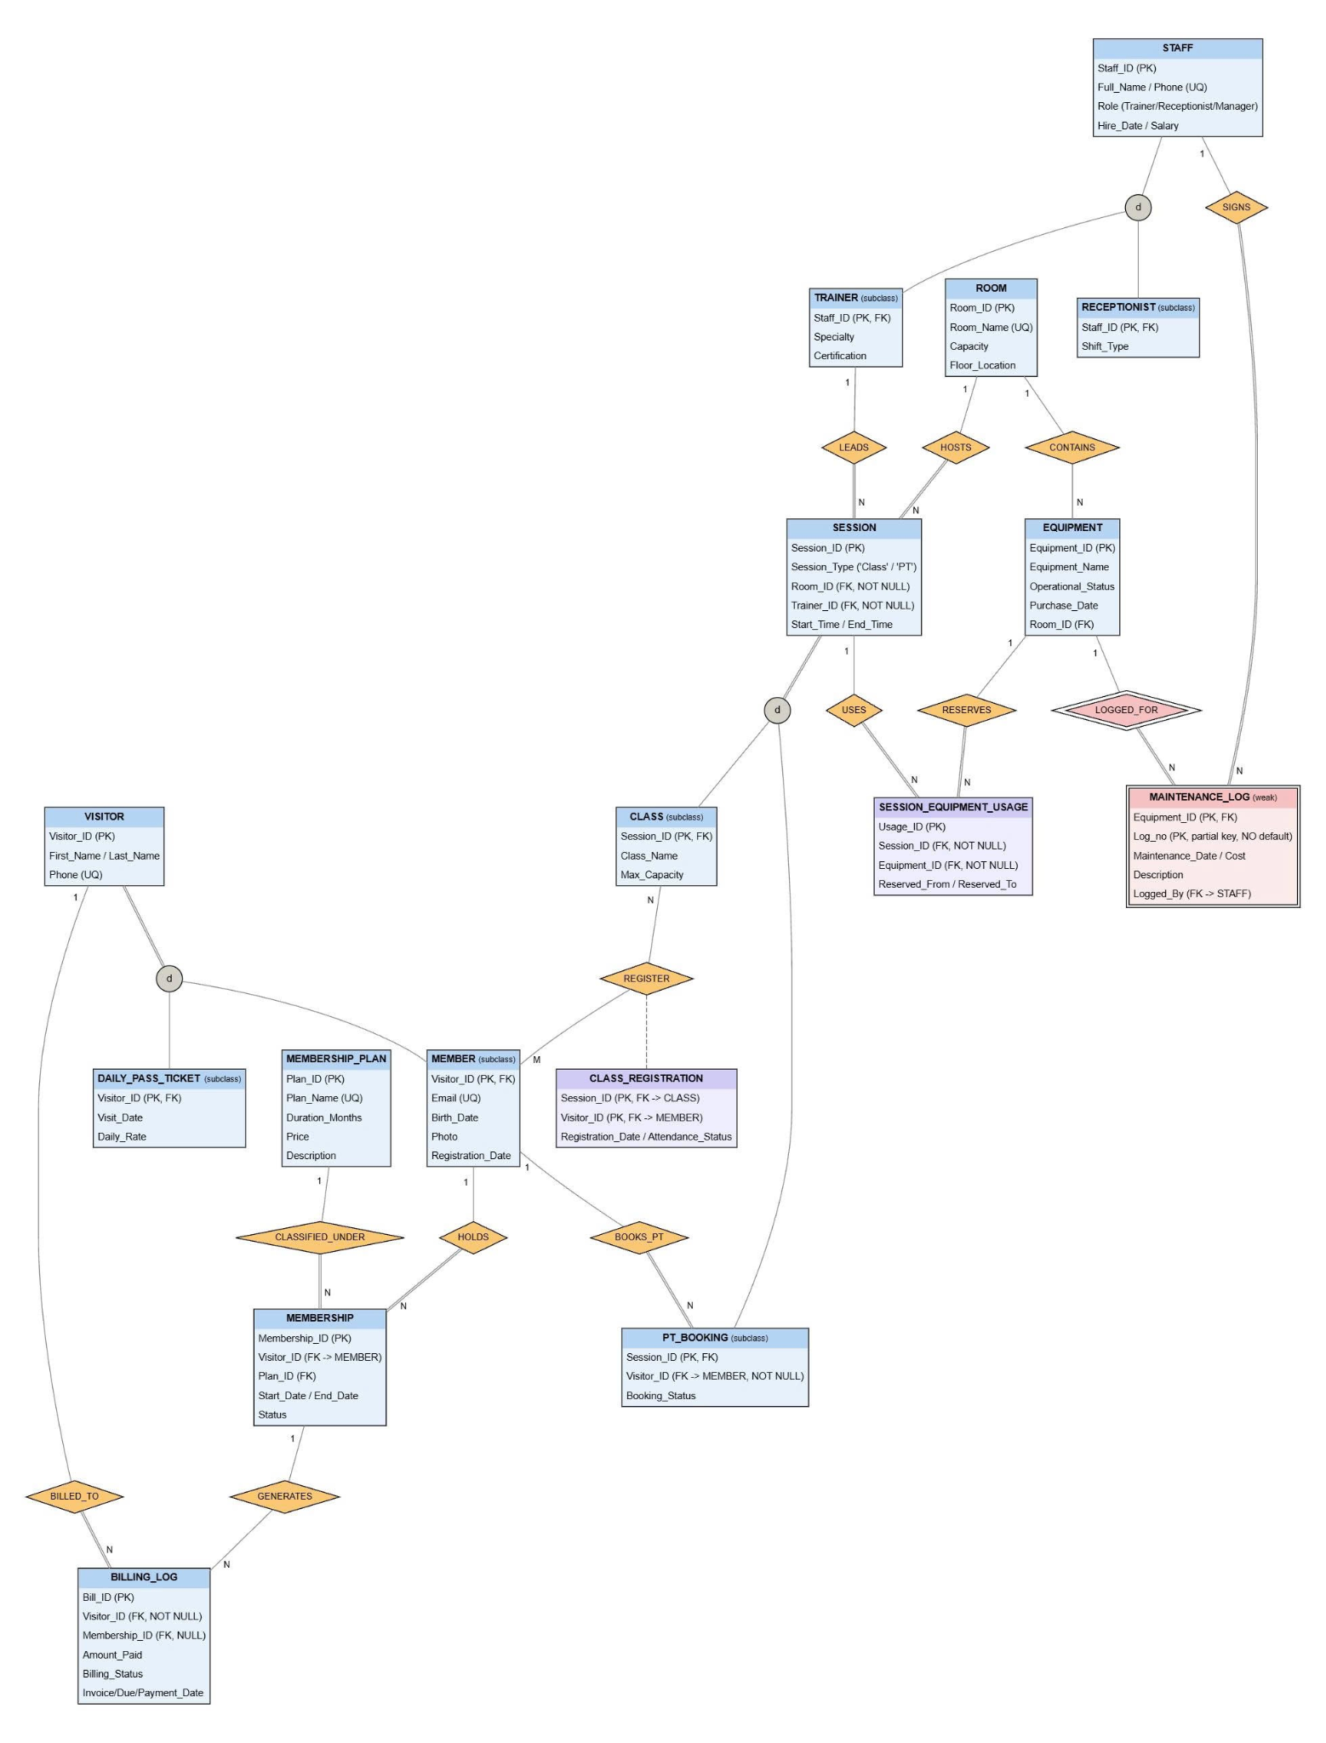
Logical Schema Mapping
Mapping the EER Model to Tables (Elmasri & Navathe, Chapter 9: Steps 1-9)
● Step 1: Map strong entity types: Create a table R for each strong entity type E with all of its simple attributes, and choose one candidate key as the primary key (PK). Other candidate keys become UNIQUE columns [UQ]. Foreign keys are not added yet; they are added in Steps 4 and 5:

// Anh em thêm vào
  - VISITOR(Visitor_ID [PK], First_Name, Last_Name, Phone)
  - MEMBERSHIP_PLAN(Plan_ID [PK], Plan_Name, Duration_Months, Price, Description)
○ EQUIPMENT(Equipment_ID [PK], Equipment_Name, Operational_Status, Purchase_Date)
● Step 2: Map weak entity types: Create a table R for each weak entity type W with owner entity type E. Include all simple attributes of W and the PK of E as a foreign key (FK). The PK of R combines the PK of E and the partial key of W. Elmasri and Navathe recommend the CASCADE option on this foreign key, because a weak entity cannot exist without its owner (FK_MLOG_EQUIPMENT in Section 2.2.3; see Mapping Figure 4):
○ MAINTENANCE_LOG({Equipment_ID [FK -> EQUIPMENT], Log_no} [PK], Maintenance_Date, Cost, Description)

● Step 3: Map binary 1:1 relationship types: The book gives three options: a foreign key in one of the two tables (preferred), merging the two tables, or a separate relationship table. This design has no binary 1:1 relationship type: the link between a superclass and its subclass is handled in Step 8, and every other relationship type is 1:N or M:N.
● Step 4: Map binary 1:N relationship types: For each 1:N relationship type, add the PK of the table on the 1-side to the table on the N-side as a foreign key (the foreign-key approach, which the book prefers because it needs no extra table). Each foreign key is added to a table created in Step 1 or Step 2:

// Anh em thêm vào
- MEMBERSHIP (phía N của liên kết HOLDS với MEMBER và CLASSIFIED_UNDER với MEMBERSHIP_PLAN)
MEMBERSHIP(Membership_ID [PK], Visitor_ID [FK -> MEMBER], Plan_ID [FK -> MEMBERSHIP_PLAN], Start_Date, End_Date, Status)
- BILLING_LOG (phía N của liên kết BILLED_TO với VISITOR và GENERATES với MEMBERSHIP):
BILLING_LOG(Bill_ID [PK], Visitor_ID [FK -> VISITOR, NOT NULL], Membership_ID [FK -> MEMBERSHIP, NULLABLE], Invoice_Date, Due_Date, Payment_Date, Amount_Paid, Billing_Status)
○ EQUIPMENT: add Room_ID [FK -> ROOM, NULLABLE] (1:N CONTAINS)
○ MAINTENANCE_LOG: add Logged_By [FK -> STAFF] (1:N SIGNS)
○ SESSION_EQUIPMENT_USAGE: add Session_ID [FK -> SESSION, NOT NULL] (1:N USES) and Equipment_ID [FK -> EQUIPMENT, NOT NULL] (1:N RESERVES). This table is an associative entity with its own key Usage_ID, not the pair (Equipment_ID, Session_ID): the same machine can be reserved more than once in one session, at different times, so the pair is not unique.

○ Bước 5: Ánh xạ liên kết nhị phân M:N: Tạo một bảng R mới cho mỗi kiểu liên kết M:N. Đưa PK của các thực thể tham gia vào R làm FK; các FK này cùng nhau tạo thành PK phức hợp của R:
// Anh em thêm vào
● Step 6: Map multivalued attributes: Create a new table for each multivalued attribute. (The design has no multivalued attributes: each visitor has one Phone and each member one Email, stored as single-valued UNIQUE columns.)

● Step 7: Map N-ary relationship types: Create a table R for each relationship type that joins three or more entity types. This design has none: every relationship type is binary (Steps 3 to 5), so no table is created in this step.

● Step 8: Map specialization/generalization hierarchies (EER): Map the disjoint specializations with Option 8A (one table for the superclass and one for each subclass, sharing the same PK):

// Anh em thêm vào
Chuyên biệt hóa VISITOR (Toàn phần, Rời nhau - Total, Disjoint):
- VISITOR đóng vai trò là Superclass.
- MEMBER (Visitor_ID [PK, FK -> VISITOR], Email, Birth_Date, Photo, Registration_Date)
- DAILY_PASS_TICKET (Visitor_ID [PK, FK -> VISITOR], Visit_Date, Daily_Rate)

Hình ánh xạ 1: Chuyên biệt hóa STAFF ánh xạ theo Phương án 8A (không toàn phần, rời nhau). STAFF, TRAINER và RECEPTIONIST mỗi thực thể được ánh xạ thành một bảng; khóa Staff_ID của lớp con đồng thời là khóa ngoại tới STAFF.
// hình chứng minh 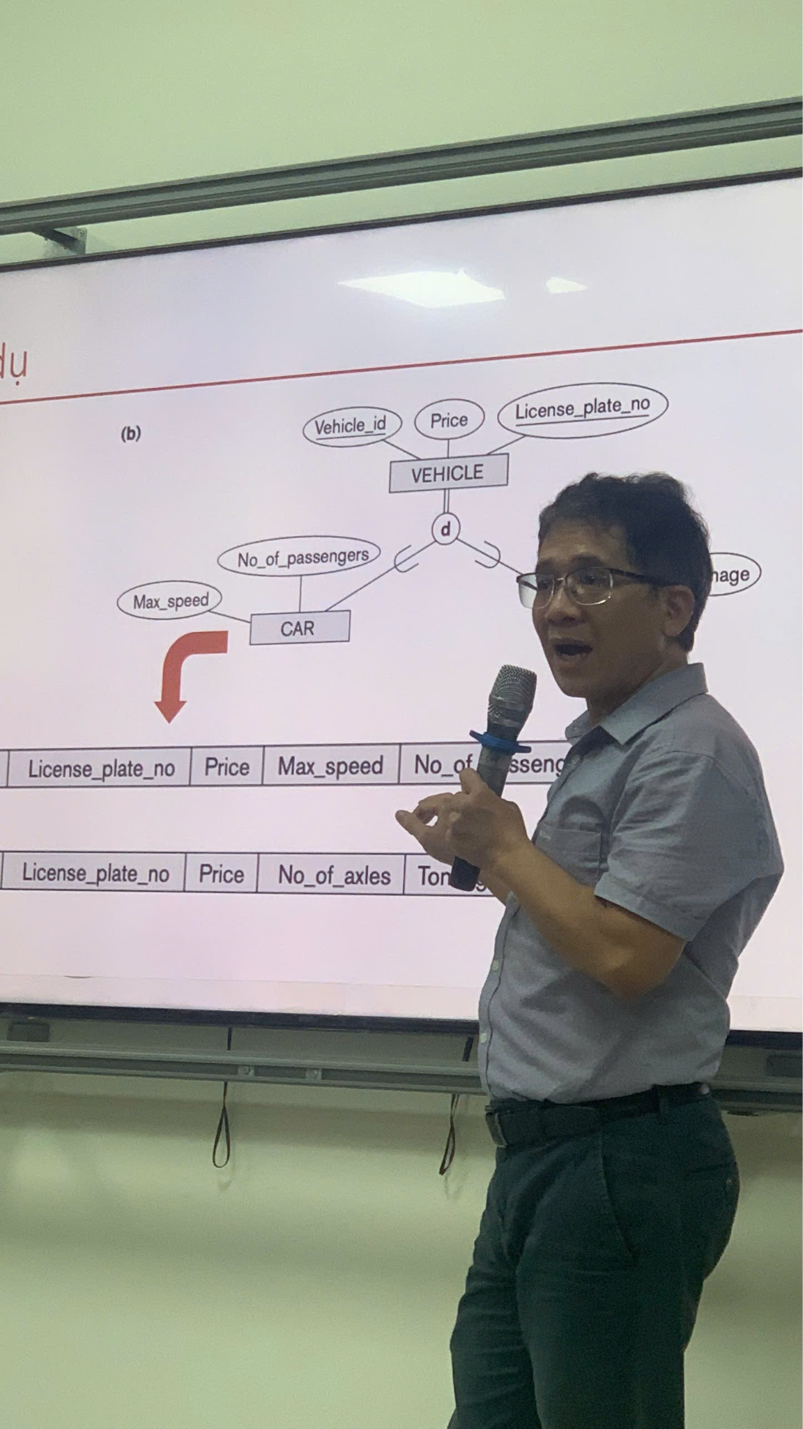
Hình ánh xạ 2: Chuyên biệt hóa VISITOR ánh xạ theo Phương án 8A (toàn phần, rời nhau). MEMBER và DAILY_PASS_TICKET dùng chung Visitor_ID với VISITOR làm khóa chính và khóa ngoại.
// tương tự
Hình ánh xạ 3: Chuyên biệt hóa SESSION ánh xạ theo Phương án 8A (toàn phần, rời nhau). CLASS và PT_BOOKING dùng chung Session_ID với SESSION; Session_Type ghi bảng lớp con nào chứa mỗi buổi tập; liên kết BOOKS_PT trở thành khóa ngoại Visitor_ID.
// tương tự

Mapping Figure 4: Weak entity MAINTENANCE_LOG mapped in Step 2. The primary key combines the owner key Equipment_ID (also a foreign key to EQUIPMENT) with the partial key Log_no.
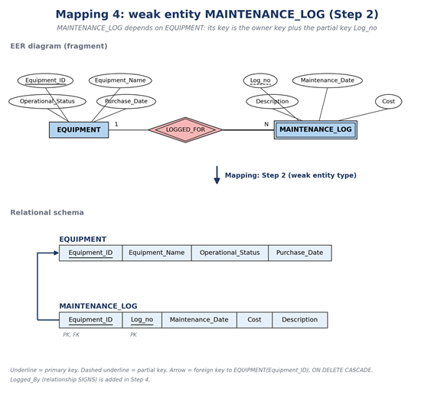
● Why Option 8A: Elmasri and Navathe describe four options (8A to 8D). Option 8B removes the superclass table, which does not fit here: STAFF is a partial specialization (a Manager belongs to no subclass and would have no row), and other tables refer to a superclass (BILLING_LOG to VISITOR, SESSION_EQUIPMENT_USAGE to SESSION). Options 8C and 8D put the whole specialization in one table; the book prefers them only when the subclasses have few local attributes. Here they would leave many NULL values (a daily-pass visitor would carry the Email and Photo columns of a member), and the subclasses have their own relationships (MEMBER is referenced by MEMBERSHIP, CLASS_REGISTRATION and PT_BOOKING), which need a table of their own. Option 8A works for any specialization, so it is used for all three.
● Type attributes: Option 8A as the book describes it has no type column in the superclass. This design keeps STAFF.Role and SESSION.Session_Type, which work like the type attribute t of Option 8C: triggers use them to check that a row is in the right subclass table (BR-SCH-01, BR-SCH-06). VISITOR has no type column; BR-MEM-01 is checked by triggers on MEMBER and DAILY_PASS_TICKET.
● Step 9: Map categories (union types): Not needed. A category is a subclass of the union of several superclasses that can have different keys. Every subclass here has exactly one superclass and shares its key, so no surrogate key is added.
● Referential actions: The book suggests CASCADE for both ON UPDATE and ON DELETE on weak entities, M:N tables and multivalued attributes. This design uses ON DELETE CASCADE on these tables (MAINTENANCE_LOG, CLASS_REGISTRATION, SESSION_EQUIPMENT_USAGE) but ON UPDATE NO ACTION, because key values are never changed once they are created (Section 2.2.3).

Relational Schema (17 Normalized Tables)
- VISITOR: (Visitor_ID [PK], First_Name, Last_Name, Phone [UQ])
- MEMBER: (Visitor_ID [PK / FK -> VISITOR], Email [UQ], Birth_Date, Photo, Registration_Date)
- DAILY_PASS_TICKET: (Visitor_ID [PK / FK -> VISITOR], Visit_Date, Daily_Rate)
- MEMBERSHIP_PLAN: (Plan_ID [PK], Plan_Name [UQ], Duration_Months, Price, Description)
- MEMBERSHIP: (Membership_ID [PK], Visitor_ID [FK -> MEMBER], Plan_ID [FK -> MEMBERSHIP_PLAN], Start_Date, End_Date, Status)
- BILLING_LOG: (Bill_ID [PK], Visitor_ID [FK -> VISITOR], Membership_ID [FK -> MEMBERSHIP, NULLABLE], Invoice_Date, Due_Date, Payment_Date, Amount_Paid, Billing_Status)

- EQUIPMENT: (Equipment_ID [PK], Equipment_Name, Room_ID [FK->ROOM], Operational_Status, Purchase_Date)
○ MAINTENANCE_LOG: (Equipment_ID [PK/FK->EQUIPMENT], Log_no [PK], Maintenance_Date, Cost, Description, Logged_By [FK->STAFF])
- SESSION_EQUIPMENT_USAGE: (Usage_ID [PK], Equipment_ID [FK->EQUIPMENT], Session_ID [FK->SESSION], Reserved_From, Reserved_To)
Foreign Keys and Delete Rules

Referencing Table (FK) | Referenced Table (PK) | ON DELETE | ON UPDATE | Reason
MEMBER (Visitor_ID) | VISITOR | CASCADE | CASCADE | Khóa chính của MEMBER là Visitor_ID kế thừa từ VISITOR. Nếu xóa thực thể cha VISITOR, thông tin lớp con MEMBER sẽ tự động xóa theo
DAILY_PASS_TICKET (Visitor_ID) | VISITOR | CASCADE | CASCADE | DAILY_PASS_TICKET là lớp con của VISITOR. Xóa VISITOR sẽ xóa bản ghi vé ngày tương ứng
MEMBERSHIP(Visitor_ID) | MEMBER | NO ACTION | CASCADE | Không cho phép xóa MEMBER khi đang có hợp đồng gói tập (kể cả active hay expired) để bảo toàn lịch sử giao dịch & hợp đồng
MEMBERSHIP(Plan_ID) | MEMBERSHIP_PLAN | NO ACTION | CASCADE | Không được xóa gói tập (MEMBERSHIP_PLAN) nếu đã có hội viên đăng ký mua gói đó
BILLING_LOG (Visitor_ID) | VISITOR | NO ACTION | CASCADE | Giữ vững toàn vẹn tài chính audit log. Không cho phép xóa thông tin khách hàng nếu đã phát sinh hóa đơn tiền mặt
BILLING_LOG (Membership_ID) | MEMBERSHIP | SET NULL | CASCADE | Nếu một hợp đồng membership bị hủy/xóa, hóa đơn vẫn được lưu giữ trong hệ thống để đối soát sổ sách (chỉ chuyển Membership_ID về NULL
TRAINER (Staff_ID)
RECEPTIONIST (Staff_ID)
SESSION (Room_ID)
SESSION (Trainer_ID)
CLASS (Session_ID)
PT_BOOKING (Session_ID)
CLASS_REGISTRATION (Session_ID)
CLASS_REGISTRATION (Visitor_ID)
PT_BOOKING (Visitor_ID)
EQUIPMENT (Room_ID) | ROOM (Room_ID) | SET NULL | NO ACTION | Machine kept, but its room is cleared when the room is deleted
MAINTENANCE_LOG (Equipment_ID) | EQUIPMENT (Equipment_ID) | CASCADE | NO ACTION | Logs of the weak entity deleted with the machine
MAINTENANCE_LOG (Logged_By) | STAFF (Staff_ID) | RESTRICT | NO ACTION | Keeps a record of who signed each log
SESSION_EQUIPMENT_USAGE (Equipment_ID) | EQUIPMENT (Equipment_ID) | CASCADE | NO ACTION | Reservations deleted when the machine is removed
SESSION_EQUIPMENT_USAGE (Session_ID) | SESSION (Session_ID) | CASCADE | NO ACTION | Reservations deleted when the session is deleted

Lược đồ cơ sở dữ liệu vật lý (ký hiệu Crow's Foot)

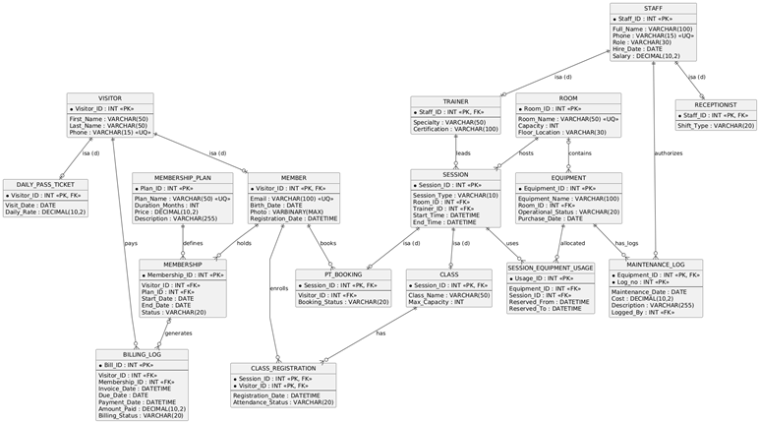

Normalization Verification (1NF -> 2NF -> 3NF / BCNF -> 4NF)

Formal Definitions:
● Functional Dependency (FD): X → Y holds in R if, for any two tuples t1 and t2 in R, t1[X] = t2[X] implies t1[Y] = t2[Y].
● Attribute Closure (X+): The set of all attributes of R that X determines under the FD set F.
● Superkey Test for BCNF: A relation R is in BCNF if, for every non-trivial FD X → Y, X is a superkey of R (i.e., X+ = R).
● Superkey Test for 3NF: A relation R is in 3NF if, for every non-trivial FD X → Y, EITHER X is a superkey of R, OR every attribute A in (Y - X) is a prime attribute (part of a candidate key).

Functional Dependencies and Normal Form Checks
Relation 1: VISITOR
- Candidate Key(s): {Visitor_ID}
- FD Set: Visitor_ID -> {First_Name, Last_Name, Phone}
- Proof & Verdict: {Visitor_ID}+ = {Visitor_ID, First_Name, Last_Name, Phone}. Since the closure contains all attributes of VISITOR, Visitor_ID is a candidate key and a superkey. All non-trivial functional dependencies have a superkey as their determinant. The relation is in BCNF (and 3NF).
Relation 2: MEMBER
- Candidate Key(s): {Visitor_ID}
- FD Set: Visitor_ID -> {Email, Birth_Date, Photo, Registration_Date}
- Proof & Verdict: {Visitor_ID}+ = {Visitor_ID, Email, Birth_Date, Photo, Registration_Date}. Since Visitor_ID determines all attributes in MEMBER, it is a candidate key and a superkey. No non-trivial functional dependency violates the superkey condition. The relation is in BCNF (and 3NF).
Relation 3: DAILY_PASS_TICKET
- Candidate Key(s): {Visitor_ID}
- FD Set: Visitor_ID -> {Visit_Date, Daily_Rate}
- Proof & Verdict: {Visitor_ID}+ = {Visitor_ID, Visit_Date, Daily_Rate}. The closure contains all attributes of DAILY_PASS_TICKET, so Visitor_ID is a candidate key and a superkey. All non-trivial functional dependencies have a superkey as their determinant. The relation is in BCNF (and 3NF).
Relation 4: MEMBERSHIP_PLAN
- Candidate Key(s): {Plan_ID}; {Plan_Name} is also a candidate key if the UNIQUE constraint on Plan_Name is enforced.
- FD Set:
  - Plan_ID -> {Plan_Name, Duration_Months, Price, Description}
  - Plan_Name -> {Plan_ID, Duration_Months, Price, Description}
- Proof & Verdict: {Plan_ID}+ = MEMBERSHIP_PLAN, so Plan_ID is a candidate key and a superkey. Because Plan_Name is unique, {Plan_Name}+ = MEMBERSHIP_PLAN as well. Both determinants are candidate keys; therefore, all non-trivial functional dependencies satisfy the BCNF condition. The relation is in BCNF (and 3NF).
Relation 5: MEMBERSHIP
- Candidate Key(s): {Membership_ID}
- FD Set: Membership_ID -> {Visitor_ID, Plan_ID, Start_Date, End_Date, Status}
- Proof & Verdict: {Membership_ID}+ = {Membership_ID, Visitor_ID, Plan_ID, Start_Date, End_Date, Status}. The closure contains every attribute in MEMBERSHIP; therefore, Membership_ID is a candidate key and a superkey. Visitor_ID and Plan_ID are foreign keys and do not, by themselves, determine the other attributes of a membership record. The relation is in BCNF (and 3NF) under the stated functional dependencies.
Relation 6: BILLING_LOG
- Candidate Key(s): {Bill_ID}
- FD Set:
  - Bill_ID -> {Visitor_ID, Membership_ID, Invoice_Date, Due_Date, Payment_Date, Amount_Paid, Billing_Status}
  - Membership_ID -> Visitor_ID — a conditional dependency for billing records linked to a membership, provided the design requires the member associated with that membership to be the same visitor recorded in the billing log.
- Proof & Verdict: {Bill_ID}+ = {Bill_ID, Visitor_ID, Membership_ID, Invoice_Date, Due_Date, Payment_Date, Amount_Paid, Billing_Status}. Thus, Bill_ID is a candidate key and a superkey. However, when Membership_ID -> Visitor_ID is treated as a valid non-trivial functional dependency over the relation, Membership_ID is not a superkey because one membership may have multiple billing records. Therefore, the relation cannot be confirmed as BCNF under this FD set. It may also fail 3NF if Visitor_ID is not a prime attribute. This dependency and the billing-source design need to be reviewed before assigning the final normal-form verdict.
Relation 15: EQUIPMENT
● Candidate Key(s): {Equipment_ID}
FD Set: Equipment_ID -> {Equipment_Name, Room_ID, Operational_Status, Purchase_Date}
Proof & Verdict: {Equipment_ID}+ = EQUIPMENT (all attributes). The left side Equipment_ID is a superkey. In BCNF (and 3NF).
Relation 16: MAINTENANCE_LOG
● Candidate Key(s): {Equipment_ID, Log_no}
FD Set: {Equipment_ID, Log_no} -> {Maintenance_Date, Cost, Description, Logged_By}
Proof & Verdict: {Equipment_ID, Log_no}+ = MAINTENANCE_LOG (all attributes). The composite key on the left side is a superkey. In BCNF (and 3NF).
Relation 17: SESSION_EQUIPMENT_USAGE
● Candidate Key(s): {Usage_ID}
● FD Set: Usage_ID -> {Equipment_ID, Session_ID, Reserved_From, Reserved_To}
● Proof & Verdict: {Usage_ID}+ = SESSION_EQUIPMENT_USAGE (all attributes). The left side Usage_ID is a superkey. In BCNF (and 3NF).

Normal Forms Step by Step (1NF -> 2NF -> 3NF / BCNF)
● 1NF: All attributes in the 17 relations hold single, atomic values of simple types (INT, VARCHAR, VARBINARY, DATETIME, DECIMAL, DATE). There are no multivalued attributes or repeating groups.
● 2NF: Every non-prime attribute in every table depends on the whole primary key. In MAINTENANCE_LOG, with the composite key {Equipment_ID, Log_no}, Cost and Maintenance_Date depend on the whole key, not on Equipment_ID alone.
3NF and BCNF: For every non-trivial functional dependency X → Y in the 17 tables, X is a superkey, with one documented exception: BILLING_LOG keeps a controlled redundancy (Membership_ID -> Visitor_ID, see Relation 6) to support daily pass payments. All other relations are in BCNF.

Normalization Figure 6: FD diagrams of EQUIPMENT, MAINTENANCE_LOG and SESSION_EQUIPMENT_USAGE.
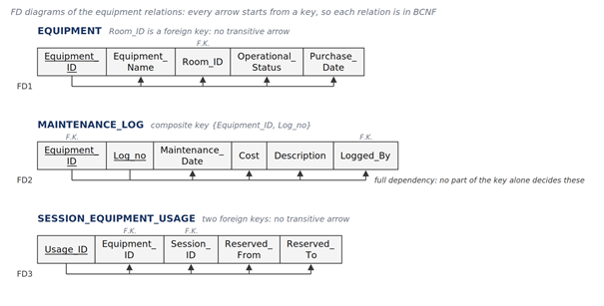
Equipment relations: EQUIPMENT holds the foreign key Room_ID, but the room details stay in ROOM. MAINTENANCE_LOG has the composite key {Equipment_ID, Log_no}; the date, cost, description and signer of a service record depend on the pair, not on Equipment_ID alone, because one machine has many service records. SESSION_EQUIPMENT_USAGE has its own single-attribute key Usage_ID, so it cannot have a partial dependency. In all three relations every FD starts from a key, which is the BCNF condition.

Các cột cho phép NULL (chính sách NULL)
Trong 17 bảng có chín cột cho phép NULL; mọi cột còn lại đều NOT NULL. Có ba lựa chọn thiết kế giúp giảm số NULL. (1) Dùng bảng lớp con thay cho một bảng rộng (Bước 8, Phương án 8A): nếu Specialty, Certification và Shift_Type là cột của STAFF, mỗi dòng Manager sẽ có ba NULL và mỗi dòng Receptionist có hai. (2) Dùng giá trị DEFAULT cho các cột luôn có giá trị khi thêm dòng, ví dụ MEMBERSHIP.Status = 'Active', BILLING_LOG.Amount_Paid = 0.00 và BILLING_LOG.Invoice_Date = thời điểm hiện tại. (3) Lưu thông tin không bắt buộc thành dòng riêng: máy chưa từng bảo dưỡng thì không có dòng MAINTENANCE_LOG, thay vì có các cột bảo dưỡng để trống. Bảng dưới liệt kê từng cột cho phép NULL và ý nghĩa của NULL.
Bảng | Cột | Vì sao cho phép NULL | Ý nghĩa của NULL / luật áp dụng
MEMBER | Birth_Date | Thông tin cá nhân không bắt buộc; hội viên có thể không cung cấp. | Không cung cấp.
MEMBER | Photo | Ảnh được tải lên sau khi tạo hồ sơ hội viên. | Chưa tải ảnh. BR-MEM-03 chặn mua gói tập, đăng ký lớp và đặt PT cho tới khi có ảnh.
MEMBERSHIP_PLAN | Description | Phần mô tả tự do; không cần để bán gói. | Chưa viết mô tả.
BILLING_LOG | Membership_ID | Hóa đơn vé ngày không có gói tập. | Hóa đơn vé ngày. Khi khác NULL, BR-MEM-07 kiểm tra Visitor_ID là chủ của gói tập.
BILLING_LOG | Payment_Date | Hóa đơn tồn tại trước khi được thanh toán. | Chưa thanh toán (Billing_Status là 'Pending' hoặc 'Failed').
TRAINER | Certification | Chứng chỉ có thể chưa được ghi khi tuyển huấn luyện viên. | Chưa ghi chứng chỉ.
ROOM | Floor_Location | Có giá trị mặc định 'Floor 1'; chỉ NULL khi vị trí không được ghi. | Chưa ghi vị trí.
EQUIPMENT | Room_ID | Máy có thể đang để trong kho; ON DELETE SET NULL xóa giá trị này khi phòng của máy bị xóa. | Chưa gán phòng.
EQUIPMENT | Purchase_Date | Có thể không rõ với thiết bị cũ. | Không rõ ngày.

- Data Dictionary (ISO/IEC 11179 Metadata Standards)

Table 15: EQUIPMENT (Machines)
Attribute Name | Data Type | Key Type | Nullable? | Default Value | Business Rules / Constraints
Equipment_ID | INT | PK | NO | IDENTITY | Machine identifier
Equipment_Name | VARCHAR(100) | None | NO | None | Machine name (brand/model)
Room_ID | INT | FK -> ROOM | YES | NULL | Refers to the room
Operational_Status | VARCHAR(20) | None | NO | 'Active' | Status: CHECK (Operational_Status IN ('Active','Under Maintenance','Broken'))
Purchase_Date | DATE | None | YES | NULL | Date the machine was bought

Table 16: MAINTENANCE_LOG (Weak Entity: Service History)
Attribute Name | Data Type | Key Type | Nullable? | Default Value | Business Rules / Constraints
Equipment_ID | INT | PK, FK -> EQUIPMENT | NO | None | Part 1 of the composite PK; refers to the machine
Log_no | INT | PK (partial key) | NO | None | Part 2 of the composite PK (log number for each machine)
Maintenance_Date | DATE | None | NO | CAST(GETDATE() AS DATE) | Date of the service
Cost | DECIMAL(10,2) | None | NO | 0.00 | Cost of the repair (CHECK Cost >= 0.00)
Description | VARCHAR(255) | None | NO | None | Short description of the work done
Logged_By | INT | FK -> STAFF | NO | None | Refers to the staff member who signed the log; Role must be 'Receptionist' or 'Manager' (BR-FAC-05, checked by trigger)

Value Definitions for Status and Type Columns

Table | Column | Value | Default? | Used by | Meaning
MEMBERSHIP
MEMBERSHIP
MEMBERSHIP
BILLING_LOG
BILLING_LOG
BILLING_LOG
STAFF
STAFF
STAFF
RECEPTIONIST
SESSION
SESSION
CLASS_REGISTRATION
CLASS_REGISTRATION
CLASS_REGISTRATION
PT_BOOKING
PT_BOOKING
PT_BOOKING
EQUIPMENT | Operational_Status | Active | Yes | BR-SCH-07, BR-FAC-06 | The machine works and can be reserved.
EQUIPMENT | Operational_Status | Under Maintenance | No | BR-SCH-07, BR-FAC-06 | The machine is being serviced; new reservations are rejected.
EQUIPMENT | Operational_Status | Broken | No | BR-SCH-07, BR-FAC-06 | The machine is out of order; new reservations are rejected until it is repaired.
Database Implementation (SQL Style Guide Compliant)

