DATABASE PROJECT REPORT
Gym Membership & Personal Training Planner
(Project ID: #9)
____________________________________________________
A. PROJECT IDENTITY
Team Name | Dong Vui
Project ID & Title | #9: Gym Membership & Personal Training Planner
Course | INT1313 - Database Basics
Instructor | Lê Hà Thanh
Academic Year | 2026-2027 (Semester 1)

Team Members:

Full Name | Student ID | Class | Institutional Email
Tran Duc Phuong | N24DCCN154 | D24CQCN02-N | n24dccn154@student.ptithcm.edu.vn
Nguyen Luu Trieu Quang | N24DCCN158 | D24CQCN02-N | n24dccn158@student.ptithcm.edu.vn
Nguyen Van Hoang Te | N24DCCN071 | D24CQCN01-N | n24dccn071@student.ptithcm.edu.vn

Table of Contents
—

B. REPORT STRUCTURE
- Introduction & Project Scope (ISO/IEC/IEEE 29148 Standard)
  - System Objective
(Content) In the modern fitness industry, managing memberships, tracking personal training schedules, and maintaining equipment manually often lead to data errors, scheduling conflicts, and operational inefficiency.
(Overall Objective) To address these challenges, the Gym Membership and Personal Training Management System is designed to digitalize and streamline core gym operations. (Specific Objectives) Through a centralized relational database, the system efficiently manages member profiles, class schedules, personal trainer bookings, and fitness facility maintenance records. It aims to ensure strict data consistency and integrity, prevent scheduling conflicts, and maintain accurate subscription and billing records to support reliable data tracking and efficient gym management.
  - Business Rules Constraints
    - Membership & Subscription Domain (Triệu Quang)
Member - Membership - Membership Plan:
- Member: Refers to an individual or customer. A Member can remain in the system indefinitely, even if they do not currently have an active service package:
- Member ID
- Full name
- Phone number
- Necessary contact details
- Information for customer management/marketing purposes
- Profile pictures or verification photos (if required by business processes).
(Ex: Nguyen Van A)
- Membership: This refers to a member's right to access services for a specific period, established when the member subscribes to a plan. When the Membership expires or the member completes a course or service package, the Membership record must be retained in the system as history rather than being deleted.
(Ex: Nguyen Van A subscribes to the Premium plan from September 1, 2026, to October 1, 2026 / Renewing the subscription may entitle the member to special offers.)
-> A member can have multiple memberships over time.
(Ex: 01/06 → 01/07 Membership #1 with plan Basic and status is Expired, 01/08 → 01/09 Membership #2 with plan Premium and Status is Active
- Membership Plan: A type of service package offered by the gym, functioning as a Product/ Template
The plan specifies the entitlements included for the customer, such as:
- Duration
- Price
- Number of Personal Training (PT) sessions
- Access rights
- Other benefits.
-> A plan is not a specific subscription held by a member.
- Member = Who?
- Membership = Which service?
- Membership Plan = What type?
Four object: Member, Membership_Plan, Subscription, Recurring Billing/Billing_Record
- BR-M01: Each member must have a unique member identifier.
- BR-M02: Each membership plan must have a unique Plan ID and a defined price and duration.
- BR-M03: Each subscription belongs to exactly one member and is associated with exactly one membership plan.
- BR-M04: Each subscription must have a defined start date, end date, and status.
- BR-M05: A subscription has a status indicating whether it is active, expired, or cancelled.
- BR-M06: An active subscription may generate multiple billing records according to its billing cycle.
- BR-M07: Each billing record belongs to exactly one subscription.
- BR-M08: Billing records must be retained as historical records even after a subscription expires or is cancelled.
- BR-M09: Each billing record must store the amount charged and the billing period to which the charge applies.
    - Training & Scheduling Domain (Trần Đức Phương)

    - Facility & Maintenance Domain (Nguyễn Văn Hoàng Te)

- Database Design (Conceptual ER/EER Modeling)

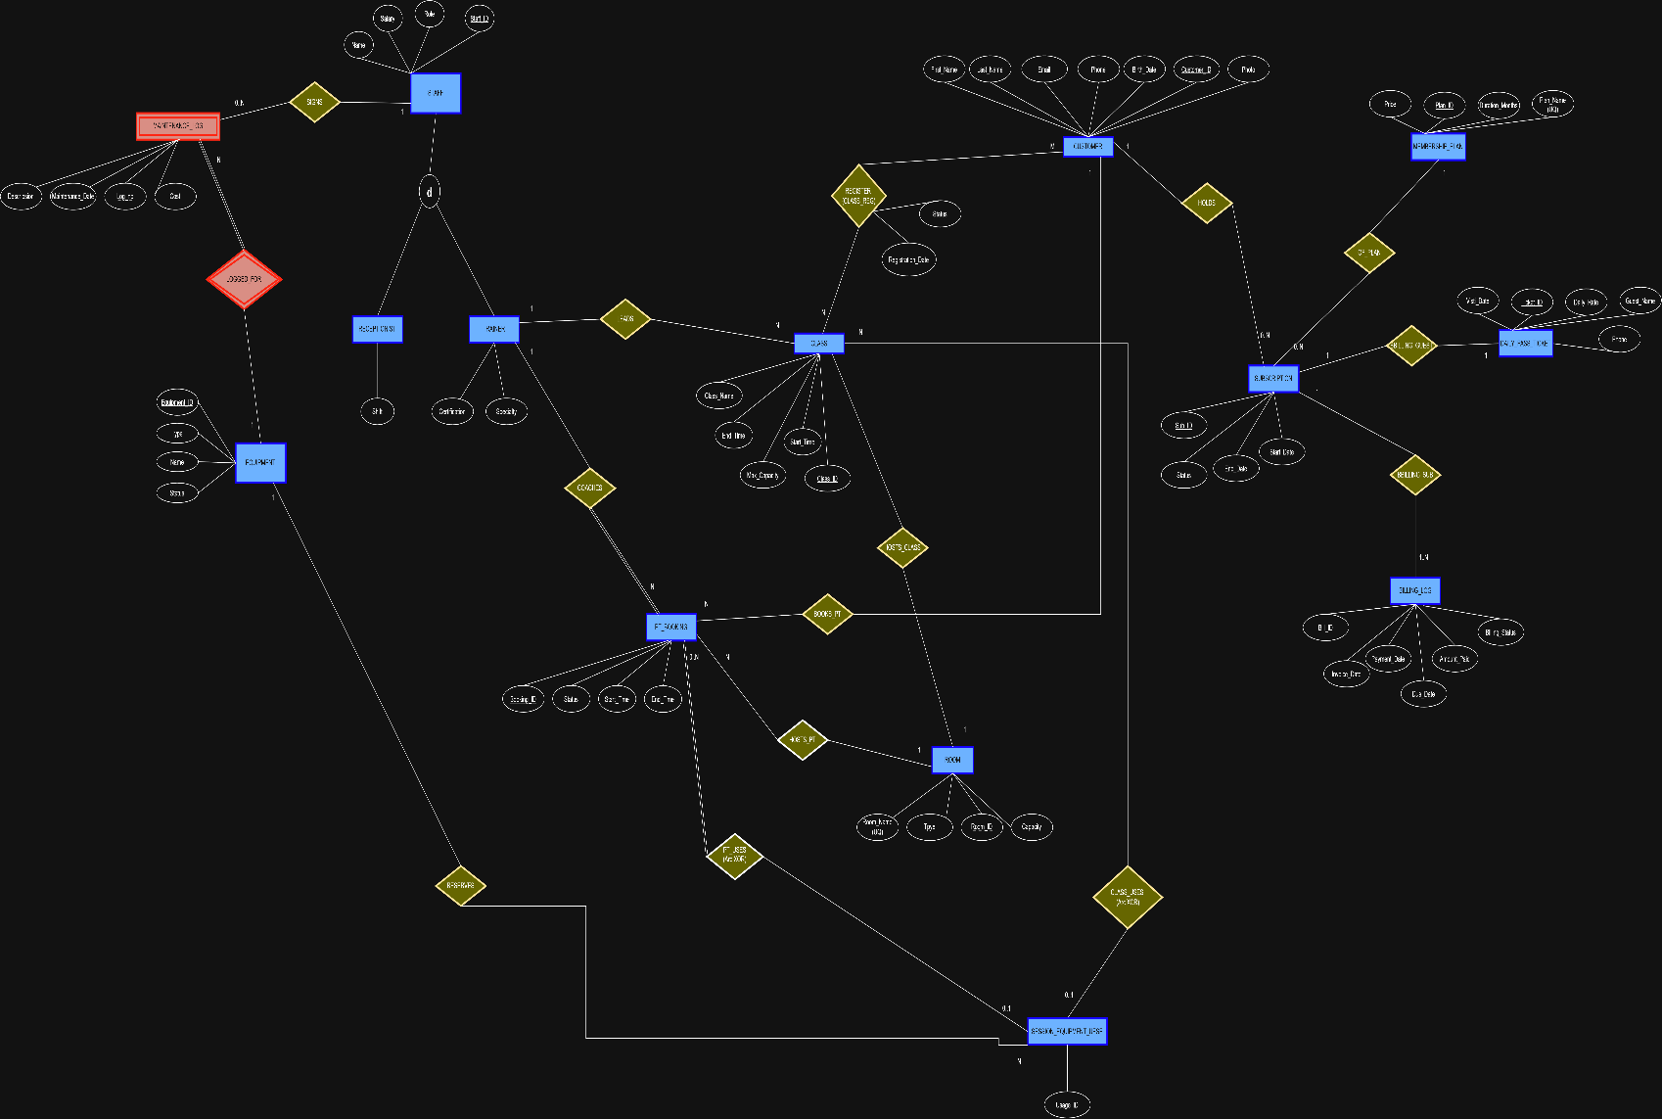

- Data Dictionary (ISO/IEC 11179 Metadata Standards)

