DATABASE PROJECT REPORT
Gym Membership & Personal Training Planner
(Project ID: #9)
____________________________________________________
A. PROJECT IDENTITY
Team Name | Dong Vui
Project ID & Title | #9: Gym Membership & Personal Training Planner
Course | INT1313 - Database Basics
Instructor | Lê Hà Thanh
Academic Year | 2026-2027 (Semester 1)

Team Members:

Full Name | Student ID | Class | Institutional Email
Tran Duc Phuong | N24DCCN154 | D24CQCN02-N | n24dccn154@student.ptithcm.edu.vn
Nguyen Luu Trieu Quang | N24DCCN158 | D24CQCN02-N | n24dccn158@student.ptithcm.edu.vn
Nguyen Van Hoang Te | N24DCCN071 | D24CQCN01-N | n24dccn071@student.ptithcm.edu.vn

Table of Contents
—

B. REPORT STRUCTURE
- Introduction & Project Scope (ISO/IEC/IEEE 29148 Standard)
  - System Objective
- (Content) In the modern fitness industry, managing memberships, tracking personal training schedules, and maintaining equipment manually often lead to data errors, scheduling conflicts, and operational inefficiency.
- (Overall Objective) To address these challenges, the Gym Membership and Personal Training Management System is designed to digitalize and streamline core gym operations. (Specific Objectives) Through a centralized relational database, the system efficiently manages member profiles, class schedules, personal trainer bookings, and fitness facility maintenance records. It aims to ensure strict data consistency and integrity, prevent scheduling conflicts, and maintain accurate subscription and billing records to support reliable data tracking and efficient gym management.
    - Core Entity Definitions & Business Semantics
To establish a common understanding of the system and avoid ambiguity in the requirements, the following key terms are defined:
      - Member: Refers to an individual who is registered in the gym's system and can use the gym's services. A Member may remain in the system indefinitely, even when they do not currently have an active Membership. Core attributes include Member_ID (Primary Identifier), Full_Name, a unique Phone_Number, necessary contact details, and information required for customer management and marketing purposes. Profile pictures or verification photos may also be stored when required by business processes.
      - Membership: A transactional entity representing an active or historical contract linking a registered Member to a specific Membership Plan over a defined duration (from Start_Date to End_Date). It tracks the specific lifecycle Status (e.g., 'Active', 'Expired', 'Cancelled'). A Member can hold zero or multiple Membership records over their lifetime, but at any single timestamp, a member can have at most one active Membership. When a package expires or is terminated, the record is permanently retained in the database as historical information rather than deleted.
      - Membership Plan: Defines the standardized membership packages pre-set by the gym (e.g., Monthly, Annual, VIP). It includes Plan_ID (Primary Identifier), Plan_Name (UNIQUE), Duration_Months (with constraint CHECK (Duration_Months > 0)), and Price (NOT NULL, with constraint CHECK (Price > 0)).
      - Daily Pass Ticket: An automated financial ledger tracking all cash inflows. It supports both membership billings (linked to a registered Member via Membership_ID) and walk-in ticket sales (linked to a Daily Pass Ticket via Ticket_ID). It tracks Billing_Status ('Pending', 'Paid', 'Failed'), Invoice_Date, Due_Date, Payment_Date (set upon payment), and Amount_Paid, identified uniquely by Bill_ID.
      - Billing Log: An automated financial ledger tracking all cash inflows. It supports both subscription billings (linked to a registered Customer via Sub_ID) and walk-in ticket sales (linked to a Daily_Pass_Ticket via Ticket_ID). It tracks Billing_Status ('Pending', 'Paid', 'Failed'), Invoice_Date, Due_Date, and the Payment_Date (set upon payment), providing a comprehensive audit trail and supporting automated billing workflows.
  - Business Rules & Constraints
    - Membership & Subscription Domain (Triệu Quang)
Four object: Member, Membership_Plan, Subscription, Recurring Billing/Billing_Record
- BR-M01: Each member must have a unique member identifier (Member_ID).
- BR-M02: Each membership plan must have a unique plan identifier (Plan_ID), a defined positive price, and a valid duration.
- BR-M03: Each membership belongs to exactly one member and is associated with exactly one membership plan.
- BR-M04: Each membership record must have a defined start date (Start_Date), end date (End_Date), and lifecycle status (Status).
- BR-M05: The status of a membership must be strictly one of the following values: 'Active', 'Expired', or 'Cancelled'.
- BR-M06: An active subscription can generate multiple billing records according to its defined billing cycle.
- BR-M07: Each billing record must be associated with either exactly one membership (Membership_ID) or exactly one daily pass ticket (Ticket_ID), but never both (Exclusive OR / XOR constraint). (Membership_ID # Ticket ID)
- BR-M08: Billing records must be retained as historical financial records and must not be deleted when the associated subscription expires or is cancelled.
- BR-M09: Each billing record must store the amount charged (Amount_Paid), billing status (Billing_Status), invoice date, and payment date.
- BR-M10: At any single timestamp, a member may have at most one active membership (Status = 'Active').
    - Training & Scheduling Domain (Trần Đức Phương)
    - Facility & Maintenance Domain (Nguyễn Văn Hoàng Te)
- Database Design (Conceptual ER/EER Modeling)

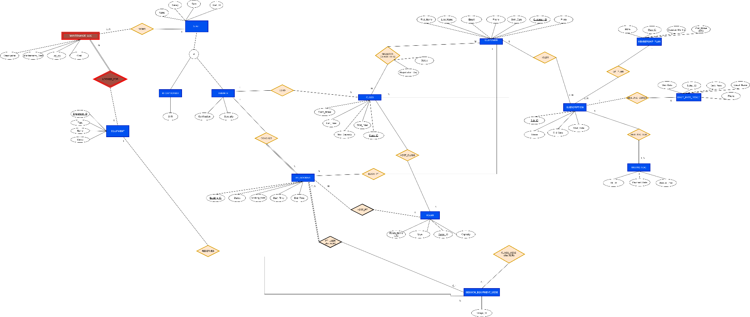

- Data Dictionary (ISO/IEC 11179 Metadata Standards)

