**Group Project PRN221**

**Team: JumpKing**

**Project topic: Interactive Family Tree**

**Member:**

* **Lê Hiếu Nghĩa - SE150939**
* **Nguyễn Hữu Thiện - SE162041**
* **Thái Huy Hoàng - SE162042**

1. **Context:**

Family Branches : A web that contains all family member’s information and all the events in your family. Help users easily manage family’s information and overview family interactive trees.

1. **Use case:**

- Guest can register their own account to create their family tree

- Guest can login

* 1. **- Member must login to do these actions:**

+ Logout

+ View detail Tree

+ View member’s information

+ Manage changing their information

* 1. **- Family manager is a Member**

+ CRUD their own tree form (Add more connection, fixing template)

+ CRUD members information (Update information, change status, change role in system)

+ CRUD Family Events

+ CRUD Family Album

+ CRUD Study Promotion

+ Send notification Events

+Confirm change information request

* 1. **- Admin must login to do these action:**

+ View all tree in system (general : number member, manager, time)

+ Delete tree (member = 0 or Family Manager request)

+ Confirm guest create account (Sending confirm action, modify member)

1. **Workflow**s:
   1. **Workflow 1:**
      1. **Guest** (1)Register →(2)Login
      2. **Member** (3) Create a new tree
      3. **Family Manager** (4) Edit Tree→ (5) Add member → (6) Manage member’s Relationship
   2. **Workflow 2**:
      1. **Guest** (1) Login → (2) Update personal information
      2. **Member** (3)View others member in tree → (4)View events list→ (5) Ask to join an event
   3. **Workflow 3**:
      1. **Family Manager** (1) View list of events/activities → (2) Manage events/activities → (3) Add participants→ (4) View events’s participants
2. **Database Diagram**

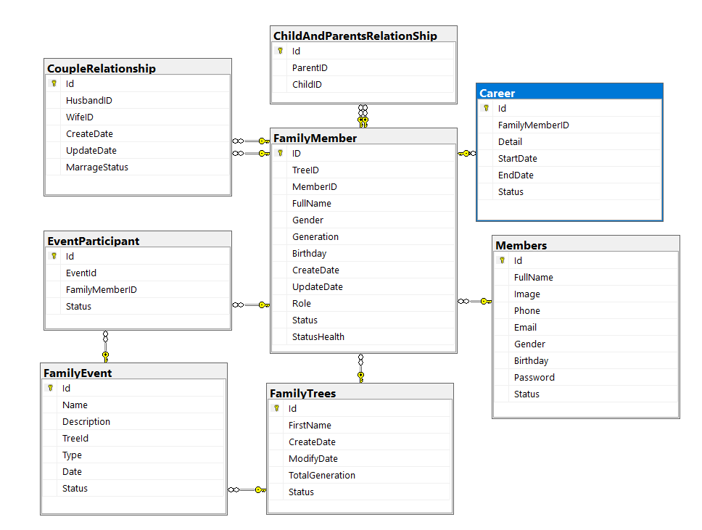

1. **ERD**

