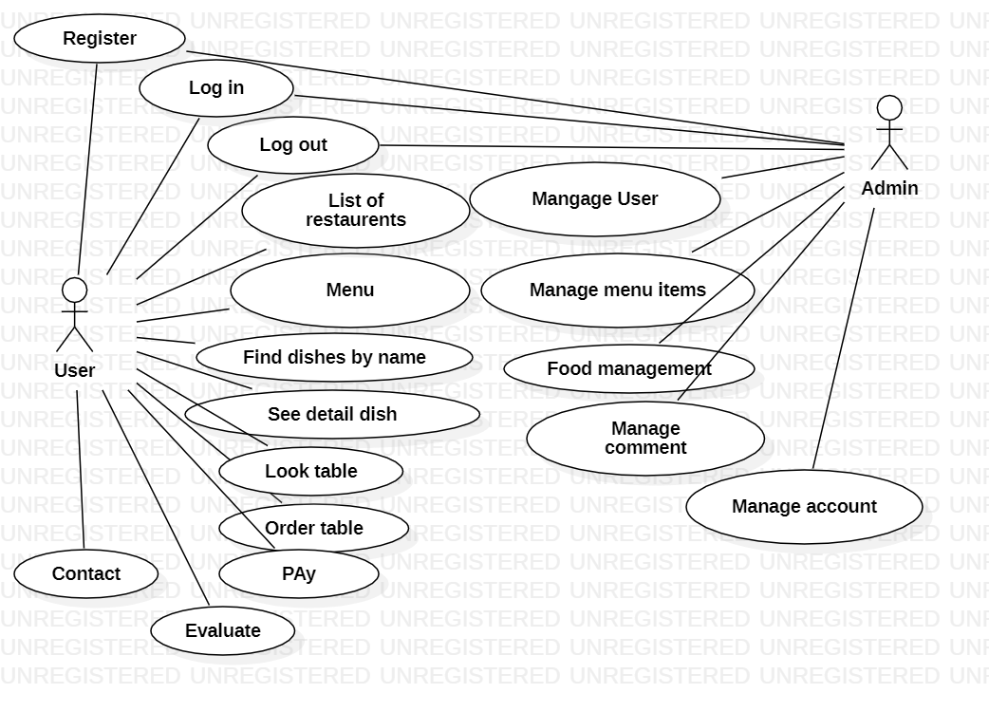

USER

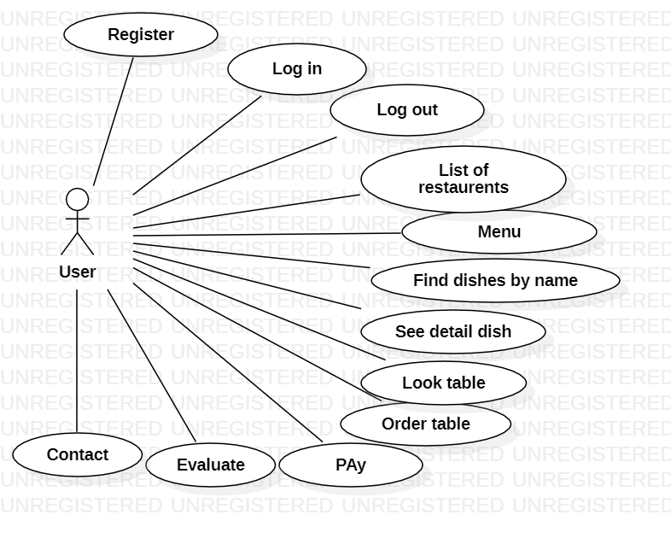

ADMIN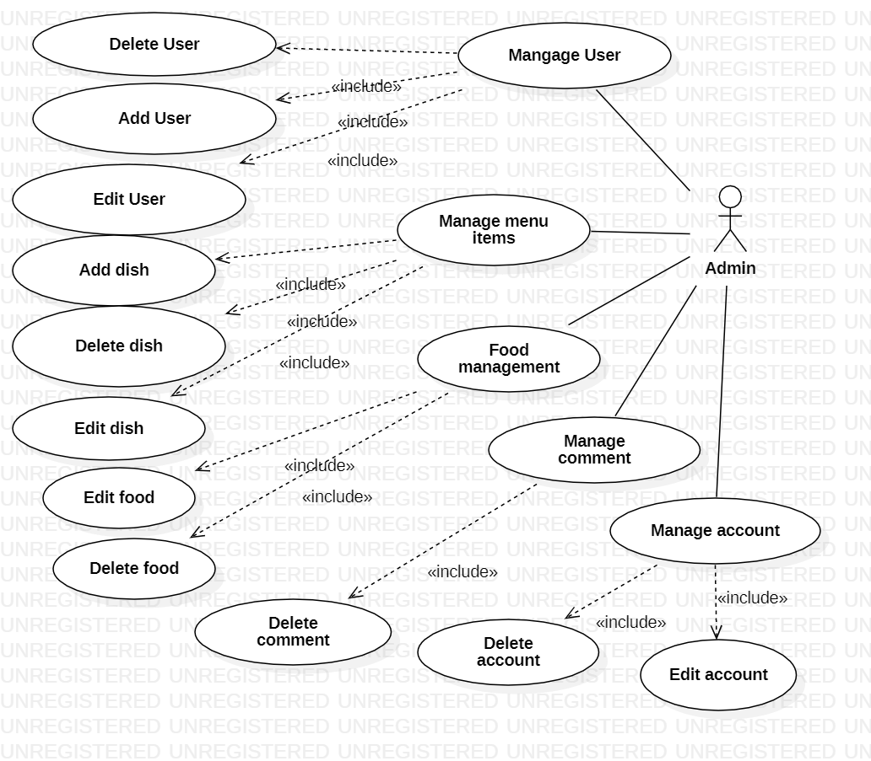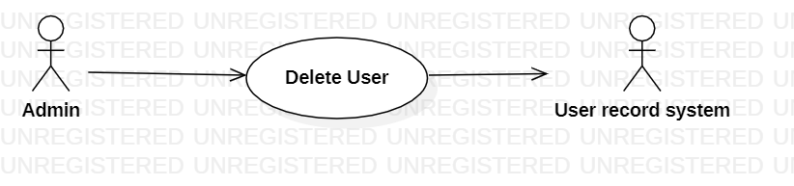

|  |  |
| --- | --- |
| **Delete User** | |
| Actors | Admin, User record system |
| Description | An admin send the user name to user record system with the command that delete this user from database |
| Data | User name |
| Stimulus | Interface that including username and delete button |
| Response | Message that : delete success of fail |
| Comments | Admin must have permission to delete user. |

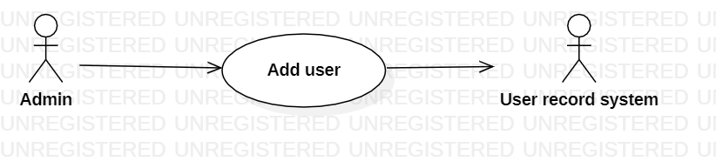

|  |  |
| --- | --- |
| **Add User** | |
| Actors | Admin, User record system |
| Description | An admin send the user name to user record system with the command that add this user from database |
| Data | User name |
| Stimulus | Interface that including username and add button |
| Response | Message that : add success of fail |
| Comments | Admin must have permission to add user. |

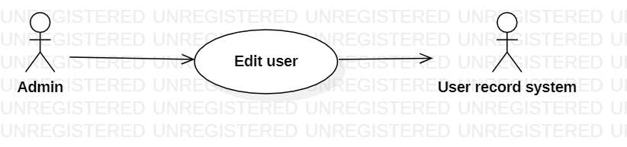

|  |  |
| --- | --- |
| **Edit User** | |
| Actors | Admin, User record system |
| Description | An admin send the user name to user record system with the command that edit this user from database |
| Data | User name |
| Stimulus | Interface that including username and add button |
| Response | Message that : edit success of fail |
| Comments | Admin must have permission to edit user. |