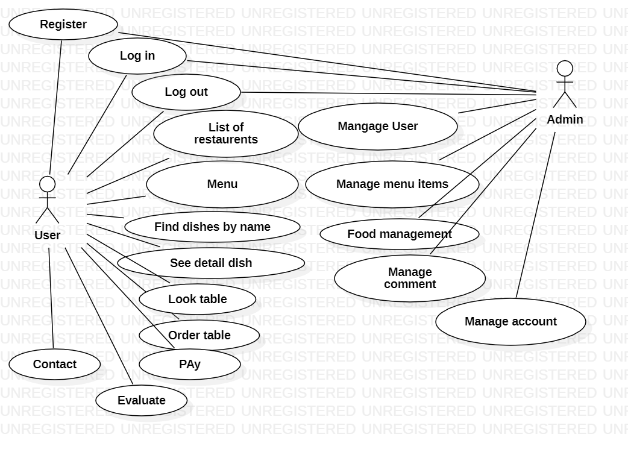

USER

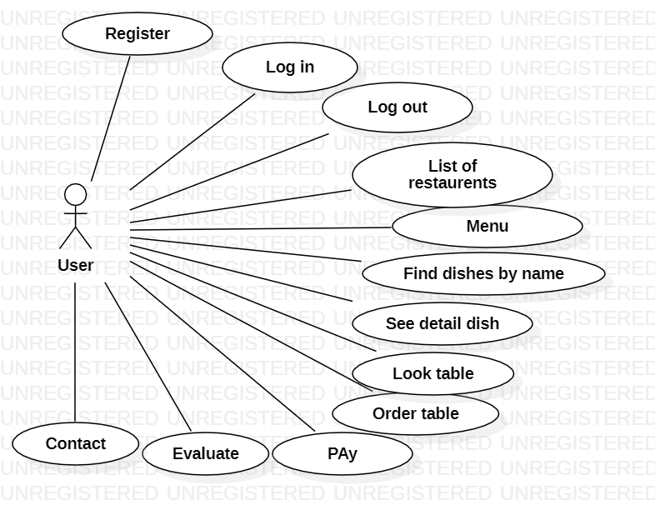

ADMIN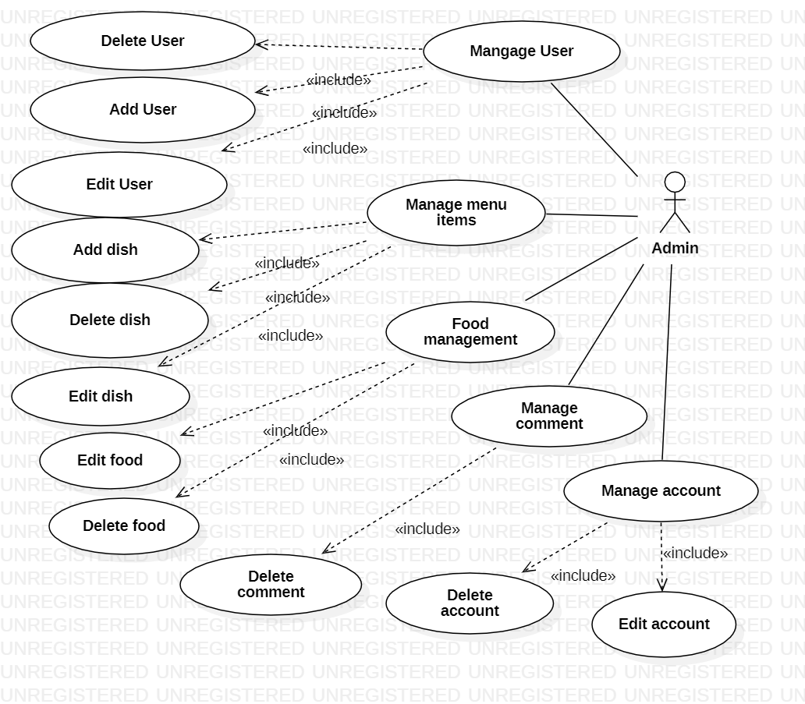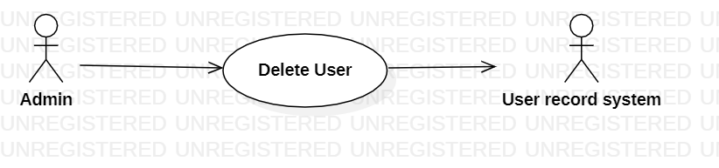

MANAGE USER

|  |  |
| --- | --- |
| **Delete User** | |
| Actors | Admin, User record system |
| Description | An admin send the user name to user record system with the command that delete this user from database |
| Data | User name |
| Stimulus | Interface that including username and delete button |
| Response | Message that : delete success of fail |
| Comments | Admin must have permission to delete user. |

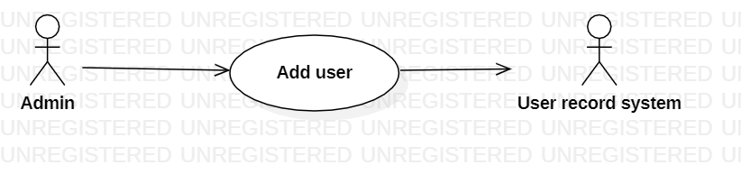

|  |  |
| --- | --- |
| **Add User** | |
| Actors | Admin, User record system |
| Description | An admin send the user name to user record system with the command that add this user from database |
| Data | User name |
| Stimulus | Interface that including username and add button |
| Response | Message that : add success of fail |
| Comments | Admin must have permission to add user. |

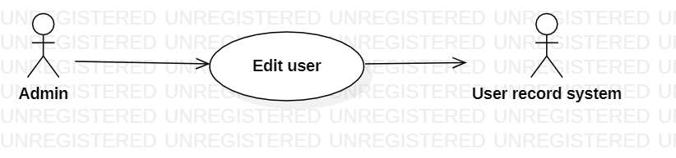

|  |  |
| --- | --- |
| **Edit User** | |
| Actors | Admin, User record system |
| Description | An admin send the user name to user record system with the command that edit this user from database |
| Data | User name |
| Stimulus | Interface that including username and add button |
| Response | Message that : edit success of fail |
| Comments | Admin must have permission to edit user. |

MANAGE MENU ITEM

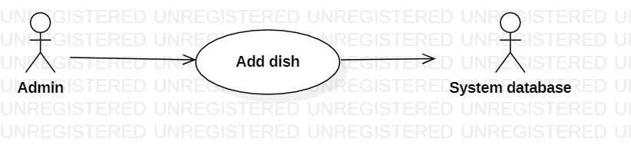

|  |  |
| --- | --- |
| **Add dish** | |
| Actors | Admin, System database |
| Description | An admin add new dish into menu and system database will store it |
| Data | dishes |
| Stimulus | Interface that including : dishes and add button |
| Response | Message that : add success of fail |
| Comments | Admin must have permission to add dish. |

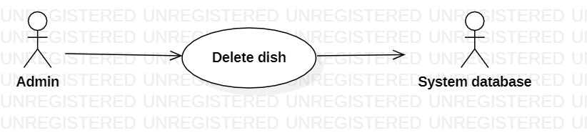

|  |  |
| --- | --- |
| **Delete dish** | |
| Actors | Admin, System database |
| Description | An admin delete dish from menu and system database will delete it. |
| Data | dishes |
| Stimulus | Interface that including : dishes and delete button |
| Response | Message that : delete success of fail |
| Comments | Admin must have permission to delete dish. |

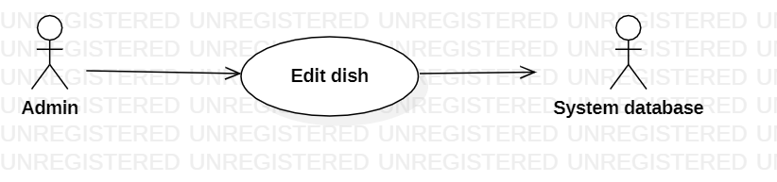

|  |  |
| --- | --- |
| **Edit dish** | |
| Actors | Admin, System database |
| Description | An admin edit dish from menu and system database will edit it. |
| Data | dishes |
| Stimulus | Interface that including : dishes and edit button |
| Response | Message that : edit success of fail |
| Comments | Admin must have permission to edit dish. |

MANAGE COMMENT

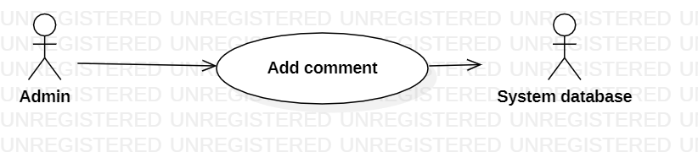

|  |  |
| --- | --- |
| **Add comment** | |
| Actors | Admin, System database |
| Description | An admin add comment and system database will store it |
| Data | comment |
| Stimulus | Interface that including : comment and add button |
| Response | Message that : add comment success or fail |
| Comments | Admin must have permission to add comment. |

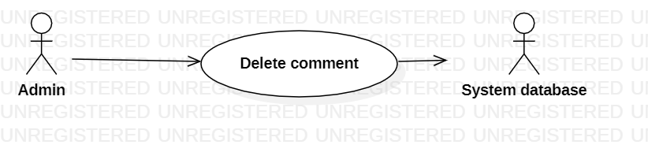

|  |  |
| --- | --- |
| **Delete comment** | |
| Actors | Admin, System database |
| Description | An admin delete comment and system database will delete it |
| Data | comment |
| Stimulus | Interface that including : comment and delete button |
| Response | Message that : delete comment success or fail |
| Comments | Admin must have permission to delete comment. |

MANAGE ACCOUNT

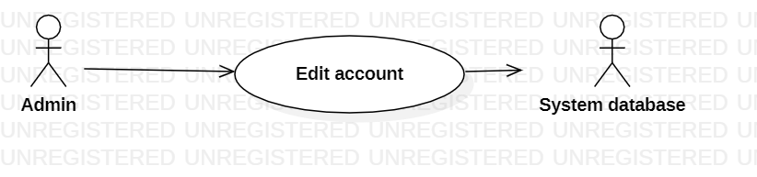

|  |  |
| --- | --- |
| **Edit comment** | |
| Actors | Admin, System database |
| Description | An admin edit account and system database will edit it. |
| Data | comment |
| Stimulus | Interface that including : comment and edit button |
| Response | Message that : edit account success or fail |
| Comments | Admin must have permission to delete comment. |

USER

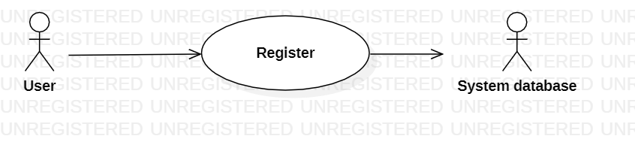

|  |  |
| --- | --- |
| **Register account** | |
| Actors | User, System database |
| Description | A user create account and store at database. |
| Data | User |
| Stimulus | Interface that including : Register and sign in button |
| Response | Message that : create account success or fail |
| Comments | User must have permission to Register. |

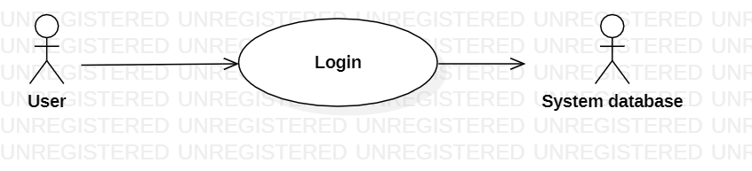

|  |  |
| --- | --- |
| **Login** | |
| Actors | User, System database |
| Description | A user login and information of account will store at database . |
| Data | User |
| Stimulus | Interface that including : Login and log in button |
| Response | Message that : Welcome to website. |
| Comments | User must have permission to Register. |

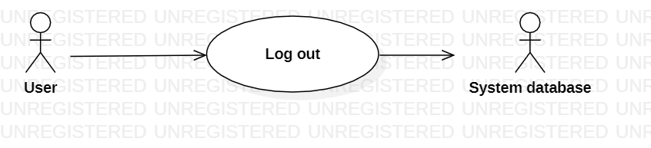

|  |  |
| --- | --- |
| **Log out** | |
| Actors | User, System database |
| Description | A user log out and information of account will store at database . |
| Data | User |
| Stimulus | Interface that including : Log out and log out button |
| Response | Message that : log out success or fail. |
| Comments | User must have permission to log out. |

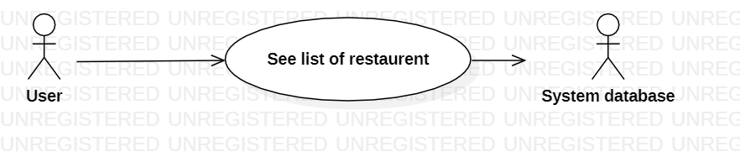

|  |  |
| --- | --- |
| **List of restaurant** | |
| Actors | User, System database |
| Description | A user click to view list of restaurant, database will push information and it will be appear on web browser |
| Data | User |
| Stimulus | Interface that including : Restaurant and view button |
| Response | Message that : here is list of restaurant. |
| Comments | User must have permission to view. |

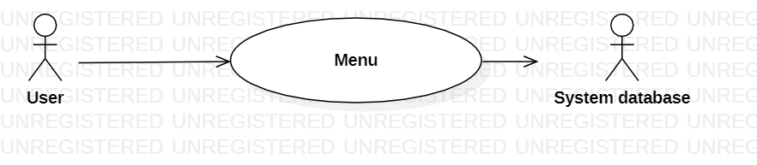

|  |  |
| --- | --- |
| **Menu** | |
| Actors | User, System database |
| Description | A user click to view Menu, database will push information and it will be appear on web browser |
| Data | User |
| Stimulus | Interface that including : Restaurant and menu button |
| Response | Message that : here is Menu. |
| Comments | User must have permission to view. |

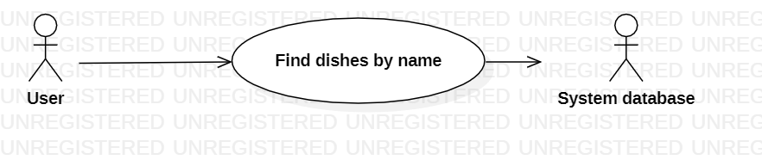

|  |  |
| --- | --- |
| **Find dishes** | |
| Actors | User, System database |
| Description | A user type name to find dish, database will push information and it will be appear on web browser |
| Data | User |
| Stimulus | Interface that including : dishes and find button |
| Response | Message that : Here is dish’sname. |
| Comments | User must have permission to find. |

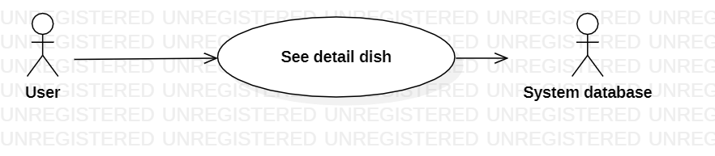

|  |  |
| --- | --- |
| **Detail dish** | |
| Actors | User, System database |
| Description | A user click on dish, database will push information and dish will be appear on web browser |
| Data | User |
| Stimulus | Interface that including : dishes and find button |
| Response | Message that : Here is dish’s name. |
| Comments | User must have permission to see. |

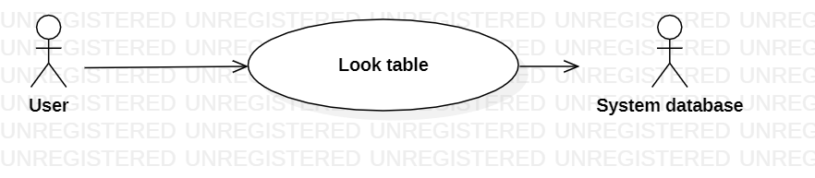

|  |  |
| --- | --- |
| **Look Table** | |
| Actors | User, System database |
| Description | A user click on table, database will push information and table will be appear on web browser |
| Data | User |
| Stimulus | Interface that including : table and find button |
| Response | Message that : Here is table. |
| Comments | User must have permission to find. |

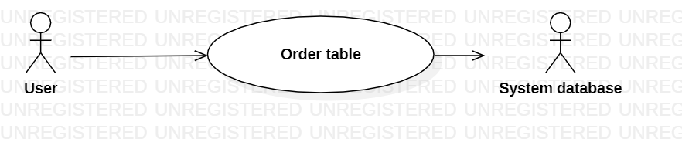

|  |  |
| --- | --- |
| **Order table** | |
| Actors | User, System database |
| Description | A user click on order button, database will store the information. |
| Data | User |
| Stimulus | Interface that including : table and order button |
| Response | Message that : Order success or fail. |
| Comments | User must have permission to order. |

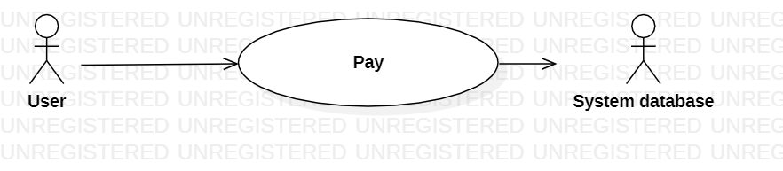

|  |  |
| --- | --- |
| **Pay** | |
| Actors | User, System database |
| Description | A user click on pay button, database will store the information. |
| Data | User |
| Stimulus | Interface that including : table and pay button |
| Response | Message that : Pay success or fail. |
| Comments | User must have permission to pay. |

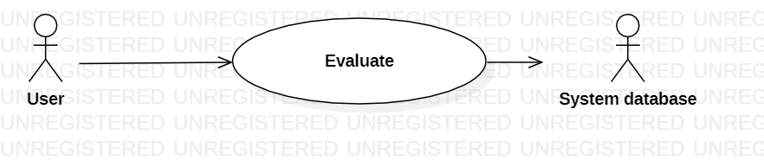

|  |  |
| --- | --- |
| **Evaluate** | |
| Actors | User, System database |
| Description | A user click on post, database will store the information. |
| Data | User |
| Stimulus | Interface that including : user and post button |
| Response | Message that : Post success or fail. |
| Comments | User must have permission to post. |

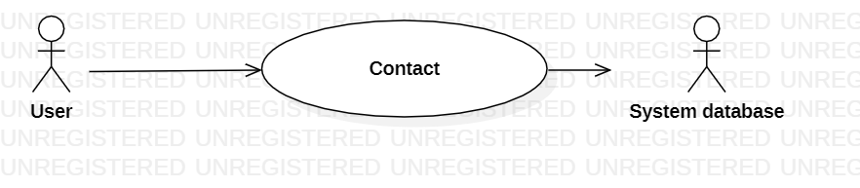

|  |  |
| --- | --- |
| **Contact** | |
| Actors | User, System database |
| Description | A user click on contact, database will push information to web browser. |
| Data | User |
| Stimulus | Interface that including : user and contact button |
| Response | Message that : Here is the contact. |
| Comments | User must have permission to see. |