– Create 3-packed nodemon //restart server automaticaly
– Create Json file // track the local file what package are using in project
– Install ‘loadash’
– To share project with other people, we use ‘install npm’
– Express
– Html&Css login page: https://youtu.be/eeHqZeJ9Vqc
–> I want to access local host from friend out of my localhost
– https://stackoverflow.com/questions/5108483/access-localhost-from-the-internet?fbclid=IwAR1dLa6wd_tcXACR2gu4uf2aNwahOMePpq2rKL8wqs87K7u9o8p99ob3eXI#:~:text=You%20are%20accesing%20localhost%20%2C%20meaning,Port%20number%20is%20normally%2080
→ I use localhost.run to accesss.
--run localhost: ssh -R 80:localhost:3000 localhost.run => generate domain.
* install openssh
– https://www.cyberciti.biz/faq/ubuntu-linux-install-openssh-server/ => install Openssh
--id is 100d8acf-71bc-4880-b55a-5b093439b933
--https://docs.gitlab.com/ee/ssh/ => about Gitlab and SSH keys
--Create ssh key:https://docs.vhost.vn/article/h%C6%B0%E1%BB%9Bng-d%E1%BA%ABn-t%E1%BA%A1o-v%C3%A0-s%E1%BB%AD-d%E1%BB%A5ng-ssh-key-450.html

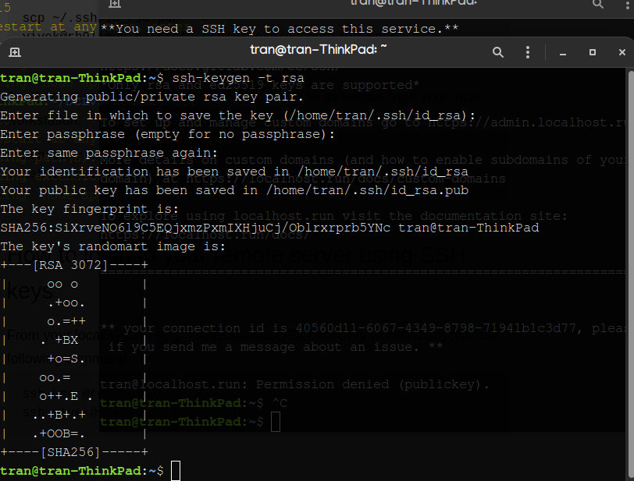
*final:
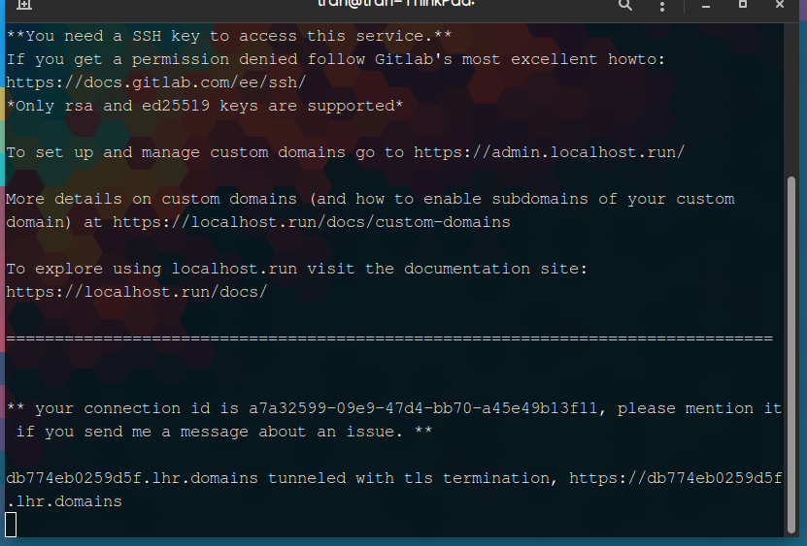
=> it will automaticaly create a domain to access to our localhost.

- Express
- ejs engine

partial templates

