LM35 With LCD

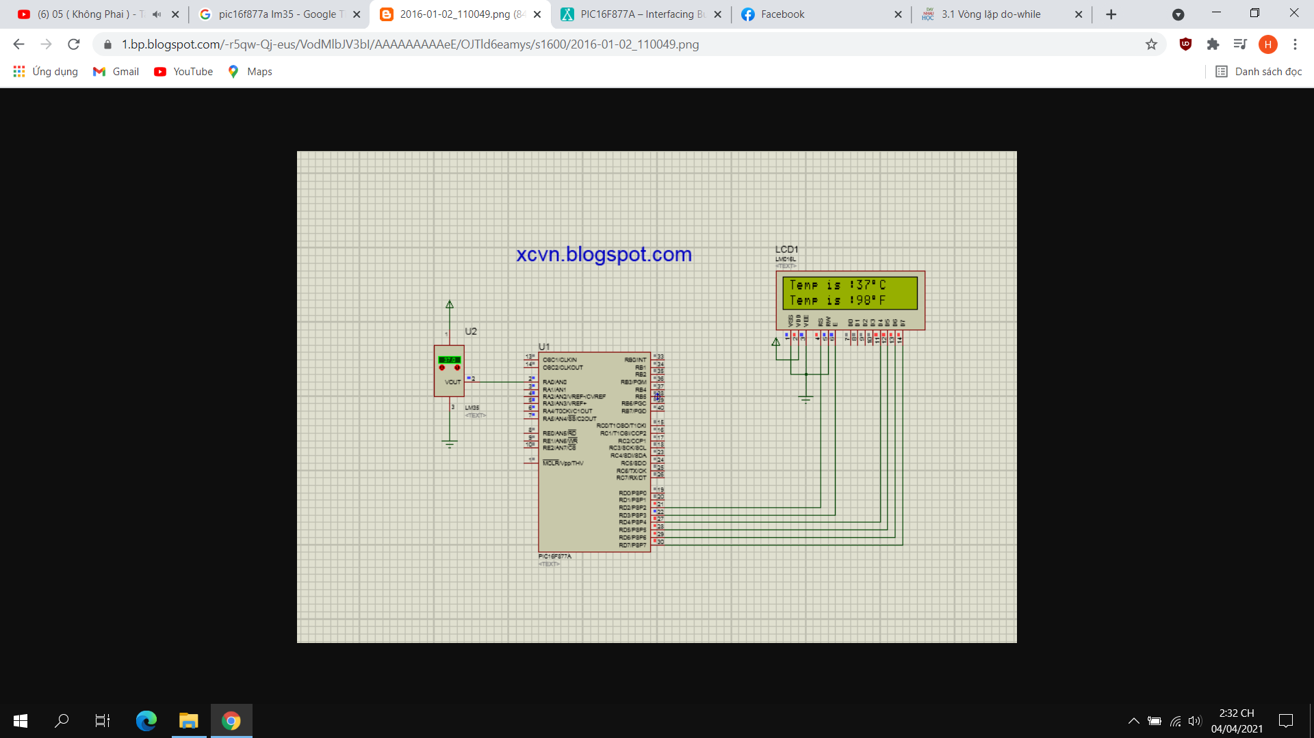

PIC16F877A with Buzzer

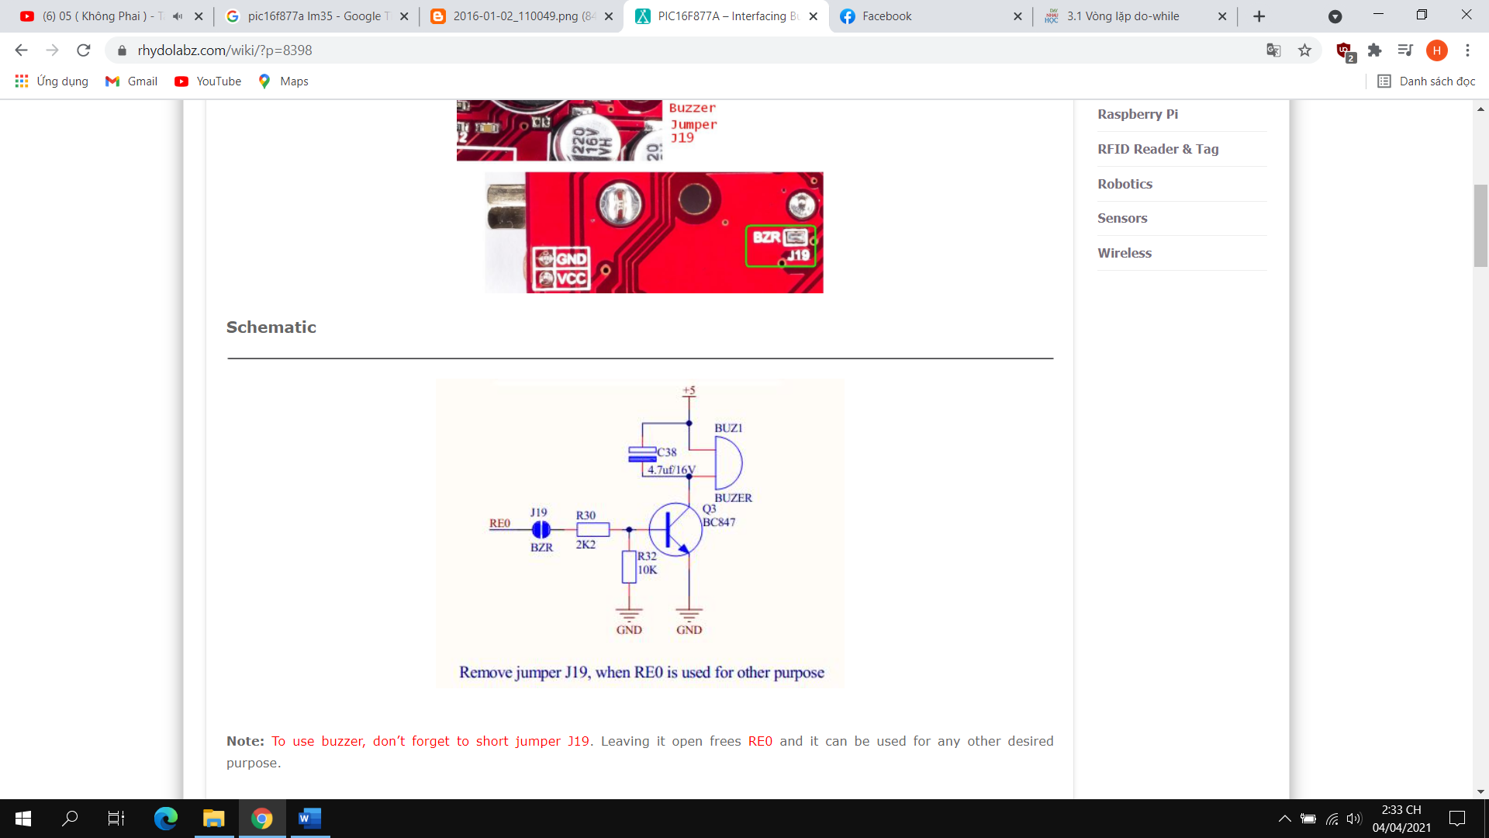

**Warning: Use right library for lcd.c and connecr right port for equipment**