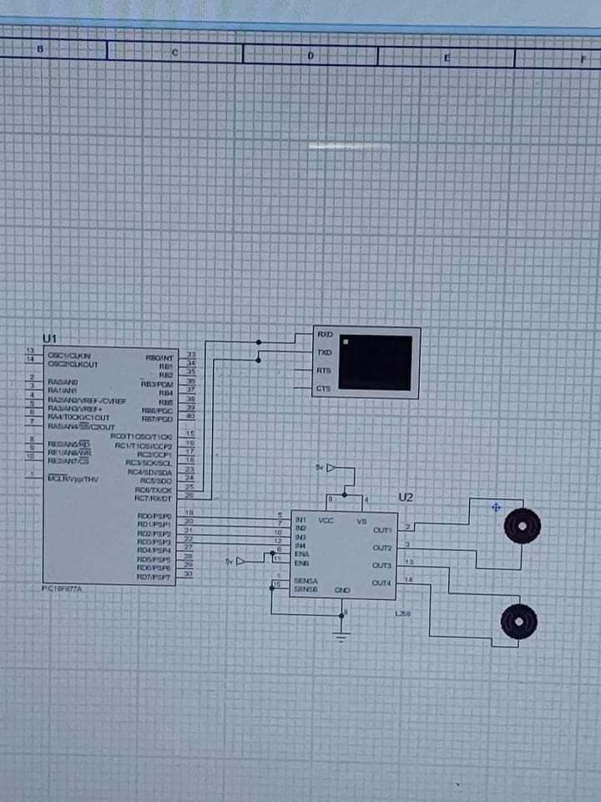

Pic16f877a with motor with bluetooth