NGAY HOI DOC SACH PTIT 2026
Hoc vien Cong nghe Buu chinh Vien thong
Quillora.
Nen tang doc sach thong minh ung dung AI cho sinh vien PTIT
"Tu ngoi but den binh minh tri thuc"
Anh chup trang chu Quillora

Giao dien trang chu voi hero section, ke sach giao trinh PTIT, nut CTA vao thu vien. Responsive, ho tro dark mode.

THU VIEN SACH
Ke sach giao trinh PTIT
Hien thi tat ca giao trinh duoi dang grid card. Moi card co: bia sach (Google Books), tom tat AI, danh muc, muc do kho, nut yeu thich. Click vao bat ky sach nao de mo reader.
Giao dien thu vien
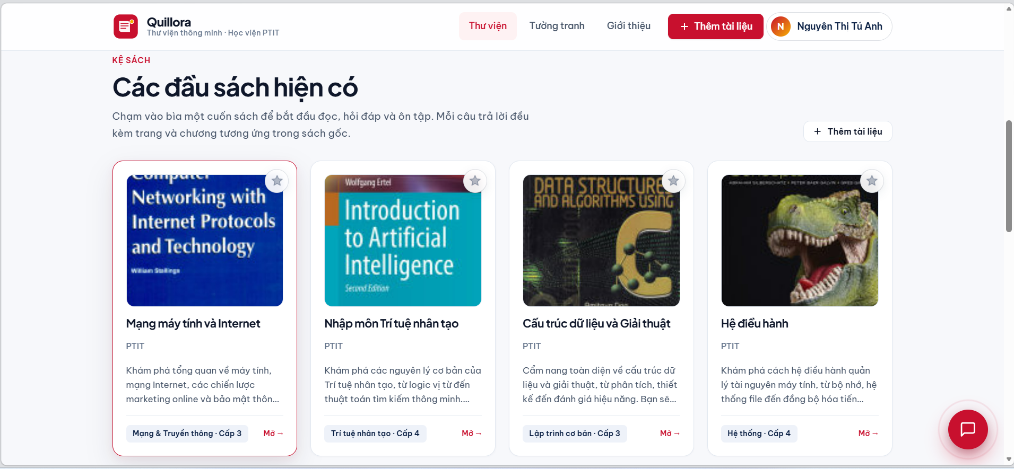
- 10 giao trinh PTIT san co: Mang may tinh, He dieu hanh, CTDL, Java, CNPM, Do hoa, ATTT, Kho DL, Toan roi rac, AI.
- Bia sach that tu Google Books API.
- Tom tat AI tu dong cho moi cuon sach khi upload.
- Danh dau yeu thich - luu vao trang ca nhan.
- Upload them PDF moi: keo tha -> trich xuat -> embedding -> san sang chat trong vai giay.

XAC THUC
Dang nhap & Dang ky
Hai phuong thuc: email/password hoac Microsoft OAuth qua Auth0. Sinh vien PTIT dang nhap 1-click bang email @stu.ptit.edu.vn.
Modal dang nhap

Modal dang ky


DOC SACH PDF
PDF Reader tren trinh duyet
Doc giao trinh truc tiep tren web voi PDF.js - zoom, cuon trang, lazy loading. Khong can tai ve hay cai phan mem.
Giao dien doc sach
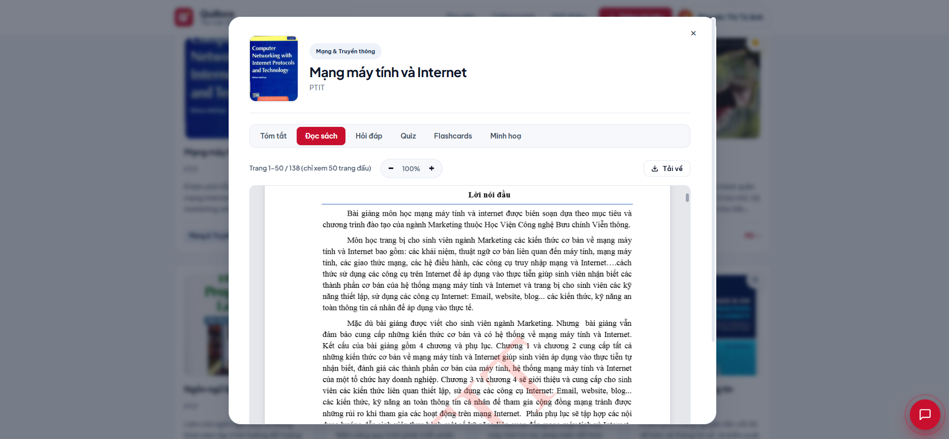
- PDF.js (Mozilla): render PDF client-side, lazy load tung trang khi scroll.
- Zoom: 43% -> 214%. Download PDF goc voi ten file tieng Viet co dau.
- Tab navigation: Doc sach / Hoi dap / Tom tat / Quiz / Flashcard / Minh hoa / Nghe sach.

HOI DAP AI
Chat truc tiep voi sach
Dat cau hoi bang tieng Viet tu nhien. Quillora tim dung doan lien quan trong sach (RAG), sinh cau tra loi kem trich dan [Chuong - tr.X]. Ho tro lich su hoi thoai lien mach.
Cau hoi dau tien
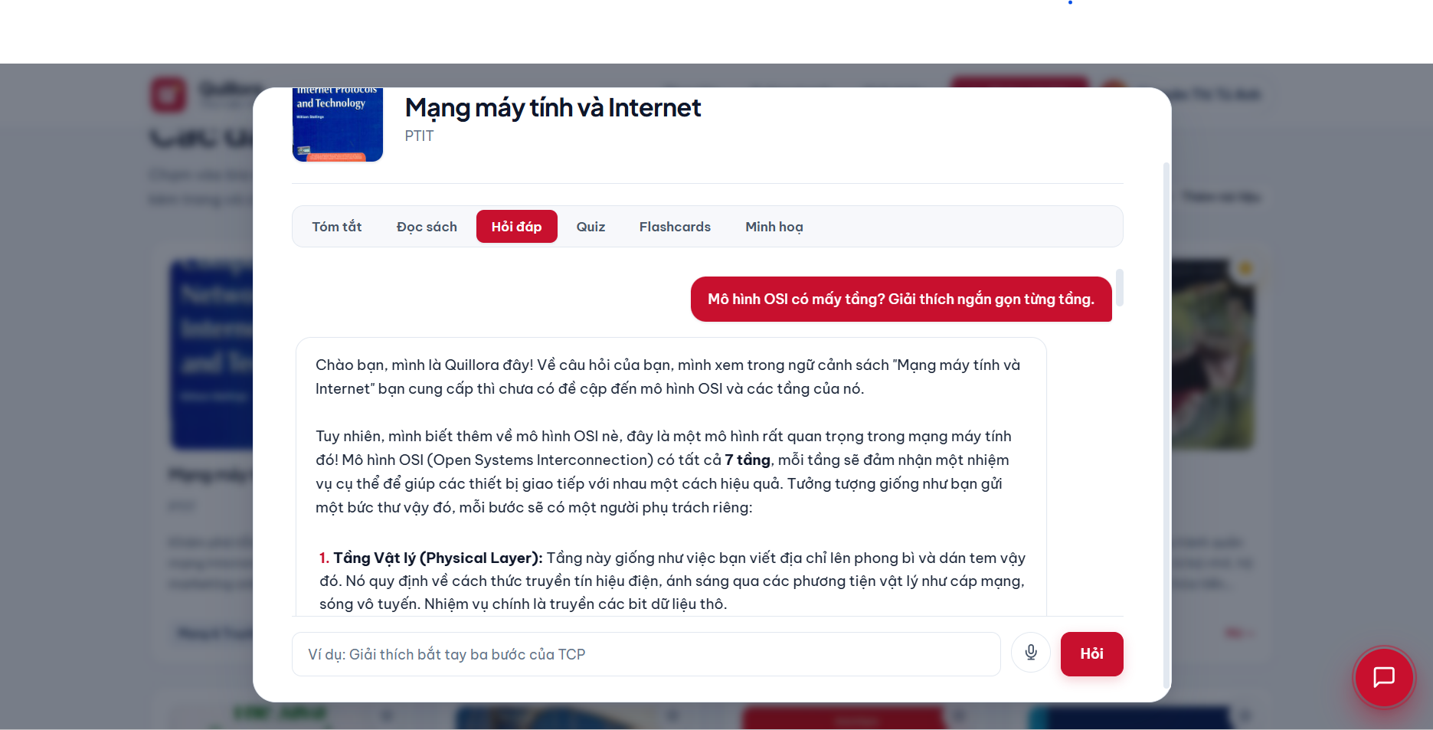
Hoi tiep (chat history)
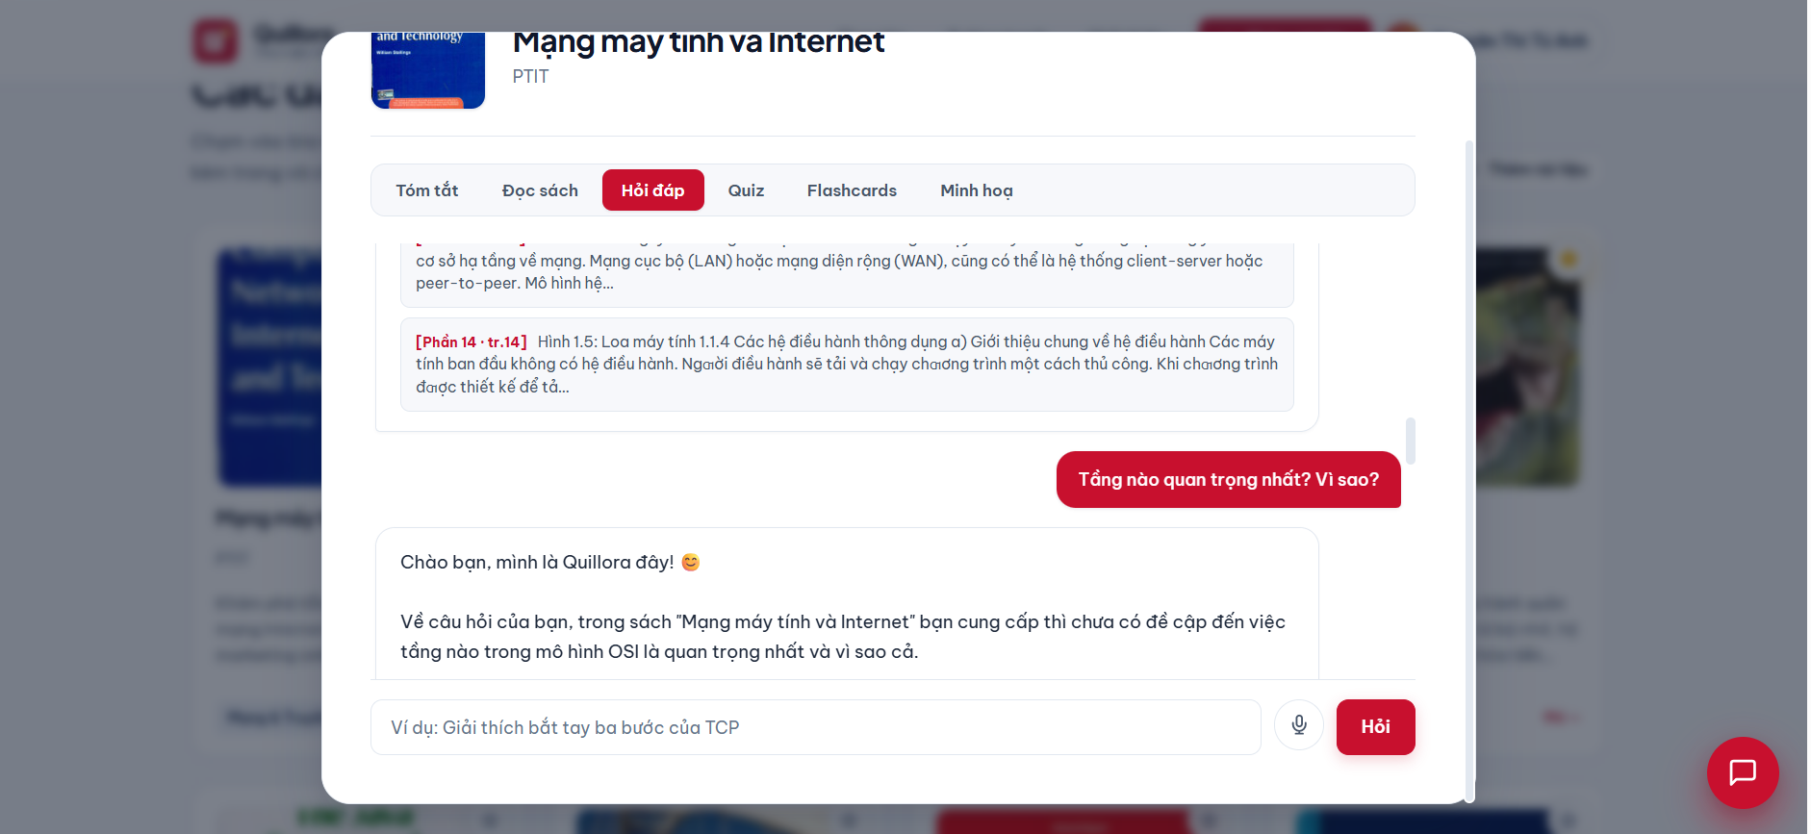

HOI DAP & TOM TAT
Format Markdown & Tom tat sach
Cau tra loi format dep (bold, list, trich dan)
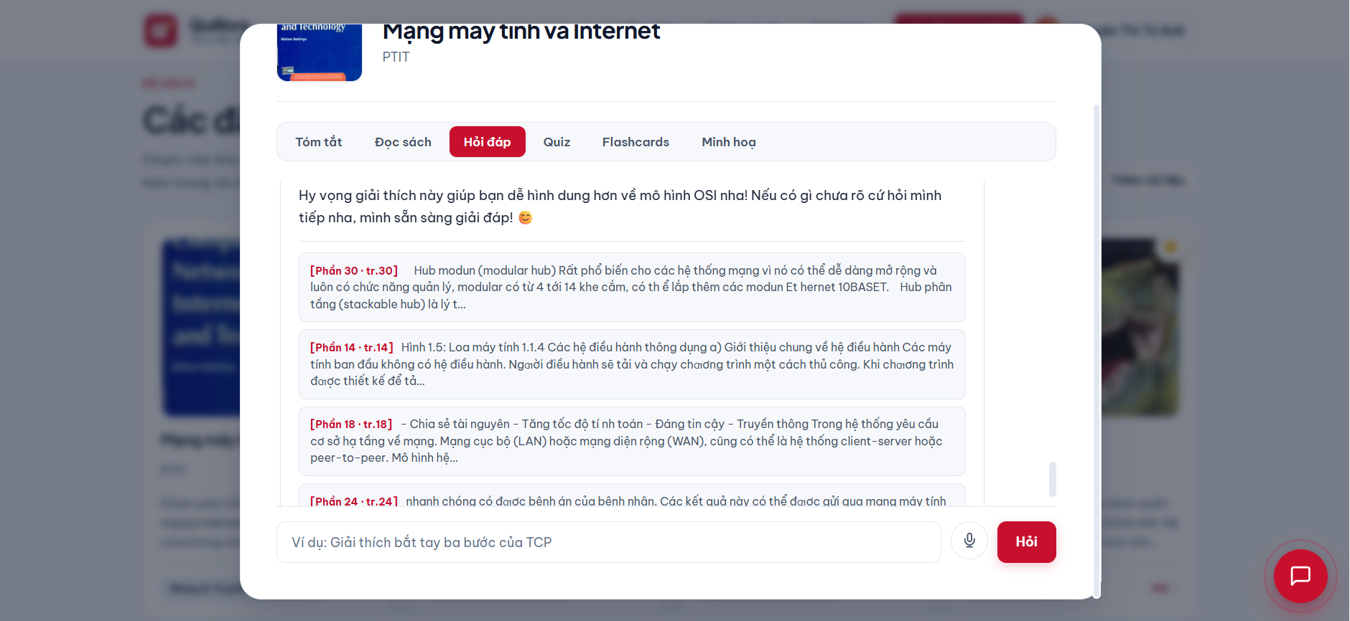
Tom tat noi dung sach bang AI (~200 tu)
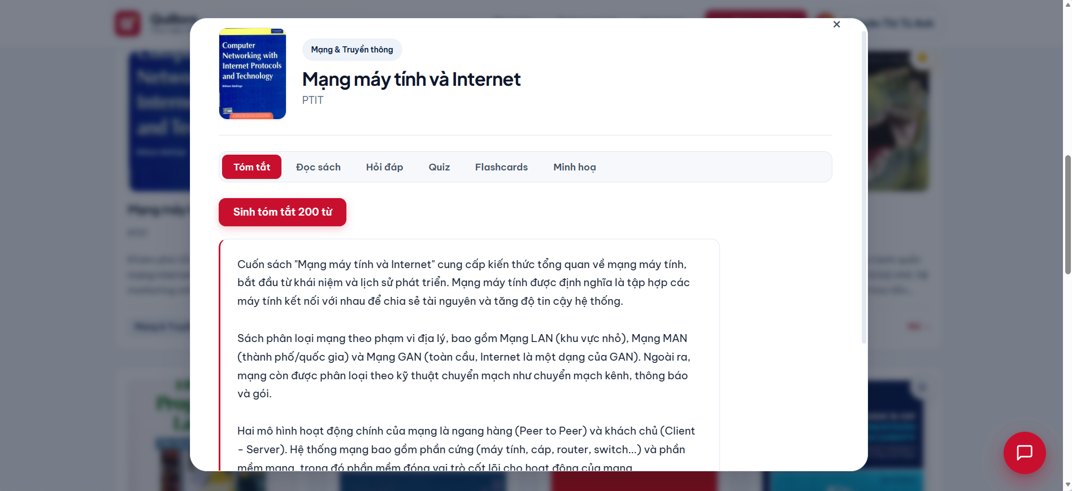
RAG truy hoi cac doan quan trong nhat, Gemini 2.5 Flash sinh tom tat ngan gon, de hieu.

QUIZ TU DONG
On tap bang trac nghiem AI
Sinh 3-20 cau hoi trac nghiem theo chu de tuy chon tu noi dung sach goc. Cham diem tuc thi, giai thich dap an chi tiet. Lam quiz giup nho gap 5x so voi doc lai (Roediger, 2006).
Tao quiz theo chu de

Ket qua cham diem
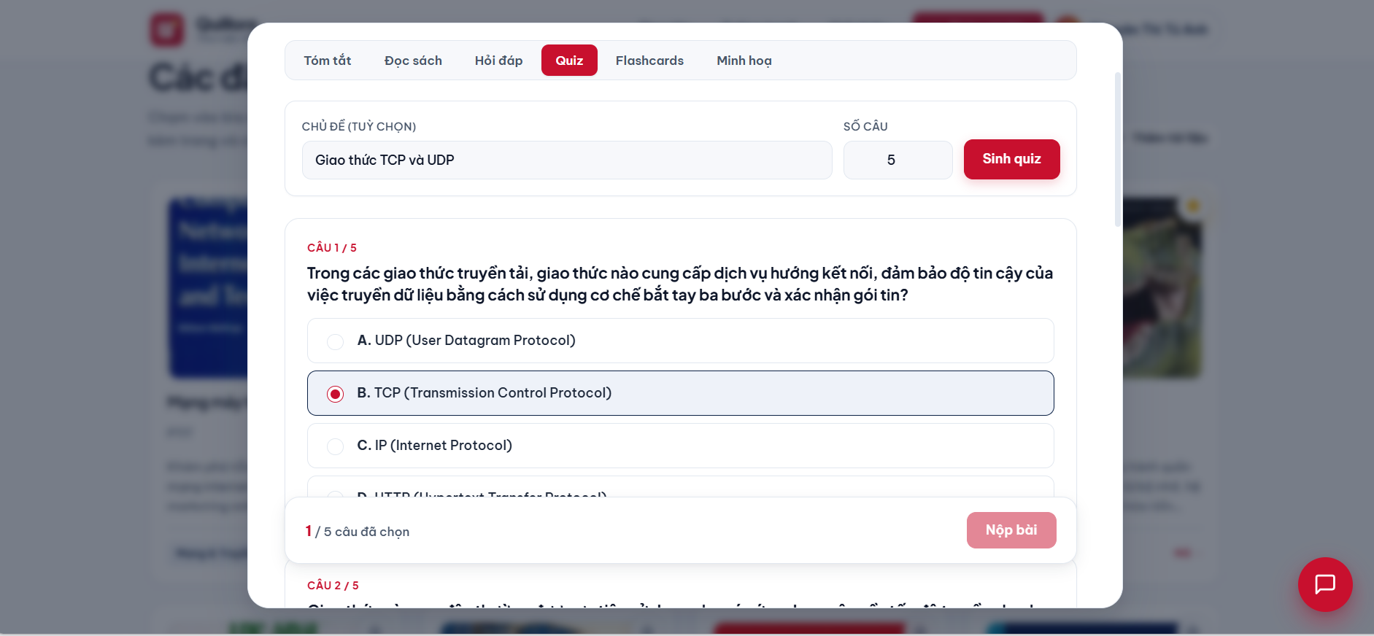

FLASHCARD
Flashcard on tap nhanh
Tao 3-20 the thuat ngu - dinh nghia tu noi dung sach. Click lat the. On tap trong 24h dau tang 80% ghi nho (Murre & Dros, 2015).
Mat truoc (thuat ngu)

Mat sau (lat the)
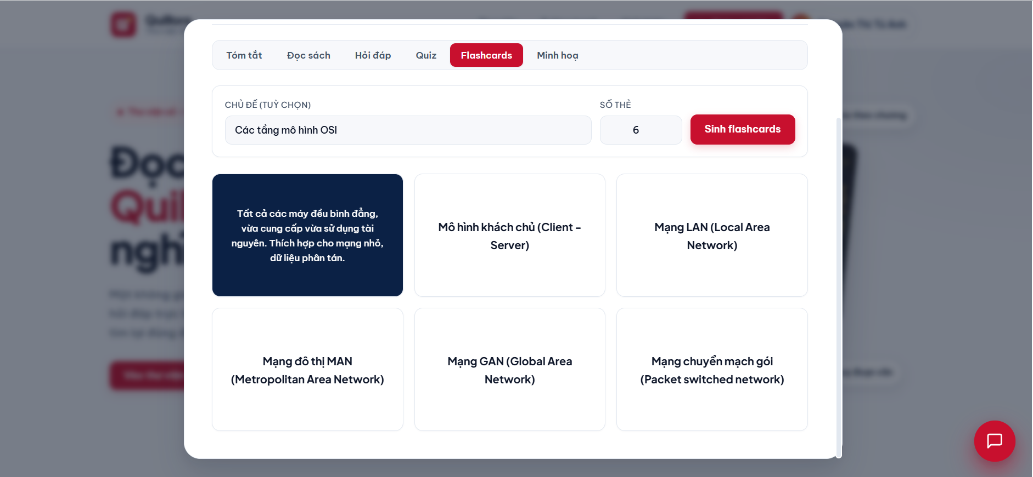

MINH HOA DOAN VAN
AI ve tranh tu doan van
Chon doan van yeu thich -> AI chuyen thanh prompt tieng Anh -> Gemini Image Generation ve tranh phong cach watercolor / children's book illustration.
Nhap doan van & gen anh

Ket qua minh hoa AI
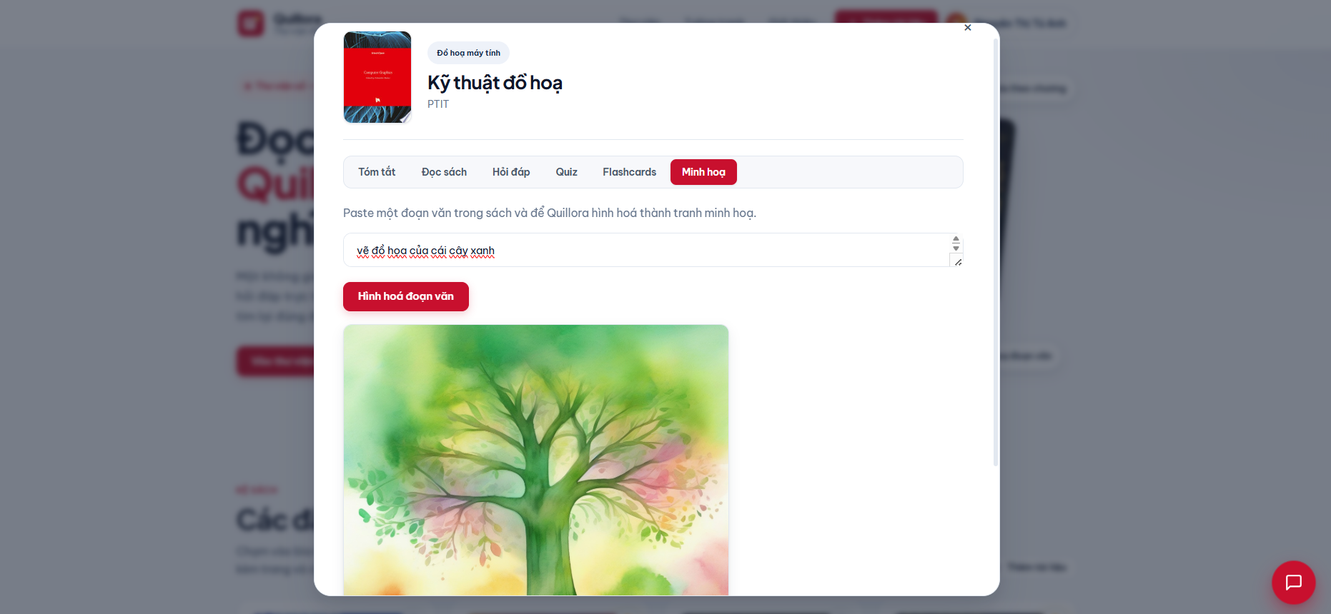

TUONG TRANH
Gallery minh hoa ca nhan
Moi user co tuong tranh rieng - luu lai tat ca anh AI da gen. Dang nhap khac -> tuong tranh khac.
Tuong tranh /wall
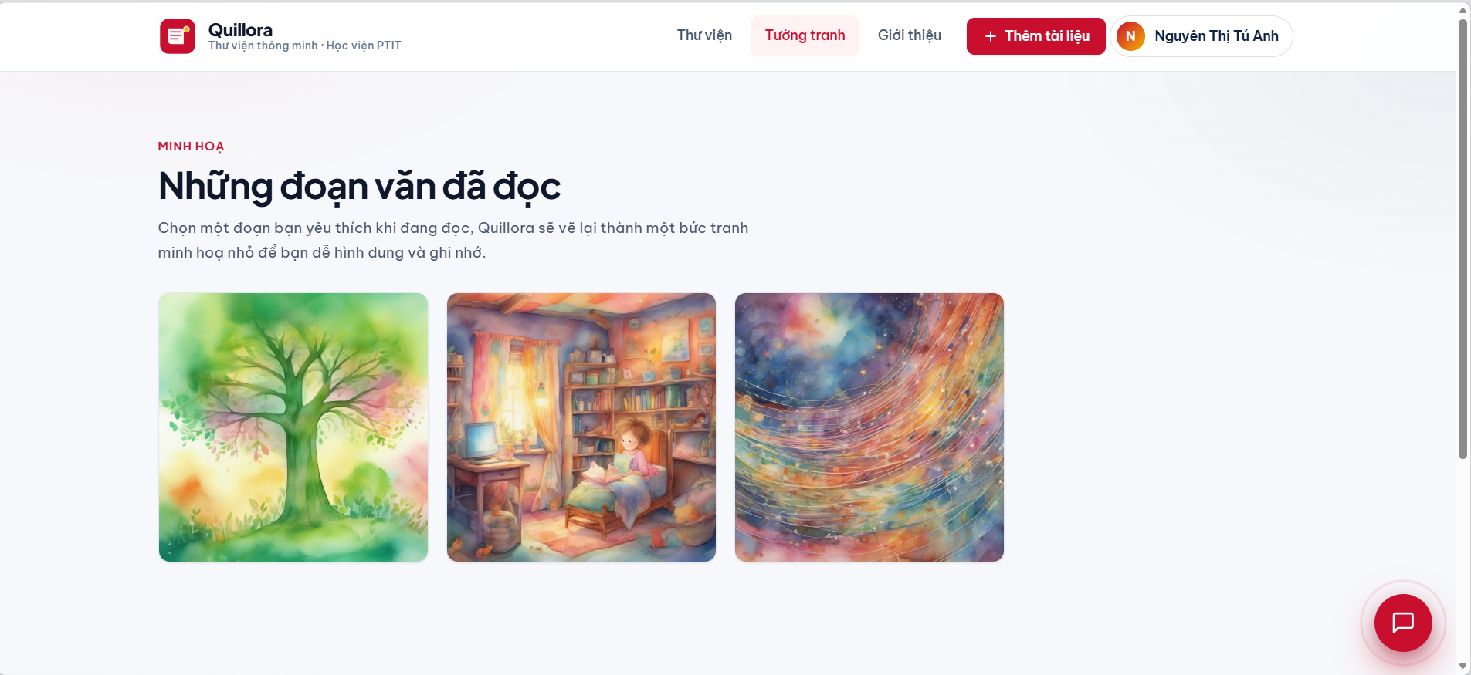
Ca nhan hoa: anh chi hien thi cho user da tao. Gan user_id tu JWT token vao moi visualization.

CHATBOT THU VIEN
Tro ly noi - hoi dap da sach
FAB goc phai duoi, luon hien o moi trang. Tim kiem ngu nghia xuyen suot toan bo thu vien, trich dan tu nhieu sach.
Chatbot noi
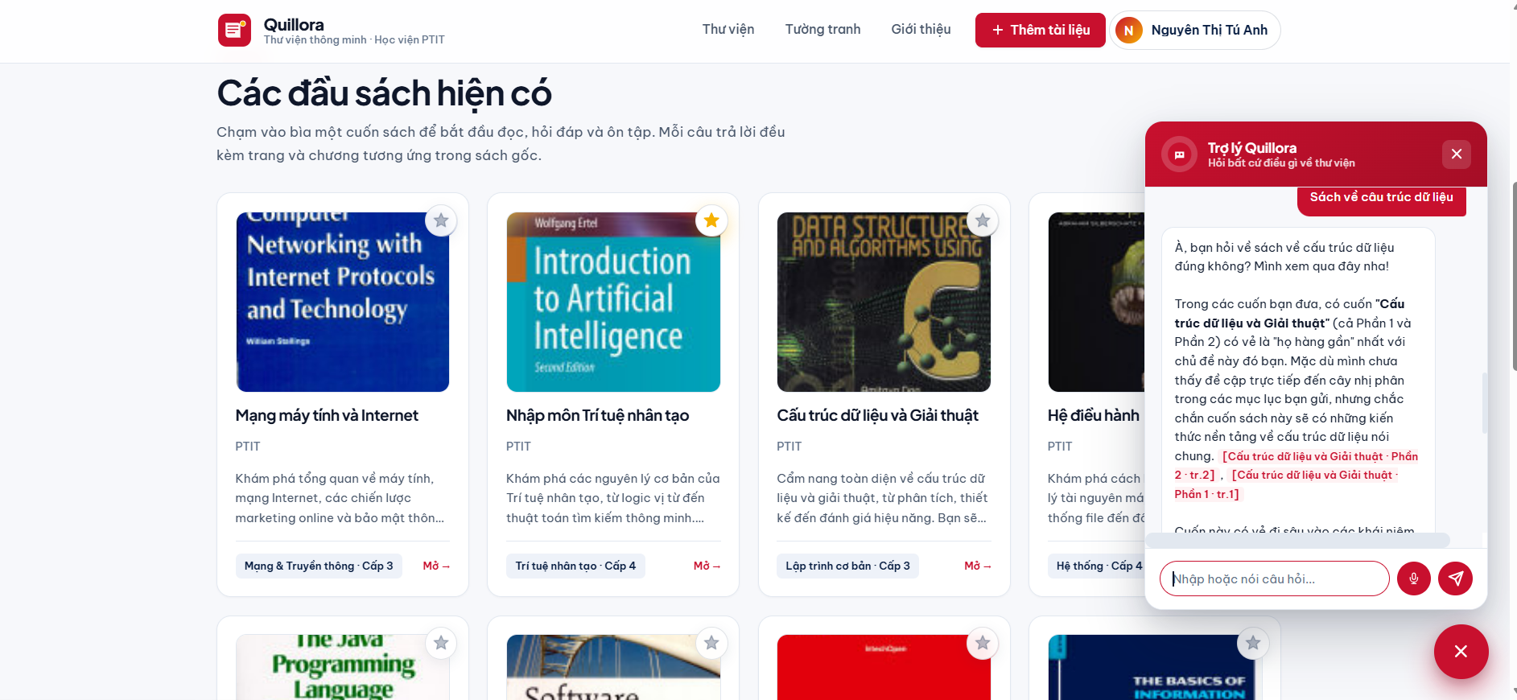
- Cross-book RAG: hoi 1 cau -> tim trong TAT CA sach cung luc.
- Goi y cau hoi mau, lich su hoi thoai lien mach.
- Breathing glow animation thu hut nguoi dung.

UPLOAD & TRANG CA NHAN
Tai tai lieu & Dashboard hoc tap
Upload PDF - san sang chat vai giay

Trang ca nhan - thong ke & lich su


GIOI THIEU
Trang About - 4 tinh nang noi bat
Trang /about trinh bay 4 tinh nang cot loi voi mo ta cuon hut, so lieu khoa hoc.
Giao dien trang gioi thieu
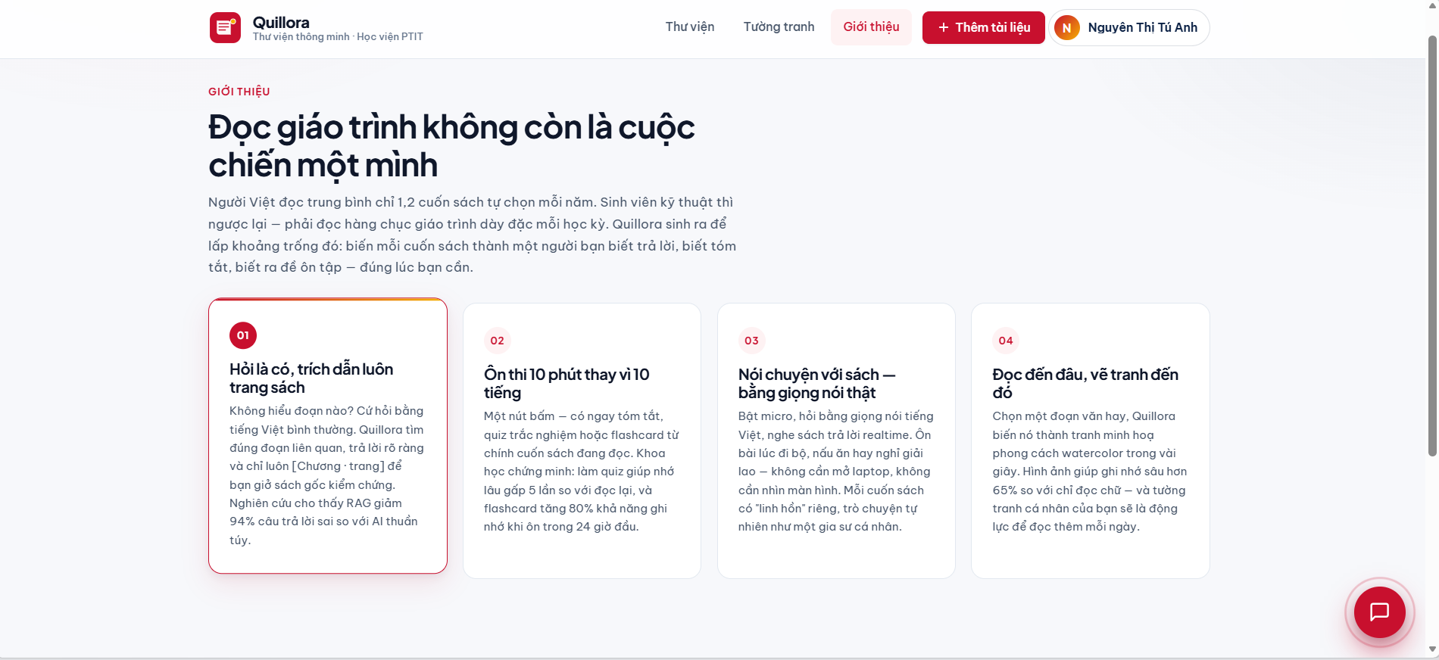
- Hoi la co, trich dan luon trang sach - RAG giam 94% cau tra loi sai.
- On thi 10 phut thay 10 tieng - Quiz nho gap 5x, Flashcard +80% ghi nho.
- Noi chuyen voi sach bang giong noi that - gia su ca nhan realtime.
- Doc den dau, ve tranh den do - hinh anh giup nho sau hon 65%.

