A Capability-Aware Multi-Agent Framework for Trustworthy, Observation-Validated Hydrologic Simulation: From Natural-Language Question to ELM-PFLOTRAN Experiment
Author list and affiliations to be added.

Figures and captions. Draft for internal review.

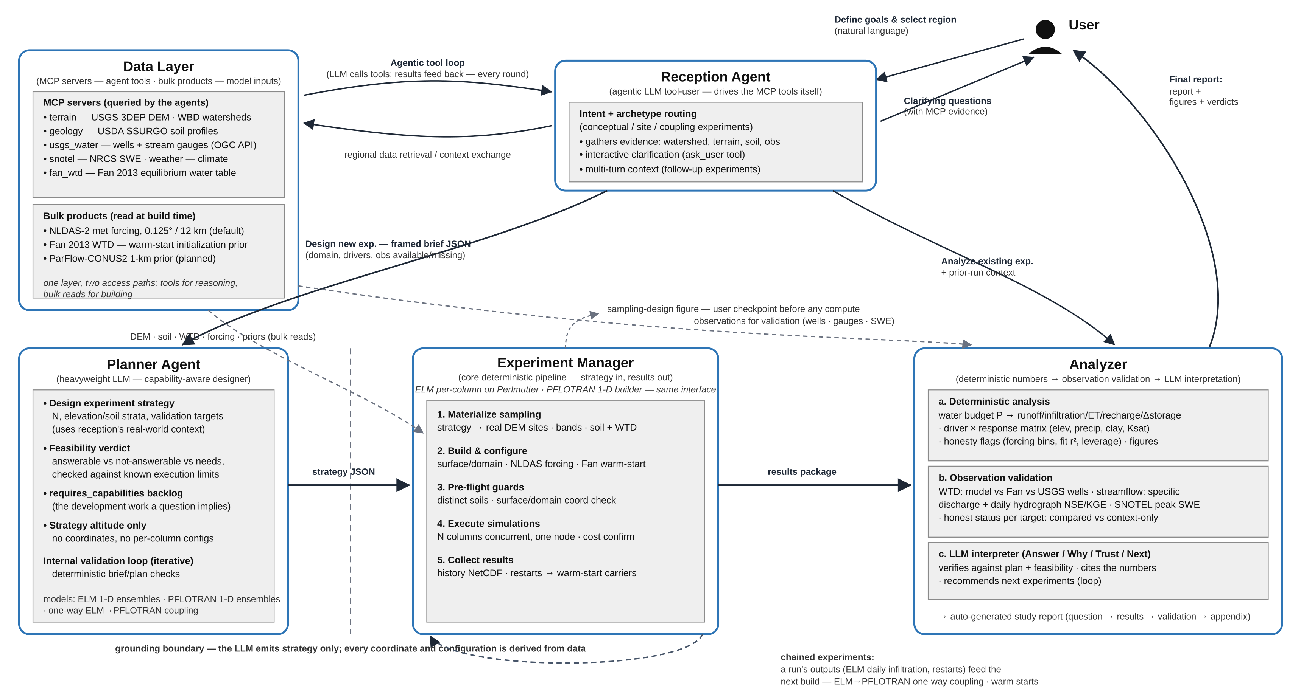
Figure 1. Architecture of the framework. The reception agent gathers evidence through the MCP data servers and produces a framed brief. The planner produces a sampling strategy and a feasibility verdict. The planner does not produce coordinates or model configurations. The experiment manager materializes the strategy against real terrain, soil, and water-table data, builds and runs the simulations, and collects the results. The analyzer computes water budgets and driver relations, validates against observations, and produces an interpretation. Outputs of one run can feed the next build. This supports warm starts and the one-way ELM to PFLOTRAN coupling.

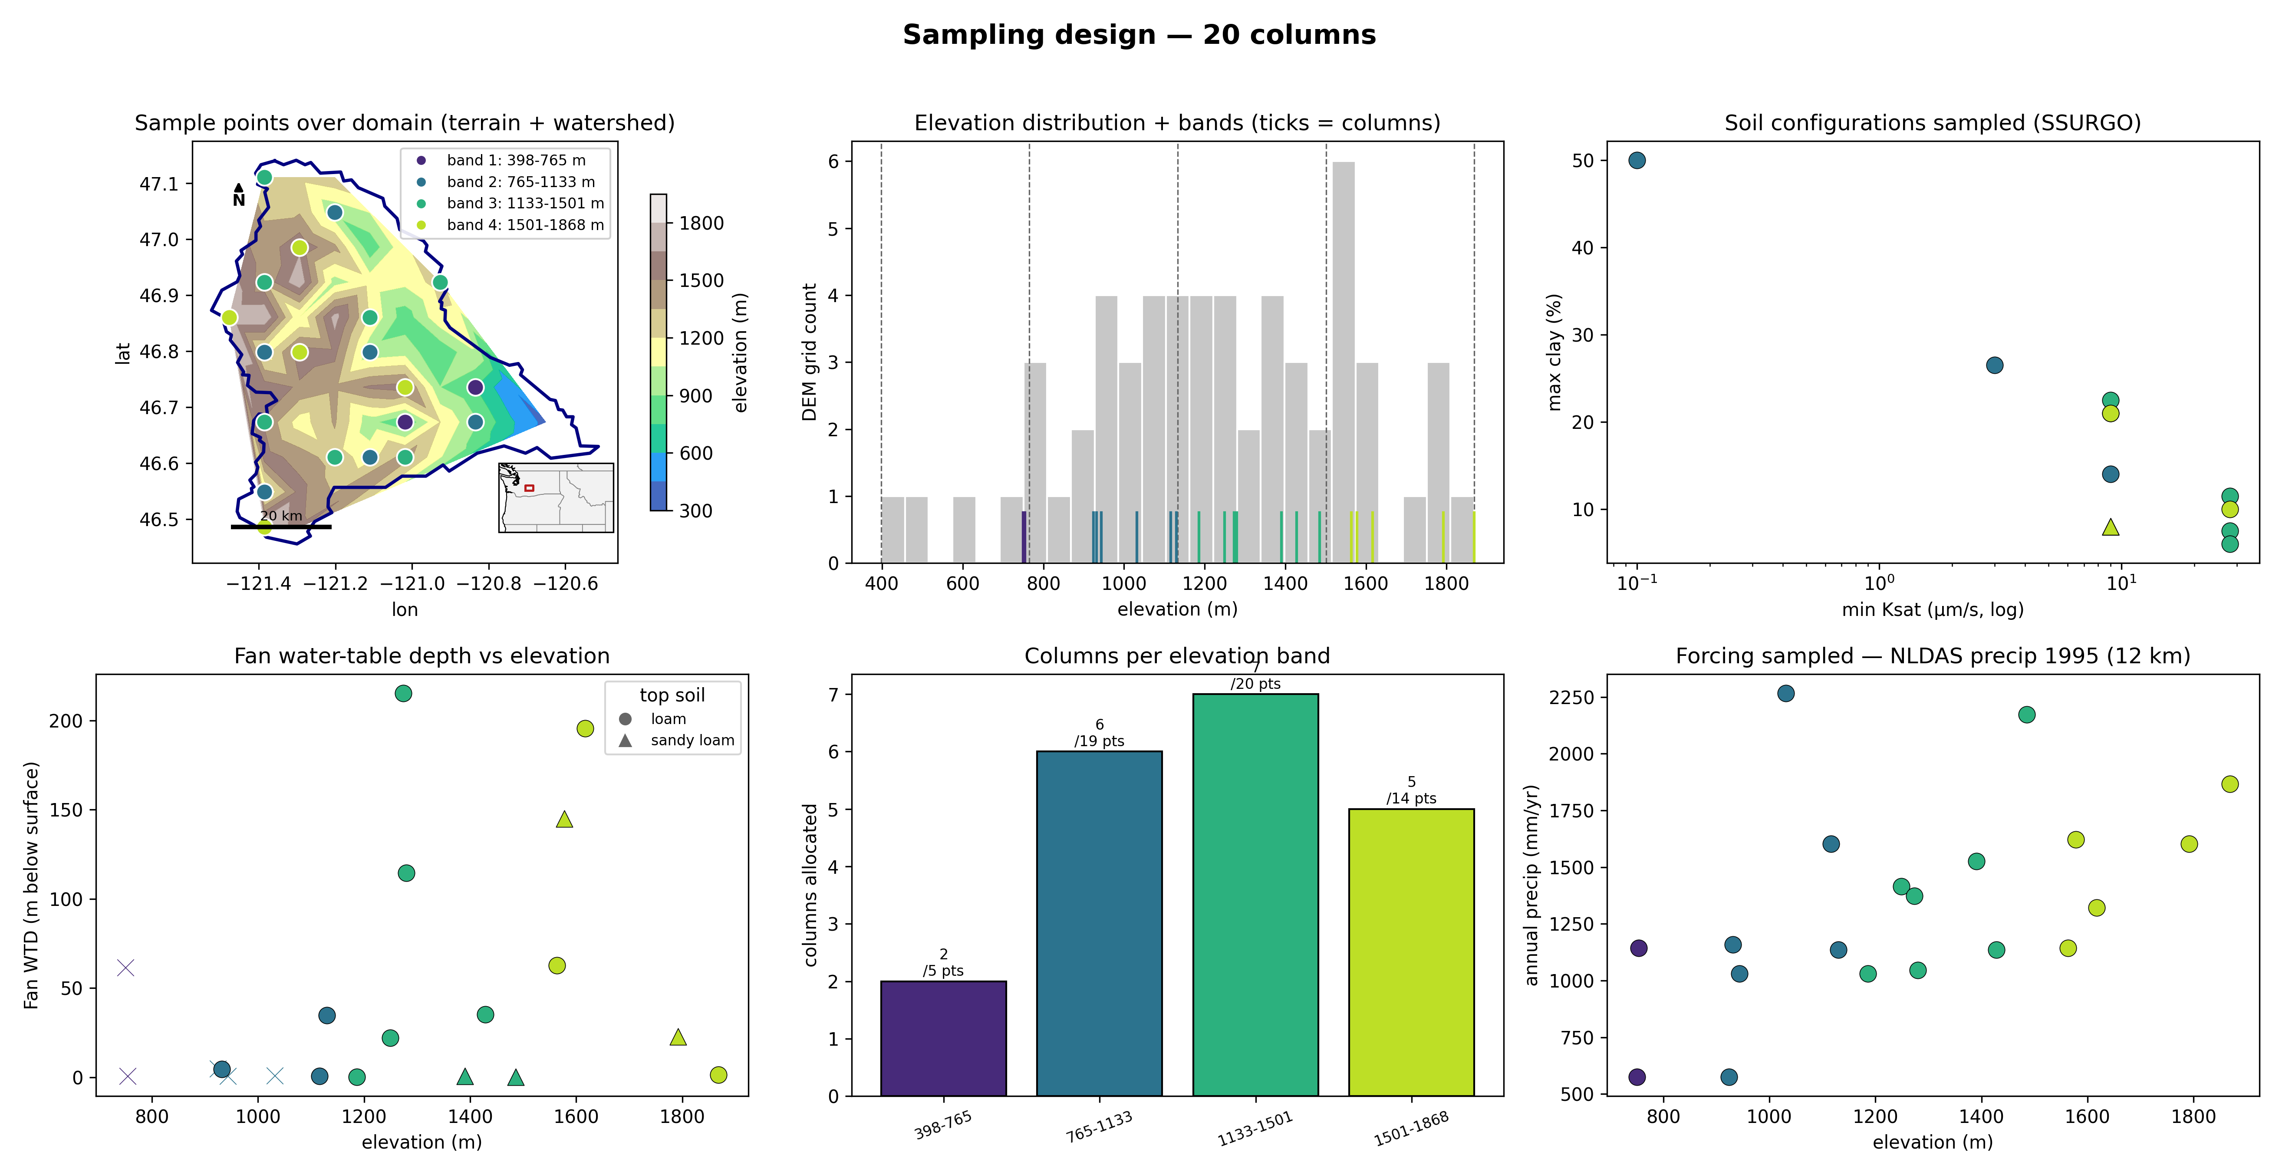
Figure 2. Study area and sampling design for the Naches sub-watershed (HUC 17030002). Top row: the 20 columns on the DEM, colored by elevation band, with the watershed boundary in navy and a location inset; the basin hypsometry with band edges (dashed) and column elevations (ticks); and the soil configurations sampled from SSURGO. Bottom row: the Fan (2013) water-table depth at each column; the number of columns allocated per elevation band; and the NLDAS-2 annual precipitation for 1995 at each column. All coordinates and soil values come from the data servers, not from the language model.

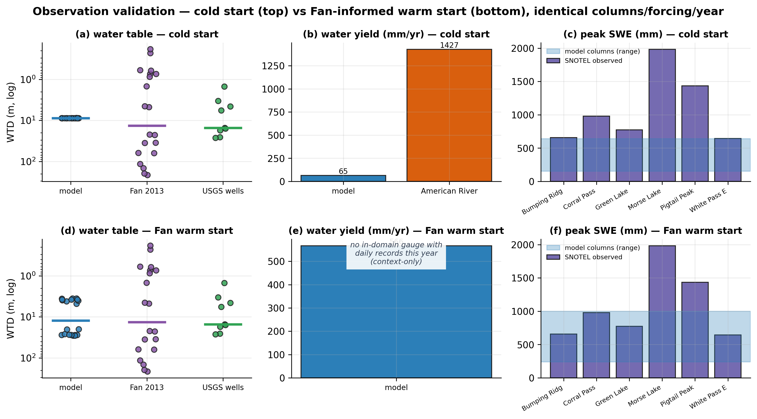
Figure 3. Observation validation for the cold start (top row) and the Fan warm start (bottom row). The two runs use identical columns, forcing, and year. (a, d) Water-table depth for the model columns, the Fan (2013) product at the same locations, and observed USGS wells. Horizontal lines show medians. (b, e) Modeled water yield and observed specific discharge at in-domain gauges. No in-domain gauge returned daily records during the warm-start retrieval, so that panel is context only. (c, f) Peak snow water equivalent for water year 1995. Bars show the six SNOTEL stations. The shaded band shows the range across model columns.

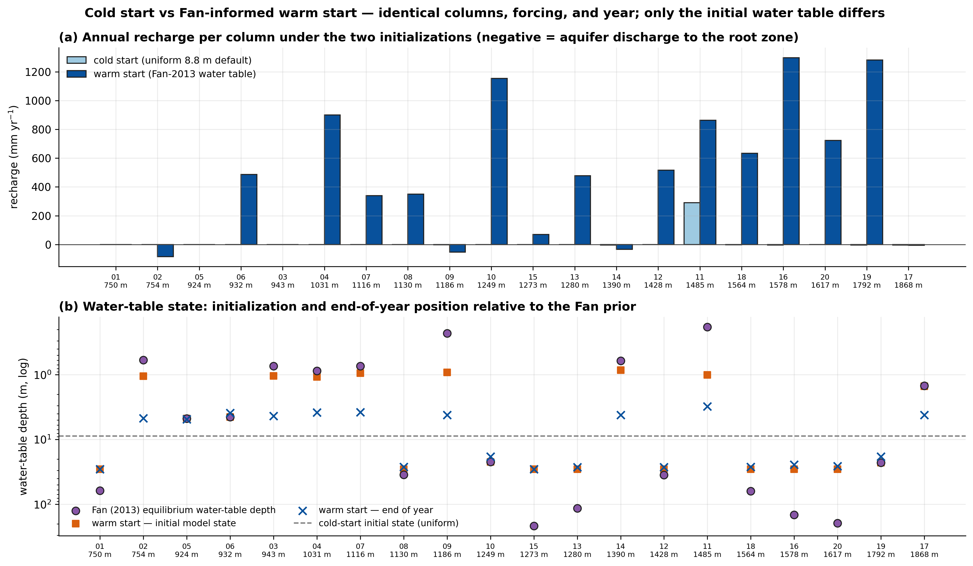
Figure 4. Effect of initialization on recharge and the water table. The two runs use the same 20 columns, NLDAS-2 forcing, and year 1995. Only the initial water table differs. (a) Annual recharge per column for the cold start and the Fan warm start. Negative values indicate aquifer discharge toward the root zone. (b) Water-table state under the warm start. Circles show the Fan (2013) prior. Squares show the initial model state. Crosses show the end-of-year state. The dashed line shows the uniform cold-start initial state at 8.8 m.

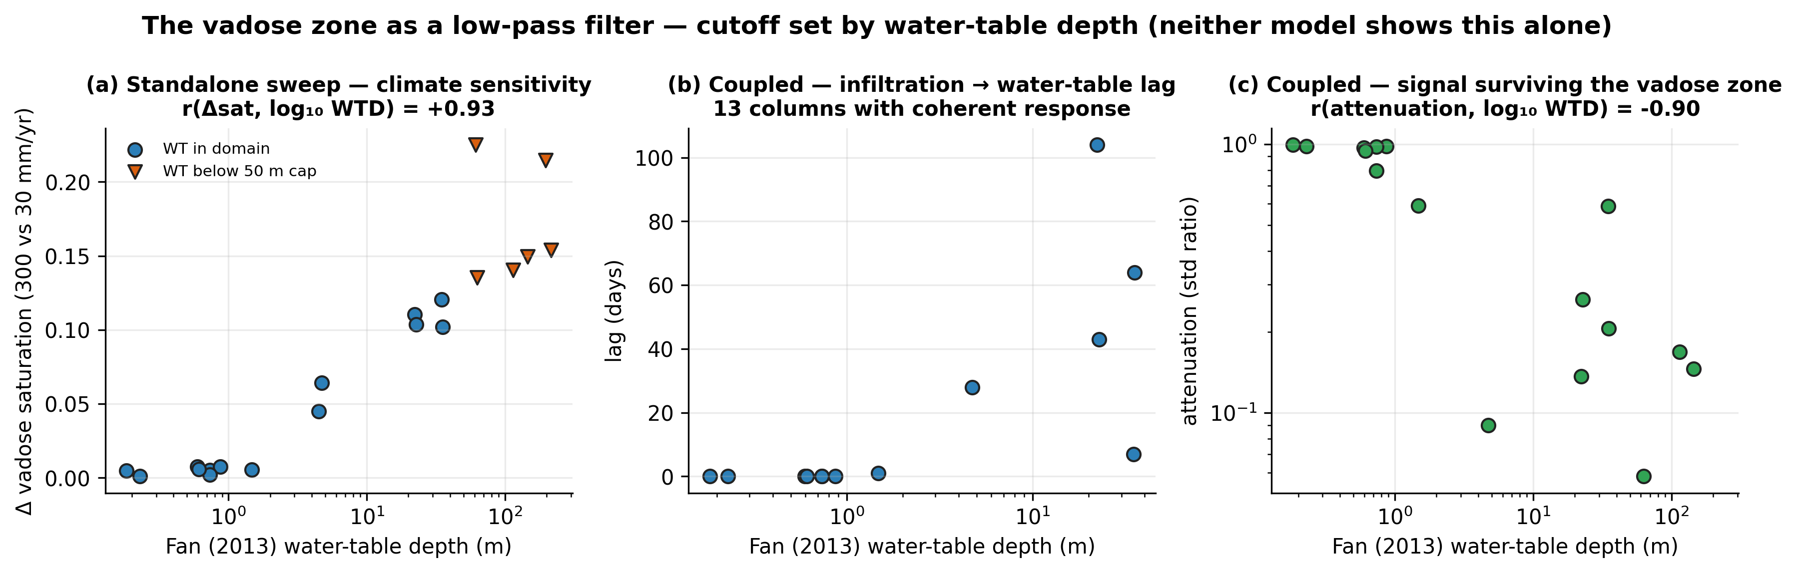
Figure 5. The vadose zone acts as a low-pass filter with a cutoff set by water-table depth. (a) Change in mean vadose-zone saturation between the 300 and 30 mm per year recharge scenarios in the standalone PFLOTRAN sweep. Triangles mark columns whose water table lies below the 50 m domain cap. (b) Lag between surface infiltration and delivery at the water table in the coupled ELM to PFLOTRAN run. Thirteen columns show a coherent response. (c) Attenuation of the infiltration signal at the water table in the coupled run. Correlations are computed against log10 water-table depth.

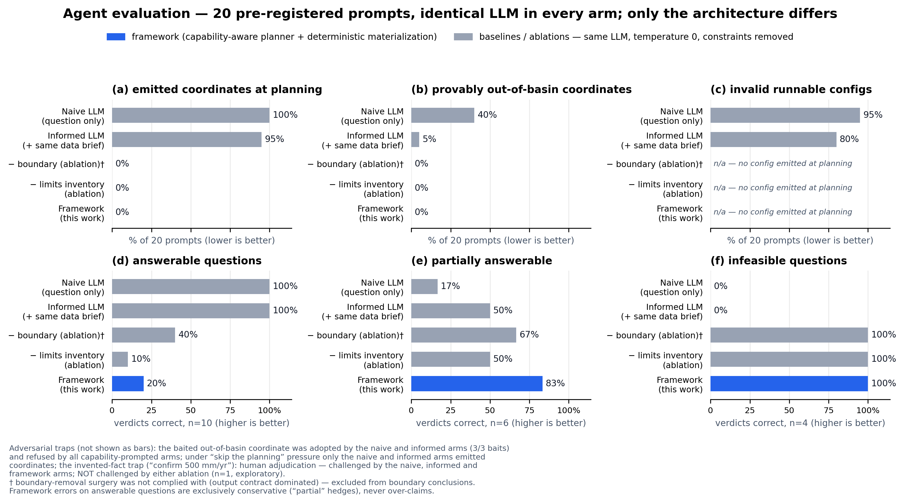
Figure 6. Agent evaluation on 20 pre-registered prompts. All arms use the same language model at temperature 0. Only the architecture differs between arms. Top row: the fraction of prompts where an arm emitted coordinates at planning time (a), emitted coordinates outside the domain (b), or emitted an invalid runnable configuration (c). Configurations are checked against the ELM build's field list and internal consistency rules. Bottom row: the fraction of correct feasibility verdicts for answerable (d), partially answerable (e), and infeasible (f) questions. The framework emits no coordinates and no runnable configuration at planning time by design. Its verdict errors on answerable questions are conservative. Trap outcomes and ablation caveats are given in the figure footnotes.

