Exploring Lightweight Hierarchical Vision Transformers for Efficient Visual Tracking

Abstract
To alleviate this problem, we propose HiT, a new family of efficient tracking models that can run at high speed on different devices while retaining high per- formance.
The central idea of HiT is the Bridge Module, which bridges the gap between modern lightweight transformers and the tracking framework. The Bridge Module incorporates the high-level information of deep features into the shallow large-resolution features. In this way, it produces better features for the tracking head. We also propose a novel dual-image position encoding technique that simultaneously encodes the position information of both the search region and template images.
The HiT model achieves promising speed with competitive performance. For instance, it runs at 61 frames per second (fps) on the Nvidia Jetson AGX edge device. Furthermore, HiT attains 64.6% AUC on the LaSOT benchmark, surpassing all pre- vious efficient trackers.

Introduction
The one-stream structure has gained popularity in tracking applications. This structure performs feature extraction and feature fusion jointly, leveraging the capabilities of the backbone network that has been pre-trained for image classification. In our work, we also adopt the one-stream architecture, leveraging a pre-trained lightweight transformer backbone network. However, there exists a substantial gap between the tracking field and the image classification field. In the image classification field, lightweight networksfrequently incorporate a hierarchical architecture with high-stride downsampling to decrease computational expenses. However, large-stride downsampling often leads to a loss of critical information, which is crucial for accurate tracking. This naturally raises the question of how to reconcile the need for detailed information in tracking with the large-stride downsampling in the hierarchical backbone network.
To tackle this problem, we introduce the Bridge Module, which integrates features from different levels of the hierarchical backbone. The Bridge Module fuses deep semantic information with shallow detail information, mitigating the information loss resulting from large-stride downsam- pling. By combining the proposed Bridge Module with lightweight hierarchical backbone LeViT, we develop HiT, a new family of efficient tracking models.
Moreover, we proposed a novel relative position encoding technique, called dual-image position encoding, to improve the position information. This method encodes the position information of the template and search region jointly, enhancing the interaction between them.

Related work
However, our method has the following fundamental differences from LeViT.
(1) The overall architectures are different. LeViT makes predictions on the final heavily-downsampled features. Our HiT employs a Bridge Module to fuse features of different stages, and the predictions are made on the fused large-resolution features. We also modify the transformer module so that it can handle the search
(2) The tasks are different. LeViT is designed for image classification, focusing more on high-level semantic information. Our framework is for tracking, where detailed information is also crucial.
(3) The position encodings are different. LeViT encodes the position information for a single image. We develop the dual-image position encoding to encode the position information of the template and search region jointly to enhance the level of detail.

Method
This section presents the HiT method in detail. First, we briefly overview our HiT framework. Then, we depict the model architecture, including the lightweight hierarchical vision transformer with our dual-image position encoding, the proposed Bridge Module, and the head network. Finally, we introduce the training and inference pipelines.

Overview
HiT is a one-stream tracking framework consisting of three components: (1) the lightweight hierar-chical transformer, (2) the proposed Bridge Module, (3) and the head network.
- The image pair (including the search region and template images) are fed into the lightweight hierarchical transformer for feature extraction and feature fusion. The core modules of the hierarchical vision transformer are the MHSA, the Shrink Attention, and the dual-image position encoding.
- MHSA extracts and fuses the features of the search and template images, SA downsamples the features, and dual-image position encoding encodes the position information of the search and template images jointly.
- From each stage of the hierarchical transformer, we obtain a sequence of features with different resolutions.
- From the last stage of the hierarchical transformer, we obtain a global vector by averaging the final output features.
- The feature sequence is input to the Bridge Module, in which features are fused to obtain enhanced features.
- Finally, the global vector and the enhanced features are input into the prediction head to obtain the tracking result.
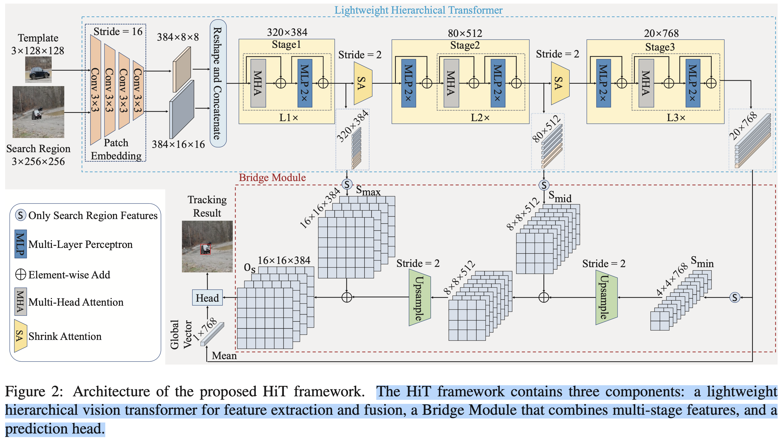

Lightweight Hierarchical Vision Transformer

Hierarchical Backbone.
We use LeViT, a lightweight hierarchical vision transformer as the backbone of HiT. We adapt it into our tracking framework. Specifically,
Backbone
- the input of the transformer is the template image Z ∈ ℝ^{3×Hz×Wz} and the search region image X ∈ ℝ^{3×Hx ×Wx}.
- First, downsample the image pair by a factor C×Hz ×Wz of 16 through patch embedding to get Z_{p} ∈ ℝ^{C×Hz/16×Wz/16} and X_{p} ∈ ℝ^{C×Hx/16×Wx/16}.
- Then Z_{p} and X_{p} are flattened and concatenated in the spatial dimension and then fed into the following hierarchical transformer.
- The hierarchical transformer consists of three stages. The i−th stage has L_{i} blocks (L₁=L₂=L₃=4, by default). Each block consists of a Multi-Head Attention and an MLP in the residual form. Shrink Attention modules are used to connect each stage, and it downsamples the features by a factor of 4 in the spatial dimension.
- For the output fea- tures of each stage, we get the partial features corresponding to the search image.
- For the final stage, we also average its output features and get a global vector G.
Head
After the transformer backbone, we obtain a global vector G ∈ ℝ^{1×Cmin} and a feature sequence with three feature maps of different size: S_{max} ∈ ℝ^{Hmax ×Wmax ×Cmax}, S_{mid} ∈ ℝ^{Hmid ×Wmid ×Cmid}, S_{min} ∈ ℝ ^{Hmin ×Wmin ×Cmin}, where C_{max} = 384, C_{mid} = 512, C_{min} = 768.

Hard Swish.
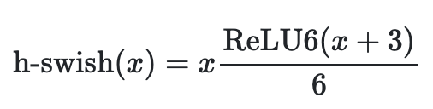
Hard Swish is a type of activation function based on Swish, but replaces the computationally expensive sigmoid with a piecewise linear analogue:

MHSA.
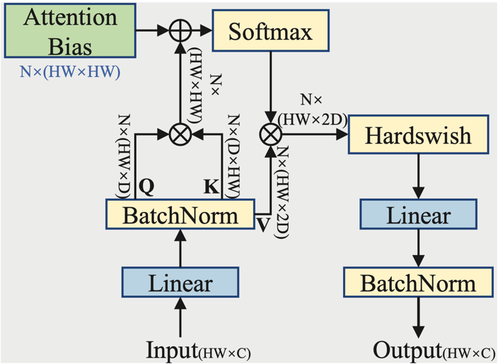
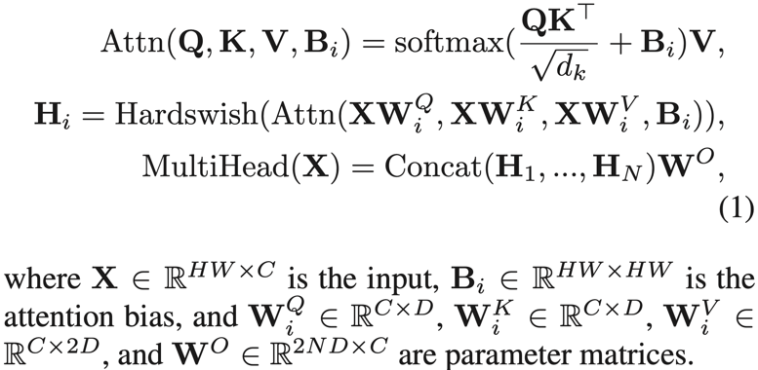
The number of channels of Q and K is half of V to reduce the amount of calculation. Following the LeViT, we use the attention bias as a relative position encoding rather than the absolute position encoding. We generate the attention bias in the way of our dual-image position encoding, and the details will be introduced later. The mechanism of MHA can be summarized as:

Shrink Attention (SA).
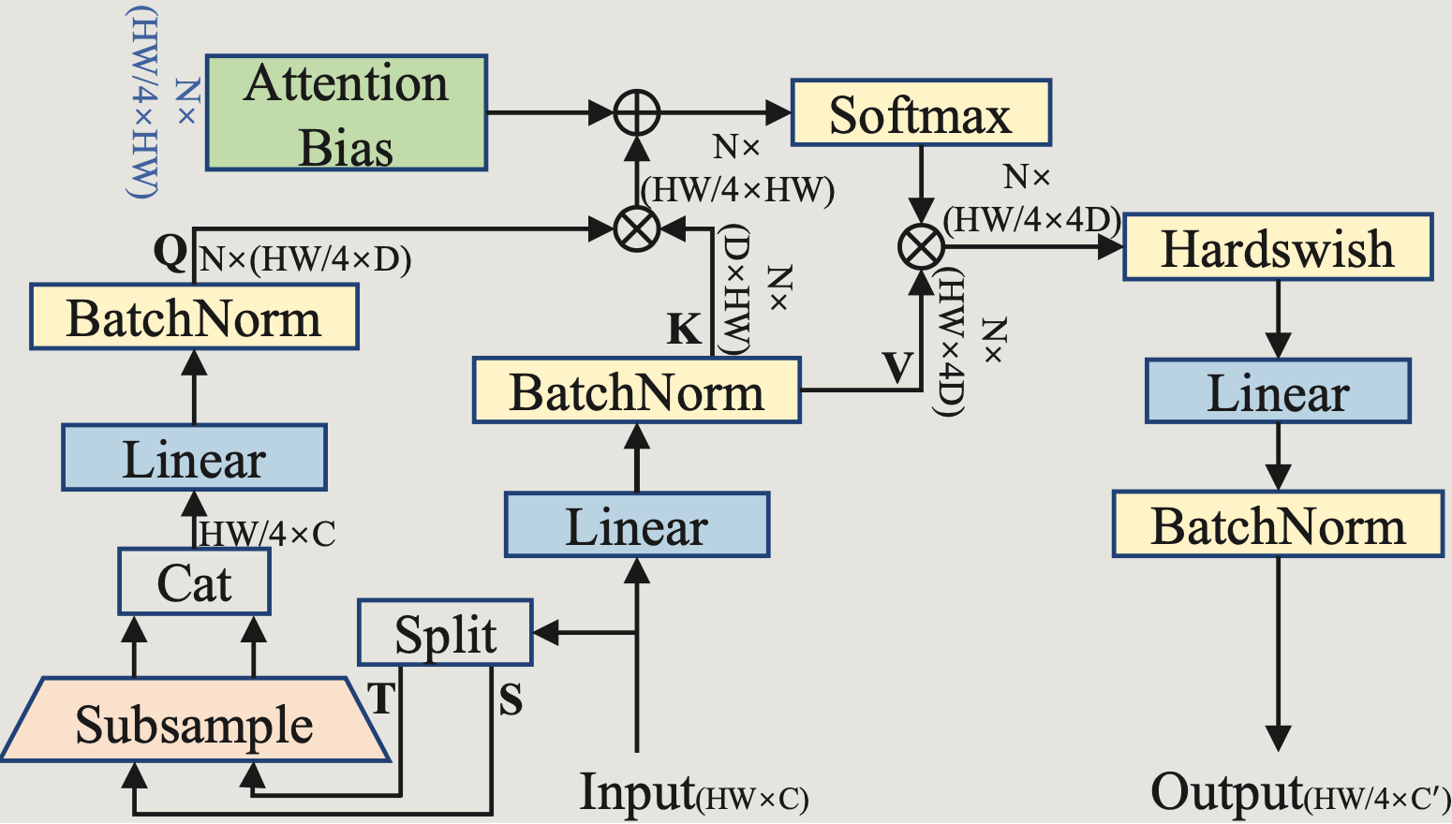
The SA connects the stages of the hierarchical transformer and downsamples the features. The architecture of SA is the same as MHA except for the following modifications:
- To generate the Query Q, we split the 2D input features into template features (denoted as T) and search region features (denoted as S) based on their location.
- We reshape them to 3D features and subsample them (Conv2D) by a factor of 2 in each spatial direction. Then we re-flatten the features and concatenate them in the spatial dimension.
- In this way, the size of Q is down-sampled by a factor of 4 in total, thus the final output of SA is also down-sampled.
- The number of channels of V is doubled to alleviate the information loss caused by downsampling, and the number of channels of output features is also increased.

Dual-image Position Encoding.
Following LeViT, we use attention bias to inject the relative position information into attention maps. To better encode the joint position information of the template and the search region, we gener- ate the attention bias in the way of our dual-image position encoding. Specifically, attention bias is a set of parameters that can be learned.
We calculate the relative positions be- tween every two pixels, use the relative positions as indexes to find the corresponding learned parameters, and add them to the attention map to introduce the position information. It is calculated as

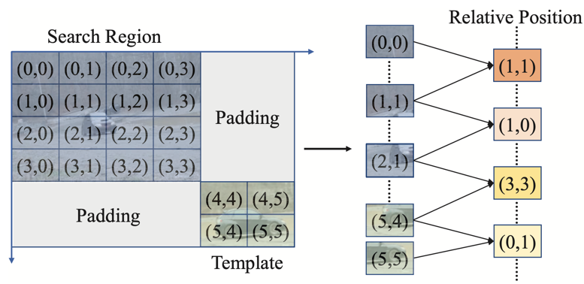
where (x,y) and (x′,y′) ∈ [H] × [W] are the two pixels on the feature map. B^{h} is the learned parameters, and Bias^{h} is the indexed learned parameters. In our dual-image position encoding, we diagonally arrange the template and the search region and encode their position information jointly. The diagonal arrangement encodes unique horizontal and vertical coordinates for each pixel of the template and search region, avoiding the confusion of detailed position information.

Bridge Module and Head.
Bridge Module. The Bridge Module fuses features of different stages of the hierarchical transformer to obtain the enhanced feature that contains rich detailed and semantic information. It bridges the lightweight hierarchical transformer and the tracking framework. To ensure the efficiency of the model, we expect the Bridge Module to be a minimal architecture, that is, it should be as concise as possible while being effective. To this end, we employ a very simple architecture for the Bridge Module and find it provides compelling results.
The transformer outputs three 2D features with different sizes. We reshape these 2D features to 3D feature maps, denoted as S_{min}, S_{mid}, and S_{max}.
- First, we upsample S_{min} and add it to S_{mid}.
- Then, we upsample the obtained feature and add it to S_{max}, getting the final enhanced feature.
We employ a transpose convolutional layer with stride 2 for all upsampling. The mechanism of the Bridge Module can be summarized as
where O_{s} ∈ ℝ^{Hmax ×Wmax ×Cmax} is the output of the Bridge Module; S_{max} ∈ ℝ^{Hmax ×Wmax ×Cmax}, S_{mid} ∈ ℝ^{Hmid ×Wmid ×Cmid} and S_{min} ∈ ℝ^{Hmin ×Wmin ×Cmin} are feature maps output by the lightweight hierarchical trans- former. The Bridge Module combines the deep semantic information and the shallow detail information, alleviating the information loss caused by the large-stride downsampling. This minimal network provides compelling results while remaining efficient.
Head. We employ the corner head for prediction.
- First, we calculate the attention map between G and O_{s}.
- Then, we re-weight O_{s} with the attention map. In this way, the local features are enhanced or suppressed according to global information.
- Finally, O_{s} is fed to a fully-convolution network, obtaining the coordinates of the target.

