Transformer-based Backbone

MOBILE-VIT

(Comments)
- Visual-feature extraction works better on image-specific inductive bias extractor that are introduced in CNN convolution stem, rather than linear-combination of pixel space.
- Key ideas: MHSA module is integrated in the convolution block of MobileViT in order to capture long-range dependencies of superpixels's feature with receptive field size is the whole image. Positional encoding is not required because this network treats MHSA as a convolution layer so permutation invariant property is employed in this network.
- Architecture: Kind of CNN with MHSA module acts role as convolution layer.
Conv(3x3) => MobileNetv2_block×3 => (MobileViT_block + MobileNetv2_block) ×2 => MobileViT_block => Conv(1x1) => AvgPool => FCN.
  - MobileViT composes of Conv(nxn) => Fold+Normal MHSA => Unfold =>Concat =>Conv(nxn), which Conv(nxn) acts role as convolutional stem.
- 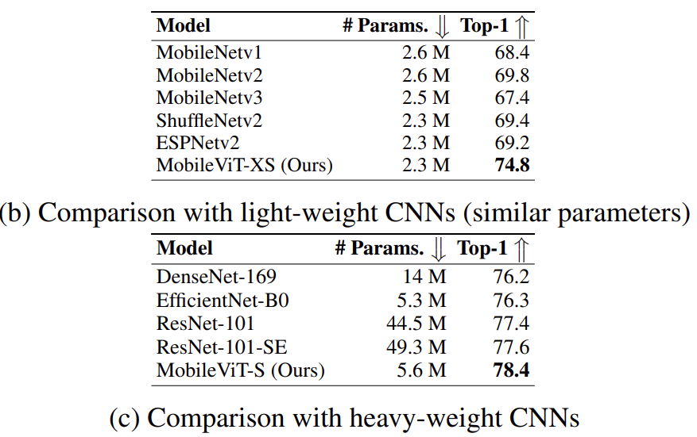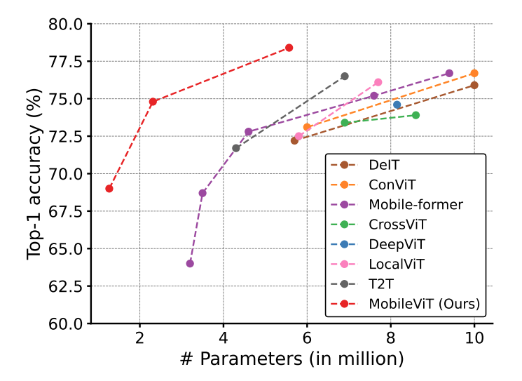

Introduction
To the best of our knowledge, this is the first work that shows that light-weight ViTs can achieve light-weight CNN-level performance with simple training recipes across different mobile vision tasks. For a parameter budget of about 5-6 million, MobileViT achieves a top-1 accuracy of 78.4% on the ImageNet-1K dataset (Russakovsky et al., 2015), which is 3.2% more accurate than MobileNetv3 and has a simple training recipe (MobileViT vs. MobileNetv3: 300 vs. 600 epochs; 1024 vs. 4096 batch size). We also observe significant gains in performance when MobileViT is used as a feature backbone in highly optimized mobile vision task-specific architectures.

Related work
Light-weight CNNs. This work views transformers as convolutions; allowing to leverage the merits of both convolutions (e.g., versatile and simple training) and transformers (e.g., global processing) to build light-weight and general-purpose ViTs.
Vision Transformers. ViTs can achieve CNN-level accuracy without image-specific inductive bias. With extensive data augmentation, heavy L2 regularization, and distillation, ViTs can be trained on the ImageNet dataset to achieve CNN-level performance. However, unlike CNNs, ViTs show substandard optimizability and are difficult to train. Incorporating such biases using convolutions in ViTs improves their stability and performance.
- ViT-C of Xiao et al. (2021) adds an early convolutional stem to ViT.
- CvT (Wu et al., 2021) modifies the multi-head attention in transformers and uses depth-wise separable convolutions instead of linear projections.
- BoTNet (Srinivas et al., 2021) replaces the standard 3×3 convolution in the bottleneck unit of ResNet with multi-head attention.
- ConViT (d’Ascoli et al., 2021) incorporates soft convolutional inductive biases using a gated positional self-attention.
- PiT (Heo et al., 2021) extends ViT with depth-wise convolution-based pooling layer.

MobileVIT
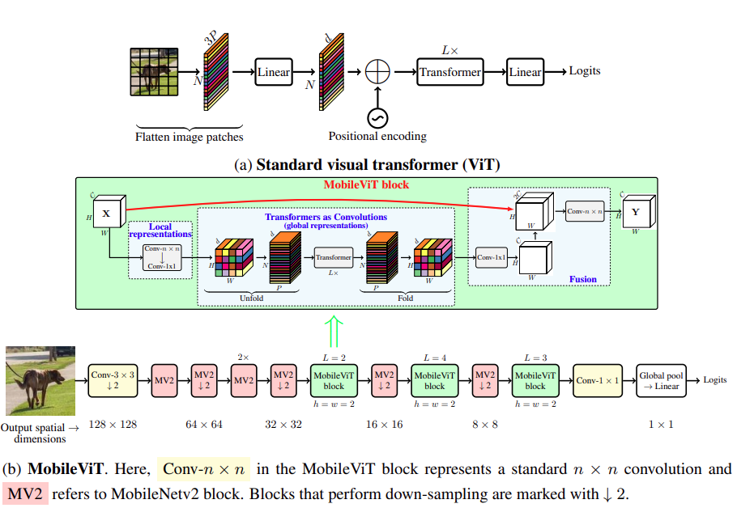

MobileViT architecture
The MobileViT block aims to model the local and global information in an input tensor with fewer parameters.

Conv(n×n) layer
Formally, for a given input tensor X ∈ ℝ^{H×W×C}, MobileViT applies a n×n standard convolutional layer followed by a point-wise (or 1×1) convolutional layer to produce X_{L}∈ ℝ ^{H×W×d}. The n×n convolutional layer encodes local spatial information while the point-wise convolution projects the tensor to a high-dimensional space (or d-dimensional, where d > C) by learning linear combinations of the input channels.

MobileViT block
To enable MobileViT to learn global representations with spatial inductive bias, we (1) unfold X_{L} into N non-overlapping flattened patches X_{U} ∈ ℝ^{P ×N×d}. Here, P = wh, N = HW/P is the number of patches, and h ≤ n and w ≤ n are height and width of a patch respectively. For each p ∈ {1,···, P}, inter-patch relationships are encoded by applying transformers to obtain XG ∈ ℝ^{P ×N×d} as:
(p ∈ P is num of patches)
Unlike ViTs that lose the spatial order of pixels, MobileViT neither loses the patch order nor the spatial order of pixels within each patch. Therefore, we can fold X_{G} ∈ ℝ^{P×N×d} to obtain X_{F} ∈ ℝ^{H×W×d}. X_{F} is then projected to low C-dimensional space using a point-wise convolution and combined with X via concatenation operation.
Another Conv(n×n) layer is then used to fuse these concatenated features. Note that because X_{U}(p) encodes local information from n×n region using convolutions and X_{G}(p) encodes global information across P patches for the p-th location, each pixel in X_{G} can encode information from all pixels in X. Thus, the overall effective receptive field of MobileViT is H×W.
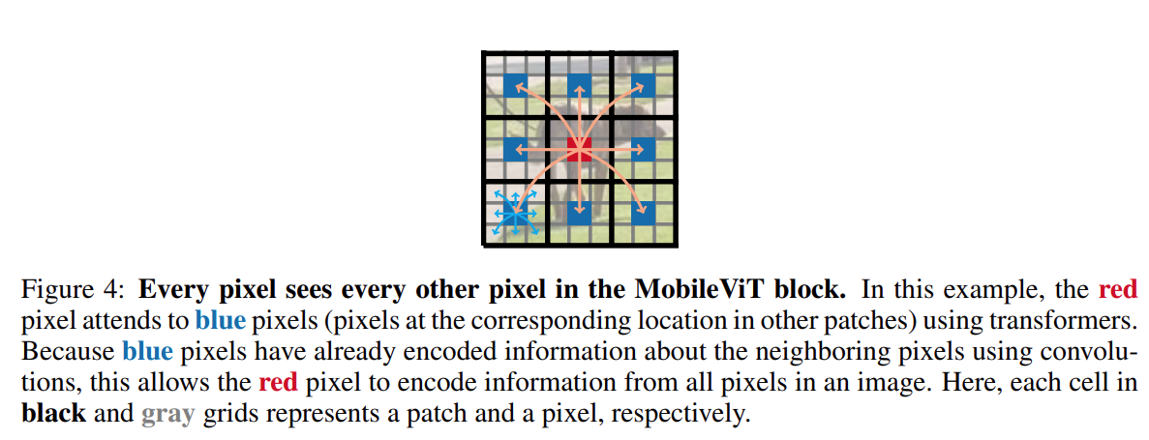

Relationship to convolutions.
MobileViT block replaces the local processing (matrix multiplication) in convolutions with deeper global processing (a stack of transformer layers). As a consequence, MobileViT has convolution-like properties (e.g., spatial bias). Hence, the MobileViT block can be viewed as transformers as convolutions. An advantage of our intentionally simple design is that low-level efficient implementations of convolutions and transformers can be used out-of-the-box; allowing us to use MobileViT on different devices without any extra effort.

Light-weight
MobileViT block uses standard convolutions and transformers to learn local and global representations respectively.
Why MobileViT is light-weight? We believe that the issues lie primarily in learning global representations with transformers. For a given patch, previous works convert the spatial information into latent by learning a linear combination of pixels. The global information is then encoded by learning inter-patch information using transformers. As a result, these models lose image-specific inductive bias, which is inherent in CNNs. Therefore, they require more capacity to learn visual representations. Hence, they are deep and wide. Unlike these models, MobileViT uses convolutions and transformers in a way that the resultant MobileViT block has convolution-like properties while simultaneously allowing for global processing. This modeling capability allows us to design shallow and narrow MobileViT models, which in turn are light-weight.

Computational cost
The computational cost of multi-headed self-attention in MobileViT and ViTs is O(N²Pd) and O(N²d), respectively. In theory, MobileViT is inefficient as compared to ViTs. However, in practice, MobileViT is more efficient than ViTs. MobileViT has 2× fewer FLOPs and delivers 1.8% better accuracy than DeIT on the ImageNet-1K dataset.

Multi-scale sampler for training efficiency
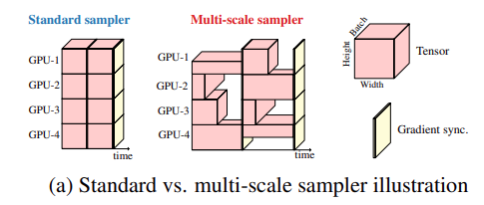

Unified TransFormer
UniFormer: Unifying Convolution and Self-attention for Visual Recognition

(Comments)
- Key ideas: employ the light-weight Unified UniFormer unifies convolution and self-attention in a concise transformer format. To extract input, UniFormer employs convolution stem to extract local features. In the first 2 stages, UniFormer captures local-range dependencies by Local MHRA - type of "local" MHSA. In the following 2 stages, UniFormer learns global features by capture long-range dependencies like ViT. In order to lower computational cost, it introduces H_MHRA that use the externally learnable score token to query and ranking the attention score of tokens. These score can be used to reduce attention map between tokens and can be recovered before going to FFN part.
- Architecture: Type of Hierarchical Transformer with new defined Local MHRA and light-weight hourglass global MHRA.
UniFormer: (ConvStem + Local_MHRA)×2=> (ConvStem + Global_MHRA)×2 => Pool + FC.
H-UniFormer: ConvStem => Local_MHRA×2 => H_Global_MHRA×2 => Pool + FC.
- Local_MHRA: A kind of MHSA with a local receptive field.
- Global_ MHRA = Multi-head Self-Attn.
- H_Global_MHRA = Multi-head with learnable external embedded token which are used to reduce attention map.
H-UniFormers achieves 2-4× higher throughput than the recent lightweight models.
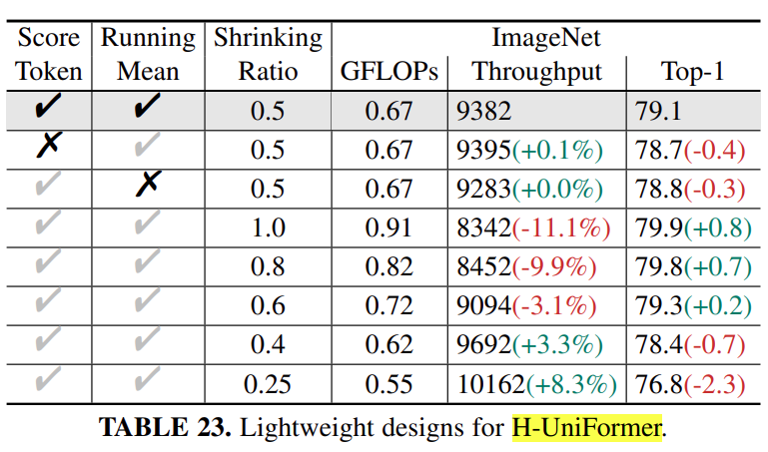

Abstract
Though CNNs can efficiently decrease local redundancy by convolution within a small neighborhood, the limited receptive field makes it hard to capture global dependency.
Alternatively, ViTs can effectively capture long-range dependency via self-attention, while blind similarity comparisons among all the tokens lead to high redundancy.
To resolve these problems, we propose a novel Unified transFormer (UniFormer), which can seamlessly integrate the merits of convolution and self-attention in a concise transformer format. Different from the typical transformer blocks, the relation aggregators in our UniFormer block are equipped with local and global token affinity respectively in shallow and deep layers, allowing tackling both redundancy and dependency for efficient and effective representation learning. Finally, we flexibly stack our blocks into a new powerful backbone, and adopt it for various vision tasks from image to video domain, from classification to dense prediction.
Without any extra training data, our UniFormer achieves 86.3 top-1 accuracy on ImageNet-1K classification task.

Introduction
ViTs indeed capture detailed visual features in the shallow layer, while spatial and temporal attention are redundant. One can easily see that, given an anchor token, spatial attention largely concentrates on the tokens in the local region (mostly 3×3), and learns little from the rest tokens in this image. Similarly, temporal attention mainly aggregates the tokens in the adjacent frames, while losing sight of the rest tokens in the distant frames. However, such local focus is obtained by global comparison among all the tokens in space and time. Clearly, this redundant attention manner brings large and unnecessary computation burden, thus deteriorating the computation-accuracy balance in ViTs.
Based on these discussions, we propose a novel Unified TransFormer (UniFormer) in this work. It flexibly unifies convolution and self-attention in a concise transformer format, which can tackle both local redundancy and global dependency for effective and efficient visual recognition. Specifically, our UniFormer block consists of three key modules, i.e., Dynamic Position Embedding (DPE), Multi-Head Relation Aggregator (MHRA), and Feed-Forward Network (FFN). The distinct design of the relation aggregator is the key difference between our UniFormer and the previous CNNs and ViTs.
(1) In the shallow layers, our relation aggregator captures local token affinity with a small learnable parameter matrix, which inherits the convolution style that can largely reduce computation redundancy by context aggregation in the local region.
(2) In the deep layers, our relation aggregator learns global token affinity with token similarity comparison, which inherits the self-attention style that can adaptively build long-range dependency from distant regions or frames. Via progressively stacking local and global UniFormer blocks in a hierarchical manner, we can flexibly integrate their cooperative power to promote representation learning.
(3) Finally, we provide a generic and powerful backbone for visual recognition and successfully address various downstream vision tasks with simple and elaborate adaptations. Additionally, we further introduce the lightweight design for UniFormer, which can achieve a preferable accuracy-throughout balance, by a concise hourglass style of token shrinking and recovering.

Related Work
To bridge the gap between CNNs and ViTs, researchers have tried to take advantage of them to build stronger vision backbones for image understanding, by adding convolutional patch stem for fast convergence introducing convolutional position embedding, inserting depthwise convolution into feed-forward network, utilizing convolutional projection in self-attention, and combining MBConv with Transformer.
However, all these approaches ignore inherent relations between convolution and self-attention, leading to inferior local and/or global token relation learning. Several recent works have demonstrated that self-attention operates similarly to convolution. But they suggest replacing convolution instead of combining them together.
Differently, our UniFormer unifies convolution and self-attention in the transformer style, which can effectively learn local and global token relation, and achieve better accuracy-computation trade-offs on all the vision tasks from image to the video domain.

UniFormer
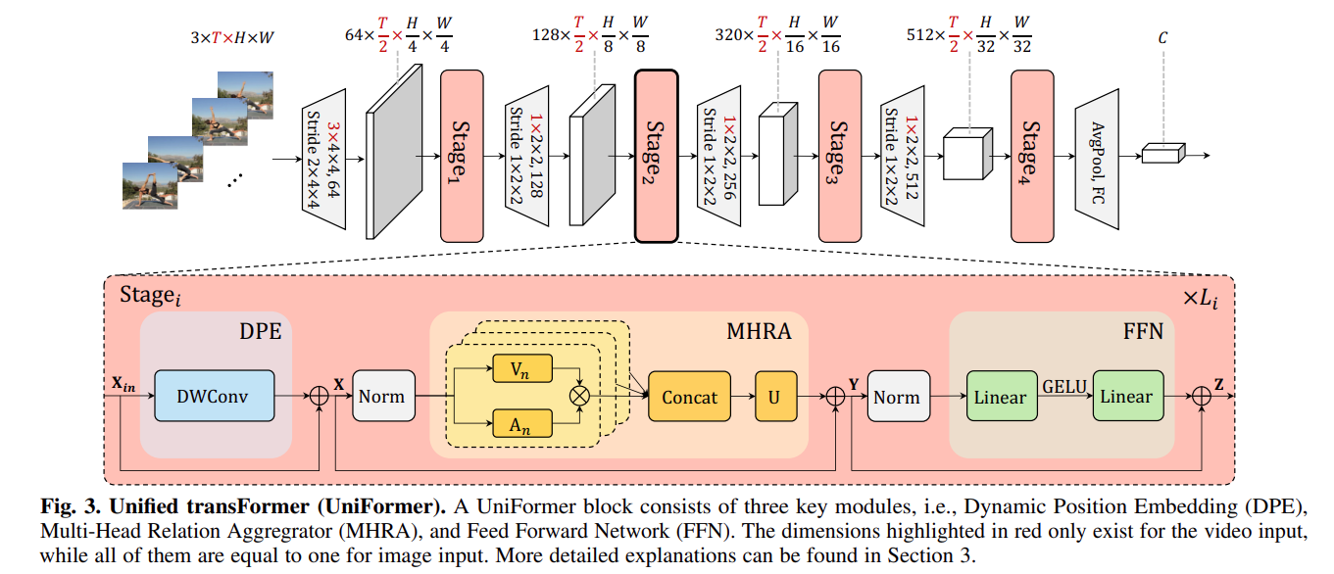
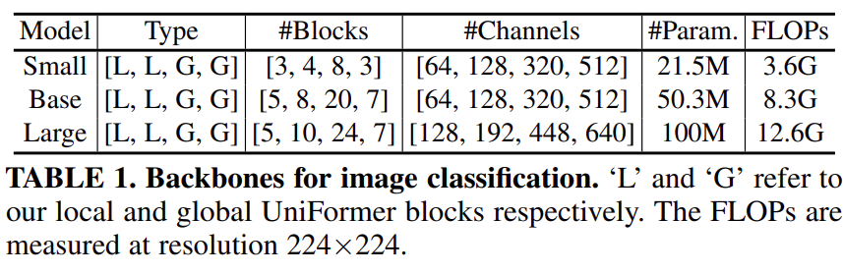
Specifically, our UniFormer block consists of three key modules: Dynamic Position Embedding (DPE), Multi-Head Relation Aggregator (MHRA) and Feed-Forward Network (FFN):
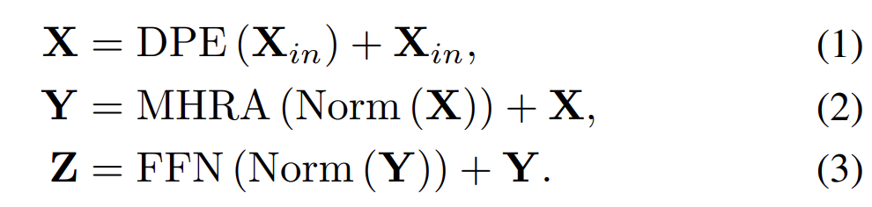
(1) Considering the input token tensor X_{in} ∈ ℝ^{C×T×H×W} (T=1 for an image input), we first introduce DPE (a Depth-wise sepretable Conv stem) to dynamically integrate position information into all the tokens. It is friendly to arbitrary input resolution and makes good use of token order for better visual recognition.
(2) Then, we use MHRA to enhance each token by exploiting its contextual tokens with relation learning. Via flexibly designing the token affinity in the shallow and deep layers, our MHRA can smartly unify convolution and self-attention to reduce local redundancy and learn global dependency.
(3) Finally, we add FFN like traditional ViTs, which consists of two linear layers and one non-linear function, i.e., GELU. The channel number is first expanded by the ratio of 4 and then recovered, thus each token will be enhanced individually.

Multi-Head Relation Aggregator
We introduce a generic Relation Aggregator (RA), which elegantly unifies convolution and self-attention for token relation learning. It can achieve efficient and effective representation learning by designing local and global token affinity in the shallow and deep layers respectively.
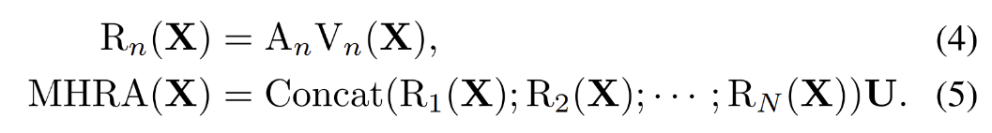
Given the input tensor X ∈ ℝ^{C×T×H×W},
- we first reshape it to a sequence of tokens X ∈ ℝ^{L×C} with the length of L=T×H×W.
- R_{n}(·) refers to RA in the n-th head and U ∈ ℝ^{C×C} is a learnable parameter matrix to integrate N heads. Each RA consists of token context encoding and token affinity learning.
- We apply a linear transformation to encode the original tokens X into contextual tokens V_{n}(X) ∈ ℝ^{L×C/N}.
- Learn A_{n} by Local MHRA (Multi-Head Relation Aggregator) module.

Local MHRA
We suggest learning token affinity in a small neighborhood, which coincidentally shares a similar insight with the design of a convolution filter. Hence, we propose to represent local affinity as a learnable parameter matrix in the shallow layers. Concretely, given an anchor token Xi , our local RA learns the affinity between this token and other tokens in the small neighborhood Ω_{i}^{t×h×w} (t=1 for an image input):
Where a_{n} ∈ ℝ^{t×h×w} is the learnable parameter, and X_{j} refers to any neighbor token in Ω_{i}^{t×h×w}. (i−j) denotes the relative position between token i and j. Note that, visual content between adjacent tokens varies subtly in the shallow layers, since the receptive field of tokens is small. In this case, it is not necessary to make token affinity dynamic in these layers. Hence, we use a learnable parameter matrix to describe local token affinity, which simply depends on the relative position between tokens.
Comparison to Convolution Block
Interestingly, we find that our local MHRA can be interpreted as a generic extension of MobileNet block.
- Firstly, the linear transformation V(·) in Eq. 4 is equivalent to a pointwise convolution (PWConv), where each head is corresponding to an output feature channel V_{n}(X).
- Furthermore, our local token affinity Alocal n can be instantiated as the parameter matrix that operated on each output channel (or head) V_{n}(X), thus the relation aggregator R_{n}(X) = A_{n}^{local} = V_{n}(X) can be explained as a depthwise convolution (DWConv).
- Finally, the linear matrix U, which concatenates and fuses all heads, can also be seen as a pointwise convolution.
- As a result, such local MHRA can be reformulated with a manner of PWConv-DWConv-PWConv in the MobileNet block.

Global MHRA
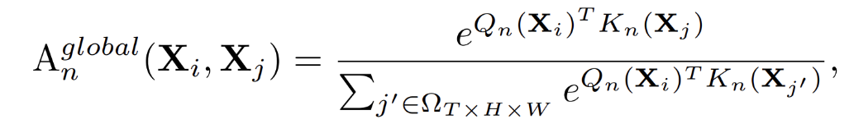
where Xj can be any token in the global tube with a size of T×H×W (T=1 for an image input), while Q_{n}(·) and K_{n}(·) are two different linear transformations.
Comparison to Transformer Block.
Our global MHRA A_{n}^{global} can be instantiated as a spatiotemporal self attention, where Q_{n}(·), K_{n}(·) and V_{n}(·) become Query, Key and Value in ViT. However, our global UniFormer block is different from the previous ViT blocks.
First, most video transformers divide spatial attenttion and temporal attention in the video domain, in order to reduce the dot-product computation in token similarity comparison. But such an operation inevitably deteriorates the spatiotemporal relation among tokens.
In contrast, our global UniFormer block jointly encodes spatiotemporal token relation to generate more discriminative video representation for recognition. Since our local UniFormer block largely saves computation of token comparison in the shallow layers, the overall model can achieve a preferable computation-accuracy balance. Second, instead of absolute position embedding, we adopt dynamic position embedding (DPE) in our UniFormer. It is in convolution style, which can overcome permutation-invariance and be friendly to different input lengths of visual tokens.

Framework

Image Classification
More specifically, we use the local UniFormer blocks in the first two stages to reduce computation redundancy, while the global UniFormer blocks are utilized in the last two stages to learn long-range token dependency.
For the local UniFormer block, MHRA is instantiated as PWConv-DWConv-PWConv with local token affinity, where the spatial size of DWConv is set to 5×5 for image classification.
For the global UniFormer block, MHRA is instantiated as multi-head self-attention with global token affinity, where the number of attention heads is set to 64. For both local and global UniFormer blocks, DPE is instantiated as DWConv with a spatial size of 3×3, and the expand ratio of FFN is 4.
We utilize BN for convolution and LN for self-attention. For feature downsampling, we use the 4×4 convolution with stride 4×4 before the first stage and the 2×2 convolution with stride 2×2 before other stages. Besides, an extra LN is added after each downsampling convolution.
Finally, the global average pooling and fully connected layer are applied to output the predictions. When training models with Token Labeling , we add another fully connected layer for auxiliary loss.

Light Weight UniFormer
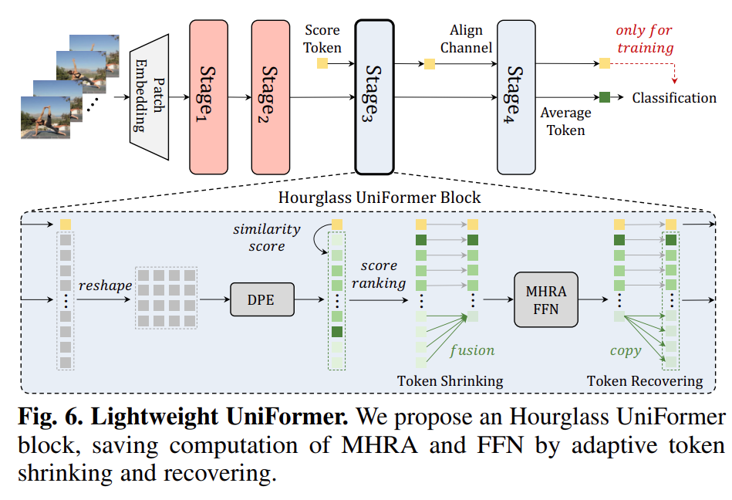

Hourglass UniFormer Block
Hourglass UniFormer Block replaces global UniFormer block which consists of global MHRA. Note that, the existing token pruning methods are infeasible for our UniFormer and those ViTs with convolution. The main reason is that, after pruning, the rest tokens often maintain a broken spatiotemporal structure, which makes convolution inapplicable. To overcome such difficulty, we propose a concise integration of token shrinking and recovering in our H-UniFormer block.
Token Shrinking. We introduce a score token s ∈ ℝ^{C} to measure the importance of the visual tokens X ∈ ℝ^{C×THW} = {X¹, ..., X^{THW}} after DPE. Specifically, we compare similarity by Softmax between the score token s and a visual token X_{j}, and average the similarity values over N attention heads.
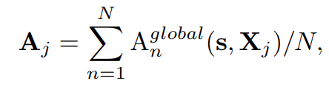
Where A_{j} represents the importance of visual token X_{j}, and we use A ∈ ℝ^{THW} to represent the importance vector of all the visual tokens. For tokens with high values in A, we consider them to be crucial tokens and keep them. For tokens with low values, we consider them to be unimportant tokens. Hence, we fuse them as one representative token, where their score values are used as the fusing weights. By such unimportant token reduction, we can shrink visual tokens from X ∈ ℝ^{C×THW} to X^{S} ∈ ℝ^{C×M}, where the number of tokens M ≪ THW. Subsequently, the reduced visual tokens are fed into global MHRA and FFN, for computation saving. Additionally, we pass this score token through all the H-UniFormer blocks in Stage3 and Stage4, and use it to calculate the classification loss when training. In this case, the score token is effectively guided by the ground-truth label, and it thus becomes discriminative to weight token importance.
Token Recovering. After learning token interactions in global MHRA and FFN, we replicate the representative token to recover the unimportant tokens. Thus, we can maintain the spatiotemporal structure of all the visual tokens, for effective dynamic position encoding (i.e., convolution) in the next H-UniFormer block.

EfficientViT - ReLU-based Multi-Scale Attn

(Comments)
- Type of MHSA which can achieve Linear Complexity.
- Recipe for improving model performance = Multi-Scale Representation Learning (medium.com) + Global Receptive Field.
- Key idea: Modify EfficientNet by the EfficientViT modules in the later stages. Linear-complexity Attention + Multi-scale Aggregation.

Abstract
This work presents EfficientViT, a new family of high-resolution vision models with novel lightweight multi-scale attention. Unlike prior high-resolution dense prediction models that rely on heavy self-attention, hardware-inefficient large-kernel convolution, or complicated topology structure to obtain good performances, our lightweight multi-scale attention achieves a global receptive field and multi-scale learning (two critical features for high-resolution dense prediction) with only lightweight and hardware-efficient operations. As such, EfficientViT delivers remarkable performance gains over previous state-of-the-art high-resolution dense prediction models with significant speedup on diverse hardware platforms, including mobile CPU, edge GPU, and cloud GPU.

Introduction
Specifically, to have a global receptive field, we propose substituting the inefficient self-attention with lightweight ReLU-based global attention. By leveraging the associative property of matrix multiplication, ReLU-based global attention can reduce the computational complexity from quadratic to linear while preserving functionality. In addition, it avoids hardware inefficient operations like softmax, making it more suitable for hardware deployment.
Furthermore, we propose a novel lightweight multi-scale attention module based on the ReLU-based global attention. Specifically, we aggregate nearby tokens with small-kernel convolutions to generate multi-scale tokens and perform ReLU-based global attention on multi-scale tokens to combine the global receptive field with multi-scale learning.

Related Work
To close the gap,
- MobileViT proposes to combine the strength of CNN and ViT by replacing local processing in convolutions with global processing using transformers.
- MobileFormer proposes to parallelize MobileNet and Transformer with a two-way bridge in between for feature fusing.
- NASViT proposes to leverage neural architecture search to search for efficient ViT architectures.
However, these models mainly focus on image classification and still rely on self-attention with quadratic computational complexity, thus unsuitable for high-resolution dense prediction.

EfficientVIT
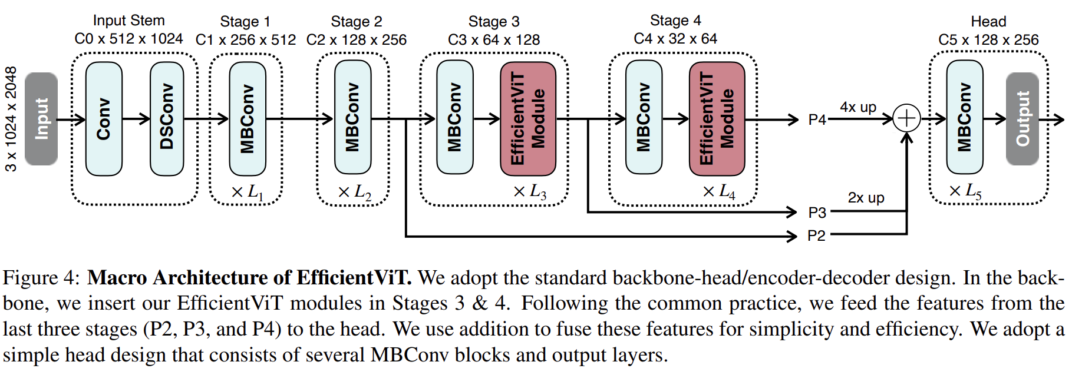

Lightweight Multi-Scale Attention
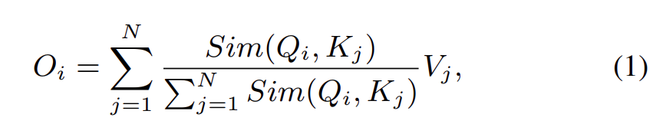
Where Q = xW_{Q}, K = xW_{K}, V = xW_{V} and W_{Q}/W_{K}/W_{V} ∈ ℝ^{f×d} is the learnable linear projection matrix. O_{i} represents the i-th row of matrix O. Sim(·, ·) is the similarity function.
In this work, we use ReLU-based global attention to achieve both the global receptive field and linear computational complexity. In ReLU-based global attention, the similarity function is defined as:
(1) can be written as:
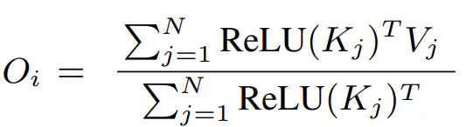
O(N) computational cost and O(N) memory. Prefer another activation function to avoid setting the gradients to 0 when input is negative.
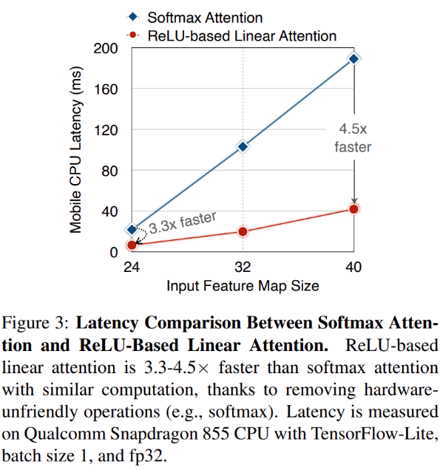

Generate Multi-Scale Tokens
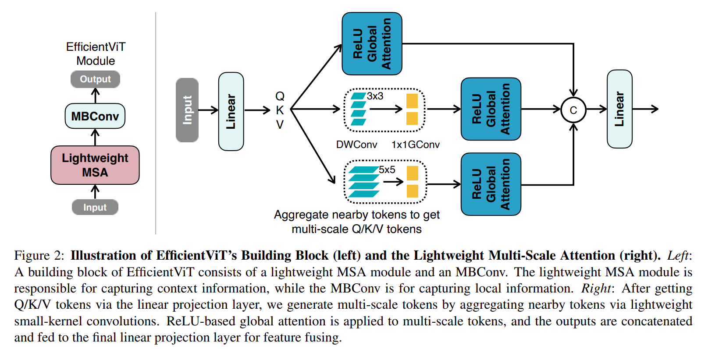
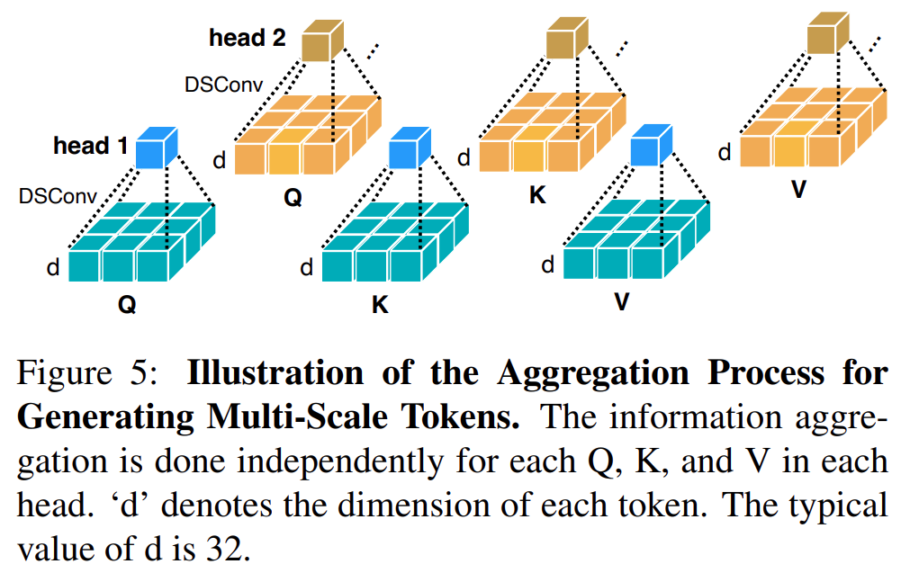
ReLU-based attention alone has limited model capacity. To mitigate this limitation, we first enhance it with the depthwise convolution to improve its local information extraction ability. In addition, to enhance its multi-scale learning ability, we propose to aggregate the information from nearby Q/K/V tokens to get multi-scale tokens. This information aggregation process is indepen-dent for each Q, K, and V in each head.` We only use small-kernel convolutions for information aggregation to avoid hurting hardware efficiency.
In the practical implementation, independently executing these aggregation operations is ineffi-cient on GPU. Therefore, we take advantage of the infrastructure of group convolution in modern deep learning frameworks to reduce the number of total operations. Specifically, all DWConvs are fused into a single DWConv while all 1x1 Convs are combined into a single 1x1 group convolution (Figure 2 right) where the number of groups is 3 × #heads and the number of channels in each group is d.
After getting multi-scale tokens, we perform global attention upon them to extract multi-scale global features. Finally, we concatenate the features from different scales along the head dimension and feed them to the final linear projection layer to fuse the features.

EfficientViT Architecture
We build a new family of vision models based on the proposed lightweight MSA module. Specifically, an EfficientViT module comprises a lightweight MSA module and an MBConv. The lightweight MSA module is for context information extraction, while the MBConv is for local information extraction. The macro architecture of EfficientViT is demonstrated in Figure 4. We use the standard backbone-head/encoder decoder architecture design.
- Backbone. The backbone of EfficientViT also follows the standard design, which consists of the input stem and four stages with gradually decreased feature map size and gradually increased channel number. We insert the EfficientViT module in Stages 3 and 4. For downsampling, we use an MBConv with stride 2.
- Head. P2, P3, and P4 denote the outputs of Stages 2, 3, and 4, forming a pyramid of feature maps. For simplicity and efficiency, we use 1x1 convolution and standard upsampling operation (e.g., bilinear/bicubic upsampling) to match their spatial and channel size and fuse them via addition. Since our backbone already has a strong context information extraction capacity, we adopt a simple head design that comprises several MBConv blocks and the output layers (i.e., prediction and upsample). In the

