Fingerprint Recognition

By

WUZHILI (99050056)

A thesis submitted in partial fulfillment of
the requirements for the degree of

Bachelor of Science (Honors) in Computer Science

Computer System

Hong Kong Baptist University
Date: 19 April 2002

Declaration

I Hereby declare that all the design and implementation of the Honors Project is my independent effort except otherwise specified. I also certify that this project have never been submitted for academic or employment credit.

(99050056) Wu zhili

Computer System Major
Department of Computer Science
Hong Kong Baptist University

Date: 19/April/2002
Hong Kong Baptist University
Department of Computer Science

Computer System Major

We hereby recommend that the Honors Project submitted by Wuzhili entitled “Fingerprint Recognition” be accepted in partial fulfillment of the requirements for the degree of Bachelor of Science (honors) in Computer Science (Computer System).

Supervisor: Dr. Y.Y. Tang Observer: Dr Y.W. Leung

Date: Date:

Acknowledgement

I would like to express my great gratitude towards my supervisor, Dr. Tang, Yuan Yan who has given me much suggestion, support and help. Also I would like to thank my observer, Dr. Leung, Yiu wing, for his useful comments. I also take this opportunity to give thanks to all others who give me support for the project or in other aspects of my study at HKBU.

Fingerprint Recognition

By

WUZHILI (99050056)

Abstract

My Honors Project is to investigate the current techniques for fingerprint recognition. This target can be mainly decomposed into image preprocessing, feature extraction and feature match. For each sub-task, some classical and up-to-date methods in literatures are analyzed. Based on the analysis, an integrated solution for fingerprint recognition is developed for demonstration.

My demonstration program is coded by MATLAB. For the program, some optimization at coding level and algorithm level are proposed to improve the performance of my fingerprint recognition system. These performance enhancements are shown by experiments conducted upon a variety of fingerprint images. Also, the experiments illustrate the key issues of fingerprint recognition that are consistent with what the available literatures say.

Table of Contents

Chapter 1: Introduction P1
  - What is A Fingerprint P1
  - What is Fingerprint Recognition P3
  - Two main approaches for Fingerprint Recognition P5

Chapter 2: System Design P6
2.1 System Level Design P6
2.2 Algorithm Level Design P7

Chapter 3: Fingerprint Image Preprocessing P9
3.1 Fingerprint Image Enhancement P9
3.2 Fingerprint Image Binarization P13
3.3 Fingerprint Image Segmentation P14

Chapter 4: Minutia Extraction P17
4.1 Fingerprint Ridge Thinning P17
4.2 Minutia Marking P18

Chapter 5 Minutia Post-processing P20
5.1 False Minutia Remove P20
5.2 Unify Minutia Representation Feature Vectors P22

Chapter 6:Minutia Match P24
6.1 Alignment Stage P25
6.2 Match Stage P28

Chapter 7: Experimentation Results P29
7.1 Evaluation Indexes P29
7.2 Experiment Analysis P30

Chapter 8: Conclusion P32

References P33

User Manual P35

CHAPTTER 1: INTRODUCTION

  - What is A Fingerprint?

A fingerprint is the feature pattern of one finger (Figure 1.1.1). It is believed with strong evidences that each fingerprint is unique. Each person has his own fingerprints with the permanent uniqueness. So fingerprints have being used for identification and forensic investigation for a long time.
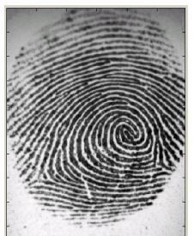
Figure1.1.1 A fingerprint image acquired by an Optical Sensor

A fingerprint is composed of many ridges and furrows. These ridges and furrows present good similarities in each small local window, like parallelism and average width.

However, shown by intensive research on fingerprint recognition, fingerprints are not distinguished by their ridges and furrows, but by Minutia, which are some abnormal points on the ridges (Figure 1.1.2). Among the variety of minutia types reported in literatures, two are mostly significant and in heavy usage: one is called termination, which is the immediate ending of a ridge; the other is called bifurcation, which is the point on the ridge from which two branches derive.

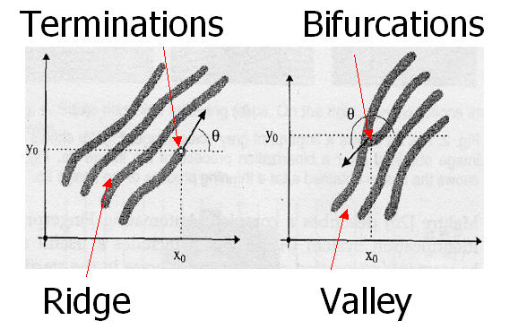

Figure 1.1.2 Minutia. (Valley is also referred as Furrow,
Termination is also called Ending,
and Bifurcation is also called Branch)

1.2 What is Fingerprint Recognition?

The fingerprint recognition problem can be grouped into two sub-domains: one is fingerprint verification and the other is fingerprint identification (Figure 1.2.1). In addition, different from the manual approach for fingerprint recognition by experts, the fingerprint recognition here is referred as AFRS (Automatic Fingerprint Recognition System), which is program-based.
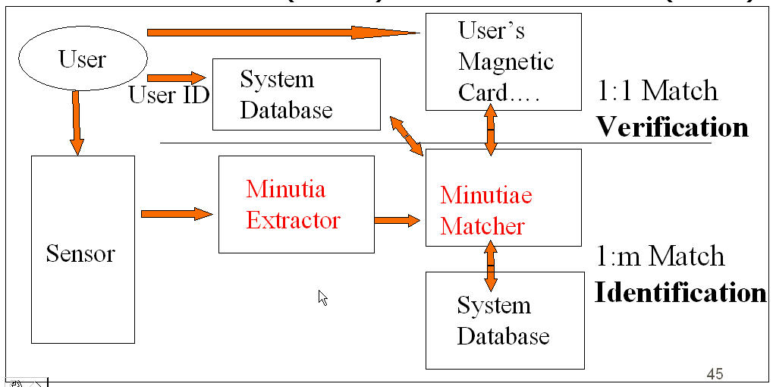
Figure 1.2.1 Verification vs. Identification

Fingerprint verification is to verify the authenticity of one person by his fingerprint. The user provides his fingerprint together with his identity information like his ID number. The fingerprint verification system retrieves the fingerprint template according to the ID number and matches the template with the real-time acquired fingerprint from the user. Usually it is the underlying design principle of AFAS (Automatic Fingerprint Authentication System).

Fingerprint identification is to specify one person’s identity by his fingerprint(s). Without knowledge of the person’s identity, the fingerprint identification system tries to match his fingerprint(s) with those in the whole fingerprint database. It is especially useful for criminal investigation cases. And it is the design principle of AFIS (Automatic Fingerprint Identification System).

However, all fingerprint recognition problems, either verification or identification, are ultimately based on a well-defined representation of a fingerprint. As long as the representation of fingerprints remains the uniqueness and keeps simple, the fingerprint matching, either for the 1-to-1 verification case or 1-to-m identification case, is straightforward and easy.

1.3 Two approaches for Fingerprint recognition

Two representation forms for fingerprints separate the two approaches for fingerprint recognition.

The first approach, which is minutia-based, represents the fingerprint by its local features, like terminations and bifurcations. This approach has been intensively studied, also is the backbone of the current available fingerprint recognition products. I also concentrate on this approach in my honors project.

The second approach, which uses image-based methods[6][7], tries to do matching based on the global features of a whole fingerprint image. It is an advanced and newly emerging method for fingerprint recognition. And it is useful to solve some intractable problems of the first approach. But my project does not aim at this method, so further study in this direction is not expanded in my thesis.

CHAPTER 2 SYSTEM DESIGN

2.1 System Level Design

A fingerprint recognition system constitutes of fingerprint acquiring device, minutia extractor and minutia matcher [Figure 2.1.1].
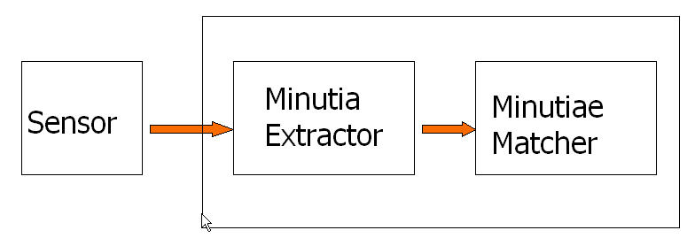

Figure 2.1.1 Simplified Fingerprint Recognition System

For fingerprint acquisition, optical or semi-conduct sensors are widely used. They have high efficiency and acceptable accuracy except for some cases that the user’s finger is too dirty or dry. However, the testing database for my project is from the available fingerprints provided by FVC2002 (Fingerprint Verification Competition 2002). So no acquisition stage is implemented.

The minutia extractor and minutia matcher modules are explained in detail in the next part for algorithm design and other subsequent sections.
2.2 Algorithm Level Design

To implement a minutia extractor, a three-stage approach is widely used by researchers. They are preprocessing, minutia extraction and postprocessing stage [Figure 2.2.1].
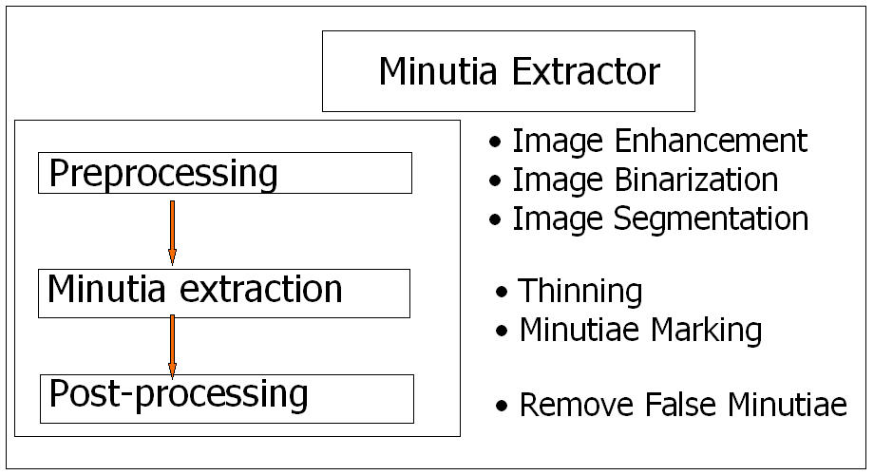
Figure 2.2.1 Minutia Extractor

For the fingerprint image preprocessing stage, I use Histogram Equalization and Fourier Transform to do image enhancement [9]. And then the fingerprint image is binarized using the locally adaptive threshold method [12]. The image segmentation task is fulfilled by a three-step approach: block direction estimation, segmentation by direction intensity [4] and Region of Interest extraction by Morphological operations. Most methods used in the preprocessing stage are developed by other researchers but they form a brand new combination in my project through trial and error. Also the morphological operations for extraction ROI are introduced to fingerprint image segmentation by myself.

For minutia extraction stage, three thinning algorithms [12][2] are tested and the Morphological thinning operation is finally bid out with high efficiency and pretty good thinning quality. The minutia marking is a simple task as most literatures reported but one special case is found during my implementation and an additional check mechanism is enforced to avoid such kind of oversight.

For the postprocessing stage, a more rigorous algorithm is developed to remove false minutia based on [12][1]. Also a novel representation for bifurcations is proposed to unify terminations and bifurcations.
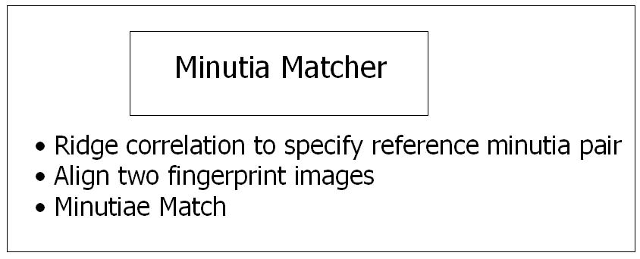
Figure2.2.2 Minutia Matcher

The minutia matcher chooses any two minutia as a reference minutia pair and then match their associated ridges first. If the ridges match well [1], two fingerprint images are aligned and matching is conducted for all remaining minutia [Figure 2.2.2].

CHAPTER 3 FINGERPRINT IMAGE PREPROCESSING

3.1 Fingerprint Image Enhancement

Fingerprint Image enhancement is to make the image clearer for easy further operations. Since the fingerprint images acquired from sensors or other medias are not assured with perfect quality, those enhancement methods, for increasing the contrast between ridges and furrows and for connecting the false broken points of ridges due to insufficient amount of ink, are very useful for keep a higher accuracy to fingerprint recognition.

Two Methods are adopted in my fingerprint recognition system: the first one is Histogram Equalization; the next one is Fourier Transform.

3.1.1 Histogram Equalization:

Histogram equalization is to expand the pixel value distribution of an image so as to increase the perceptional information. The original histogram of a fingerprint image has the bimodal type [Figure 3.1.1.1], the histogram after the histogram equalization occupies all the range from 0 to 255 and the visualization effect is enhanced [Figure 3.1.1.2].

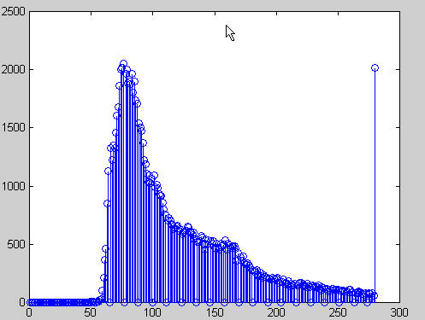 | 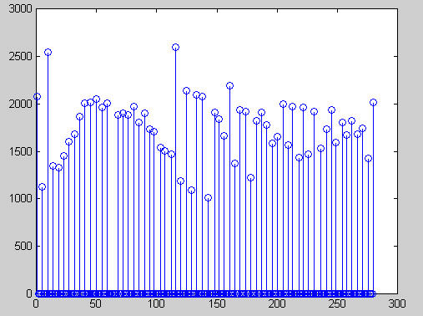
Figure 3.1.1 the Original histogram  of a fingerprint image | Figure 3.1.2 Histogram after the Histogram Equalization

The right side of the following figure [Figure 3.1.1.3] is the output after the histogram equalization.
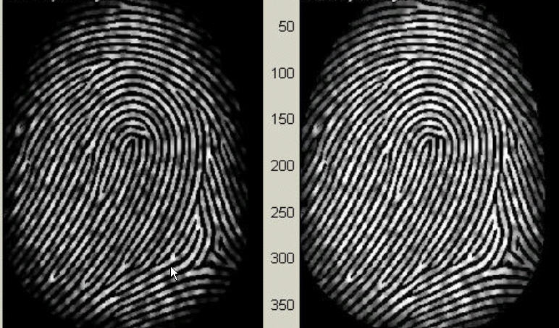
Figure 3.1.3 Histogram Enhancement.
Original Image (Left). Enhanced image (Right)
3.1.2 Fingerprint Enhancement by Fourier Transform

We divide the image into small processing blocks (32 by 32 pixels) and perform the Fourier transform according to:
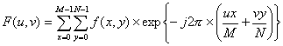 (1)
for u = 0, 1, 2, ..., 31 and v = 0, 1, 2, ..., 31.

In order to enhance a specific block by its dominant frequencies, we multiply the FFT of the block by its magnitude a set of times. Where the magnitude of the original FFT = abs(F(u,v)) = |F(u,v)|.

Get the enhanced block according to
(2) ,
where F⁻¹(F(u,v)) is done by:
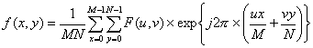 (3)
for x = 0, 1, 2, ..., 31 and y = 0, 1, 2, ..., 31.

The k in formula (2) is an experimentally determined constant, which we choose k=0.45 to calculate. While having a higher "k" improves the appearance of the ridges, filling up small holes in ridges, having too high a "k" can result in false joining of ridges. Thus a termination might become a bifurcation. Figure 3.1.2.1 presents the image after FFT enhancement.
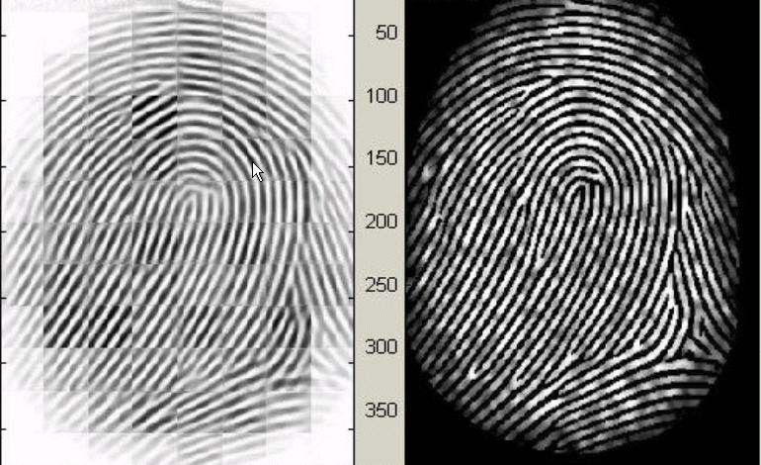
Figure 3.1.2.1 Fingerprint enhancement by FFT
Enhanced image (left), Original image (right)

The enhanced image after FFT has the improvements to connect some falsely broken points on ridges and to remove some spurious connections between ridges. The shown image at the left side of figure 3.1.2.1 is also processed with histogram equalization after the FFT transform. The side effect of each block is obvious but it has no harm to the further operations because I find the image after consecutive binarization operation is pretty good as long as the side effect is not too severe.

3.2 Fingerprint Image Binarization

Fingerprint Image Binarization is to transform the 8-bit Gray fingerprint image to a 1-bit image with 0-value for ridges and 1-value for furrows. After the operation, ridges in the fingerprint are highlighted with black color while furrows are white.

A locally adaptive binarization method is performed to binarize the fingerprint image. Such a named method comes from the mechanism of transforming a pixel value to 1 if the value is larger than the mean intensity value of the current block (16x16) to which the pixel belongs [Figure 3.2.1].
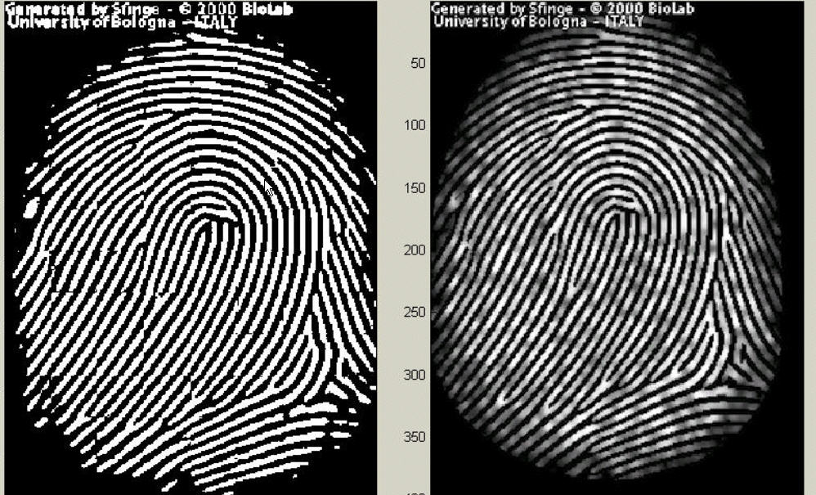
Figure 3.2.1 the Fingerprint image after adaptive binarization
Binarized image(left), Enhanced gray image(right)
3.3 Fingerprint Image Segmentation

In general, only a Region of Interest (ROI) is useful to be recognized for each fingerprint image. The image area without effective ridges and furrows is first discarded since it only holds background information. Then the bound of the remaining effective area is sketched out since the minutia in the bound region are confusing with those spurious minutia that are generated when the ridges are out of the sensor.

To extract the ROI, a two-step method is used. The first step is block direction estimation and direction variety check [1], while the second is intrigued from some Morphological methods.

- Block direction estimation

1.1 Estimate the block direction for each block of the fingerprint image with WxW in size(W is 16 pixels by default). The algorithm is:

- Calculate the gradient values along x-direction (g_{x}) and y-direction (g_{y}) for each pixel of the block. Two Sobel filters are used to fulfill the task.
- For each block, use Following formula to get the Least Square approximation of the block direction.
tg2ß = 2 ∑ ∑ (gx*gy)/∑ ∑ (gx2-gy2) for all the pixels in each block.

The formula is easy to understand by regarding gradient values along x-direction and y-direction as cosine value and sine value. So the tangent value of the block direction is estimated nearly the same as the way illustrated by the following formula.
tg2θ = 2sinθ cosθ /(cos2θ -sin2θ )

1.2 After finished with the estimation of each block direction, those blocks without significant information on ridges and furrows are discarded based on the following formulas:
E = {2 ∑ ∑ (gx*gy)+ ∑ ∑ (gx2-gy2)}/ W*W*∑ ∑ (gx2+gy2)
For each block, if its certainty level E is below a threshold, then the block is regarded as a background block.

The direction map is shown in the following diagram. We assume there is only one fingerprint in each image.
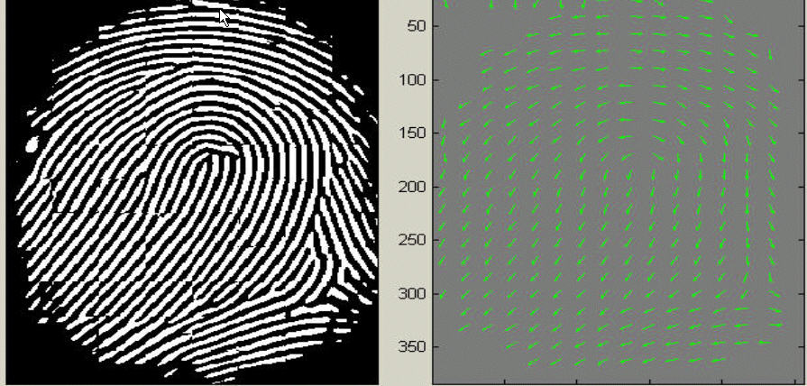
Figure 3.3.1.1 Direction map.
Binarized fingerprint (left), Direction map (right)

- ROI extraction by Morphological operations
Two Morphological operations called ‘OPEN’ and ‘CLOSE’ are adopted. The ‘OPEN’ operation can expand images and remove peaks introduced by background noise [Figure 3.3.2.2]. The ‘CLOSE’ operation can shrink images and eliminate small cavities [Figure 3.3.2.3].



Figure 3.3.2.1 Original Image Area Figure 3.3.2.2 After CLOSE operation

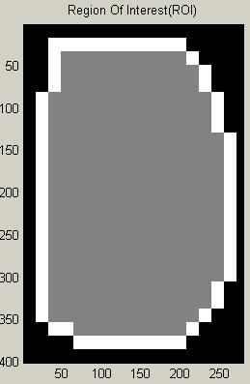

Figure 3.3.2.3 After OPEN operation Figure 3.3.2.4 ROI + Bound

Figure 3.3.2.4 show the interest fingerprint image area and its bound. The bound is the subtraction of the closed area from the opened area. Then the algorithm throws away those leftmost, rightmost, uppermost and bottommost blocks out of the bound so as to get the tightly bounded region just containing the bound and inner area.
CHAPTER 4 MINUTIA EXTRACTION

4.1 Fingerprint Ridge Thinning

Ridge Thinning is to eliminate the redundant pixels of ridges till the ridges are just one pixel wide. [12] uses an iterative, parallel thinning algorithm. In each scan of the full fingerprint image, the algorithm marks down redundant pixels in each small image window (3x3). And finally removes all those marked pixels after several scans. In my testing, such an iterative, parallel thinning algorithm has bad efficiency although it can get an ideal thinned ridge map after enough scans. [2] uses a one-in-all method to extract thinned ridges from gray-level fingerprint images directly. Their method traces along the ridges having maximum gray intensity value. However, binarization is implicitly enforced since only pixels with maximum gray intensity value are remained. Also in my testing, the advancement of each trace step still has large computation complexity although it does not require the movement of pixel by pixel as in other thinning algorithms. Thus the third method is bid out which uses the built-in Morphological thinning function in MATLAB.

The thinned ridge map is then filtered by other three Morphological operations to
remove some H breaks, isolated points and spikes.
4.2 Minutia Marking

After the fingerprint ridge thinning, marking minutia points is relatively easy. But it is still not a trivial task as most literatures declared because at least one special case evokes my caution during the minutia marking stage.
1
0
1
0
1
0
0
1
0
1
0
0
0
1
0
0
0
0
In general, for each 3x3 window, if the central pixel is 1 and has exactly 3 one-value neighbors, then the central pixel is a ridge branch [Figure 4.2.1]. If the central pixel is 1 and has only 1 one-value neighbor, then the central pixel is a ridge ending [Figure4.2.2].

Figure 4.2.1 Bifurcation Figure 4.2.2 Termination
0
0
1
1
1
0
0
1
0

Figure 4.2.3 Triple counting branch

Figure 4.2.3 illustrates a special case that a genuine branch is triple counted. Suppose both the uppermost pixel with value 1 and the rightmost pixel with value 1 have another neighbor outside the 3x3 window, so the two pixels will be marked as branches too. But actually only one branch is located in the small region. So a check routine requiring that none of the neighbors of a branch are branches is added.

Also the average inter-ridge width D is estimated at this stage. The average inter-ridge width refers to the average distance between two neighboring ridges. The way to approximate the D value is simple. Scan a row of the thinned ridge image and sum up all pixels in the row whose value is one. Then divide the row length with the above summation to get an inter-ridge width. For more accuracy, such kind of row scan is performed upon several other rows and column scans are also conducted, finally all the inter-ridge widths are averaged to get the D.

Together with the minutia marking, all thinned ridges in the fingerprint image are labeled with a unique ID for further operation. The labeling operation is realized by using the Morphological operation: BWLABEL.
CHAPTER 5 MINUTIA POSTPROCESSING

5.1 False Minutia Removal

The preprocessing stage does not totally heal the fingerprint image. For example, false ridge breaks due to insufficient amount of ink and ridge cross-connections due to over inking are not totally eliminated. Actually all the earlier stages themselves occasionally introduce some artifacts which later lead to spurious minutia. These false minutia will significantly affect the accuracy of matching if they are simply regarded as genuine minutia. So some mechanisms of removing false minutia are essential to keep the fingerprint verification system effective.

Seven types of false minutia are specified in following diagrams:

m1 m2 m3 m4

m5 m6 m7

Figure 5.1.1. False Minutia Structures. m1 is a spike piercing into a valley. In the m2 case a spike falsely connects two ridges. m3 has two near bifurcations located in the same ridge. The two ridge broken points in the m4 case have nearly the same orientation and a short distance. m5 is alike the m4 case with the exception that one part of the broken ridge is so short that another termination is generated. m6 extends the m4 case but with the extra property that a third ridge is found in the middle of the two parts of the broken ridge. m7 has only one short ridge found in the threshold window.

[4] only handles the case m1, m4,m5 and m6. [9] and [2] have not false minutia removal by simply assuming the image quality is fairly good. [12] has not a systematic healing method to remove those spurious minutia although it lists all types of false minutia shown in Figure 5.1.1 except the m3 case.

My procedures in removing false minutia are:
- If the distance between one bifurcation and one termination is less than D and the two minutia are in the same ridge(m1 case) . Remove both of them. Where D is the average inter-ridge width representing the average distance between two parallel neighboring ridges.
- If the distance between two bifurcations is less than D and they are in the same ridge, remove the two bifurcations. (m2, m3 cases).
- If two terminations are within a distance D and their directions are coincident with a small angle variation. And they suffice the condition that no any other termination is located between the two terminations. Then the two terminations are regarded as false minutia derived from a broken ridge and are removed. (case m4,m5, m6).
- If two terminations are located in a short ridge with length less than D, remove the two terminations (m7).

My proposed procedures in removing false minutia have two advantages. One is that the ridge ID is used to distinguish minutia and the seven types of false minutia are strictly defined comparing with those loosely defined by other methods. The second advantage is that the order of removal procedures is well considered to reduce the computation complexity. It surpasses the way adopted by [12] that does not utilize the relations among the false minutia types. For example, the procedure3 solves the m4, m5 and m6 cases in a single check routine. And after procedure 3, the number of false minutia satisfying the m7 case is significantly reduced.
5.2 Unify terminations and bifurcations

Since various data acquisition conditions such as impression pressure can easily change one type of minutia into the other, most researchers adopt the unification representation for both termination and bifurcation. So each minutia is completely characterized by the following parameters at last: 1) x-coordinate, 2) y-coordinate, and 3) orientation.

The orientation calculation for a bifurcation needs to be specially considered. All three ridges deriving from the bifurcation point have their own direction, [9] represents the bifurcation orientation using a technique proposed in [13] [Figure 1.1.2]. [1] simply chooses the minimum angle among the three anticlockwise orientations starting from the x-axis. Both methods cast the other two directions away, so some information loses. Here I propose a novel representation to break a bifurcation into three terminations. The three new terminations are the three neighbor pixels of the bifurcation and each of the three ridges connected to the bifurcation before is now associated with a termination respectively [Figure 5.2.1].
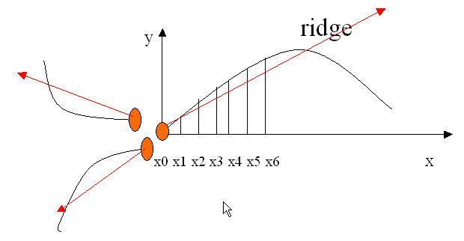
1
0
0
0
1
1
1
0
0
Figure 5.2.1 A bifurcation to three terminations
Three neighbors become terminations (Left)
Each termination has their own orientation (Right)

And the orientation of each termination (tx,ty) is estimated by following method [book ch2]:
Track a ridge segment whose starting point is the termination and length is D. Sum up all x-coordinates of points in the ridge segment. Divide above summation with D to get sx. Then get sy using the same way.
Get the direction from: atan((sy-ty)/(sx-tx)).

CHAPTER 6 MINUTIA MATCH

Given two set of minutia of two fingerprint images, the minutia match algorithm determines whether the two minutia sets are from the same finger or not.

An alignment-based match algorithm partially derived from the [1] is used in my project. It includes two consecutive stages: one is alignment stage and the second is match stage.
- Alignment stage. Given two fingerprint images to be matched, choose any one minutia from each image, calculate the similarity of the two ridges associated with the two referenced minutia points. If the similarity is larger than a threshold, transform each set of minutia to a new coordination system whose origin is at the referenced point and whose x-axis is coincident with the direction of the referenced point.
- Match stage: After we get two set of transformed minutia points, we use the elastic match algorithm to count the matched minutia pairs by assuming two minutia having nearly the same position and direction are identical.

6.1 Alignment Stage

1. The ridge associated with each minutia is represented as a series of x-coordinates (x₁, x₂…x_{n}) of the points on the ridge. A point is sampled per ridge length L starting from the minutia point, where the L is the average inter-ridge length. And n is set to 10 unless the total ridge length is less than 10*L.

So the similarity of correlating the two ridges is derived from:
S = ∑^{m}_{i=0}x_{i}X_{i}/[∑^{m}_{i=0}x_{i}²X_{i}²]^0.5,
where (x_{i~}x_{n}) and (X_{i~}X_{N} ) are the set of minutia for each fingerprint image respectively. And m is minimal one of the n and N value. If the similarity score is larger than 0.8, then go to step 2, otherwise continue to match the next pair of ridges.

2. For each fingerprint, translate and rotate all other minutia with respect to the reference minutia according to the following formula:

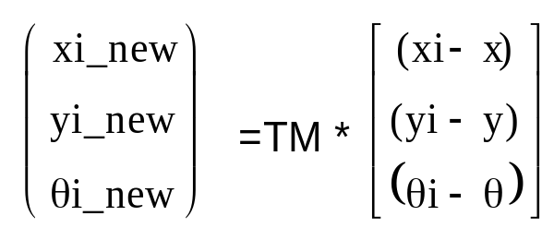,
where (x,y,θ) is the parameters of the reference minutia, and TM is

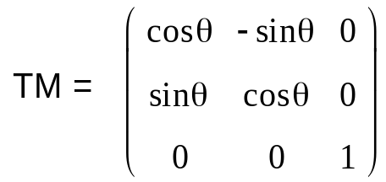
The following diagram illustrate the effect of translation and rotation:
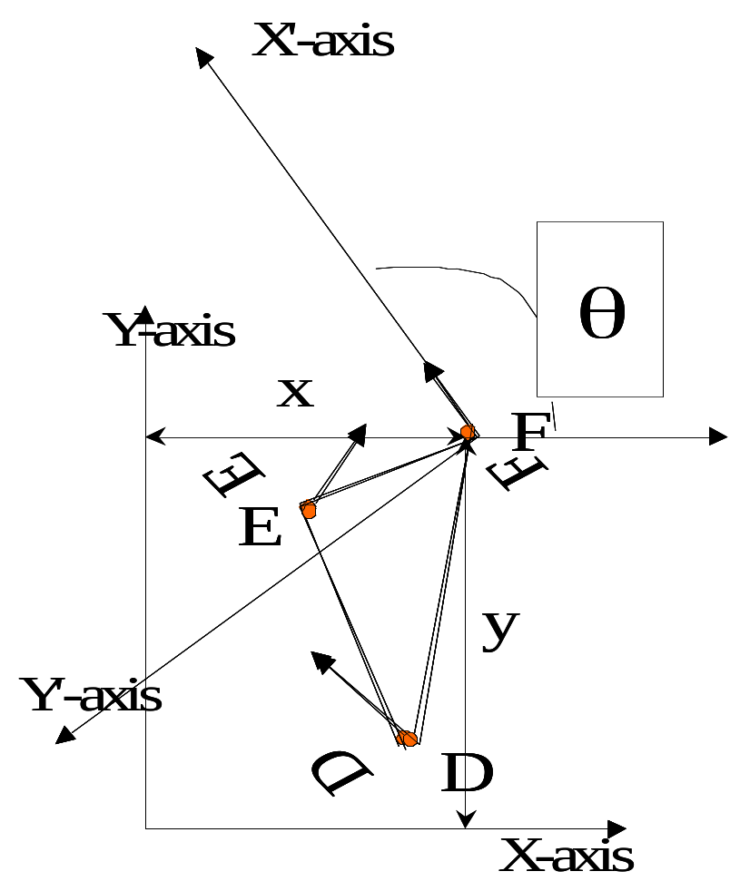

The new coordinate system is originated at minutia F and the new x-axis is coincident with the direction of minutia F. No scaling effect is taken into account by assuming two fingerprints from the same finger have nearly the same size.

My method to align two fingerprints is almost the same with the one used by [1] but is different at step 2. Lin’s method uses the rotation angle calculated from all the sparsely sampled ridge points. My method use the rotation angle calculated earlier by densely tracing a short ridge start from the minutia with length D. Since I have already got the minutia direction at the minutia extraction stage, obviously my method reduces the redundant calculation but still holds the accuracy.

Also Lin’s way to do transformation is to directly align one fingerprint image to another according to the discrepancy of the reference minutia pair. But it still requires a transform to the polar coordinate system for each image at the next minutia match stage. My approach is to transform each according to its own reference minutia and then do match in a unified x-y coordinate. Therefore, less computation workload is achieved through my method.

6.2 Match Stage

The matching algorithm for the aligned minutia patterns needs to be elastic since the strict match requiring that all parameters (x, y, θ) are the same for two identical minutia is impossible due to the slight deformations and inexact quantizations of minutia.

My approach to elastically match minutia is achieved by placing a bounding box around each template minutia. If the minutia to be matched is within the rectangle box and the direction discrepancy between them is very small, then the two minutia are regarded as a matched minutia pair. Each minutia in the template image either has no matched minutia or has only one corresponding minutia.

The final match ratio for two fingerprints is the number of total matched pair over the number of minutia of the template fingerprint. The score is 100*ratio and ranges from 0 to 100. If the score is larger than a pre-specified threshold, the two fingerprints are from the same finger.

However, the elastic match algorithm has large computation complexity and is vulnerable to spurious minutia.

CHAPTER 7 EXPERIMENTATION RESULTS

7.1 Evaluation indexes for fingerprint recognition

Two indexes are well accepted to determine the performance of a fingerprint recognition system: one is FRR (false rejection rate) and the other is FAR (false acceptance rate). For an image database, each sample is matched against the remaining samples of the same finger to compute the False Rejection Rate. If the matching g against h is performed, the symmetric one (i.e., h against g) is not executed to avoid correlation. All the scores for such matches are composed into a series of Correct Score. Also the first sample of each finger in the database is matched against the first sample of the remaining fingers to compute the False Acceptance Rate. If the matching g against h is performed, the symmetric one (i.e., h against g) is not executed to avoid correlation. All the scores from such matches are composed into a series of Incorrect Score.

7.2 Experimentation Results

A fingerprint database from the FVC2000 (Fingerprint Verification Competition 2000) is used to test the experiment performance. My program tests all the images without any fine-tuning for the database. The experiments show my program can differentiate imposturous minutia pairs from genuine minutia pairs in a certain confidence level. Furthermore, good experiment designs can surely improve the accuracy as declared by [10]. Further studies on good designs of training and testing are expected to improve the result.

Here is the diagram for Correct Score and Incorrect Score distribution:
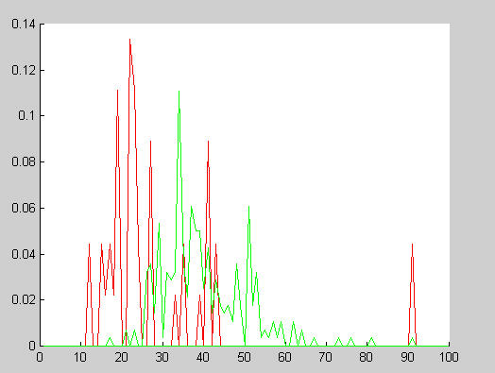

Figure 7.2.1 Distribution of Correct Scores and Incorrect Scores
Red line: Incorrect Score
Green line: Correct Scores

It can be seen from the above figure that there exist two partially overlapped distributions. The Red curve whose peaks are mainly located at the left part means the average incorrect match score is 25. The green curve whose peaks are mainly located on the right side of red curve means the average correct match score is 35. This indicates the algorithm is capable of differentiate fingerprints at a good correct rate by setting an appropriate threshold value.
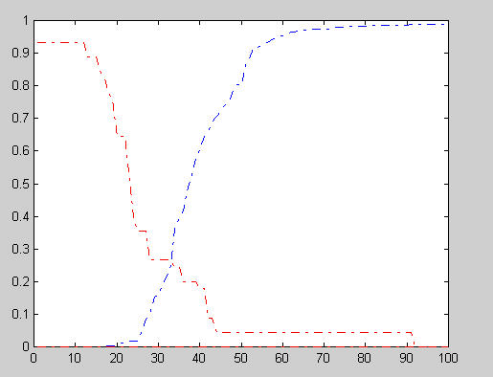

Figure 7.2.2 FAR and FRR curve
Blue dot line: FRR curve
Red dot line: FAR curve

The above diagram shows the FRR and FAR curves. At the equal error rate 25%, the separating score 33 will falsely reject 25% genuine minutia pairs and falsely accept 25% imposturous minutia pairs and has 75% verification rate.

The high incorrect acceptance and false rejection are due to some fingerprint images with bad quality and the vulnerable minutia match algorithm.

CHAPTER 8 CONCLUSTION

My project has combined many methods to build a minutia extractor and a minutia matcher. The combination of multiple methods comes from a wide investigation into research paper. Also some novel changes like segmentation using Morphological operations, minutia marking with special considering the triple branch counting, minutia unification by decomposing a branch into three terminations, and matching in the unified x-y coordinate system after a two-step transformation are used in my project, which are not reported in other literatures I referred to.

Also a program coding with MATLAB going through all the stages of the fingerprint recognition is built. It is helpful to understand the procedures of fingerprint recognition. And demonstrate the key issues of fingerprint recognition.

REFERENCES
[1] Lin Hong. "Automatic Personal Identification Using Fingerprints", Ph.D. Thesis, 1998.
[2] D.Maio and D. Maltoni. Direct gray-scale minutiae detection in fingerprints. IEEE Trans. Pattern Anal. And Machine Intell., 19(1):27-40, 1997.
[3] Jain, A.K., Hong, L., and Bolle, R.(1997), “On-Line Fingerprint Verification,” IEEE Trans. On Pattern Anal and Machine Intell, 19(4), pp. 302-314.
[4] N. Ratha, S. Chen and A.K. Jain, "Adaptive Flow Orientation Based Feature Extraction in Fingerprint Images", Pattern Recognition, Vol. 28, pp. 1657-1672, November 1995.
[5] Alessandro Farina, Zsolt M.Kovacs-Vajna, Alberto leone, Fingerprint minutiae extraction from skeletonized binary images, Pattern Recognition, Vol.32, No.4, pp877-889, 1999.
[6] Lee, C.J., and Wang, S.D.: Fingerprint feature extration using Gabor filters, Electron. Lett., 1999, 35, (4), pp.288-290.
[7] M. Tico, P.Kuosmanen and J.Saarinen. Wavelet domain features for fingerprint recognition, Electroni. Lett., 2001, 37, (1), pp.21-22.
[8] L. Hong, Y. Wan and A.K. Jain, "Fingerprint Image Enhancement: Algorithms and Performance Evaluation", IEEE Transactions on PAMI ,Vol. 20, No. 8, pp.777-789, August 1998.
[9] Image Systems Engineering Program, Stanford University. Student project By Thomas Yeo, Wee Peng Tay, Ying Yu Tai. http://ise0.stanford.edu/class/ee368a_proj01/dropbox/project22/finger/
[10] FVC2000. http://bias.csr.unibo.it/fvc2000/
[11] FVC2002. http://bias.csr.unibo.it/fvc2002/
[12] L.C. Jain, U.Halici, I. Hayashi, S.B. Lee and S.Tsutsui. Intelligent biometric techniques in fingerprint and face recognition. 1999, the CRC Press.
[13] M. J. Donahue and S. I. Rokhlin, "On the Use of Level Curves in Image Analysis," Image Understanding, VOL. 57, pp 652 - 655, 1992.

User Manual

1. Type command start_gui_single_mode in MATLAB 6.0
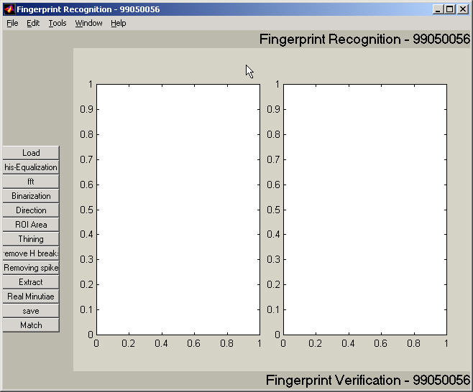
Figure M.1 the User Interface of the Fingerprint Recognition System. The series of buttons on the left side will be invoked sequentially in the consequent demonstration. The two blank areas are used to show the fingerprint image before and after a transaction respectively.

2. Click Load Button
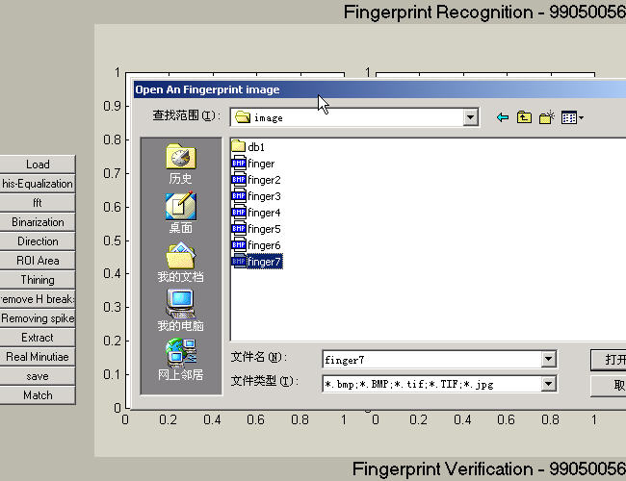
Figure M.2 Load a gray level fingerprint image from a drive specified by Users. Multiple formats are supported and the image size is not limited. But the fingerprint ridges should have large gray intensity comparing with the background and valleys.

3. Click his-Equalization Button

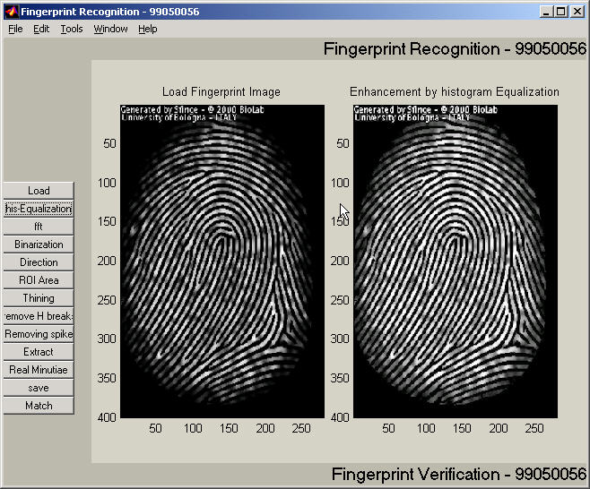

Figure M.3 After Histogram Equalization. The image on the left side is the original fingerprint. The enhanced image after the Histogram Equalization is shown on the right side.

4. Click fft Button

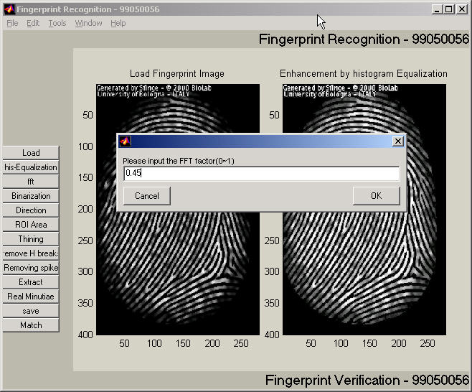

Figure M.4 Captured window after click ‘FFT’ button. The pop-up dialog accepts the parameter k (please refer the formula 2). The experimental optimal k value is 0.45. Users can fill any other constant in the dialog to get a better performance. The enhanced image will be shown in the left screen box, which however is not shown here.

5. Click Binarization Button
6.Click Direction Button

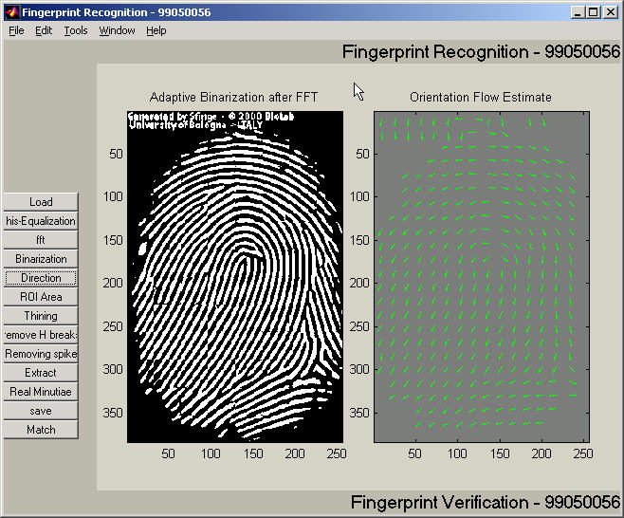

Figure M.5.6 Screen capture after binarization (left) and block direction estimation (right).

7. Click ROI Area Button

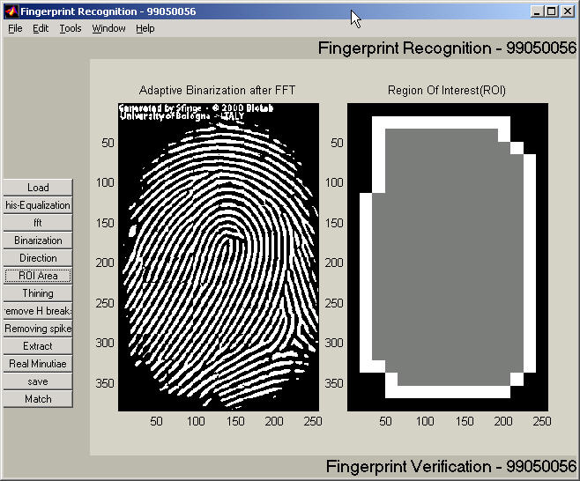

Figure M.7 ROI extraction(right). The intermediate steps for all the morphological operations such close and open are not shown. The right screen box shows the final region of interest of the fingerprint image. The subsequent operations will only operate on the region of interest.

8. Click Thinning Button

9. Click Remove H breaks Button

10. Click Remove spikes Button

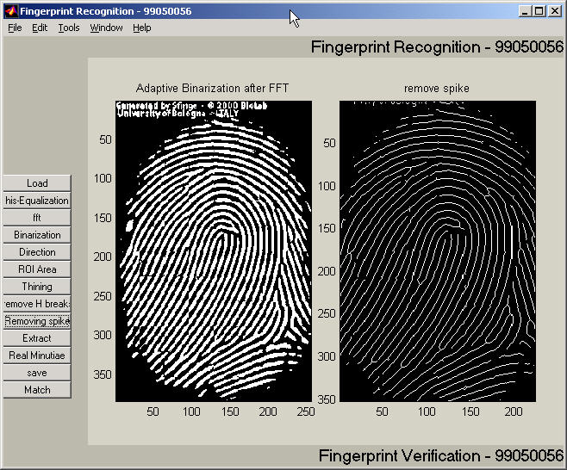

Figure M.10 the Fingerprint image after thining, H breaks removal, isolated peaks removal and spike removal.(right).

- Click Extract Button

12. Click Real Minutia Button

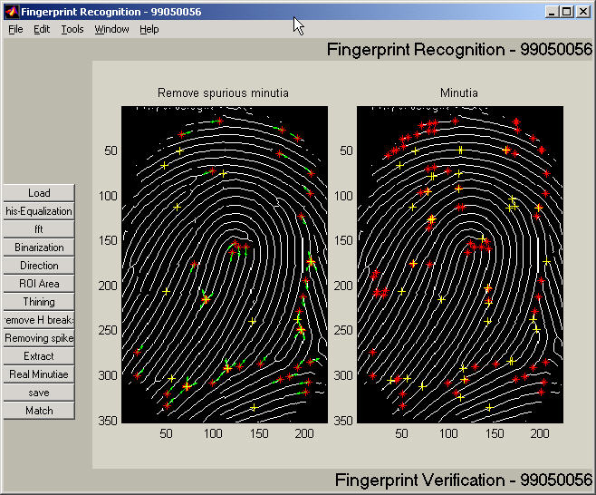

Figure M.12 Minutia Marking (right) and False Minutia Removal (Left). Bifurcations are located with yellow crosses and terminations are denotes with red stars. And the genuine minutia (left) are labeled with orientations with green arrows.

13. Click Save Button

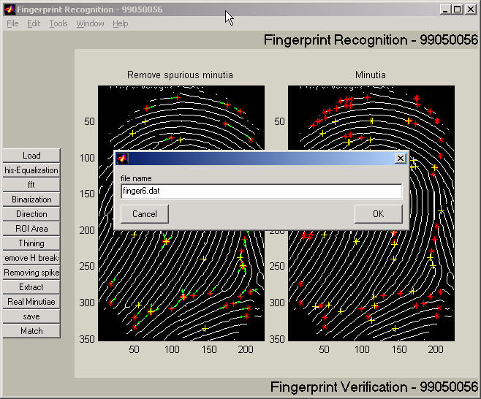

Figure M.13 Save minutia to a text file. The saved text file stores the information on all genuine minutia. The exact format of the files are explained in the source code.

14. Click Match Button

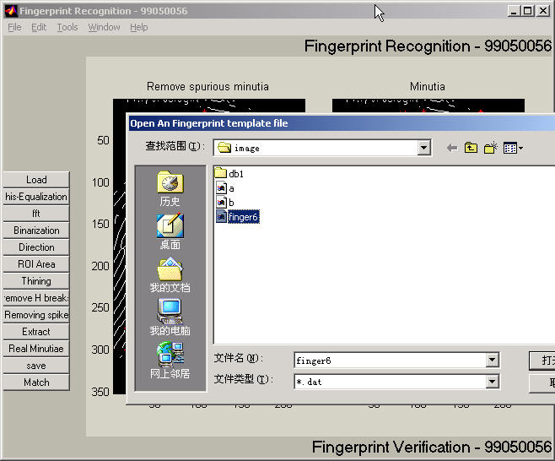

Figure M.14 Load two minutia files and do matching. Users can open two minutia data files from the dialog invoked by clicking the ‘Match’ button. The match algorithm will return a prompt of the match score. But be noted that matching in the GUI mode is not encouraged since the match algorithm relies on heavy computation. Unpredicted states will happen after a long irresponsive running time. Batch testing is prepared for testing match. Please refer the source files for batch testing.

