

CAPSTONE PROJECT REPORT
Report 3 – Software Requirement Specification

– Da Nang, October 2023–
Table of Contents
I. Record of Changes 4
II. Software Requirement Specification 5
1. Product Overview 5
2. User Requirements 6
2.1 Actors 6
2.2 Use Cases 7
2.2.1 Diagram(s) 7
2.2.2 Descriptions 8
2.2.3 Use case details 10
01: Sign Up 10
02: Sign In 14
03: Edit Profile 17
04: Create Group 22
05: Update Group 25
06. Delete Group 28
07. Create Post 30
08. Delete Post 31
09. View Post 32
10. Search Group 32
11. Search Post 33
12. Edit Post 34
13. View Hot Post 35
14. Report Post 36
15. Comment 37
16. Edit Comment 38
17. Delete Comment 39
18. Report Comment 40
19. Like Post/Comment 41
20. Upload Document 42
21. Download Document 44
22. Rate Document 45
23. Edit Document 46
24. Delete Document 47
25. View Document 48
26. Join In Group 49
27. Exit Group 50
28. Buy Coins 50
29.Donate Coins 52
30. Exchange Coins To Money 53
30. Like Post/Comment 54
31. Kick Member Out 56
32. View All Accounts 57
33. Delete Accounts 57
34. Lock/Open Accounts 59
35. View Report 62
36. Accept/Reject Document 63
37. View All Groups 64
38. Notify Group 65
39. Delete Group 66
40. View Charts 67
41. Do Survey 68
3. Functional Requirements 70
3.1 System Functional Overview 70
3.1.1 Screens Flow 70
3.1.2 Screen Descriptions 70
3.1.3 Screen Authorization 73
3.1.4 Non-Screen Functions 76
3.1.5 Entity Relationship Diagram 76
4. Non-Functional Requirements 79
4.1 External Interfaces 80
4.2 Quality Attributes 80
5. Requirement Appendix 81
5.1 Business Rules 81
5.2 Common Requirements 81
5.3 Application Messages List 82
5.4 Other Requirements… 82

I. Record of Changes
Date | A*  M, D | In charge | Change Description
20/8/2023 | M | Java spring spring boot version | Change spring boot version from 3.2.0 to 3.0.11
10/9/2023 | M | Upload Image | Change from upload image using spring boot storage to use CLOUDinary
20/9/2023 | A | Use Case Exchange coins | Add use case exchange coins to money
*A - Added M - Modified D - Deleted

II. Software Requirement Specification

1. Product Overview
Camp-Scholar is an academic exchange platform that provides an online environment exclusively for the academic community. This platform allows users to:
- Exchange academic information: Users can post articles to share academic knowledge or ask questions about academic issues they are interested in.
- Search for academic information: If you need to search for specific information or academic documents, you can access the website to search for information or previous discussions.
- Engage in academic discussions: The platform provides a space for discussing academic issues and exchanging opinions with the community.
- Buy and sell academic materials: Users can buy and sell academic materials on this platform using the website's own currency unit. Money can be deposited into accounts or exchanged between users.
The main goal of the project is to create a diverse academic environment and support the Vietnamese language, promoting the sharing and development of knowledge within the academic community. Camp-Scholar is committed to providing an effective and user-friendly platform for anyone interested in the academic field.

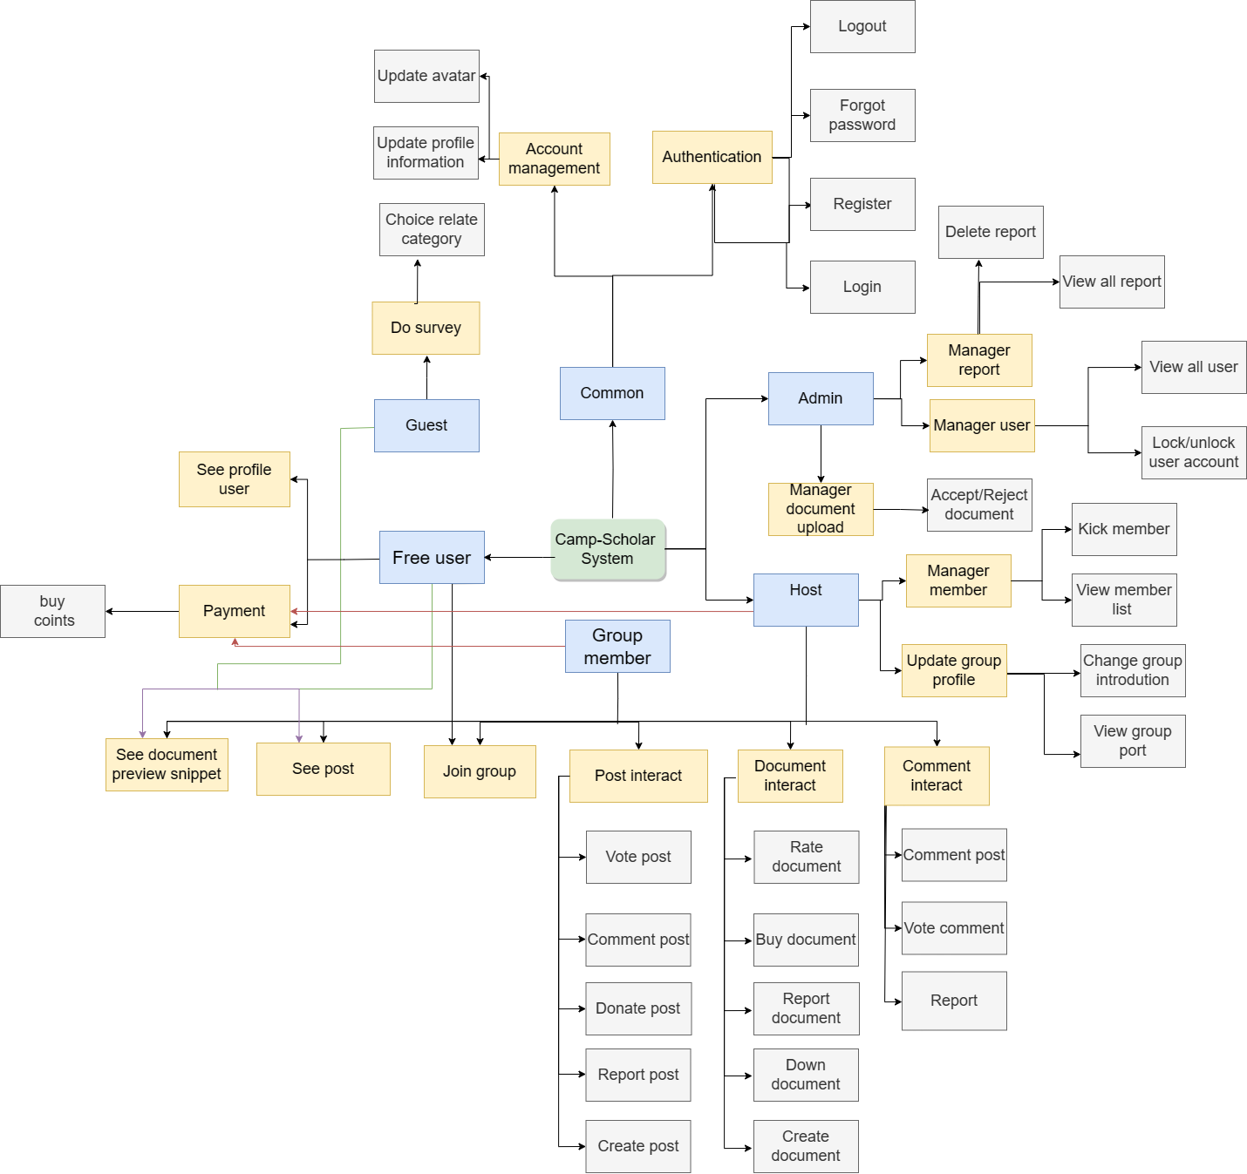
View full

2. User Requirements

2.1 Actors

# | Actor | Description
1 | Student, Worker | Those who need to find a place where they can post questions and answers or discuss, find extra exercises to practise, read academic articles to improve their knowledge, and buy and sell cheap academic materials.
2 | Expert | Those who post their academic reports, documents to reach many readers and earn extra income.
3 | Group Host | Those who create a group and manage the members and activities of that group.
4 | System Admin | Those who manage groups, manage users, manage reports on bad, toxic, and inappropriate content to improve the community better.

2.2 Use Cases

2.2.1 Diagram(s)
2.2.1.1 Use Case for Admin

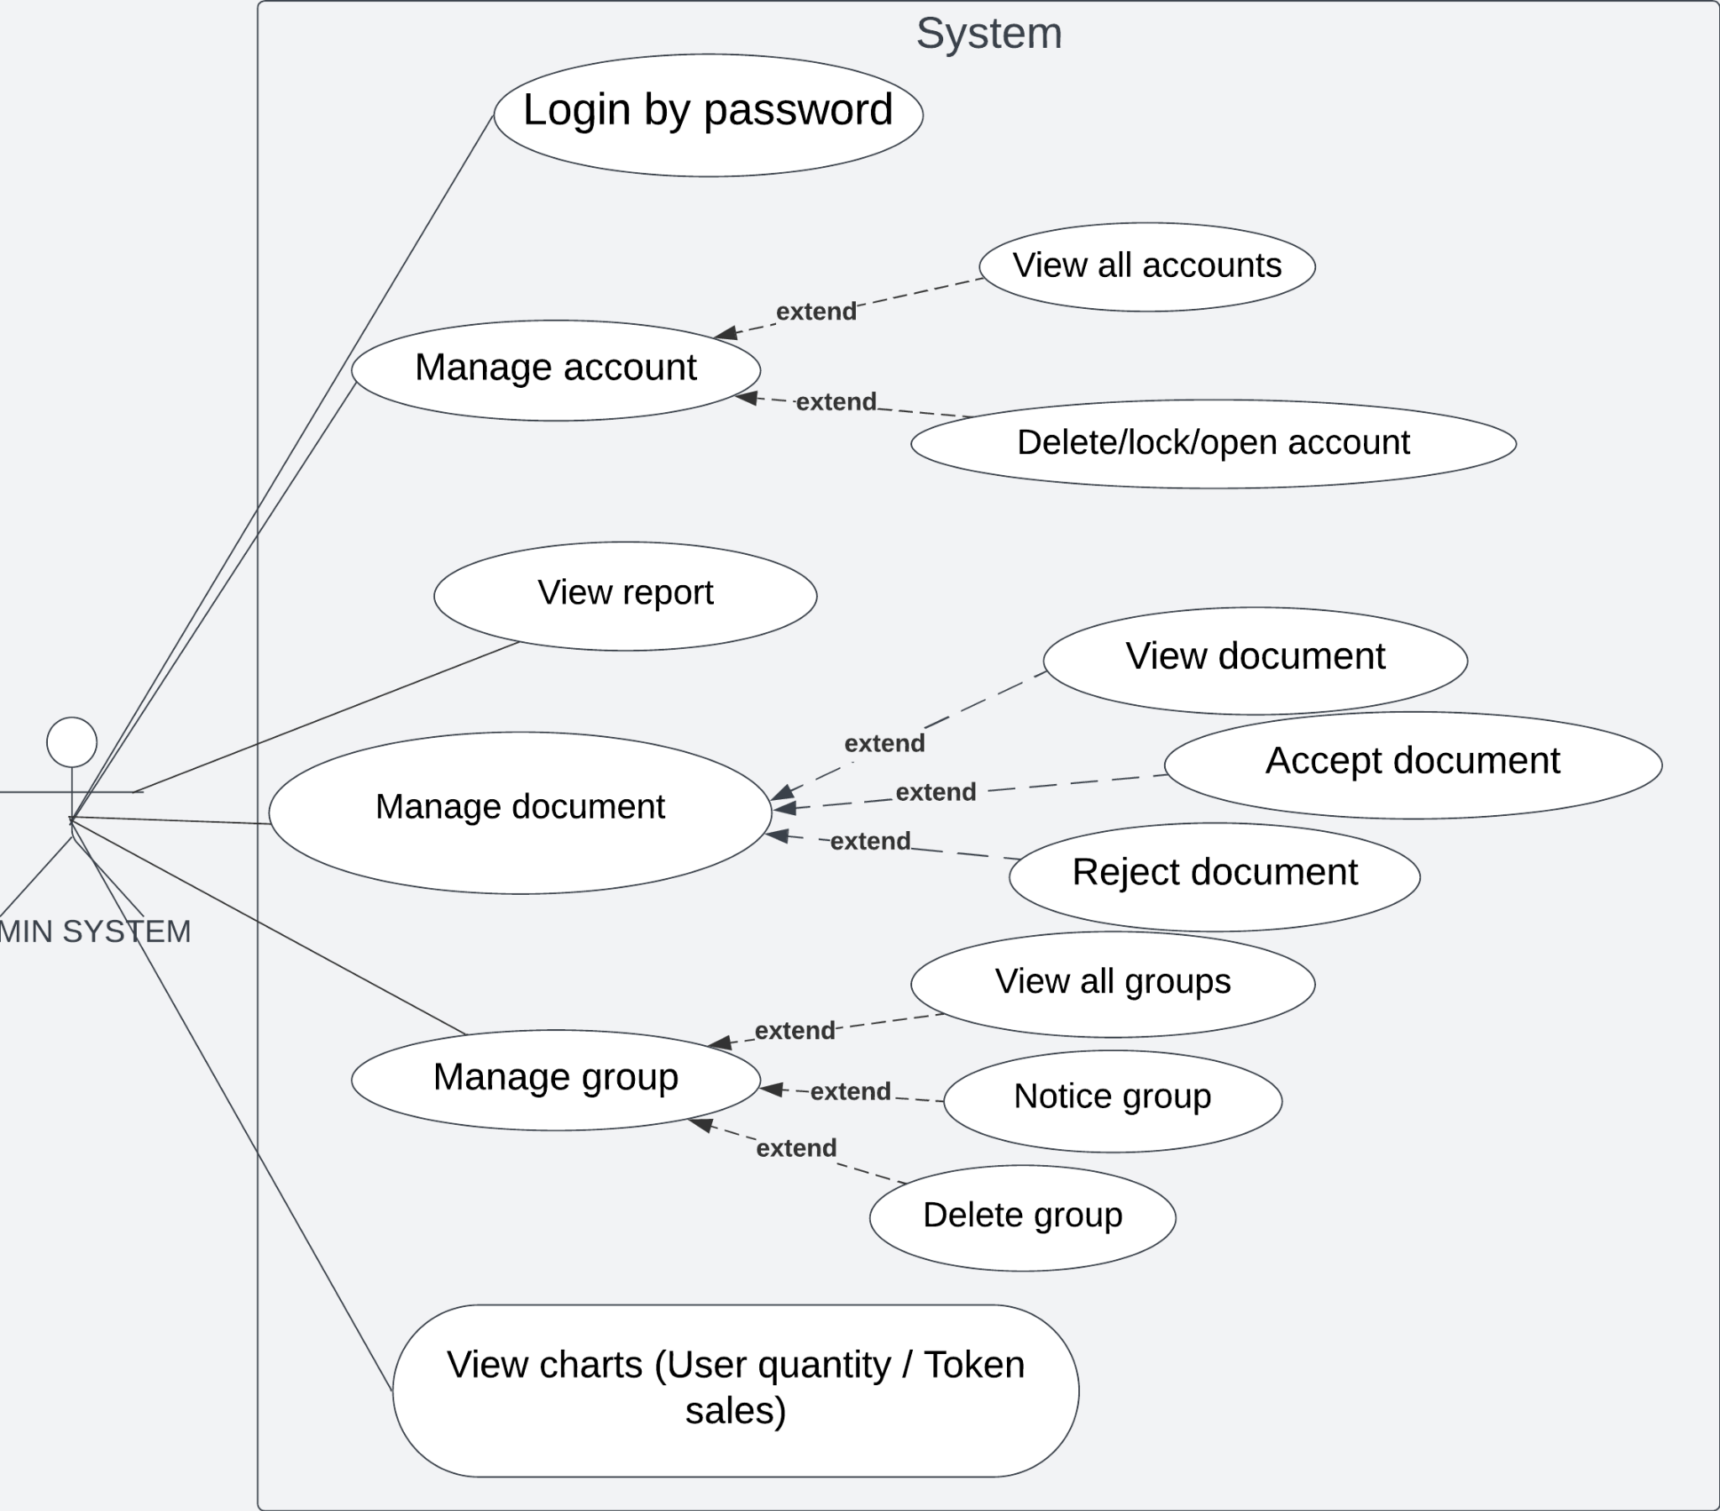
2.2.1.2 Use Case for User
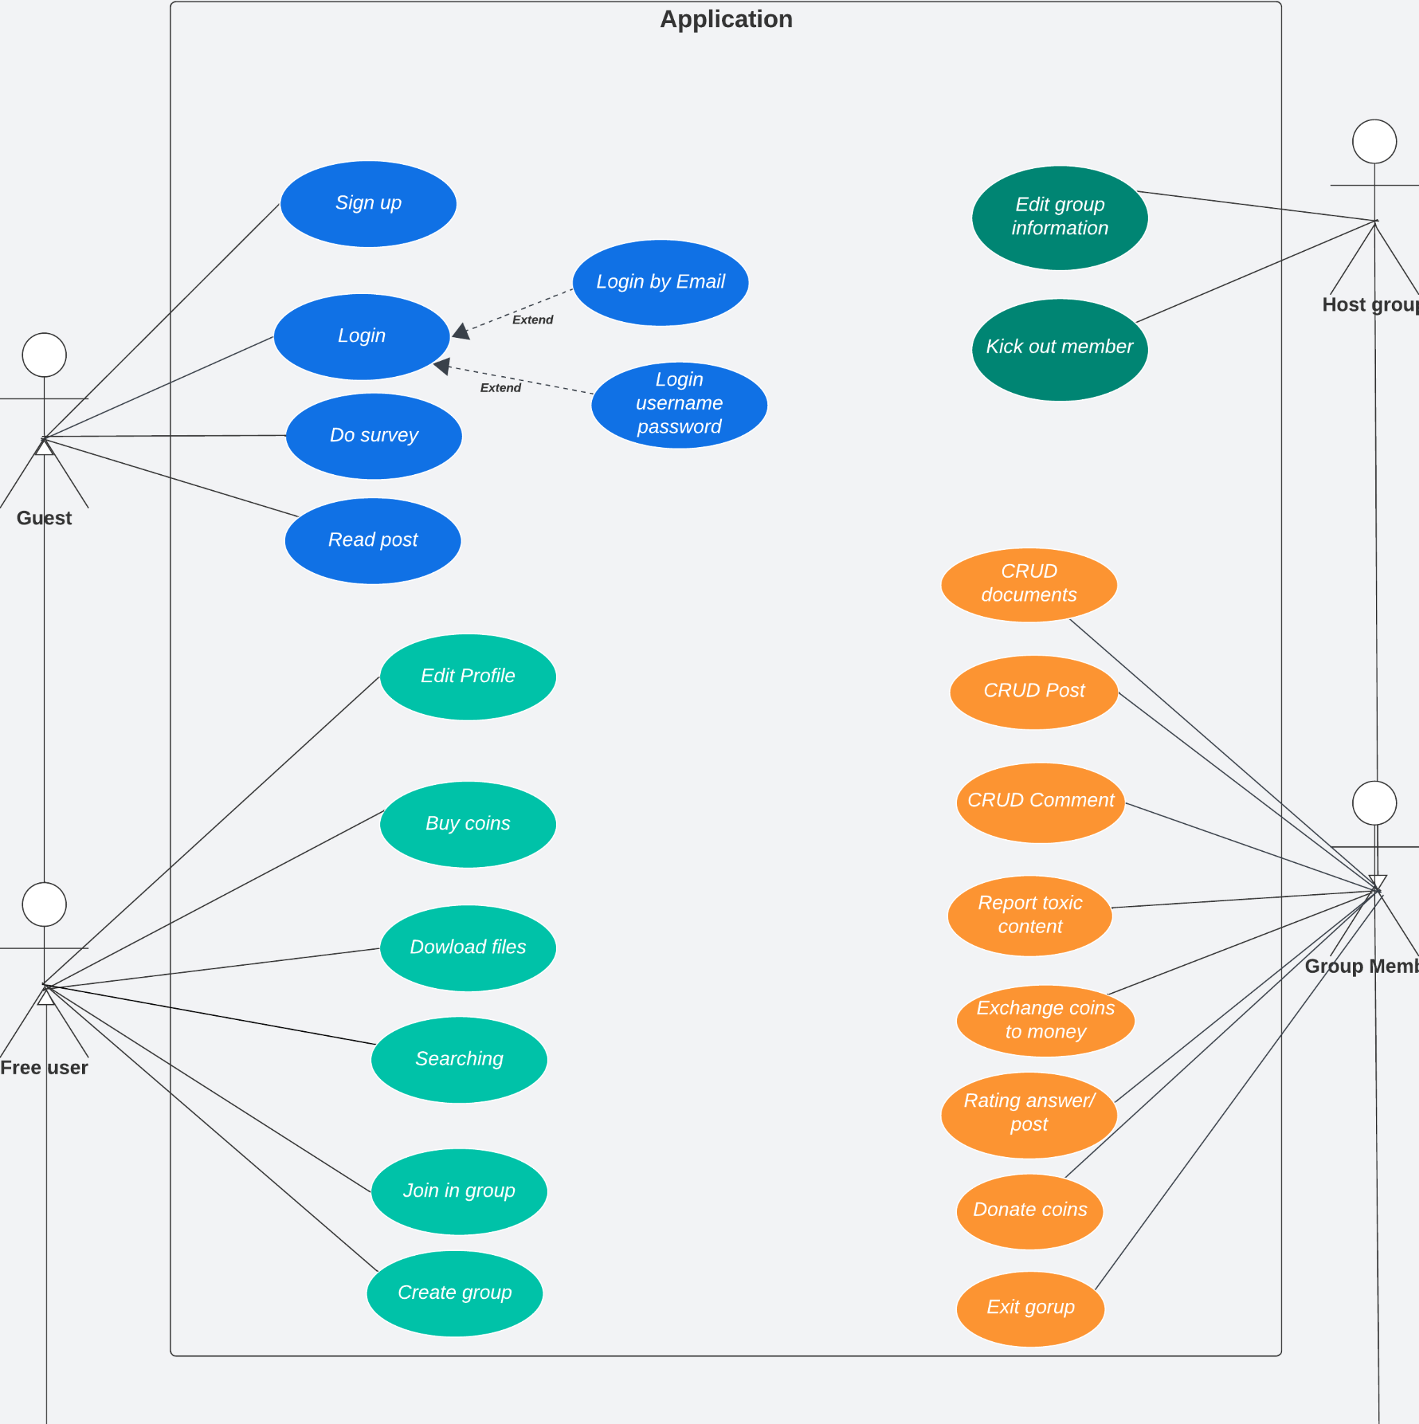

2.2.2 Descriptions
ID | Use Case | Actors | Use Case Description
UC-01 | Sign Up | User | The feature allows user to sign up the system
UC-02 | Sign In | User/Admin | The feature allows user to login the system
UC-03 | Edit Profile | User | The feature allows user to change their avatar, username, password, phone number
UC-04 | Create Group | User | The feature allows user to create groups
UC-05 | Update Group | Host | The feature allows host to update their groups
UC-06 | Delete Group (By Host) | Admin | The feature allows admin to delete groups
UC-07 | Create Post | User | The feature allows user to create new posts
UC-08 | Delete Post | User | The feature allows user to delete their posts
UC-09 | View Post | User | The feature allows user to view any posts
UC-10 | Search Group | User | The feature allows user to search groups
UC-11 | Search Post | User | The feature allows user to search posts by title
UC-12 | Edit Post | User | The feature allows user to edit their posts
UC-13 | View Hot Post | User | The feature allows user to see all hot posts which have the most comments, and upvotes.
UC-14 | Report Post | User | The feature allows user to report any posts
UC-15 | Comment | User | The feature allows user to comment posts
UC-16 | Edit Comment | User | The feature allows user to edit their comments
UC-17 | Delete Comment | User | The feature allows user to delete their comments
UC-18 | Report Comment | User | The feature allows user to report any comments
UC-19 | Like Post/Comment | User | The feature allows user to like or dislike posts/comments
UC-20 | Upload Document | User | The feature allows user to upload their documents onto groups
UC-21 | Download Document | User | The feature allows user to download documents
UC-22 | Rate Document | User | The feature allows user to rate documents
UC-23 | Edit Document | User | The feature allows user to edit their documents’ information
UC-24 | Delete Document | User | The feature allows user to delete their document
UC-25 | View Document | User | The feature allows user to view any documents
UC-26 | Join In Group | User | The feature allows user join in any groups
UC-27 | Exit Group | User | The feature allows user exit groups
UC-28 | Buy Coins | User | The feature allows user buy coins
UC-29 | Donate Coins | User | The feature allows user donate their coins to others
UC-30 | Exchange Coins To Money | User | The feature allows user to exchange their coins to money
UC-31 | Kick Member Out | Host | The feature allows host to kick members in their own groups out
UC-32 | View All Accounts | Admin | The feature allows admin to view the details of all accounts
UC-33 | Delete Accounts | Admin | The feature allows admin to delete accounts
UC-34 | Lock/Open Accounts | Admin | The feature allows admin to lock or open accounts
UC-35 | View Report | Admin | The feature allows admin to view all reports sent to them
UC-36 | Accept/Reject Document | Admin | The feature allows admin to accept or reject documents before releasing
UC-37 | View All Groups | Admin | The feature allows admin to view the details of all groups
UC-38 | Notify Group | Admin | The feature allows admin to notify groups
UC-39 | Delete Group (By Admin) | Admin | The feature allows admin to delete groups
UC-40 | View Charts | Admin | The feature allows admin to view charts about community’s activities
UC-41 | Do Survey | User | The feature allows user to choose their interesting category from a survey popup.

2.2.3 Use case details

01: Sign Up
ID and Name | UC-01: Sign Up
Created By: | KhoaNVD | Date Created: | 30/9/2023
Primary Actor | Guest | Secondary Actors: | N/A
Priority: | High | Frequency of Use: | Usually
Trigger: | The user wants to create new account in the Camp Scholars web app
Description: | This feature allows actor to create new account
Preconditions: | User must have authorised email
Post-conditions: | Success: Redirect to sign in window  Fail: The system shows error message corresponding to error code
Normal Flow: | Step Actor Action System Response  1 In the home page, user clicks “Sign up” System show a form with these fields: - Email: A string input must follow the email regex (abc@xxx.yyy) - Username: A string input is not empty and duplicate - Password: A string input is not empty and at least 8 characters - Confirm password: A string is identical with password - A button “Sign up with google” (Optional)  2 User inputs email, username, password, confirm password  3 User clicks “Next” System sends to that registered mail an OTP code, then shows a new window with a new field - OTP code input that has 6 characters  4 User input OTP code  5 User clicks “Sign up” System checks if OTP code is correct. If correct, the system redirects the user to the sign in window.
Alternative Flow | Step Actor Action System Response  1 In the home page, user clicks “Sign up” System show a form with these fields: - Email: A string input must follow the email regex (abc@xxx.yyy) - Username: A string input is not empty and duplicate - Password: A string input is not empty and at least 8 characters - Confirm password: A string is identical with password - A button “Sign up with google” (Optional)  2 User clicks “Sign up with google” button System requires user to input google account  3 User clicks “Sign up” If the google account is correct, the system redirects the user to the home page.
Exceptions: | No Cause System Response  1 At least one input field doesn’t match the constraint System shows a warning error corresponding to the fail constraint.  2 Email does not exist System shows an warning error : “Email does not exist”  3 OTP code is expired System shows an warning error: “OTP is expired”  4 OTP code is not correct System shows an warning error: “Incorrect OTP”
Business Rules: | - OTP code consists of 6 positive numbers and is valid in 10 minute.  - If users input incorrect OTP 5 times, their email/phone will be locked in 10 minutes.
Assumptions: | - User’s internet connection is available

02: Sign In
ID and Name | UC-02: Sign In
Created By: | KhoaNVD | Date Created: | 30/9/2023
Primary Actor | User | Secondary Actors: | N/A
Priority: | High | Frequency of Use: | Usually
Trigger: | The user wants to sign in to the Camp Scholars web app
Description: | This feature allows user to sign in
Preconditions: | The user must have an account before or authorised email
Post-conditions: | Success: Redirect to home page  Fail: The system shows error message corresponding to error code
Normal Flow: | Step Actor Action System Response  1 In the home page, user clicks “Sign in” System show a form with these fields: - Username - Password - A button “Sign in with google” (Optional)  2 User inputs username and password  3 User clicks “Sign in” System checks if the account is correct. If correct, the system redirects the user to the home page.
Alternative Flow | Step Actor Action System Response  1 In the home page, user clicks “Sign in” System show a form with these fields: - Username - Password - A button “Sign in with google” (Optional)  2 User clicks “Sign in with google” button System requires user to input google account  3 User clicks “Sign in” If the google account is correct, the system redirects the user to the home page.
Exceptions: | No Cause System Response  1 Username or password is incorrect System shows an warning error : “Username or password is incorrect”
Business Rules: | - If users input incorrect username or password 5 times, they must wait 10 minutes for the next try.
Assumptions: | - User’s internet connection is available

03: Edit Profile
ID and Name | UC-03: Edit Profile
Created By: | HungVV | Date Created: | 30/09/2023
Primary Actor | User | Secondary Actors: | N/A
Priority: | High | Frequency of Use: | Often
Trigger: | The user wants to edit their profile in the Camp Scholars web app
Description: | This feature allows the user to change their password, email. Add their phone information
Preconditions: | The user must have an account before
Post-conditions: | Success: System show the successful notification
Normal Flow: | Step Actor Action System Response  1 In the home page, user clicks profile section System redirects user to the profile page showing: - Avatar - Username - Email (Can not change) - Coins - Level - Activity Point - Phone number (Adding if empty) - “Change password” button  2 User clicks the “edit” button of the field they want to change (avatar, username, phone) Profile shows “save” button  3 User input new username and then clicks “Save” System checks if the username is unique. If unique, the system show successful notification
Alternative Flow | - Change avatar  Step Actor Action System Response  1 In the profile page, user clicks “edit avatar” The profile page shows a window to the user selects their image  2 The user add new avatar and then clicks “Save” System shows successful notification  - Change phone  Step Actor Action System Response  1 In the profile page, user clicks “edit phone” The profile page enables the user to input their new phone number  2 The user input their new phone number and then clicks “Save” System sends to that new phone an OTP code, then shows a new window with a new field - OTP code input that has 6 characters  3 User input OTP code  4 User clicks “Save” System checks if OTP code is correct. If correct, the system shows successful notification.  - Change password  Step Actor Action System Response  1 In the profile page, the user clicks “change password” The profile page shows new form including: - Old password: A string input to authenticate user - Password: A string input is not empty and at least 8 characters - Confirm password: A string is identical with password  2 The user input password and confirm password and then clicks “Save” System checks if 2 fields are identical. If identical, the system shows successful notification.
Exceptions: | No Cause System Response  1 OTP code is expired System shows an warning error: “OTP is expired”  2 OTP code is not correct System shows an warning error: “Incorrect OTP”  3 Avatar image is not correct file format System shows an warning error: “Image incorrect format”
Business Rules: | - All input information must be correct before you can click create group
Assumptions: | - User’s internet connection is available

04: Create Group
ID and Name | UC-04: Create Group
Created By: | AnTDH | Date Created: | 27/9/2023
Primary Actor | User | Secondary Actors: | N/A
Priority: | High | Frequency of Use: | Usually
Trigger: | The user wants to create group in the Camp Scholars web app
Description: | This feature allows user to create a group
Preconditions: | - User must have an account before.  - User must have activity points >= 2000 to operate
Post-conditions: | Success: Redirect to group page  Fail: The system shows error message corresponding to error code
Normal Flow: | Step Actor Action System Response  1 In the home page, user clicks “Create Group” System show a form with these fields: - Name: - Description: - Category: - Hash Tag: - Avatar image: - Cover image:  2 System checks condition input  3.a User clicks “Create Group” System checks condition input. If correct, create new group and redirect to group page
Alternative Flow: | Step Actor Action System Response  3.b User clicks “Cancel” System redirect to home page
Exceptions: | No Cause System Response  1 At least one input field doesn’t match the constraint System shows an warning error corresponding to the fail constraint.  2 Category is not correct System shows an warning error : “Category is not valid”  3 Hashtags do not comply with regulations System shows an warning error: “Hashtags is not valid”  4 Avatar image is not correct file format System shows an warning error: “Image incorrect format”  5 Cover image is not correct file format System shows an warning error: “Image incorrect format”
Business Rules: | Constraints:  - All input information must be correct before you can click create group
Assumptions: | - User’s internet connection is available

05: Update Group
ID and Name | UC-05: Update Group
Created By: | AnTDH | Date Created: | 27/9/2023
Primary Actor | Host | Secondary Actors: | N/A
Priority: | High | Frequency of Use: | Usually
Trigger: | The user wants to update information about group
Description: | This feature allows user to update information about group
Preconditions: | - The user must have an account before.  - User must be the Host of that group.
Post-conditions: | Success: Redirect to group page  Fail: The system shows error message corresponding to error code
Normal Flow: | Step Actor Action System Response  1 In the group page, user clicks “Update Group” System show a form with these fields: - Name: - Description: - Category: - Hash Tag: - Avatar image: - Cover image:  2 User inputs name, description,category,hashtag, avatar image, cover image  3.a User clicks “Update Group” System checks condition input. If correct, create new group and redirect to group page
Alternative Flow: | Step Actor Action System Response  3.b User clicks “Cancel” System redirect to group page
Exceptions: | No Cause System Response  1 At least one input field doesn’t match the constraint System shows an warning error corresponding to the fail constraint.  2 Category is not correct System shows an warning error : “Category is not valid”  3 Hash tags do not comply with regulations System shows an warning error: “Hash tags is not valid”  4 Avatar image is not correct file format System shows an warning error: “Image incorrect format”  5 Cover image is not correct file format System shows an warning error: “Image incorrect format”
Business Rules: | Constraints:  - All input information must be correct before you can click create group
Assumptions: | - User’s internet connection is available

06. Delete Group
ID and Name | UC-06: Delete Group
Created By: | AnTDH | Date Created: | 27/9/2023
Primary Actor | Group Host | Secondary Actors: | N/A
Priority: | Normal | Frequency of Use: | Often
Trigger: | The group host wants to delete their groups.
Description: | This feature allows the group host to delete their groups.
Preconditions: | - The user must have an account before.  - User must be the Host of that group.
Post-conditions: | Success: System displays a successful message and redirects the host to the previous page.
Normal Flow: | Step Actor Action System Response  1 In the list group column, the host clicks the garbage icon on the right of the group they want to delete. System displays the alert to check the host's decision with 2 buttons “Yes” and “No”  2 User clicks “Yes” System shows a message that says “Delete group success!” ,removes this group and redirects the host to the previous page.
Alternative Flow | N/A
Exceptions: | N/A
Business Rules: | N/A
Assumptions: | - User’s internet connection is available

07. Create Post
Id and Name: | UC-07: Create posts in group
Created By: | TaiNL | Date Created: | 27/9/2023
Primary Actor: | User | Secondary Actors: | N/A
Priority: | High | Frequency of Use: | Usually
Trigger: | The user wants to make a post inside the group.
Description: | This feature allows the user who has created an account to make a post about the problem or questions which they want to know.
Preconditions: | The user needs to have an account, and users have already joined the group.
Post-conditions: | Success: Redirect to the group with their post.  Fail: The system shows error message corresponding to error code
Normal Flow: | Step Actor Action System Response  1 In the group page user click on button “Make Post” System shows a form with these fields: -Content: a text input - Add image: a file input with type .png, .jpg, .gif, .bmp.  2 User input the content or add picture(Optional) for their post  3 The user click “Post” System checks the validation. If correct, create a new post and redirect users to group with their post.
Alternative Flow: | N/A
Exceptions: | No Cause System Response  1 At least one file does not follow the type of file which is supported. System shows an error message corresponding to the fail constraint.  2 The file is in correct support type but with the size bigger than 5 MB System shows an error message corresponding to the fail constraint.
Business Rules: | BR-05, BR-06, BR-12
Assumptions: | - User’s internet connection is available

08. Delete Post
Id and Name: | UC-08: Delete posts in group
Created By: | TaiNL | Date Created: | 27/9/2023
Primary Actor: | User | Secondary Actors: | N/A
Priority: | Normal | Frequency of Use: | Usually
Trigger: | The user wants to delete their post inside the group.
Description: | This feature allows the user who had created an account to delete their post after making it.
Preconditions: | The user need to have an account, and users have already joined a group and have at least one post. They can delete their post only.
Post-conditions: | Success: Message “Delete Successfully” and Redirect to the group.
Normal Flow: | Step Actor Action System Response  1 In the group page user click the arrow icon on the top right of their post System shows a list with these fields: - Edit Post - Delete Post  2 User click on delete post System shows a message: ”Do you want to delete ?” with 2 option button: - Delete - Cancel  3 The user click “Delete” The System delete their post.  4 The user click “Cancel” The System hides the window and message.
Alternative Flow: | N/A
Exceptions:
Business Rules: | BR-12
Assumptions: | - User’s internet connection is available

09. View Post
Id and Name: | UC-08: View posts in group
Created By: | TaiNL | Date Created: | 27/9/2023
Primary Actor: | User | Secondary Actors: | N/A
Priority: | High | Frequency of Use: | Usually
Trigger: | The user wants to view post made by others inside group.
Description: | The user can see all posts inside the group.
Preconditions: | Users need to have an account.
Post-conditions: | Success: Redirect to the group with posts.
Normal Flow: | Step Actor Action System Response  1 User clicks on the droplist which is on the top left of the website. System shows a list of group which they had joined  2 User click on the group which they want to see the post inside System redirects user to the group they choose and allows them to see all the posts inside.
Alternative Flow: | N/A
Exceptions: | No Cause System Response  1 No post in group, postlist empty. System shows an error message. “Group empty post”
Business Rules: | N/A
Assumptions: | - User’s internet connection is available

10. Search Group
Id and Name: | UC-09: Search groups
Created By: | TaiNL | Date Created: | 27/9/2023
Primary Actor: | User | Secondary Actors: | Guest
Priority: | High | Frequency of Use: | Usually
Trigger: | People want to find groups base on group name
Description: | The user can see the list of group contain what the had input in the group name
Preconditions: | N/A
Post-conditions: | Success: Redirect to the list of group  Failed: Show message “Not found”
Normal Flow: | Step Actor Action System Response  1 Click on the search box System shows the text cursor.  2 User input what they want to find System redirects the user to the result page.
Alternative Flow: | N/A
Exceptions: | No Cause System Response  1 No group name contains what people search. System shows an error message. “Not found”
Business Rules: | N/A
Assumptions: | - User’s internet connection is available

11. Search Post

Id and Name: | UC-11: Search posts
Created By: | TaiNL | Date Created: | 27/9/2023
Primary Actor: | User | Secondary Actors: | Guest
Priority: | High | Frequency of Use: | Usually
Trigger: | People want to find post base on post titles
Description: | The user can see the list of post contain what the had input in the titles.
Preconditions: | N/A
Post-conditions: | Success: Redirect to the list of posts.  Failed: Show message “Not found”
Normal Flow: | Step Actor Action System Response  1 Click on the search box System shows the text cursor.  2 User input what they want to find System redirects the user to the result page.
Alternative Flow: | N/A
Exceptions: | No Cause System Response  1 No post titles contain what people search. System shows an error message. “Not found”
Business Rules: | N/A
Assumptions: | - User’s internet connection is available

12. Edit Post
Id and Name: | UC-11: Edit posts in group
Created By: | TaiNL | Date Created: | 27/9/2023
Primary Actor: | User | Secondary Actors: | N/A
Priority: | High | Frequency of Use: | Usually
Trigger: | The user wants to edit their post inside the group.
Description: | This feature allows the user who has created an account to edit their post after making it.
Preconditions: | The user needs to have an account, and users have already joined a group and have at least one post. They can edit their posts only.
Post-conditions: | Success: Redirect to the group with their post after edit.  Fail: The system shows error message corresponding to error code
Normal Flow: | Step Actor Action System Response  1 In the group page user click the arrow icon on the top right of their post System shows a list with these fields: - Edit post - Delete Post  2 User click on edit post System allows user change this post’s content  3 The user click “Done” System creates a new version of this post and redirects users to the group page they are standing
Alternative Flow: | N/A
Exceptions: | No Cause System Response  1 At least one file does not follow the type of file which is supported. System shows an error message corresponding to the fail constraint.  2 The file is in correct support type but with the size bigger than 5 MB System shows an error message corresponding to the fail constraint.
Business Rules: | BR-12
Assumptions: | - User’s internet connection is available

13. View Hot Post
Id and Name: | UC-12: View Hot Post
Created By: | TaiNL | Date Created: | 27/9/2023
Primary Actor: | User | Secondary Actors: | Guest
Priority: | Normal | Frequency of Use: | Usually
Trigger: | People want to view the hot post inside groups.
Description: | The user can see all hot posts which have the most comments, and upvote.
Preconditions: | N/A
Post-conditions: | Success: Redirect to the hot post page and showing result.
Normal Flow: | Step Actor Action System Response  1 Click on the hot post tab on the landing page. System shows a list of post which have the most comments and upvotes.
Alternative Flow: | N/A
Exceptions: | No Cause System Response  1 No post on the website, Post list empty. System shows an error message. “empty post”
Business Rules: | N/A
Assumptions: | - User’s internet connection is available

14. Report Post
Id and Name: | UC-13: Report posts
Created By: | KhoaNVD | Date Created: | 03/10/2023
Primary Actor: | User | Secondary Actors: | N/A
Priority: | Normal | Frequency of Use: | Often
Trigger: | People want to report posts with negative contents.
Description: | The feature allows user to report any posts with negative contents.
Preconditions: | The user needs to have an account, and users have already joined a group.
Post-conditions: | Success: Redirect to the group page which user is standing
Normal Flow: | Step Actor Action System Response  1 Click “Report” on the top-right of the post System shows a form with list report types and checkboxes lies beside each one: - Báo cáo vi phạm bản quyền - Báo cáo spam hoặc quảng cáo không đúng chỗ - Báo cáo lạm dụng hoặc vi phạm quy tắc ứng xử - Báo cáo nội dung không phù hợp với chủ đề nhóm - Báo cáo vi phạm quy tắc về thông tin cá nhân - Báo cáo vi phạm ngôn ngữ và nội dung không đúng đắn  2 User selects the checkbox corresponding to post content and then click “Next” System show a text field to input report description  3 User input report description then click “Submit” System shows successful notification and redirects user to the group page they are standing
Alternative Flow: | N/A
Exceptions: | No Cause System Response  1 User write description over 250 characters System shows an error message. “Description must not exceed 250 characters”
Business Rules: | All description are restricted to 250 characters
Assumptions: | - User’s internet connection is available

15. Comment
Id and Name: | UC-15: Comment under posts
Created By: | KhoaNVD | Date Created: | 03/10/2023
Primary Actor: | User | Secondary Actors: | N/A
Priority: | High | Frequency of Use: | Usually
Trigger: | People want to discuss with others under the post
Description: | The user can comment under the post
Preconditions: | The user needs to have an account, and users have already joined a group.
Post-conditions: | Success: Redirect to the comment space of the post which user is standing
Normal Flow: | Step Actor Action System Response  1 Click on “Comment” button under the post user want to discuss System will show a text field in the comment space of the post  2 User write comment on the text field and then enter System redirects user to new comment they created
Alternative Flow: | N/A
Exceptions: | N/A
Business Rules: | N/A
Assumptions: | - User’s internet connection is available

16. Edit Comment
Id and Name: | UC-16: Edit comments
Created By: | KhoaNVD | Date Created: | 03/10/2023
Primary Actor: | User | Secondary Actors: | N/A
Priority: | Normal | Frequency of Use: | Often
Trigger: | User want to change the comment they created
Description: | The feature allows user to edit their comments
Preconditions: | The user needs to have an account, and users have already joined a group and have at least one comment. They can edit their comments only.
Post-conditions: | Success: Redirect to the comment space and show the new comment in it.
Normal Flow: | Step Actor Action System Response  1 In the comment space user click the arrow icon on the right of their comment System shows a list with these fields: - Edit comment - Delete comment  2 User click on edit comment System allows user change this comment’s content  3 The user click “Done” System creates a new version of this comment and redirects users to the comment they changed
Alternative Flow: | N/A
Exceptions: | N/A
Business Rules: | N/A
Assumptions: | - User’s internet connection is available

17. Delete Comment
Id and Name: | UC-17: Delete comments
Created By: | KhoaNVD | Date Created: | 03/10/2023
Primary Actor: | User | Secondary Actors: | N/A
Priority: | Normal | Frequency of Use: | Often
Trigger: | User want to delete the comment they created
Description: | The feature allows user to delete their comments
Preconditions: | The user needs to have an account, and users have already joined a group and have at least one comment. They can delete their comments only.
Post-conditions: | Success: Redirect user to the comment space they are standing
Normal Flow: | Step Actor Action System Response  1 In the comment space user click the arrow icon on the right of their comment System shows a list with these fields: - Edit comment - Delete comment  2 User click on delete comment System deletes the comment and redirects users to the comment space they are standing
Alternative Flow: | N/A
Exceptions: | N/A
Business Rules: | N/A
Assumptions: | - User’s internet connection is available

18. Report Comment
Id and Name: | UC-18: Report comments
Created By: | KhoaNVD | Date Created: | 03/10/2023
Primary Actor: | User | Secondary Actors: | N/A
Priority: | Normal | Frequency of Use: | Often
Trigger: | People want to report comments with negative contents.
Description: | The feature allows user to report any comments with negative contents.
Preconditions: | The user needs to have an account, and users have already joined a group.
Post-conditions: | Success: Redirect to the group page which user is standing
Normal Flow: | Step Actor Action System Response  1 Click “Report” on the right of the comment System shows a form with list report types and checkboxes lies beside each one: - Báo cáo vi phạm bản quyền - Báo cáo spam hoặc quảng cáo không đúng chỗ - Báo cáo lạm dụng hoặc vi phạm quy tắc ứng xử - Báo cáo nội dung không phù hợp với chủ đề bai viet - Báo cáo vi phạm quy tắc về thông tin cá nhân - Báo cáo vi phạm ngôn ngữ và nội dung không đúng đắn  2 User selects the checkbox corresponding to comment content and then click “Next” System show a text field to input report description  3 User input report description then click “Submit” System shows successful notification and redirects user to the group page they are standing
Alternative Flow: | N/A
Exceptions: | No Cause System Response  1 User write description over 250 characters System shows an error message. “Description must not exceed 250 characters”
Business Rules: | All description are restricted to 250 characters
Assumptions: | - User’s internet connection is available

19. Like Post/Comment
Id and Name: | UC-19: Like posts or comments
Created By: | KhoaNVD | Date Created: | 01/10/2023
Primary Actor: | User | Secondary Actors: | N/A
Priority: | Normal | Frequency of Use: | Often
Trigger: | People want to like or dislike posts or comments they want to rate.
Description: | The feature allows user to like or dislike posts/comments
Preconditions: | The user needs to have an account, and users have already joined a group.
Post-conditions: | Success: Redirect user to the post or comment space they are standing
Normal Flow: | Step Actor Action System Response  1 At the post or comment space user want to rate, they click the “up arrow” symbol at the left of the post or comment System shows that the total like of the post or comment increases 1 unit.
Alternative Flow: | Step Actor Action System Response  1 At the post or comment space user want to rate, they click the “down arrow” symbol at the left of the post or comment System shows that the total like of the post or comment decreases 1 unit.
Exceptions: | N/A
Business Rules: | If user continuously like/dislike 2 times on 1 post/comment, the total like made by that user will return 0
Assumptions: | - User’s internet connection is available

20. Upload Document
Id and Name: | UC-20: Upload document
Created By: | HungVV | Date Created: | 01/10/2023
Primary Actor: | User | Secondary Actors: | N/A
Priority: | High | Frequency of Use: | Usually
Trigger: | Users want to sell their document
Description: | This feature allow user to upload a document, set price and add more information about it.
Preconditions: | Actors must sign in as “User”.  Actors must be a member of a group  Actors should be in a group view
Post-conditions: | Success: System save document and add status is not approved then return document page
Normal Flow: | Step Actor Action System Response  1 In group view, clicks on “Document” button System redirects user to group’s documents page  2 Clicks on “Add your document” in the right top of the page The page shows a form include: - Upload document: the upload file must belong to these format: doc, pdf, txt, xlsx, docx; and not be empty - Name: a string >= 8 chars and does not contains special chars - Descrpition: not null string - Cost: a natural number implies the numbers of coins that user want to be earned with each purchase.  3 User input data then clicks “Upload” System save document and send it to waiting list that the admins can consider and approve documents.
Alternative Flow: | N/A
Exceptions: | No Cause System Response  1 The file is too large System shows an error message. “The file is too large”  2 Incorrect format file System shows an error message. “Your file must be in doc, pdf, txt, xlsx, docx”
Business Rules: | - All input information must be correct before you can click create group
Assumptions: | - User’s internet connection is available

21. Download Document
Id and Name: | UC-21: Download document
Created By: | HungVV | Date Created: | 01/10/2023
Primary Actor: | User | Secondary Actors: | N/A
Priority: | High | Frequency of Use: | Usually
Trigger: | Users want to download the documents.
Description: | This feature allow user buy a document by coins and download it.
Preconditions: | Actors must sign in as “User”.  Actor should be viewing the documents in group’s document page or document home page  Actor coins >= document’s cost
Post-conditions: | Success: Save file to user’s device and return .
Normal Flow: | Step Actor Action System Response  1 Clicks on a document to select. Current page shows a window include document information and “Buy” button  2 Actor checks the costs by him/herself and click on “Buy” button System save the bills and show document in user’s document list
Alternative Flow: | Step Actor Action System Response  1 In home page, clicks “My documents” button System redirects to User’s document page  2 Pays attention to “Purchased documents” and select document in list then clicks on. Shows download window to choose destination folder and save on device
Exceptions: | No Cause System Response  1 User’s coins is not enough. System shows an error message. “Lack of coins”
Business Rules: | N/A
Assumptions: | - User’s internet connection is available

22. Rate Document
Id and Name: | UC-22: Rate Document
Created By: | HoangVH | Date Created: | 01/10/2023
Primary Actor: | User | Secondary Actors: | N/A
Priority: | Normal | Frequency of Use: | Regularly
Trigger: | User wants to rate a document they have purchased.
Description: | Users can rate the document they build.
Preconditions: | N/A
Post-conditions: | Success: Show current vote of user  Error : Throw exception
Normal Flow: | Step Actor Action System Response  1 Click document user have purchased in history build Show the document page preview of document  2 On the document page, the user selects the star corresponding to the document and submit in rating bar Show the current status rating bar of user for the document
Alternative Flow: | Step Actor Action System Response  1.b Search document in search bar System shows list document relate search key  1.c Select documents that the user has previously paid for Show the document page preview of document
Exceptions: | No Cause System Response  1 User not login to website Hide rating bar ( only show status rating bar )  2 User not purchased document Hide rating bar ( only show status rating bar )
Business Rules: | Actors must sign in as “User”.  Actors should buy this document.
Assumptions: | - User’s internet connection is available

23. Edit Document
Id and Name: | UC-23: Edit document
Created By: | HungVV | Date Created: | 01/10/2023
Primary Actor: | User | Secondary Actors: | N/A
Priority: | High | Frequency of Use: | Often
Trigger: | Users want to edit their created document
Description: | This feature allow user to change the document’s name, description and cost
Preconditions: | Actors must sign in as “User”.  Actors has created at least one document.  Actor should be in user’s document page
Post-conditions: | Success: System update data.
Normal Flow: | Step Actor Action System Response  1 User pays attention to “Documents for sale” and select the document in the list then clicks on. Current page shows a window allow user edit name, description, cost, “Save” and “Delete ”button  2 User edits then clicks on “Save” button Systems save document
Alternative Flow: | N/A
Exceptions: | N/A
Business Rules: | - Name: a string >=8 chars and doesn’t contain special chars  - Description: not null string  - Cost: natural number  - Document Resourses can not be changed
Assumptions: | - User’s internet connection is available

24. Delete Document
Id and Name: | UC-24: Delete Document
Created By: | HungVV | Date Created: | 01/10/2023
Primary Actor: | User | Secondary Actors: | N/A
Priority: | High | Frequency of Use: | Often
Trigger: | People want to delete their created document.
Description: | This feature allows user select document from their created document list and delete it.
Preconditions: | Actors must sign in as “User”.  User has created at least one document.  Usershould be in user’s document page
Post-conditions: | Success: Shows result in user’s document page and delete document in database.
Normal Flow: | Step Actor Action System Response  1 User pays attention to “Documents for sale” and select the document in the list then clicks on. Current page shows a window allow user edit name, description, cost, “Save” and “Delete ”button  2 Clicks “Delete ”button Shows smaller window contains string “Do you definitely want to delete this document?” and 2 choices button “Yes”, “No”  3 Clicks “Yes” Deletes documents in database in storage and shows result in User’s document page
Alternative Flow: | N/A
Exceptions: | N/A
Business Rules: | N/A
Assumptions: | - User’s internet connection is available

25. View Document
Id and Name: | UC-25: View Document
Created By: | HungVV | Date Created: | 01/10/2023
Primary Actor: | User | Secondary Actors: | N/A
Priority: | High | Frequency of Use: | Usually
Trigger: | The Actors want to view the documents.
Description: | This feature allow user to view approved document list, and get information of each document
Preconditions: | N/A
Post-conditions: | Success: Shows window contains document information
Normal Flow: | Step Actor Action System Response  1 In landing page/home page, clicks on “Document” button System redirects to document page shows list of approved documents. The site is paginated 12 documents per page.  2 Clicks on each document name to selects Current page shows window contains information and “Buy” button
Alternative Flow: | Step Actor Action System Response  1 Signed in User can goes to a group page and clicks on “Document” button of that page System redirect to group documents page that shows the list of document created by group member
Exceptions: | No Cause System Response  1 Guest clicks “Buy” button System shows an error message. “You are not have authority”
Business Rules: | - Guest must sign up to buy document
Assumptions: | - User’s internet connection is available

26. Join In Group
Id and Name: | UC-26: Join In Group
Created By: | AnTDH | Date Created: | 05/10/2023
Primary Actor: | User | Secondary Actors: | N/A
Priority: | Normal | Frequency of Use: | Often
Trigger: | People want to join in groups.
Description: | This feature allows user to create a group
Preconditions: | User must log in to Camp Scholars
Post-conditions: | Success: Redirect to group page
Normal Flow: | Step Actor Action System Response  1 In the group page, user clicks “Join Group” System redirect to group page
Alternative Flow: | N/A
Exceptions: | N/A
Business Rules: | N/A
Assumptions: | - User’s internet connection is available

27. Exit Group
Id and Name: | UC-27: Exit Group
Created By: | AnTDH | Date Created: | 05/10/2023
Primary Actor: | User | Secondary Actors: | N/A
Priority: | Normal | Frequency of Use: | Often
Trigger: | The user wants to exit group
Description: | This feature allows user to delete group
Preconditions: | User must log in to Camp Scholars
Post-conditions: | Success: Redirect to home page
Normal Flow: | Step Actor Action System Response  1 In the group page, user clicks “Join Group” System redirect to group page
Alternative Flow: | N/A
Exceptions: | N/A
Business Rules: | - The group host can’t exit
Assumptions: | - User’s internet connection is available

28. Buy Coins
Id and Name: | UC-28: Buy coin
Created By: | TaiNL | Date Created: | 05/10/2023
Primary Actor: | User | Secondary Actors: | N/A
Priority: | High | Frequency of Use: | Often
Trigger: | User want to by coins which help them pay for document, donate..
Description: | The user can pay to buy coins, with 1 USD they can get 20 coins
Preconditions: | N/A
Post-conditions: | Success: Redirect to the new page and showing success result, add coins they had bought to their account  Failed: Redirect to the new page and showing failed result.
Normal Flow: | Step Actor Action System Response  1 Click on their name on the top right of screen. System shows a list of features - Profile - Buy Coins - Exchange Coins  2 Click on Buy Coins System will redirect user to new page which showing: Method: Paypal Currency: USD Description: Input Text Coins: input number >20 Amount: Result number  3 User enter the number of coins they want to buy System will calculate on change the amount for the coins which user request  4 User click “Pay with paypal“button System will redirect user to the paypal login and showing: - Enter the paypal email - Enter the paypal password  5 User Enter paypal email and password and click “login” System will redirect users to the new page and show their invoice. and list of card and paypal wallet  6 User choice card or wallet and click “Continue to Review Order” The system will process the payment and redirect user to the result page
Alternative Flow: | N/A
Exceptions: | No Cause System Response  1 The payment not success cause by paypal or bank account problem System shows an error message. in the new page ”payment Error”
Business Rules: | BR13, BR-14
Assumptions: | - User’s internet connection is available

29.Donate Coins
Id and Name: | UC-29: Donate Coins
Created By: | TaiNL | Date Created: | 01/10/2023
Primary Actor: | User | Secondary Actors: | N/A
Priority: | Normal | Frequency of Use: | Often
Trigger: | People want to donate coins for the owner of post
Description: | The user can donate their coins for the owner of the post which they are interested in.
Preconditions: | N/A
Post-conditions: | Success: Subtract the user coin and add it to the owner's post.
Normal Flow: | Step Actor Action System Response  1 Click donate icon on the bottom right of post System shows a window where the donated coins which is the input number.  2 User input number of coin they want to donate System will check the donate coin fewer than all the coins they have.  3 User click Donate System shows the result message.
Alternative Flow: | N/A
Exceptions: | No Cause System Response  1 input not integer number System shows an error message. “Please input an integer number”  2 input the number of coins for donate larger than which they have System shows an error message. “Not Enough Coin, try again”
Business Rules: | BR-11, BR12
Assumptions: | - User’s internet connection is available

30. Exchange Coins To Money
Id and Name: | UC-31: Exchange Coins To Money
Created By: | TaiNL | Date Created: | 01/10/2023
Primary Actor: | User | Secondary Actors: | N/A
Priority: | Normal | Frequency of Use: | Often
Trigger: | People want Exchange their coins to money.
Description: | When the user have too much coins from selling document or getting donation, they can exchange their coins back to money, money will be send to their paypal account.
Preconditions: | N/A
Post-conditions: | Success: Get accepted message from admin, and subtract the coins which they had exchanged.  Failed: Get rejected message from admin.
Normal Flow: | Step Actor Action System Response  1 Click on their name on the top right of screen. System shows a list of features - Profile - Buy Coins - Exchange Coins  2 User click on exchange coin System will redirect user to the new page and showing: - Exchange coins number: input number - Amount: on change result  3 User input number of coin they want to exchange and click “Done” button - System will send the request exchange to the admin to make a process and decision. - Redirect user to their request list with exchange status.
Alternative Flow: | N/A
Exceptions: | N/A
Business Rules: | BR-11, BR-13, BR15
Assumptions: | - User’s internet connection is available

30. Like Post/Comment
Id and Name: | UC-18: Like posts or comments
Created By: | KhoaNVD | Date Created: | 01/10/2023
Primary Actor: | User | Secondary Actors: | N/A
Priority: | Normal | Frequency of Use: | Often
Trigger: | People want to view the hot post inside groups.
Description: | The user can see all hot posts which have the most comments, and upvote.
Preconditions: | N/A
Post-conditions: | Success: Redirect to the hot post page and showing result.
Normal Flow: | Step Actor Action System Response  1 Click on the hot post tab on the landing page. System shows a list of post which have the most comments and upvotes.
Alternative Flow: | N/A
Exceptions: | No Cause System Response  1 No post on the website, Post list empty. System shows an error message. “empty post”
Business Rules: | N/A
Assumptions: | - User’s internet connection is available

31. Kick Member Out
Id and Name: | UC-31: Kick Member Out
Created By: | AnTDH | Date Created: | 05/10/2023
Primary Actor: | Host | Secondary Actors: | N/A
Priority: | Normal | Frequency of Use: | Often
Trigger: | Host want to kick out toxic members.
Description: | This feature allows host to kick members out
Preconditions: | User must login to their account as “Host” role  Host of the group
Post-conditions: | Success: Redirect list user of group page
Normal Flow: | Step Actor Action System Response  1 In the list user of group page, host, clicks on the member System shows a list with these fields: - Kick out - Cancel  2.a Host clicks “Kick out” System shows a message that says “Kick out success!” and redirect list user of group page
Alternative Flow: | Step Actor Action System Response  2.b Host clicks “Cancel” System redirect the list user of group page
Exceptions: | N/A
Business Rules: | N/A
Assumptions: | - Host’s internet connection is available

32. View All Accounts
Id and Name: | UC-32: View All Accounts
Created By: | AnTDH | Date Created: | 05/10/2023
Primary Actor: | Admin | Secondary Actors: | N/A
Priority: | High | Frequency of Use: | Usually
Trigger: | Admin wants to view accounts’ details
Description: | The feature allows admin to view the details of all accounts
Preconditions: | User must login to their account as “admin” role
Post-conditions: | Success: System redirects admin to the Account Detail page.
Normal Flow: | Step Actor Action System Response  1 In the home page clicks on “Accounts” System redirect to the list accounts page includes: - “Select” button of the top right - A list of all accounts  2 Admin clicks on 1 account System redirects the admin to the Account Detail page includes: - User’s profile - User’s posts - User’s groups
Alternative Flow: | N/A
Exceptions: | N/A
Business Rules: | N/A
Assumptions: | - Admin’s internet connection is available

33. Delete Accounts
Id and Name: | UC-33: Delete accounts
Created By: | KhoaNVD | Date Created: | 05/10/2023
Primary Actor: | Admin | Secondary Actors: | N/A
Priority: | Normal | Frequency of Use: | Often
Trigger: | Admin wants to delete the user's account permanently.
Description: | The feature allows admin to delete accounts
Preconditions: | Admin must login to their account as “admin” role
Post-conditions: | Success: System displays a message “Delete successfully!” and redirects admin to the list accounts page
Normal Flow: | Step Actor Action System Response  1 In the list accounts page, the admin clicks the arrow icon on the right of the account they want to delete. System shows a list with these fields: - Delete account - Lock account (or Open account)  2 Admin clicks “Delete account” System displays the alert to check the admin's decision with 2 buttons “Yes” and “No”  3 Admin click “Yes” System displays a message “Delete successfully!” and redirects admin to the list accounts page
Alternative Flow: | - Admin clicks “No”  Step Actor Action System Response  1 In the list accounts page, the admin clicks the arrow icon on the right of the group they want to notify. System shows a list with these fields: - Delete account - Lock account (or Open account)  2 Admin clicks “Delete account” System displays the alert to check the admin's decision with 2 buttons “Yes” and “No”  3 Admin click “No” System return admin back to the previous page.  - Admin clicks “Select” button  Step Actor Action System Response  1 In the list accounts page, the admin clicks ”Select” button System shows checkboxes on the right of groups and 2 icons: - Lock icon - Open icon - Delete icon  2 Admin clicks on checkboxes of the accounts they want to delete and then click the “Delete” icon. System displays the alert to check the admin's decision with 2 buttons “Yes” and “No”  3 Admin click “Yes” System displays a message “Delete successfully!” and redirects admin to the list accounts page
Exceptions: | N/A
Business Rules: | N/A
Assumptions: | - Admin’s internet connection is available

34. Lock/Open Accounts
Id and Name: | UC-34: Like posts or comments
Created By: | KhoaNVD | Date Created: | 05/10/2023
Primary Actor: | Admin | Secondary Actors: | N/A
Priority: | Normal | Frequency of Use: | Often
Trigger: | Admin wants to lock or open user’s account
Description: | The feature allows admin to lock user to restrict them by bad behaviours or open them to continue participating in the activities.
Preconditions: | - Admin must login to their account as “admin” role  - The account must:  - be locked before to open it  - not be locked before to lock it
Post-conditions: | - Lock account -> Success: System displays a message “Lock successfully!” and redirects admin to the list account page  - Open account -> Success: System displays a message “Open successfully!” and redirects admin to the list account page
Normal Flow: | - Lock account ->  Step Actor Action System Response  1 In the list accounts page, the admin clicks the arrow icon on the right of the account they want to lock.. System shows a list with these fields: - Delete account - Lock account  2 Admin clicks “Lock account” System displays the alert to check the admin's decision with 2 buttons “Yes” and “No”  3 Admin click “Yes” System displays a message “Lock successfully!” and redirects admin to the list accounts page  - Open account ->  Step Actor Action System Response  1 In the list accounts page, the admin clicks the arrow icon on the right of the account they want to open. System shows a list with these fields: - Delete account - Open account  2 Admin clicks “Open account” System displays the alert to check the admin's decision with 2 buttons “Yes” and “No”  3 Admin click “Yes” System displays a message “Open successfully!” and redirects admin to the list accounts page
Alternative Flow: | - Lock account -> click “No”  Step Actor Action System Response  1 In the list accounts page, the admin focuses on the account they want to delete. Then the admin clicks the arrow icon on the right of that account System shows a list with these fields: - Delete account - Lock account  2 Admin clicks “Lock account” System displays the alert to check the admin's decision with 2 buttons “Yes” and “No”  3 Admin click “No” System return admin back to the previous page.  - Open account -> click “No”  Step Actor Action System Response  1 In the list accounts page, the admin focuses on the account they want to delete. Then the admin clicks the arrow icon on the right of that account System shows a list with these fields: - Delete account - Open account  2 Admin clicks “Open account” System displays the alert to check the admin's decision with 2 buttons “Yes” and “No”  3 Admin click “No” System return admin back to the previous page.  - Click “Select” button  Step Actor Action System Response  1 In the list groups page, the admin clicks ”Select” button System shows checkboxes on the right of groups and 2 icons: - Lock icon - Open icon - Delete icon  2 Admin clicks on checkboxes of the accounts they want to delete and then click the “Lock” icon. System displays the alert to check the admin's decision with 2 buttons “Yes” and “No”  3 Admin click “Yes” System displays a message “Lock successfully!” and redirects admin to the list accounts page
Exceptions: | - Lock account ->  No Cause System Response  1 The account is locked before System shows an error message. “Account is already locked”  - Open account ->  No Cause System Response  1 The account is not locked yet System shows an error message. “Account is not locked yet”
Business Rules: | N/A
Assumptions: | - Admin’s internet connection is available

35. View Report
Id and Name: | UC-35: Like posts or comments
Created By: | KhoaNVD | Date Created: | 05/10/2023
Primary Actor: | User | Secondary Actors: | N/A
Priority: | Normal | Frequency of Use: | Often
Trigger: | Admin want to view all reports sent to them
Description: | The feature allows the admin to view all reports in order to manage the quality of the community
Preconditions: | Admin must login to their account as “admin” role
Post-conditions: | Success: System redirects the admin to the post/comment reported
Normal Flow: | Step Actor Action System Response  1 In the home page, the admin clicks “Reports” on the navigation bar. System redirects the admin to the list reports page  2 Admin clicks on 1 report System ticks that report “checked” and redirects the admin to the post/comment reported
Alternative Flow: | N/A
Exceptions: | No Cause System Response  1 Post/comment is deleted before the admin check System shows an error message. “Post is deleted” (or “Comment is deleted”)
Business Rules: | N/A
Assumptions: | - Admin’s internet connection is available

36. Accept/Reject Document
Id and Name: | UC-36: Like posts or comments
Created By: | KhoaNVD | Date Created: | 01/10/2023
Primary Actor: | User | Secondary Actors: | N/A
Priority: | Normal | Frequency of Use: | Often
Trigger: | People want to view the hot post inside groups.
Description: | The user can see all hot posts which have the most comments, and upvote.
Preconditions: | N/A
Post-conditions: | Success: Redirect to the hot post page and showing result.
Normal Flow: | Step Actor Action System Response  1 Click on the hot post tab on the landing page. System shows a list of post which have the most comments and upvotes.
Alternative Flow: | N/A
Exceptions: | No Cause System Response  1 No post on the website, Post list empty. System shows an error message. “empty post”
Business Rules: | N/A
Assumptions: | - Admin’s internet connection is available

37. View All Groups
Id and Name: | UC-37: View all groups
Created By: | KhoaNVD | Date Created: | 07/10/2023
Primary Actor: | Admin | Secondary Actors: | N/A
Priority: | High | Frequency of Use: | Usually
Trigger: | Admin wants to view groups’ details.
Description: | The feature allows admin to view the details of all groups.
Preconditions: | Admin must login to their account as “admin” role
Post-conditions: | Success: System redirects admin to the Group Detail page.
Normal Flow: | Step Actor Action System Response  1 In the home page clicks on “Groups” System redirect to the list groups page includes: - “Select” button of the top right - A list of all groups  2 Admin clicks on 1 group System redirects the admin to the Group Detail page includes: - Group’s information - Group’s post
Alternative Flow: | N/A
Exceptions: | N/A
Business Rules: | N/A
Assumptions: | - Admin’s internet connection is available

38. Notify Group
Id and Name: | UC-38: Like posts or comments
Created By: | KhoaNVD | Date Created: | 07/10/2023
Primary Actor: | Admin | Secondary Actors: | N/A
Priority: | Normal | Frequency of Use: | Often
Trigger: | Admin wants to interact with the group host about that group’s situation.
Description: | The feature allows admin to send notifications to groups.
Preconditions: | Admin must login to their account as “admin” role
Post-conditions: | Success: System redirects admin to the List Groups page.
Normal Flow: | Step Actor Action System Response  1 In the list groups page, the admin clicks the arrow icon on the right of the group they want to notify. System shows a list with these fields: - Delete group - Notify group  2 Admin clicks “Notify group” System displays the input form include 2 text fields: - Title - Content and a “Send” button  3 Admin input notification content then click “Send” System displays a message “Sent successfully!” and redirects admin to the list accounts page
Alternative Flow: | Step Actor Action System Response  1 In the list groups page, the admin clicks ”Select” button System shows checkboxes on the right of groups and 2 icons: - Notify icon - Delete icon  2 Admin clicks on checkboxes of the groups they want to notify and then click the “Notify” icon. System displays the input form include 2 text fields: - Title - Content and a “Send” button  3 Admin input notification content then click “Send” System displays a message “Sent successfully!” and redirects admin to the list accounts page
Exceptions: | N/A
Business Rules: | N/A
Assumptions: | - Admin’s internet connection is available

39. Delete Group
Id and Name: | UC-39: Delete groups
Created By: | KhoaNVD | Date Created: | 08/10/2023
Primary Actor: | Admin | Secondary Actors: | N/A
Priority: | Normal | Frequency of Use: | Often
Trigger: | Admin wants to delete groups in community
Description: | The feature allows admin to delete groups.
Preconditions: | Admin must login to their account as “admin” role
Post-conditions: | Success: System displays a successful message and redirects the admin to the List Groups page.
Normal Flow: | Step Actor Action System Response  1 In the list groups page, the admin clicks the arrow icon on the right of the group they want to notify. System shows a list with these fields: - Delete group - Notify group  2 Admin clicks “Delete group” System displays the alert to check the admin's decision with 2 buttons “Yes” and “No”  3 Admin click “Yes” System displays a message “Delete successfully!” and redirects admin to the list group page
Alternative Flow: | - Click “No”  Step Actor Action System Response  1 In the list groups page, the admin clicks the arrow icon on the right of the group they want to notify. System shows a list with these fields: - Delete group - Notify group  2 Admin clicks “Delete group” System displays the alert to check the admin's decision with 2 buttons “Yes” and “No”  3 Admin click “No” System return admin back to the previous page.  - Click “Select”  Step Actor Action System Response  1 In the list groups page, the admin clicks ”Select” button System shows checkboxes on the right of groups and 2 icons: - Notify icon - Delete icon  2 Admin clicks on checkboxes of the groups they want to notify and then click the “Delete” icon. System displays the alert to check the admin's decision with 2 buttons “Yes” and “No”  3 Admin click “Yes” System displays a message “Delete successfully!” and redirects admin to the list group page
Exceptions: | N/A
Business Rules: | N/A
Assumptions: | - Admin’s internet connection is available

40. View Charts
Id and Name: | UC-40: Like posts or comments
Created By: | KhoaNVD | Date Created: | 01/10/2023
Primary Actor: | User | Secondary Actors: | N/A
Priority: | Normal | Frequency of Use: | Often
Trigger: | People want to view the hot post inside groups.
Description: | The user can see all hot posts which have the most comments, and upvote.
Preconditions: | N/A
Post-conditions: | Success: Redirect to the hot post page and showing result.
Normal Flow: | Step Actor Action System Response  1 Click on the hot post tab on the landing page. System shows a list of post which have the most comments and upvotes.
Alternative Flow: | N/A
Exceptions: | No Cause System Response  1 No post on the website, Post list empty. System shows an error message. “empty post”
Business Rules: | N/A
Assumptions: | - Admin’s internet connection is available

41. Do Survey
Id and Name: | UC-41: Do Survey
Created By: | HoangVH | Date Created: | 01/10/2023
Primary Actor: | User | Secondary Actors: | N/A
Priority: | High | Frequency of Use: | Single use only
Trigger: | The user has access to the website.
Description: | The user can choose their interesting category from a survey popup. The system saves their choices and it helps user see their wish post feed.
Preconditions: | Browser supports cookies and should be enabled.  Cookies storage not save before survey
Post-conditions: | Success: Message thanks user and close popup
Normal Flow: | Step Actor Action System Response  1 User access to a website. System shows a survey popup with some default cate and search bar.  2 User choose at least the category they want in the default category. Storage it into a cookie and popup toast message “Thanks you” with 2s before close popup.
Alternative Flow: | Step Actor Action System Response  2.b User search new category in search bar System shows list category searching relate with user search key-word  2.c User choice at least category they want from category searching box Storage it into a cookie and popup toast message “Thanks you” with 2s before close popup.
Exceptions: | No Cause System Response  1 Survey in cookie exits Don’t show popup to survey user
Business Rules: | - Browser support cookie or enable cookie
Assumptions: | - Admin’s internet connection is available

3. Functional Requirements

3.1 System Functional Overview

3.1.1 Screens Flow
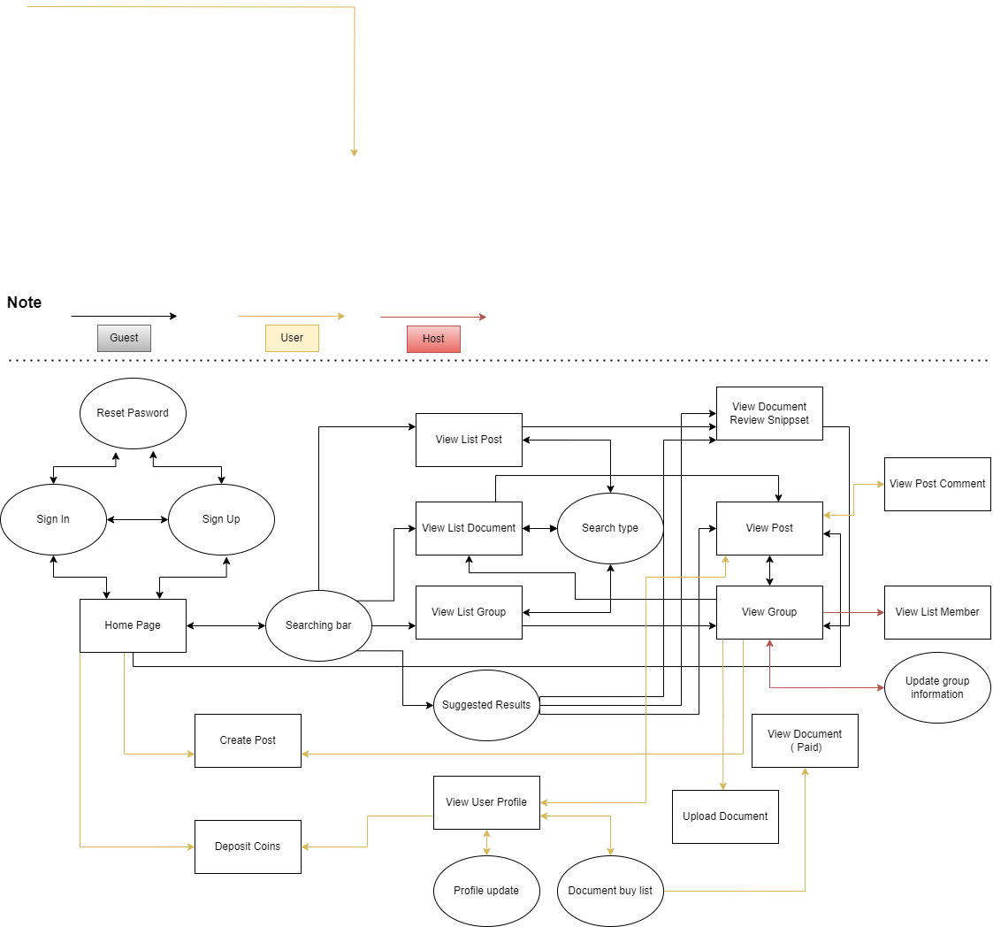
View full

3.1.2 Screen Descriptions

# | Feature | Screen | Description
1 | View All Hot Post | Landing Page | The guest can see all the hot posts inside all groups, but they can’t see the comments.
2 | Login | Login | The user login to their account.
3 | Register | Signup | The guest created an account.
4 | Reset Password | Reset Password | User forgot the password and they want to reset to make a new password.
5 | View Profile | User Profile | The user wants to view their profile.
6 | Edit Username | Edit Profile | The user wants to change their username.
7 | Edit Phone | Edit Profile | The user wants to change or add their Phone.
8 | Edit Avatar | Edit Profile | The user wants to change or add their Avatar.
9 | Change Password | Edit Profile | The user wants to change their password.
10 | View All Post | Home Page | The user can see all the posts available.
11 | Create Group | Home Page | The User who has enough 2000 activity points can create a group.
12 | Edit Group Avatar | Group Page | The host of the group can change the group avatar.
13 | Edit Group Background | Group Page | The host of the group can change the group background.
14 | Edit Group Description | Group Page | The host of the group can change the group description.
15 | View your group list | Home Page | The user can see all the groups that they have joined in the drop list.
16 | View Hot Post By Group | Group Page | The user can see all the hot posts of each group.
17 | Comment | Group Page, Home Page | The user can make a comment on the post which they care about.
18 | Edit comment | Group Page, Home Page | The user can edit their comment.
19 | Delete comment | Group Page, Home Page | The user can delete their comment.
20 | View Comment | Group Page, Home Page | The user can view all comments.
21 | Like/ Dislike post | Group Page, Home Page | The user can like or dislike the post.
22 | Like/ Dislike Comment | Group Page, Home Page | The user can like the comment.
23 | Create Post | Group Page | The user can make a post inside the group which they had joined.
24 | Edit Post | Group Page, Home Page | The user can edit their post, edit content, add or remove pictures.
25 | Delete Post | Group Page, Home Page | The user can delete their post.
26 | Search Post | Landing Page, Group Page, Home Page
27 | Report Post | Group Page, Home Page | The user can report the post not following the rule of the website or group to the admin .
28 | Report Comment | Group Page, Home Page | The user can report the comment not following the rule of the website or group to the admin.
29 | Buy Coins | Payment | The user can use their own money to buy coins which are needed for paying documents.
30 | Donate coins | Group Page, Home Page | The user can donate coins for someone, who have good sharing  on post.
31 | Exchange coins to money | Home page | The user can exchange their coins back to money
32 | View all accounts | Admin home page | Admin can view accounts’ details
33 | Delete accounts | List accounts page | Admin can delete the user's account permanently.
34 | Lock/Open accounts | List accounts page | Admin can lock/open the user’s account temporarily.
35 | View all reports | Admin home page | Admin can view reports’ details
36 | View document to approve | Admin home page | Admin can view documents before approving them.
37 | Accept/Reject document | List documents page | Admin can accept documents to release to the community or reject them.
38 | View all groups | Admin home page | Admin can view groups’ details
39 | Notify groups | List groups page | Admin can send notification to groups.
40 | Delete groups | List groups page | Admin can delete groups permanently.
41 | View User quantity/Coin sales charts | Admin home page | Admin can view community statistics about user quantity and coin sales.

3.1.3 Screen Authorization

Screen | User | Group Host | Group Member | Admin | Guest
<<Landing Page>> |  |  |  |  | X
View All Hot Post |  |  |  |  | X
<<Login>> | X | X | X | X | X
Login | X | X | X | X | X
<<Register>> | X | X | X |  | X
Register | X | X | X |  | X
<< Reset Password >> | X | X | X
Reset Password | X | X | X
<<Edit Profile>> | X | X | X
Edit Username | X | X | X
Edit Avatar | X | X | X
Edit Phone | X | X | X
Change Password | X | X | X
<<User Profile>> | X | X | X
View Profile | X | X | X
<< Home Page>> | X | X | X
View All Post | X | X | X
Create Group | X | X | X
View your group list | X | X | X
Comment |  | X | X
Edit comment |  | X | X
Delete comment |  | X | X
View Comment |  | X | X
Like/ Dislike post | X | X | X
Like/ Dislike Comment | X | X | X
Edit Post |  | X | X
Delete Post |  | X | X
Search Post | X | X | X
Report Post | X | X | X
Report Comment | X | X | X
Buy Coins | X | X | X
Donate coins | X | X | X
Exchange coins to money | X | X | X
<< Group Page >> |  | X | X
Edit Group Avatar |  | X
Edit Group Background |  | X
Edit Group Description |  | X
View Hot Post By Group |  | X | X
Create Post |  | X | X
View all accounts |  |  |  | X
Delete accounts |  |  |  | X
Lock/Open accounts |  |  |  | X
View all reports |  |  |  | X
View document to approve |  |  |  | X
Accept/Reject document |  |  |  | X
View all groups |  |  |  | X
Notify groups |  |  |  | X
Delete groups |  |  |  | X
View User quantity/Coin sales charts |  |  |  | X

3.1.4 Non-Screen Functions

# | Feature | System Function | Description
1 | Get Activity Points | Add Activity Points | Add points that are needed for upgrading the user's level when the user does specific activities.
2 | Verify Email | Send Verify Key | Send a key to input email to verify the user every time the user wants to reset password.
3 | Get Coins | Do Transaction | Get coins from the user transfering money to give to the recipient.

3.1.5 Entity Relationship Diagram

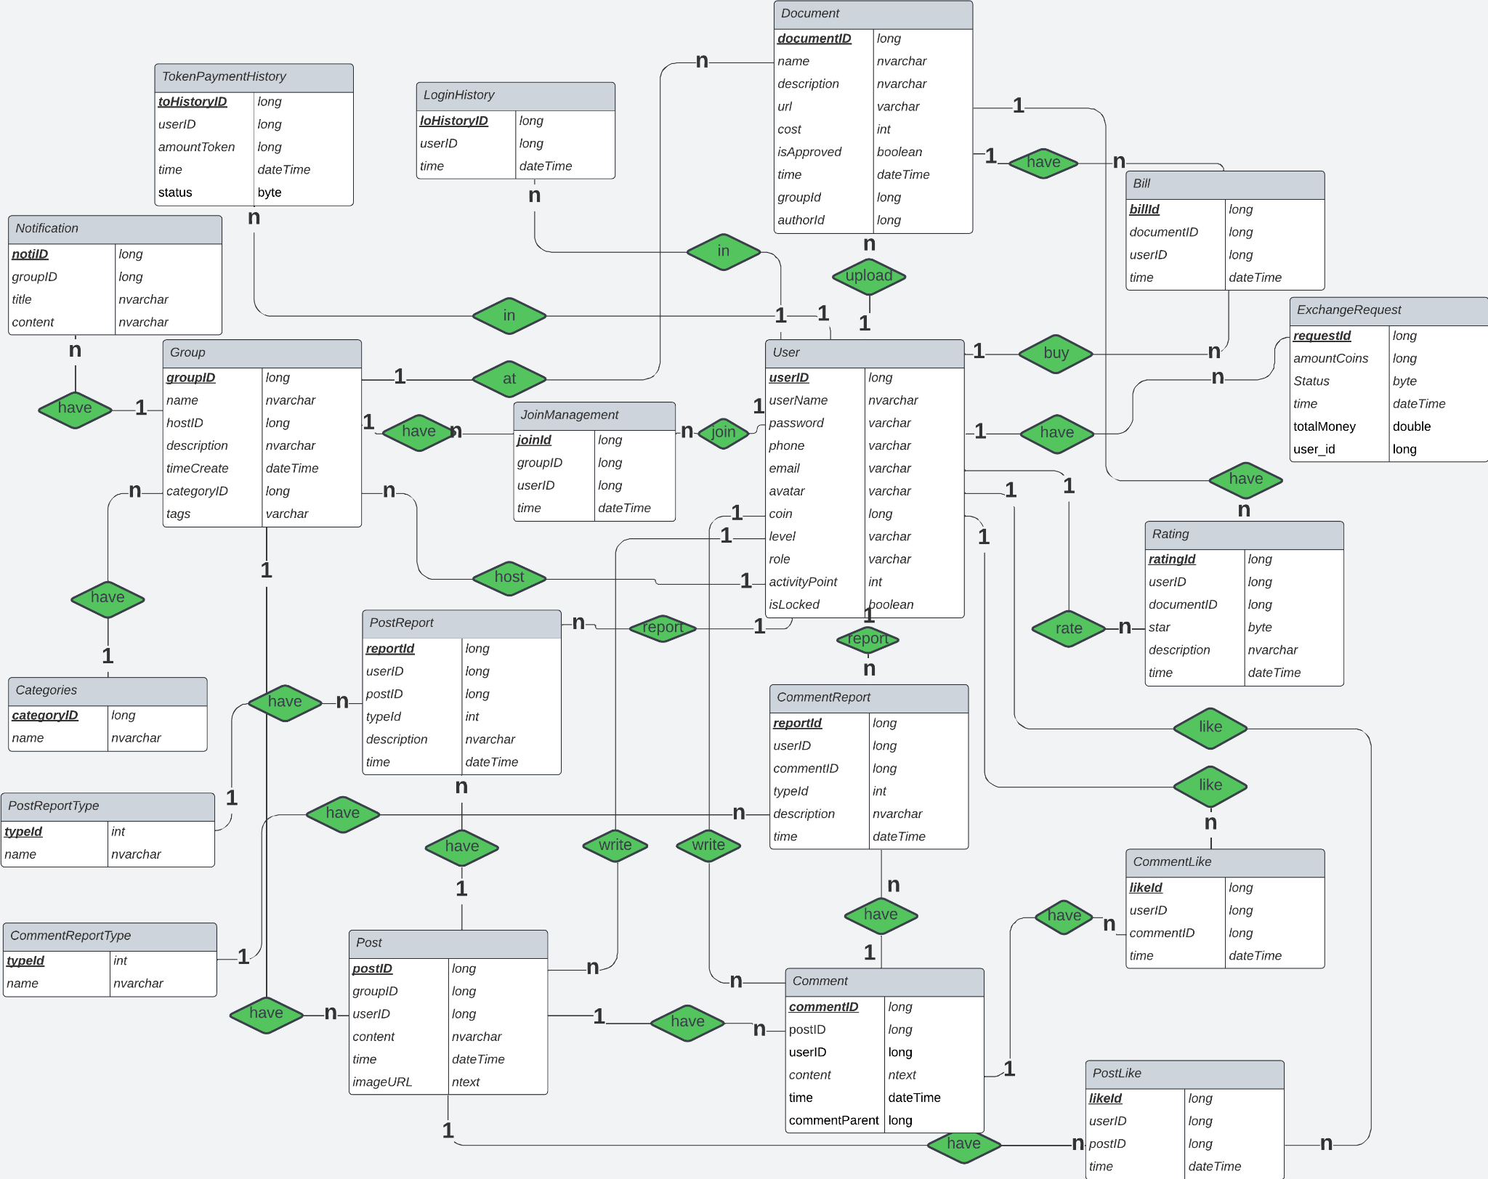
Entities Description

# | Entity | Description
1 | User | Define 3 types of user in Camp Scholars system, store information about a user
2 | Group | Users can create Group  Each group information including Categories, JoinManagement and consists of many Post
3 | Categories | Categories belong to each Group, represents categories or genres of the group
4 | JoinManagement | JoinManagement belong to each Group, including users and join time
5 | Post | Posts belong to each Group, including content and many Comment
6 | PostLike | PostLikes belong to each Post,users can like posts interesting
7 | PostReport | Users can report invalid posts
8 | PostReportType | PostReportType belong to each PostReport, including the name of the reports type
9 | Comment | Comments belong to each Post, including content
10 | CommentLike | CommentLikes belong to each Post,users can like comments interesting
11 | CommentReport | Users can report invalid comments
12 | CommentReportType | CommentReportType belong to each CommentReport, including the name of the reports type
13 | Document | Users can buy or upload documents for sell on the system
14 | Bill | Bills belong to each Document,Bills to confirm the users has paid token for the document
15 | Rating | Rating belong to each Document, to review the quality of document
16 | TokenPaymentHistory | Stores user transaction history
17 | LoginHistory | Stores user login logs including login time
18 | Notification | Stores all notification admin sent to groups.
19 | ExchangeRequest | Stores information of the coin transactions.

4. Non-Functional Requirements

4.1 External Interfaces
- All text, messages should be written in Vietnamese
- The academic website should have a user-friendly interface accessible via web browsers.
- It should support various web browsers, including Chrome, Firefox, Safari, and Edge.

4.2 Quality Attributes
4.2.1 Usability
- The academic website should have an intuitive and easy-to-navigate design.
- Users, both guest and member, should be able to become productive within 15 minutes of using the website.
- Measurable task times:
  - User registration: < 2 minutes
  - Search for academic articles: < 10 seconds
  - Upload research papers, academic documents: < 5 minutes
4.2.2 Reliability
- Availability: The website should be available 99.9% of the time (excluding scheduled maintenance).
- Mean Time Between Failures (MTBF): The system should have an MTBF of at least 10,000 hours.
- Mean Time To Repair (MTTR): In the event of a failure, the system should be restored within 2 hours.
- Accuracy: The website should provide precise and accurate academic information and data, meeting industry standards for data accuracy.
- Maximum Bugs or Defect Rate: The website should have a maximum bug rate of 1 bug per 1,000 lines of code (1 bug/KLOC).
- Bugs or Defect Rate: Categorised as minor, significant, and critical bugs, with critical bugs defined as those that result in a complete loss of data or a significant disruption of core functionality.
4.2.3 Performance
- Response time for a transaction:
  - Average response time for searching academic articles: < 2 seconds
  - Maximum response time for submitting research papers: < 10 seconds
- Throughput: The system should support a minimum of 50 concurrent users and handle at least 10 transactions per second during peak usage.
- Capacity: The website should accommodate a minimum of 100 registered users and store at least 500 academic data.

5. Requirement Appendix

5.1 Business Rules
ID | Rule Definition
BR-01 | OTP code consists of 6 positive numbers and is valid in 1 minute.
BR-02 | If users input incorrect OTP 5 times, their email/phone will be locked in 10 minutes.
BR-03 | If users input incorrect username or password 5 times, they must wait 10 minutes for the next try.
BR-04 | All descriptions are restricted to 250 characters.
BR-05 | Image type must be png, jpg, gif, bmp.
BR-06 | Image <= 5MB.
BR-07 | If user continuously like/dislike 2 times on 1 post/comment, the total like made by that user will return 0
BR-08 | Network transmissions that involve financial information or personally identifiable information require 256-bit encryption.
BR-09 | Only regular employees can register for payroll deduction for any company purchase.
BR-10 | An employee can register for payroll deduction payment of cafeteria meals if no more than 40 percent of his gross pay is currently being deducted for other reasons.
BR-11 | Coins in wallet > Coin use
BR-12 | User must be a member of group
BR-13 | Paypal account still working
BR-14 | Buy coins price: 1 USD = 20 coins
BR-15 | Exchange coins price: 30 coins = 1 USD
BR-16 | Login to system

5.2 Common Requirements

5.3 Application Messages List
# | Message code | Message Type | Context | Content
1 | MSG01 | In line | There is not any search result | No search results.
2 | MSG02 | In red, under the text box | Input-required fields are empty | The * field is required.
3 | MSG03 | Toast message | Updating asset(s) information successfully | Update asset(s) successfully.
4 | MSG04 | Toast message | Adding new asset successfully | Add assets successfully.
5 | MSG05 | Toast message | Confirming email of asset hand-over is sent successfully | A confirmation email has been sent to {email_address}.
6 | MSG06 | Toast message | Resetting asset information successfully | Return asset(s) successfully.
7 | MSG07 | Toast message | Deleting asset information successfully | Delete asset(s) successfully.
8 | MSG08 | In red, under the text box | Input value length > max length | Exceed max length of {max_length}.
9 | MSG09 | In line | Username or password is not correct when clicking sign-in | Incorrect username or password. Please check again.

