LAB8
Bài 1.2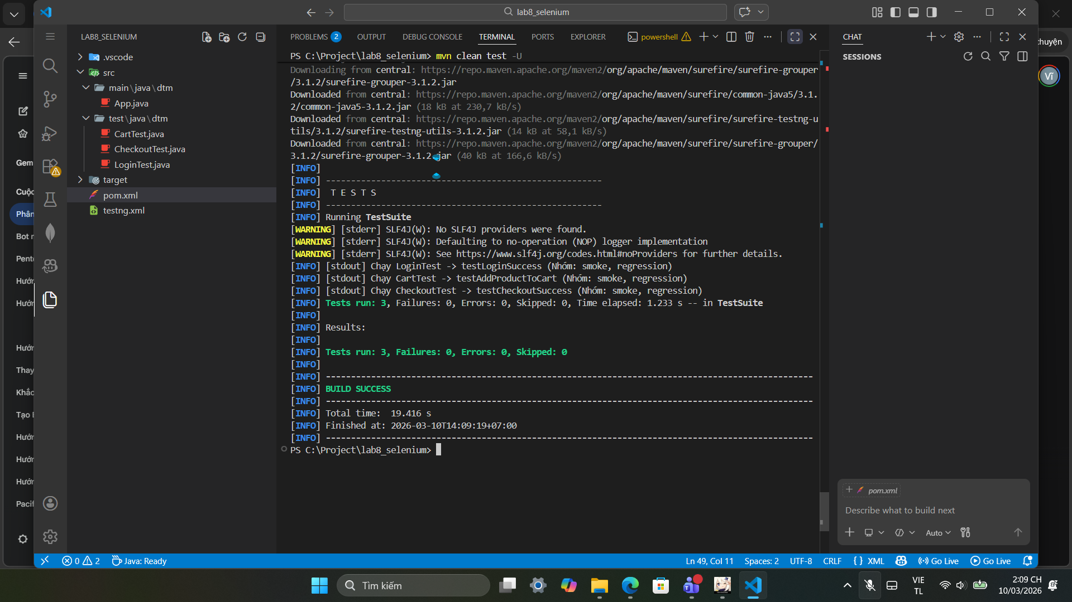

Bài 2
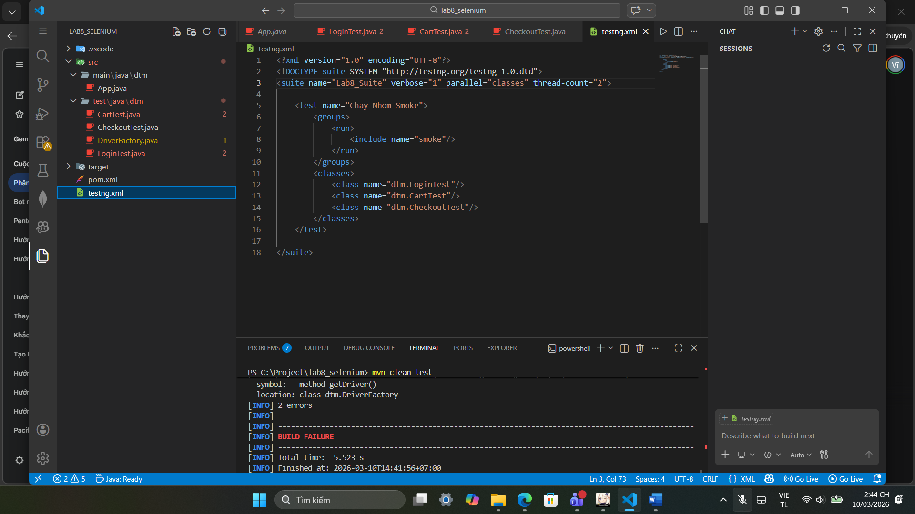
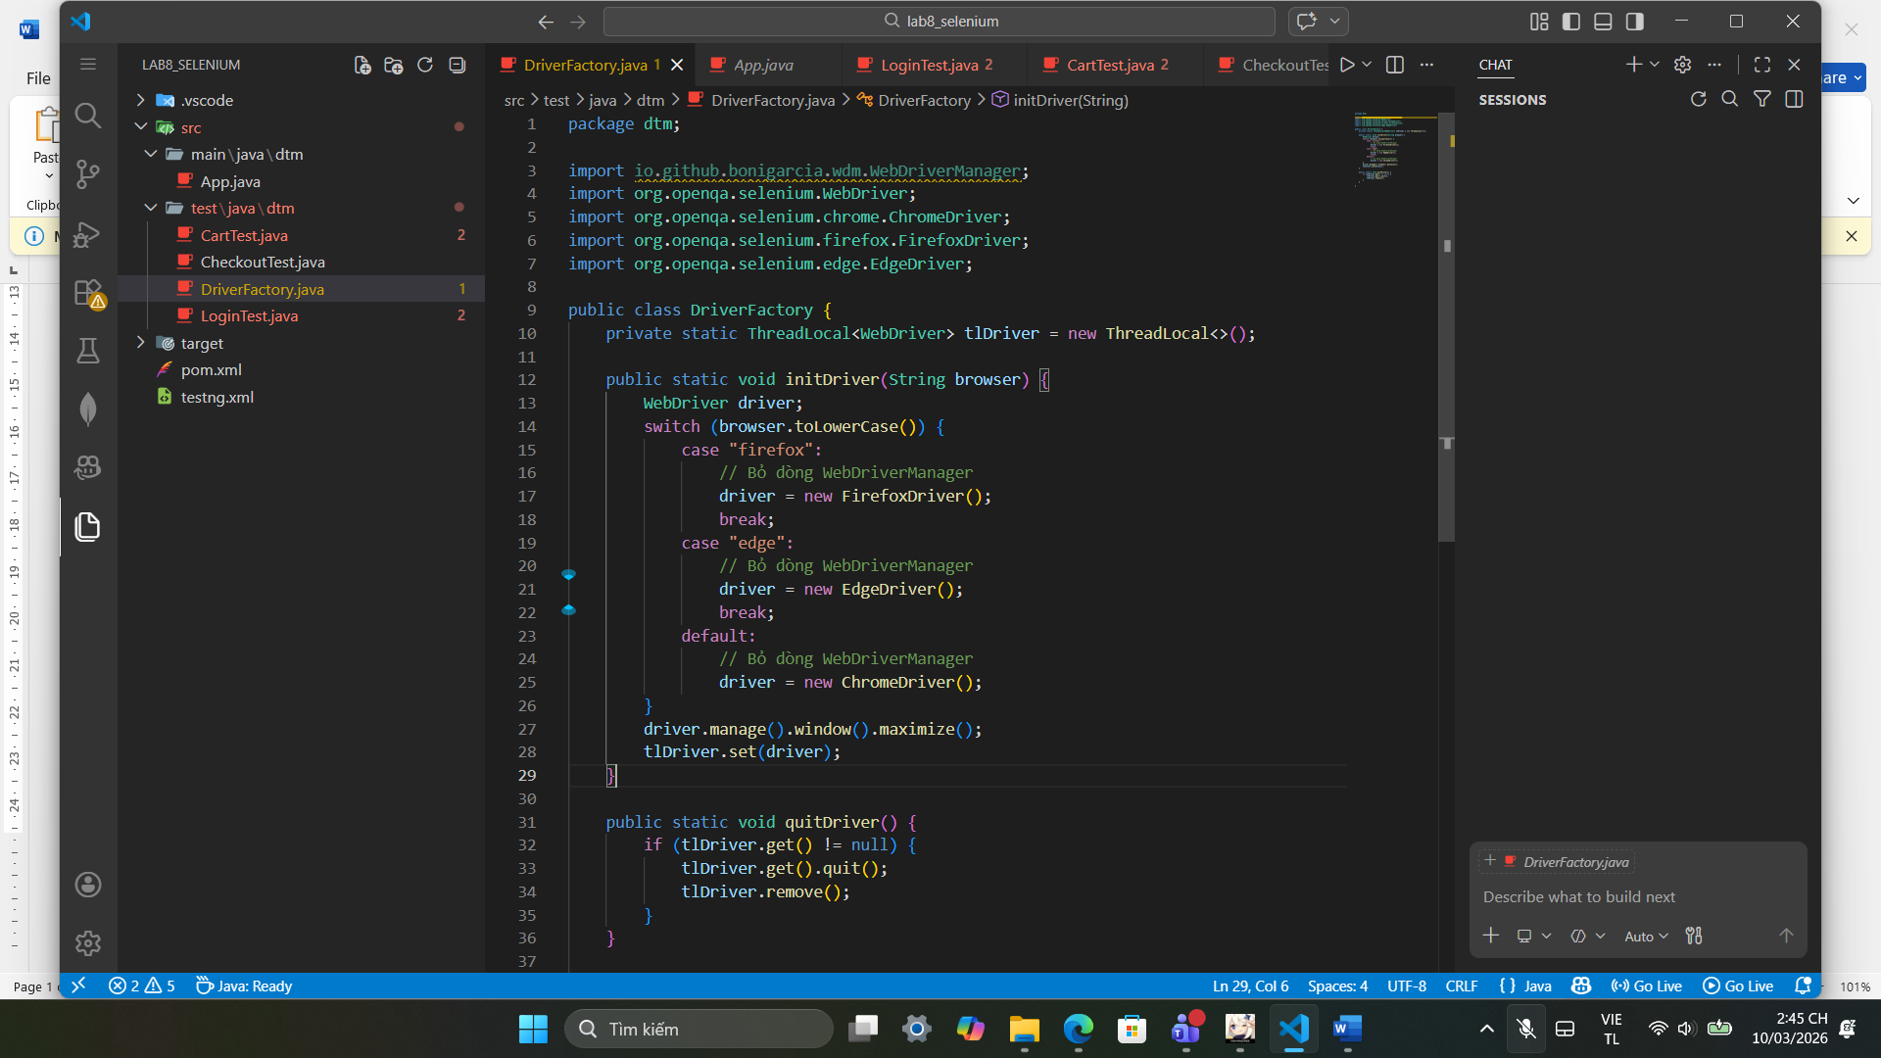
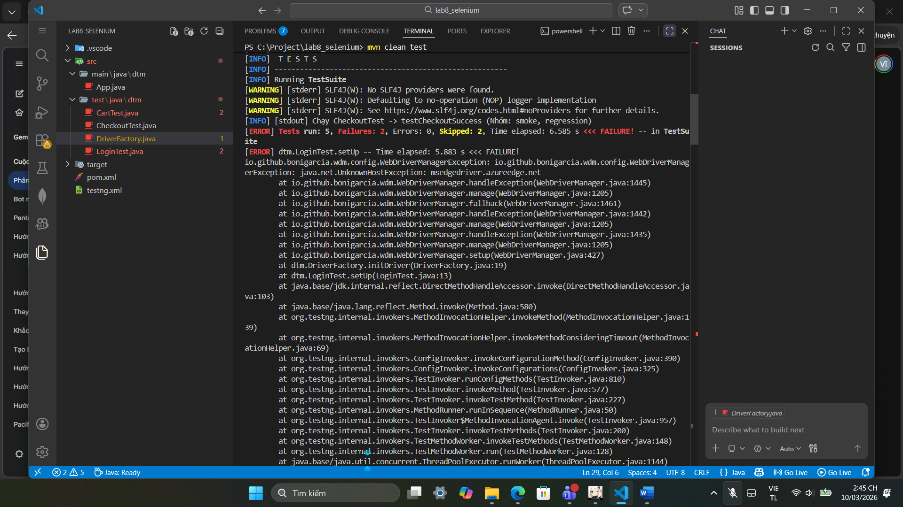

Bài 3
Node 1 (Decision): if (diemTB < 0 || diemTB > 10)
Node 2 (Statement): return "Diem khong hop le";
Node 3 (Decision): if (diemTB >= 8.5)
Node 4 (Statement): return "Gioi";
Node 5 (Decision): if (diemTB >= 7.0)
Node 6 (Statement): return "Kha";
Node 7 (Decision): if (diemTB >= 5.5)
Node 8 (Statement): return "Trung Binh";
Node 9 (Decision): if (coThiLai)
Node 10 (Statement): return "Thi lai";
Node 11 (Statement): return "Yeu - Hoc lai";
Exit: Điểm thoát của hàm.

TC ID | diemTB | coThiLai | Đường đi trên CFG (Path) | Kết quả mong đợi | Node đi qua
TC_01 | -1 | false | N1(True) -> N2 -> Exit | "Diem khong hop le" | N1, N2
TC_02 | 9 | false | N1(False) -> N3(True) -> N4 -> Exit | "Gioi" | N1, N3, N4
TC_03 | 8 | false | N1(F) -> N3(F) -> N5(True) -> N6 -> Exit | "Kha" | N1, N3, N5, N6
TC_04 | 6 | false | N1(F) -> N3(F) -> N5(F) -> N7(True) -> N8 -> Exit | Trung Binh" | N1, N3, N5, N7, N8
TC_05 | 4 | true | N1(F) -> N3(F) -> N5(F) -> N7(F) -> N9(True) -> N10 -> Exit | "Thi lai" | N1, N3, N5, N7, N9, N10
TC_06 | 4 | false | N1(F) -> N3(F) -> N5(F) -> N7(F) -> N9(False) -> N11 -> Exit | "Yeu - Hoc lai" | N1, N3, N5, N7, N9, N11

