1. If db already has existing tables, run UserScripts/Droptables.sql first.
2. Run Schema Compare. Then, update the target db to add tables.

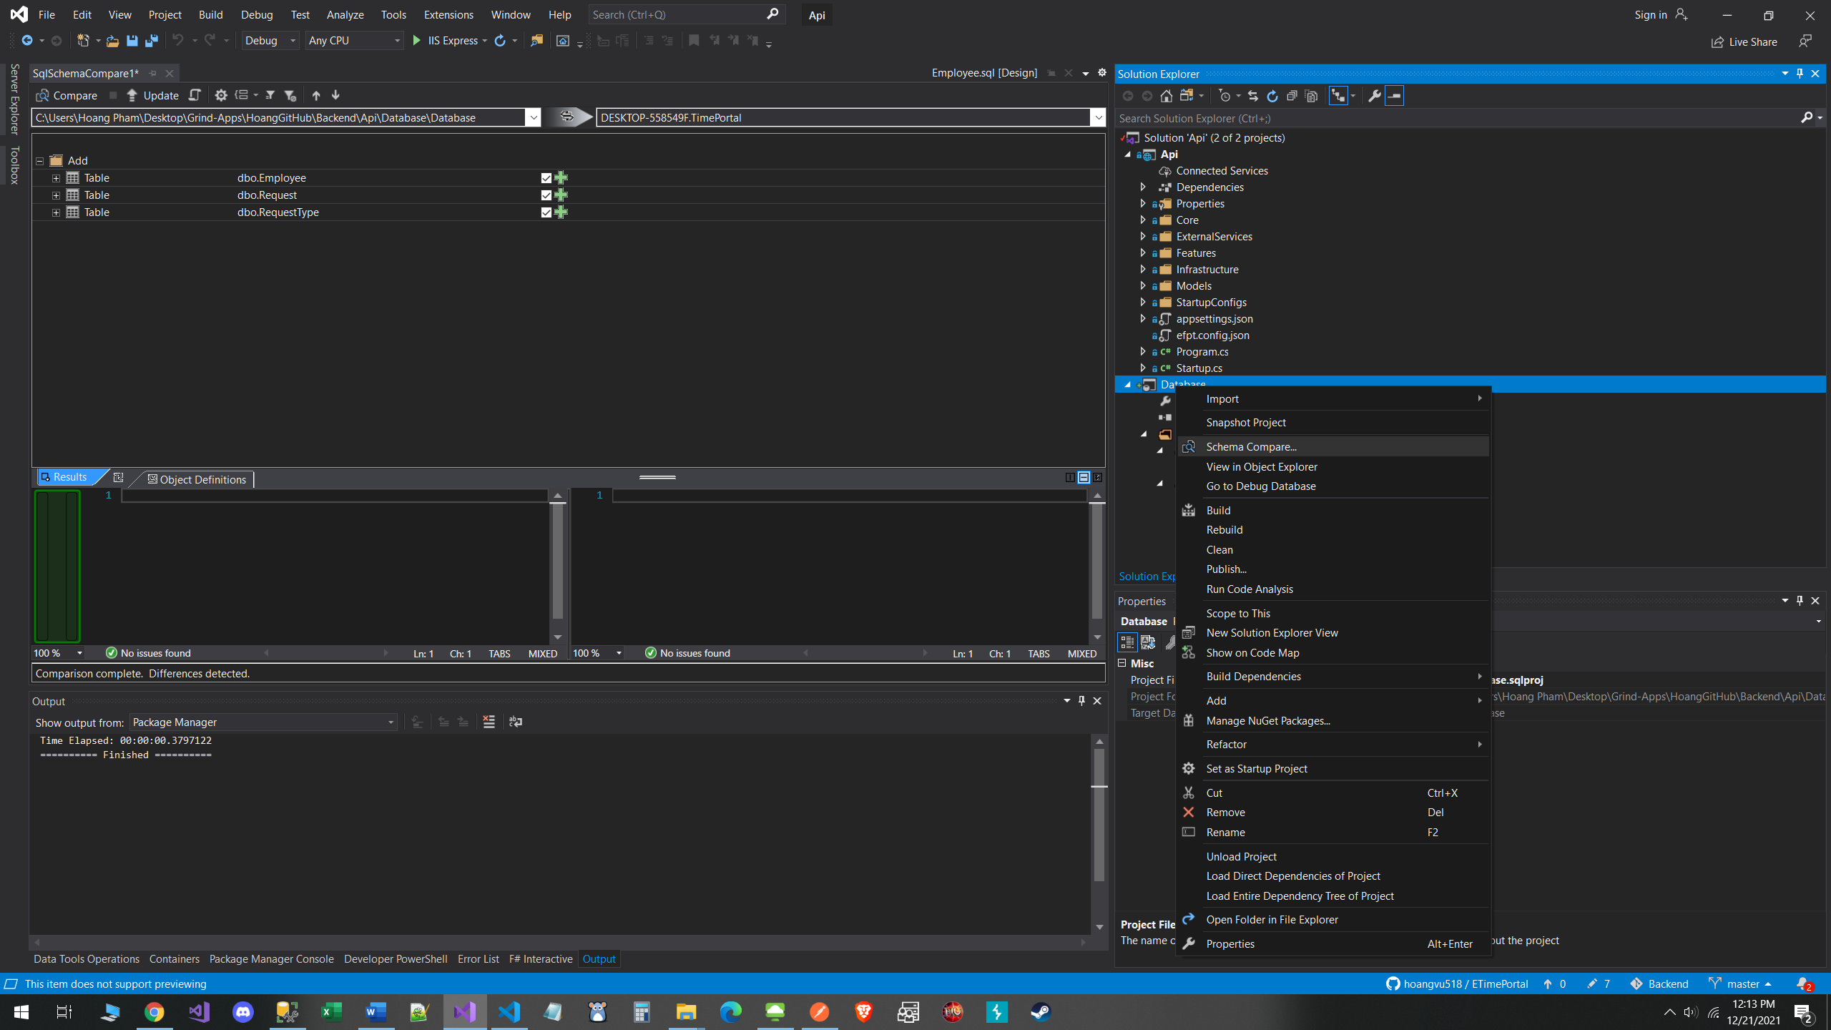

1. Run SeedData script in your DB to seed data